22/04/2026
University of Wales Trinity Saint David
London Campus
ASP Assignment

Module Name: Analyzing and Solving Problem
Module code: ACCA4019

Student Name: Maksim Zanev
Student ID: 2436811
Group: 2

Lecture’s Name: Redhwan Al Amiri

Contents
Problem Scenario: 2
Problem Deconstruction 2
Solution and Explanation 3
Flowchart 3
Explanation 5
Reflection 7
IPO Table (Input – Process – Output) 9
Variables 9
Assumptions Made 9
Constraints 10
Justification of the Approach 10
Limitations of the Solution 10
Alternative Solutions 10
Conclusion 10
References 11

Problem Scenario:
A local college is facing difficulties in managing its classroom allocations efficiently. Some rooms are overcrowded while others remain underused, leading to timetable clashes and wasted time as staff and students move between rooms. The college aims to optimise classroom allocation to make better use of available space and improve the overall learning experience.
You have been asked to develop a solution that achieves the following:

- Efficient allocation of classrooms based on class sizes and room capacities.
- Minimised time wasted by students and staff moving between classes.
- Accurate timetabling to ensure all lessons start on time without scheduling conflicts.

Problem Deconstruction
The problem described in this scenario is related to inefficient classroom allocation within a college. At the moment, some classrooms are overcrowded while others are underused. This leads to timetable clashes and unnecessary movement of both students and staff between different locations. As a result, time is wasted and the overall learning experience is negatively affected.
In order to understand the issue more clearly, the problem can be broken down into smaller components. Firstly, there is a mismatch between class sizes and room capacities. Some classes are assigned to rooms that are too small, while larger rooms are not used efficiently. Secondly, there are scheduling issues, where multiple classes may be planned at the same time without proper coordination. Thirdly, there is the issue of movement between classrooms, which increases when rooms are not allocated strategically.
Several key variables are involved in this problem. These include the number of students in each class, the capacity of available classrooms, the number of time slots, and the physical layout of the college. These variables directly affect how efficiently classrooms can be allocated. If they are not considered properly, the system will continue to produce conflicts and inefficiencies.
To better define the requirements, the MoSCoW prioritisation technique can be applied. The “must have” requirements include assigning each class to a room with sufficient capacity and ensuring that no timetable clashes occur. The “should have” requirements include reducing the amount of movement between classes and improving the overall distribution of room usage. The “could have” requirements might include preferences such as assigning certain rooms to specific teachers or departments. Finally, the “won’t have” requirements include advanced optimisation systems that are not necessary for the basic functionality of the solution.
There are also several constraints that limit how the problem can be solved. These include the limited number of classrooms, fixed lesson times, and the physical distance between rooms. These constraints must be considered when designing a solution, as they restrict the possible options for allocation.

Solution and Explanation

Flowchart
START
tart

Class size data

Room capacity data

Class schedule

Room availability

Sort classes by size
(largest first)

Pick next class

Prioritize largest class

Check available rooms for this time

Filter rooms avoiding overcrowding

Is this room available?
NO

YES

YES
Is the distance acceptable?
YES
NO

Assign room to class
Attempt reallocation

Update system
(mark room as occupied)

Can the class be reallocated?
More classes to assign?
Assign alternative room
YES

NO
NO
Mark conflict
Are there any conflicts left?

YES
Generate conflict report

NO

Generate final timetable
END

Explanation
*The proposed solution uses a logical and step-by-step classroom allocation process designed to improve efficiency, reduce overcrowding, minimise unnecessary movement, and prevent timetable clashes [1][2].
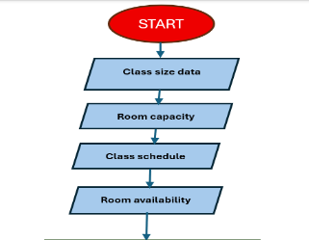
The process begins by collecting all relevant data, including class sizes, room capacities, class schedules, and room availability. This information is necessary to ensure that accurate decisions can be made during the allocation process [2].

*Once the data is prepared, all classes are sorted by size, with the largest classes processed first. This approach is important because larger classes have fewer suitable room options and therefore need to be prioritised. By allocating larger groups first, the risk of overcrowding is reduced, and room resources are used more effectively [3].
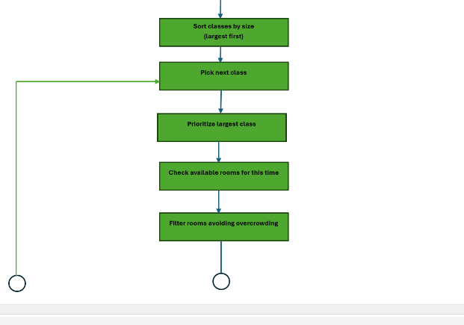
The system then selects the next class and checks which rooms are available during the required time slot. Rooms that do not meet capacity requirements are filtered out in order to avoid overcrowding. This ensures that only realistic room options remain [4].

*After filtering, the first decision point asks whether the room is suitable. A room is considered suitable if it has enough capacity and is available at the correct time. If the answer is yes, the process continues to the second decision point, which checks whether the distance is acceptable. This helps reduce unnecessary travel time for students and staff between classes [1].
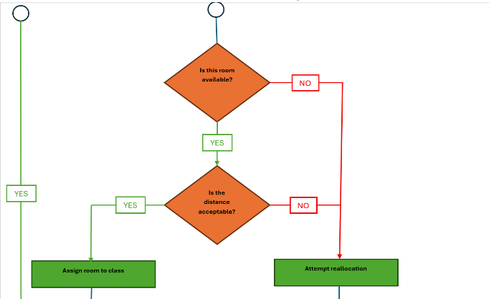
If both decisions return yes, the room is assigned to the class, and the system updates the timetable by marking the room as occupied. The process then checks whether more classes remain to be allocated. If so, the cycle repeats until all classes have been processed [2].

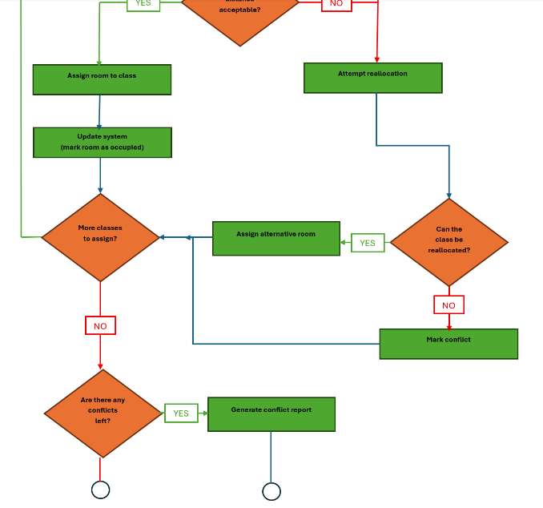
*If either the room is unsuitable or the distance is not acceptable, the system attempts reallocation. This means searching for an alternative room or adjusting previous allocations to create a better solution. If reallocation is successful, the class is assigned to an alternative room and the process continues normally [3].

*If reallocation is not possible, the issue is marked as a scheduling conflict. After all classes have been processed, the system checks whether any unresolved conflicts remain. If conflicts exist, a conflict report is generated. If no conflicts remain, the system generates the final timetable [2].

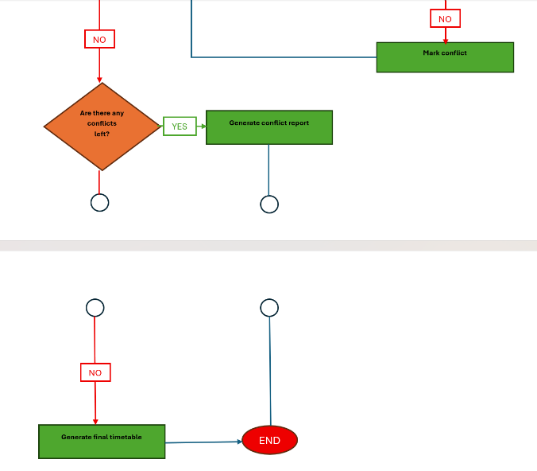

This structured solution ensures that classrooms are allocated fairly and efficiently while considering the main constraints of capacity, availability, movement distance, and timetable accuracy.

Reflection
In this task, several problem-solving techniques were used to analyse and address the issue. One of the main techniques applied was abstract thinking, which allowed the problem to be simplified into key components such as capacity, scheduling, and movement. This made it easier to focus on the core issues without being distracted by unnecessary details [7].
Another important technique used was decomposition. The problem was broken down into smaller parts, which helped to identify the main variables and constraints. By analysing each component separately, a clearer understanding of the overall problem was achieved [5].
The use of a structured approach also played a significant role in developing the solution. By following a logical sequence of steps, it was possible to design a system that is both efficient and easy to understand [2]. This is important in real-world applications, where solutions must be practical and implementable [6].
The proposed solution is appropriate because it directly addresses the main issues identified in the problem. It ensures that classrooms are allocated based on capacity, prevents timetable clashes, and reduces unnecessary movement. These improvements contribute to a more efficient and organised system [1][3].
However, there are some limitations to this approach. For example, the solution relies on accurate data, which may not always be available. Additionally, it does not account for unexpected changes, such as last-minute timetable adjustments or changes in class size [6].
Despite these limitations, the solution provides a strong foundation for improving classroom allocation. With further development, it could be enhanced to handle more complex scenarios and adapt to real-time changes [2].
MoSCoW Table
Category | Requirement | Explanation
Must Have | Allocate each class to a room with sufficient capacity | Every class must be placed in a room that can safely hold all students.
Must Have | Prevent timetable clashes | Two classes must not be assigned to the same room at the same time.
Must Have | Ensure rooms are available during required time slots | Only free rooms can be allocated.
Should Have | Minimise movement between classes | Students and staff should move shorter distances between consecutive lessons.
Should Have | Improve room usage efficiency | Large rooms should not be wasted on very small classes where avoidable.
Should Have | Start all lessons on time | Delays caused by poor room planning should be reduced.
Could Have | Allocate preferred rooms to departments | Certain subjects may benefit from being placed in specialist rooms.
Could Have | Prioritise lecturer room preferences | Teachers may prefer familiar rooms or areas.
Could Have | Generate automatic reports | Reports could show room usage and conflicts.
Won’t Have | Full AI predictive scheduling system | Advanced predictive systems are outside the scope of this solution.
Won’t Have | Real-time mobile navigation integration | Live navigation features are not required in the current design.

IPO Table (Input – Process – Output)

Input | Process | Output
Class size data | Compare class size with room capacity | Suitable rooms identified
Room capacity data | Filter rooms too small for class | Overcrowding avoided
Class timetable data | Check required lesson times | Correct time allocation
Room availability data | Detect free rooms | Available room selected
Building layout data | Measure room distance | Reduced travel time
All scheduling data | Allocate rooms by priority order | Optimised timetable
Conflict data | Detect unresolved clashes | Conflict report generated

Variables
Several variables influence the efficiency of classroom allocation. These include the number of students enrolled in each class, the seating capacity of each classroom, available lesson time slots, lecturer availability, room location, and specialist equipment requirements. Additional variables such as accessibility needs and room maintenance status may also affect final allocation decisions.

Assumptions Made
Several assumptions were made during the development of the proposed solution. It was assumed that student numbers are accurate before scheduling begins. It was also assumed that classroom capacities are correctly recorded and that room availability data is updated. Furthermore, it was assumed that lecturers and students are able to move between rooms within the allocated break periods.

Constraints
A number of constraints must be considered. The number of classrooms is limited, lesson times are fixed, and some rooms may require specialist equipment for certain subjects. Physical distance between buildings may also create movement delays. In addition, accessibility requirements may restrict the use of some rooms for particular groups of students.

Justification of the Approach
The selected approach is appropriate because it uses a structured and logical process to solve a real operational problem. By allocating larger classes first, the risk of overcrowding is reduced. By checking availability before assignment, timetable clashes are prevented. By considering room distance, unnecessary movement time is reduced. This creates a balanced and practical solution.

Limitations of the Solution
Although effective, the solution has limitations. It depends heavily on accurate data. Unexpected timetable changes, staff absence, room maintenance issues, or sudden increases in student numbers may reduce effectiveness. In addition, the model does not fully optimise human preferences such as lecturer room choices.

Alternative Solutions
Alternative solutions could include manual scheduling by administrative staff or advanced software using artificial intelligence. Manual scheduling allows human judgement but is slower and more prone to mistakes. AI systems may achieve better optimisation but would involve higher costs and greater technical complexity.

Conclusion
It can be concluded that classroom allocation can be significantly improved through structured problem-solving methods. By analysing requirements, constraints, and variables, an effective scheduling process can be designed. The proposed system improves room usage, reduces clashes, and minimises unnecessary movement while providing a practical foundation for future improvement.

References

[1] O'Brien, J. A. and Marakas, G. M. (2011) Management Information Systems. 10th edn. New York: McGraw-Hill.

[2] Shelly, G. B. and Rosenblatt, H. J. (2012) Systems Analysis and Design. 9th edn. Boston: Cengage Learning.

[3] Hillier, F. S. and Lieberman, G. J. (2015) Introduction to Operations Research. 10th edn. New York: McGraw-Hill.

[4] Kendall, K. E. and Kendall, J. E. (2014) Systems Analysis and Design. 9th edn. Harlow: Pearson.

[5] Checkland, P. (1999) Systems Thinking, Systems Practice. Chichester: Wiley.

[6] Beynon-Davies, P. (2013) Business Information Systems. 2nd edn. Basingstoke: Palgrave Macmillan.

[7] Cottrell, S. (2019) Critical Thinking Skills. 3rd edn. London: Red Globe Press.

[8] Brookshear, J. G. and Brylow, D. (2018) Computer Science: An Overview. 13th edn. Harlow: Pearson.

