Embedded Electronic Systems

Electrical and Electronic Principles

ACDA4006

Lewy Harrison (2321772)

Resonance Circuit Practical

Abstract:
Using Proteus as our simulator we designed a simple resonance circuit using only a resistor, a capacitor and an inductor. We attached a signal generator and an oscillator to simulate and read results. We set the signal generator’s output to 2 Vpk-pk (keeping it at this value for each reading), at 100Hz. We then measured the voltages across the circuit, from 100Hz up to a maximum of 20kHz.
After collecting those results we calculated the attenuation in dB, using the following formula:

Figure 1: Formula used to calculate the attenuation in dB.
We plotted the results on a graph of frequency against attenuation, with frequency on the y axis and the x axis being on a logarithmic scale from 100 to 20k dB. Results showed that the resonant frequency was close to 5000dB.
We created the circuit on a breadboard next and physically hooked it up to a waveform generator and a signal generator. The results were similar and showed that the resonant frequency was close to 5000dB.

Introduction:
The resonance circuit that was built only consisted of 3 components: a resistor, an inductor and a capacitor, arranged in series or parallel. These components interact with each other to produce resonance, which is characterized by a peak in the circuit’s impedance at a specific frequency.
The resistor’s role in the circuit is to dissipate energy and help dampen oscillations to prevent the circuit form becoming unstable.
The inductor is a coil of wire that produces a magnetic field when current flows through it. In this circuit, the inductor stores energy in its magnetic field and opposes changes in current flow.
The capacitor is 2 conductive plates separated by a dielectric material that stores energy in an electric field. In this circuit, the capacitor stores energy in its electric field and opposes changes in voltage.
At resonance, the inductive reactance (X_{L}) of the inductor cancels out the capacitive reactance (X_{C}) of the capacitor, resulting in maximising impedance.
In the real world, these circuits are used in various applications across different fields due to their ability to selectively amplify or filter signals at specific frequencies.
Examples include turning circuits in radios – used in lots of communication devices to select and amplify signals at specific frequencies. Tuning circuits consisting of inductors and capacitors are adjusted to resonate at the desired frequency.
They are also utilized in power factor correction systems to improve the efficiency of electrical power distribution. By adjusting the phase relationship between voltage and current, resonance circuits can reduce reactive power losses and improve the power factor of electrical loads, leading to greater energy efficiency and reduced electricity costs in industrial and commercial applications. According to Power Electronics New Zealand, “power factor correction capacitors act as a low impedance device” [1].
These circuits can also be used in oscillators to generate sine waves at specific frequencies. By configuring the components of the circuit to resonate at the desired frequency, oscillators can produce stable and precise output signals for various applications such as timing circuits, frequency synthesizers and signal generators.
Resonance circuits are employed as filters to selectively pass or reject signals at certain frequencies while attenuating other frequencies. Depending on the configuration of the circuit, resonance circuits can act as a high-pass, low-pass, band-pass or band-stop filters, allowing them to tailor the frequency response of a system to meet specific requirements. Filters are used in audio systems, telecommunications, instrumentation and signal processing applications.
These also may be used as sensors or detectors to detect changes in physical quantities such as pressure, temperature or magnetic fields. By monitoring changes in the resonant frequency of the circuit caused by variations in the external environment, sensors and detectors can provide valuable information for applications such as medical diagnostics, environmental monitoring and industrial automation.
Reactance is the opposition to the flow of alternating current (AC) caused by inductive (X_{L}) and capacitive (X_{C}) elements in the circuit. Inductive reactance (X_{L}) increases with frequency, while capacitive reactance (X_{C}) decreases with frequency.
Impedance (Z) is the total opposition to the flow of AC in a circuit, consisting of resistance (R), inductive reactance (X_{L}) and capacitive reactance (X_{C}). It is represented as a complex number in the form Z = R + j (X_{L} – X_{C}), where j is the imaginary unit.
The theory behind a resonance circuit is based on the principle of resonance, which occurs when the reactances of the inductor (X_{L}) and capacitor (X_{C}) in the circuit cancel each other out at a specific frequency, resulting in maximum impedance or voltage across the circuit. The resonant frequency (f_{r}) is the frequency at which resonance occurs in the circuit. It is determined by the values of the inductance (L) and capacitance (C) according to the formula:
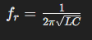 Figure 2: Formula for calculating resonant frequency for a circuit.
Resonance occurs when the inductive reactance and capacitive reactance in the circuit cancel each other out, resulting in a net impedance of zero or maximum impedance. This condition is expressed mathematically as X_{L}=X_{C}.
At resonance, the voltage across the circuit reaches its maximum amplitude, while the current through the circuit is also at its maximum. This is because the circuit offers maximum opposition to the flow of current at resonance, resulting in maximum voltage drop across the components.
To also touch on attenuation, which is the reduction in signal strength or amplitude as it travels through a medium or passes through a circuit. It’s a measure of how much the signal’s intensity decreases from its original strength. Attenuation can occur due to various factors such as distance, absorption, scattering and impedance mismatch.
In electrical circuits, attenuation is often expressed in decibels (dB) and can be positive or negative.
A positive value indicates that the signal has decreased in amplitude as it traverses through medium or circuit. This typically occurs in situations where the signal encounters resistance, impedance or lossy components that dissipate energy.
Negative attenuation, also known as gain, indicates that the signal has increased in amplitude. This can occur in situations where the signal is amplified or boosted by active components such as amplifiers or repeaters. [2]
The rest of this report will detail the setup of both the computer simulated results and the breadboard simulated results, show tables and graphs of results, a discussion about what the results mean and lastly a conclusion stating the findings and summarizing results.
Simulation Setups:
The first simulation that was done was a computer simulation on software called Proteus. Assembling the circuit is very easy, there is a catalogue of components to choose from, so it was easy to select the resistor, inductor and capacitor. Given Proteus’ simple interface, locating the oscillator and signal generator were easy too, along with assembling the circuit.
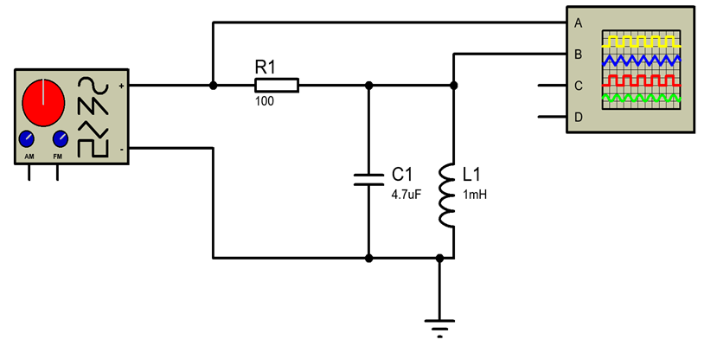
Figure 3: shows the circuit built using proteus.
After pressing the “simulate circuit button” two new windows opened. One for manipulating the signal generator and the voltage in, and the other for manipulating the oscillator and gathering results from the voltage out.
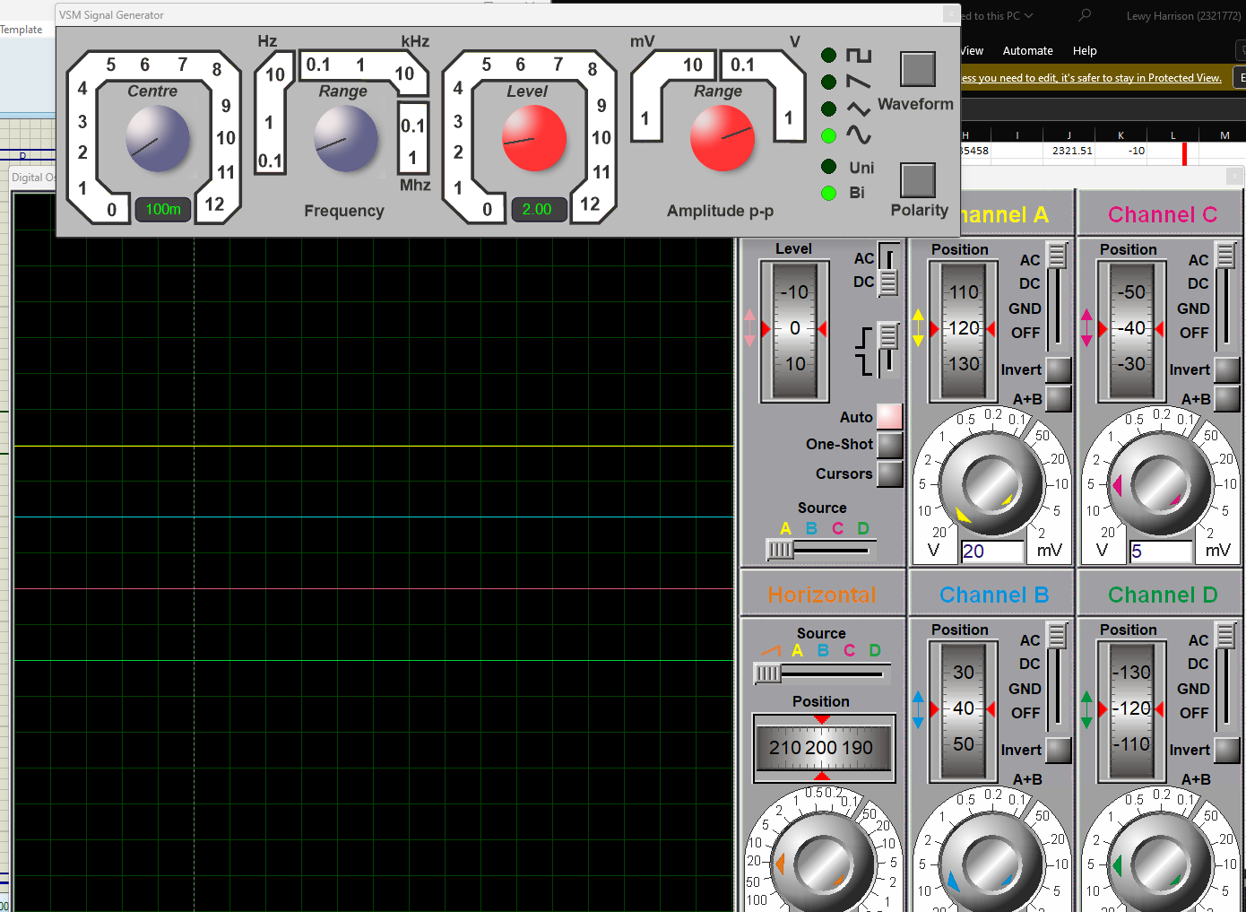
Figure 4: shows the windows used to gather results from. The top window shows 2 sets of knobs. The red set change the input peak-to-peak voltage, which was set to 2 and not changed afterwards. The grey set change the input frequency of the circuit and was our variable. It was changed at appropriate steps from 100 to 20k.
After gathering the initial set of data and examining it, there was a loose pattern of it spiking around 5000Hz. The data points gathered around there weren’t sufficient to determine where the resonant frequency was so more data points nearby were gathered. Data points like 4000Hz, 5200Hz and 6000Hz were used to more accurately locate the resonant frequency.

When we simulated this circuit using breadboards, we were given our components and it was very simple to construct the circuit, as all the components went on a straight line on the breadboard.
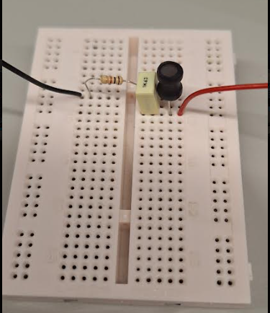
Figure 5: shows the components connected on a breadboard ready to be tested.
After assembling the circuit, it then needed to be correctly hooked up to a waveform generator and an oscillator. Using an assortment of hooks and clips, the circuit was ready to be tested.
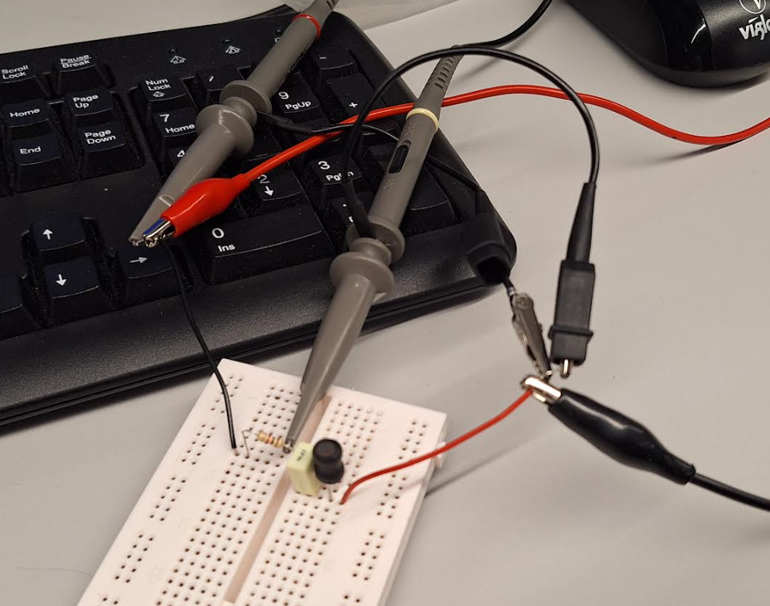
Figure 6: Shows the circuit hooked up and ready to be tested.
Before testing could start, the machines needed to be checked and set to the right settings. For example, the waveform generator had to be set to 2Vpk-pk, to ensure the right input voltage was achieved. Plus, the oscillator had to be showing the wave the right way so that a precise and correct reading could be collected.
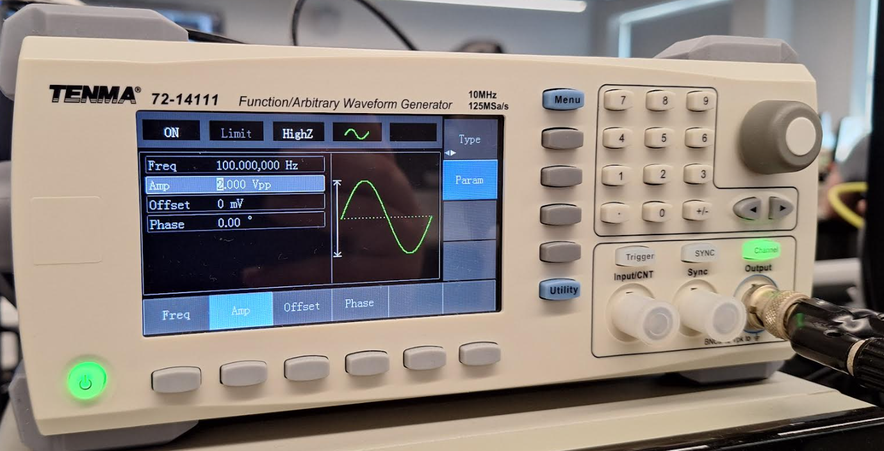
Figure 7: shows the waveform generator giving out 2Vpk-pk and giving out 100Hz, which is our starting frequency.
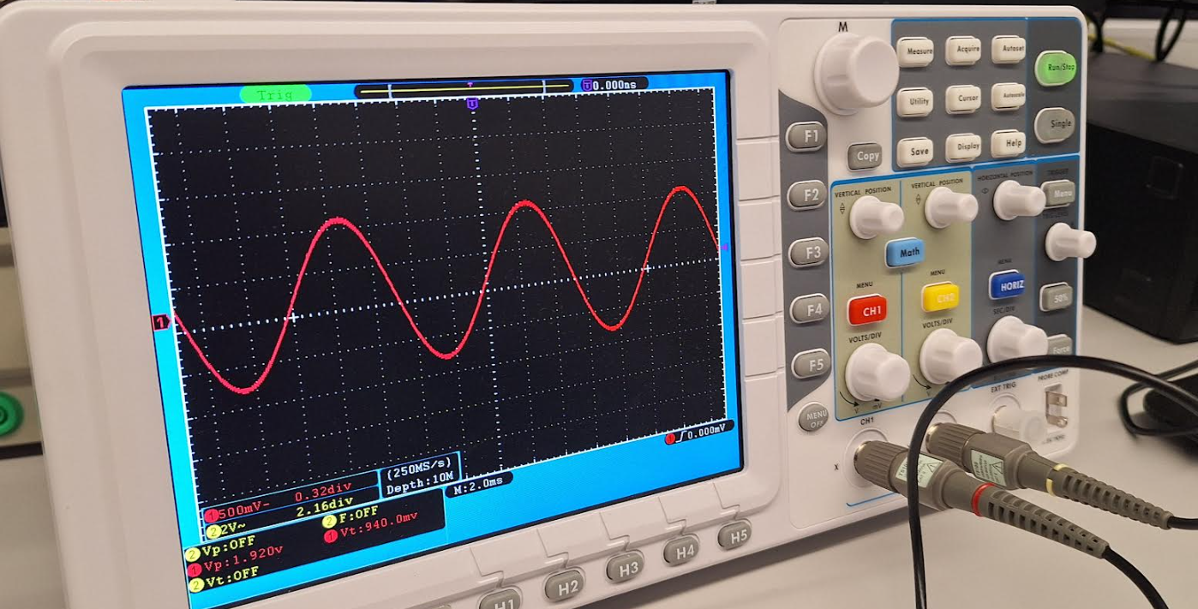
Figure 8: shows the oscillator showing a sine wave and in the bottom left, both input voltage (1.92V) and output voltage (940mV) can be seen.
While collecting data and changing frequencies, the oscillator had to be adjusted throughout, as if either peak touched the edge of the screen, the full peak-to-peak voltage wouldn’t be measured, and an incorrect reading would have taken place.
Results:
As stated earlier in this report, the attenuation (in dB) at each frequency needed to be found. The formula to calculate the attenuation is:
Figure 9: shows the formula to calculate the attenuation in dB.
Attenuation is the measure of how much the signal’s intensity decreases from its original strength.
Results from Proteus Simulation:
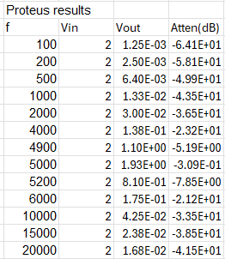
Figure 10: shows the table of results gathered from proteus simulation.
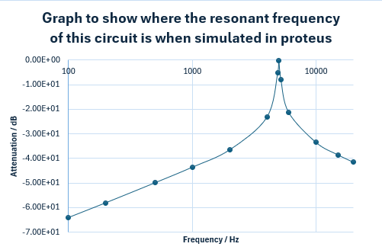
Figure 11: shows the graph of Frequency, on the x axis with a logarithmic scale, plotted against attenuation on the y axis.
Notice the sharp peak around 5000Hz, showing that the resonant frequency is nearby.
Results from Breadboard Simulation:
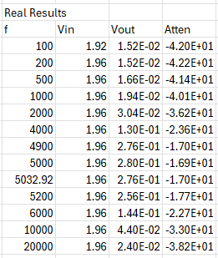
Figure 12: shows the results in a table from the breadboard simulation.
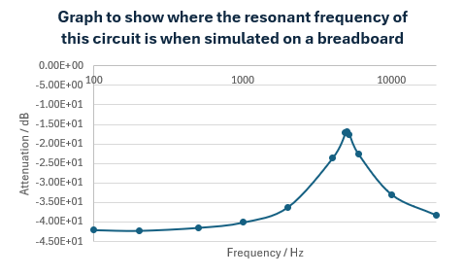
Figure 13: shows the results on a graph with frequency on the x axis on a logarithmic scale and attenuation on the y axis.
For both sets of results, the following is true. At low frequencies (100Hz – 2000Hz), the output voltage remains relatively low, indicating minimal signal amplification or attenuation. As the frequency increases, there is a very gradual increase in output voltage suggesting some degree of resonance behaviour.
As the frequency starts to reach resonance (4000Hz-5200Hz), especially around the resonant frequency of approximately 5000Hz, the output voltage peaks, indicating maximum signal amplification or resonance. At the resonance frequency, the output voltage is significantly higher compared to the input voltage, resulting in negative attenuation values.
And at higher frequencies (6000Hz – 20kHz) the output voltage starts to decrease, indicating signal attenuation. The attenuation values become more negative as the frequency increases, indicating increasing signal attenuation.
Discussion:
These results show that the resonant frequency is very close to 5000Hz. In both sets of data, the peak is close-by. However, when you start to examine the two sets of data more closely, even though they are simulated off the same circuit using the same components, the results are quite different.
At just 100Hz, the proteus results say the voltage out should be 0.00125V, but on the breadboard results the voltage out is 0.0152V which is a huge difference of 0.01405V. another example of this is at 5000Hz. The proteus simulation gives the output voltage at 1.93V, but the breadboard simulation gives the output voltage as 0.28V, and incredible difference of 1.65V.
They aren’t all opposite results, as at 2000Hz, the voltage output given by proteus simulation is 0.03V and the voltage output given by the breadboard is 0.0304V which only has a tiny difference of 0.0004V.
These differences could occur for several reasons, for example the proteus software may make some simplifications or assumptions compared to the real-world simulation which could lead to discrepancies.
The real-world components may have some damage, or some wear after being used for so long, or very simply there could have been a fault at the production line and that specific part was made slightly differently so the results given by any one of the 3 parts could be slightly off.
One other affecting factor could be the environment the test took place in. Things such as the temperature in the room, the humidity of that day, the electromagnetic interference from any number of places or even the component placement, for example the different lines on the breadboard.
To work out the resonant frequency, as mentioned in the introduction, this formula is used:
Figure 2: Formula for calculating resonant frequency for a circuit.
The L value is the value we gave to our inductor, which was 1mH and the C value is the one we gave to out capacitor, which is 1uF. After calculating what f_{r} would be, we get 5030Hz as our resonant frequency. If we compare this result to the graphs and tables, this result matches perfectly, showing that our data must be quite accurate.
Conclusion:
In this experiment, it has been determined that in a resonance circuit with only a 100-ohm resistor, a 1uF capacitor and a 1mH inductor has a resonance frequency ~5030Hz. This has been shown using two different simulations, one was a computer simulation using the software proteus and the other a real-world simulation using a breadboard. To find the frequency where the attenuation was highest it was calculated using a previously mentioned formula and plotted on a graph against the frequency. After looking at the data on the graph, it could be easily determined whether resonance frequency calculated at the start lined up with the data gathered in the experiment.

References

[1] | P. E. N. Zealand, “Power Factor Correction - Understanding the issues,” Power Electronics New Zealand, 09 March 2021.
[2] | I. S. University, “Attenuation of Waves,” Iowa State University.

