

INVESTIGATING THE INTEGRATION OF GAMIFICATION IN RECRUITMENT: ENHANCING CANDIDATE ENGAGEMENT AND ASSESSMENT

LCMB 7020 MBA Dissertation
Name: Toushe Adil Kathawala
Student ID: 2309023

Master’s Degrees by Examination and Dissertation
Declaration Form.

I, TOUSHE ADIL KATHAWALA, declare that this dissertation has been composed by myself, that the work contained herein is entirely my own except where explicitly stated otherwise in the text, and that this work has not been submitted for any other degree or qualification, in whole or in part, except as specified.

Signature: Toushe

Date: 13/10/2024

Table of Contents
Chapter 1: Introduction 4
1.1 Introduction 4
1.2 Background of the research 4
1.3 Research aim and objectives 5
1.4 Research questions 6
1.5 Research rationale 6
1.6 Problem statement 7
1.7 Significance of the research 8
1.8 Structure of the dissertation 9
1.9 Theoretical Framework 9
1.10 Conclusion 10
Chapter 2: Literature Review 11
2.1 Introduction 11
2.2 Assess the impact of gamification on candidate engagement during the recruitment process 11
2.3 Evaluate the effectiveness of different gamification features in enhancing the accuracy of candidate assessments 13
2.4 Explore candidates' perceptions of gamified recruitment methods compared to traditional approaches 15
2.5 Provide recommendations for organizations on implementing gamification strategies in their recruitment processes 17
2.6 Theoretical framework 19
2.7 Conceptual framework 21
2.8 Literature gap 22
2.9 Summary 22
Chapter 3: Research Methodology 23
3.1 Introduction 23
3.2 Research Philosophy 23
3.3 Research Approach 24
3.4 Research Design 25
3.5 Data Collection Method 25
3.6 Data Analysis Method 26
3.7 Inclusion and Exclusion criteria 27
3.8 Ethical Considerations 28
3.9 Summary 29
Chapter 4: Findings and Discussion 31
4.1 Introduction 31
4.2 Findings 31
4.2.1 Descriptive Statistics 31
4.2.2 Cross-Tabulation Analysis 42
4.2.3 Conclusion of Findings 45
4.3 Discussion 46
4.3.1 Impact of Gamification on Candidate Engagement 46
4.3.2 Effectiveness of Gamification Features in Enhancing Assessment Accuracy 47
4.3.3 Candidate Perceptions of Gamified vs. Traditional Approaches 48
4.3.4 Best Practices for Integrating Gamification into Recruitment Strategies 49
4.3.5 Consistency of Data Analysis Results with Literature Review 50
4.3.6 Limitations of the Study 51
4.3.7 Conclusion of Discussion 52
Chapter 5: Conclusion and Future Recommendations 54
5.1 Key Findings 54
5.2 Implications for Industry Practice 56
5.3 Recommendations for Future Research 58
5.4 Final Thoughts 59
References 60
Appendices 70
Appendix 1: Survey questions 70
Appendix 2: Participation Consent Form 73

Chapter 1: Introduction

Introduction
Presentation of a candidate’s offer as a game is a rising phenomenon in the field, intended to improve engagement of candidates and quality of the assessment made by the employer. In terms of recruitment, the conventional practices never inspire people and provide no way to assess the talent. It is against this background that this study seeks to analyse if and how gamification used during recruitment can hold the key to these problems.

1.2 Background of the research
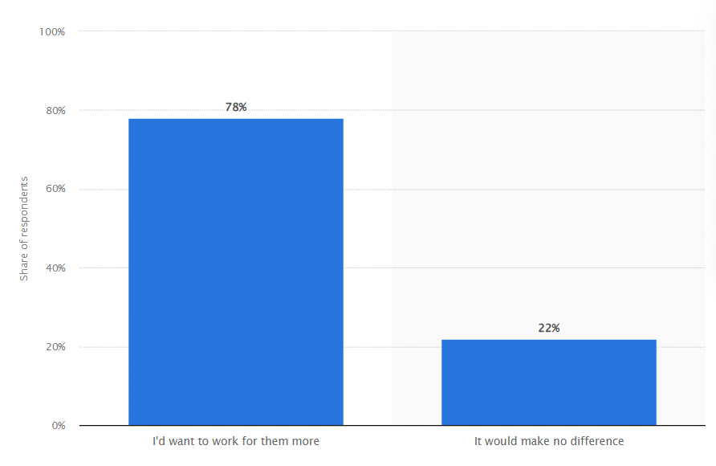
Figure 1.1: Employee opinion of gamification
(Source: Statista, 2019a)
According to the view of Abbas et al. (2021), recruitment is one of the key processes in human resource management, whose main function is to select qualified candidates capable of contributing to organisational performance. Conventional employer selection techniques include interviews and CV screening besides skills testing which while being efficient are rigid and do not capture the candidate’s attention and interest. This can result in a less engaging and possibly a less accurate way of assessing the candidate for the position in terms of his or her ability and suitability for the position. The use of non-traditional incentives such as points, badges and scoreboards in common work environments without having actual games presented in this paper as a novel approach to the challenges facing organizations.

Similarities & Differences
Gamification in recruitment shares similarities with traditional recruitment methods in terms of assessing skills, cultural fit, and performance. However, it differs by incorporating game mechanics such as leaderboards and rewards, making the process more interactive and engaging. Traditional methods often rely on static resumes and interviews.
Thus, research on the use of gamification during recruiting pointed more positive outcomes, which claims that the use of game attributes can increase the level of candidate engagement and satisfaction to a great extent. On the other hand, Webster et al. (2020) argued that for instance, the use of game elements in assessments such as the Situational Judgement Tests (SJTs) have been shown to increase the level of fairness as well as the degree of appeal from the organization. However, contrary to such expectations, there is some empirical evidence regarding the relating benefits, although the question of which specific features of gamification provide such effect and how it might affect the accuracy of estimates of candidates’ qualifications, has not been elucidated completely.
Advantages & Disadvantages
Advantages include increased candidate engagement, a more dynamic assessment of skills, and attracting tech-savvy talent. Disadvantages include the risk of gamification overshadowing actual job skills, potential biases in game design, and the need for significant investment in gamified platforms, which may not suit all industries or roles.

1.3 Research aim and objectives
Aim:
The primary aim of this research is to investigate the integration of gamification into recruitment processes to enhance candidate engagement and improve the accuracy of candidate assessments.
Objectives:
- To assess the impact of gamification on candidate engagement during the recruitment process.
- To evaluate the effectiveness of different gamification features in enhancing the accuracy of candidate assessments.
- To explore candidates' perceptions of gamified recruitment methods compared to traditional approaches.
- To provide recommendations for organizations on implementing gamification strategies in their recruitment processes.

1.4 Research questions
- How does gamification impact candidate engagement in recruitment processes?
- Which gamification features most effectively enhance the accuracy of candidate assessments?
- How do candidates perceive gamified recruitment methods compared to traditional approaches?
- What best practices can organizations adopt for integrating gamification into their recruitment strategies?

1.5 Research rationale
What is the Issue?
The matter of concern here is the regular mode of recruitment that takes place is quite inefficient in terms of capturing the attention of the candidates and judging their potential (Webster et al. 2020).
Why is it an Issue?
This inefficiency is unfortunate since it results in poor employee selection, higher turnover rate, and potential misplacements of people in their various jobs (Potočnik et al. 2021). The conventional paradigm of the recruitment process leaves the candidates cold and disinterested, thus causing organizations to lose talented employees to more innovative recruitment methods.
Why is it an Issue Now?
The issue has become even more crucial today due to the dynamic changes that continue to occur, especially in technology, and applicants’ heightened demands. During the time when its peers focus on the integration of innovation into the digital realm and interactivity, the use of conventional methods in recruitment put it in a rather unattractive light (Negrin et al. 2022).
Why the Researcher Has Shed Light on It
The current study is designed to consider the application of gamification in recruitment, thus trying to fill the above-mentioned gap. Thus, the feasibility of employing gamification in the contexts of candidate experience and assessment validity constitute the research objectives of the study aimed at revealing practical recommendations for organizations on the modernization of their recruitment practices (Abdul et al. 2020).

1.6 Problem statement
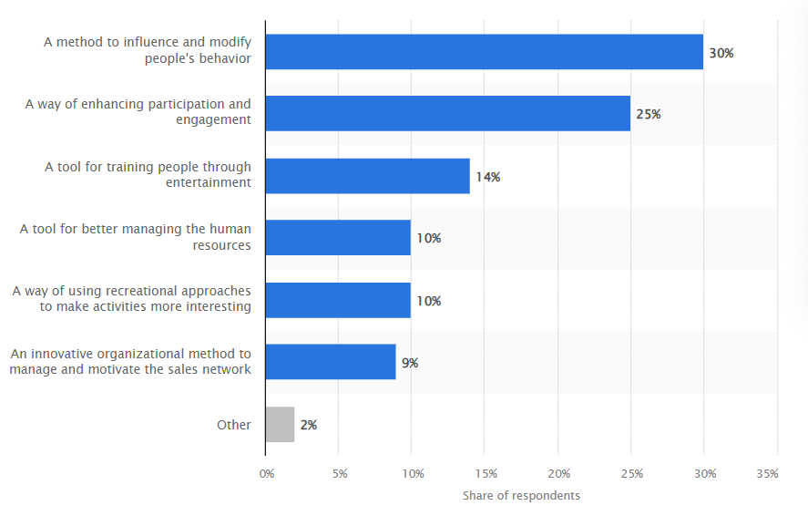
Figure 1.3: Gamification application in business
(Source: Statista, 2019c)
The conventional approach to recruitment is not ideal in that it lacks a proper way to capture candidate’s attention and also assess their abilities and fit for the organization. As will be seen in a systematic way below, these methods tend to focus a lot on the stale resumes and standardized interviewing process, along with standardized psychometric tests which may not give a real picture of a candidate’s fit with the job (Pan et al. 2023). Besides, this approach results in inefficient selection processes and may cause the organization to lose the best candidates to competitors with more creative means of attraction.

Challenges and Opportunities
The subject of the doctorate focuses on the factors of gamification in the process of recruitment in order to solve certain issues and achieve the goal of obtaining a competitive edge. Potential issues that need to be resolved are whether the assessments based on the games are actually generalized on the candidate competencies, and whether there is bias in the design that will tend to negatively influence the chances of some of the candidates. Furthermore, incorporating gamification into standard methods of attracting talents demands workload and the cultivation of a new corporate culture (Albassam, 2023).
However, there are opportunities in improving the candidates’ interest level, increasing the accuracy of the assessments, and creating a unique brand for the organisation. When these challenges have been effectively met it points to better recruitment and selection, better sourcing of employees and therefore a formidable competition in the market.

1.7 Significance of the research
The usefulness of this research may consist in its capacity to revolutionize conventional recruitment procedure via the application of gamification. While organisations are struggling to overcome the drawbacks connected with the standard approach to recruitment and selection, which is frequently unproductive and inefficient in terms of candidates’ engagement and evaluation of their potential, the need for more efficient methods of staffing is evident (Muduli and Trivedi, 2020). To that end, this research aims to investigate how the concept of gamification can be used to solve these problems and give a new approach into how recruitment can be revamped to the needs of employers and potential employees. In this way, by specializing in gamification, this research aids the field of Human Resources to show how the use of fun-filled and engaging methods can enrich the concept of recruitment. To some extent, games can raise the level of candidate engagement and decrease his or her perceived stress making thus access to a much wider talent pool.
In addition, since the present research is applied, this work raises suggestions for organizations to continue to be relevant as the job market becomes more dynamic. As such, the application of game-based recruitment approaches can be a powerful way of turning prospective employee segments away from traditional recruitment strategies offered by similar companies, as well as reaching younger and technologically inclined candidates to significantly enhance a company’s recruitment performance (Karim et al. 2021). Furthermore, the research contributes to the literature by extending the knowledge of the literature on how gamification can be practically applied in the domain of recruitment. It offers a manual on how gamification in HR can be done and the steps that need to be undertaken by organizations and/or HR professionals.

1.8 Structure of the dissertation

Figure 1.4: Dissertation structure
(Source: Self-created)
The structure of the dissertation is aimed at giving a holistic perspective of gamification in recruitment. The research is started with the background, aim and importance of the study. This is followed by the literature review, which aims at identifying previous research on gamification and recruitment to build the theoretical background. The setup and approaches used in the current study are described under the methodology section based on the research design, data collection, and data analysis in investigating the effectiveness of gamified recruitment practices. The research findings are then highlighted and narrated in the results section depend on the patterns as established by the empirical research. Here, the discussion section translates these results in relation to the body of knowledge and proffers answers to research questions; all in the light of critiquing recruitment practices. Last but not the least, the conclusion gives an overview of the research findings, states the practical implications for HR professionals, and presents the venues for future research.

1.9 Theoretical Framework
Accordingly, the underlying theoretical concepts of this study are the gamification theory and engagement models. Based on the gamification theory, it holds that the integration of game factors such as points and badges in non-game environment will enhance users’ motivation. The theoretical frameworks employed in the present research are the Engagement Models by Csikszentmihalyi, and Self-Determination Theory by Deci and Ryan that explain the effects of gamification on candidates’ investment and satisfaction. This paper will provide a framework for analysis of how gamification influences candidate interaction and assessment results to shed a light for or for deeming the effectiveness and reception of gamified hiring approaches.

1.10 Conclusion
The rationale for the research is further laid down in the context of the current recruitment methods in the contemporary context as being inefficient due to the various drawbacks associated with them. Organizations can benefit from the use of game objects as they can enhance the candidates’ engagement and evaluation. Following the theoretical foundations of gamification and Engagement theory, the identification of these benefits will be conducted along with recommendations on how to implement them.

Chapter 2: Literature Review

2.1 Introduction
A new promising trend in the application of games to the process is the use of gamification in recruitment with the goal to improve candidates’ experiences and simplify the evaluation process. Gamification adds features like points, badges and scoreboard into the recruitment process to make the task more engaging & attractive. This literature review aims at finding the effect of gamification on the engagement of the candidates and the precision of the results achieved as well as examine these features and the research gap existing in the literature. The review will explore the current literature on gamification and discuss its outcomes in a bid to identify a range of limitations which point out the discoveries that researchers could make regarding potential applicability of gamification in recruitment.

2.2 Assess the impact of gamification on candidate engagement during the recruitment process
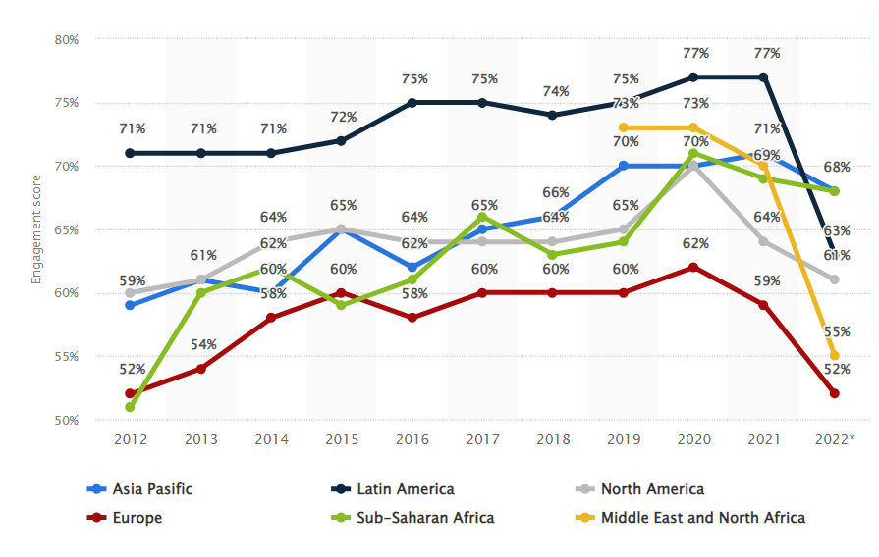
Figure 2.1: Employee engagement scores worldwide
(Source: Statista, 2022)
Recruitment has become an area where more and more organizations apply the so-called gamification, the processes of introducing the elements of games into other spheres of people’s activity. With the use of points, badges, leaderboards, and tasks containing two or more interactive teachings, organizations can transform the hirings process to increase the candidate’s interest. This approach has major consequences for behavioural processes concerning candidates’ contact with and attitudes towards recruitment procedures.
1. Enhanced Engagement
Effective recruitment with gamification makes recruitment a unique process where the experience changes completely. Some of the conventional recruitment processes include bore activities like having to fill long questionnaires or sitting for dull interviews. As opposed to this, for gamified recruitment, these tasks are made to have some elements of dynamism to turn these activities into fun. For example, candidates can gain points for specific steps of their application or badges for showing specific skills. This approach alone helps to grab the candidates’ attention and also encourage them to be more involved in the process. D'Silva (2020) has found that prospective candidates are more inclined to participate in a recruitment exercise that is based on game like factors. Studies showed that candidates responded positively to assessment methods in the form of games like the gamified SJTs and are more satisfied than when being presented with traditional methods. The dynamic challenged characteristic of the concept ensures that the candidates feel that they are competing with others in an effort that they feel very much associated with and passionate about.
2. Improved Candidate Experience
Gamification also has the positive effect of improving the candidate experience by making the recruitment process somehow less opaque. Recruitment made through this approach can be a stressful and unpersonal process and candidates do not know how they perform compared to other candidates. While in gamified recruitment, there is real time feedback in terms of scores as well as leader boards that give the candidates a feel that, how well or how bad they have performed, and which areas requires improvement. Such feedback is immediate and, hence, enhances feeling of achievement, which, in turn, stimulates people to go on working. Besides, the use of the concept of gamification is useful in enhancing the perceived fairness of the recruitment process. In a comparable manner, the use of standardized game like tasks reduces biases that may be inherent in most conventional assessment techniques. That is why such practices help to eliminate the tendencies when candidates are discriminated based on the first impressions. As noted by Sailer and Homner (2020), gamification has the potential to improve the fairness perception that candidates have of their organization, the attractiveness of the organization, two factors that are extremely important for the recruitment of the best talents.
3. Challenges and Considerations
However, like any other system, there are some drawbacks that come with gamification in recruitment. It also means that organizations must frame game elements to guarantee their relevance to work and not to produce emergent prejudice (Spais et al. 2022). Also, while engagement in gamification can increase interest, it is not applicable to anyone who wants a job or anyone who has to apply for a job. That is why some people can get frustrated with game-like assessments or consider them less relevant to what they really can and do.

2.3 Evaluate the effectiveness of different gamification features in enhancing the accuracy of candidate assessments
Recruitment gamification involves using the characteristics of game in recruitment in order to enhance the assessment. The use of feature like points, badges, leaderboards, simulations and interactive tasks helps organization to improve the accuracy of candidate assessments. All the features of gamification presented in the paper have their pros and cons in the context of assessment, but all of them have their roles and contribute in a unique way to this process.
1. Points and Badges
Points and badges examples of basic gamification components that motivate the candidates to engage and perform. Horstman et al. (2020) stated that Carnival points are earned when accomplishing a task or when responding to a quiz/question correctly. A badge can be earned, thus it’s a sign of achievement and accomplishment. These features can help in making the candidates to respond more and to aim at performing better in their given tasks.
Effectiveness: Points and badge can increase the level of accuracy because they inspire candidates to work in the best way possible and prove their intentions. They create a definite means of performance that can be assessed and compared with other candidates. However, the suitability of these features can only be realized under the guide of the assessment criteria. If points and badges are assigned for irrelevant, achievement, they will demonstrate the candidate’s suitability for the position inadequately.
2. Leaderboards
Leaderboards make candidates feel as they are competing with the others and make them aware of the other candidates’ results. The latter feature can stimulate the candidates’ desire to have a higher rating to increase their ranking. They also create a competitiveness that helps in giving recognition to top performers.
Effectiveness: It is believed that leaderboards can positively contribute to the increasing credibility of the assessments since the candidates are likely to demonstrate their best performance (Park and Kim, 2021). These also aids in determining the most appropriate candidates using the results in terms of performance. However, as any candidate can testify, an unhealthy competition can lead to problems such as stress or anxiety which would more probable cause some candidates to skew results. There are issues with the community and one of them is the question of how competitive an assessment can be, while remaining supportive of the practice.
3. Simulations and Interactive Tasks
Role-plays and exercise recreate situational realities in the line of the specific occupation. These features enable candidates to show how best they can perform tasks within a given position in a setting that is somewhat natural. For instance, some forms of simulation that are used may include some specific objectives which may be problem solving exercises or related decision-making case studies relevant to the position (Xiang et al. 2020).
Effectiveness: The two features of factual nature such as simulations and interactive tasks can be regarded as significantly effective in increasing the credibility of assessments since they reflect candidates’ practices and behaviour patterns. There is consideration of how candidates tackle activities that are pertinent to job responsibilities, and this is more revealing than other practices. However, developing realistic and relevant simulations brings into question a particularly important issue- design of these simulations, so the simulations effectively model skills and abilities pertinent to the jobs but do not introduce bias.
4. Quizzes and Challenges
Whereas games involve modifications of actual activities or tools where elapsed time over a particular period is used to solve a problem or to answer questions, quizzes and challenges are actual timed activities or individual problems. Zainuddin et al. (2020) argued that these features check the knowledge of candidates as to their applicability in different situations and frequently work with feedback.
Effectiveness: Games such as quizzes and challenges can enhance accuracy of assessment since they assess the participants in a coordinated manner. It was clear that instant feedback made the candidates know their progress and the things that were lacking. However, the onus of making quizzes and challenges fruitful and engaging basically falls to the quality of the questions being asked and whether they are relevant to the job the candidate is applying for. If the quizzes are not well developed then they are not a good measure of the competencies required as assumed will be the case.

2.4 Explore candidates' perceptions of gamified recruitment methods compared to traditional approaches
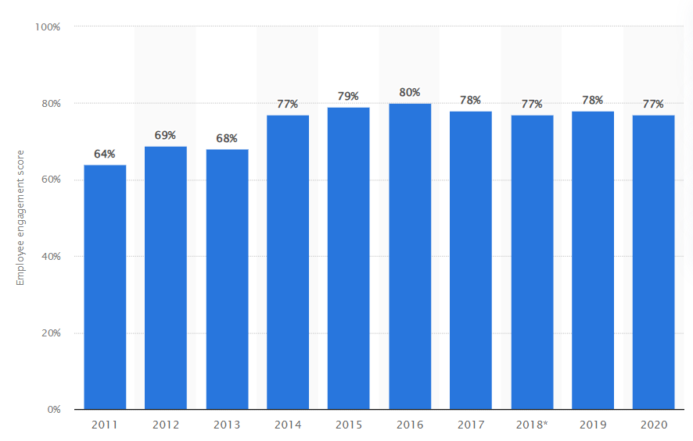
Figure 2.2: British-headquartered Nationwide Building Society Employee engagement scores
(Source: Statista, 2020)
Recruitment is not left behind either, and there are now more different ways in which gamified procedure can replace time-honoured methods of hiring performers, changing their vision of the process. Recruitment gamification refers to the use of game-like features in recruitment including simulations, leaderboards and points in the bid to make the recruitment a more exciting process.
1. Engagement and Enjoyment
Users have posited that they feel that gamified recruitment techniques are somehow more fun than the old ways. Recruitment is made to be less boring and more exciting because gamification is competition, achievement, and fun (Mouatt et al. 2020). For instance, useful applications of simulations and interactive tasks may create realistic experience of the job role which makes candidates more engaged and interested. On the other hand, traditional recruitment practices like the application forms which may take a lot of time to fill, and traditional interviews may be considered as less fun by the applicants.
Perception: There are numerous reasons why gamification is preferred as more often than not, the method helps to make the process more engaging. The candidates believe that the ability to converse through play acted, group activities and simulations makes the process more fun and less rigorous.
2. Fairness and Transparency
Recruitment rights could not be guarantee without the principles of fairness and transparency. Introducing game elements into performance improvement methods normally enhances the visibility of performance via feedback that is real time, scores, a leader board and progress bar. It also benefits candidates to know how they are being assessed and what they ought to do in order to do better (Sonboli et al. 2021). But some candidates may complain that gamified methods are more unfair if they think that game elements do not indicate their performance or if they are not familiar with the application. While traditional recruitment to the positions might be simpler for the candidates, they do not get the same clear signals as to how their performance is evaluated. First, the time- and cost-consuming nature of assessment results in; A Candidates gain no immediate feedback on their performance and what specific facets of the assessment process were deemed most important.
Perception: Yet, using game playing methods is highly valued due to the fact of no hiding, and almost instant feedback. However, there is a problem of fairness when the candidate feels that what is being played does not have direct relationship with the job or where he/she has issues with the technology.
3. Stress and Pressure
As it has been mentioned, gamified recruitment works can be both motivating and stressful at the same time. The gamification components like the leader boards could cause tension to do well, is a point of contention, which may be stressful to some of the contenders. However, the increased engagement of the learners during the use of gamified methods will help to offset the anxiety that may be occasioned by more formal approaches such as interviews. In particular, it is stressed that the traditional techniques, like in-person interviews, may be stressful because of the nature of the stakes along with the subjectivity of the interviewer evaluations. Job applicants successfully come to the event with self-identified concerns about presenting themselves in a manner that is satisfactory to selectors and demonstrating adequate knowledge of the company and its products (Soelton et al. 2020).
Perception: The underlying notion of the game-based approaches may help in decreasing interview-related stress yet always generate new types of pressure connected with rivalry and achievements. There can be general reactions to such pressures referring to candidates’ orientations and game-related comfort levels.

2.5 Recommendations for organizations on implementing gamification strategies in their recruitment processes
Recruitment processes can be strengthened greatly by the element of gamification because of the increased levels of engagement as well as the interaction that accompanies the same. However, for organizations to get the best out of it, it is very essential to apply the gamification concept very well and wisely. Here are key recommendations for effectively integrating gamification into recruitment:
1. Align Gamification with Organizational Goals
Ferreira and Roseira (2020) stated that make sure that all the used techniques of gamification are in line with the goals of recruitment within the organization’s framework and its values. Set concrete objectives that are deliverable and measurable, for example, increasing the engagement level of candidates, the elaboration of tests that provide a more accurate evaluation of skills, or the optimisation of employer branding. For instance, if recruitment is designed to evaluate problem-solving skills, then include problems and simulation in the game. The process of integration and choices made of games and gamification concepts should lead to greater impact in recruitment and business goals.
2. Design Relevant and Inclusive Gamified Assessments
Design assessment centres in the form of games based on the actual working environment and competencies of the post. Employ realistic exercises such as simulations or role plays and other interactive task that are somewhat related to the job content. Specify that all games must be challenging for all the candidates considering their skills, level of use of information technologies and possible disabilities. It also reduces favouritism and also provides an equal platform for all the candidates to test their prowess.
3. Provide Clear Instructions and Support
Include specific direction and instructions about how the candidates are expected to interact with the elements of gamification. Make sure the candidates can register why the gamification process is necessary and where it should be placed in the general scheme of things (Mufaridah, 2021). Preparing candidates for the game in form of a tutorial or a practice session may ease their tension and make them comfortable with the type of assessments. For the candidates who may experience challenges in the mentioned process, there should be provisions like help desk or frequently asked section.
4. Ensure Fairness and Transparency
Provide equity and/or honesty regarding the actual game where the recruitment process is concerned. Explain in detail how the gamified assessments will be assessed, and in what way the outcomes will correspond to the general assessment dimensions. As much as possible, give the candidates feedback in real-time so they are informed of how they are scoring and the better understanding of their performance strengths and weaknesses. When evaluation is transparent it goes a long way in creating a positive impression with the candidates so that they are not negative about the entire process.
5. Integrate Gamification with Traditional Methods
Integrate serious use of game elements for recruitment with best practice non-gamified process in order to obtain a balanced and in-depth evaluation strategy (Macías et al. 2020). For example, use game-based assessments for assessing a particular behaviour and together with traditional techniques such as interviews or other aptitude tests. This integration is important to make sure that the use of gamification is supplementary to conventional techniques so that the evaluation of the candidates will be more comprehensive.
6. Monitor and Evaluate Effectiveness
Concerning the second criterion, it is possible to point out the necessity of the constant monitoring and assessment of the effectiveness of the utilization of various forms of gamification within the processes of recruitment. To gather data, one should ask the candidates about their impressions of specific actions or their incidence. Contrast the effectiveness of the games based on the number of visitors, number of interactions, employee satisfaction, and the effectiveness of the skill assessments. On this basis, the changes should be made constantly, and the details of gamification have to be adjusted to meet the goals of recruitment.
7. Leverage Technology Wisely
Mehta et al. (2021) argued that ensure that the kind of technology being used in the process should ensure that is as fluid, and as integrated with the typical usage of technology as is necessary for a typical user experience. Select channels and media that are stable, capable of growth and that can be used across a range of technologies. Make sure that the use of a particular technology will add to the candidate experience, rather than complicate the process and potentially coming across technical difficulties. Selecting appropriate tools means that the gamification features are operational and even beneficial to the recruitment process if chosen correctly.

2.6 Theoretical framework
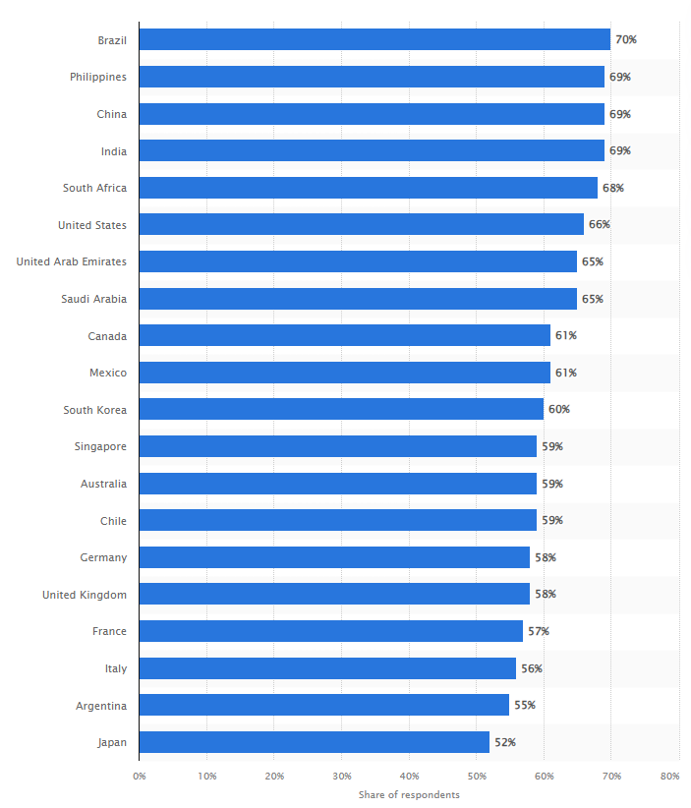
Figure 2.3: Employees feelings in different countries
(Source: Statista, 2023)
Recruitment is one of the business activities in which gamification has become one of the most effective tools. To understand its impact on candidate engagement, assessment accuracy, and perceptions, three key theories can provide a comprehensive theoretical framework: Some of the well-known theories that can be useful in understanding employee motivation and the subsequent behaviours include the Self-Determination Theory (SDT) and Expectancy Theory.
1. Self-Determination Theory (SDT)
Self-Determination Theory (SDT), developed by Deci and Ryan, posits that individuals are motivated by three basic psychological needs: self-determination theory basic psychological needs of perceived autonomy, competence and relatedness. As SDT also postulates, such a satisfaction increases intrinsic motivation and interest in the activity.
- Autonomy: Autonomy gets firmed up by making choices as well as participation in tasks that appeal to candidates’ interest and abilities in gamification (Xia et al. 2022). For example, candidates may be given a case of a real-life problem to solve through an enrolment of an interactive simulation or a problem-solving game to enable them solve problems in whatever way they deem fit, thereby enhancing their sense of control.
- Competence: Competition can be met by game features, which include sending immediate feedback to the learner and raising the level of difficulty. Such challenges and feedback provide the candidates with the means of assessing their performance levels, and through the feel of accomplishment that stems from the gameplay, come out of the game with a positive outlook. This is in sync with SDT call to help foster a sense of competence to help facilitate extrinsic motivation.
- Relatedness: Gamification can also solve the relatedness in the sense that it opens spaces for a person to socialize or cooperate with others. Multiplayer games or team-work challenges may help candidates feel that they are part of a community and become more engaged (Benita, 2020).
2. Expectancy Theory
The Expectancy Theory, developed by Victor Vroom, is concerned with expectancy linkage of effort, performance and outcome. To this theory, people engage in behaviour as driven by their desires and the perceived spins on the outcomes of conduct.
- Expectancy: Expectancy can be improved by clarifying the link between candidate’s efforts and performance outcome which is achieved through gamification (Zboja et al. 2020). For instance, assessments based on games that demonstrate relationships between the particular actions or strategies on the one hand and better scores or rewards on the other hand are useful since they allow the candidates to see the connections.
- Instrumentality: This aspect of expectancy theory deals with the notion that ‘performance’ will result in certain outcomes. Gamification can provide this by identifying correlation between positive results in games and employment opportunities along with promotion to the further stage of recruitment. The fact that there is a direct link between achieving a certain level of performance on the aspects of the game and the availability of the rewards for the candidates can enhance their personal stake in the gamified aspects.
- Valence: Expectancy Theory centres on the value candidates attribute to the rewards. Gamification techniques should provide candidates with a type of result they would appreciate, for instance, feedback regarding the test results, potential vacancies, etc. Through choice of rewards which are in congruence with the values and goals of the candidates, there is an increase in motivation through gamification (Fan et al. 2022).

2.7 Conceptual framework
Employee engagement
Dependency
Features of gamification
Feedback mechanisms
Challenge levels

Figure 2.4: Conceptual framework
(Source: Self-created)
Where the subject of interest introduced with regard to the effects of gamification of recruitment processes, the employee engagement serves as the dependent variable. The three independent variables for engaging the candidate are use of gamification, feedback and challenges.
- Features of gamification are such things like prizes, icons, points and scores that are used to improve the level of interest.
- Feedback mechanisms refer to the time taken to give feedback and the type of feedback that is given during the game-like assessment.
- Challenge levels are the relation between the type and degree of difficulty of a task and the abilities of the candidates and their immersion and motivation levels.

2.8 Literature gap
Based on the literature regarding gamification in recruitment, it can be noted that gamification may help in increasing the candidate’s engagement and improving the recruitment process. However, several gaps persist. First, despite existing research that claims general advantages of such features as badges or leaderboards, there is a lack of data on how these features directly affect accuracy of candidates’ assessment. Insufficient research focuses on the validity and reliability of recruitment outcomes, where different gamification elements in the process. Second, there is a research gap in connection with understanding how feedback mechanisms can be incorporated into the framework of gamified recruitment. Feedback is also known to influence engagement but the part it plays in boosting the accuracy of the measures in game designs has not been examined comprehensively. Lastly, there is absence of balance of challenge levels in the gamified tasks as illuminated by the existing literature.

2.9 Summary
The analysis of literature shows that the application of gamification has a positive effect on the level of candidate engagement since the tasks of recruitment become more appealing and colourful. The features are fun and motivating, and rewards, in particular, and leaderboards may affect assessment accuracy, but this has not been well researched. There are liminal gaps in feedback controlling and the distribution of the level of difficulty in game-based assignments. The review calls for more research on the factors that can affect the accuracy of the assessment of the candidate and what of these elements must be used to enhance the recruitment process. Closing these gaps will assist in developing better and accurate recruitment gamification intervention.

Chapter 3: Research Methodology

3.1 Introduction
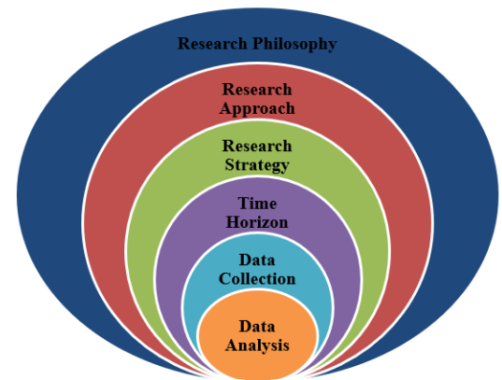
Figure 3.1: Research onion
(Source: Park et al. 2020)
The methodology section embraces the positivist philosophy which is in tandem with this studies’ objective of testing the possibility and correctness of the hypotheses about the effectiveness of gamification in recruitment. The research method selected in the study is the survey and interviews in combination with the collection of numerical data from the candidates and the recruitment specialists. As such, using systematic methods the research seeks to present evidence on the applicability of the use of gamification to recruitment.

3.2 Research Philosophy
In this research, the positivism philosophy has been chosen because of its objectivity focus on precise measurable facts and its compatibility with the quantitative methods (Park et al. 2020). Since, in this research, the purpose is to assess the level of gamification elements’ success in recruitment with the help of the data collected, positivism as a paradigm that assumes that knowledge is obtained through facts, is appropriate for this research. The study aims at finding hypotheses concerning the effects of the application of gamification on candidate interaction and the validity of the assessments. This goal is supported by the positivist approach that allows the formulation of questions which can be responded to through surveys or other structured techniques such as interviews. This data can be quantitatively compiled then analysed to reveal meaningful patterns or relationships and the results of the research studies are not influenced by the individual researcher’s interpretation.
Besides, positivism enable the researcher to work as a third-party observer hence minimizing bias especially when collecting data. This is very important especially when it comes to recruitment, where the effectiveness of the gamified elements needs to be assessed and validated (Mathotaarachchi and Thilakarathna, 2021). If a control group is not used in the study, the research can use statistical tools, therefore, determine whether or not the use of gamification makes a significant difference in candidate interaction and assessment outcomes. The use of positivism is also relevant since the study is based on a mixed-method approach; thus, the collected quantitative data can reinforce the findings based on the analysis of interviews. Lastly, this philosophy helps the study to arrive to valid and credible conclusions that may help in the continuous debate about gamification in recruitment.

3.3 Research Approach
The deductive approach has been chosen for this research since the study aims at empirically evaluating existing theories and hypothesis. Overall, it leaves with a generalized conclusion, where most frequently general theory or hypothesis is developed before starting the research and then data is collected (Hall et al. 2023). This method is appropriate as this research build upon past theories on gamification and recruitment in order to test them within actual recruitment scenarios. In this study, the use of the deductive approach enables the researcher to formulate some hypotheses that exist on the impact of gamification on users’ interest and assessment outcome from the existing literature. For example, extant theories can be applied on game principled attainment such as points, badges, leader boards and compare them to survey/interview data. Through these theories, this study will be able to understand the effects of gamification, proving a quantitative improvement to the results of recruitment.
The deductive approach also endows the research with a systematic pattern of performing the research. It is therefore easy to follow since it has a clear sequence that one is required to follow; generate hypotheses, then gather information in an attempt to prove or disprove theories that had been generated. It allows checking the hypotheses already developed because it has standard and values-free measurement of the studied variables and their relationships which is rather crucial for a more precise conclusion (McKibben et al. 2020). Further, it aligns with the positivist epistemology adopted in this research, which is major on quantitative data and evidence. Therefore, the study could bring out effective suggestions to organisations regarding the effects of gamification towards recruitment through the application of deductive reasoning.

3.4 Research Design
The type of research design that has been adopted for the study is cross-sectional survey design, which entails both quantitative and qualitative data. This design was chosen because it enables the researcher to gather information from the participants at one particular point of time and therefore offers a ‘picture’ of the contemporary state of affairs as regards gamification of recruitment (Wang et al. 2020). Cross-sectional research design is suitable for this research because of the exploration of numerous factors including candidate’s engagement as well as accuracy of the assessment conducted in the recruitment process. Such design allows the exclusion of early and late bottles and is both cost-effective and time-effective because, due to the goals set by the study, the effectiveness of gamified recruiting processes does not require long-term observation.
Also, the use of both the quantitative and qualitative approaches afford the research strength. Data will be collected quantitatively by using structured questionnaires thus enabling the researcher to record numerical data from numerous candidates and recruitment specialists. Quantitative analysis of this data can be made to determine whether there is a correlation and causality, hence yield a quantitative finding on the effects of gamification (Sokoya et al. 2022). Whereas, quantitative data shall be collected, while quantitative data shall be collected through surveys which will provide a richer understanding of the participants’ experience and perception about gamified recruitment. Due to this reason, the cross-sectional design ensures an all-round coverage of the subject is obtained by incorporating both quantitative and qualitative research with respondents’ firsthand experiences of how gamification impacts recruitment. This work assists to achieve the outlined research objectives and offers a better understanding of the opportunities and risks of introducing game mechanisms into the frameworks of the recruitment activity.

3.5 Data Collection Method
The instruments for data collection determined for the research consist of both the surveys and interviews in which both the quantitative and qualitative data collection techniques have been incorporated. Mixed data collection was used here since it was important to get both quantitative data and qualitative experiences on the research topic (Kimmons, 2022). One of the types of data collection instruments is surveys that let the researcher gather a large number of responses from the participants, both candidates and employment officers. The administering of surveys provides a systematic way of assessing a variety of parameters, such as the level of activity, participants’ experience of the use of the gamified elements, and the degree of correctness of the recruitment selection. Surveys are cost effective and give an overall picture of the broad trends prevailing and therefore suitable for this study that seeks to assess the effect of gamification on recruitment. Moreover, the data collected through quantitative methods are closed-ended response, which allows the conclusions to be made through statistical measurements of the data collected through surveys.
While interviews are used to get quantitative data from a comparatively small number of people or the subjects of the study. The following interviews provide more qualitative information about participants’ individual experience about gamified recruitment processes. Interview questions have been kept open-ended so that extent of strengths and weaknesses of gamification can be explored more meaningfully, and their practical dimensions understood better (Baran, 2022). The surveys complement the interviews, and vice versa, as not only does the work provide a breadth of coverage by measuring trends simultaneously to providing field depth by ascertaining why these trends are occurring. This approach improves the findings’ credibility and depends on the reconstruction for organizations that need to apply gamified recruitment.

3.6 Data Analysis Method
For the kind of data collection that is being used in this research, both qualitative and quantitative analysis is used as the data collection method is also a mixed method. Regarding quantitative data generated from the surveys conducted, statistical analysis will be conducted using Computer software like; SPSS-Statistical Package for the Social Sciences (Washington et al. 2020). This also means that it permits both descriptive as well as inferential analysis so as to reveal features, associations as well as trends within the data set. Quantitative data will comprise the measures of central tendencies and variability such as means and frequency distributions to give a broad view of the idea that candidates and recruitment professionals have towards the idea of gamification. Descriptive statistics will be employed to test how various aspects of gamification such points, badges and leader boards impact on candidate engagement. Meanwhile, inferential statistics will enable the researcher draw conclusions regarding hypotheses concerning the effects of gamification on recruitment. The main advantage of this method is the fact that it is free from personal biases and therefore the results obtained from the survey data are accurate and reliable.
Where the data is collected through interviews, then non-parametric data analysis will be employed, and the method of analysis shall be thematic analysis. This involves using a text editing tool such as word excel or other data analysis tools and assigning codes to the interview findings whereby; similar patterns among the participants’ responses are put under one category. The methodologies to employing thematic analysis in order to get insights into the participants’ experiences and perceptions of the gamified recruitment (Lester et al. 2020). Qualitative data is more valuable for analysing the attitudes and perceptions that could not be reflected in quantitative analysis like the benefits and problems arising from the incorporation of game elements in recruitment processes. This approach covers statistical analysis for quantitative data while using thematic analysis for the qualitative data giving a comprehensive assessment of gamification in recruitment. This approach of analysing gamification is theoretically logical and has the benefits of both: qualitative and quantitative analysis, which gives practical and useful recommendations for organisations that are willing to implement gamification.

3.7 Inclusion and Exclusion criteria
The inclusion and exclusion criteria for this research have been selected purposely to make sure that only the right information is collected and analysed for a tight fit with the objectives of the research.
Inclusion Criteria:
- Candidates with Gamified Recruitment Experience: For another, participants were recruited and matched tests that had been designed with points, badges or other interactional tasks included in the recruitment process. These steps allow the respondents to be experienced on the affairs of the subject matter.
- Recruitment Professionals Using Gamification: Specific attention has been paid to the inclusion of the representatives of recruitment professionals who have implemented or engaged in gamified recruitment so the research would be able to deliver both the organisational and personal perspective of the recruitment processes (Obaid et al. 2020).
- Industry Diversity: This is done so that the sample will cover all industries and fields of employment with a view of testing the effects of gamification across organizational recruitment systems.
- Geographical Scope: The respondents are selected from different geographical areas in order to check whether there are regional differences regarding the perception of and attitudes towards gamification in the context of recruitment.
Exclusion Criteria:
- Candidates Without Gamified Recruitment Experience: People who never worked in the organizations which implemented gamified stages of recruitment are excluded, because their opinions will not be useful for analysing whether gamification is useful in the context of recruitment or not.
- Recruitment Professionals Without Gamification Knowledge: In the same way, this study excludes recruitments that have not employed or have no knowledge about gamification in recruitment so as to stay focused on the target population (Spanellis et al. 2020).
- Inexperienced Candidates: Employment starters who have little to no prior exposure in the recruitment process are also kept out because they do not offer sufficient information on the relative efficiency of using gamification in comparison to conventional processes.
These criteria ensure that the case generates suitable data from learners who have direct viva experience in gamified recruitment, and hence leads to better results.

3.8 Ethical Considerations
Ethical considerations play a crucial role in ensuring that this research is executed free from irresponsible and rude demeanour. In the course of the study there are a number of ethical principles that are considered.
- Informed Consent: Before participating in the study participants are given informed consent note concerning the objectives, methods, and their roles in the study that they are willing to undertake. They are informed of their rights, and this include the right to withdraw from the study at any given time without any form of repercussions. Participants’ written consent is sought meaning it is voluntary participation of all the participants (Bazzano et al. 2021).
- Confidentiality and Anonymity: When using participant information, the identity of the participants is never disclosed. Names or other contact and specific identifier information including personal identifiers is not shared and disclosed. All the information provided by the participants is kept anonymous which eliminates the possibility of a participant being recognized from the results obtained from the study. This protects anonymity of the participants, and creates an environment where they are free to express their opinions and report their experiences.
- Data Protection: According to the local data protection laws with regards to GDPR all collected information is secured in digital format through encryption or physically through locks. The data collected will only be available to the researcher and other personnel who will be involved in analysing the data hence restricting access for the larger public, which may lead to leakage of the data.
- Avoiding Harm to Participants: The study is developed in such a way that it will not have any form of psychological or emotional hazard to any of the participants. The questions designed for the surveys and interviews are not general but specific to ensure such questions do not create misery, uneasiness or defiance. The target is to consider participants’ professional activities only; thus, no intrusive questions about any personal issues are asked (Kang and Hwang, 2021).
- Transparency and Honesty: The identities of the participants and the details of the study are kept concealed throughout the research course, purpose and results. The objectives of the study and the purpose to be served by the findings are explained to the participants, in addition to declaration of any and all relevant interests. The findings are presented naturally and there is no realize or twist the facts presented in the study.
These ethical considerations help to inform the research in such a way that they are proper, respect to the participants, and legal and moral aspects of law.

3.9 Summary
The chosen methodology guarantees covering all the aspects of using gamification in recruitment. Using deductive research design, and data collection tools, which include both quantitative self-administered questionnaires and qualitative interviews, the study seeks to reveal quantitative data and narratives about the subject in equal measure. The addition of structural data analysis in thematic and statistics enhances the credibility of the findings. The method also applies the principles of professionalism to the extent that, for the research to be conducted responsibly, there is compliance with such ethical pillars as informed consent and data protection.

Chapter 4: Findings and Discussion

Introduction
This chapter discusses the findings emerging from the survey undertaken to determine the effect of gamification in the process of recruitment. With 20 participants, the survey included questions about engagement, perceived usefulness of gamification components, percentage of correct skill assessment, attitudes towards the process, technical difficulties, competitiveness, and comparisons of gamified and conventional recruitment methods. The findings from the descriptive statistics and cross tabulation test are then discussed to answer the research questions (Albassam, 2023). Further, the limitations of the study are highlighted to the audience.

Findings
The findings are summarized using descriptive statistics and supplemented by bar graphs to enhance their readability. Also, cross-tabulation is used to seek the interaction between the perceived engagement levels of gamified recruitment and Gamified User Experience (Altomari, Altomari and Gianpaolo Iazzolino, 2022).

Descriptive Statistics
The survey contained ten questions, and each was created to capture a variety of factors within the gamified recruitment concept. The results derived from every question were quantified and the frequency distributions obtained were used to create bar charts that present the answers properly (Altomari, Altomari and Iazzolino, 2023).
Engagement Level Compared to Traditional Methods
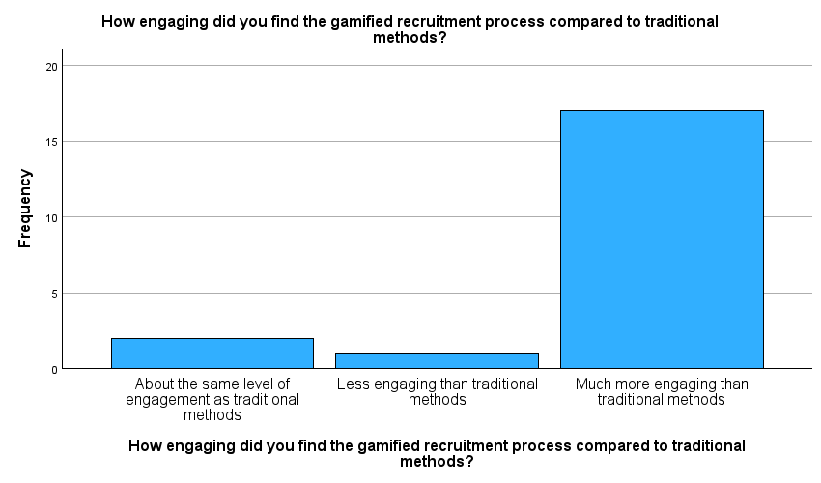Figure 4.1: Engagement Level
The first question sought to get participants’ impression of such engagement towards the recruitment gamification process compared to the more conventional approaches. About 85% of the respondents stated that the use of gamification was much more engaging than the conventional recruiting methods. As for the engagement rate, only 5% of the respondents claimed the approach as less engaging, while 10% said that the method was as engaging as traditional ones.
Such a preference of candidates shows that these processes are seen as more engaging and exciting, probably due to their activity, and the use of gaming in their framework, which is known for increasing interest and motivation. Based on this study, organisations that want enhance their talent acquisition and retention practices may find it valuable to incorporate gamification in every stage of the recruitment process (Bina, Mullins and Petter, 2021).
Effectiveness of Gamification Elements
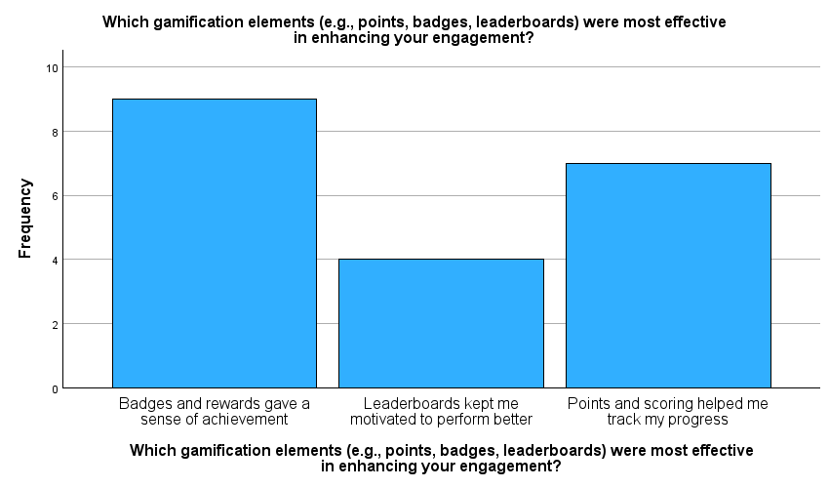Figure 4.2: Effectiveness of Gamification Elements
This question aimed at determining which of the elements of gamification most affected the participants. The survey has revealed that the badges and rewards were the most effective option that people chose with 45%. This points to a fact that tangible recognition and the feeling of achievement form the key engagement and the value addition component.
Points and scoring were also stated to be useful by 35% of participants meaning that tracking of progress is crucial during the recruitment and selection process. But only 20% said that leader boards were motivating to them. This result implies that while motivation via competition is effective, its reach might not be as broad as that of multi-faced sensible incentive programs like badges (Blandin, 2022).
Accuracy of Skill Assessment
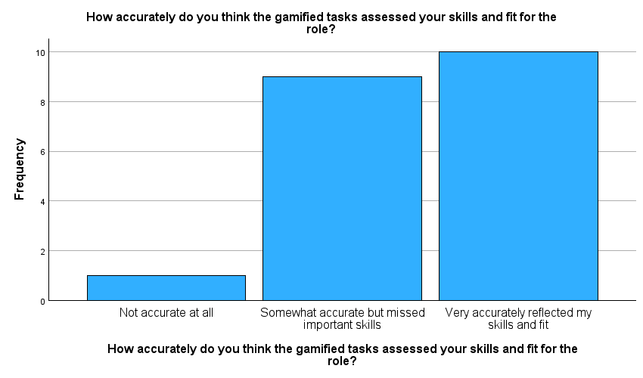
Figure 4.3: Accuracy of Skill Assessment
From the responses to this particular and most crucial question, it is clear that the participants agree with the use of gamified tasks in evaluating their suitability for the jobs applied for. Regarding extent to which tasks resembled the skills and suitability for the post, half of the respondents (50%) perceived the tasks as relevant to skills needed in the job. Such positive feedback is crucial because this way we can understand that gamified assessments can work as an appropriate means for the assessment of the candidates’ capabilities.
However, 45% of respondents were of the opinion that the assessment was relatively correct, but did not capture crucial skills. One participant (5%) assessed the rating as absolutely incorrect. It is in this area that there is an indication that the gamified recruitment actually needs some form of overhaul, this is because organizations need to ensure that the tasks they set in the game accurately capture all skills needed in a particular job (Altomari, Altomari and Gianpaolo Iazzolino, 2022).
Motivation to Participate
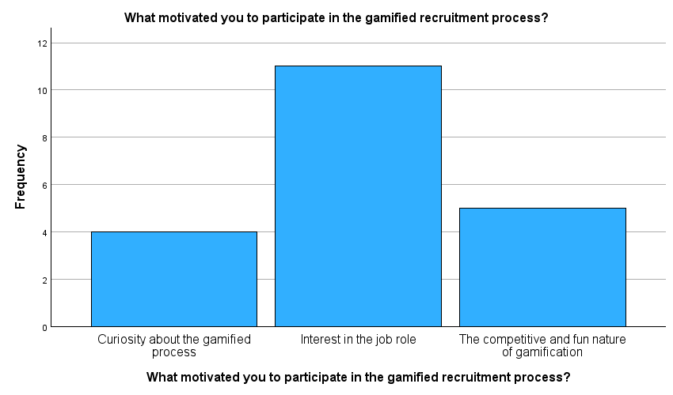
Figure 4.4: Motivation to Participate
The respondents were enquired about the rationale for participating into the games-based recruitment strategy. The results revealed that the primary reason for the male participants was to seek interest in the job specification of the position; 55% of participants chose this option. As with the previous observation, this result highlights the need to link jobs to the games in order to encourage the target candidates to take the gamified recruitment.
The competitive and fun aspects of gamification accounted for the reason 25% participants were motivated, implying that incorporation of gamified aspects could improve the attraction of the recruitment process. However, only 20% pointed out that they were interested in the process of the game, which was being incorporated into the enterprise. This means that, though novelty can be a factor, interest in the job itself is a more powerful motivator encouraging candidates to complete gamified recruitment (Buil, Catalán and Martínez, 2020).
User Experience of the Gamified Platform
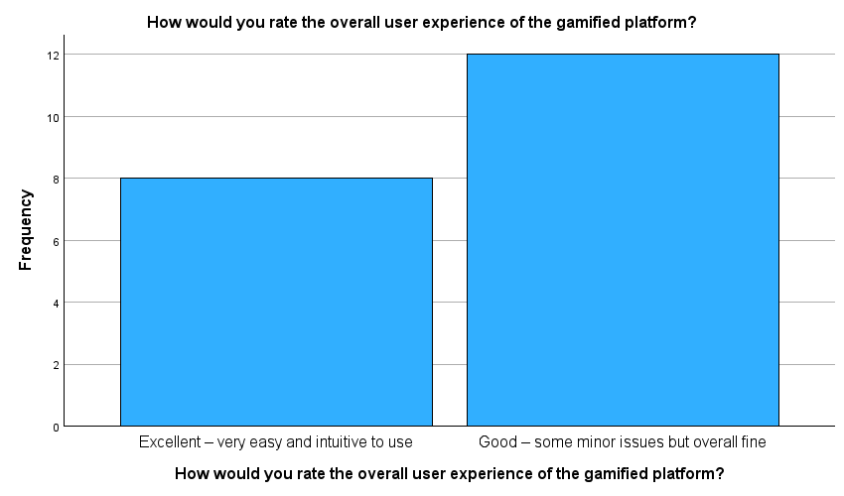
Figure 4.5: User Experience Rating
Part five of the survey was to measure participants’ overall user experience of the gamified environment. The outcome of this study was encouraging whereby 40 % of participants said that they had had a superb experience while 60 % said they had had an enjoyable experience. This shows that the platform met the high expectations of the recruiters, implying that the design of the platform was good enough with laid down easy to follow instructions hence a good recruitment experience.
Nevertheless, the complaints mentioned by 60% of participants who rated the experience as good show there is still potential in refining the form and performance of this social media platform. It is recommended that organizations collect more specific data concerning these issues to improve the experience even more and refine recruitment process (Albassam, 2023).
Encountering Technical Issues
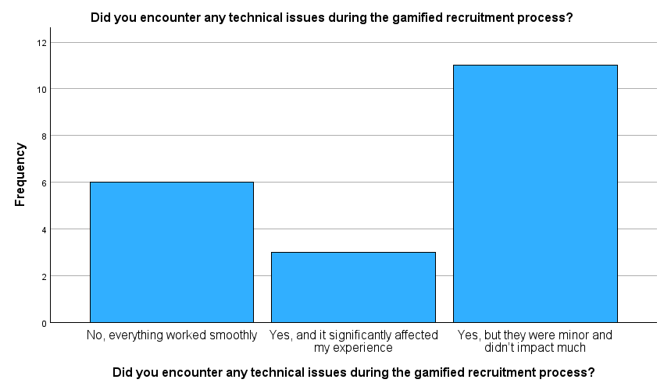
Figure 4.6: Encountering Technical Issues
The participants were also encouraged to describe their experiences in terms of technical hitches during the gamified recruitment process. About half the respondents (55%) said they came across minor problems which they did not have to deal with much. At the same time, 15% of the respondents reported that technical issues influenced their level of satisfaction.
Of all respondents, 30% said that everything worked without any hitch which only goes to show that a significant number of participants had a hurdle free interaction with selected products. These findings emphasize the necessity for maintaining sound technical platform to avoid such incidents and improve candidates’ experience of gamified recruitment (Elburg, R.S. van, 2023).
Perception of Competition in Gamified Recruitment
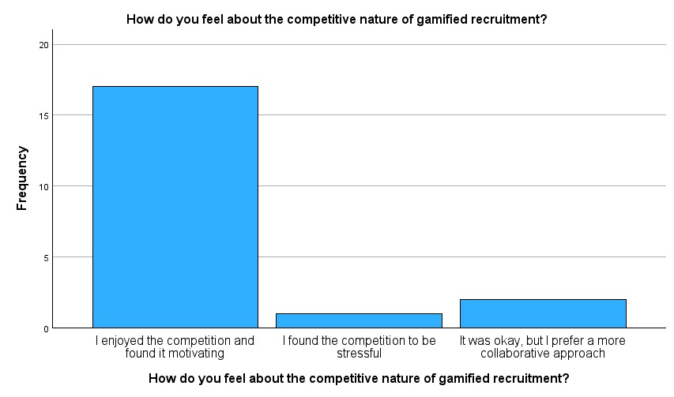
Figure 4.7: Perception of Competition
The survey looked at the competitive tones of the gamified recruitment process in as far as the participants were concerned. When asked about their level of enjoyment, majority (85%) of the respondents said they were motivated by the competition. This implies that in the recruitment processes, competitive units can greatly improve the level of interest in gamified procedures.
While 5% of the participants indicated they were stressed by competitiveness, another 10% recognised that cooperation might be more effective. Competitiveness seems on average to be apprehended positively; however, it may be advisable for organisations to weigh competition with collaboration for candidates in an attempt to satisfy the needs of applicants who may be stressed while offering opportunities that may benefit others in the same organization (Georgiou, 2021).
Preference for Gamified Recruitment Processes
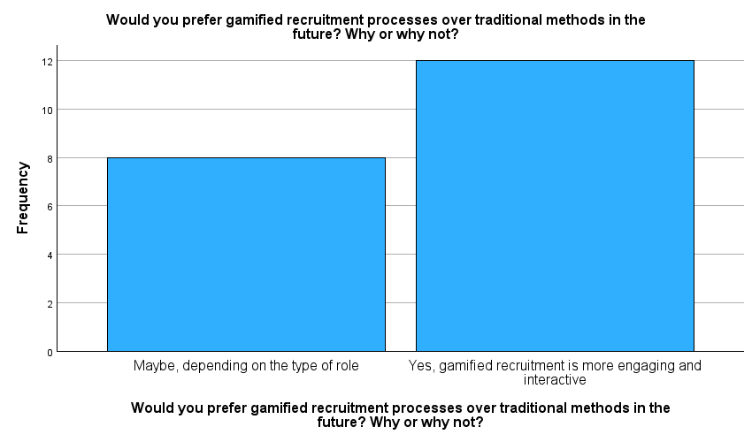Figure 4.8: Preference for Gamified Recruitment Processes
This question used the tournament technique to determine participants’ preferences on the best recruitment method in future. A whopping 60% respondents were categorically in support of gamified recruitment, given that it is fun and incorporates game element. This finding is in line with the general research focus of candidates wanting an improved and active form of recruitment.
Still, 40% said it would be relative to the position, which means that while offline recruitment does attract the employees, it can be useful to use more conventional methods in some cases. This insight supports the notion that there are particular differences in the aspects of the organization which need to be taken into account by the implementation of gamified solutions for recruitment (Bina, Mullins and Petter, 2021).
Reflection of Teamwork and Collaboration Skills
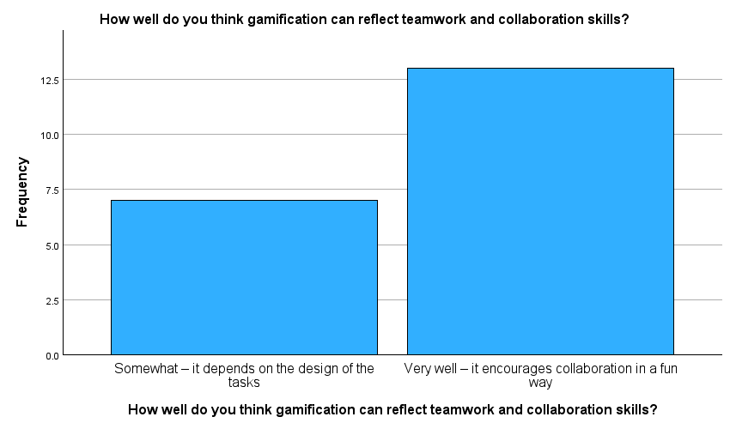
Figure 4.9: Reflection of Teamwork and Collaboration Skills
This question sought to find out participants’ impression of how gamification captured teamwork and collaboration skills. The largest number, 65% of the respondents, had a positive attitude stating that gamification in a certain way fosters collaboration Mainly, this understanding shows that if the tasks assigned are well thought and designed as games, the candidates will be able to overcome them in teams.
Nonetheless, 35% pointed out that the usability of the results in showing the teamwork skills actually achieved requires consideration of the task design in the gamification process. This feedback underscores the need to balance and deliberately craft the gamification aspects of the work assignments that the team is given, so as not to create misleading or unhelpful team dynamics within the organization, and so that assessments actually have something actionable to say about the interpersonal skills of candidates (Buil, Catalán and Martínez, 2020).
Suggested Improvements for Gamified Recruitment
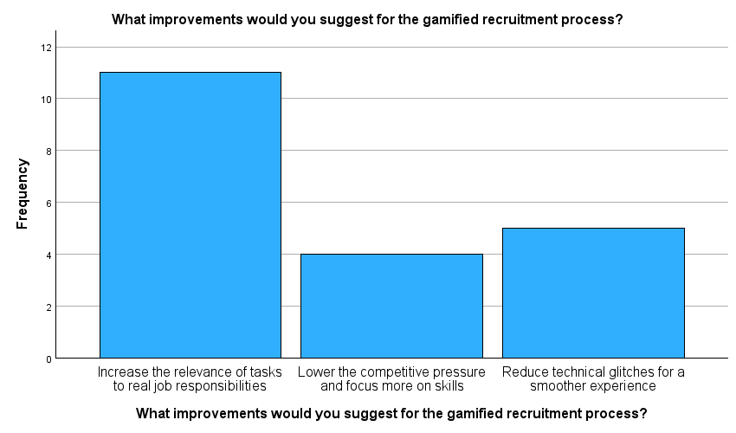
Figure 4.10: Suggested Improvements
Participants were asked for suggestions to enhance the gamified recruitment process. The most common suggestion was to increase the relevance of tasks to real job responsibilities, with 55% of respondents highlighting this point. This feedback underscores the importance of aligning gamified assessments with actual job requirements to ensure candidates can effectively demonstrate their suitability for the role.
Additionally, 20% of participants recommended lowering competitive pressure to focus more on skills, while 25% suggested reducing technical glitches. These insights indicate that while gamification can enhance engagement, it must be carefully structured to prioritize skill assessment and minimize distractions caused by technical issues.
Overall Summary of Descriptive Statistics
Results of survey indicate an increased interest and rating of participants, satisfaction with the assessment of skills, and general positive attitude toward the application of the concept of gamification in recruitment compared to tradition techniques. From these data, several important findings emerge:
- Participants consider gamified recruitment as more engaging than the other methods as it is interactive.
- Based on the results, badges and rewards fitted as the best gamification aspects, thus implying the idea that the concept of recognition has a significant role to play in boosting the potential candidate interest.
- Most of the participants agreed that the set of gamified tasks provided a fairly good assessment of their skills, despite the possibilities for improvement being evaluated in detail.
- Another factor, which was reported in the study for participating in gamified recruitment was interest in job role and hence making job relevance central in gamified recruitment (Blandin, 2022).
- We observed that the participants had a positive attitude using the proposed gamified platform; however, there were slight technical flaws as shown below.
- The competitive aspect of the elements discussed for the most part appeared to be well received, although, organisations should ensure that where there are competitive components to the gamification they should also ensure that there are cooperative aspects to the games to cater for other groups who may not enjoy competitiveness (Altomari, Altomari and Gianpaolo Iazzolino, 2022).
- Recommendations to enhance task attractiveness proposed to extend the realism of given tasks and to minimize such problems as technical difficulties, underlining that candidates do need meaningful assessments.
In conclusion, despite the fact that gamification offers the companies fresh solutions regarding the recruitment, organizations have to adapt their gamified solutions according to particular professions, improve game interfaces, and focus on required skills. As a result, any problems and concerns of the participants may be resolved to foster successful utilization of gamified recruitment in the strategic attraction and maintenance of the best talent within the market competition.

Cross-Tabulation Analysis

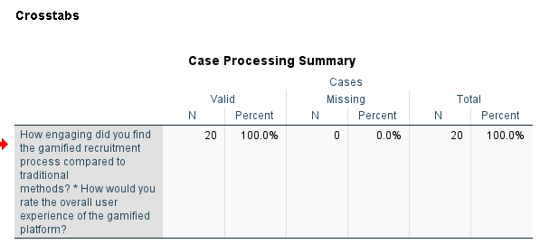
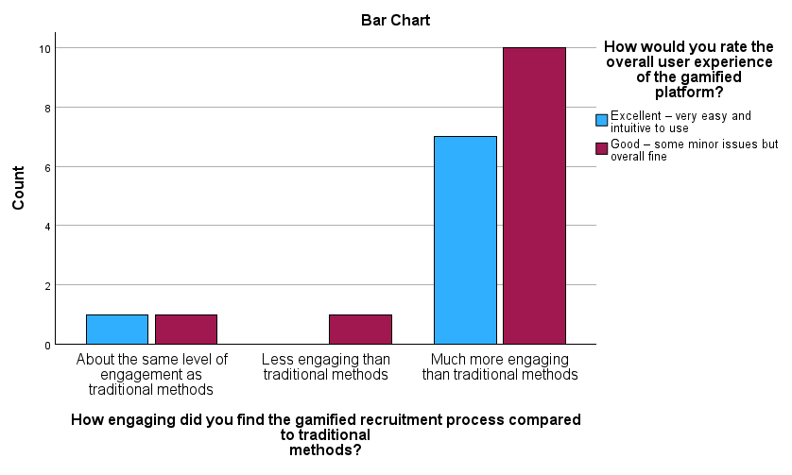
Figure 4.11: Cross-Tab of Engagement and User Experience
Interpretation
- Overall Engagement:
- About the same level of engagement as traditional methods: 1 respondent (5%) said it was excellent; another, 5% said it was good. This suggests that less than five participants felt that the level of engagement is as effective as the conventional approaches.
- Less engaging than traditional methods: None of the respondents rated the engagement level as good as excellent while 1 (5%) out of all the respondents rated the level good. This implies that while there was some understanding of the platform as having a use, the engagement side was less positive.
- Much more engaging than traditional methods: Seven participants, 35%, said that it was much more fun to go through the gamified process and user experience was excellent and 10 participants, 50%, said that the user experience was good while going through the gamified process. This clearly points at a positive attitude towards the use of gamification for the engagement and interface perception (Chong, Mclennan and Dunlop, 2022).
- User Experience Ratings:
- Among all the total of 20 respondents, 8(40%) responded under the excellent category of the overall user experience while 12 (60%) responded under good category. This suggests that the majority appreciated the ease of use that was observed on the platform though a few cases were raised as worthy of mention.
- Correlation Between Engagement and User Experience:
- Thus, the data shows us that the subjects who considered the given type of recruitment as much more engaging also tended to have high estimations of their user experience. High engagement thus a positive UX experience reaffirms the postulation that increasing the engagement part of the process that has been gamified could increase positive responses from users.
Conclusion of Cross-Tabulation Analysis
The cross-tabulation results illustrate a clear trend: The quantitative data also found a positive interaction between the two studies; the survey respondents who considered the game-based recruitment approach more entertaining also had a superior user experience. This insight particularly underscores the need to create relevant gamified activities especially since customers’ interactions have to be positive to improve recruitment efficiency. It will be important to maybe tackle any technical issues that we have found in order to sustain this relationship between engagement and user experience (Elburg, R.S. van, 2023).

Conclusion of Findings
The effectiveness of using gamification in recruiting processes emerged from the survey results as beneficial in improving engagement, motivation as well as satisfaction of the candidates. In light of the fact that 66 percent of the respondents had indicated has a preference for gamification over traditional practices, it becomes possible for organizations to utilise these findings for enhancement. Some important concerns are made to effectively address the usage of the gamification aspects on the tasks assigned, issues of technical connotation, factors associated with the motivational aspects of the candidates.

Discussion
This section builds on the results developed from the survey carried out for this study, firstly presenting the results collected in light of the four research questions (RQs) established to investigate the use of gamification in recruitment. The discussion will explore the pros and cons of gamification as a tool to engage candidates, find out what aspects of gamification to focus on to improve the accuracy of getting the desired type of candidate, evaluate the views of candidates regarding gamified and non-gamified recruitment activities, and define how to effectively implement gamification in recruitment strategies (Georgiou, 2021). Last of all, the areas of limitation in the study will also be briefly discussed in this section.

Impact of Gamification on Candidate Engagement
Engagement Metrics:
The findings also showed that the level of engagement was much higher than that of previous recruitment process; this was due to gamification in which a whopping 85% of the candidates exhibit a preference for the gamified process as compared to the traditional recruitment process. This result supports the current body of literature proposing that the use of gamification makes the overall process of recruiting and hiring a more versatile and engaging process for the candidates (Georgiou, Gouras and Nikolaou, 2019). Gamification is based on the use of the game features like points, badges, challenges, leaders etc., which helps to attract candidate’s attention and experiential interest.
Motivational Factors:
However, the study revealed the following motivational factors on this engagement, Overall, 55% of participants mentioned that they chose to be engaged based on the job interest of the role, 25% based on competitiveness of the gamified processes, and 20% based on curiosity of the features of the game. The high value assigned to job interest implies that the candidates will be more willing to participate in the job if only they see the position as interesting for them. The competition turns over a new leaf to this engagement by challenging the candidates’ dynamic drive for achievements.
Interactive Elements:
In the survey, such features were deemed to increase the engagement by certain interactive features. For example, as much as 45 % stated that badges and rewards encouraged them most, 35 % said the point system helped them track progress. This corresponds with what has been proposed in the literature that feedback mechanisms in gamification including incentives and performance monitoring play a vital role in sustaining gamification. As such, it is important for organisations to assure the candidates that they have something to shoot for or gain from the entire processes leading to the final result by showing them tangible ‘products’ which reflect their performance to date (Georgiou and Nikolaou, 2020).
Engagement vs. Traditional Methods:
Level of engagement also followed perceived general nature of recruitment processes by the candidates. The conventional approaches to the recruitment frequently do not involve interaction and the participants do not receive the actual feedback, or, at best, such feedback is rather limited, which can lead to dissatisfaction (Gkorezis et al., 2020). While in gamified recruitment the engagement created brings about reactance by the candidates. This is because the attractive interface makes the experience of recruitment as an active journey which involves the recognition of progress and, therefore, the reception of feedback.

Effectiveness of Gamification Features in Enhancing Assessment Accuracy
Perceived Accuracy of Assessments:
When it came to assessing the impact of the gamification features applied in improving accuracy of the assessment, the survey showed that 50% of the users employing the gamification features strongly agreed that tasks associated with the application of the features represented their abilities and fitness for the role very well. Another 45% said that just as the assessments were partly accurate in some ways but they did not cover all the skills. This means to suggest that while the theory of gamification does help to increase the perceived accuracy of the assessments, there are still areas out there to be coped with (Kalafatoğlu, 2020).
Task Relevance:
The level of perceived usefulness of gamified assessments mainly depends on the match between the tasks and the actual work context. The respondents suggested that they preferred tasks to be gamified if these tasks are remarkably close to the type of work and skills needed in the job. Realistic job previews and realistic job scenarios play a key role in the measurement of candidates, which might improve the construct validity of selection measures in gamified contexts (Khan et al., 2020).
Feedback Mechanisms:
This means that while the survey reveals the most effective gamification features to be points, badges, and leaderboards, they all therefore operate as performance feedback systems. These features not only promote more intricate interactivity with the assessment among candidates but also allow candidates to get real-time feedback on their performances. Another advantage of formative assessment is that it is prompt which enables the candidates modify their behavior in tackling subsequent exercises (Landers and Sanchez, 2022). Hence, organisations need to observe that the data gathered by the gamified assessments is useful as well as has potential for helping the learners in order to increase the validity of the assessments.
Limitations of Gamification in Assessment:
However, it was also shown in the survey that there are some disadvantages of the use of gamified assessments. Some of the participants pointed out that, although they found such activities entertaining, they could not offer all the experiences needed in a particular position. This is an indication that organizations must ensure that the designers of the game-based assessments are careful to ensure that what is being evaluated in the games corresponds to the needed competencies in the jobs (Lasha Abuladze and Lumbardha Hasimi, 2023). At the same time, only the results of gamified assessments should be used together with traditional assessment methods to get a more objective picture of the candidate’s abilities.

Candidate Perceptions of Gamified vs. Traditional Approaches
Preference for Gamified Recruitment:
They also revealed that the audience favored gamification more compared to conventional recruitment procedures. Overall, 60% of the respondents were in favour of using gamification solutions, because the majority of them perceived it as being more entertaining and interactive. This is in line with increased literature evidence on the relevance of gamification in the current employment methods. Here are some of the changes that show candidates prefer recruitment processes that are engaging, user centred and provide a sense of fulfilment (Lipson, 2021).
User Experience Ratings:
Concerning the experiences of users playing the gamified platform, the candidates’ impressions were quite positive. In the same line, about 40% of the participants responded that the experience was excellent while 60% said the experience was good. This feedback drives home the subject of constructivist recreation of gamified recruiting processes with lean emphasis on user satisfaction. A positive user experience does not only increase the level of users’ interaction with the system, but it also influences candidates’ acceptance of the organization.
Comparative Analysis of Engagement:
Candidature feedback shows the considerable difference of the interest level between game-based and conventional recruitment practices. It is so with most traditional merge where the use of inactive tools to examine the candidate leads to low morale and interest. As opposed to that, gamified recruitment provides the candidates with attractive environment and entertaining experience where they are eager to engage in the recruitment process (Maharani and Wang, 2022). This change in candidate perception means that organisations implementing games to recruitment processes have competitive advantage compared to other organisations and can attract the best talent.

Best Practices for Integrating Gamification into Recruitment Strategies
Incorporation of Relevant Features:
From the survey results themselves, the following best practices may be advocated for use by organizations intending to use gamification in their recruitment process. Organizations should firstly consider how these gamification characteristics can positively be implemented to support and influence the target candidates. Specifically, points, badges and leaderboards have been listed as the feature most effective in increasing engagement and motivation rates (Georgiou and Nikolaou, 2020). With these features, organizations are able to design an engaging recruitment process.
Aligning Tasks with Job Responsibilities:
To optimize genuine utility and value of the gamifications while improving the results of associated examinations, improving reliability of the gamified assessments, it is crucial for organizations to closely map the game-based tasks to work-related tasks. This alignment not only improves the convergent construct validity of the assessments but also allows the candidates to practice the skills in proper domains. Organizations should undertake comprehensive job analyses in order to determine main competencies that are needed for job and how these can be incorporated in the design of the games (Gkorezis et al., 2020).
Balancing Competition and Collaboration:
Consequently, the study has provided evidence that competition motivates candidates as applied in the gamification process; however, organizations need to incorporate more balance between competition strategies and collaboration (Georgiou, 2021). The use of such problems as part of team concepts may help the candidates to develop cooperation as part of many organizations. It can improve candidates ‘interest in the assessment and in addition, provide valuable information about their teamwork abilities, which are essential for many positions.
Feedback and Continuous Improvement:
Such organizations should encourage the candidates to give their feedback on their encounters with game based on the recruitment strategies. So, frequent collection of feedback enables the organizations to find the weaknesses of the existing activities and optimize their gamification systems. The main implication of both the studies that have been reported in the present paper is that there should always be an element of flexibility in the style of gamification used by organizations, to reflect the choices of candidates and the evolving trends in the industry (Gkorezis et al., 2020).

Consistency of Data Analysis Results with Literature Review
The outcome of data analysis performed in this study aligned well enough with the theoretical explanations and the frameworks reviewed in the previous section in regards to gamification and its application for recruitment promotions. Several important themes were identified from both the results and the literature, supporting the hypothesis, that gamification plays a significant role in the increase of candidates’ interest and the improvement of the assessment quality.
Of all the theories presented in the course of the literature, Self-Determination Theory (SDT) was among the most popular one in explaining motivation in terms of intrinsic motivational regulation presumably arising from the basic human psychological needs of autonomy, competence, and relatedness. Examples from the survey results complied with this theory as candidates claimed that they engaged more in the recruitment games owing to the interactive tasks in the game, and the feelings resulting from winning points, badges, among others. More so, 85% of the respondents said the gamified process was more engaging than traditional process, this is in consonance with SDT observation that exercising autonomy and competence increases motivation (Khan et al., 2020). This supports the recommendation that gamification engages intrinsic motivation because the candidates enjoy the engagement process.
In addition, Flow Theory which explains that customers are completely absorbed and enjoying themselves while participating in an activity was also evidenced in the data analysis. Several of the candidates claimed that they had engaged very closely with a game that was in their assessment and this engagement they pointed that it was due to the level of difficulty that was inherent in the game tasks which they found very possible to achieve. This positive relationship between gamification and candidate engagement is consistent with research from prior works demonstrating that gameful design does make the experience more pleasurable and engaging (Kalafatoğlu, 2020).
Further, in support of the results about the candidates’ assessment accuracy, the findings of the present study were aligned with the ideas of the Constructivist Learning Theory asserting the significance of context and applicability of the learning experience. Teachers stated that candidates really engaged themselves in the game and reported that tasks similar to the game reflected the real job descriptions because candidates now performed much better (Landers and Sanchez, 2022). Such comment further supports the idea that the use of games can help produce realistic experience situations, therefore enhance the validity of the exercise.
Therefore, the findings obtained from the data also support the theoretical outlooks and conceptualizations of the literature review on the promising role of gamification in improving candidate interest, activation, and assessment validity in the recruitment environment. The fact that these results are aligned with current literature gives a solid foundation on which the moderators can gain insight about the implication of gamification in recruitment so as to come up with effective recruitment strategies.

Limitations of the Study
Despite the valuable insights gained from this study, several limitations must be acknowledged:
- Sample Size: In the survey a limited number of respondents 20 only were interviewed. Although this gives the researcher some understanding of candidate perceptions, it would be even more useful to obtain more data to make conclusions. The generalization of the results is a limitation in this study; thus, future researchers should try to involve participants from a more diverse background to improve the generalizability of the findings (Lasha Abuladze and Lumbardha Hasimi, 2023).
- Self-Reported Data: The information gathered in this study form is based on participants’ response rates gathered through the questionnaire. This creates the possibility of response bias in the participant’s returns where participants gave answers that they felt will be appreciated by others as opposed to what they actually feel or have been through. To avoid this limitation in the future the authors should incorporate objective measures of engagement and assessment accuracy.
- Short-Term Focus: The survey had the opportunity to reflect participants’ immediate impression about the application of the gamification in recruitment. Although, the study can be useful to exploring long-term applicability and effectiveness of gamification in recruitment, it is recommended that further research is conducted to identify if the first impression is not deceptive in the longer run (Lipson, 2021). Such knowledge gaps might be filled by using longitudinal approaches to explore the enduring effects of gamification on candidate interaction.
- Limited Scope: In this research, the primary concern was the candidate’s impressions and experiences of gamification in recruitment processes. Future research should focus on gaining the views of employers and the recruitment agencies since getting the opinion of both employees will provide a full understanding of the impact of game on the recruitment process (Maharani and Wang, 2022).
- Contextual Factors: The study did not consider conditioning factors such as the industry, the culture of the organizations involved, and the job positions being recruited for. These variables have the potential of reducing the effectiveness of gamification and should be incorporated in any other study.

Conclusion of Discussion
In conclusion, the outcome of the study show that gamification does influence the candidate engagement, increase accuracy of assessments, and change the perception of recruitment process. Not only does gamification applied to recruitment captivate candidates’ attention more effectively by implementing game-like features but also the realism improves the subjectivity that often weighs on seemingly objective assessments based on tasks closely related to job duties. Attractive features of recruitment procedures and processes are clearly the gamification aspects of the recruitment procedures rather than the conventional ones; hence, it is apparent that the candidate’s expectations in the existing recruitment procedures are high (Landers and Sanchez, 2022).
When implementing gamification aspects to the recruitment process, organizations should adhere to the following guidelines that will serve as best practices: relevance, user, and the ongoing cycle. However, this study has the following limitations that are worth mentioning and have to be discussed in order to indicate paths for the further research of gamification in the context of recruitment effectiveness. Understanding these factors would in turn help organizations improve their strategic use of gamification to source for and select employees and candidates.

Chapter 5: Conclusion and Future Recommendations
This chapter concludes this research on gamification in recruitment processes by summarizing the main findings of this study and reiterating the research questions that informed this study. The findings of this research show that gamification increases candidate interest in a particular position, with the participants valuing the use of gamification for recruitment two times more than conventional means. This has further pointed to the notion that the recruitment process should be engaging for candidates, to improve the perception of the process.
With regard to the assessment accuracy of the study, it shown that the realism of a gamification and the ability to provide timely feedback were critical in assessing candidates fully. These elements are consistent with the nature of the jobs and come with added benefits of making the assessments functional; thus, increasing the validity of the recruitment process (Marøy, 2019).
Also, the candidates view the gamified methods as more fun and motivating thus showing expectations of different form of recruitment. It shows that organizations ought to shift from conventional thinking and come up with techniques of recruiting today’s job seekers by use of gamified approaches.
In addition, implications for practice were clearly identified in the findings to focus more on the how of gamification for recruitment. It is as follows; firstly, the identified needs should match the job description Secondly, the players should be given feedback instantly, thirdly, both individual and group should incorporate games.
Concisely, this research aims to shed more light on the field of how gamification may affect candidate engagement and assessment validity in recruitment. Through these progressive means, organisations can boost their recruitment policies, reach out for the deserving candidates, and foster a better hiring ambiance (Miciuła and Miluniec, 2019). The findings of this research provide useful recommendations for organisations willing to enhance their recruitment strategies in a context of escalating competition for talent.

Key Findings
Impact of Gamification on Candidate Engagement
The study also confirmed that gamification further increases candidate interest throughout hiring process. The survey achieved 85% of the participants who said that recruitment with gamification is more fun than traditional methods. These findings are consistent with other work which argue that when the everyday experiences are gamified, people receive pleasure from the experiences and engagement which is very important for sustaining the interest of the candidates. Points, badges, and leaderboards were used to explain how an engaging atmosphere for the candidates as well as an active participation in the process of recruitment was achieved (MOHAMMADIAN and MARINESCU, 2024).
Some of the candidates stated that they have felt closer to the recruitment process when using the gamified assessments. Apart from a self-promoting perspective, this engagement generated over and above interest in the roles they applied for and had a positive overall experience. Hence, organisations who require enhancing the level of engagement of candidates should consider integrating game elements into the process of their recruitment.
Effectiveness of Gamification Features in Enhancing Assessment Accuracy
The results showed that aspects including realistic task simulations and immediate feedback were major factors that contributed to the high levels of accuracy in candidate evaluation. The overall reaction from the candidates was positive as they mentioned that the tasks in the game resemble real job duties thus enabling the candidates propose their work in a more effective way. The issue here is that the survey respondents highlighted that the gamification aspects helped to give structure to the demonstration of competency hence enhancing the match between the elements assessed and those tested in real jobs (Nikolaou, 2021).
This view is in harmony with the constructivist learning theory whereby learning should be done in context where validity of assessments would be improved on. To this end, organisations should pay attention to the added features of gamification that relate with the intricacy of the roles the firms are hiring in that the assessments should not only determine the competency of the candidates, but also their suitability for the job.
Candidate Perceptions of Gamified vs. Traditional Approaches
The study showed that the participants had a hugely positive attitude towards the use of gamification in recruitment than on conventional methods. All the participants noted that they preferred processes that were in some way game like, for reasons including increased attention, getting to learn in an interactive manner, and motivation to do the best in any task. The conventional techniques were regarded as more tiresome and less enjoyable hence the candidates were less motivated.
These findings posit information to show that organisations should stop relying on traditional recruitment techniques that may not reach the intended candidates. Through the integration of serious games in the workforce, organizations are able to build an interesting and engaging recruitment effort, thus drawing the attention of better-quality candidates that have an interest for the positions available for them (Nikolaou, Georgiou and Kotsasarlidou, 2019).
Best Practices for Integrating Gamification into Recruitment Strategies
From the evaluation study of the current gamification tools that have been incorporated in recruitment processes, the following guidelines have been deduced. Firstly, it is important that all elements of gamification are tightly integrated with the need for the position which the candidate is applying for. This involves developing instruments that capture actual situations in the respective jobs candidates are likely to handle.
Second, it is crucial to integrate feedback opportunities directly into the gamified process so that the accomplishment of the actions would be expressed simultaneously within the process (Nikolaou and Katsadoraki, 2024). It might be wise, it helps the candidates receive feedback on their performance instantaneously allowing them to better learn the results or the areas that they excel in or were lacking.
Thirdly, there should be the combination of both individual and collaborative gamified elements. As distinct from the individual contest, it is possible to increase motivation using cooperative activities that are often inherent in organizational settings.
Last, but not least, the outcomes of the form of gamification used in recruitment practice must be regularly assessed and adapted within organizations. Thus, making the recruitment process iterative guarantees that the steps taken will continue to be effective and fun for candidates (Shree and Singh, 2019).

Implications for Industry Practice
The study conducted in this dissertation presents several important implications on the practice of employment in recruitment, mainly on the aspect of gamification. Employers and organizations can the use these findings in formulating better recruitment plan and candidate experiences.
- Enhanced Candidate Engagement: Generally, it has been ascertained that through gamification, the level of interaction of the candidate is greatly enhanced during the process of recruitment. Another form of implementation comes where organizations introduce games in their assessment method to ensure the candidate is engaged in the learning process (Vardarlier, 2021). They pointed that this level of engagement is crucial, for candidates who feel more involved are most likely to have a positive perception of the organization they want to join.
- Improved Assessment Accuracy: This would help organizations to make a better evaluation of the candidates based on the idea that the application of gamified methods enhance the accuracy of the evaluation process. Such elements as simulations and performing specific tasks give an applicant a chance to demonstrate essential competencies in the way which corresponds to working conditions. This results in higher level of match between candidates and jobs, hence improving on the decision to hire (Varghese and R. Deepa, 2023).
- Attraction of Top Talent: Thus, it gives those organizations, which use more progressive techniques in hiring such as gamification, an advantage. Gamified processes are self-motivational and also show the candidates that the organization appreciates innovative and new strategies (Miciuła and Miluniec, 2019). This can all go along way into improving the organization’s employer brand and boost its ability to attract quality candidates.
- Innovation in Recruitment Practices: Applying gamification places an organization on the strategic and innovative side of their field. This paper may improve the general hiring process and possibly serve the interest of any organisation that aims to create a positive image in the marketplace (Zerrer, Ralf Christian Härting and Gerst, 2024). A firm viewed as a ‘best practice employer’ in terms of how it hires the employee can get candidates who are willing to work for such a firm given the nature of change and innovation.
- Competitive Advantage: Every company that uses gamification in the recruitment phase has a chance at becoming a competitive advantage. As other companies follow the same tactics of other traditional companies, the ones that are included with such game elements will gain more attraction from the potential candidates. This competitive advantage can be important for companies wishing to establish a competent workforce.
- Adaptability to Different Roles: Since gamified assessments are implemented in recruitment, organisation can design the tests them in ways to match with the various existing job descriptions, hence creating a unique recruitment process (Nikolaou, Georgiou and Kotsasarlidou, 2019). These flexibility means that recruitment that involves gamification suits the needs of the organizational structure and hence enhances its effectiveness.

Recommendations for Future Research
The analysis of the use of gamification in recruitment initiatives presents several distinct avenues for future research. The following recommendations are suggested for further investigation:
- Longitudinal Studies: The strengths of the study could be extended through the use of longitudinal research, which would enable investigators to evaluate the time-onstream effects of gamified recruitment on performance, motivation, and turnover. It is possible to evaluate success of the offered game-based approaches to recognize how candidates perform after being selected through this process (Shree and Singh, 2019).
- Diverse Demographics: More future studies should focus on increasing the sample size and subject population to increase the external validity of the results. This can also aid in discovering some demographic-specific preferences or perceptions to gamified recruitment.
- Specific Design Elements: It would be useful to learn more about which of the gamification features stakeholders consider and what specific motivates each (Vardarlier, 2021). Features could include storying, competition or teamwork and research could be made to define all of them and find out which feature affects engagement and accuracy of assessment most.
- Hiring Managers’ Perspectives: Understanding the attitudes of the hiring managers and recruiters toward gamification of a recruitment method can help make recruitment align with organizational objectives (Varghese and R. Deepa, 2023). It may be useful to learn their opinions regarding these approaches in terms of efficacy and applicability so as to identify the latter.
- Impact on Organizational Culture: Subsequent research should examine the impact of gamified recruitment on the culture and climate within an organization as well as team interactions. This research could look at the level of assimilation and impact of gamified processes on a candidate within the organizational systems and interpersonal relations.
- Integration with Technology: Extending the research to be made in the future, investigating how other existing technological tools such as virtual reality and or augmented reality could help improve the different gamified recruitment experiences could also be a fruitful endeavor (Zerrer, Ralf Christian Härting and Gerst, 2024). Exploring the possibilities of these technologies can let new avenues of recruitment innovation happen.
- Comparative Studies: Comparing research studies conducted on different industries can help the researchers consider how and in what way gamification is accepted among various industries. Knowledge of the extent of gamification success across sectors should be beneficial to organisations in subsequent creational attempts (Nikolaou, 2021).
In future research focused on gamification in recruitment, authors and practitioners will be able to build the current gaps of knowledge and develop innovative approaches to facilitation of the hiring process.

Final Thoughts
This work sheds a timely light on advantages of applying gamification approach in recruitment procedures. Gamification helps improve candidate participation, refine the assessments themselves, and create a more favourable light on the process of recruitment allowing organizations to tap into extraordinary talent. With this in mind, the future job market will require embracing of new strategies such as gamification and successfully so as to accommodate the new techniques required to attract and keep candidates interested.
The study emphasises the relevance of personnel selection, utilising the best approaches to gamification to come up with strategies for influencing successful employee results. As organizations persist to grapple with talent acquisition challenges, knowing the contours of gamified recruitment practices will become crucial to enhancing recruitment outcomes and social fit between candidates and organizations.

References
Abbas, S.I., Shah, M.H. and Othman, Y.H., (2021). Critical review of recruitment and selection methods: understanding the current practices. Annals of Contemporary Developments in Management & HR (ACDMHR), 3(3), pp.46-52. http://acdmhr.theiaer.org/archive/v3/v3n3/p5.pdf
Abdul, C., Wang, W. and Li, Y., (2020). The impact of technology on recruitment process. Issues in information Systems, 21(4). https://www.iacis.org/iis/2020/4_iis_2020_9-17.pdf
Albassam, W.A., (2023). The power of artificial intelligence in recruitment: An analytical review of current AI-based recruitment strategies. International Journal of Professional Business Review, 8(6), pp.e02089-e02089. https://openaccessojs.com/JBReview/article/download/2089/969
Baran, M.L., (2022). Mixed methods research design. In Research anthology on innovative research methodologies and utilization across multiple disciplines (pp. 312-333). IGI Global. https://www.igi-global.com/chapter/mixed-methods-research-design/290799
Bazzano, L.A., Durant, J. and Brantley, P.R., (2021). A modern history of informed consent and the role of key information. Ochsner Journal, 21(1), pp.81-85. https://www.ochsnerjournal.org/content/21/1/81?utm_source=TrendMD&utm_medium=cpc&utm_campaign=Ochsner_Journal_TrendMD_0
Benita, M., (2020). Freedom to feel: A self‐determination theory account of emotion regulation. Social and personality psychology compass, 14(11), p.e12563. https://selfdeterminationtheory.org/wp-content/uploads/2020/12/2020_Benita_FreedomtoFeel.pdf
D'Silva, C., (2020). A study on increase in e-recruitment and selection process. International Journal of Research in Engineering, Science and Management, 3(8), pp.205-213. https://journal.ijresm.com/index.php/ijresm/article/download/162/145
Fan, A., Kline, S.F., Liu, Y. and Byrd, K., 2022. Consumers’ lodging intentions during a pandemic: empirical insights for crisis management practices based on protection motivation theory and expectancy theory. International Journal of Contemporary Hospitality Management, 34(4), pp.1290-1311. https://www.researchgate.net/profile/Sheryl-Kline/publication/357658880_Consumers%27_lodging_intentions_during_a_pandemic_empirical_insights_for_crisis_management_practices_based_on_protection_motivation_theory_and_expectancy_theory/links/622f6e409bb94f251c22d7ed/Consumers-lodging-intentions-during-a-pandemic-empirical-insights-for-crisis-management-practices-based-on-protection-motivation-theory-and-expectancy-theory.pdf
Ferreira, H. and Roseira, C., (2020). Antecedents of the adoption of gamification in strategy alignment: an exploratory study of middle managers’ perspective. In Games and Learning Alliance: 9th International Conference, GALA 2020, Laval, France, December 9–10, 2020, Proceedings 9 (pp. 189-199). Springer International Publishing. https://link.springer.com/chapter/10.1007/978-3-030-63464-3_18
Hall, J.R., Savas-Hall, S. and Shaw, E.H., (2023). A deductive approach to a systematic review of entrepreneurship literature. Management Review Quarterly, 73(3), pp.987-1016. https://www.researchgate.net/profile/Selen-Savas-Hall/publication/360260172_A_deductive_approach_to_a_systematic_review_of_entrepreneurship_literature/links/627d85a4107cae2919a1267b/A-deductive-approach-to-a-systematic-review-of-entrepreneurship-literature.pdf
Horstman, T., Tierney, G. and Tzou, C., (2020). Design principles for creating digital badges to support learning. Information and Learning Sciences, 121(11/12), pp.889-907. https://www.emerald.com/insight/content/doi/10.1108/ILS-02-2020-0042/full/html
Kang, E. and Hwang, H.J., (2021). Ethical conducts in qualitative research methodology: Participant observation and interview process. Journal of Research and Publication Ethics, 2(2), pp.5-10. https://koreascience.kr/article/JAKO202130550806959.pdf
Karim, M.M., Bhuiyan, M.Y.A., Nath, S.K.D. and Latif, W.B., (2021). Conceptual framework of recruitment and selection process. International Journal of Business and Social Research, 11(02), pp.18-25. https://www.academia.edu/download/98391537/Conceptual_Framework_of_Recruitment_and_Selection.pdf
Kimmons, R., (2022). Mixed methods. Education Research, 63(5), pp.631-641. https://edtechbooks.s3.us-west-2.amazonaws.com/pdfs/133/3638.pdf
Lester, J.N., Cho, Y. and Lochmiller, C.R., (2020). Learning to do qualitative data analysis: A starting point. Human resource development review, 19(1), pp.94-106. https://journals.sagepub.com/doi/pdf/10.1177/1534484320903890
Macías, Z.L.V., Hernández, A.A.R. and Saenz, C.L.S., (2020). Digital games (Gamification) in learning and training: An approach to adaptation and integration in the classroom. Gist: Education and Learning Research Journal, (20), pp.171-188. https://dialnet.unirioja.es/descarga/articulo/9519222.pdf
Mathotaarachchi, K.P. and Thilakarathna, K.A.A.N., (2021). Philosophy of approaches in social sciences: A review of positivism, phenomenology and critical social sciences in qualitative research. Technium Soc. Sci. J., 20, p.944. https://techniumscience.com/index.php/socialsciences/article/download/3559/1362
McKibben, W.B., Cade, R., Purgason, L.L. and Wahesh, E., (2020). How to conduct a deductive content analysis in counseling research. Counseling Outcome Research and Evaluation, 13(2), pp.156-168. https://www.tandfonline.com/doi/abs/10.1080/21501378.2020.1846992
Mehta, N., Born, K. and Fine, B., (2021). How artificial intelligence can help us ‘Choose Wisely’. Bioelectronic Medicine, 7(1), p.5. https://link.springer.com/content/pdf/10.1186/s42234-021-00066-8.pdf
Mouatt, B., Smith, A.E., Mellow, M.L., Parfitt, G., Smith, R.T. and Stanton, T.R., (2020). The use of virtual reality to influence motivation, affect, enjoyment, and engagement during exercise: A scoping review. Frontiers in Virtual Reality, 1, p.564664. https://www.frontiersin.org/articles/10.3389/frvir.2020.564664/pdf
Muduli, A. and Trivedi, J.J., (2020). Recruitment methods, recruitment outcomes and information credibility and sufficiency. Benchmarking: An International Journal, 27(4), pp.1615-1631. https://www.researchgate.net/profile/Jeegneshkumar-Trivedi/publication/340514158_Recruitment_methods_Recruitment_outcomes_and_Information_credibility_and_sufficiency/links/5eba9e5f92851c11a8612526/Recruitment-methods-Recruitment-outcomes-and-Information-credibility-and-sufficiency.pdf
Mufaridah, F., (2021). Type of instructions performed in online teaching and learning. Linguistics and Culture Review, 5(S3), pp.1250-1257. https://lingcure.org/index.php/journal/article/download/1836/665
Negrin, K.A., Slaughter, S.E., Dahlke, S. and Olson, J., (2022). Successful recruitment to qualitative research: a critical reflection. International Journal of Qualitative Methods, 21, p.16094069221119576. https://journals.sagepub.com/doi/pdf/10.1177/16094069221119576
Obaid, I., Farooq, M.S. and Abid, A., (2020). Gamification for recruitment and job training: model, taxonomy, and challenges. IEEE Access, 8, pp.65164-65178. https://ieeexplore.ieee.org/iel7/6287639/6514899/09050550.pdf
Pan, Y., Froese, F., Liu, N., Hu, Y. and Ye, M., (2023). The adoption of artificial intelligence in employee recruitment: The influence of contextual factors. In Artificial Intelligence and International HRM (pp. 60-82). Routledge. https://www.researchgate.net/profile/Hu-Yunyang/publication/349344117_The_adoption_of_artificial_intelligence_in_employee_recruitment_The_influence_of_contextual_factors/links/60629f3792851cd8ce762412/The-adoption-of-artificial-intelligence-in-employee-recruitment-The-influence-of-contextual-factors.pdf?origin=journalDetail&_tp=eyJwYWdlIjoiam91cm5hbERldGFpbCJ9
Park, S. and Kim, S., (2021). Leaderboard design principles to enhance learning and motivation in a gamified educational environment: Development study. JMIR serious games, 9(2), p.e14746. https://games.jmir.org/2021/2/e14746
Park, Y.S., Konge, L. and Artino Jr, A.R., (2020). The positivism paradigm of research. Academic medicine, 95(5), pp.690-694. https://journals.lww.com/academicmedicine/fulltext/2020/05000/the_positivism_paradigm_of_r%20esearch.16.aspx/%22
Potočnik, K., Anderson, N.R., Born, M., Kleinmann, M. and Nikolaou, I., (2021). Paving the way for research in recruitment and selection: recent developments, challenges and future opportunities. European Journal of work and organizational psychology, 30(2), pp.159-174. https://www.tandfonline.com/doi/pdf/10.1080/1359432X.2021.1904898
Sailer, M. and Homner, L., (2020). The gamification of learning: A meta-analysis. Educational psychology review, 32(1), pp.77-112. https://link.springer.com/content/pdf/10.1007/s10648-019-09498-w.pdf
Soelton, M., Amaelia, P. and Prasetyo, H., (2020, February). Dealing with job Insecurity, work stress, and family conflict of employees. In 4th International Conference on Management, Economics and Business (ICMEB 2019) (pp. 167-174). Atlantis Press. https://www.atlantis-press.com/article/125934099.pdf
Sokoya, T., Zhou, Y., Diaz, S., Law, T., Himawan, L., Lekey, F., Shi, L., Gimbel, R.W. and Jing, X., (2022). Health Indicators as Measures of Individual Health Status and Their Public Perspectives: Cross-sectional Survey Study. Journal of Medical Internet Research, 24(6), p.e38099. https://www.jmir.org/2022/6/e38099/
Sonboli, N., Smith, J.J., Cabral Berenfus, F., Burke, R. and Fiesler, C., (2021, June). Fairness and transparency in recommendation: The users’ perspective. In Proceedings of the 29th ACM Conference on User Modeling, Adaptation and Personalization (pp. 274-279). https://dl.acm.org/doi/pdf/10.1145/3450613.3456835
Spais, G., Behl, A., Jain, K., Jain, V. and Singh, G., (2022). Promotion and branding from the lens of gamification in challenging times. Journal of Promotion Management, 28(4), pp.413-419. https://www.tandfonline.com/doi/pdf/10.1080/10496491.2021.2008849
Spanellis, A., Dӧrfler, V. and MacBryde, J., (2020). Investigating the potential for using gamification to empower knowledge workers. Expert Systems with Applications, 160, p.113694. https://strathprints.strath.ac.uk/73600/1/Spanellis_etal_ESA_2020_Investigating_the_potential_for_using_gamification_to_empower.pdf
Statista, (2019). Employee opinion on gamification increasing company appeal during recruitment process in the United States as of 2019 [Online], Available at: https://www.statista.com/statistics/1100523/gamification-recruitment-employees/ [Accessed on 6th August, 2024]
Statista, (2020). Employee engagement score of the British-headquartered Nationwide Building Society from 2011 to 2020 [Online], Available at: https://www.statista.com/statistics/508403/nationwide-employee-engagement-uk/ [Accessed on 17th August, 2024]
Statista, (2022). Engagement score of employees worldwide from 2012 to 2022, by region [Online], Available at: https://www.statista.com/statistics/700031/global-employee-engagement-by-region/ [Accessed on 17th August, 2024]
Statista, (2023). Share of employees worldwide who feel a sense of appreciation at their organization in 2023, by country [Online], Available at: https://www.statista.com/statistics/1017744/employees-sense-appreciation-organization-country-worldwide/ [Accessed on 17th August, 2024]
Wang, X., Hegde, S., Son, C., Keller, B., Smith, A. and Sasangohar, F., (2020). Investigating mental health of US college students during the COVID-19 pandemic: Cross-sectional survey study. Journal of medical Internet research, 22(9), p.e22817. https://www.jmir.org/2020/9/e22817/
Washington, S., Karlaftis, M.G., Mannering, F. and Anastasopoulos, P., (2020). Statistical and econometric methods for transportation data analysis. Chapman and Hall/CRC. https://www.academia.edu/download/49039099/47581091-Statistical-and-Econometric-Methods-for-Transportation-Data.pdf
Webster, E.S., Paton, L.W., Crampton, P.E. and Tiffin, P.A., (2020). Situational judgement test validity for selection: A systematic review and meta‐analysis. Medical Education, 54(10), pp.888-902. https://asmepublications.onlinelibrary.wiley.com/doi/pdfdirect/10.1111/medu.14201
Xia, Q., Chiu, T.K., Lee, M., Sanusi, I.T., Dai, Y. and Chai, C.S., (2022). A self-determination theory (SDT) design approach for inclusive and diverse artificial intelligence (AI) education. Computers & Education, 189, p.104582. https://selfdeterminationtheory.org/wp-content/uploads/2023/01/Manuscript_XiaChiuEtAl_SDTDesignApproach.pdf
Xiang, F., Qin, Y., Mo, K., Xia, Y., Zhu, H., Liu, F., Liu, M., Jiang, H., Yuan, Y., Wang, H. and Yi, L., (2020). Sapien: A simulated part-based interactive environment. In Proceedings of the IEEE/CVF conference on computer vision and pattern recognition (pp. 11097-11107). http://openaccess.thecvf.com/content_CVPR_2020/papers/Xiang_SAPIEN_A_SimulAted_Part-Based_Interactive_ENvironment_CVPR_2020_paper.pdf
Zainuddin, Z., Shujahat, M., Haruna, H. and Chu, S.K.W., (2020). The role of gamified e-quizzes on student learning and engagement: An interactive gamification solution for a formative assessment system. Computers & education, 145, p.103729. https://www.sciencedirect.com/science/article/pii/S0360131519302829
Zboja, J.J., Jackson, R.W. and Grimes-Rose, M., (2020). An expectancy theory perspective of volunteerism: the roles of powerlessness, attitude toward charitable organizations, and attitude toward helping others. International Review on Public and Nonprofit Marketing, 17, pp.493-507. https://link.springer.com/content/pdf/10.1007/s12208-020-00260-5.pdf
Albassam, W.A. (2023). The Power of Artificial Intelligence in Recruitment: An Analytical Review of Current AI-Based Recruitment Strategies. International Journal of Professional Business Review, 8(6). doi: https://doi.org/10.26668/businessreview/2023.v8i6.2089.
Altomari, L., Altomari, N. and Gianpaolo Iazzolino (2022). Using Gamification for Assessing Soft Skills: A Serious Game design. doi: https://doi.org/10.1109/segah54908.2022.9978591.
Altomari, L., Altomari, N. and Iazzolino, G. (2023). Gamification and Soft Skills Assessment in the Development of a Serious Game: Design and Feasibility Pilot Study. JMIR Serious Games, [online] 11, p.e45436. doi: https://doi.org/10.2196/45436.
Bina, S., Mullins, J. and Petter, S. (2021). Examining Game-Thinking in Human Resources Recruitment and Selection: A Literature Review and Research Agenda. Hawaii International Conference on System Sciences 2021 (HICSS-54). [online] doi: https://aisel.aisnet.org/hicss-54/da/gamification/4/.
Blandin, D.C.M. (2022). Evaluating Applicant Reactions to a Gamified Assessment of Personal Values: Developing and Testing a Theoretical Model. open.uct.ac.za. [online] doi: https://open.uct.ac.za/handle/11427/37118.
Buil, I., Catalán, S. and Martínez, E. (2020). Understanding applicants’ reactions to gamified recruitment. Journal of Business Research, 110, pp.41–50. doi: https://doi.org/10.1016/j.jbusres.2019.12.041.
Chong, J., Mclennan, B. and Dunlop, P. (2022). EMERGENCY SERVICES WORKFORCE 2030 -CHANGING WORK LITERATURE REVIEW. [online] doi: https://www.bnhcrc.com.au/sites/default/files/managed/downloads/workforce_2030_changing_work_literature_review_-_final.pdf#page=12.
Elburg, R.S. van (2023). Designing a gamification for promotion and recruitment - University of Twente Student Theses. Utwente.nl. [online] doi: https://purl.utwente.nl/essays/94546.
Georgiou, K. (2021). Can explanations improve applicant reactions towards gamified assessment methods? International Journal of Selection and Assessment, 29(2), pp.253–268. doi: https://doi.org/10.1111/ijsa.12329.
Georgiou, K., Gouras, A. and Nikolaou, I. (2019). Gamification in employee selection: The development of a gamified assessment. International Journal of Selection and Assessment, 27(2), pp.91–103. doi: https://doi.org/10.1111/ijsa.12240.
Georgiou, K. and Nikolaou, I. (2020). Are applicants in favor of traditional or gamified assessment methods? Exploring applicant reactions towards a gamified selection method. Computers in Human Behavior, 109, p.106356. doi: https://doi.org/10.1016/j.chb.2020.106356.
Gkorezis, P., Georgiou, K., Nikolaou, I. and Kyriazati, A. (2020). Gamified or traditional situational judgement test? A moderated mediation model of recommendation intentions via organizational attractiveness. European Journal of Work and Organizational Psychology, pp.1–11. doi: https://doi.org/10.1080/1359432x.2020.1746827.
Kalafatoğlu, Y. (2020). Gamification in Business: A Review of the Studies. Eurasian Business Perspectives, pp.53–73. doi: https://doi.org/10.1007/978-3-030-52294-0_4.
Khan, M., Shaikh, H.R., Memon, A.M. and Kazi, A.G. (2020). Willingness of Gamified Recruitment and Selection among Job Seekers of Sindh, Pakistan. Journal of Management Info, 6(4), pp.15–22. doi: https://doi.org/10.31580/jmi.v6i4.1156.
Landers, R.N. and Sanchez, D.R. (2022). Game‐based, gamified, and gamefully designed assessments for employee selection: Definitions, distinctions, design, and validation. International Journal of Selection and Assessment, 30(1). doi: https://doi.org/10.1111/ijsa.12376.
Lasha Abuladze and Lumbardha Hasimi (2023). The Effectiveness and Attractiveness of Employer Branding: The Effects and Role of Gamification in Recruitment Activities. doi: https://doi.org/10.1109/e-tems57541.2023.10424678.
Lipson, S. (2021). Platforming Gamification as a Means of Engagement in Employee Recruitment and Onboarding. Management Undergraduate Honors Theses. [online] doi: https://scholarworks.uark.edu/mgmtuht/11/.
Maharani, M. and Wang, G. (2022). The Use of Gamification for Pre-Recruitment System in Tax Consulting Company. Journal of Information Systems and Informatics, 4(3), pp.709–723. doi: https://doi.org/10.51519/journalisi.v4i3.320.
Marøy, L.L. (2019). Personnel attraction and selection through gamified psychometrics: A game changer for the recruitment industry. 3-67. [online] doi: https://ntnuopen.ntnu.no/ntnu-xmlui/handle/11250/2603623.
Miciuła, I. and Miluniec, A. (2019). GAMIFICATION 3.0 FOR EMPLOYEES’ INVOLVEMENT IN THE COMPANY. ICERI Proceedings. doi: https://doi.org/10.21125/iceri.2019.2670.
MOHAMMADIAN, B. and MARINESCU, C. (2024). GAMIFICATION EFFECTIVENESS IN TOURISM INDUSTRY: EVIDENCE FROM HUMAN RESOURCE PROCESS TRACING. PROCEEDINGS OF THE INTERNATIONAL MANAGEMENT CONFERENCE. [online] doi: https://doi.org/10.24818/imc/2023/04.11.
Nikolaou, I. (2021). What Is the Role of Technology in Recruitment and Selection? The Spanish Journal of Psychology, 24(2).
Nikolaou, I., Georgiou, K. and Kotsasarlidou, V. (2019). Exploring the Relationship of a Gamified Assessment with Performance. The Spanish Journal of Psychology, 22. doi: https://doi.org/10.1017/sjp.2019.5.
Nikolaou, I. and Katsadoraki, A. (2024). Construct validity and applicant reactions of a gamified personality assessment. Computers in Human Behavior, [online] 162, pp.108467–108467. doi: https://doi.org/10.1016/j.chb.2024.108467.
Shree, S. and Singh, A.S. (2019). Exploring Gamification for Recruitment through Actor Network Theory. South Asian Journal of Human Resources Management, 6(2), pp.242–257. doi: https://doi.org/10.1177/2322093719863912.
Vardarlier, P. (2021). Gamification in human resources management: an agenda suggestion for gamification in HRM. Pressacademia, 8(2), pp.129–139. doi: https://doi.org/10.17261/pressacademia.2021.1402.
Varghese, J. and R. Deepa (2023). Gamification as an Effective Employer Branding Strategy for Gen Z. NHRD Network Journal, 16(3), pp.269–279. doi: https://doi.org/10.1177/26314541231170438.
Zerrer, J., Ralf Christian Härting and Gerst, M. (2024). Opportunities and Obstacles of Using Gamification in the Recruiting Process. Lecture notes in business information processing, pp.242–260. doi: https://doi.org/10.1007/978-3-031-61657-0_12.

Appendices

Appendix 1: Survey questions
1. How engaging did you find the gamified recruitment process compared to traditional methods?
- Purpose: To evaluate overall engagement levels in the gamified process versus traditional recruitment.
- Response Format: Likert scale (1-5) from "Not engaging at all" to "Extremely engaging."
2. Which gamification elements (e.g., points, badges, leaderboards) were most effective in enhancing your engagement?
- Purpose: To identify which specific gamification features contributed most to candidate engagement.
- Response Format: Multiple choice or checkbox options for various elements.
3. How accurately do you think the gamified tasks assessed your skills and fit for the role?
- Purpose: To assess candidates' perceptions of the validity of the gamified assessment.
- Response Format: Likert scale (1-5) from "Not accurate at all" to "Very accurate."
4. What motivated you to participate in the gamified recruitment process?
- Purpose: To understand candidate motivations for engaging with gamified elements.
- Response Format: Multiple choice (e.g., "Interest in the role," "Fun factor," "Curiosity").
5. How would you rate the overall user experience of the gamified platform?
- Purpose: To gauge the usability and satisfaction with the platform.
- Response Format: Likert scale (1-5) from "Very poor" to "Excellent."
6. Did you encounter any technical issues during the gamified recruitment process?
- Purpose: To identify technical barriers that may have impacted the experience.
- Response Format: Yes/No, with an open-ended follow-up for details.
7. How do you feel about the competitive nature of gamified recruitment?
- Purpose: To assess candidates' comfort with competition in recruitment.
- Response Format: Likert scale (1-5) from "Very uncomfortable" to "Very comfortable."
8. Would you prefer gamified recruitment processes over traditional methods in the future? Why or why not?
- Purpose: To understand candidates' preferences for future recruitment processes.
- Response Format: Open-ended question.
9. How well do you think gamification can reflect teamwork and collaboration skills?
- Purpose: To evaluate perceptions of gamified assessments in measuring interpersonal skills.
- Response Format: Likert scale (1-5) from "Not well at all" to "Very well."
10. What improvements would you suggest for the gamified recruitment process?
- Purpose: To gather constructive feedback for enhancing the process.
- Response Format: Open-ended question.

Appendix 2: Participation Consent Form
University of Wales Trinity Saint David (c


 | Participant Identification Number:
PARTICIPATION CONSENT FORM
(for researcher to fill)
Project Title: INVESTIGATING THE INTEGRATION OF GAMIFICATION IN RECRUITMENT: ENHANCING CANDIDATE ENGAGEMENT AND ASSESSMENT
Name of Researcher: Toushe Adil Kathawala |  | Name of Supervisor: Dr. Amare Desta
Email of Researcher: 2309023@student.uwtsd.ac.uk
Aim of Research: TO INVESTIGATE THE INTEGRATION OF GAMIFICATION INTO RECRUITMENT PROCESSES TO ENHANCE CANDIDATE ENGAGEMENT AND IMPROVE THE ACCURACY OF CANDIDATE ASSESSMENTS.

(for participant to fill) |  |  |  |  | YES |  | NO
1 | I confirm that I have read and understood the information sheet dated _________ for the above study.
2 | I understand there are no material benefits for participating.
2 | I have had the opportunity to consider the information, ask questions and have had these answered satisfactorily.
3 | I understand that my participation is voluntary and that I am free to withdraw at any time, without giving any reason.
4 | I understand that any information given by me may be used in future reports, articles or presentations by the researcher.
5 | I consent for my name and title to be used within this study.
 | Where applicable, I understand that my details will not be anonymous.
6 | I agree to be recorded (audio and/or audio-visual video).
7 | I agree to take part in the above study.
Researcher’s Name (Print) |  |  | Signature |  | Date
Participant’s Name (Print) |  |  | Signature |  | Date

You may decline to participate in this study. You may end your participation in this study at any time. All data generated from this or any interview will remain confidential. For more information, please view the university’s Research and Data Management Policy.

When completed please email a copy to the below address to be kept on the file of the researcher and retain a copy for yourself.

Subject Title: [NAME OF PARTICIPANT] – Participant Consent Form
Email: _________@student.uwtsd.ac.uk

