Job Application
Role – Banking customer service
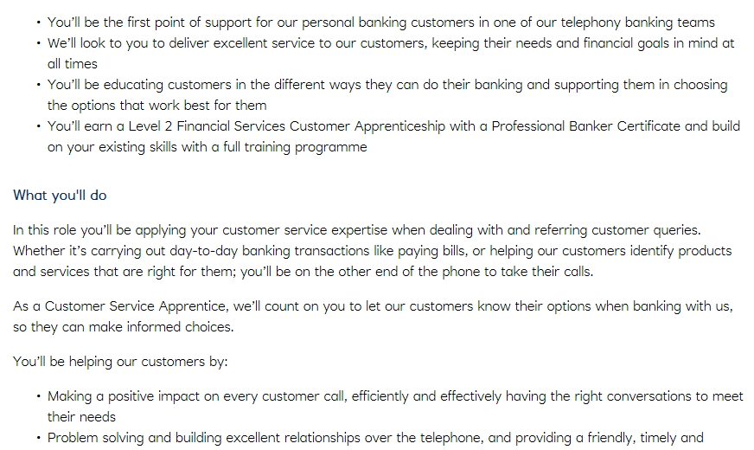

Cover Letter
Hello Barclays,
I have always been interested in banking and over the years I have achieved certain skills that will help me as a banking representative. I have achieved excellent hospitality skills by working in restaurants as a bartender and waiter. This allowed me to improve my customer service skills because I had to make sure all the customers were comfortable, and their needs were looked after. I always love helping others and I think this job will allow me to express and further increase my customer service skills by helping clients resolve any banking problems. I am always eager to learn which gives me motivation and passion for subjects that are interesting. My recent subjects include business management, information technology and applied sciences. Therefore, I have learnt how to manage business and how professional businesses operate. I’ve also learnt how to confidently use technologies such as computers. In addition, I have learnt sciences which gave me knowledge about human life. I have also researched on psychology which gave me insight on the human mind. This allows me to communicate correctly with others as well as treat others in a respectable manner.
Barclays could use a young person like me as I am keen on learning from others and work great as a team. I have fresh ideas and I always love to receive feedback to always improve myself to strive further.

CV
Syed Miah
1714970
Personal profile
I am reliable, hard-working and keen to learn new skills. I am also confident and outgoing and enjoy working with other people. I enjoy learning off others and working as a team. I have worked in various warehouses and achieved skills that will help me easily adapt to different environments. I also enjoy receiving feedback as it helps me develop my skills further.
Education and qualifications
Holte Visual & Performing Arts School, Birmingham September 2010 – July 2015
Holte Visual & Performing Arts Sixth Form, Birmingham September 2015 – July 2017
Subjects - 2015 |  | Grade
GCSE | Mathematics | C
GCSE | Core Science | B
GCSE | Additional Science | B
GCSE | English | C
GCSE | Literature | C
GCSE | French | C
GCSE | ICT | C
GCSE | RE | B
GCSE | History | B
BTEC | Sport | Pass
Subjects - 2017
BTEC Level 3 | Grade
Double ICT | D*D*
Applied Sciences | D*

Skills and achievements
I am confident when using computers and my school records are excellent. I have developed employability skills by the experiences that I’ve earned. I have developed time management skills which has helped me work efficiently in order to complete my tasks in the work placements. I have been an academic mentor in my school which had gave me a lot of responsibility and dedication. I can work as part of a team as well as working independently. Taking part in charities helped me improve my organisational skills and increased my motivation.
Work Experience
Work | Date | Duties
Codsall Spice – Restaurant | November 2016 | Taking orders and serving food. Providing hospitality
Amazon – Warehouse Operative | March 2017 | Picking and packing. Scanning, Labelling and dispatching orders
Shababs - Restaurant | November 2017 | Bartender and waiter providing hospitality
WHSmith – Warehouse Operative | August 2018 | Scanning books, organising stock and labelling orders.
Ocado – Personal shopper | September 2019 | Picking and packing orders. Organising food and drinks.

