
certificate of higher education skills for the workplace.
Professional Career Development

November 15, 2019
stacey evans
University of Wales Trinity Saint David

Table of Contents

Introduction……………………………………………………………………… 2
Findings…………………………………………………………………………… 3- 10
Conclusion……………………………………………………………………….. 11
Bibliography…………………………………………………………………….. 12
Appendices……………………………………………………………………… 14

Introduction

I’m currently looking after my gran who has Alzheimer’s, so I haven’t really mixed with a lot of people therefore I am studying this course for me to get more confidence to get myself a job and to work with different types of people. Soon I’m hoping to be in a job that I like.
In this assignment I’m going to do two learning styles and apply a SWOT and GO MAD framework for myself. The purpose of my report is to help me manage my own learning and growth throughout my career. It is to ensure I continue to work effectively and safely.

Findings
Bit about swot. What it is
introduction to swot

Swot Analysis;
Swot analysis is all about your strengths, weaknesses, threats and opportunities it is a framework for identifying and analysing the internal ad external factors that can have an impact on the viability of a person.
‘A SWOT analysis can help them gain insights into the past and think of possible solutions to existing or potential problems, either for an existing business or for a new venture’ Ommani, A (2011)

I’ve applied a swot analysis to help me get a better understanding of the strategic choices that I face.

Strengths;- I am able to work overtime which I can match with a opportunity of job vacancies who are looking for people to work overtime. I love a new challenge, I always like to keep myself busy. I’m always willing to learn different things.
Weaknesses;- However I briefly familiar with IT skills, I do need to further my skills and experience within the IT sector. I will be converting this into a strength by going to IT classes and this is part of a conversation strategy. Also I find I loose concentration quite easily someone could be talking to me and I could loose complete interest and my mind will go else where. I find a quite hard to deal with different people, everyone has different personalities and different outlooks and this is what I need to work on if I want to go and work with different people.
Opportunities;- The opportunity to gain experience within IT skills By going on IT classes to gain experience. I want to gain more qualifications for myself so I will get a better chance to find a job what I like.
Threats:- Competition with other jobs. Jobs downsizing, losing jobs

Weaknesses
Dealing with different people
I.T skills
Concentration

Strengths
Work overtime
Love a new Challenge
Willingness to learn

SWOT ANALYSIS

Threats
Competition with other jobs
Jobs downsizing
Losing jobs
Opportunities
Job vacancies
Different qualifications
Volunteering

GO MAD FRAMEWORK

Go mad thinking enables people or groups to solve problems more easily. MAD stands for Monitor, Analyze, Detail.
‘Go mad= Go make a difference’ ecologist (2001)
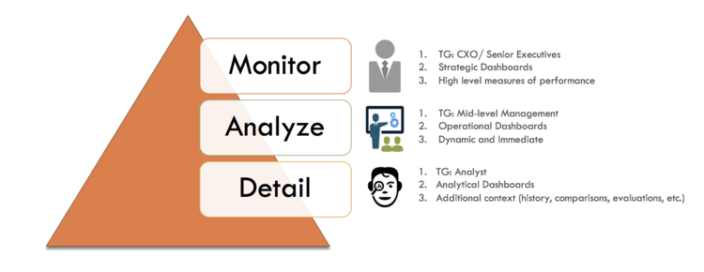

‘GO MAD’ thinking all started in 1997.
We set out to find a success process. What we discovered was a Results Framework of seven interlinking success principles. A framework, to help you think in a solution focused way to solve problems and achieve goals. (24th January 2018)

I am going to apply a ‘GO MAD’ Framework for myself.

Take Action and measure results
I’ve started taking action and I’m going to measure my results every week.

Involve others
I will involve my tutors, family and friends.
Self-belief
I’ve got self-belief that I will complete my course and build more confidence to find myself a job
Personal Responsibility
Handing all work in on time. Completing assignments on time.

Reasons why?
The reason I am doing this is because I want to go and get a job which I’m
Define Goal
I want to complete my course and build enough confidence to go and find myself a job.
Possibilities and Priorities
childcare could get in the way.
Smart Objectives

Smart Objectives can be used for both professional and personal planning. Help ensure that your objectives are more than just wishes by making sure they are SMART.
Doran (1981) first introduced the specific, measurable, assignable, realistic, and time-related (SMART) method for writing effective management goals. Bjerke M & Renger R. (2017)

S= Completing my course and confidence to get myself a Job.
M= Every week I will evaluate how I am getting along
A= This is achievable as long as I hand in all my work on time and achieve the best possible mark I can get.
R= This objective is realistic, and I will try my hardest to do it.
T= It will take me 1 year to complete my course but I’m hoping I can find myself a job as well in this time frame.

Introduction about learning styles
Two Learning styles I have chosen is Honey and Mumford and VARK.

Honey and Mumford (1992) identified 4 types of learners and they are Activist, Reflector, theorist, Pragmatist. See results in appendices.
Following doing the questionnaire On Honey and Mumford I learned that I am a Activist learner which means I like to deal with new problems. I like new experiences and love a new challenge which is one of my strengths as a reflector. I Fully agree with this learning style as I always like to keep busy and always like to keep occupied. I enjoy doing assignments but then worry if I’m actually doing them correct as my weakness as a reflector is IT Skills.
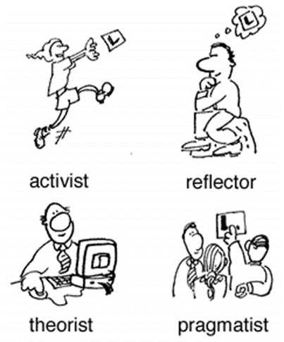

Vark- Model of learning styles VARK- Fleming & Mills (1992)
See results of questionnaire in appendices
On Vark I agree that I am a Kingethetic Learner which means I like to carry out physical activities, rather than listening to a lecture or watching demonstrations. Kingethetic learners tend to learn best when they are physically active and I totally agree with this I loose concentration if I’m listening which is one of my weaknesses as a reflector. I would much do it than to listen.
‘The VARK questionnaire was administered in English to students to determine their preferred mode of learning’. Davidson Gv (1990)
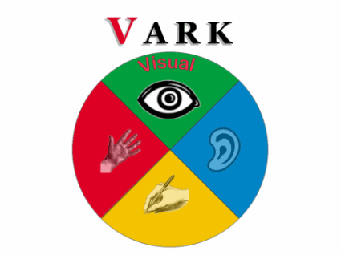
Increasing self awareness according to Havard Businesses revew article by Antony Tjan in 2015, there are 5 ways to become more self aware:-
- Meditate
- Write down your keys plans and priorities
- Undertake psychometric tests and profiling
- Ask trusted friends
- Get regular feedback at work.

Personal Development Plan
My Personal development plan is to complete my current course and get confidence to go and find myself a job what I like. There are some weakness skills I require to achieve in my PDP such as dealing with different people. I would need to deal with different types of people when out in a workplace which I’m not quite confident at doing right now and this is why I started the course. I will analyse my weakness and threats as well as strengthen my abilities then look forward for my opportunities.
See appendix

Maslow’s Two factor theory
A.H Maslow (1943)
Maslow’s theory is the results of a person’s attempt at fulfilling five basic needs : Physiological, Safety, Social, esteem and self-actualization. According to Maslow, theses needs can create internal pressures that can influence a person’s behaviour.
As I can for my gran I can apply a Maslow’s theory to the practice of patient care.

Motivates | Hygiene
Responsibility | Relationships
Growth | Work conditions
The work itself | Salary
Recognition | Security

The two factor theory states that there exist some factors that are responsible for a job satisfaction in the workplace whereas some factors cause dissatisfaction in the workplace.
‘Maslow (1943) Developed a theory about humans motivation following research done in the United States, His theory- known as the hierarchy of need- gives a number of hierarchical levels to explain motivation’ Peter Morgan (2017)

Conclusion

On the whole getting myself a job is a goal that I would really like to accomplish, it will be quite hard for me now as I’ve got no confidence to go for a interview but after I finish my course I’ll have enough confidence to be able to, as well as extra qualifications.
To be able to reach my goals I will have to hand in all my assignments on time. I will continue to be on time to class so I don’t miss any important information being given.

Bibliography

Ommani, A (2011) Strengths, weaknesses, opportunities and threats (SWOT) analysis for farming system businesses management: Case of wheat farmers of Shadervan District, Shoushtar Township, Iran. Vol.5 [Online] Available; http://www.academicjournals.org/app/webroot/article/article1380639652_Ommani.pdf Accessed on 06/11/19 at 20.47

Anon (2018) Go MAD Thinking - 21 years and still going strong! Woodhouse Eaves, Leicestershire. [Online] Available; https://www.gomadthinking.com/contact/ Accessed on 06/11/19 at 21.20

Mogan p (2017) The business students guide to study and Employability. London. PP-85

Davidson GV. Matching learning styles with teaching styles: Is it a useful concept in instruction? Perform Instr 1990;29:36-8.
[Online] accessed; http://www.jdrr.org/article.asp?issn=2348-2915;year=2015;volume=2;issue=1;spage=10;epage=12;aulast=Saran#ft1 Accessed on 06/11/19 at 23.05

Bjerke M, Renger R. (2017) Evaluation and program planning. Vol 61. University of North Dakota, United States. [Online] Available; https://www-sciencedirect-com.ezproxy.uwtsd.ac.uk/science/article/pii/S0149718916302580 Accessed on 07/11/19 at 20.46

Tjan, A. (February 2015) 5 Ways to Become More Self-Aware.
https://hbr.org/2015/02/5-ways-to-become-more-self-aware [Accessed 12/11/19] at 21.35

Ecologist (2001) Go mad= go make a difference. London

Appendices

Honey and Mumford questionnaire
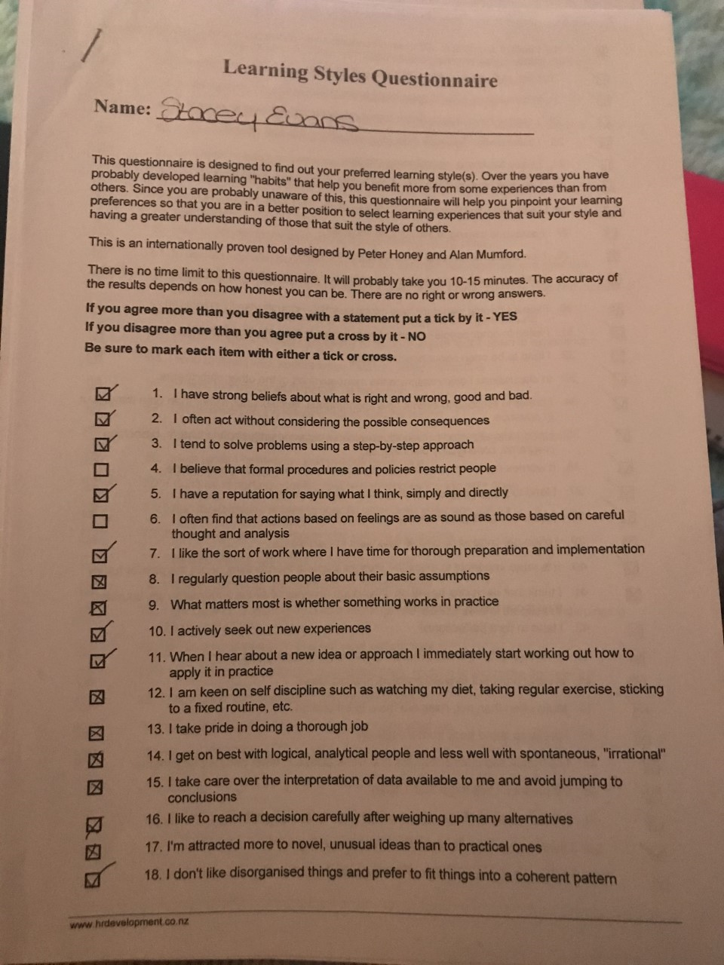

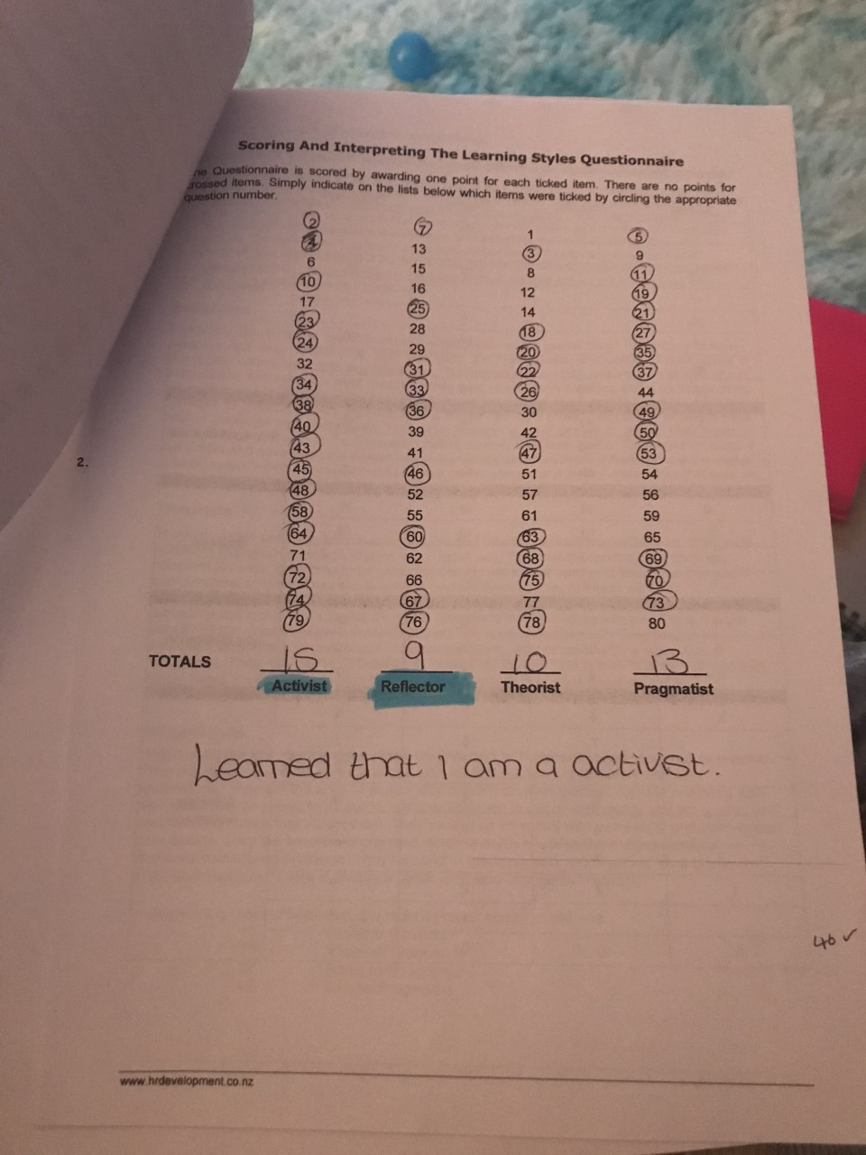

Vark



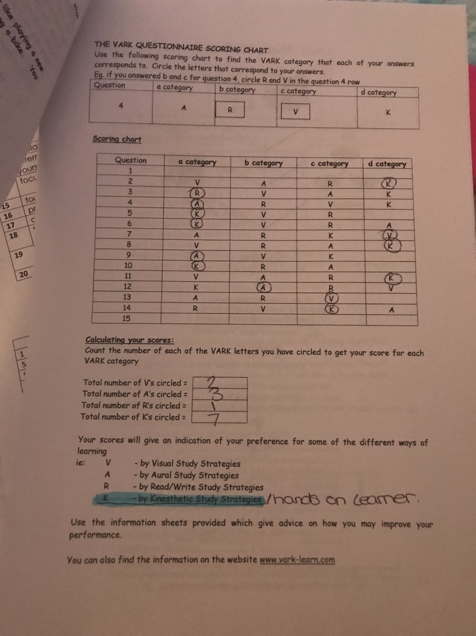

Personal development plan
A personal development plan is a process that consists of defining what is important and what you want to achieve, what strengths you already have to help to achieve your goals.


