Building a Free, Gemini-Powered Data Analysis Agent with LangChain
A practical tutorial for building and running an LLM-powered data analysis agent using Google’s free Gemini API.

What this tutorial covers
This tutorial builds a pandas dataframe agent: an LLM-backed agent that can answer natural-language questions about a real dataset by writing and running its own Python/pandas code. The whole thing runs on a local Anaconda/Jupyter setup on Windows, using Google’s free Gemini API tier, so there’s no billing or paid API key needed anywhere in the build.
By the end, you’ll be able to ask a question in plain English , “what’s the average age in this dataset, and how many people have the condition we’re tracking?” , and have the agent write, run, and explain the actual pandas code that answers it.

1. Setting up a clean environment
Mixing a new project’s dependencies into an existing, heavily-used conda environment is a common source of unresolvable version conflicts. The most reliable fix is a dedicated environment built fresh:
conda create -n gl-agent python=3.11 -y
conda activate gl-agent
python -m ipykernel install --user --name gl-agent --display-name "Python (gl-agent)"
The last line registers this environment as a selectable kernel inside Jupyter , without it, Jupyter won’t offer “Python (gl-agent)” as an option when you open a notebook.
One install cell covers everything this tutorial needs. Run it once, inside a notebook cell using this kernel (not a separate terminal , see the kernel-mismatch note below):
import sys
!{sys.executable} -m pip install langchain langchain-community langchain-google-genai langchain_experimental crewai crewai-tools faiss-cpu pypdf mypy_extensions tabulate pandas matplotlib seaborn google-genai
Why !{sys.executable} -m pip install ... instead of plain !pip install ...? On Windows/Anaconda, plain !pip inside a notebook can silently install into a different Python environment than the one the notebook’s kernel is actually running , usually your base Anaconda environment, if it appears earlier on your system PATH. Using {sys.executable} -m pip forces the install into the exact Python the current kernel uses, which avoids a confusing class of “but I just installed it!” ModuleNotFoundErrors. If you ever hit that error despite having “just installed” something, this mismatch is the first thing to check:
import sys
print(sys.executable) # should contain ...envs\gl-agent\python.exe

2. Getting a free Gemini API key
Google’s Gemini API has a genuinely free tier , no card required, with a daily quota generous enough for learning and small projects (currently 1,500 requests/day on the Flash-tier models).
- Go to Google AI Studio and sign in.
- Open the API Keys page from the sidebar.
- Click “+ Create API key”, name it, and choose a project.
- In the “API key details” dialog that appears, click “Copy key” next to the field labelled API Key. (Current Gemini keys may start with AQ. rather than the older AIzaSy... format , either is legitimate if it’s copied straight from this official dialog.)
Never paste a key directly into your code. Use getpass, which pops up a separate masked input box:
import getpass, os
os.environ["GEMINI_API_KEY"] = getpass.getpass("Paste your Gemini API key: ")
Type/paste your key into the box that appears below the cell after running it , not inside the parentheses in the code itself. Pasting it into the code, or showing it in a screenshot, exposes it; if that happens, treat the key as compromised and generate a new one.

3. The imports you’ll need
LangChain reorganised its package structure for its 1.0 release, so a number of commonly-referenced import paths from older examples online no longer work as written. The old “batteries-included” agent/toolkit APIs moved into a separate langchain_classic package, integration-specific pieces (document loaders, vector stores, SQL utilities) moved to langchain_community, and text splitters got their own tiny package. Here are the correct, current imports for this build:
import pandas as pd
import os
from langchain_classic.agents.agent_types import AgentType
from langchain_community.utilities import SQLDatabase
from langchain_community.llms import HuggingFaceHub
from langchain_community.document_loaders import PyPDFLoader
from langchain_community.document_loaders import UnstructuredPDFLoader
from langchain_text_splitters import RecursiveCharacterTextSplitter
from langchain_community.vectorstores import FAISS
from langchain_classic.agents.agent_toolkits.conversational_retrieval.openai_functions import create_conversational_retrieval_agent
from langchain_classic.agents.agent_toolkits.conversational_retrieval.tool import create_retriever_tool
from langchain_classic import hub
from langchain_core.runnables import RunnablePassthrough
from langchain_community.agent_toolkits.load_tools import load_tools
import sqlite3
from langchain_google_genai import ChatGoogleGenerativeAI
from langchain_google_genai import GoogleGenerativeAIEmbeddings
from langchain_experimental.agents import create_pandas_dataframe_agent
If you’ve seen older examples that import straight from langchain (e.g. from langchain.vectorstores import FAISS or from langchain.agents import load_tools), those paths have moved , the table below maps the common ones to where they live now:
Older import path | Current path
from langchain.agents.agent_types import AgentType | from langchain_classic.agents.agent_types import AgentType
from langchain.sql_database import SQLDatabase | from langchain_community.utilities import SQLDatabase
from langchain.document_loaders import PyPDFLoader | from langchain_community.document_loaders import PyPDFLoader
from langchain.text_splitter import RecursiveCharacterTextSplitter | from langchain_text_splitters import RecursiveCharacterTextSplitter
from langchain.vectorstores import FAISS | from langchain_community.vectorstores import FAISS
from langchain.agents.agent_toolkits import create_retriever_tool | from langchain_classic.agents.agent_toolkits.conversational_retrieval.tool import create_retriever_tool
from langchain import hub | from langchain_classic import hub
from langchain.schema.runnable import RunnablePassthrough | from langchain_core.runnables import RunnablePassthrough
from langchain.agents import load_tools | from langchain_community.agent_toolkits.load_tools import load_tools

4. Building the LLM
The language model sits at the centre of the whole build. Wire it up with your Gemini key:
llm = ChatGoogleGenerativeAI(
model="gemini-3.8-flash",
temperature=0,
max_tokens=None,
timeout=None,
max_retries=5,
google_api_key=os.environ["GEMINI_API_KEY"],
)
Quick test to confirm the whole chain , key, library, network, model , actually works end to end:
response = llm.invoke("Say hello in one short sentence.")
print(response.content)
A model-name note worth knowing: Google periodically retires older model names (e.g. gemini-2.5-flash was retired for new API keys in favour of newer models like gemini-3.8-flash). If a model name you’re using starts returning a 404 NOT_FOUND error, the error message itself usually names the replacement , just swap it in.
Everything downstream that references the llm variable will use this Gemini-backed model automatically.

5. Building the pandas dataframe agent
This is where the “agentic” behaviour becomes visible: rather than you writing pandas code, you ask a question in plain English, and the agent decides what code to write, runs it, and interprets the result.
df = pd.read_csv("SAHeartData.txt")
agent = create_pandas_dataframe_agent(
llm,
df,
verbose=True,
allow_dangerous_code=True,
handle_parsing_errors=True,
max_iterations=15,
max_execution_time=240.0,
)
If you don’t have a dataset saved locally yet, this public dataset works directly from its source URL:
df = pd.read_csv("https://hastie.su.domains/ElemStatLearn/datasets/SAheart.data")
What allow_dangerous_code=True actually means: the agent will have the LLM write real Python and execute it locally against your dataframe. That’s exactly what makes it useful for analysis, but it’s a genuine capability, not just a formality , appropriate here because the dataset is public and the code only runs locally, but worth remembering if you ever point this pattern at a different data source.
create_pandas_dataframe_agent accepts any LangChain-compatible chat model, which is why this step needs no further changes once llm already points at ChatGoogleGenerativeAI.

6. Asking it questions
With verbose=True, you see the agent’s reasoning step by step , the pandas code it decides to write, the result it gets back, and how it turns that into a plain-English answer.
agent.invoke("What are the column names in this dataset, and what does each one represent?")
agent.invoke("What is the average age of people in this dataset, and what percentage have coronary heart disease (chd)?")
agent.invoke("Compare the average tobacco use between people who have chd=1 versus chd=0. What does that suggest?")
agent.invoke("Which numeric column has the strongest correlation with chd?")
agent.invoke("Create a bar chart showing how many people have chd versus how many don't, and save it as a PNG file.")
Example 1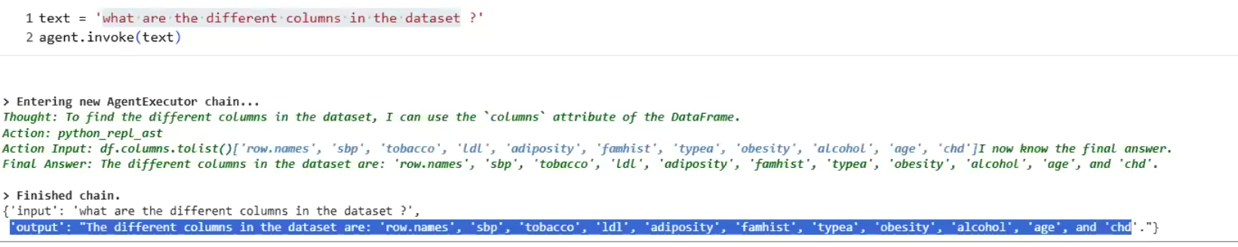
Example 2
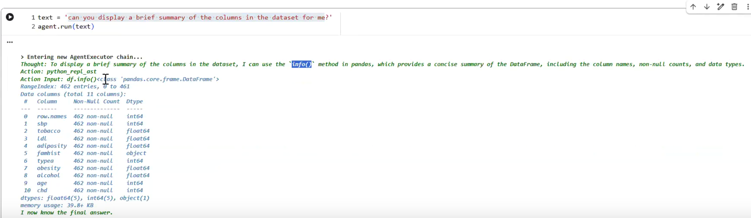
Example 3
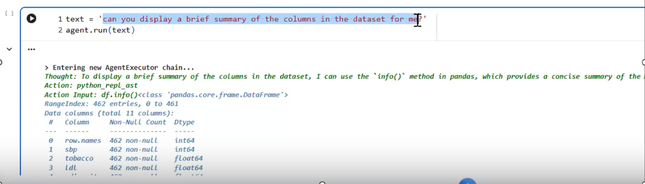
Example 4
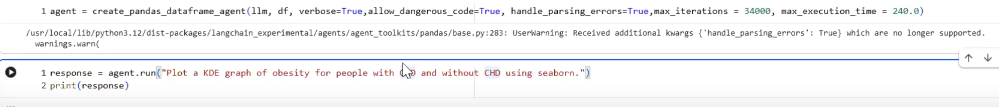

Example 5
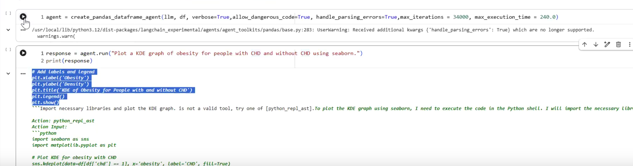
Each question typically costs just 1–3 actual Gemini API calls under the hood (one per reasoning step), well within the free tier’s daily quota.

7. Troubleshooting checklist
Common issues you may hit while building this, and their fixes:
- ModuleNotFoundError for a package you “just installed” → you likely installed into the wrong Python. Run import sys; print(sys.executable) to check which environment your kernel is actually using, then reinstall with !{sys.executable} -m pip install ....
- A variable like llm, df, or agent suddenly NameErrors → the kernel was restarted (or the notebook reopened from a new location), which wipes all variables from memory. Rerun your setup cells from the top , imports, key, llm, df, agent , in order.
- ImportError: cannot import name 'X' from 'langchain...' → almost certainly one of the legacy import paths from Section 3. Check the table there.
- A model name returns 404 NOT_FOUND → that specific model has been retired; the error message names the current replacement.
- A cell seems to hang → Google’s client library retries automatically with increasing delays on network hiccups, so up to ~60–90 seconds of apparent silence is normal. Past ~2 minutes with no output, interrupt the cell and try again; persistent hangs often point to a VPN/firewall blocking generativelanguage.googleapis.com.
- DeprecationWarning messages (e.g. for langchain-experimental, or handle_parsing_errors) → safe to ignore; these are maintenance notices, not errors.

8. Where things are saved
- This environment: conda environment gl-agent, registered as Jupyter kernel “Python (gl-agent)”.
- Your Gemini API key: entered fresh via getpass each session (never hard-coded).
- The working notebook and dataset file should live in the same folder , check with os.getcwd() and os.listdir() if read_csv("SAHeartData.txt") can’t find the file.

Key takeaway
The “agentic” idea at the heart of this build , a model that can choose to call tools, inspect results, and loop until it has an answer , is independent of which LLM provider sits underneath it. Everything in this tutorial that touches the model itself (which class you import, which parameter name holds the key) is a thin wrapper layer; the agent logic on top of it stays the same regardless of vendor.

