July 18, 2019
Shaun davies
1903572

Internet technology & security
html & css web development
Table of Contents
Abstract 2
1. Requirements 3
1.1 Keto Life Website 3
2. Implementation 4
2.1 Images of the Keto Life website 4
2.2 Validation 13
2.3 HTML Validator Results 13
2.4 CSS Validator Results 15
3. Evaluation 15
3.1 Evaluation of the #KETO LIFE website 15
3.2 Search Engine Optimisation 17
3.3 Web Accessibility 18
References 20

Abstract

During the following report the author will explain what website they chose to create, who the target audience is, what the website has been created for and its functions. The author will explain the meaning of web accessibility and how accessible their website is. It will also cover any errors that were found within the website and how/if they were corrected.

Requirements

Keto Life Website

The author created a website based on a personal interest of his own, the Keto diet. The Keto diet is based on the dieter entering ketosis by consuming a high fat, low carbohydrate (carbs) diet. The reason for this is because the human body can burn fat far more efficiently than it can carbohydrates.
By consuming a very low amount of carbs approximately below 50 grams daily and a high amount of natural fats. Natural fats that are recommended for the keto diet are from grass fed red meats such as beef, pork, fish etc. Other foods such as eggs, whole nuts and berries are also encouraged on the keto diet.
The carbohydrates should mainly come from vegetables such as broccoli, spinach, pak choi, cauliflower etc. Starchy vegetables and sugary fruits such as potatoes, bananas, carrots etc, and sugary snacks are to be completely avoided.
The author designed the site with the health and fitness industry in mind. The author himself practices the keto diet and relies heavily on web content for things such as food recipes, advice and success stories.
The author has kept this in mind when designing their website and has included what they would want from a keto website. The #KETO LIFE website provides breakfast ideas which are aligned with the keto diet.
It provides recipes for lunch/dinner for the keto diet which are relatively easy to make and not high cost. The same can be said for the snacks section which gives recipes for quick snacks that can be used as and when appropriate to keep hunger away.
All the food pages have ingredients and instructions on how to prepare. The website explains what the Keto diet is and the main benefits. The main aim of persons participating in the keto diet are usually to lose weight and become healthier.
The author placed images within the website which suggest that keto would/can help the participant lose weight. The images depicted can be seen in the images of the website in the Implementation section of the report. The authors aim was to make the message of the website clear and to entice the intended audience.
Bright colours were also used to promote a vibrant atmosphere and energy. This was to make the website attractive and grab the user’s attention. Bright colours are usually associated with happiness and health.
The author created a section which included exercise regimes for the user to incorporate into their new lifestyle. This was to promote weight loss and health benefits. The regimes do not require any special equipment and can be performed by persons of varying fitness and experience. This gives the user encouragement to try the regimes.
The website has a subscription service which provides further recipes and exercise regimes. The amount provided is dependent on the subscription chosen by the user. The prices range from £5.99, £7.99 and £9.99. The author has also included 3 fictitious #KETO LIFE stores, located in Carmarthenshire and Swansea. These stores are keto supermarkets which provide only keto approved foods.

Implementation

Images of the Keto Life website

Over the next few pages of the report the author has provided images of the website.
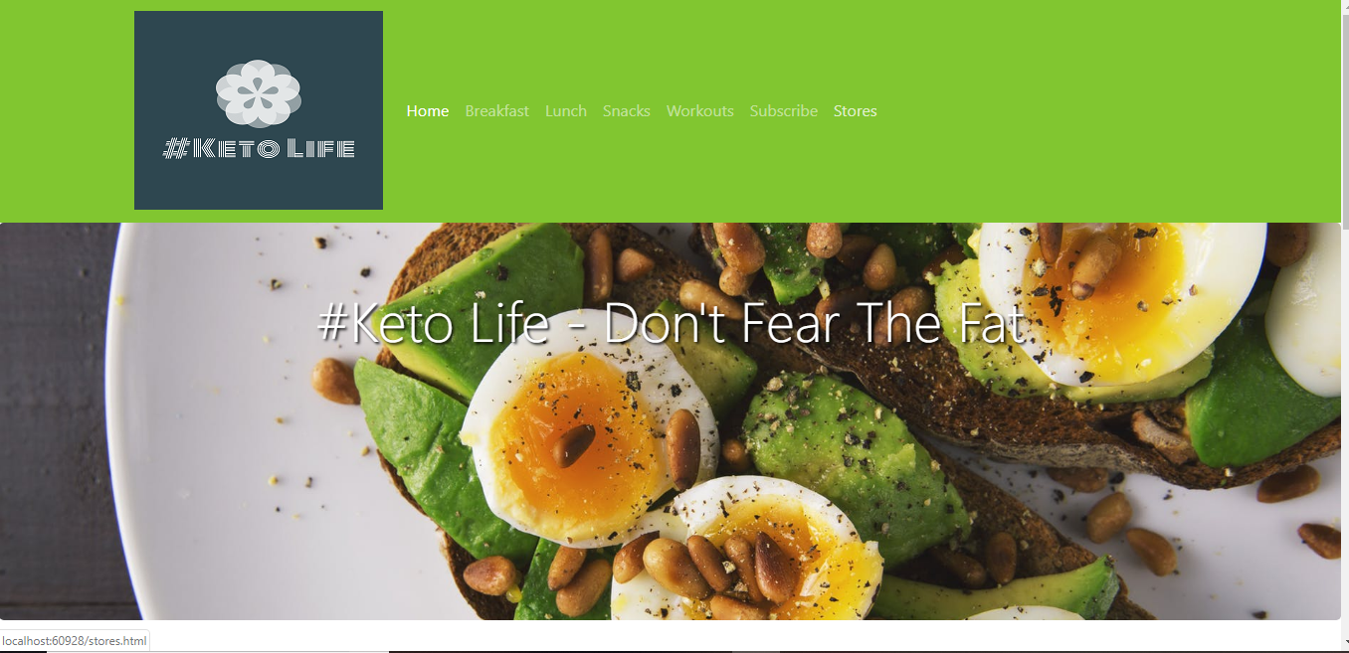
Index page with header, navigation bar and jumbotron.

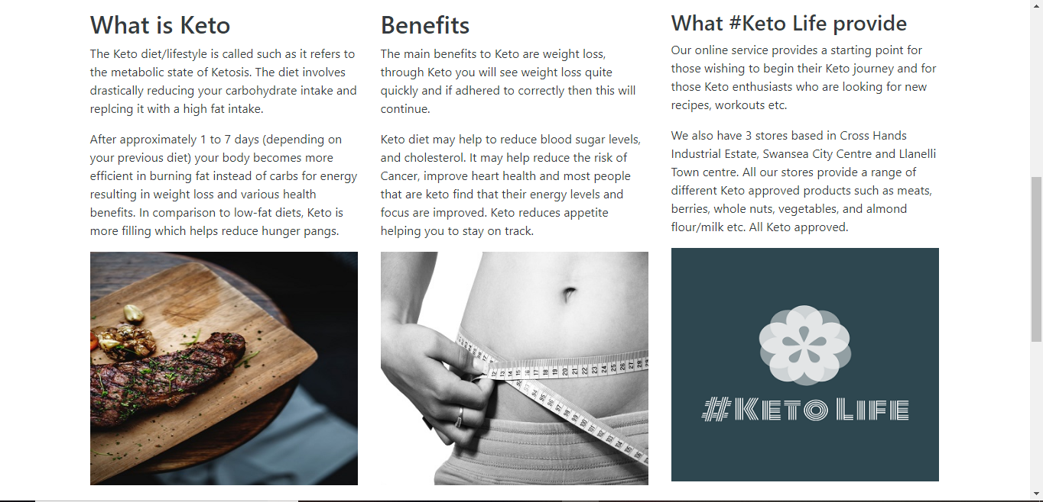
Main body of the index page.

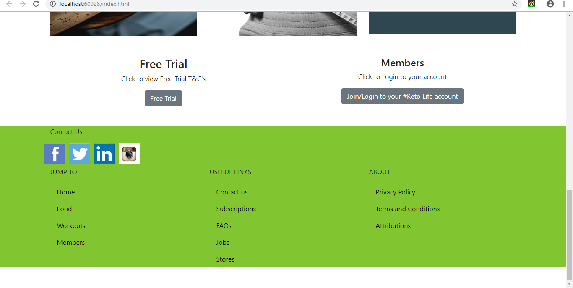
Footer of the index page with navigation links.

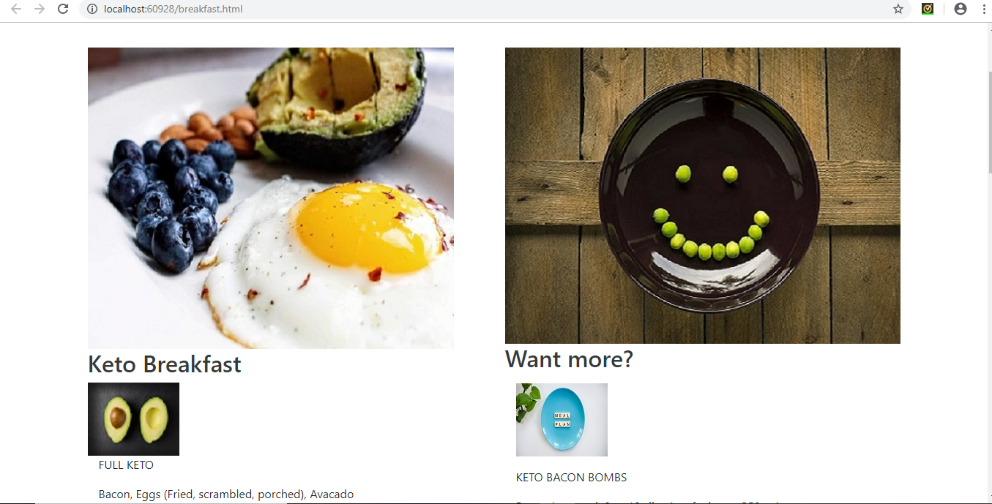
Breakfast page.
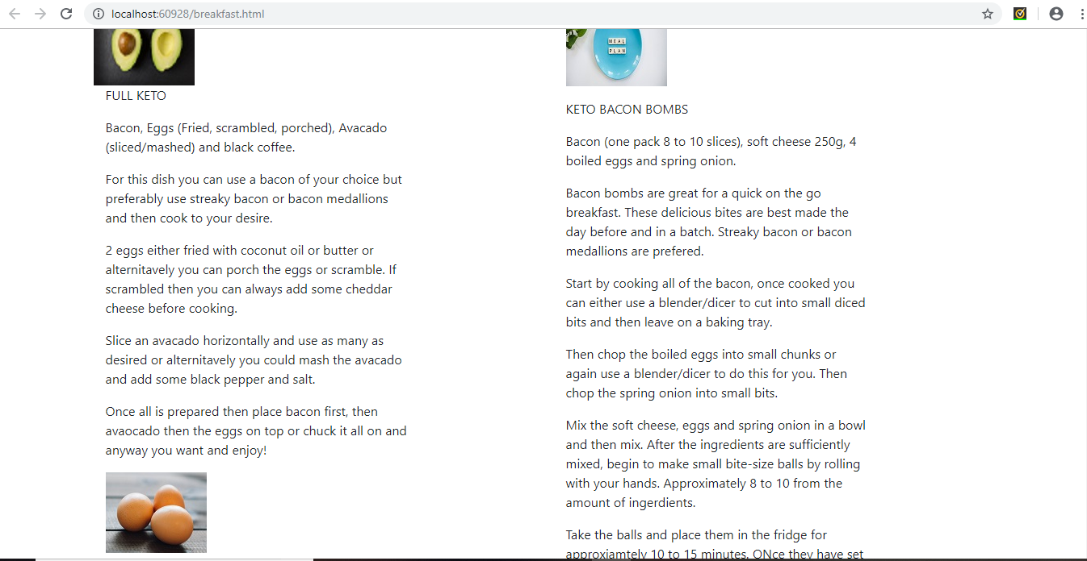
Breakfast page content.

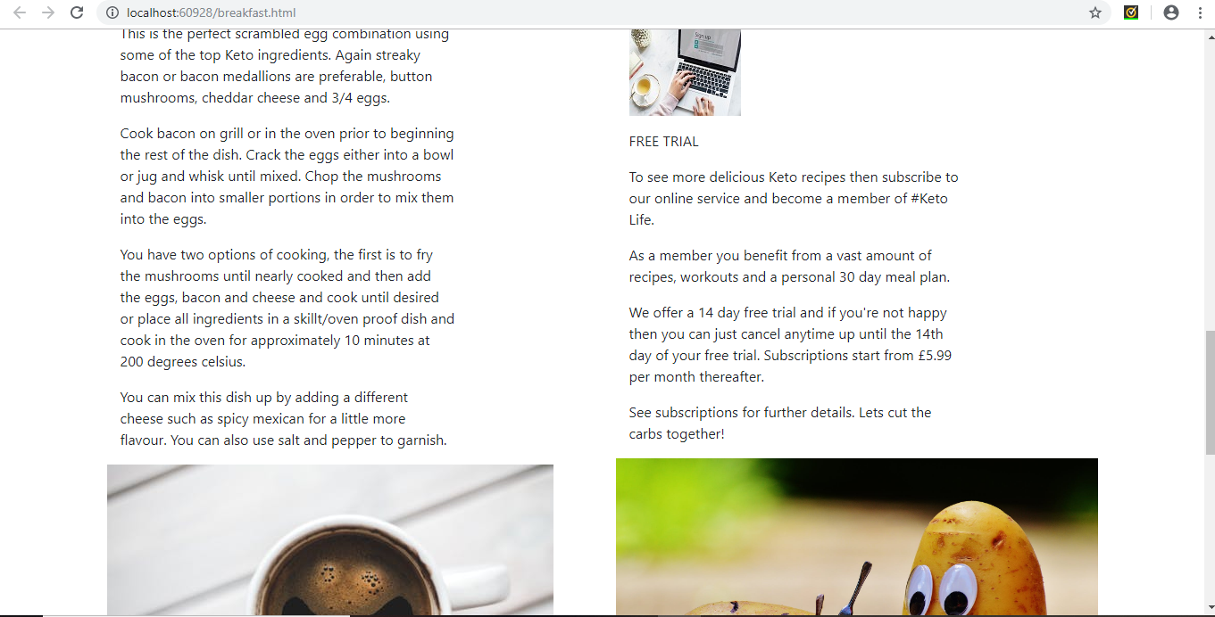
Breakfast page, further content.
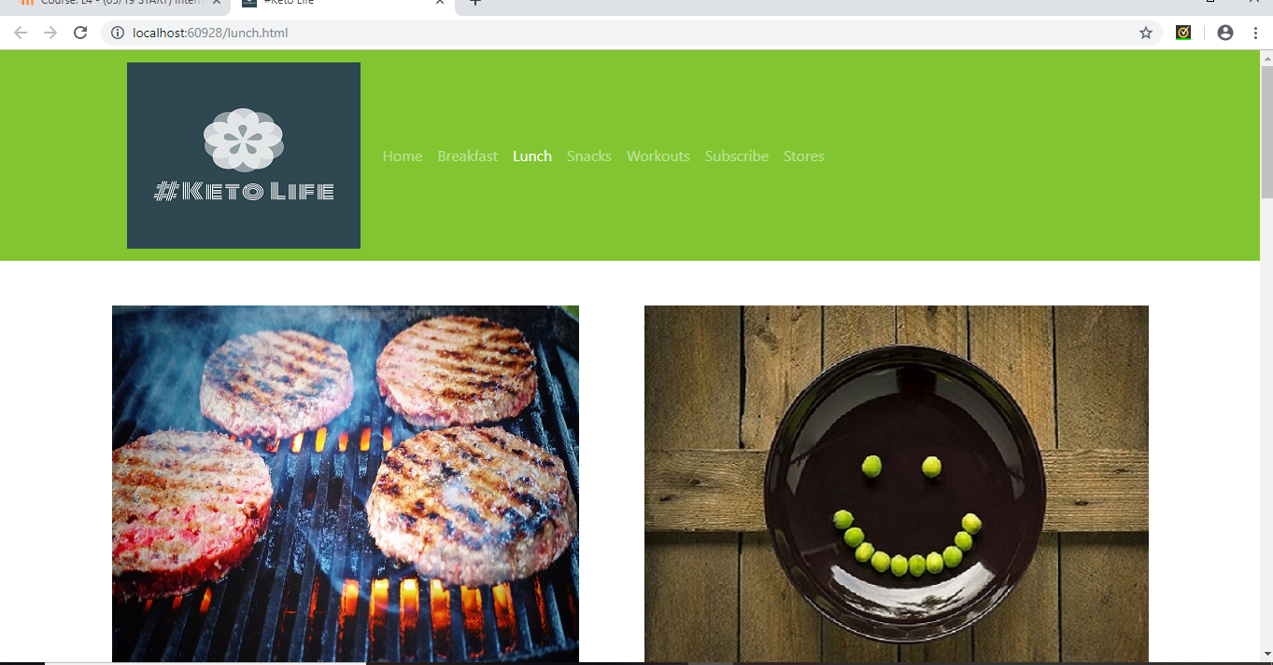
Lunch page.

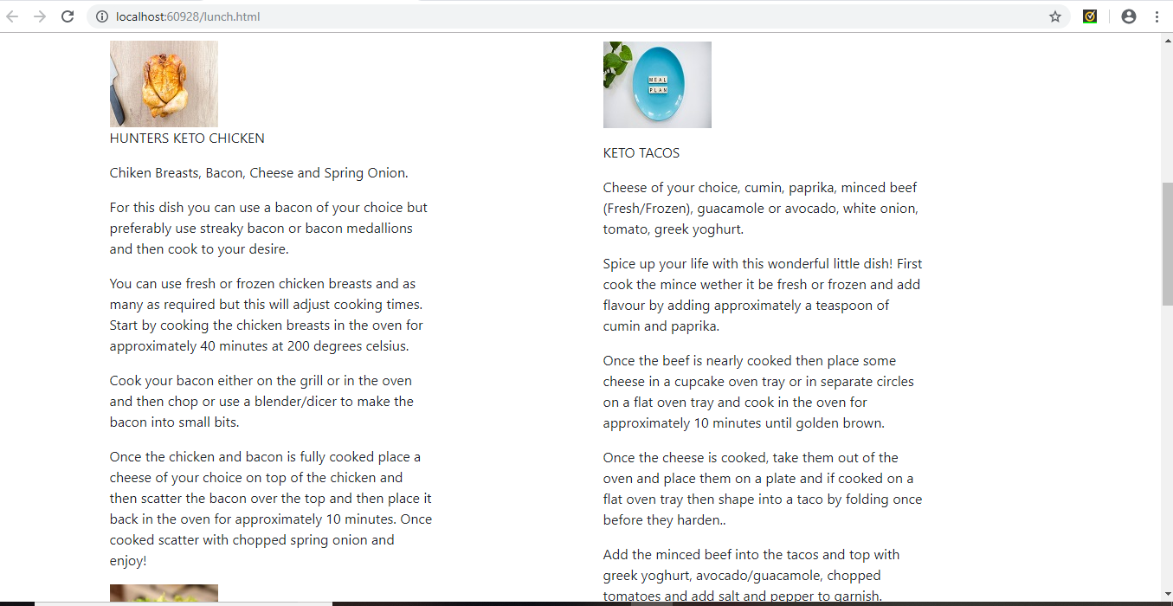
Lunch page content.

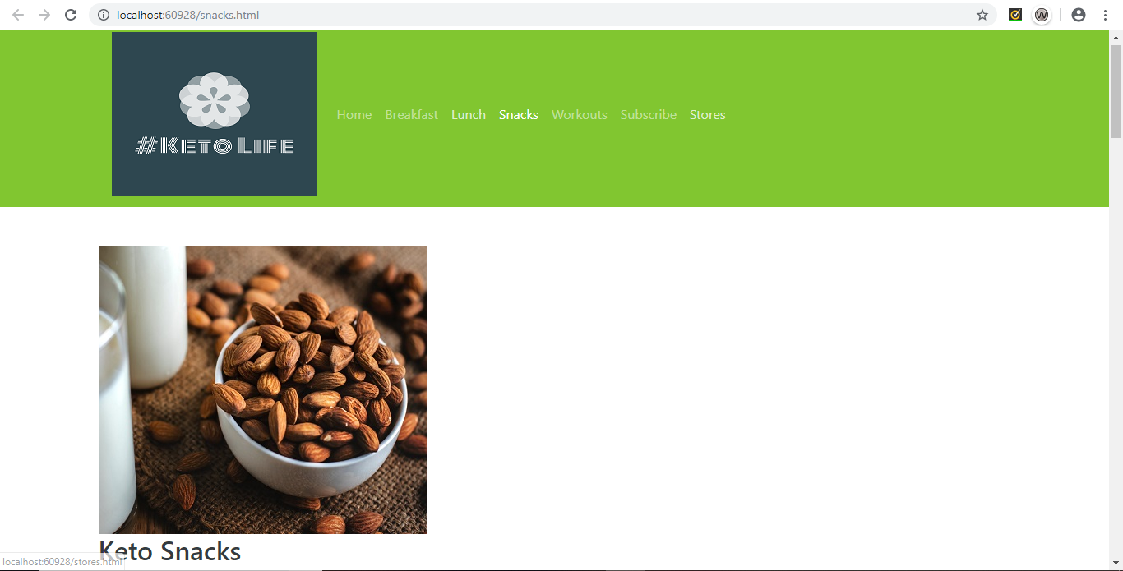
Snacks page.

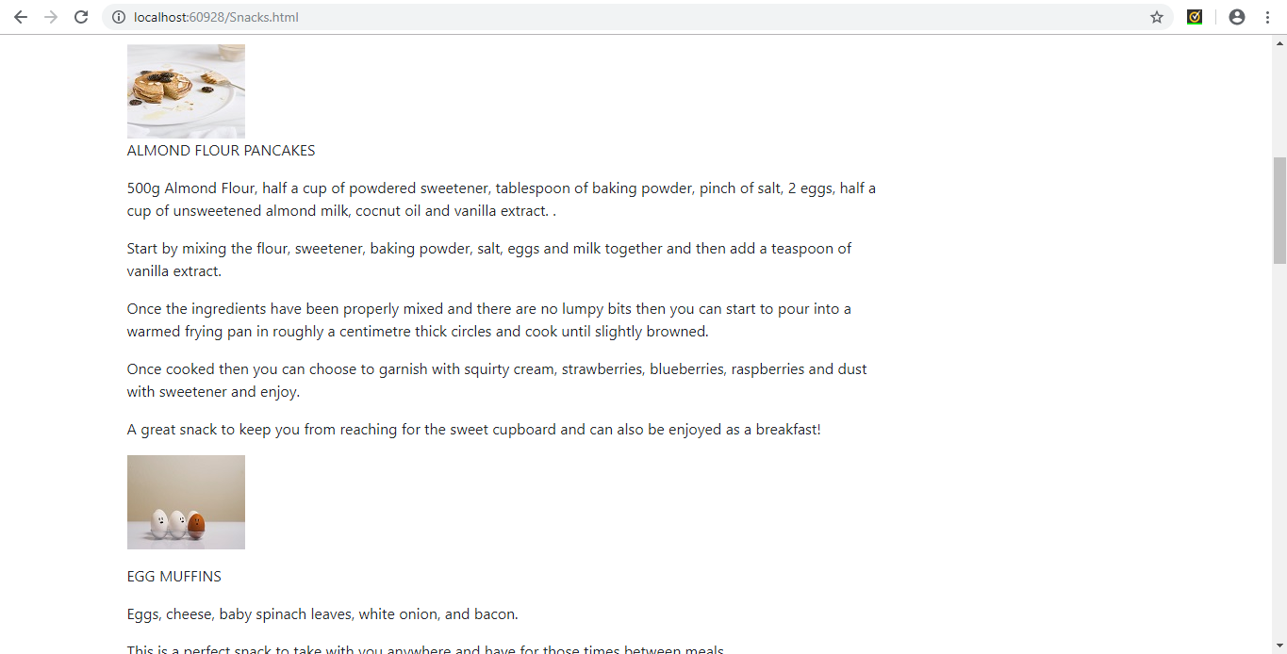
Snacks page content.
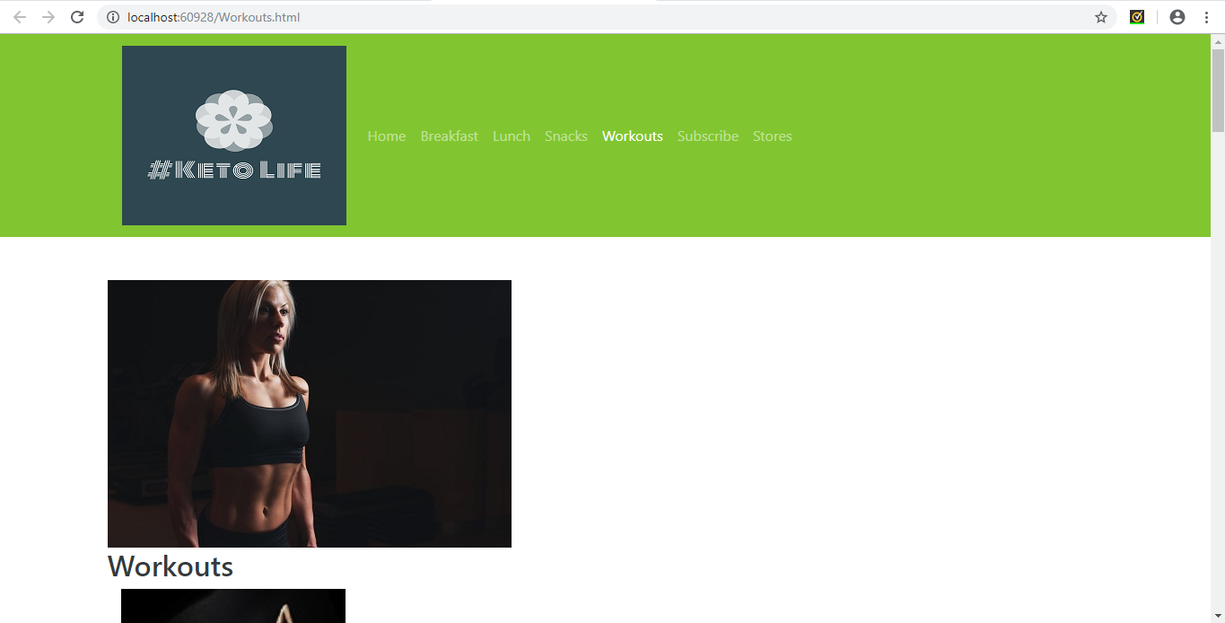
Workouts Page.

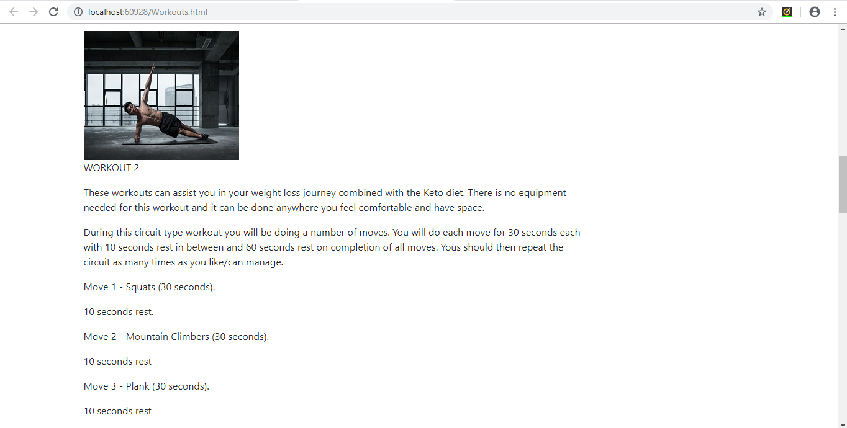
Workouts page content.

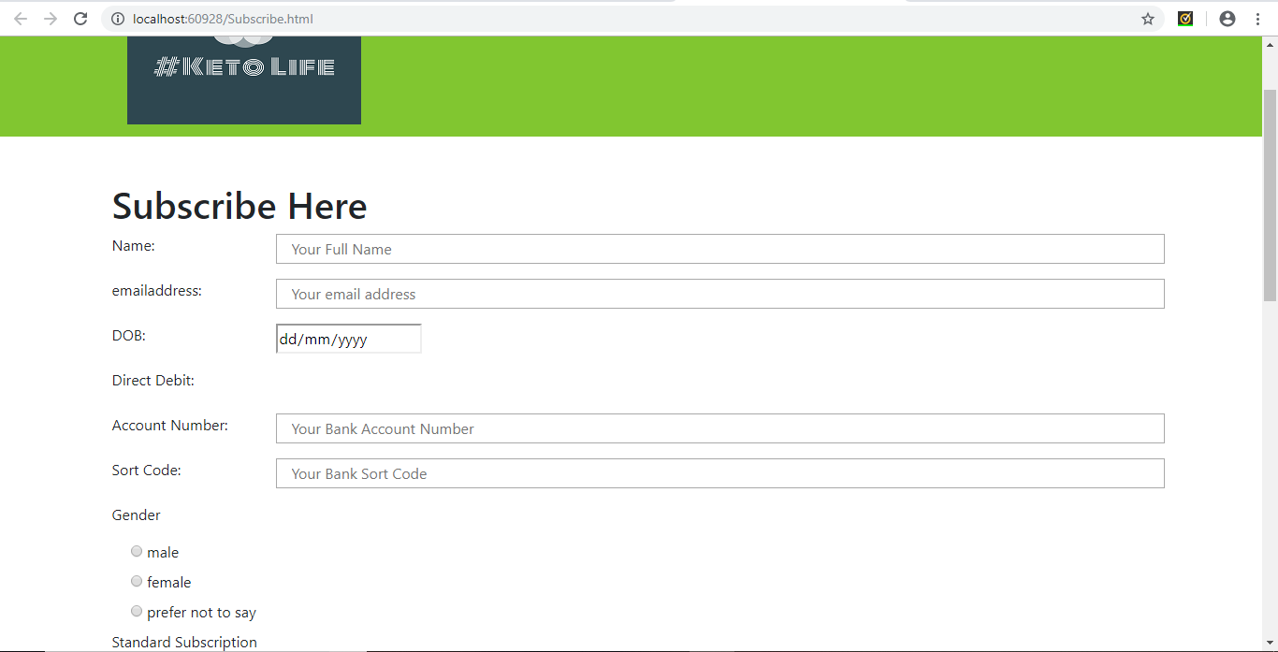
Subscription page.

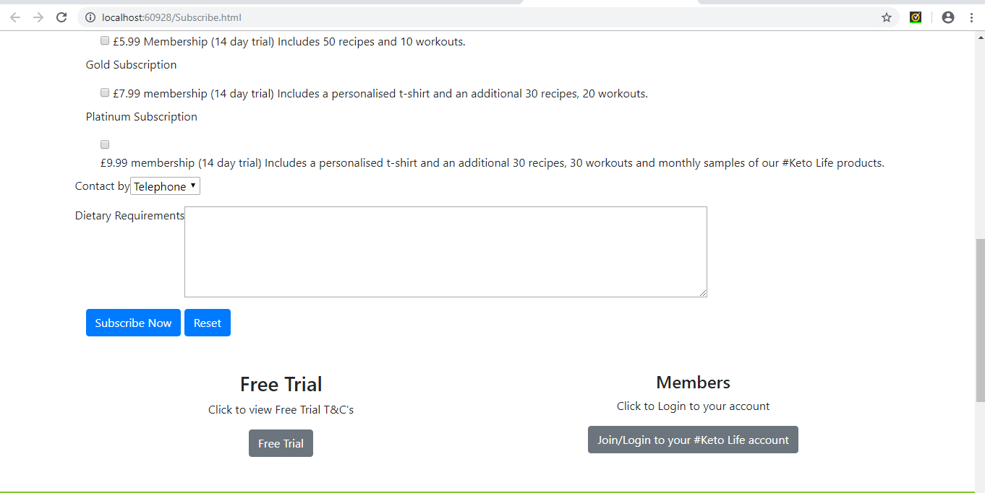
Subscription page continued.
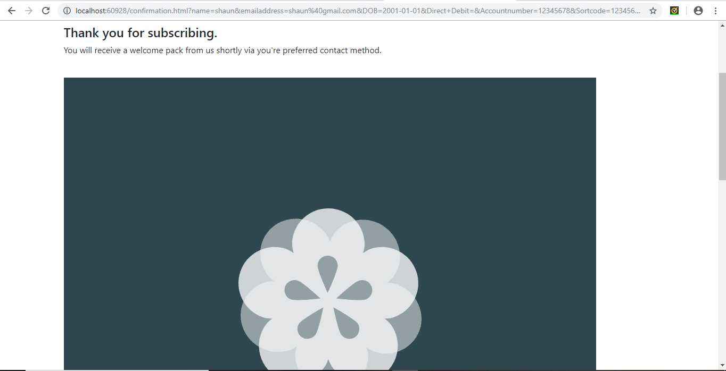
Confirmation page.

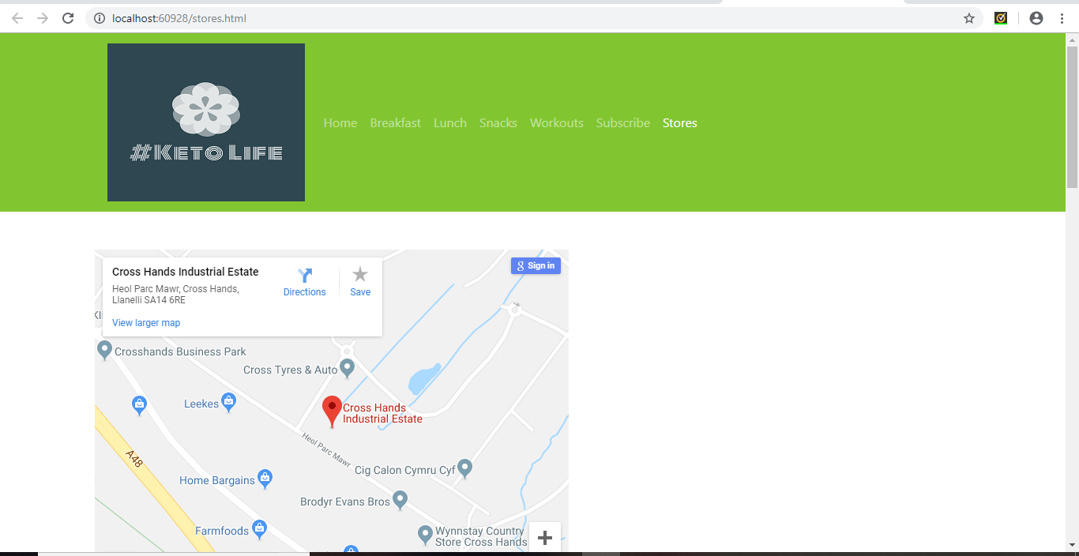
Stores page.

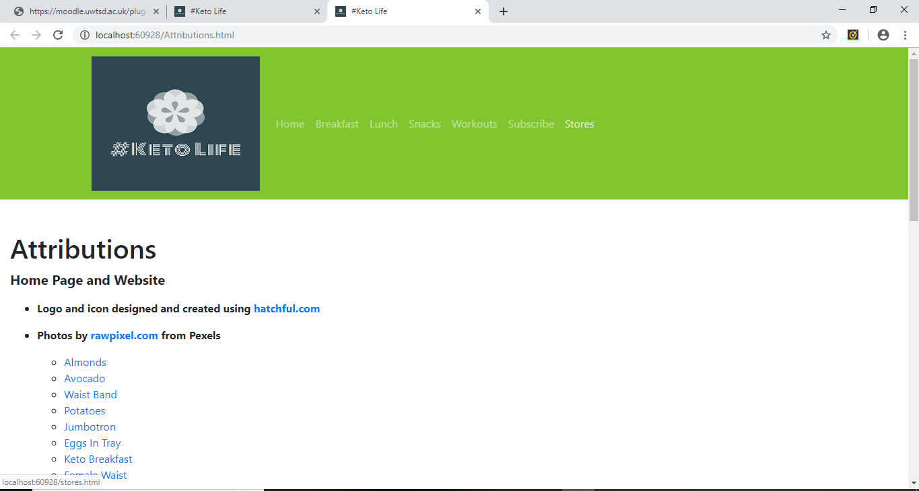
Attributions page.

Validation

HTML Validator Results

The author used a HTML Validator [1] to validate the HTML used to create the website and find any errors. The results are shown in the below image.
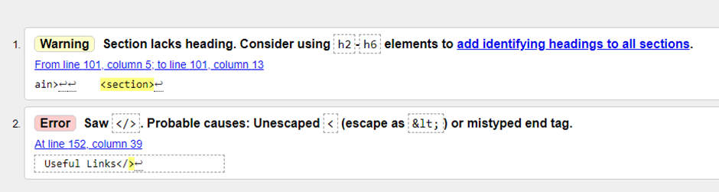

There were 2 errors found by the validator. The first being the use of the h2-h6 elements to identify a heading within a section. The heading elements range from h1 through to h6, with h1 being the highest rank or of more importance. They imply paragraph breaks before and after, necessary white space if applicable and font changes [2].
The author then inspected the code and found that the issue was that the headings both used the same element of h2. They both hold the same rank and the validator suggested that a different element was used. The author changed the second heading within the section to the h3 element.
By doing this the h2 element is seen as the most senior and then the 2 elements differed in font size. This was not appropriate for the website as the area of the website needed both headings to be the same font as can be seen below.
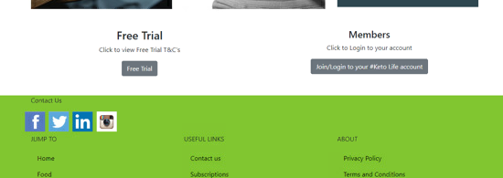
By changing the header elements it meant that Free Trial was now larger than Members and the website was not aligned any longer. The author decided to revert the heading back to its previous element to correct the website and leave the error.
The second error found by the validator was in relation to a misplaced end tag. This was quickly rectified by placing the correct end tag as can be seen in the highlighted are of the below image.
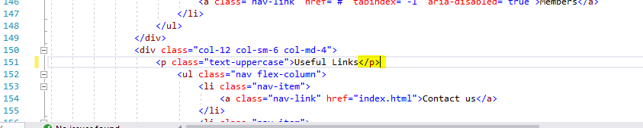

CSS Validator Results

The author then used a CSS validator [3] to inspect the CSS for the website. As can be seen from the below image there were no issues found with the CSS. The Validator then provided the HTML code for the validation websites icon. The icon shows the user that the CSS has been validated.
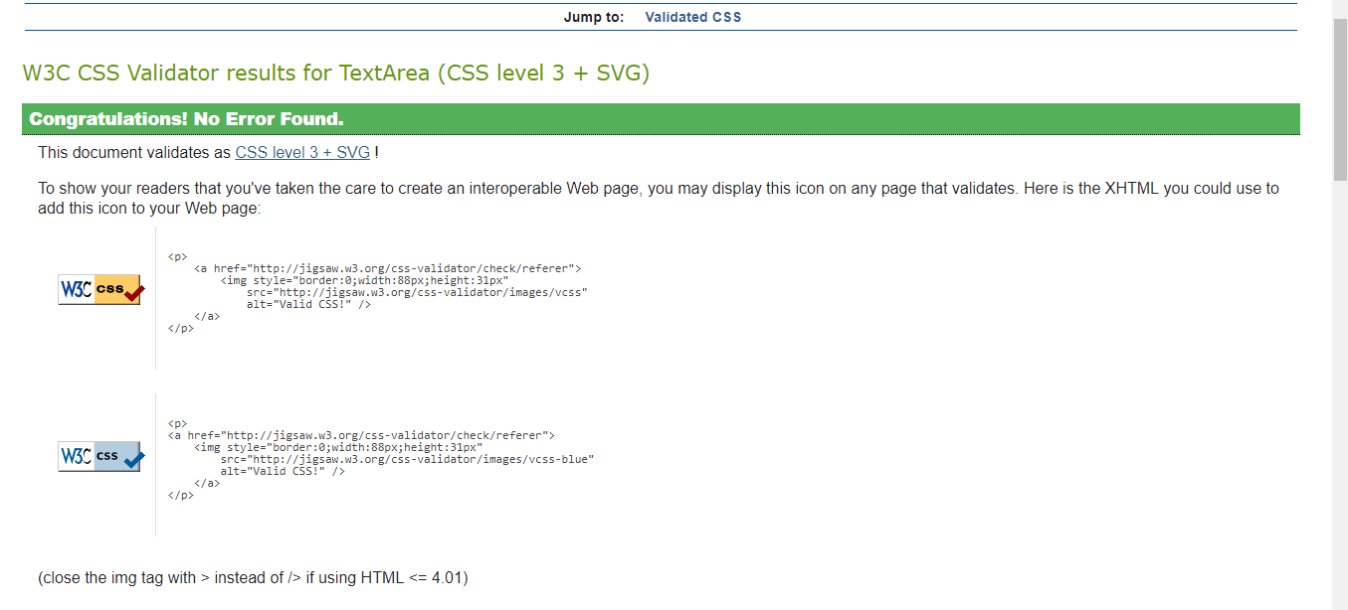

Evaluation

Evaluation of the #KETO LIFE website

The author evaluated the website based on the design, usability and, content. The author believes that the website has a vibrant appearance and is an attractive website. The logo design is modern with an easily identifiable name.
The green colour used for the main theme of the website draws the attention of the user and gives a welcoming appearance. It has a minimalistic design as not to overwhelm and confuse the user. This should make the users experience more enjoyable.
Images used in the website [4] were carefully selected to ensure that they represented the website’s agenda. As can be seen in the website photos in the previous section of the report, the images used were of keto friendly food/ingredients such as steak, burgers, eggs, avocado etc.
This was to show the user the wide range of foods allowed with the keto diet. They were also used to entice the user into the keto diet by appearing healthy and appetising.
Images suggesting weight loss and exercise were used to imply that the user could lose weight and benefit their health when taking part in the keto diet and using the services of the website.
Images of toned professional models were used in the Workouts page of the website. They were used to imply that the user could achieve that standard by following the keto diet combined with the services of the website.
On reflection the author thinks that he may have used more images of completed recipe dishes, to show the user what portion size and how the finished dish appears. He would also consider using more relatable images for the workouts to more represent the targeted audience as the current images could potentially put off some users.
The website’s functionality is quite basic. The links created in the header will all lead to the stated sections of the website as would be expected from a website however they currently open in a new tab rather than in the current tab. This may not be to everyone’s requirements.
The links created in the footer of the website under the headings “Jump To”, “Useful Links” and, “About” are all functional. However the links that do not yet have a specific HTML page created are directed back to the index page. This would obviously be corrected before being published. The correct HTML pages would be created and then the links would direct them appropriately.
The same could be said for the buttons “Free Trial” and “Join/Login..” as at present they both are directed to the subscribe page, this is relevant but the author would consider having a page with more information available for the free trial button. The author would also have created a login page for members which would allow full access to the appropriate areas of their subscription.
The content provided on the website is straightforward and to the point and can be easily read/understood by the majority of users. The author would consider having the content laid out differently with more sections and images to clearly differentiate recipes and workouts. Videos relating to the website content would also be considered to increase the appeal of the website.
The logo [5] used by the author is modern and to the point. It contrasts the main colour theme of the website in order that it stands out.

Search Engine Optimisation

Search engine optimisation (SEO) is a tactic used by developers to enhance the websites placing in search engine results from websites such as Google and Bing etc. [6]. To optimize the chances of the website appearing higher in the search engine pages the author would use SEO tactics.
The author would use a domain that would be recognized by a search engine to relate to the relevant key words. A domain name example for the keto life website would be http://ketolifediet.com/health-weight-loss. [7]

The author would not use www as a subdomain as it is the most commonly used subdomain. Using keywords like keto and diet it would allow the search engine to relate the domain name to the relevant subjects. It also makes the domain name memorable whereas using random numbers or letters is the opposite. [7]
Using broad keywords such as health and weight makes it obvious to the search engine what the website does/involves. Using .com as a top level domain (TLDs) is best practice as it is more commonly known. Other commonly known TLDs include .co .net .org. Les commonly used TLDs such as .biz are likely to attract less traffic to the website. [7]
The content of a page also plays a major part in SEO. By making the site links appropriate and directed within the site. Having authentic, obvious information that is clear to read/see and high quality images. Having no more than 4 clicks required from any page. [7]
The website is able to be easily shared via social media platforms and has the appropriate social media tags for the user. It should be multi-device ready so that the website is accessible and functional through different devices such as smart phones, iPads, laptops and desktops etc. [7]

Web Accessibility

The term web accessibility relates to how accessible websites are to all people, including those with disabilities. Making a website accessible means that it should be easy to see, read and navigate for everyone, including people who may be blind, partially sighted or a physical disability such as a broken arm for example. [8]
Situational limitations are included also, such as when the user is in a location which may be bright and affects their view of the website or a slow internet connection. Web accessibility encompasses auditory, cognitive, physical, neurological, speech and visual disabilities that may affect the users’ access to the website. [8]
There are a number of web accessibility evaluation tools which can help the developer improve their website. It is far easier however to have accessibility in mind when first building the website. Evaluation tools can help to advise the developer on accessibility but also human evaluation is necessary from a knowledgeable source. [8]
The author used the Wave accessibility evaluation tool [9] to evaluate the keto life website. A brief overview of the results can be seen below.
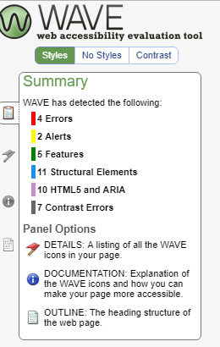 [9]

As can be seen there a number of areas that were suggested by the evaluation tool. One of the main areas was the headings structure which was discussed in the HTML validation. When the headings were changed it created issues in the website that unplaced various other paragraphs and images within the website. The headers were then kept as they were originally.
Another issue was the contrast of the website, the aim of the design of the website was to be vibrant and attractive to the user. However after seeing the results of the evaluation tool, the author would consider altering the colours to comply with web accessibility rules.
In reflection the author appreciates that the website is not quite the finished product and would need some attention to rectify the identified issues.

References

[1] | “"The W3C Markup Validation Service",” Validator.w3.org, 2019. [Online]. Available: http://validator.w3.org/. [Accessed 17 July 2019].
[2] | “"Headings",” w3.org, 2019. [Online]. Available: http://www.w3.org/MarkUp/html3/headings.html. [Accessed 18 July 2019].
[3] | “"The W3C CSS Validation Service",” jigsaw.w3.org, 2019. [Online]. Available: http://jigsaw.w3.org/css-validator/. [Accessed 17 July 2019].
[4] | “"Free Sock Photos . Pexels",” Pexels.com, 2019. [Online]. Available: https://www.pexels.com/. [Accessed 01 July 2019].
[5] | “"Hatchful Your digital logo designer",” Hatchful, 2019. [Online]. Available: https://hatchful.shopify.com/business-services-logo-maker. [Accessed 01 July 2019].
[6] | “"What is SEO - Search Engine Optimization? Webopedia",” webopedia.com, 2019. [Online]. Available: https://www.webopedia.com/TERM/S/SEO.html. [Accessed 18 July 2019].
[7] | “"On-Page Ranking Factors [2019 SEO]",” Moz, 2019. [Online]. Available: https://moz.com/learn/seo/on-page-factors. [Accessed 18 July 2019].
[8] | “"Introduction to Web Accessibility",” Web Accessibility Initiative (WAI), 2019. [Online]. Available: http://www.w3.org/WAI/fundamentals/accessibility-intro/. [Accessed 18 July 2019].
[9] | “"WAVE Web Accessibility Tool",” Wave.webaim.org, 209. [Online]. Available: https://wave.webaim.org/. [Accessed 17 July 2019].

marking criteria and Student FEEDBACK

This section details the extent to which the assessment criteria are demonstrated by you, which in turn determines your mark. The marks available for each category of skill are shown. Lecturers will use the space provided to comment on the achievement of the task(s), including those areas in which you have performed well and areas that would benefit from development/improvement.

Common Assessment Criteria Applied (Assignment 1) | Marks available | Marks  awarded
1. Engagement with Literature Skills

Overall, demonstrates very good engagement with literature skills and materials have been appropriately referenced including third-party content used for the website. I would have also liked to see some evidence of research for the on-page SEO evaluation section. (Grade mark: 80.00%) | 5 | 4
2. Knowledge and Understanding Skills

Demonstrates a very good understanding of the standards used to design and implement a website as demonstrated by the interpretation of the validation results and overall valid HTML and CSS implemented in the website. . Good research on web accessibility and this is further evidenced by a good accessibility evaluation of the implemented website. The on-page SEO evaluation is good but could be improved and a few good recommendations for improvements have been discussed. (Grade mark: 63.33%) | 30 | 19
3. Cognitive and Intellectual Skills

NA | NA | NA
4. Practical Application Skills

A very good attempt featuring a well-thought-out website with good and relevant content and a very good attempt at making it responsive. There is, however, some room for improvement in the layout of some sections. The practice of opening links in new tabs is better suited to links for external websites. For links to pages within your website, it is better to open them in the same tab. See your report for detailed, suggested improvements and some corrections. (Grade mark: 73.33%) | 60 | 44
5. Transferable Skills for Life and Professional Practice

The report is generally well-written and presented. (Grade mark: 60.00%) | 5 | 3

Assignment Mark (Assessment marks are subject to ratification at the Exam Board. These comments and marks are to give feedback on module work and are for guidance only until they are confirmed. ) | Late Submission Penalties (tick if appropriate) |  | 70%
 | Up to 1 week late (40% Max) |  | 70%
 | Over 1 week late (0%) |  | 70%

