
Module ：Human Resource Management
(BMMB7007)
Name ：Niu Chenchong
ID: 2106311
- mail：2106311@student.uwtsd.ac.uk
Tutor： Dr Rachel Cook
Completion time：1-4-2022

Completion time

Analysis of Huawei’s
employee management——Take ‘wolf culture’ as an example
Catalog
1.Executive summary 2
2. Organisational overview 2
3 The interactive relationship between corporate culture and human resource management 4
4.Conclusions 8
5.Recommendations 8
6.0 Reference list 12

1.Executive summary
Huawei is a corporate which is famous world-wide. In line with its corporate image, Huawei's human resources management department and policies have undergone continuous changes. From a simple support to a dedicated department that works organically with other departments, Huawei's HR plays an increasingly important role in the development of the company, but it has also given rise to many problems, such as staff encouragement, which is mentioned in this article. Some recommendations following are pinpointed to the issues put forward.

2. Organisational overview
Huawei Technologies Co., LTD., founded in 1987, is headquartered in Shenzhen City, Guangdong Province. Huawei is the world's leading information and communication technology (ICT) solutions provider, ranked 44th in the fortune Global 500 list of companies in 2021.
Huawei adheres to the corporate philosophy of ‘customer-centric, strivers-oriented’and continues to innovate based on customer needs. A research resulted by Huawei shows that ‘1% of HR staff investment will bring 7% of revenue and 9% of profit growth’.
From 1987, Huawei has adopted the incentive policy of sharing stocks. In the period of 1992-1997, the company gradually took professional management and systematic human resource management, emphasizing ‘employee Competency-based’ human resource management approach. In the process of strategic transformation of human resources, Huawei has established a three-pillar HRBP model and created the V-CROSS HR role to achieve 6 major role changes: strategic partner; HR solution integrator; HR process operator; relationship manager; change agent; and core values inheritance driver. (Chen Hongquan,2015)
Now, Huawei designs and implements an internal control system (Internal control ) based on its organizational structure and operation mode, such as being a pioneer in rotating CEO system. The issued internal control management system and internal control framework are applicable to all processes (including business and finance), subsidiaries and business units of the company. (Huawei,2022)

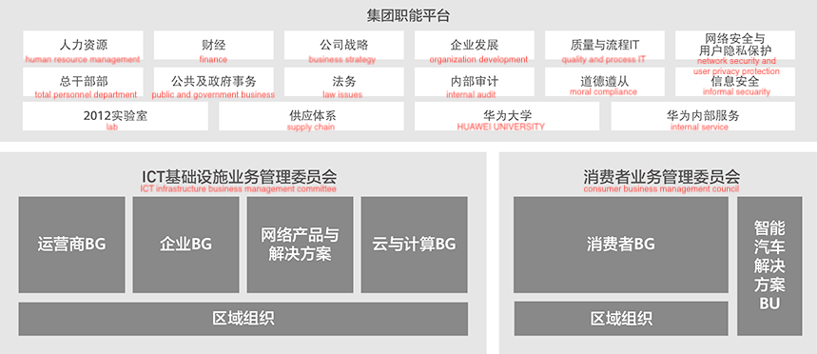
Picture 1 Group intelligent platform of Huawei

The area I have picked to illustrate is “performance management ＆ employee management”. With huawei's huge success, "Wolf" corporate culture began to be respected by the Chinese business community. However, this has also brought huge controversy to Huawei. "Wolf culture" is understood as absolute obedience, collectivism regardless of personal gain and loss, and competitive thinking that dares to sacrifice everything. Some people more intuitively interpret it as "overtime culture", which has affected huawei's image in the industry. This poses a serious challenge to the human resources department of performance management ＆ employee management.

3 The interactive relationship between corporate culture and human resource management

3.1 The priority area that needs improving: staff encouragement policys

3.1.1The influence on HRM generated by Huawei's ‘Wolf culture’
In the process of human resource management, the core content of corporate culture and corporate values must be added.
Huawei's core culture is "Wolf culture", that is, customer-centered, striver oriented, hard work as the root, and long-term consistency. Therefore, Huawei has developed corresponding incentive policies.

3.1.2 Advantages of Huawei’s incentive policies
First of all, Huawei abandons the influence of age, experience and other factors, and sets remuneration based on contribution and treatment based on responsibility. Huawei have relatively perfect equity incentive policy during operation, a conditional offer incentives for part or all of the shareholders, make the whole enterprise benefit community, for short-term returns, then by the fixed rights into virtual restricted shares, share out bonus with virtual stock to buy shares in the company, but leave must be sold to the company. (Jiang Ruinan,2021)
Wang Qiming's study shows that Huawei's employee stock ownership plan shows a positive relationship between the effect of equity incentives and Huawei's innovation capacity, which maximizes the company's innovation capacity by attracting and maintaining the best talent, maximizing the company's innovation capacity by leveraging human resource innovation. (Wang Qiming,2020)
Wu Pei et al. argue that the equity incentives generated by Huawei's employee stock ownership plan facilitate the monitoring of executives' investment behavior and effectively reduce the agency costs within Huawei. (Wu Pei,2020)

3.1.2 Disdvantages of Huawei’s incentive policies
On the other hand, the collectivism without regard to personal gain and loss and the competitive mentality that dares to sacrifice everything make employees under heavy load for a long time, such as ‘overtime work culture’， which is a common dilemma in chinese workplace.Zhu Zhaolu et al. analysis shows that the increased work intensity pressure generated by Huawei's employee stock ownership plan, neglect of employees' spiritual needs and personnel conflicts in a competitive environment can have a negative impact on employees' psychological state, resulting in an increase in employee turnover. (Zhu Zhaolu,2018)

3.2 Benefits of improving the incentive policies for the organisation

3.2.1 Improve the assessment mechanism
The former step of rewarding staffs is to assess everybody’s working results. Improving the incentive policies can make a closed loop of work, assess and incentives. Making a balance, so that people can make the best use of their talents.

Picture 2 The closed loop of work, assess and incentives
According to IEEE, a business organization should augment its approach with human-in-the-loop to improve its performance.
A positive feedback loop is a continual process in which an organization solicits or gives feedback so they can improve the company structure and processes.
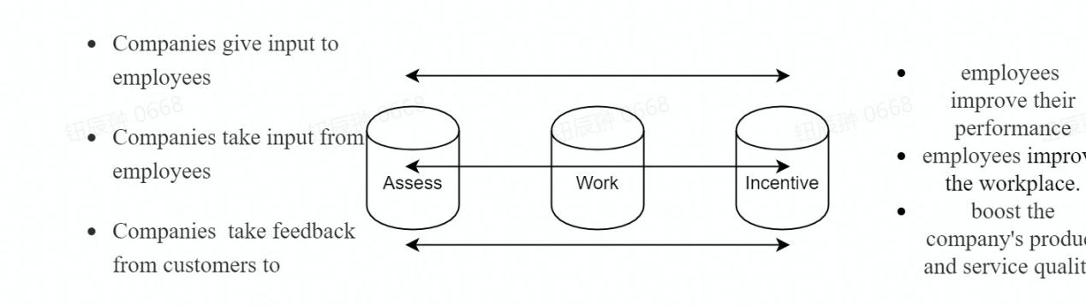
picture 3 The closed loop of work, assess and incentives
These processes are called loops because the employees or management take the input and use it to adjust their actions and goals. They then direct the results of those actions back into the feedback process, which creates more input.
Feedback loops in business should function the same way they do in the scientific fields. Each stage of the process should build upon successes so the company achieves increasingly higher goals. Since each stage is so crucial, it is necessary to constantly monitor feedback to make sure it stays positive and that employees are responding in positive ways. In the workplace, this may entail regular employee reviews or surveys, or monitoring concrete objectives like increased sales.（Indeed Editorial Team，2022）

3.2.2Conducting and improving business culture
The ‘Wolf Culture’ is one of the Huawei’s personalities which can not be deprived, many people start to get in touch with this company through the culture. Therefore, the company need to enhance the culture rather than abandon it because its shortcomings. Huawei needs to focus on giving its employees a strong work motivation while at the same time giving him great incentives.

3.2.3 Adding more ethical and humanistic elements to the rigid management mechanism
Once synonymous with cruelty, wolf culture was the driving force behind the squeeze on employee time. New compensation incentive programs, such as TUP , have been introduced. It not only motivates young people to work harder for more bonuses, but also increases the loyalty of new employees and makes them stay longer. It not only motivates young people to work hard for more bonuses, but also increases the loyalty of new employees, allowing them to stay in the company and concentrate on their ideas.

4.Conclusions
From the establishment of Huawei, we can see a process of continuous improvement of HR system.
In order to survive in the fierce competition in the market, Huawei has instilled ‘wolf culture’ to its employees and taken human management measures like sharing stock, three-pillar HRBP model and created the V-CROSS HR role, internal control system.
However, the same cruel and high-handed management policy has posted to much pressure on the employees, even damaging to the company's reputation and image in the community.
In conclude, Huawei should improve its human management system, to adapt to the current state of development of the company and motivate the organization to make further progress.

5.Recommendations

5.1 Adjust the position of human resource department in the company
In the past, CHRO always serve the overall performance goals of the company, and take measures to keep the company running by squeezing employees at all costs.(Charan R., Barton D., and Carey D.,2015)
It is time for HR to take the same leap forward as Finance has done in recent decades and become a true partner to the CEO. CHRO should help the CEO by developing and assigning talent, especially key individuals, and working to unleash the energy of the organization. Managing human capital must be given the same priority as managing financial capital. The CEO must have a clear view of the significant contributions CHRO can make and clearly articulate those expectations.
Monitor employee satisfaction, workforce engagement, benefits and compensation, diversity ....... Some of these things seem to be the usual charter for CHROs, but they are largely absent in practice, to the frustration of most CEOs.
To address these issues, people should be paid according to how much value they contribute to the company - combining the importance of the job with the way they handle it. Finance and HR should work together to determine expected value in advance, using both qualitative and quantitative factors.
CHRO, on the other hand, should also be able to make meaningful predictions about the competition. Just as every army general learns about his opponents on the enemy side, the CFO should have information about the competition and how their key decision makers and executives compare to the CFO's organization.

5.2 Leveraging HR to drive a better company culture
According to Kosiorek and Szczepańska, the division of organizational culture based on a bipolar matrix with two variables and generating four culture types is very popular in the literature on the subject.
Huawei now has a company culture that can be defined as being in the middle role between "power" (this type is characterized by domination of the environment, competitiveness, intransigence, high power distance, strong competition) and task (it is characterized by organizational flexibility and rapid response to changes in the environment), which should be directed toward the role (it is characterized by bureaucracy, privileges closely related to the position held, stability of actions, compliance with regulations) and people (it is based on low power distance, consensual decision making, cooperation, mutual support and experience sharing) closer.
The impact of cultural values will be reflected in all practices of HRM operations, including recruitment, selection, hiring, motivation, development, evaluation, and termination activities. However, blind change can also damage company culture and create confusion in the minds of employees, and this should be taken seriously.

5.3 Improve productivity through improving workforce diversity
Saxenaa has said that Workforce diversity refers to similarities and differences among employees in terms of age, cultural background, physical abilities and disabilities, race, religion, gender and sexual orientation. When everyone is talking about competition and elimination, it's a good idea to think more about workforce diversity.

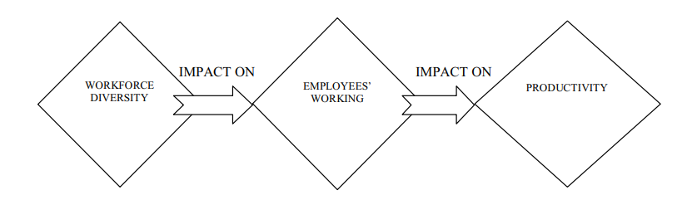
picture 4 Impact of Workforce on Productivity

For example, Huawei is now facing a difficult internationalization process that requires all types of people to deal with obstacles, which cannot be assessed in terms of individual achievements.

When the organization employs human resources of different ages, genders, perceptions, attitudes, castes, religions, and regions, it will become very difficult for management and employees to manage and adapt to this environment. Managing a diverse workforce is a huge challenge for any organization.

5.4 Build psychological contracts with employees
Unlike legal contracts, psychological contracts may be more influential because they describe the perception of the relationship between employer and worker and influence the way people behave on a daily basis. At its core, the psychological contract is built on the daily actions and statements of one party - and how they are perceived and interpreted by the other party. It is intangible in nature, unlike the legal employment contracts signed by employers and workers.(CIPD,2019)
The psychological contract is at the heart of people's performance and engagement at work. The successful management of employee expectations requires professionals to be invested in a broad organizational strategy and to design and implement people management and development practices that support that strategy. Specific areas of focus include. Building an employer brand, creating an effective two-way dialogue between employer and employee, and providing ongoing opportunities for employee skills and career development.

6.0 Reference list
- Charan, R., Barton,D. and Carey D.(2015) ‘People Before Strategy: A
New Role for the CHRO ’,HUMAN RESOURCE MANAGEMENT, July-August.

- CIPD. 2022. Psychological Contract | Factsheets | CIPD. [online] Available at: <https://www.cipd.co.uk/knowledge/fundamentals/relations/employees/psychological-factsheet#gref> [Accessed 20 March 2022].Saxena, A., 2014. Workforce Diversity: A Key to Improve Productivity. Procedia Economics and Finance, 11, pp.76-85.

- huawei. 2022. 公司治理 - 关于华为. [online] Available at: <https://www.huawei.com/cn/corporate-governance> [Accessed 20 March 2022].

- Indeed Career Guide. 2022. Your Guide To Positive Feedback Loops (With Examples) | Indeed.com. [online] Available at: <https://www.indeed.com/career-advice/career-development/positive-feedback-loop> [Accessed 20 March 2022].

- Jiang, R. N.(2021) ‘On the interaction between corporate culture and HUMAN resource management take Huawei and Fang Tai as an example’, Business Culture, No.491.

- Szczepańska K., Kosiorek1 D.(2016) ‘Relationships between organisational culture and human resource management’,Jagiellonian Journal of Management,vol. 2 (2016), no. 3, pp. 205–215.

- S. Asthana, S. Kwatra, C. T. Wolf, P. Chowdhary and T. Nakamura.(2020) ‘Human-in-the-Loop Business Modelling for Emergent External Factors’, IEEE International Conference on Big Data (Big Data),pp.3045-3051.DOI:10.1109/BigData50022.2020.9377743

- Xu, X. D.(2021) ‘Systematic review and review of the research on the impact of esOP on Huawei’, The marketing world, (09).

- Zhao, X. T.(2020) ‘Analysis and Discussion of Huawei's Wolf Culture’, human resource management, (07).

