Student Name: Joyce Gibson Missa

Student ID 2419636

Programme: BSc Health and Social Care

Assignment Title: Component 1: Written
Assignment (Case Study Report)

Lecturer Name: Dr. Robert Nartowski

Module: Introduction to Physiology

Module Code: BMHP5023

Submission deadline: Monday 23rd February
2026

Word count- 2000

Table of content:
1.Introduction…………………………………………………………………………………………
2. Describe the structure of the respiratory system and explain the process of mechanical respiration……………………………………………………………………………………………
3. Briefly explain the process of gas exchange in the lungs, showing how oxygen is absorbed into the blood and carbon dioxide is released into the alveoli……………………………….
4. Explain how increased levels of irritants in the respiratory system leads to swelling om the lung tissue, and the impact of this on respiration…………………………………………………
5. Briefly examine how recording and tracking respiratory functions, such as peak flow readings, helps individuals with asthma to monitor and safely manage their condition…
6. Include evidence-based recommendations on how lifestyle changes could help improve their condition…………………………………………………………………………………………………
7. Conclusion………………………………………………………………………………………………
8. Reference list……………………………………………………………………………………………

Written Assignment (Case Study Report)-
Introduction-
Asthma is an inflammation condition of the airways. It happens when the airways narrow and swell causing chest rigidity, wheezing and shortness of breath. Asthma is a genetic condition, meaning if the parent of a youngster has asthma, the child has a higher chance of having or developing asthma at some point in their life. Allergies such as hay fever can also trigger asthma, this is because the pollen can irritate the airways and cause the flare up of asthma. Another risk factor of Asthma is viral infections, this can be effects such as a common cold, flu or COVID as these infections have an influence on the airways and lungs, it increases the chance of breathlessness which people suffering with Asthma may experience to a higher level requiring their inhaler a lot more during this period as well as requiring their rescue antibiotics from their GP to help get over the symptoms sooner. Obesity is also a common risk factor for people who suffer with Asthma; this is due to the additional pressure on the lungs it can make the symptoms worse and increase the risk of developing Asthma, making it important that a healthy diet and regular exercise is within your day-to-day life.
Respiratory System –
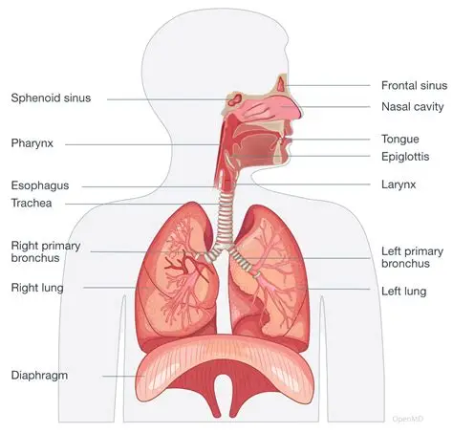

The respiratory system is a system which is responsible for breathing and exchanging gases. As shown in the diagram above, starting with the nose (nasal cavity) when breathing in the nasal cavity filters the air and catches any dust and pollen with the hairs in the nose to stop it travelling down the airways, this is also where dust and pollen is caught by mucus. This is a sticky product in the nose which helps protect the airways. When unwell the mucus can increase and this is when phlegm and ‘runny noses’ occur. The Pharynx passes the air through to the Larynx also known as the voice box, which keeps the airways open for the air to pass through to the Trachea which leads the air into the lungs through the Bronchioles to distribute the air. The Diaphragm is the muscle which when contracts enable breathing to happen as it changes the volume of the lungs allowing you to inhale and exhale pushing out the carbon dioxide from the respiratory system.

Process of Mechanical Respiration-

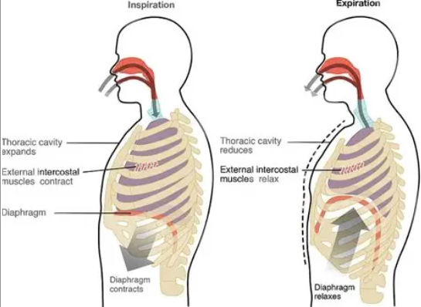

The process of Mechanical Respiration is the way in which we inhale and exhale, this is because of the Diaphragm muscle. When inhaling air, the diaphragm contracts moving down, increasing the volume in the lung for the flow of air to get into the lungs. When exhaling the diaphragm relaxes it causes it to go back in a curved position, reducing the volume in the lungs pushing out the air also known as exhaling. When patients are hospitalized due to breathing difficulties, the hospital may place them on ventilation devices which supply oxygen to the lungs through masks either nasal or over the mouth masks (CPAP machines), force the above process to occur in the lungs. In more severe cases the patient may require a tracheostomy tube into the neck which supplies air through the airways and into the lungs, this is more for patients in the intensive care department of the hospitals sometimes in comas.
Gas exchange in the lungs-
The process of gas exchange in the lungs begins with the respiratory system function as mentioned above. The air travels down the trachea into the bronchi into the bronchioles and into the small sacs in the lungs. Once the air reaches small sacs in the lungs also known as Alveoli, here it defuses the oxygen into the blood through the alveoli walls and binds into the hemoglobin in the red blood cells this is because the oxygen has a higher concentration in the alveoli. This oxygen is then transported all around the body where it is needed. The carbon dioxide known as a waste product is then defused from the red blood cells due to the higher concentration levels which is then defused into the alveoli and pushed out when exhaling out the air as this is not needed within the body.

Increased levels of irritants in the respiratory system-
There are various irritants that can have an impact on the respiratory system, these are things such as pollen, dust and smoke. When entering the respiratory system these factors can irritate the airways and lungs, causing inflammation in the lungs and swelling of the lung tissue. This can also increase the amount of mucus in the airways, which causes you to produce phlegm when coughing. As a result of the swelling the airways narrow, and the Alveoli walls begin to thicken making it harder for the defuse of the oxygen into the red blood cells. With a reduced amount of oxygen going into the red blood cells, breathing can become a lot more difficult, this is where people develop breathlessness which can happen on exertion or if more severe it can affect you when walking short distance such as walking to the bathroom from your bedroom in your home. People who suffer with Asthma may also experience hay fever in the summer months as the pollen can have an impact on their lungs requiring them to take medications such as antihistamines what help to suppress the symptoms of hay fever.
Recording and tracking-
Sometimes individuals with Asthma find it useful to record and track their lung functions through things such as peak flow diary. Peak flow is a test done to measure how fast you can blow out air of your lungs to see the capacity of air held in the lungs. Peak flows can also help with the diagnosis of Asthma for some people as due to Asthma narrowing the airways, when breathing out into the peak flow device it will give a lower score as not as much air is leaving the lungs. These are sometimes recorded down in a paper booklet called a Peak Flow diary which is given to the individual by their GP or Asthma nurse to help monitor the peak flow of a patient. This can help the practitioner to get an understanding of when and why your symptoms are changing, i.e. getting worse and what is triggering them to help the patient to reduce the symptoms they are facing. Knowing this, they will be able to help keep control over their own Asthma by reducing the number of times they have to see their GP for any symptoms. The patient will be able to know when their symptoms are coming on and start their rescue antibiotics to help suppress the infection before it worsens or increase the number of puffs they are taking from their inhaler to help them with the symptoms they are facing. By monitoring the peak flow scores, it can also help to reduce the risk of Asthma attacks from occurring which also helps to reduce the chances of any inpatient stays within the local hospitals. By recording the peak flows, it can also help the GP and nurse to monitor the medication they are on or inhaler they are using. If they are experiencing symptoms more often they GP/ nurse may increase the dosage on their inhaler increase from 1 puff daily to 2 or even trialing other inhalers to see if they help suppress the symptoms or may change the rescue packs that they are taking to strong antibiotics or steroids to help reduce the infection or the risk of it developing anymore leading to hospitalization.
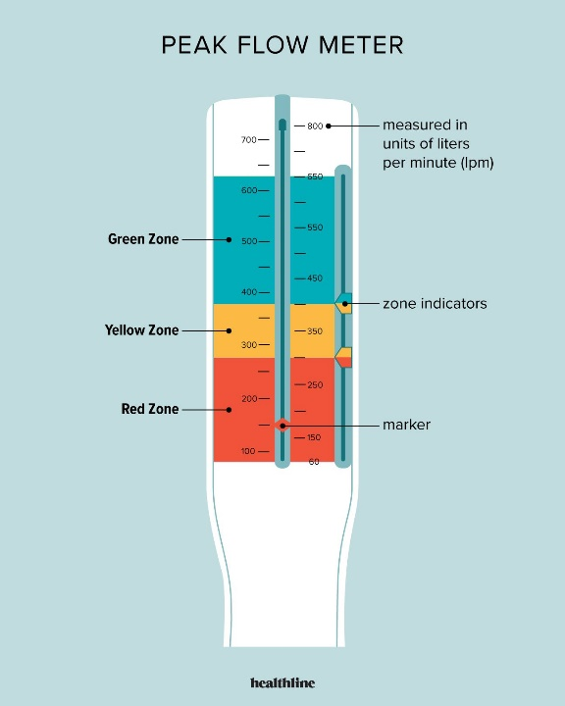
Green Zone- (80-100%) reaching this zone means your breathing is good and no symptoms are being shown. This is usually the zone in which people will reach those who do not suffer with Asthma.
Yellow Zone- (50-79%) caution zone, this is usually a caution that airways are narrowing where symptoms such as wheezing, shortness of breath and coughing may occur, requiring you to take your rescue medication to help suppress these symptoms before they develop further.
Red Zone- (<50%) this is seen as a danger zone, meaning the airways have severe narrowing, and to seek medical attention via the GP emergency or A&E department.

Evidence based recommendations on how lifestyle changes can improve their condition-
There are a variety of different recommendations given to people who suffer with Asthma to help them reduce symptoms or flare ups of Asthma attacks. One of these recommendations is maintaining a healthy weight, this is due to excess weight reducing the expansion of the lungs therefore losing weight can help to reduce the symptoms of breathlessness and help give the patient a better control over their Asthma, this can be through maintaining a healthy diet cutting out any fatty foods and ensuring to eat a five a day. Another recommendation is regular physical activity; by doing regular exercise it helps to strengthen the respiratory muscles. Improving the lung capacity this can be by doing regular exercise it helps the lungs to expand bigger to take in more air producing more oxygen and helping with breathing when doing strenuous activities and helping to keep Asthma under control. An important recommendation is to avoid any triggers. This could reduce the exposure to pollen, pollution and other allergens such as dust ensuring that your house is cleaned of dust mites and you can also buy things such as anti-allergen pillows which can also help to reduce symptoms. It is also important to minimize any smoking of tobacco or vapes as by smoking it can also influence the airways such as tar build up, this will then also narrow the air ways making it a lot harder to breathe, it can also cause a cough which can strain the lungs. Cutting out any smoking can help to reduce the overall risk of any exacerbations or asthma attacks for the patient. Stress can also have an impact on Asthma as stress can have an impact on your breathing technique. It is important to try and reduce stress levels this can be through things such as taking slow walks, breathing techniques or mediating.
Conclusion-
To conclude my case study report on Asthma, I have now been able to show a clear understanding and acknowledgment of the definition of Asthma, the causes of this condition along with having a clearer understanding of the respiratory system and how it works using the multiple different websites that I have referenced below. Within my case study report I have shown clear understanding of Asthma and the implications that it can cause in a patient’s day-to-day life and ways in which you can help reduce these from occurring and reduce the chances of the patient requiring to seek help from medical professionals but to control their asthma on their own.

References-
- 22.4 Gas Exchange – Anatomy & Physiology 2e
- Asthma - Managing Asthma | NHLBI, NIH
- Asthma - NHS
- Asthma - Wikipedia
- Introduction to the Respiratory System
- Mechanics of Breathing - Inspiration - Expiration - TeachMePhysiology
- Obesity-and-Asthma-for-health-care-providers-final-1.pdf
- Peak flow | Asthma + Lung UK
- teachmephysiology.com used Cloudflare to restrict hotlinking | teachmephysiology.com | Cloudflare
- www.artofit.org

