“HOW DO ORGANISATIONAL BELIEFS, ATTITUDES, AND VALUE SYSTEMS AFFECT WORKPLACE BEHAVIOUR? HOW WILL WORKPLACE CHANGES FOR THE POST-COVID BUSINESS ENVIRONMENT TACKLE THE NEW BUSINESS CHALLENGES, AND CREATE MORE RESILIENT BUSINESSES IN FUTURE?”

Name: Andreea Ciorascu
Student No.: 2121532
Module Code: BMSW 5101
Module Title: Developing workplace critical thinking
Lecturer’s Name: Akinseys Aluko

Executive summary
The outbreak of Covid-19 had impacted the organisations, in national, regional and global levels. Turbulence had been noted in the economic structure and the social aspects of the companies. In such a scenario, the integration of change management by the companies had to be asserted, for recovering the same from the disruptive workforce. The study has focused upon the firm of Co-Op or Co-operative Group, and examined the application of the theories of digital transformation and resource based theory. Through such means, the retention of the employees has been seen to increase due to the growth of productivity, and competitive edge can be achieved. Lastly, recommendations for the creation of a more resilient structure and to further improve the corporate working of Co-Op has been jotted down in the report.

Table of Contents
Part 1: Individual Business Report 4
1. Introduction 4
Background of the company of Co-Op 4
2. Key management theories in corporate background of Co-Op 5
Digital transformation theory 5
Resource based theory 6
3. Factors affecting workplace behaviour and creation of more resilient businesses in the future 7
Impact of Digital transformation theory upon organisational beliefs, attitudes, and value systems 8
Integration of Resource based theory for tackling the challenges in post Covid-19 scenario 9
4. Critical evaluation of the theories to examine someone with different point of views 10
In terms of digital transformation theory 10
In terms of resource based theory 10
5. Recommendations for developing resilient businesses in the future 11
6. Conclusion 11
Part 2: Reflective Journal 12
Teaching and learning session from week 1 to week 9 12
Weeks 1-3 12
Weeks 4-6 12
Weeks 7-9 13
Examination of self-skills 14
Strengths 14
Weaknesses 15
References 17
Part A 17
Part B 19

Part 1: Individual Business Report

Introduction
The report introduces the company of Co-Op or Co-operative Group and highlights the different kinds of managerial theories for improving the working perspective of the organisation. Along with such the factors which impact the organisational background would be noted and the impact of the aligning theories to search a corporate perspective would be noted. Critical evaluation of the two specific theories of digital transformation theory and resource based theory would be performed for mentioning the different points of views.

Background of the company of Co-Op
The retail market in the United Kingdom had been greatly affected due to the presence of social restrictions during the Covid-19 scenario. According to the comments by Verhoef et al. (2023), the lack of consumers had caused the decrease in the footfall into the retail stores and hence, the sales volume from the physical stores have been affected. Co-Op had been established in 1863, and had expanded their business in wholesale marketing (Co-operative.coop, 2023). The firm provides the customers with retail items through online deliveries. The firm has also been associated with the provision of insurance, aids in funeral care, and provides legal advice (Co-operative.coop, 2023). With the expansion of the ecommerce business, the company of Co-Op did not have to face such a drastic diminishment in their sales volume.
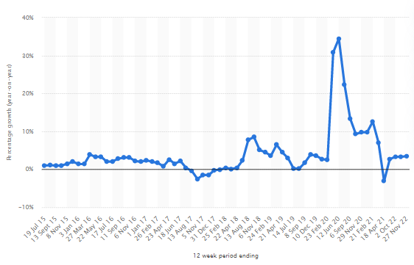
Figure 1: Percentage changes in the volume of sales for Co-Op in the UL from 2015 to 2022
(Source: Statista, 2023)
As noted from figure 1, the volume of sales for the firm had drastically enhanced during the span from February 2020 to September 2020. According to the workings by Gupta and Mukherjee (2022), this was the big time during which the UK had been tremendously affected with the coronavirus. Therefore change management brought into the organisation during the outbreak of Covid-19 had allowed the firm to resurface and provide the consumers with their needs and requirements.

Key management theories in corporate background of Co-Op
Following corporate frameworks, models and theories enable the organisations to keep their work in a streamlined manner, and attain the desired set of goals. According to the suggestions of Ilmudeen and Bao (2020), the two theories which serve to have a positive outcome and help the organisations work in an efficient manner are the digital transformation theory and resource based theory. As per the depictions by Yong et al. (2020), focusing their management and evolving in a periodic manner to fit the needs and the wants of the upcoming market is achieved with the help of corporate theories.

Digital transformation theory
In the case of the Digital transformation theory, the integration of scientific technologies in the organisation aids in the development of accurate working of the employees. As stated by Čirjevskis (2020), through the digital transformation occurring in the organisational background, the improvement of the productivity and the easier accomplishment of jobs can be achieved. In the case of Co-Op, the application of digital transformation theory has enabled the firm to meet the requirements of the consumers over the digital platform.
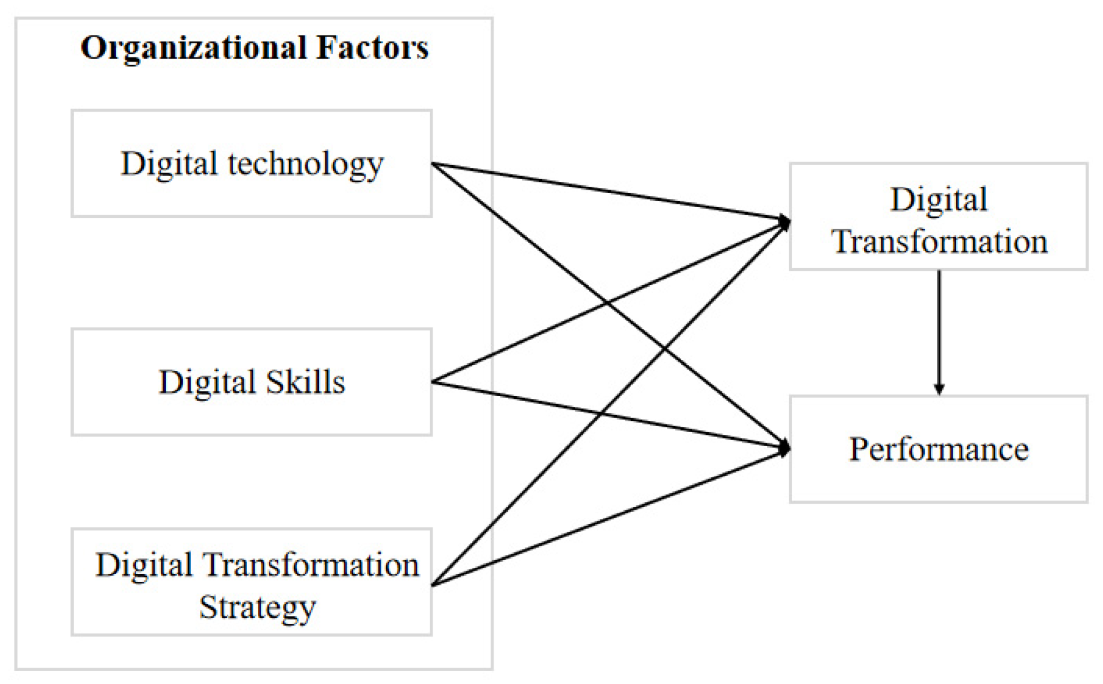
Figure 2: Elements of the digital transformation theory
(Source: Bärsch et al. 2019)
As depicted by Ishfaq et al. (2022), the holistic approach of such a theory has allowed the company to optimise the processes in a streamlined manner, and has focused on the betterment of the customer services. As per the comments by Bärsch et al. (2019), by meeting the demands of the consumers in a swift manner, the firm has enabled the growth in its sales volume and caused the firm to enlighten the employees working remotely. As noted from figure 2, the internal factors of the organisation which enables the company to reach heightened performance through digital transformation is the integration of digital technology, the digital skills of the employees and the correct strategic approach. Co-Op had adjusted their working perspectives over the online platform in such a manner so as to reach their desired outcomes through the integration of such a theoretical base.
According to the views of Papanagnou et al. (2022), in the post Covid scenario the company has requirements to adapt to certain approaches which would help the employees work in a more cohesive manner. From designing wellness related activities within the organisation through the aid of digital means, Co-Op needs to incorporate the strategies and evolve the firm to fit in more human resources related benefits. As per the statements by Pinto et al. (2023), through the integration of such a theory, the organisation would be able to keep in check the performances of the workers and seek out the ones falling behind.

Resource based theory
For Resource based theory, the correct integration of resources is required to be performed by the organisations which would enable them to gain a better competitive advantage over their rivals. According to the thoughts by Nandi et al. (2020), with the help of the theory, the firms are able to segregate their factors into the ones which are valuable, rare, and imitable and helps in the growth of the organisational output. The values of an organisation are restricted to the principles which are to be followed, the rareness comes as per the lack of other rival companies not able to meet the individual factors whereas in the case of imitation, the elements need to have a particular uniqueness. As per the views of Safari and Saleh (2020), once the factors are not rare and easily imitable, the company loses its competitive edge.
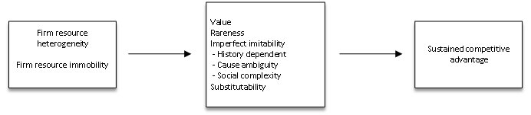
Figure 3: Steps wise performance of Resource based theory
(Source: Safari and Saleh, 2020)
As mentioned in figure 3, the achievement of sustainable competitive advantage can be obtained once the firm produces such goods and services which are valuable, rare, and inimitable and cannot be substituted. In the case of Co-Op, the all-round facilities provided by the firm in terms of retail, funeral services, legal advice and others had enabled it to reach heights, such a versatile approach had not been provided by any other retail firm in the United Kingdom during the Covid-19 scenario, and hence, the sales volume of the firm had rocketed.
In the post-Covid scenario, the application of the resource based theory in the organisation background has enabled the firm to keep in check the different variables which can provide them with the necessary competitive edge. As per the thoughts by Cerruti and Godoski (2020), reshaping the scenario with the help of flexible work timing, the performances of the employees can be drastically enhanced. According to the opinions of Donnellan and Rutledge (2019), once the organisation has the means to provide the same, the flexible working arrangements would help them to maintain a proper work life balance.

Factors affecting workplace behaviour and creation of more resilient businesses in the future
Values, beliefs and attitudes of the organisation needs to be inculcated with the workspace for obtaining the required working culture. In the thoughts and beliefs by Varadarajan (2020), the prevalence of an amalgamated nature of principle with the firm enables it to perform in an efficient manner, meet the demands of the consumers in an ethical way and dissolve any discriminatory effects in the firm. The mission on the goals of the organisation are heavily affected with the kind of leadership qualities present in the respective working culture, and hence, the kind of leaders and managers in the walking background of a company is severely important. As per the suggestions by Nandi et al. (2021), through the integration of digital transformation theory and the resource based theory, the change management in the firm had to be regulated in a strict manner for avoiding a disruptive workforce. Hence, the establishment of organisational beliefs with theories are significantly important to increase retention rate of the workers and grow the mentality of digital change into the firm.

Impact of Digital transformation theory upon organisational beliefs, attitudes, and value systems
The inculcation of change management in a firm can have a negative impact upon the established culture in an organisation. As suggested by AlNuaimi et al. (2022), the employees tend to believe that the acceptance of technology would help them increase their own working proficiency, and develop means to increase their productivity. On the other hand, the perception and the attitude of the workers to growth, by the inculcation of training and development of their skills (Pelletier and Cloutier, 2019). With the aid of the digital transformation theory, the organisational beliefs, as a whole, tends to be propelled in a positive direction as the working adaptability of the human resources are drastically enhanced.
Along with such, the growth of team collaboration is achieved with the aid of digital transformation. In the case of Co-Op, the establishment of the digital communication platform has enabled the workers to communicate with the hierarchy and meet their organisational goals. Therefore, with the aid of digital transformation, the integration of positive communication and an amalgamated working belief has been established into the organisation.
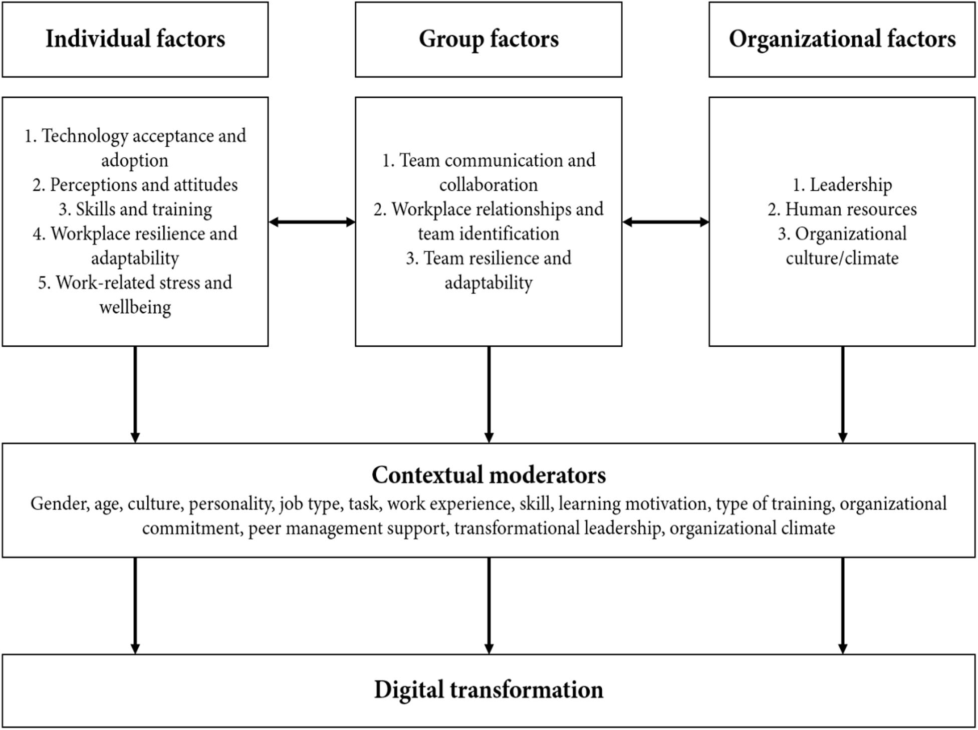
Figure 4: Relation between individual believes, group believes and organisational values for promoting digital transformation
(Source: Imran et al. 2021)
As seen from figure 4, the discrimination of gender, age and personality of the workforce do not impact how the digital transformation is achieved. However, the superior notes of a cohesive working value through such means can be applied into the firms with the aid of digital transformation. As per the notions by Isensee et al. (2020), along with such, the beliefs and the values of the firms can be conveyed thoroughly with the help of the integrated digital platform, in the post-Covid scenario. Working in both internal and external perspective, the spread of the mission and values of the company can reach within the working force, and the external stakeholders (Imran et al. 2021). Therefore, with the help of digital transformation in Co-Op, the spread of a cohesive cultural belief and values can be achieved within the internal and the external environment of Co-Op.

Integration of Resource based theory for tackling the challenges in post Covid-19 scenario
The amalgamation of the working perspectives of the employees in an organisation in the same value system is of vehement importance as it enables the firm to reach their target and goals. As per the opinions of Gupta and Mukherjee (2022), through the identification of the various elements which impact such a belief system, the firm has the ability to mould the working culture and reach the desired heights. In the case of Co-Op, the prevalence of the Resource based theory has enabled the company to meet their aims through the performance of a positive working note. Once the organisation had gained the capability to turn the elements of the culture into one which cannot be imitated, are rare and valuable in nature, the achievement of a collaborative nature within the firm was constructed (Ilmudeen and Bao, 2020).
Along with such, the strengthening of the working force through the elements which cannot be substituted and has a grave impact upon the values of Co-Op, the firm has been able to reach their respective goals. In the post pandemic approach, the inclusion of flexible working hours, the diversification of the nature of work and cutting back the purchase of non‐essential products had enabled the company to bring about a positive growth in the firm. With the prevalence of employee benefits, the firm had been able to hike its rare and valuable resources, for reaching out to the employees and establishing a bonded working culture.

Critical evaluation of the theories to examine someone with different point of views

In terms of digital transformation theory
As opined by Manita et al. (2020), the implementation of the theory of digital transformation has been majorly in respect to the integration of stability within the firm through digital means. However, as commented by Hanelt et al. (2021), digital transformation theory has been linked with the occurrence of disruptive working in a traditional firm, where the employees are not too familiar with the scientific technologies. Hence, the manner in which digital theory is applied in a firm depends largely on how the firm is able to sustain the change management and help the employees become used to the digital management.

In terms of resource based theory
The interpretation of the resource based theory can also be approached in various manners, as per the elements being taken under consideration by the firm. As thought by Freeman et al. (2021), the managerial implications of the resource based theory depends on the elements giving the firm a competitive edge, such as their brand value and brand awareness. However, as dictated by Hynes et al. (2020), the concept of brand perception from the ends of the consumers keep on altering. Hence, there is no fixed manner in which the concepts of resource based theory can be integrated into the background of a firm.

Recommendations for developing resilient businesses in the future
The construction of a resilient business is necessary to keep the firm prevalent in the growing business market. According to the findings by Ivanov (2021), the gain of a competitive edge is important to keep the loyal consumers attached to the firn. Along with such, the diminishment of any sudden change which can impact the company negatively is to be declined. Through the integration of the following recommendations, Co-Op has the ability to keep itself buoyant in the retail market of the UK.
Recommendation 1: Integration of data prediction models in the business
Through the gathering of large amounts of data from the surfing of the digital website of Co-Op, the company has the capacity to sieve the information of each of the users and integrate personal user based experiences. Not only would it enable the firm to provide better customer experience, but also utilise the information to construct data prediction models. In such a manner, the organisation would be able to manage its change and bring in disruption to fit the future trends and market approaches.
Recommendation 2: Integration of disaster recovery efforts through risk analysis
The performance of strict risk analysis is important for the firm to dissolve any unforeseen conditions in the market business. Through the presence of a disaster recovery team in the risk management department, Co-Op would be able to construct a strong and resilient business environment.

Conclusion
Hence, the study highlighted the organisation of Co-Op, UK, and looked into the two major theories of digital transformation theory and resource based theory to have an impact upon the organisation. With the help of the different elements which impact the working culture of Co-Op, the impact laid down by each of the theories have been noted. Along with such, the critical evaluation of the two respective theories, from various viewpoints have been examined, which enables the study to examine the theories from different perspectives. Lastly, recommendations have been noted down in the study to enable the growth of the business of Co-Op in a post pandemic environment, and work in a resilient manner for achieving the desired goals and targets.

Part 2: Reflective Journal

Teaching and learning session from week 1 to week 9

Weeks 1-3
Assessing the business environment of any organisation search to have a majoring pack on how the working culture of the firm would be established. As mentioned by Lu and Wang (2021), in respect to the integration of significant management methods, there can be alterations present in the leadership qualities of the managers. According to the views of Goergen and Tonks (2019), once the corporate structure of the firm is constructed in a strategic manner, the betterment of the working perspectives and the growth of competitive edges in a firm can be noted. From the course, I have been able to expand my concept of leadership practices and how the accurate management of a business structure needs to be. Not only does it enlighten me to gather acute information regarding such aspects, but also improve my critical aspects of thinking.
As depicted by Fenwick et al. (2019), through the establishment of strict goals and targets, a firm has the capacity to meet the demands from the consumers and later their working methods to fit the present market trends. As stated by Dinh and Calabrò (2019), with the presence of such a targeted method of working, the company has the ability to forecast future trends and integrate the required notes for increasing its competitive edge. In such an aspect I do believe that the cohesive working of each of the workers in the company serves to be extremely important. According to the suggestions of Velte (2022), this is due to the fact that without an amalgamated approach, the firm cannot survive in a stable manner. As viewed by Bush (2020), along with such, the retention of the workers is drastically dependent on the presence of a positive working culture. Once the employees feel that their performances are not being valued, they tend to shift. Hence, the construction of a positive workforce through strict checking of the working culture needs to be present in the firm.

Weeks 4-6
From the course, I have been able to understand the different variables which lay a vital impact on the culture of the organisation. According to the opinions of Ding et al. (2019), the attitude of the employees and the mentality with which they work in the firm and achieve the organisation targets make up its culture. As per the depictions by Figueroa et al. (2019), not only does a positive mentality and an attitude of helping others aid the organisation to work in a collaborative manner but also help in establishment of a strong productive output. Such an aspect serves to be an extreme necessity to establish a strong hold over the business market and achieve the top ranking positions. As per the statements by Kamales and Knorr (2019), with the presence of a cohesive working ground, the employees are also able to provide superior quality customer satisfaction. The interests of the stakeholders are met and the firm is able to meet their demands (Sahban, 2019). Therefore, the persistence of a strongly bonded and constructive culture is vehemently important.
In such a perspective, I believe that the course has enabled me to understand the exact importance of such a productive working culture. I believe that the information which I have achieved from the course would be useful for me in future, for establishing a strong foundation in my careerist pathway. It would also help me to understand the significance of an effective leader, who would be responsible for mitigating the issues arising in the working aspects of the firm. From the course, I have also learnt about the importance of strong managers, and characteristics which one needs to possess for turning out to be a pragmatic leader.

Weeks 7-9
I do trust that I will be able to mould myself and turn out to be an effective leader. One of the major features which an operative leader needs to contain is the ability to motivate the subordinates and co-workers. I would like to inculcate such a vital quality into myself and gain the capacity to bring about a positive notch into my future workplace. Not only would it allow me to expand my own professional horizon, but also aid me to grow myself as a supportive human being. Through the course, I have also gained the ability to delve into the various kinds of corporate strategies and the theories which help the growth of a firm in a positive direction. By understanding the basic principle of different frameworks and corporate theories, I have been able to superficially assess the relating factors which helps an organisation to sustain itself.
Along with such, from the models and theories, I have also gained the understanding of different barriers and shortcomings which can be of hindrance during the establishment of a strong workforce. According to the findings by Bush et al. (2019), factors such as the disruptive working community and the absence of diversity have been seen to impact the presence of a collaborative taskforce. As per the depictions by Aggarwal et al. (2019), in such a scenario, the orders and the strategies of the team to achieve the organisational targets have crumbled. Hence, the dissolving of such factors needs to be present in the firm, which can be achieved by a strong leader.
According to the comments by Samul (2020), the streamlined working of a firm has been noted to be both due to the presence of a strong leader, and a creative workforce. On the other hand, as stated by Podsakoff and Podsakoff (2019), several elements such as the feedback from the managers and the integration of digital transformation has enabled a firm to reach its potential. The former factor has been related to the growth of productivity of the employees due to the continuous performance check and the motivation from the leaders (Contreras et al. 2020). The latter factor relates to the heightening of work productivity with the aid from scientific technologies. As per the notions by Fenwick et al. (2019), once the employees are able to lessen their human errors and finish the tasks in a superior quality, the expansion of their own motivation occurs. As from the course, I have been able to look into the significance of such factors for the gaining of a strong organisational output. Therefore, the course within week 1 to week 9 has grown my knowledge regarding the management practices and allowed me to inculcate information relating to both my professional and personal growth.

Examination of self-skills
Understanding the positives and negatives of oneself is important for working upon the skill set. Through the identification of the reflective journal, a learner gains the capacity to not only improve oneself for the professional grounds, but also grow as a better person. According to the suggestions of Nguyen et al. (2019), from the reflective learning journal, the jotting down of the pros and the cons in the skill set of a learning can occur. In this case, the segregation of the skills into strengths and weaknesses can be performed for knowing about the skills which are to be enhanced and the ones which are to be worked upon. As depicted by Jaiswal et al. (2020), self-development of any pupil can be highlighted through the construction of a reflective journal, which would be important for growing as an all-round person.

Strengths
From studying the course, I have been able to note down the fact that one of the major strengths which I have within myself is a streamlined manner of decision making. Jotting down the tasks, looking into the necessary resources and establishing a deadline has enabled me to decide upon the tasks to be completed. Along with such, the concept of decision making has also enabled me to inculcate the strength of time management. Through the presence of decision making, I have been able to gather a large amount of information in relation to the course, and also gone through different reference books for looking into different points of views of the authors. In a similar manner, decision making has helped me to look for other alternative strategies when a particular one does not work.
Such an aspect has helped me to gain a better overview of different concepts and theories, and also pen down my own opinions. The important skill of time management has been extremely important for helping me finish off my tasks in due time. Once I am able to complete my tasks within the stringent deadlines, I feel less stressed out, and I am able to function in a smooth and framed manner. Along with such, I have established a better work and life balance. As I do not have to invest a large amount of time in my educational perspective, I can have a significant amount of time for my family and friends. Hence, through such a segregated work and life balance, I feel emotionally calm and collected. In such a manner, I do believe that I can function in a more proficient manner and help achieve my goals and targets.
Another vital skill which I believe is a positive of mine is the notion of innovative thinking and creativity. I trust that the inoculation of innovation in any perspective is important for not only looking at a particular chore from different viewpoints, but also accomplishing the same from different directions. When a particular way is not substantial in reaching the goal, the changing of the direction and working in a creative manner would enable a learner to fulfil the task. With the concept of innovation, I have gained the capacity to look into a particular aspect from different angles, and choose the one I am comfortable with. In the course of the module, I have expressed my own points of views for the management and corporate theories, which I believe is only feasible when a student has varying degrees of thought processes.
Therefore, with the inculcation of different strengths in my skill set, I think that I have the capacity to meet the needs and the demands of both my educational, personal and my future professional lives. With the betterment and polishing the strengths, one can further work upon oneself and reach the destination in a streamlined manner.

Weaknesses
Understanding the weaknesses and acknowledging the same is also important for the development of one’s character. In my belief, one of the major shortcomings which I possess is the lack of leadership qualities. From studying the course, I have been able to examine the necessity of having a strong leadership skill. In the thoughts and beliefs by Jensen et al. (2019), not only does the persistence of an effective leader help the workers to meet the organisational goals, but also enable them to reach their personal targets. Hence, the integration of the leadership skills is necessary for the individuals to reach their superior goals.
Through the establishment of such leadership notes, I would be able to meet the requirements of the firm and further impact the working environment in a positive manner. Through such a skill, I would also be able to deploy correct measures to my co-workers and help them to accomplish their objectives from the firm. Hence, through the integration of such an important skill, I believe that I would be able to expand upon my own skill set.
Along with such, another lack which I feel is present in my qualities is the absence of an effective communication skill. It has been observed that the integration of smooth communication is extremely necessary for the tasks in an organisation to proceed in a fluent manner. Without the correct collaboration between the workers, and the management, the disruption of the workforce occurs, which hampers the quality of the jobs. Along with such, miscommunication produces tasks with inferior criteria, and the overall output of the firm declines. Hence, the presence of communication skills would be extremely important for me to improve my overall skills for my professional life.

References

Part A
AlNuaimi, B.K., Singh, S.K., Ren, S., Budhwar, P. and Vorobyev, D., 2022. Mastering digital transformation: The nexus between leadership, agility, and digital strategy. Journal of Business Research, 145, pp.636-648.
Bärsch, S., Bollweg, L., Lackes, R., Siepermann, M., Weber, P. and Wulfhorst, V., 2019. Local shopping platforms–harnessing locational advantages for the digital transformation of local retail outlets: a content analysis.
Cerruti, K and Godoski, L. 2020. "Five Post-COVID Behaviors(sic) and Attitudes that will Reshape the Workplace" in Work design Magazine [Online] Available: https://www.workdesign.com/2020/06/five-post-covid-behaviors-and-attitudes-that-will-reshapethe-workplace/
Čirjevskis, A., 2020. Do Synergies Pop up Magically in Digital Transformation-Based Retail M&A? Valuing Synergies with Real Options Application. Journal of Open Innovation: Technology, Market, and Complexity, 6(1), p.18.
Co-operative.coop. 2023. Co-op history. Co-operative.coop. Available at: https://www.co-operative.coop/about-us/history [Accessed on 9th April 2023]
Donnellan, J. and Rutledge, W.L., 2019. A case for resource‐based view and competitive advantage in banking. Managerial and Decision Economics, 40(6), pp.728-737.
Freeman, R.E., Dmytriyev, S.D. and Phillips, R.A., 2021. Stakeholder theory and the resource-based view of the firm. Journal of Management, 47(7), pp.1757-1770.
Gupta, A.S. and Mukherjee, J., 2022. Decoding revenge buying in retail: role of psychological reactance and perceived stress. International Journal of Retail & Distribution Management, (ahead-of-print).
Hanelt, A., Bohnsack, R., Marz, D. and Antunes Marante, C., 2021. A systematic review of the literature on digital transformation: Insights and implications for strategy and organizational change. Journal of Management Studies, 58(5), pp.1159-1197.
Hynes, W., Trump, B., Love, P. and Linkov, I., 2020. Bouncing forward: a resilience approach to dealing with COVID-19 and future systemic shocks. Environment Systems and Decisions, 40, pp.174-184.
Ilmudeen, A. and Bao, Y., 2020. IT strategy and business strategy mediate the effect of managing IT on firm performance: empirical analysis. Journal of Enterprise Information Management, 33(6), pp.1357-1378.
Imran, F., Shahzad, K., Butt, A. and Kantola, J., 2021. Digital transformation of industrial organizations: Toward an integrated framework. Journal of change management, 21(4), pp.451-479.
Isensee, C., Teuteberg, F., Griese, K.M. and Topi, C., 2020. The relationship between organizational culture, sustainability, and digitalization in SMEs: A systematic review. Journal of Cleaner Production, 275, p.122944.
Ishfaq, R., Davis‐Sramek, B. and Gibson, B., 2022. Digital supply chains in omnichannel retail: A conceptual framework. Journal of Business Logistics, 43(2), pp.169-188.
Ivanov, D., 2021. Digital supply chain management and technology to enhance resilience by building and using end-to-end visibility during the COVID-19 pandemic. IEEE Transactions on Engineering Management.
Manita, R., Elommal, N., Baudier, P. and Hikkerova, L., 2020. The digital transformation of external audit and its impact on corporate governance. Technological Forecasting and Social Change, 150, p.119751.
Nandi, M.L., Nandi, S., Moya, H. and Kaynak, H., 2020. Blockchain technology-enabled supply chain systems and supply chain performance: a resource-based view. Supply Chain Management: An International Journal, 25(6), pp.841-862.
Nandi, S., Sarkis, J., Hervani, A. and Helms, M., 2021. Do blockchain and circular economy practices improve post COVID-19 supply chains? A resource-based and resource dependence perspective. Industrial Management & Data Systems, 121(2), pp.333-363.
Papanagnou, C., Seiler, A., Spanaki, K., Papadopoulos, T. and Bourlakis, M., 2022. Data-driven digital transformation for emergency situations: The case of the UK retail sector. International Journal of Production Economics, 250, p.108628.
Pelletier, C. and Cloutier, L.M., 2019. Conceptualising digital transformation in SMEs: an ecosystemic perspective. Journal of Small Business and Enterprise Development.
Pinto, M.R., Salume, P.K., Barbosa, M.W. and de Sousa, P.R., 2023. The path to digital maturity: A cluster analysis of the retail industry in an emerging economy. Technology in Society, 72, p.102191.
Safari, A. and Saleh, A.S., 2020. Key determinants of SMEs’ export performance: a resource-based view and contingency theory approach using potential mediators. Journal of Business & Industrial Marketing, 35(4), pp.635-654.
Statista. 2023. Percentage change in sales at the Co-operative in Great Britain compared to a year earlier from July 2015 to November 2022. Statista. Available at: https://www.statista.com/statistics/603363/the-cooperative-sales-percentage-change-great-britain-uk/ [Accessed on 9th April 2023]
Varadarajan, R., 2020. Customer information resources advantage, marketing strategy and business performance: A market resources based view. Industrial Marketing Management, 89, pp.89-97.
Verhoef, P.C., Noordhoff, C.S. and Sloot, L., 2023. Reflections and predictions on effects of COVID-19 pandemic on retailing. Journal of Service Management, 34(2), pp.274-293.
Yong, J.Y., Yusliza, M.Y., Ramayah, T., Chiappetta Jabbour, C.J., Sehnem, S. and Mani, V., 2020. Pathways towards sustainability in manufacturing organizations: Empirical evidence on the role of green human resource management. Business Strategy and the Environment, 29(1), pp.212-228.

Part B
Aggarwal, R., Schloetzer, J.D. and Williamson, R., 2019. Do corporate governance mandates impact long-term firm value and governance culture?. Journal of Corporate Finance, 59, pp.202-217.
Bush, T., 2020. Theories of educational leadership and management. Theories of Educational Leadership and Management, pp.1-208.
Bush, T., Middlewood, D. and Bell, L., 2019. Principles of educational leadership & management. Principles of Educational Leadership & Management, pp.1-408.
Contreras, F., Baykal, E. and Abid, G., 2020. E-leadership and teleworking in times of COVID-19 and beyond: What we know and where do we go. Frontiers in psychology, 11, p.590271.
Ding, W., Choi, E. and Aoyama, A., 2019. Relational study of wise (phronetic) leadership, knowledge management capability, and innovation performance. Asia Pacific Management Review, 24(4), pp.310-317.
Dinh, T.Q. and Calabrò, A., 2019. Asian family firms through corporate governance and institutions: A systematic review of the literature and agenda for future research. International Journal of Management Reviews, 21(1), pp.50-75.
Fenwick, M., McCahery, J.A. and Vermeulen, E.P., 2019. The end of ‘corporate’governance: Hello ‘platform’governance. European Business Organization Law Review, 20, pp.171-199.
Figueroa, C.A., Harrison, R., Chauhan, A. and Meyer, L., 2019. Priorities and challenges for health leadership and workforce management globally: a rapid review. BMC health services research, 19(1), pp.1-11.
Goergen, M. and Tonks, I., 2019. Introduction to special issue on sustainable corporate governance. British Journal of Management, 30(1), pp.3-9.
Jaiswal, A., Babu, A.R., Zadeh, M.Z., Banerjee, D. and Makedon, F., 2020. A survey on contrastive self-supervised learning. Technologies, 9(1), p.2.
Jensen, U.T., Andersen, L.B. and Jacobsen, C.B., 2019. Only when we agree! How value congruence moderates the impact of goal‐oriented leadership on public service motivation. Public Administration Review, 79(1), pp.12-24.
Kamales, N. and Knorr, H., 2019. Leaders with managing cultural diversity and communication. Asia Pacific Journal of Religions and Cultures, 3(1), pp.63-72.
Lu, J. and Wang, J., 2021. Corporate governance, law, culture, environmental performance and CSR disclosure: A global perspective. Journal of International Financial Markets, Institutions and Money, 70, p.101264.
Nguyen, D.T., Mummadi, C.K., Ngo, T.P.N., Nguyen, T.H.P., Beggel, L. and Brox, T., 2019. Self: Learning to filter noisy labels with self-ensembling. arXiv preprint arXiv:1910.01842.
Podsakoff, P.M. and Podsakoff, N.P., 2019. Experimental designs in management and leadership research: Strengths, limitations, and recommendations for improving publishability. The Leadership Quarterly, 30(1), pp.11-33.
Sahban, M.A., 2019. The transformational leadership, knowledge management and perceived organizational support in predicting innovation capability. Polish Journal of Management Studies, 20.
Samul, J., 2020. The research topics of leadership: Bibliometric analysis from 1923 to 2019. International Journal of Educational Leadership and Management, pp.116-143.
Simpson, M.K., 2019. Powerful leadership through coaching: Principles, practices, and tools for leaders and managers at every level. John Wiley & Sons.
Velte, P., 2022. Meta-analyses on corporate social responsibility (CSR): a literature review. Management Review Quarterly, 72(3), pp.627-675.

