Assignment Title: Component 2 (ACCA4019):
Written assessment: Problem Analysis and Solution Development

Student Name: Fatima Bandali

Student ID: 2520390

Table of Contents
1. Introduction 4
2. Problem Deconstruction 4
2.1 Overview of the Problem 4
2.2 Breaking the Problem into Smaller Components 5
2.3 Requirements According to the MoSCoW Methodology 5
2.4 Constraints 6
2.5 Key Variables 7
2.6 Conclusion on the Problem 8
3. Proposed Solution and Explanation 8
3.1 Proposed Solution Overview 8
3.2 Logical Scheduling Process 8
Step 1: Collect Availability 9
Step 2: Verification of Submitted Information 9
Step 3: Comparison of Individual Timetables 9
Step 4: Verify Weekly Deadline 9
Step 5: Select the Best Meeting Time 9
Step 6: Send Confirmation of the Meeting 10
Step 7: Conflict Resolution 10
Step 8: Conduct Meeting 10
3.3 Flowchart 11
3.4 Decision Points within the Solution 12
Decision Point 1: Is Availability Complete? 12
Decision Point 2: Is Common Free Time Available? 12
Decision Point 3: Does the Meeting Occur Before the Deadline? 12
Decision Point 4: Has Attendance Been Confirmed? 12
3.5 Assumptions Made 12
3.6 How the Solution Meets the Assignment Objectives 13
4. Reflection and Justification 14
4.1 Reflection on the Problem-Solving Techniques Used 14
4.2 Justification of the Proposed Solution 14
4.3 Limitations of the Solution 14
5. Conclusion 15
6. References 16

Optimising Group Meeting Scheduling for College Computing Students

Introduction
The use of group projects is common in higher education as they aid in developing students' teamwork skills and ability to communicate and solve problems. In most cases, organizing meetings between group members is difficult since they will have varying class schedules, part-time jobs, domestic obligations, and many other activities. This could lead to reduced collaboration, imbalance in workload distribution, poor decision-making processes, and delays in submission of the project. As such, it becomes necessary to establish an organized schedule in order to foster teamwork and enable meeting of the deadline.
This report examines the issue of coordinating meetings among members of a class on computing in a college setting and devising a solution to it through structured problem solving. The problem is broken down into component parts through requirements, constraints, and variables using the MoSCoW prioritization technique. This is followed by a solution presented in form of a flowchart and explanations thereof. Finally, this report gives an evaluation of the problem-solving techniques utilized, their effectiveness, and the scope for improvement in the future.

Problem Deconstruction

2.1 Overview of the Problem
The problem involves the difficulties that arise when trying to organize regular meetings for group assignments. The schedules of all the team members tend to differ because each of them attends classes, works, participates in out-of-school activities, and has personal obligations. Due to all the differences, it is becoming more and more difficult to choose an appropriate time for meeting.
Some problems which could be encountered through poor scheduling include postponement of the meeting, delaying of some critical decisions, ineffective communication among the team members, and some students doing most of the work [1]. In the end, this will definitely affect the final outcome of the project and academic performance as well.
In terms of problem solving, the scheduling problem can be looked at as a resource allocation problem where there is a need for optimal allocation of time to a number of people under several constraints.

2.2 Breaking the Problem into Smaller Components

Abstract thinking requires any complex problem to be broken down into smaller components before designing solutions. Rather than look at “meeting scheduling” as one big problem, we can decompose it into various components.
The main elements consist of:
- Gathering each student’s availability for each week.
- Determining unavailable time due to lectures or working.
- Analysing the schedules of all group members.
- Looking for common available time.
- Ensuring that meetings do not take place prior to the submission deadline.
- Choosing the most suitable time.
- Ensuring presence of all group members.
- Modifying the schedule in case of any disputes.
Breaking the problem down into such subtasks considerably simplifies the process of scheduling and allows automating it. In other words, each subtask becomes a separate element of the final solution [2].

2.3 Requirements According to the MoSCoW Methodology
MoSCoW prioritization methodology determines the level of requirement importance.
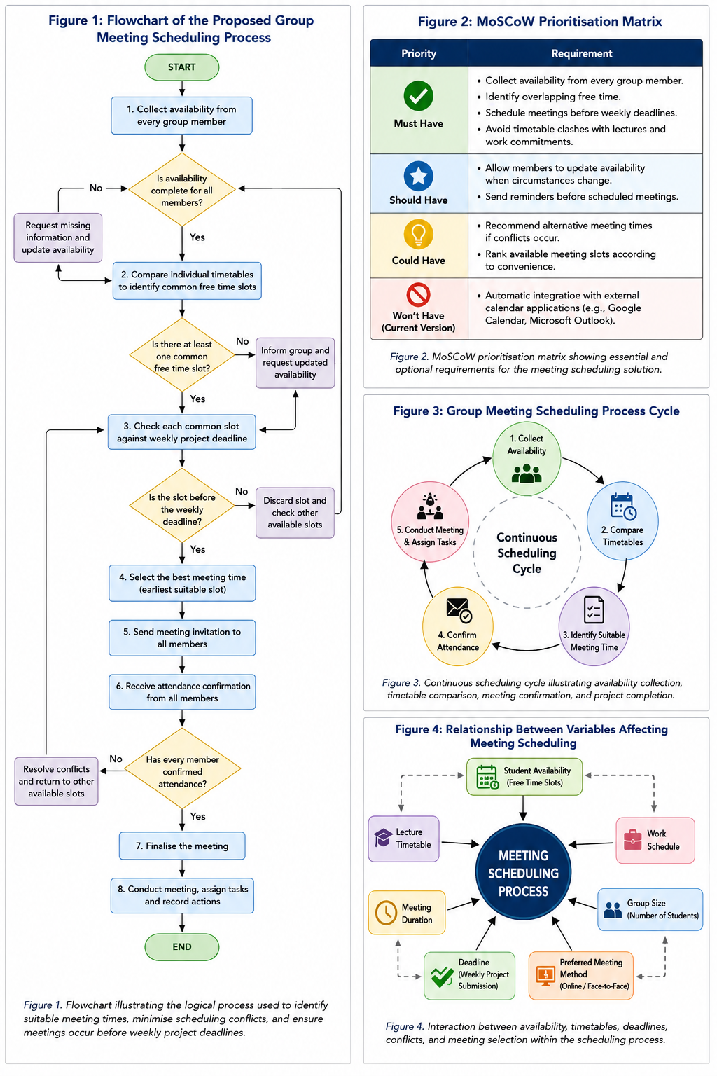
Figure 1: MoSCoW prioritisation matrix

Through the use of the MoSCoW technique, the core features are guaranteed to take precedence in the development of solutions whereas the rest are optional.

2.4 Constraints
- A number of constraints affect the process of scheduling.
- Time constraints dictate that meetings need to be concluded before the deadline for weekly projects.
- Availability constraints result from the fact that all the students have varying schedules.
- Constraints are experienced through the lack of availability of rooms or online platforms where meetings are scheduled.
- Constraints may arise due to failure to update the availability details by the students.
- Illness, family matters, examination periods, and unforeseen incidents are personal constraints.
- The solution must perform well within these constraints.

2.5 Key Variables
Some factors will have direct effects on the scheduling process.
Table 1: Key Variables
Variable | Description
Number of students | Total members within the project group
Student availability | Free time submitted by each member
Lecture timetable | Academic commitments
Work schedule | Part-time employment hours
Weekly deadline | Final date before project submission
Meeting duration | Length of each meeting
Preferred meeting method | Online or face-to-face
Attendance confirmation | Acceptance or rejection of proposed meeting

They are the data necessary for the scheduling process. By analysing them in detail, appropriate meeting times can be determined while minimizing any possible conflict.
Figure 2: Interaction between availability, timetables, deadlines, conflicts, and meeting selection within the scheduling process.

2.6 Conclusion on the Problem
The problem of scheduling arises due to the conflicting commitments of the students. After breaking down the problem into smaller components, identifying the needs according to the MoSCoW technique, understanding the constraints in operation, and identifying the variables, the basis for the scheduling solution has been laid. The next part provides a solution strategy that will help in achieving efficient meeting schedules along with meeting the deadline for the projects [3].

Proposed Solution and Explanation

3.1 Proposed Solution Overview
The solution for this problem is based on a proper scheduling process which analyzes the availability of all the group members prior to choosing the best time for meetings. Instead of planning meetings via frequent communication, the suggested solution consists of a logical chain of actions which will minimize conflicts and guarantee that the meetings are held prior to weekly deadlines of projects.
Scheduling starts with gathering the availability information for all members of the project team. The schedules provided are matched up to see what time is convenient for all the members. In case several options become available, the most appropriate one just before the project deadline is chosen. If there is no available time that works for everyone, the other time periods are analyzed until a satisfactory choice is made [1].
This structure brings fairness as all the schedules of members are taken into consideration during the decision-making process. It also minimizes communication delays that may arise and brings effective management of projects [3].

3.2 Logical Scheduling Process
The following is the order for solving the scheduling problem.

Step 1: Collect Availability
Every individual provides his/her weekly schedules, which include:
- Lecture schedules
- Part-time job schedules
- Commitments
- Meeting preference (either online or physical)
These are the input data used by the scheduling program [4].

Step 2: Verification of Submitted Information
Availability of the submitted timetables is verified.
In case of incomplete information, the student is asked to revise their availability before proceeding with scheduling.
It ensures that there will be no wrong decisions made during scheduling.

Step 3: Comparison of Individual Timetables
Availability of each group member is compared.
The system finds out intervals when all the students are free at once.
This comparison can be called the most crucial step of scheduling as it rules out all the inappropriate time intervals immediately.

Step 4: Verify Weekly Deadline
All the possible meeting times will be considered relative to the deadline of the week.
All meetings scheduled beyond the deadline will not be considered.
Late meetings are automatically excluded.

Step 5: Select the Best Meeting Time
In case of availability of several possible meeting times, the selection depends on the following criteria:
- Earliest possible meeting time
- Greatest availability of members
- Least amount of time table clashes
- Meeting duration
- Student preferences wherever possible
Choosing the earliest possible meeting time gives extra time to complete project work after the meeting.

Step 6: Send Confirmation of the Meeting
The chosen meeting time is informed to all the members.
All members confirm their participation in the meeting.
The confirmation will help in making sure that the proposed meeting time is realistic.

Step 7: Conflict Resolution
In case one or some of the members fail to attend, the scheduling process goes back to the list of other suitable times.
Other alternatives are considered until the right meeting time is found.

Step 8: Conduct Meeting
The meeting is conducted before the deadline of the project.
Tasks are distributed equally to all members.
Progress is documented for use in future meetings.

3.3 Flowchart
Figure 3: Flowchart of the Proposed Group Meeting Scheduling Process
The flowchart starts by gathering availability data from each project member and revising any incomplete information. When all data are gathered, the timetables are then compared to find common available times, thus minimizing any schedule clashes. Each available time is reviewed against the deadline set per week and any inappropriate time discarded. If there are a number of appropriate times, the earliest time is chosen for the meeting. Invitations are extended and attendance is confirmed. In case there are any clashes, the flowchart goes back to choosing alternate times rather than starting from scratch. The meeting is held, assignments are made, and the project progress tracked.

3.4 Decision Points within the Solution
A number of decision points affect the successful completion of the scheduling process.

Decision Point 1: Is Availability Complete?
If all the students have provided availability, then the scheduling process continues.
In any other case, more data should be collected.

Decision Point 2: Is Common Free Time Available?
If there is overlap between availabilities, then the appropriate time slots are analyzed.
If there is no such overlap, then some other schedule should be found [5].

Decision Point 3: Does the Meeting Occur Before the Deadline?
Only those meetings which are scheduled ahead of the project deadline will be accepted.
In any other case, some other time slot should be considered.

Decision Point 4: Has Attendance Been Confirmed?
If all participants have confirmed their attendance, then the meeting takes place.
Otherwise, some other meeting time slot is considered.

3.5 Assumptions Made
There are several assumptions that have been made throughout the solution development.
- Each and every student makes their availability information correct.
- Timetable of each week remains almost similar.
- Students will be checking communication channels on regular basis.
- Internet connection is available for virtual meetings.
- Sufficient time is allotted to discuss project activities.
- Every individual participates honestly in the scheduling process.
These assumptions make the whole scheduling procedure easier.

3.6 How the Solution Meets the Assignment Objectives
The above-described scheduling system fulfills all the goals through determination of common availability, minimization of timetable clashes, and making sure that meetings take place prior to deadlines for the week. It is a structured system that promotes communication, maintains workloads, facilitates collaboration, and provides a flexible scheduling process that can be implemented for any group project at institutes.
Figure 4 : Continuous scheduling cycle

Reflection and Justification

4.1 Reflection on the Problem-Solving Techniques Used
The suggested meeting scheduling method has been developed employing problem solving methodologies to solve the problem of meeting scheduling and formulate a logical solution. Abstract thinking has been employed to focus on all the critical factors associated with the process of scheduling which include student availability, timetable constraints, meeting time and deadlines, without taking into consideration any other unnecessary aspects. Decomposition has been applied by breaking the problem into several smaller tasks like gathering availability, comparing timetables, finding common free hours, checking deadlines, confirming attendance and dealing with conflict [6].
Logic was employed in developing decision points to ensure that there had been collection of data on availability, common time for meetings, deadlines met, and attendances confirmed. Systems thinking understood that timetable, communication, attendances, and deadlines were all interrelated, while the MoSCoW prioritisation technique helped in separating the important scheduling elements from the desirable ones in the future [7].

4.2 Justification of the Proposed Solution

The solution meets the requirements of the task since it suggests appropriate meeting times, avoids conflicts in the timetables, and ensures that the meetings happen before the deadlines of the projects. It is more just than other informal solutions, since all students' availability gets equal consideration. Besides, the flowchart can be easily interpreted and used either in spreadsheet applications or scheduling software [5].

4.3 Limitations of the Solution
The suggested solution is based on availability data and is unable to anticipate any unpredicted issues, like illnesses and emergencies. It will become increasingly difficult to schedule meetings as the number of students grows. Additionally, the procedure calls for manually inputting data and has no connection with digital calendars. Some future enhancements may include AI-based scheduling, automatic synchronization of calendars, and optimization algorithms [8].

Conclusion
Good scheduling has been seen to contribute greatly towards the successful completion of collaborative academic assignments. In this case study, the problem of scheduling of meetings for computing students in college has been examined. In doing so, it was illustrated how good problem solving skills could be employed to formulate an adequate solution for the problem at hand. Firstly, the problem has been broken down into smaller components. Furthermore, the critical requirements for the solution have been determined via MoSCoW method, while the relevant variables in the problem have also been identified. In order to solve the problem, a solution that is based on flowcharts has been provided in order to schedule meetings efficiently and avoid timetable conflicts. In addition, the reflection of the process has shown the importance of abstraction, decomposition, logic and systems thinking in formulation of a systematic solution to the problem. Despite the existence of certain limitations, the suggested solution creates a solid base for further expansion by the use of automation and intelligent scheduling technologies. Thus, group work will become more efficient and chances for success will increase.

References
[1] I. Sommerville, “Software Engineering”. 10th ed. Harlow, UK: Pearson, 2016.
[2] K. Schwaber and J. Sutherland, “The Scrum Guide: The Definitive Guide to Scrum: The Rules of the Game”. Scrum.org, 2020.
[3] Project Management Institute, “A Guide to the Project Management Body of Knowledge (PMBOK® Guide)”. 7th ed. Newtown Square, PA, USA: PMI, 2021.
[4] I. Jacobson, G. Booch, and J. Rumbaugh, “The Unified Software Development Process”. Boston, MA, USA: Addison-Wesley, 1999.
[5] T. Ruas, W. I. Grosky, “Software Engineering: A Practitioner's Approach”. 9th ed. New York, NY, USA: McGraw-Hill, 2020.
[6] M. Wooldridge, “An Introduction to MultiAgent Systems”. 2nd ed. Chichester, UK: Wiley, 2009.
[7] J. Rumbaugh, I. Jacobson, and G. Booch, “The Unified Modeling Language Reference Manual”. 2nd ed. Boston, MA, USA: Addison-Wesley, 2005.
[8] G. Polya, “How to Solve It: A New Aspect of Mathematical Method”. 2nd ed. Princeton, NJ, USA: Princeton University Press, 2004.

