
Samuel Veres - 1818847
Module Title: LCBB4004 Markenting fundamentals
Assignment Title: Assignment 2
Module Lecturer’s Name: Tushara Baladran

Contents
Introduction 3
Part A 4
Processes and stages of marketing including the role of the marketing mix 4
The role of marketing in creating value for customers 5
Stakeholder engagement and their impact on the marketing activities of an organization 7
Part B 9
Marketing Promotion 9
Reflection 10
References 11

Introduction
Marketing is one of the crucial process of management to identify, anticipate and satisfy the customer’s requirement properly to generate profit from different business activities. It is one of the most important function of the business organization to ensure better management and communication process among the organization and customers (Burns, 1994). Here the assignment is focused on understanding the processes and stages of marketing to by performing the roles of the marketing mix and how they can create value for the customers from a product or service. It also try to explore the stakeholder’s engagement and their impact on marketing activities of an organization. Overall the report will try to explain the crucial sectors of marketing management and provide better understanding about the marketing related activities.

Part A

Processes and stages of marketing including the role of the marketing mix
The marketing process and stages of marketing consists of four elements. They are: Strategic marketing analysis, Marketing-mix planning, Marketing implementation, and Marketing control.
- Strategic marketing analysis: Strategic marketing analysis is the combination of the process of market segmentation, targeting and positioning of the brand. It is one of crucial way to perform to ensure better strategic marketing analysis for the organization.
- Market segments: The aim of marketing is to meet needs of the customers and try to satisfy them. Here the organization try to find out their suitable segments by dividing the market in small groups (Burns, 1994). Here the organizations focus on find out the best suitable market segment group to fulfill their needs and demands by offering their desired products and services by their marketing and business activities.
- Find out target customers group: From many small subgroups a company identify their suitable customers group and research about their detailed needs and demands they want to fulfill. Based on their attitude, behavior, personality and other such factors target segment group is selected and company start to work on their requirements fulfillment and design proper marketing and other activities from them (Chartered Institute Of Marketing, 2012).
- Positioning: A key step in marketing strategy is creating and communicating marketing messages with their target customers and position the brand on their mind uniquely. It will enhance the reputation and the good will of the brand and also keep their marketing activities increases with the demand of the customers.
- Marketing mix planning: For developing a proper marketing mix planning it is necessary to ensure the better management of the marketing mix use and their implementation. Here the use and implementation of the marketing mix elements given below:
- Product: First of all it is important to ensure better product development process to enable efficient management of the organization to fulfill the requirements of the customers. The products features, benefits and branding is so crucial to maintain for attraction the targeted customer group and ensure sales and after sales service for the customers (Chartered Institute Of Marketing, 2012).
- Price: The price of the products and services need to be decided based on the competitiveness of the existing competitors and their same or similar product pricing. The customers will approve the price based on the value of the products they are getting from it. So the pricing strategy can play a very crucial role in the overall marketing mix process.
- Place: It is necessary to ensure better transportation and distribution facility for the product and services. It will make sure that the customers can have the product conveniently without facing any hassle (Garbarski, 2014). The retail and distribution channel need to strong and active to get the best market for the offered goods.
- Promotion: Promotion is another important marketing mix because without effective and efficient promotion process it is impossible to reach the target customers at maximum level. It depends on the quality or type of the product or services how the organization will use their promotion strategies in the better sales of the goods and services.
- Marketing Implementation: Companies need to take help in the development of advertising, sales promotion etc. to reach maximum number of customers. All the work all together can create lack of coordination between elements of the promotion mix. When components are not aligned and in harmony, confusion can be created among the customers (Garbarski, 2014). So to ensure better marketing activities implementation it is necessary to coordinate all the activities and implement them properly.
- Marketing Control: Every market is changing constantly. So to ensure the proper implementation and development of the marketing strategy they need to be evaluated time to time and also review the marketing program periodically for achieving its objectives in the long term business.

The role of marketing in creating value for customers
Marketing is the group of activities of an organizations which help it to understand, reach, and deliver value to their customers by offering different kinds of products and services according tot their customer’s needs and demands (Grönroos, 1993). It is the core responsibility of the marketing to understand the needs and demands of the market and offer something according to their desires to fulfill their needs and generate profit out of them. In a very simple form, value is the measure of the benefit acquired from a product or services relative to its price. Without the value of the products or services it is not possible to attract the customers to buy something and fulfill their needs. The value always need to be higher than customer’s expectation to delight them with great products or services. Here is the process of marketing by which the value for the customers can be created.
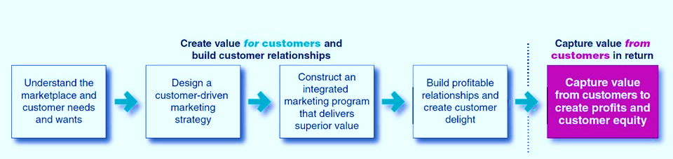
Figure: Creating value for the customers (Grönroos, 1993)
- Understand the marketplace and the customers’ requirements: For creating value of a product and service it is important to understand the condition of the market. It is important to analyze and research on the market trends to know about the customers mind. What a customers want in a product or service, how they want to use it, which benefits are important for them etc. are very necessary questions to understand by the marketers. From the overall analysis marketers get idea about the need, want and demands of the customers and focus on planning their desired products or services (Nijssen, 2011).
- Design a customer driven marketing strategy: Then the organization need to concentrate on designing customers driven marketing strategy. All the related information and ideas will be coming from the marketing research and analysis conducted by the organization. They need to focus on the market segments and divide them into subgroups to get ideas about their preferences and requirements and after finalizing the target group of the organization they need to focus on the marketing strategy to attract them to the specific products and services.
- Construct an integrated marketing program and deliver superior value: Organizations then need to focus on their integrated marketing programs such as advertising, billboards, social media marketing, and selling agents by using direct or indirect involvement of the customers. The customer’s need to get attracted by their offered products and services (Nijssen, 2011). Marketing programs involve the customers and take their feedback from different kinds of marketing activities. It provides the superior value for the customers by offering superior products and services.
- Build profitable relationship and provide them delighted services: For each and every organization it is important to build profitable relationship with the customers and provide them delighted services to increase their expectation and demand from the organization. It is also very important to maintain close relationship with the customers to maintain intimate and friendly relationship to increase the time length and closeness with the loyal customers. It is also helpful to create value of the products and services. The fulfillment of needs and demands of the customers make them feel important, precious and delighted as well.
- Capture value from the customers to create profits: Finally it is important to capture value from the customers to know about their desires and expectation for improving the quality of the products and services marketed by the company. The information will help the organization to understand the expectations and work according to that (Pride et al., 2018). The value of the product and services will be increased and profits will be generated more from the sales of the organization.
By performing all of the above activities it is possible to increase the value of the product and services and enrich the satisfaction level of the customers in future and create a loyal base on customers group for increasing profitability.

Stakeholder engagement and their impact on the marketing activities of an organization
Stakeholders are the people or the parties who can affect organization's actions, objectives and policies by their activities. They are the most important people of any organization to run their business smoothly and in a profitable way. The key stakeholders are known as creditors, directors, employees, government or government agencies, shareholders suppliers, working unions, community etc. All of the parties or individuals are directly or indirectly related to the business organization and the organization plays close attention to their action and reaction and their overall engagement towards the company to understand their impact over the business (Pride et al., 2018).
Stakeholders can make a company successful or lead to failure depending on their actions. They are the most powerful people to operate a business. There are many marketing activities and business functions depends on their actions and promotions. Stakeholders can influence the company’s profitability, business activities, marketing functions and buying habits of the customers. The efficient management of the stakeholders can provide a company competitive advantage over their other competitors (Rosenbloom, 1976). It is difficult to beat a company in the marketplace if they have a strong base on the stakeholders with them. They are the prime supporters of the organization and also company try to increase value for their stakeholders by creating exclusive and special value for their customers through their products or services.
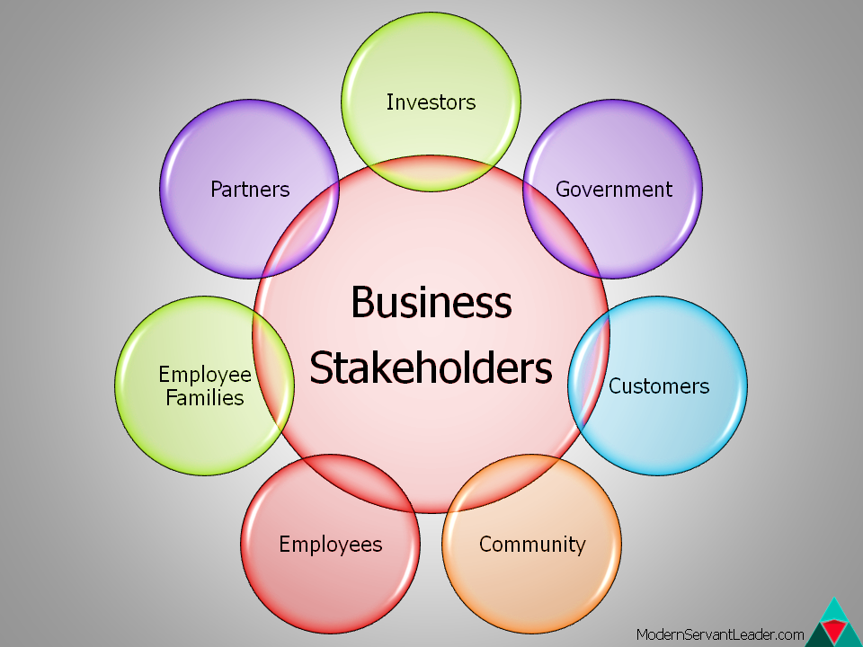
Figure: Business Stakeholders (Rosenbloom, 1976)
Stakeholders can get involved with the marketing activities such as design, implementation and evaluation of the marketing functions. As the overall functions of the marketing focused on maximizing the benefits of the stakeholders, it is their responsibility to promote and support the marketing activities of their concerned brand and make the activities successful among the customers. The engagement of the stakeholders can bring benefits for the organization and their marketing activities from very beginning. They can impact on the marketing activities in following ways:
- Increase the reach of the marketing: By the activities and direct influence of the stakeholders it is possible to reach maximum number of customers to inform about the product and services. They can promote and influence the promotion activities of the products and also suggest their reference group for using that which increase the reach of the marketing activities.
- Increase sales: By the direct involvement of the stakeholders it is possible to increase close relationship with the customers and create a close bond with them. Customers starts to believe them and build up a relation of faith and delivering promises in the long run. The marketing activities get aligned with their business policies and it is possible to increase sales of a products and services by involving the stakeholders directly in their marketing promotion activities (Srivastava, 2012).
- Improve the goodwill: The association of some bigshot stakeholders can make the business flourish their activities locally and globally. It improves their good will among the customer’s from the good will and reputation of the stakeholders. They can easily trust and believe a brand for the reputation of the stakeholders.
- Access to better resources: For the help of the stakeholders it is possible to get better and continuous access of the resources needed for the marketing activities. It is also helpful to design and implement the marketing activities of any organization by maintain better and efficient relationship with the stakeholders (Srivastava, 2012). They work as the asset of the organization to make their marketing activities acceptable and known to all of their target customer group.
Moreover, it is very important for any of the business organization to use their connection and stakeholders for their organizational betterment.

Part B

Marketing Promotion
The main idea of the promotion of any products or services refers to the marketing activities designed and developed by marketing team of companies to aware people about the brand and increase their interest and attraction to the specific products or services (Yudelson, 2008). Here offers or even campaigns design for the target market customers of the company inform about the brand, their offered good along with their features and benefits generated from them. In other way it is a way of establishing interaction or communication with the target customers directly or indirectly to make them aware about the products or services for fulfilling their own requirements or generate their needs through the promotional activities. There are many different ways to promote products or service. But it is necessary to understand the target customers and based on their features find out the appropriate and suitable promotional activities for them (Ulf Elg, 2012). It was the main theme of the blog post and try to explain the importance of the promotional activities for the companies through McDonalds. Here hot McDonald’s conduct their promotional activities among their target customers to increase their interest and attract them towards the brand to enjoy their preferred foods. They preferred to use some strategies such as catch phrases or toys in Happy Meal to make their customers interested to try out their products. It was their approaches of attracting customers to try their food brand to meet up their hunger and they become successful in their business promotional activity. It is also said that the brand use sponsorship and different advertising approaches to attract their customers to try their fast-food and satisfy their hunger. McDonald’s also try to maintain close bonding with their customers by providing exclusive offers and services compared to their other competitors of the market. They provide discounts for ordering through McDonald’s app and try to increase customer’s engagement by the overall process (Yudelson, 2008). They also promote seasonal offers for the families, children’s and couples time to time.

Reflection
McDonald’s is a very renowned and well-known brand among the people. It is one of the giant fast food brand famous for their new, attractive and innovative promotional approaches. This is why I have choose to demonstrate the blog post and work with the brand. Unlike the brand, I also have some new and innovative idea for the brand to make their promotional activities more attractive and interesting by using new advertisements with the use of catch phrases, fun, colors and interesting storyline associated with the foods. They have a very well reputation among their customers base which does not require much problem to know about the company and gather information about them. It was really fun to work with and research about the brand and collect information. Overall I enjoyed by work with McDonald’s brand and their promotional activities and hope to learn more about the brand in future.

References
- Burns, A. (1994). Review of Applying Marketing Principles. Marketing Education Review, 4(2), pp.62–63.
- Chartered Institute Of Marketing (2012). The marketing planning process ; Delivering customer value through marketing ; Managing marketing, and ; Project management in marketing. London: Bpp Learning Media Ltd.
- Garbarski, L. (2014). Creating Value for the Organization through Marketing. Management and Business Administration. Central Europe, 22(4), pp.60–69.
- Grönroos, C. (1993). From marketing mix to relationship marketing : toward a paradigm shift in marketing. Helsingfors: Swedish School Of Economics And Business Administration.
- Nijssen, E.J. and Frambach, R.T. (2011). Creating customer value through strategic marketing planning : a management approach. New York ; London: Springer.
- Pride, W.M., Ferrell, O.C., Lukas, B.A., Schembri, S., Outi Niininen and Riza Casidy (2018). Marketing principles. South Melbourne, Vic. Cengage.
- Rosenbloom, B. (1976). The Trade Area Mix and Retailing Mix: A Retail Strategy Matrix. Journal of Marketing, 40(4), p.58.
- Srivastava, R. (2012). Shift of Marketing Mix to E-Marketing Mix: The Birth to New Era. SSRN Electronic Journal.
- Ulf Elg, Amjad Hadjikhani and Ghauri, P.N. (2012). Business, society and politics : multinationals in emerging markets. Bingley: Emerald.
- Yudelson, J. (2008). Marketing green building services : strategies for success. Oxford: Elsevier/Architectural Press.

