

Enhancing Road Safety Through Machine Learning Using Data Analytics.

NAME: AJAY SUNIL
STUDENT NO: 2406774
LECTURER: SEENA JOSEPH
Table of Contents
1.Introduction 3
1.1 Context and background 3
1.2 Research Problem 4
1.3 Research Aim and Objectives 4
1.4 Significance of the research 5
2.Literature Review 5
2.1 Introduction to the Literature Review 5
2.2 Thematic Organization of Literature 6
2.3 Predictive Analytics for Road Safety 6
2.4Visualization Techniques for Traffic Accident Data. 6
2.5 Key Contributions and Gaps. 7
2.6 Theoretical and Technical Frameworks 8
2.6 Relation to This Study 10
2.7 Literature Summary 11
3. Research Design and Methodology 12
3.1 Research Design 12
3.2 Research Methods and Materials 12
4. Expected Outcomes 16
4.1 Anticipated Results 16
4.2 Implications 16
4.3 Limitations 17
5.Timeline. 18
6. References. 18

1.Introduction
Road traffic accidents remain one of the leading causes of injury and death worldwide. As cities continue to expand and traffic becomes increasingly dense, the demand for smarter, data-driven approaches to road safety grows ever more urgent. While governments and researchers have begun leveraging data analytics to better understand accident patterns, an often-overlooked aspect is the manner in which this information is presented to stakeholders [1], [2].
Effective data visualization has the potential to transform raw statistics into clear, actionable insights highlighting high-risk locations, identifying time-based trends, and supporting strategic planning. Conversely, poor design in data presentation can lead to confusion, misinterpretation, and ultimately pose serious risks to public safety [2], [3].
This research aims to explore patterns in road accident data and evaluate the impact of various visualization techniques using tools such as Tableau and Power BI [3], [5]. The primary objective is to identify and recommend best practices for designing clear, user-friendly visualizations that facilitate informed decision-making by traffic authorities, policymakers, and the general public [4].

1.1 Context and background
Road traffic accidents are a persistent global issue, resulting in substantial human and economic losses. As urban areas continue to expand and transportation systems grow increasingly complex, managing road safety demands smarter, data-driven approaches. In recent years, technologies such as Data Mining, Machine Learning, and Big Data Analytics have been widely adopted to analyse accident patterns, predict high-risk zones, and support evidence-based decision-making [1], [2].
Visualization tools like Tableau and Power BI enable researchers and analysts to transform complex datasets into accessible visual formats, assisting policymakers and traffic authorities in interpreting trends and making informed decisions [5], [6]. Despite progress in data collection and computational analysis, the design and effectiveness of visual representations of accident data often receive insufficient attention. Poorly constructed visuals can obscure crucial safety insights, ultimately diminishing their practical utility.
Improving the clarity, simplicity, and usability of data visualizations is therefore essential. Doing so ensures that critical information is communicated effectively, which in turn supports the development of more informed and proactive road safety strategies [5], [7].

1.2 Research Problem
Although data analytics and machine learning have significantly improved the ability to predict and analyse traffic accidents, the clarity and usability of accident data visualizations remain underexplored.
Most existing research emphasizes technical performance—such as model accuracy, spatial mapping precision, or data processing efficiency [1], [3], [4]—but gives limited attention to how effectively these findings are communicated to non-expert users [5], [6].
Poorly designed visualizations can confuse or overwhelm audiences, making it difficult for traffic authorities, policymakers, or the public to extract meaningful insights. Important patterns may be hidden behind complicated dashboards, poor chart selections, or unoptimized visual layouts.
This communication gap reduces the practical value of otherwise powerful analytics.
Given the increasing complexity of traffic datasets and the critical role of data-driven decision-making in road safety, there is a strong need to systematically evaluate visualization techniques.
By focusing on factors such as simplicity, clarity, accuracy, and visual appeal, this research will seek to improve how accident data is presented, helping ensure that insights lead to actionable safety interventions [5], [7].

1.3 Research Aim and Objectives
Aim.
The aim of this research is to enhance the communication of road traffic accident insights by evaluating and improving the effectiveness of data visualization techniques.
Objectives.
- To collect, preprocess, and explore traffic accident datasets using exploratory data analysis (EDA) techniques to support visualization development.
- To design and evaluate different types of accident data visualizations using structured criteria such as clarity, simplicity, and accuracy.
- To identify effective visualization practices and propose guidelines for presenting road accident data in a clear, accessible, and decision-supportive manner.

1.4 Significance of the research
The significance of this research lies in addressing a critical gap between the complex analysis of traffic data and its practical communication to stakeholders. While advancements in Machine Learning, Big Data Analytics, and visualization technologies have significantly improved the ability to understand and predict traffic accidents [1], [2], the effectiveness of how these insights are presented often remains limited or unclear [5], [6].
By focusing on evaluating and improving the design of traffic accident data visualizations, this study offers both theoretical and practical contributions. Theoretically, it proposes a structured framework for assessing the clarity, simplicity, and accuracy of visual outputs—an area that remains underexplored within the broader context of road safety research [7].
Practically, the research findings will assist traffic authorities, urban planners, and public safety agencies in developing dashboards and reports that are more intuitive, engaging, and informative. Enhanced visualization practices will promote faster and more informed decision-making, elevate public awareness of traffic safety risks, and inform the development of more targeted safety interventions.
Ultimately, improving the communication of traffic accident data through well-designed visualizations has the potential to create safer roads, reduce the number of accidents, and save lives [5], [7].

2.Literature Review

2.1 Introduction to the Literature Review
The purpose of this literature review is to critically examine the existing body of research related to road traffic accident analysis and visualization. The review aims to identify key trends, arguments, techniques, and gaps that inform the direction of this study. It focuses primarily on studies conducted within the last five to seven years, covering subfields such as predictive analytics for traffic accidents, GIS-based spatial hotspot analysis, and the use of big data visualization platforms like Tableau and Power BI for traffic safety enhancement. A systematic review of such methods has been documented by Clarinval and Dumas [10]. The literature is organized thematically, grouping studies by their main research focus to provide a coherent analysis relevant to this project.

2.2 Thematic Organization of Literature
To provide a structured and coherent overview of the existing research, the literature is organized into two primary themes:
- Predictive Analytics for Road Safety.
- Visualization Techniques for Traffic Accident Data.
This thematic division facilitates a clear understanding of how researchers have approached traffic accident analysis, the tools and methods employed, and where significant gaps remain—particularly concerning the evaluation of visualization clarity and usability. The studies reviewed span the last five to seven years, ensuring a focus on the most recent developments in the field of traffic safety analytics and visualization practices.

2.3 Predictive Analytics for Road Safety
Several studies have explored machine learning and data mining techniques to predict traffic accident severity and occurrence. Goswami et al. (2022) applied Decision Tree and Random Forest algorithms to traffic accident datasets to predict accident severity [1]. Their work demonstrated that machine learning models can effectively classify accidents based on environmental, temporal, and road-related factors, thereby enhancing the ability to forecast high-risk conditions.
Similarly, Chen and Chang (2024) emphasized the use of Big Data Analytics for improving traffic accident prediction [2]. By integrating variables such as traffic flow, weather conditions, and road infrastructure data, they developed predictive frameworks capable of providing real-time accident risk assessments. This approach supports road safety initiatives through predictive modeling and geospatial visualization [8].
The RFCNN model has also proven effective for predicting accident severity using decision-level fusion techniques, combining machine learning and deep learning outputs [9].
While these studies represent significant advancements in predictive capabilities, they placed limited emphasis on the visualization of results for end-user comprehension—a gap this research seeks to address.

2.4Visualization Techniques for Traffic Accident Data.
Recent research emphasizes the importance of visualizing traffic accident data through interactive dashboards and dynamic reporting tools. Saranya et al. (2023) developed a Power BI dashboard to visualize traffic collisions in Chennai, offering real-time filtering capabilities based on location, time, and accident type [5]. Similarly, Yang et al. (2023) utilized Tableau to display traffic violation data and link it to accident occurrences, enabling users to explore the information through multiple interactive views [6]. Dashboard visualizations are also essential in analyzing accident hotspots, as demonstrated by Chien et al. [12].
A systematic review of intra-city traffic visualization strategies can be found in the work of Clarinval and Dumas [10]. A visual analytics framework for understanding urban traffic accident patterns was proposed by Prasanna et al. [13].
While these studies successfully demonstrated the practical application of modern visualization platforms, they did not conduct systematic evaluations of visualization clarity, simplicity, or user engagement. This gap highlights the need for further research into optimizing visualization design to ensure maximum impact and usability.

2.5 Key Contributions and Gaps.
Key Contributions.
- Advances in Predictive Analytics:
Research efforts by Goswami et al. (2022) and Chen and Chang (2024) have demonstrated that machine learning models—particularly Decision Trees and Random Forests—can effectively classify accident severity and predict accident risks based on a range of factors [1], [2]. These contributions have significantly enhanced the capacity to anticipate accidents and understand risk patterns within complex traffic environments.
- Integration of Big Data in Traffic Safety Analysis:
The incorporation of big data techniques into accident prediction models, including dynamic factors such as weather conditions and traffic flow, has enabled more accurate and real-time forecasting. These developments have laid the foundation for smarter traffic management systems and proactive safety interventions.
- Application of Visualization Tools:
Studies by Saranya et al. (2023) and Yang et al. (2023) have illustrated that platforms like Power BI and Tableau can convert static accident datasets into dynamic, interactive dashboards [5], [6]. Their work underscores the potential of visual analytics to make traffic accident data more accessible, interpretable, and actionable for stakeholders.

Key Gaps.
Lack of Systematic Visualization Evaluation:
Although modern tools such as Tableau and Power BI are increasingly employed in traffic safety analytics, existing studies rarely assess the effectiveness of these visualizations using structured criteria such as clarity, simplicity, accuracy, or user engagement. There is a notable absence of established frameworks for objectively evaluating whether a visualization genuinely enhances understanding for decision-makers and the general public.
Limited Research on Best Practices for Accident Data Visualization:
Few studies offer concrete guidelines or evidence-based recommendations for designing traffic accident visualizations that adhere to human-centered principles. Consequently, many visual outputs, while technically accurate, may appear visually overwhelming, unclear, or poorly aligned with the ways users naturally interpret information.
Neglect of Human-Centered Design and Cognitive Load Considerations:
Current research in traffic safety visualization rarely incorporates insights from cognitive psychology or human-computer interaction. Critical factors—such as cognitive load, color perception, layout efficiency, and optimal chart selection—are often overlooked, potentially reducing the effectiveness and usability of accident reporting dashboards.
Gap Between Technical Innovation and Practical Communication:
Despite impressive advancements in predictive modeling and data analysis, a gap persists in effectively translating technical findings into intuitive, accessible communication for non-technical stakeholders. This disconnect can hinder the implementation of data-driven decisions in real-world traffic safety contexts.

2.6 Theoretical and Technical Frameworks
The current body of research on traffic accident data analysis and visualization largely operates within a data-driven decision-making framework. This model emphasizes the systematic collection, analysis, and interpretation of empirical data to support strategic decisions aimed at improving road safety outcomes. While significant progress has been made in predictive analytics and the development of dashboard technologies, there remains a notable lack of integration of theoretical models related to human cognition and visual communication. This gap limits the effectiveness of visualizations in conveying insights to diverse audiences—a limitation that this study specifically seeks to address.

Theoretical Frameworks
- Data-Driven Decision-Making Model:
Most reviewed studies, including those by Goswami et al. (2022) and Chen and Chang (2024), adopt a data-driven approach where traffic accident data is analyzed to inform policies and safety interventions [1], [2]. The assumption underlying this model is that more accurate and comprehensive data analysis directly leads to better decision-making by authorities and planners.
- Need for Human-Centered Design Theory:
Despite the focus on data accuracy and predictive modeling, there is minimal application of human-centered design principles in traffic safety visualization research. Cognitive load theory, which explains how excessive information can overwhelm a user's mental processing capabilities, is largely absent from existing studies. Integrating such theories could help ensure that accident data visualizations are not only informative but also intuitive and accessible, minimizing confusion and cognitive strain on users.
- Importance of Visual Perception and Information Processing Theories:
Principles from cognitive psychology and human-computer interaction — such as Gestalt laws of organization (proximity, similarity, continuity) — offer valuable guidelines for improving the design of charts, graphs, and dashboards. Proper application of these principles can significantly enhance users' ability to quickly grasp essential patterns and insights from visualized traffic accident data.
Technical Frameworks
- Machine Learning Algorithms:
Decision Trees and Random Forests have been extensively used for accident severity analysis and prediction [1], [2]. These models allow researchers to identify complex patterns in large datasets that would be difficult to detect through traditional statistical methods.
- Big Data Analytics Integration:
Incorporating dynamic variables such as weather conditions, time of day, traffic density, and road types into predictive models demonstrates the evolution towards big data approaches in traffic safety analysis.
- Visualization Platforms:
Tools like Power BI and Tableau have transformed how accident data is communicated by allowing users to interactively filter, explore, and interpret accident patterns through dashboards and reports [5], [6]. Their capacity for dynamic visualization and real-time updates offers significant advantages over static data presentation formats.
- Data Preparation Tools:
Data cleaning and preprocessing, often performed through Microsoft Excel and Python libraries (e.g., Pandas, Matplotlib), play a critical role in ensuring the accuracy, consistency, and usability of datasets before visualization development.

2.6 Relation to This Study
The review of existing literature highlights a growing focus on applying predictive analytics and visualization platforms to the field of traffic safety analysis. Studies by Goswami et al. (2022) and Chen and Chang (2024) have advanced the use of machine learning models for accident prediction [1], [2], while Saranya et al. (2023) and Yang et al. (2023) demonstrated the practical application of visualization tools like Power BI and Tableau for presenting accident data [5], [6].
However, despite these technological advances, a critical gap remains: the effectiveness of the visualizations themselves has not been systematically evaluated. A systematic review of intra-city traffic visualization strategies confirms this gap in evaluation approaches [10].
Current studies typically focus on either:
• Predicting accident severity and risk, or
• Developing dashboards to present raw data,
but they rarely assess how well these visualizations communicate crucial safety insights to end users such as policymakers, traffic engineers, or the general public.
A visual analytics framework for understanding urban traffic accident patterns was proposed by Prasanna et al. [13], but human-centered evaluation of dashboard clarity and usability remains limited in the broader literature.
This research positions itself uniquely within this landscape. Rather than developing new predictive models or merely creating dashboards, the study will:
• Analyse existing accident data,
• Design multiple visualization formats (e.g., heatmaps, bar charts, time-series graphs), and
• Evaluate these visualizations systematically based on structured criteria including clarity, simplicity, accuracy, and visual appeal.
By conducting a structured self-assessment using human-centered evaluation principles, this study aims to bridge the gap between technical data analysis and effective communication. Moreover, the study will develop a practical set of guidelines for designing clear, accessible, and impactful traffic accident visualizations. These guidelines will offer direct value to practitioners seeking to enhance public safety communication and will contribute to the academic literature by proposing a new approach to assessing visualization quality in the field of traffic accident analysis.
Ultimately, this research will not only broaden the academic understanding of traffic safety visualization but also provide actionable solutions to enhance the way accident data is presented and understood.

2.7 Literature Summary
The review of current research reveals substantial progress in traffic accident analysis through the application of predictive analytics and data visualization tools. Studies such as those by Goswami et al. (2022) and Chen and Chang (2024) have demonstrated that machine learning models can effectively predict accident severity and risk using a variety of contextual factors [1], [2]. Concurrently, Saranya et al. (2023) and Yang et al. (2023) have shown that platforms like Power BI and Tableau can present traffic data in interactive formats that support dynamic exploration and decision-making [5], [6].
Despite these advances, a critical gap remains: the effectiveness of visualizations—particularly in terms of clarity, simplicity, and user understanding—is rarely evaluated systematically. Most studies assume that visualizing data inherently improves comprehension, yet there is limited empirical evidence supporting this assumption. Furthermore, few studies incorporate principles from human-centered design, cognitive load theory, or visual communication frameworks, resulting in visualizations that may be technically rich but practically ineffective for real-world users such as traffic planners or policymakers.
This research is uniquely positioned to address these issues by focusing on three key objectives:
1. Collecting and preparing traffic accident datasets,
2. Designing and evaluating different visualization types, and
3. Identifying effective practices for presenting accident data in a clear and actionable way.
By conducting a structured evaluation of visualizations based on usability criteria, this study will not only contribute to academic theory but also provide practical design guidance for stakeholders involved in road safety initiatives. In summary, while traffic accident analytics has advanced considerably, the communication of those insights through well-designed, user-focused visualizations remains underdeveloped. This research seeks to bridge that gap by ensuring that visualized accident data serves as an effective tool for real-world decision-making and public safety.

3. Research Design and Methodology

3.1 Research Design

3.2 Research Methods and Materials
This study will adopt a Design Science Research (DSR) approach. Design Science Research is an appropriate methodology because it focuses on the creation and evaluation of artifacts intended to solve real-world problems. In this case, the artifact will be a set of data visualization designs and best practice recommendations aimed at improving how road accident data is communicated.
Rather than only analysing existing data or theories, DSR emphasizes building something new—in this study, multiple visualization models using Tableau and Power BI—and systematically evaluating their effectiveness. This method will align closely with the research aim of enhancing road safety communication by developing, testing, and refining visualization techniques based on structured evaluation criteria.
By iteratively designing and assessing visualizations for clarity, simplicity, and accuracy, the DSR approach will support both practical innovation and academic rigor, making it the most suitable choice for this project. A similar artifact-driven visualization approach was demonstrated by Prasanna et al. in their urban traffic pattern recognition framework [13].

Methods.
Research Method:
This research will follow a quantitative approach. Quantitative methods are appropriate because the project will deal with structured traffic accident datasets (containing variables like date, time, location, severity) and will evaluate visualization effectiveness through measurable criteria such as clarity, simplicity, and accuracy.
Research Strategy:
The project will use a case study strategy, focusing on real-world traffic accident datasets (e.g., the UK Department for Transport Road Accident Data). A case study will allow for in-depth exploration of accident patterns and visualization performance within a specific context. This strategy is appropriate because it provides the flexibility to deeply analyze a single dataset while allowing multiple visualization approaches to be designed, compared, and evaluated systematically.
Architecture or System Design:
The system design will consist of three core phases aligned with the research objectives:
Research Onion.

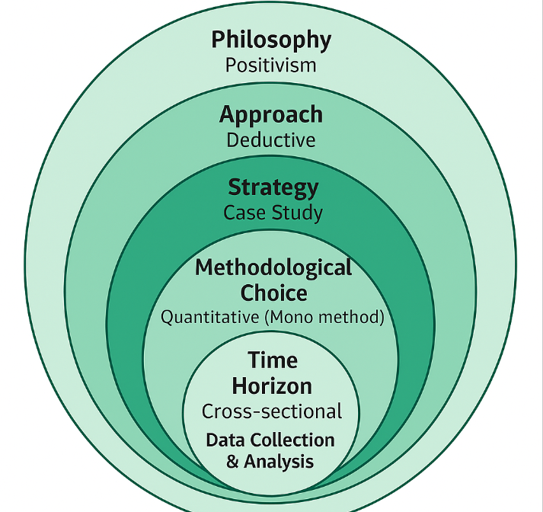
Data Preparation and Exploratory Analysis Phase:
- Collect, clean, and preprocess traffic accident data using Microsoft Excel and Python (pandas’ library).
- Perform Exploratory Data Analysis (EDA) to uncover trends, patterns, and anomalies in accident data (e.g., frequency over time, accident severity, contributing factors, and location-based patterns).
- EDA results will inform decisions about the types of visualizations most suitable for different data insights.
Visualization Development Phase:
- Create multiple types of visualizations (e.g., heatmaps, bar charts, line graphs, dashboards) using Tableau and Power BI, guided by insights identified through EDA
- Visualizations will be designed to emphasize clarity, simplicity, and interpretability.

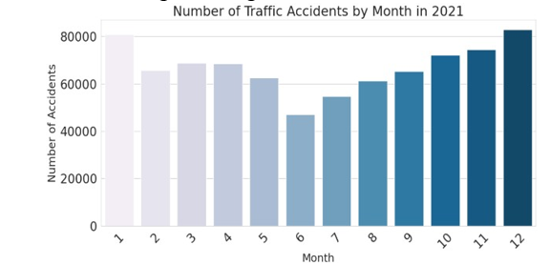
Figure 1 [1]

Evaluation Phase:
- Conduct a structured self-evaluation of each visualization using an evaluation checklist based on established design principles: clarity, simplicity, accuracy, and visual appeal.
Data Analysis and Evaluation Methods:
- Descriptive and Exploratory Analysis:
- Conduct both descriptive statistics and EDA to summarize accident data, identify trends, and explore variable relationships prior to visualization.
- Visualization Comparison:
Develop and compare multiple visualization types to determine which formats most effectively communicate key accident patterns.
- Self-Assessment Framework:
Evaluate each visualization using a structured rubric based on the following criteria:
• Clarity: Is the message immediately understandable.
• Simplicity: Is unnecessary complexity avoided.
• Accuracy: Are accident patterns represented truthfully.
• Visual Appeal: Is the design clean, accessible, and visually engaging.
Materials.
- Research Data:
- Data Source:
- Primary: UK Department for Transport "Reported Road Accidents Data" (publicly available).
- Supplementary: If necessary, additional open datasets from other countries.
- Data Collection Method:
- Downloading structured accident datasets from official government websites.
- Data cleaning will be performed manually using Excel and programmatically using Python.
- Justification:
The chosen datasets will be:
- Publicly available and reliable.
- Detailed enough to allow for meaningful analysis (contain variables such as accident time, location, weather, severity, and cause).
- Ethically safe, as they contain no personal identifiers.
- Ethical Considerations:
- Use only anonymized, secondary data.
- Provide proper attribution to data sources.
- Ensure compliance with research ethics related to secondary data usage.

- Software Tools:
- Tableau: For building clear, interactive visualizations and dashboards.
- Power BI: For dynamic and filterable analytics dashboards.
- Microsoft Excel: For initial data exploration, cleaning, and simple charts.
- Python (Pandas, Matplotlib): For preprocessing and EDA, and for creating basic visualizations or statistical summaries.
- Hardware Requirements:
  - A personal laptop or desktop with:
    - Minimum 8GB RAM
    - Standard processor (Intel i5 or equivalent)
  - No specialized GPU, server, or cloud computing resources will be necessary for this research scope.

4. Expected Outcomes

4.1 Anticipated Results
It is anticipated that this research will demonstrate that simpler, well-structured visualizations—such as heatmaps, bar charts, and time-series graphs—will be more effective at communicating road accident patterns compared to complex, overly detailed dashboards. Visualizations that prioritize clarity, simplicity, and accurate representation are expected to score higher in the structured self-evaluation framework. Through the evaluation of different visualization techniques, the study will aim to identify specific design practices—such as optimal color usage, appropriate chart types, and effective data grouping—that significantly enhance the interpretability of traffic accident data. Ultimately, the research is expected to result in the development of a set of best practice guidelines for designing traffic accident data visualizations that will be easy to understand, informative, and actionable for traffic authorities, policymakers, and the general public.

4.2 Implications
- Theoretical Contributions:
This study will contribute to the relatively underexplored area of visualization evaluation within traffic safety analytics. By proposing a structured framework for assessing visualization clarity, simplicity, and accuracy, the research will provide a foundation for future studies aiming to bridge the gap between complex data analysis and effective communication.
- Practical Applications:
The best practice guidelines developed from this research can be adopted by traffic safety organizations, urban planners, and public information offices to design better dashboards and reports. Improved visual communication could lead to better identification of accident trends, more targeted safety interventions, and more effective public awareness campaigns.
- Contributions to the Research Community:
This work will expand current academic understanding by emphasizing the importance of human-centered design in accident data visualization—an aspect often overlooked in technical research.

4.3 Limitations
While the research is carefully structured, certain limitations are acknowledged:
- Data Quality Constraints:
Public accident datasets may contain missing, incomplete, or inconsistent entries that could limit the robustness of findings.
- Subjectivity in Self-Evaluation:
Although a structured checklist will be used, the self-evaluation approach may still involve a degree of subjective judgment in assessing visualization clarity and effectiveness.
- Tool Limitations:
The use of Tableau and Power BI, while powerful, may restrict the ability to create highly customized or experimental visualization formats compared to specialized programming libraries (e.g., D3.js or Plotly).
- Generalizability:
Findings may primarily apply to accident datasets and visualization styles similar to those used in the study, potentially limiting their applicability to very different datasets or contexts.
These limitations will be considered when interpreting the study’s outcomes and in suggesting areas for future research improvement.

5.Timeline.
The Gantt chart outlines the project timeline for the road accident data visualization study, covering all phases from literature review to final report submission. It includes key milestones such as data collection, exploratory data analysis (EDA), visualization design, and evaluation. The chart ensures a structured and time-managed approach to completing each objective within the given academic period.
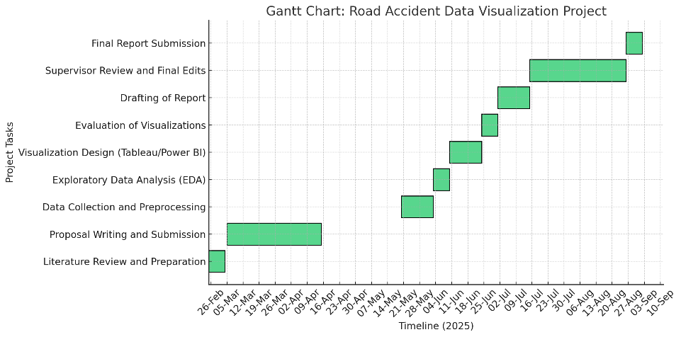

6. References.
[1] R.-C. Chen and Y.-K. Chang, “Integrating Big Data Analytics in Traffic Accident Data for Accurate Accident Prediction and Prevention,” in 2024 10th International Conference on Applied System Innovation (ICASI), IEEE, 2024.
[2] H.-C. Yang, M.-C. Chen, and I.-L. Lin, “Discussion on Application of Big Data Analysis in Improving Traffic Safety: Database of Traffic Accidents and Violation Reports,” in 2023 IEEE 3rd International Conference on Electronic Communications, Internet of Things and Big Data (ICEIB), IEEE, 2023.
[3] R. Saranya, V. Adarsh, S. Akash, P. Amirthap, S. Dinesh Ram, and N. Ajay Kumar, “Advanced Driver Assistance System for Enhanced Road Safety Analysis,” in 2023 IEEE International Conference on System, Computation, Automation and Networking (ICSCAN), IEEE, 2023.
[4] Z. Cheng, B. Liu, and J. Huang, “Causal Analysis of Road Safety Accidents in Britain Based on a Univariate Decision Tree Method,” in 2022 3rd International Conference on Intelligent Engineering and Management (ICIEM), IEEE, 2022.
[5] R. Sathiyanathan and N. Warnajith, “Integration of k-Means Clustering and Association Rule Mining for Road Safety Analysis,” in 2023 IEEE International Conference on Smart City Applications (SCA), IEEE, 2023.
[6] A. Ji and D. Levinson, “Injury Severity Prediction From Two-Vehicle Crash Mechanisms With Machine Learning and Ensemble Models,” *IEEE Open Journal of Intelligent Transportation Systems*, vol. 1, pp. 25–37, 2020.
[7] J. Zerafa, M. R. Islam, M. A. Kabir, and G. Xu, “ExTraVis: Exploration of Traffic Incidents Using a Visual Interactive System,” in *Proc. 25th Int. Conf. on Information Visualisation (IV)*, 2021.
[8] G. T. Balashivudu, D. Reshma, and I. R. P. Joe, “Driving Change: Leveraging Predictive Modeling and Geospatial Insights to Strengthen Road Safety Measures in India and USA,” in *Proc. 15th IEEE Int. Conf. on Computing, Communication and Networking Technologies (ICCCNT)*, 2024.
[9] M. Manzoor, M. Umer, and S. Sadiq, “RFCNN: Traffic Accident Severity Prediction Based on Decision Level Fusion of Machine and Deep Learning Model,” *IEEE Access*, vol. 9, pp. 9175–9192, 2021.
[10] A. Clarinval and B. Dumas, “Intra-City Traffic Data Visualization: A Systematic Literature Review,” *IEEE Trans. Intell. Transp. Syst.*, vol. 23, no. 7, pp. 6298–6315, Jul. 2022.
[11] H. M. Alnami, I. Mahgoub, and H. Al-Najada, “Highway Accident Severity Prediction for Optimal Resource Allocation of Emergency Vehicles and Personnel,” in *Proc. IEEE 11th Annual Computing and Communication Workshop and Conference (CCWC)*, 2021.
[12] M. E. Chien, H. C. Lee, and Y. H. Chan, “A Dashboard Visualization Approach to Analyze Road Traffic Accident Hotspots,” in *Proc. 2021 IEEE Int. Conf. on Systems, Man, and Cybernetics (SMC)*, pp. 1937–1942, doi: 10.1109/SMC52423.2021.
[13] A. Prasanna, S. Sengupta, and T. N. Nguyen, “Visual Analytics Framework for Urban Traffic Accident Pattern Recognition,” *IEEE Trans. Intell. Transp. Syst.*, vol. 24, no. 2, pp. 2079–2089, Feb. 2023.

