Name:_Emyr Jones

Student Number: 1701036
__________________________________________________________

WORKSHEET 5 – TESTING (Hunting for Treasure)

For this worksheet, the program can be implemented in a number of different ways and demonstrate different features.
Create your own test set to demonstrate strengths and/or limitations of your solution. Use as many of the template boxes below as you need.

Test: Enter “1” as the input

Screenshot(s) of output:
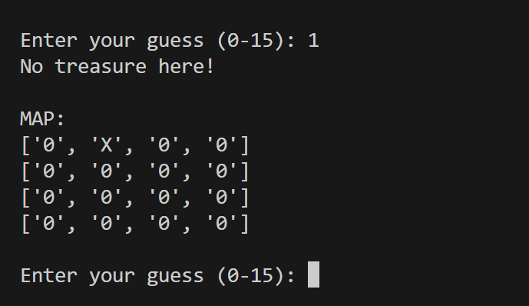
Result: Did the programme behave as expected ie syntactically and logically correct?
YES
If YES, comment on what happened.

The program registered the users input and checked location “1” and because the tressure was not located at location “1” it added an “X” to display that there is no tressure, thr program then asks the user to enter another guess.

Test: enter “a” as the input

Screenshot(s) of output:
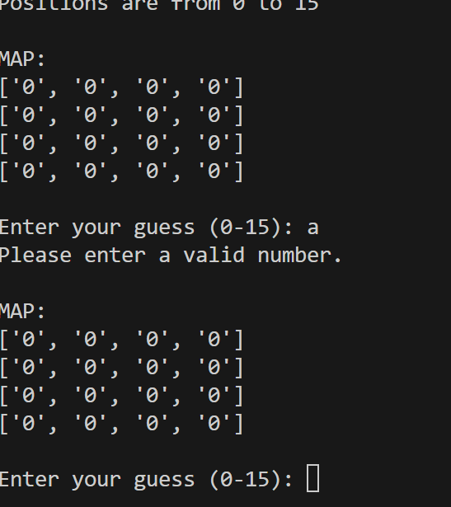
Result: Did the programme behave as expected ie syntactically and logically correct?
YES
If YES, comment on what happened.
The program catches the input error and sees it’s invalid and asks the user to input a correct guess.

Test: enter “123” as the input

Screenshot(s) of output:
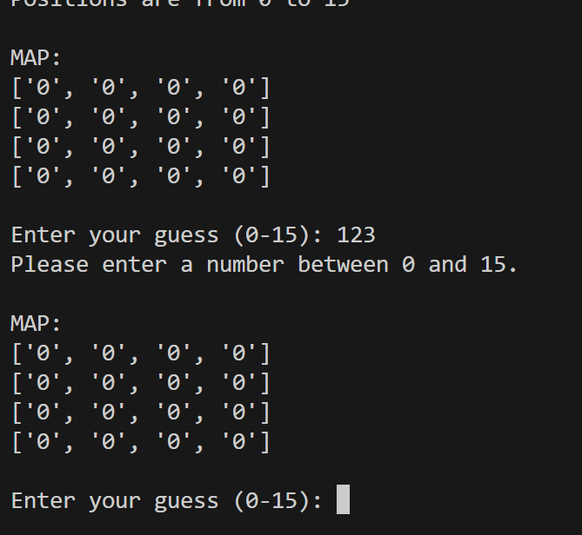
Result: Did the programme behave as expected ie syntactically and logically correct?
YES
If YES, comment on what happened.
The program sees that the guess is out of range and asks the user to enter a valid guess

Test: enter “-123” as the input

Screenshot(s) of output:
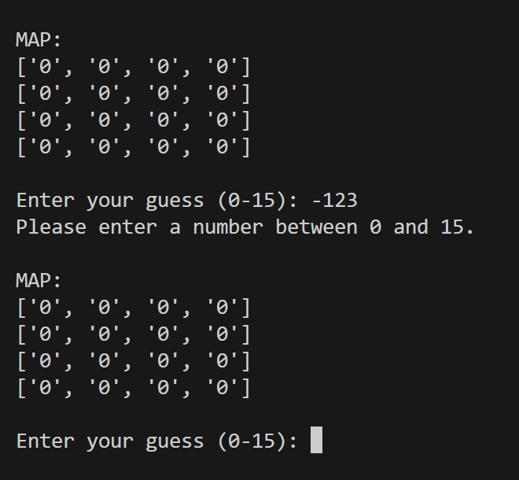
Result: Did the programme behave as expected ie syntactically and logically correct?
YES
If YES, comment on what happened.
The program catches the user input and sees that it is out of range and propts the user to enter a valid number

Test: run out of guesses and lose

Screenshot(s) of output:
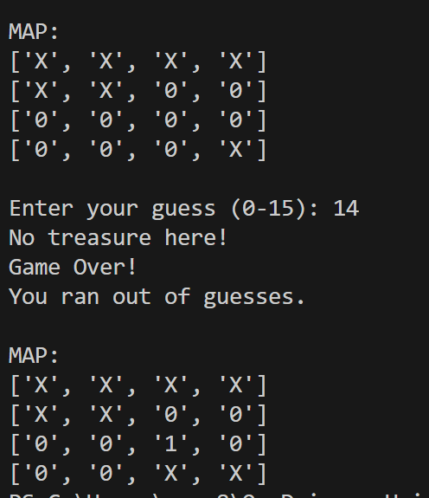
Result: Did the programme behave as expected ie syntactically and logically correct?
YES
If YES, comment on what happened.
The program tells the user each guess that there was no treasure found and updates the map, when the user runs out of guesses the program notifies the user that the game is over and displays the tressure map with all the incorrect guesses and where the tressure was located

Test: find the tressure

Screenshot(s) of output:
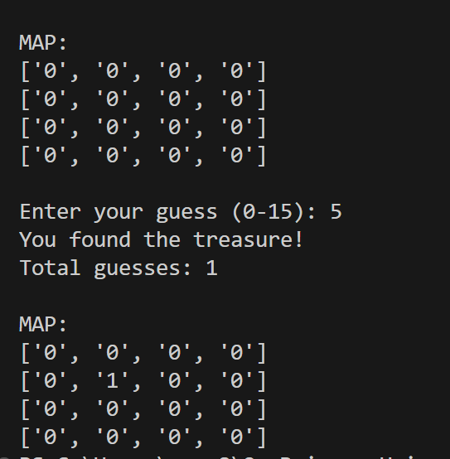
Result: Did the programme behave as expected ie syntactically and logically correct?
YES
If YES, comment on what happened.
The program ends the game when the user finds the tressure and displays the final map with all the guesses and where the tressure is located.

Test: enter “a” as the input 8 times

Screenshot(s) of output:
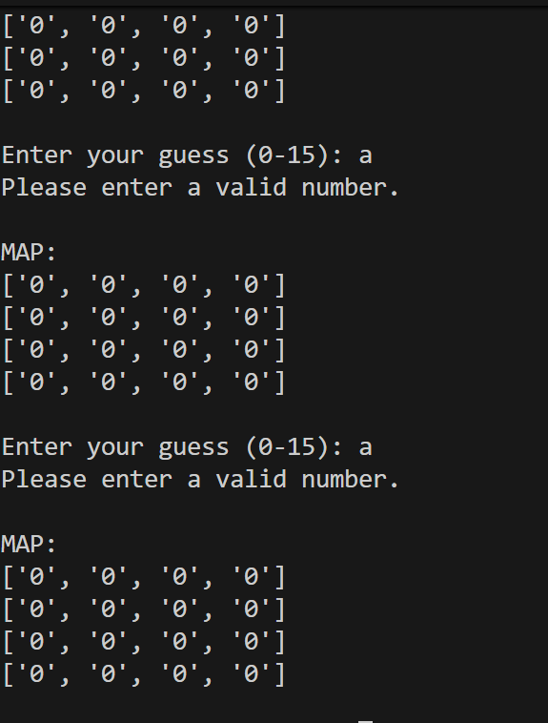
Result: Did the programme behave as expected ie syntactically and logically correct?
YES
If YES, comment on what happened.
The program catches that the user entered a invalid input and asks the user to guess again, the program does not count these guesses as the users go until they enter a valid input

Test: enter “1” 3 times as the input

Screenshot(s) of output:
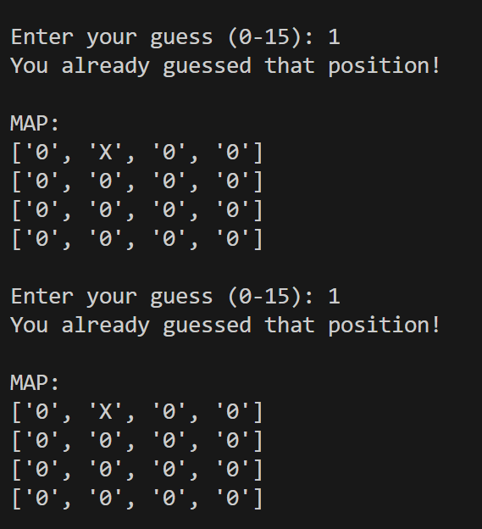
Result: Did the programme behave as expected ie syntactically and logically correct?
YES
If YES, comment on what happened.
The program sees that the user has already used that input already and asks the user to enter a valid input.

Final code:

import random

game_map = [0] * 16

display_board = ["0"] * 16

treasure_position = random.randint(0, 15)
game_map[treasure_position] = 1

guesses = 0
max_guesses = 8
found = False

def display_map():
print("\nMAP:")
for i in range(0, 16, 4):
print(display_board[i:i+4])

print("BURIED TREASURE GAME")
print("Find the hidden treasure!")
print("Positions are from 0 to 15")

while not found and guesses < max_guesses:

display_map()

try:
guess = int(input("\nEnter your guess (0-15): "))

if guess < 0 or guess > 15:
print("Please enter a number between 0 and 15.")
continue

if display_board[guess] == "X" or display_board[guess] == "1":
print("You already guessed that position!")
continue

guesses += 1

if game_map[guess] == 1:
print("You found the treasure!")
print("Total guesses:", guesses)
display_board[guess] = "1"

found = True

else:
print("No treasure here!")
display_board[guess] = "X"

except ValueError:
print("Please enter a valid number.")

if not found:
print("Game Over!")
print("You ran out of guesses.")

display_board[treasure_position] = "1"

# Final map
display_map()

