Learning in the Digital Era
Assignment 1 – E-portfolio

Title: Essential Skills for Study
(300 words without TOC & References plus 200 words Reflective Summary)

Name: Muhammad Imran
Student ID: 2130861

Table of Contents
1 Essential Study Skills 1
1.1 Time Management Skill 1
1.2 Stress Management Skill 1
1.3 Presentation Skill 2
2 Reflective Summary on Plagiarism Report 2

Introduction to Assignment
This assignment is consisting of the essential skills which are required in order to complete the study with minimum of three references. This assignment consists 300 words while 200 further words as reflective summary are described on the bases of the plagiarism report.

Essential Study Skills
The three important and essential study skills considered as per the previous literature are described below.
- Time management skill
- Stress management skill
- Presentation skill

Time Management Skill
The pandemic of the covid-19 changed the ways of study. It is having impacts on the activities of the students. The research is indicating that students need the time management skill for completing their assignment, research works and other tasks by using three aspects, named as organizing, implementing and planning (Putri and Mahmudah, 2021). There observed 168 numbers of hours per week. Students should use the idle times for completing small tasks. It shall spare the times for big tasks of the students. Student need of investing average 2 hours for each assignment per day (AlgonquinCollege, 2022).

Stress Management Skill
Because of growing rate of stresses and accompanying psychiatric illness, stresses into students are being extensively explored across the world. Stress is closely linking with the poor coping, burnout, depressions, sleep difficulties and anxieties (Heinen et al., 2017). Presentation related to speaking ability, is difficult for many students, particularly those from non-English . The students may use videos as mediums for learning the presentation skills .Therefore, students need to use stress management skills which are based on decreasing the workload of the students by doing the routine tasks in timely manner.

Presentation Skill
Presentation related to speaking ability, is difficult for many students, particularly those from non-English nations. The students may use videos as mediums for learning the presentation skills (Rafidiyah, 2018).

Reflective Summary on Plagiarism Report
The plagiarism is checked by using the Turnitin portal (Meo & Talha, 2019). The screenshots of the results having plagiarism are illustrated where it is evident that the plagiarism is observed only in the Table of contents. The similar type of the heading pattern was used in one of the assignments submitted in the Blake Hall College. As no plagiarism observed in other section of my work, therefore, it is evident that the work done is original and it is not copied from other sources. While the bibliography and the references used in this assignment are done on the bases of the standard Harvard style which are excluded while checking the plagiarism in my assignment. I am comfortable that my submitted assignment is original and I hope that I would get good marks in this assignment. From this assignment, I have also learnt that the skills of the time management, stress management and the presentation skills are very important on which I should focus in order to efficiently complete my study. By this exercise of checking the plagiarism, I am able to check my future works in term of the originality and any accidental plagiarism may be avoided by using this plagiarism checking technique.
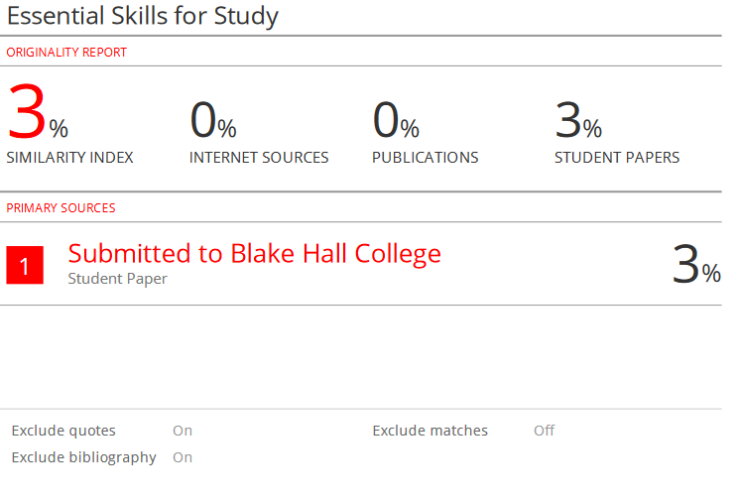
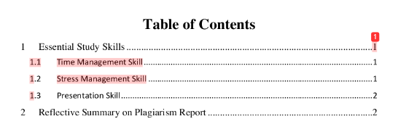

Task 2 – Becoming a Lifelong Learner
The Youth Justice Board (2016) states that working with young people needs a skill of understanding.
In order to become lifelong learner I need to read daily
I keep diverse kind of passion

1/3 of young people have mental health problems (Prison & Probations Jobs, jobs, 2020)
Becoming a Lifelong Learner
Working with young offenders

Good mental health and wellbeing. This will help with my studies within University but also a skill that is needed when working with young people as they may have experienced hardship and challenging behaviours.
Resilience is needed to cope with stress & hardship. It is a mental reservoir of power is called on when times get hard and individuals need to be strong without falling apart.
I need this for my future career so that when working with difficult working with young offenders I am able to stay calm when things are difficult.

In order to grow I seek opportunities

Task 3 – Becoming a Digital Learner

Video link:
https://youtu.be/ZA0duIWP6nA

Task 4 – Team player poster

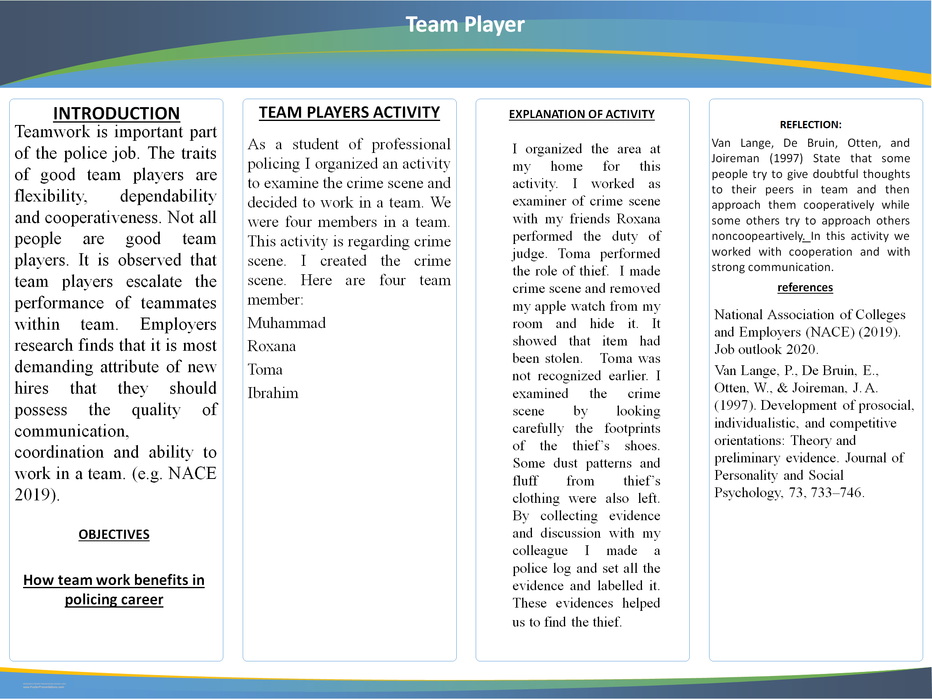

Bibliography
AlgonquinCollege 2022. Time Management - Essential Study Skills - Subject Guides at Algonquin College. Retrieved June 09, 2022, from https://algonquincollege.libguides.com/studyskills/timeManagement
Board, Y.J., 2019. Annual Report and Accounts 2018/19. YJB, London.
Heinen, I., Bullinger, M. and Kocalevent, R.D., 2017. Perceived stress in first year medical students-associations with personal resources and emotional distress. BMC medical education, 17(1), pp.1-14.
Meo, S.A. and Talha, M., 2019. Turnitin: Is it a text matching or plagiarism detection tool?. Saudi journal of anaesthesia, 13(Suppl 1), p.S48.
Putri, S.A. and Mahmudah, F.N., 2021. Time management skills: completion of student final project during the covid-19 pandemic. JHSS (JOURNAL OF HUMANITIES AND SOCIAL STUDIES), 5(3), pp.232-236.
Prison & Probation Jobs (2020) Working in Youth Justice. Available at: https://prisonandprobationjobs.gov.uk/youth-custody/working-in-youth-custody/ (Accessed date: 28/11/20)
Rafidiyah, D., 2018. VIDEO-BASED INSTRUCTION TO BOOST STUDENTS’PRESENTATION SKILL. TEFLA Journal (Teaching English as Foreign Language and Applied Linguistic Journal), 1(1), pp.11-17.

