An Analysis of Entrepreneurship in a Global Perspective

Student Name:JIN KAIXUAN
Student ID:1704114

Table of Contents
Executive Summary 4
1.0 Introduction 4
1.1 The Definitions and Implications of Entrepreneurship 4
1.2 The Definitions and Implications of International Entrepreneurship 5
1.3 Ways to Become Entrepreneurs 5
1.3.1 Model A: Everyone Can Be An Entrepreneur 5
1.3.2 Model B: Entrepreneur or Non-Entrepreneur 5
1.3.3 Model C: Instinctive Entrepreneur and Potential Entrepreneur 5
2.0 Indicators That Might Encourage Or Intervene Entrepreneurship 5
2.1 Political and Legal Influences 6
2.2 Economic System 6
2.3 Other Causes 6
3.0 The Natures of Entrepreneurship 7
3.1 Factor-Driven Economies 7
3.2 Efficiency-Driven Economies 7
3.3 Innovation-Driven Economies 7
4.0 An Evaluation of 5 Contrasting Regions Concerning Entrepreneurship Involvements 8
4.1 Botswana in Africa 8
4.1.1 Political Evaluation 8
4.1.2 Economic Evaluation 9
4.1.3 Overall Evaluation 9
4.2 Canada in North America 9
4.2.1 Political Evaluation 10
4.2.2 Economic Evaluation 10
4.2.3 Overall Evaluation 11
4.3 Australia in Oceanic 11
4.3.1 Political Evaluation 12
4.3.2 Economic Evaluation 12
4.3.3 Overall Evaluation 12
4.4 Brazil in Latin America 12
4.4.1 Political Evaluation 13
4.4.2 Economic Evaluation 13
4.4.3 Overall Evaluation 13
4.5 Bulgaria in Europe 14
4.5.1 Political Evaluation 14
4.5.2 Economic Evaluation 15
4.5.3 Overall Evaluation 15
5.0 Recommendations 15
6.0 Conclusions 16
References 17

Executive Summary
This report delves into the importance of international entrepreneurship and its implications in 5 contrasting regions in the global communities, including Africa, Latin America, Europe, Asia and North America, combined with government contributions in this process. To start with, this report introduces what entrepreneurship and international entrepreneurship, as well as their significance both for domestic nations and international states. Secondly, this report analyzes what qualifies an entrepreneur on the basis of three distinguished models. Thirdly, this report analyzes factors that might encourage or intervene the process of international entrepreneurship, respectively political and legal influences, economic system and other relative factors. Also, this report critically analyzes the natures of entrepreneurship, with the introduction of three stages, respectively factor-driven economies, efficiency-driven economies and innovation-driven economies. And this report analyzes the 5 contrasting regions in the global communities in terms of social attitudes and government participation towards entrepreneurial activities. At the end, this report drives conclusions and recommendations based on the analysis of the whole article.

1.0 Introduction

1.1 The Definitions and Implications of Entrepreneurship
Entrepreneurship is perceived as the pursuit of commercial opportunities without regard to resources that are being limited. (Stevenson,2013) Entrepreneurship is increasingly prevalent in the current world, and there are more persons who are ambitious to create their own business. Entrepreneurship is of great values both for the individuals who engage themselves in entrepreneurship(Acs,1996), and of international nations which gain much economic increase because of the entrepreneurial activities. Moreover, entrepreneurship can provide so many job positions for the unemployed, which ameliorates the unemployment dilemma in many countries particularly populated ones.

1.2 The Definitions and Implications of International Entrepreneurship
International entrepreneurship is evolution of entrepreneurship in a world which is increasingly connected because of economic communications(Alon,2004), by means of international trade. For instance, there are more and more multinational enterprises which largely determine the economic progress of the whole world, and they come from international entrepreneurial activities. International entrepreneurship is defined as the pursuit of business opportunities without the boundaries of nations. And it is widely admitted that international entrepreneurship does not only benefit the economic performances of both parent country and host country, but also helps to communicate the culture features of a certain country to the external world and thus enhancing its status as well as influences in various perspectives.

1.3 Ways to Become Entrepreneurs

1.3.1 Model A: Everyone Can Be An Entrepreneur
In this model, it is believed that everyone can be an entrepreneur(Amemiya,2014), since the traits or styles of entrepreneurs can all be cultivated later, such as the innovative ability and the skill of persisting in one goal. Thus this model is very supportive and inclusive.

1.3.2 Model B: Entrepreneur or Non-Entrepreneur
This model believes that human beings can only be divided into two types concerning entrepreneurship, respectively entrepreneurs or non-entrepreneurs(Anderson,2007). And it is held in this model that some of the traits of entrepreneurs can not be learned in later life, which are more natural.

1.3.3 Model C: Instinctive Entrepreneur and Potential Entrepreneur
This model believes that as for persons, they can be divided into instinctive entrepreneur and potential entrepreneur. This model combines the features of the two models above.

2.0 Indicators That Might Encourage Or Intervene Entrepreneurship
Given the complexity of international entrepreneurship, it has to face diverse challenges from various perspectives(Autio,2005), and there are many factors that might potentially encourage or intervene international entrepreneurship, particularly political and legal influences, a distinguished economic system.

2.1 Political and Legal Influences
In this dimension, political environment can have most influence on the conduction of entrepreneurship activities(Autio,2007). For instance, a steady political party structure would provide a safe commercial environment for the business operation, which is more than critical for the development of international corporations. Apart from that, the political preferences can directly determine the number of entrepreneurship programs in a region, which would greatly help the process of international entrepreneurial campaigns. Moreover, the political policies and concerns can be important to choose international business partners(Baum,2004), which would influence of choice of new markets for international entrepreneurs. As for legal environment, a different legal system makes different regulations as well as rules concerning the product quality and safety standards, which would be new challenges for the international corporations to remodel their commodities.

2.2 Economic System
A different economies system would make international entrepreneurs cost much time and money to get used to(Berger,1997).For instance, international entrepreneurs would have to get adjusted to the new currency and new rules of hiring people, such as different extents of gender discrimination in different working places. Moreover, the international corporations have to figure out how the new financing channels work, as well as the tendencies of new government policies concerning their treatment of international entrepreneurship, which would be the most important step of learn about the macro economic climate.

2.3 Other Causes
There are some other causes apart from political, economic and legal dimensions, such as social attitudes and technical developments. Different social attitudes can determine the willing of inhabitants to engage themselves in to entrepreneurship activities(CAF,2013), such as developing innovative products and delivery services. Technical advancements can determine the popularity of some countries as the choice of new markets. For instance, it is known that usually developed regions can enjoy technical developments with more advanced levels, while developing regions are usually poorer at technical advancements, and if this comparison is more extreme, international companies from developed regions would not be willing to select those developing regions as a choice of potential market, since they have to invest much at the first place to start up the new business.

3.0 The Natures of Entrepreneurship
There are three stages of evolution entrepreneurship for different economic entities, respectively factor-driven economies, efficiency-driven economies and innovation-driven economies. It is worth noting that the higher the stage, the more developed the region is. International entrepreneurship is defined as the pursuit of business opportunities without the boundaries of nations

3.1 Factor-Driven Economies
The first stage of entrepreneurship is considered as factor-driven economies, and this is where commercial growth is completed on the basis of unskilled labor force and the exploring of natural resources (Cameron, 2005). Usually developing regions belong to this stage, such as many regions in Africa, and infrastructure system, health care system and other factors are highly emphasized in this stage.

3.2 Efficiency-Driven Economies
Efficiency-driven economy is considered as the second stage of entrepreneurship. And for some regions which are developing in a high pace, this stage is more suitable for them(Dollan,2009). In this stage, both the efficiency of producing items and the qualities of commodities are emphasized. Key indicators in this stage are the market size, the efficiency of labor market, the efficiency of commodity market and so on.

3.3 Innovation-Driven Economies
Innovation-driven economy is the most advanced level for now concerning the development of entrepreneurship. It is worth noting that usually many developed regions belong to this stage, such as the United States, the United Kingdom, many other European economic entities and so on(Estrin,2011). In this stage of innovation-driven economy, it is worth noting that the complexity of business activities and the development of innovative inventions, are paid with the highest attentions.

4.0 An Evaluation of 5 Contrasting Regions Concerning Entrepreneurship Involvements

4.1 Botswana in Africa
Botswana is a country located in the Southern Africa, with a typical factor-driven economy like many other African countries. The population of Botswana is 2.1 million in 2018, with a GDP per capita US$ 6041.
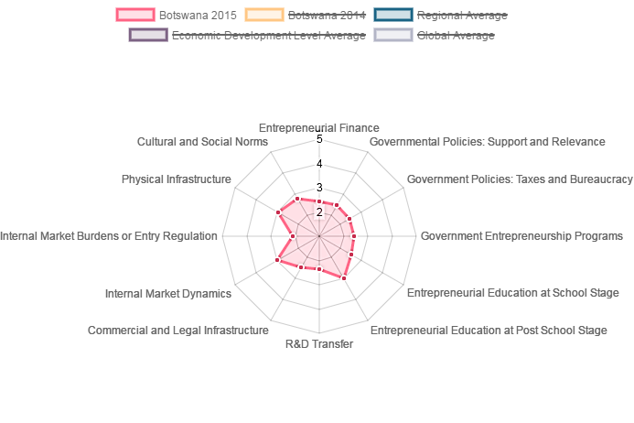
Sourceshttp://www.gemconsortium.org/country-profile/44

4.1.1 Political Evaluation
With regard to government policies, Botswana government does offer some efforts to decrease negative effects from tax and bureaucracy, which can decrease the burden of entrepreneurial activity and improve the efficiency. However, the entrepreneurship programs do not accept sufficient attention and the support and relevance related government policies are not constructive, either.

4.1.2 Economic Evaluation
As for economic aspects, with the increase of GDP, the internal market dynamics of Botswana is good, very close to the global average level. But the entrepreneurial finance is not so good, which may be affected by history. Taking infrastructure into consideration, both the commercial and legal infrastructure and physical infrastructure are not good enough to support the fast-developing entrepreneurial activities in Botswana.

4.1.3 Overall Evaluation
Apart from political and economic factors, the cultural aspect in the entrepreneurial framework conditions is remarkable. It is obvious that the Botswana government invests a lot in entrepreneurial education both at school stage and at post school stage. And the R&D transfer is noticeable, which means the investment in research and development can be transformed into income and become the impetus behind the development of entrepreneurial activities. In general, it is necessary for Botswana to shed more light on governmental policies to enhance the entrepreneurship because people who have entrepreneurial knowledge cannot become an entrepreneur without government support.

4.2 Canada in North America
Canada is the second populated country in North America, with a population of 35.8 million. The economy of Canada is innovation-driven, with and GDP of $1552.4 billion and GDP per capita of $43332. It is no denying that Canada is very good country with regard to entrepreneurship.
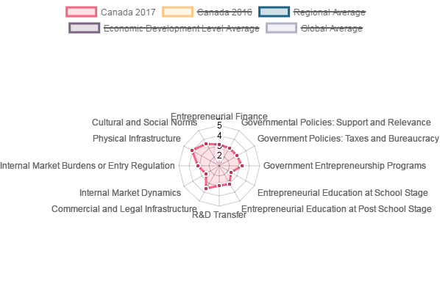
Sources: http://www.gemconsortium.org/country-profile/49

4.2.1 Political Evaluation
It is obvious that Canada government make a good effort to push the development of entrepreneurship. The government policies can provide much support and relevance to entrepreneurship and to decrease the burden of entrepreneurial activities, Canada financial department cut off the taxes. What is more, the entrepreneurial programs can combine the good ideas and resources from different people, which is quite beneficial to the entrepreneurial development in an overall perspective.

4.2.2 Economic Evaluation
In economic aspect, though the internal market dynamics is not outstanding, it is not important in such an open country. The global economy can bring much energy to this country. Especially in finance related to entrepreneurship, Canada can offer sufficient help.

4.2.3 Overall Evaluation
As one of the greatest developed countries, Canada’s infrastructure is high level. Apart from hardware construction, Canada government also attaches much emphasis on the software development. Canada’s score of R&D transfer is much higher than that of global average level. In terms to entrepreneurial education, Canada is also in a leading position all over the world. Both the entrepreneurial education at school and at post school stage are above the global level and get improved in recent years. It is advisable to do entrepreneurial activities in Canada.

4.3 Australia in Oceanic
Australia is an oceanic country, with a population of 24 million. The GDP of it is US$ 1223.9 billion and the GDP per capita is US$50962, which makes it one of the most developed countries all over the world. The economy of Australia is an innovation-driven one. And from the picture below, we can see the entrepreneurial framework conditions of Australia.
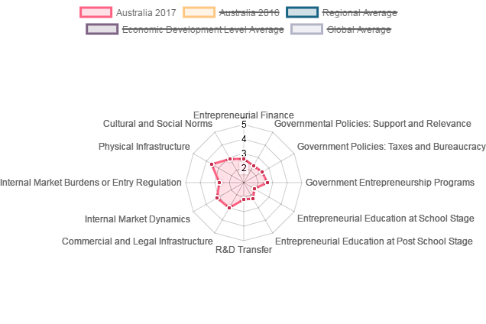
Sources: http://www.gemconsortium.org/country-profile/37

4.3.1 Political Evaluation
In terms of government policies, it is easy to judge the efforts of Australian government are sufficient, because the taxes and Bureaucracy related policies are not supportive compared to the world average level, and the entrepreneurship programs are not good enough, either. However, the regulation related to internal market burdens and entry are good, which offer a shield to the native entrepreneurs, avoiding the fierce competition from overseas.

4.3.2 Economic Evaluation
However, the entrepreneurial finance of Australia is relatively high compared to the global level, which is an advantage to the Australian entrepreneurs. What is more, the score of internal market dynamics is over 3, which is quite high in the whole region and the world. The blossom of the economic environment provides the entrepreneurs with many opportunities.

4.3.3 Overall Evaluation
Overall, the entrepreneurial framework conditions of Australia are in a medium level. Except from the economic aspects are good, its government policies and infrastructure related to commercial and legal issue and physical infrastructure are comparatively bad in comparison with other innovation-driven countries, such as the United States and the United Kingdom. Furthermore, both entrepreneurial educations at school stage and at post school stage are insufficient. As a conclusion, it is a little bit challenge to be an entrepreneur in Australia. It is not hard to find out that developed regions are usually innovation-driven, which cares most business sophistication and innovative developments.

4.4 Brazil in Latin America
Brazil is the largest country in the LatAm % Caribbean area with a population of 204.5 million. The GDP of Brazil is US$ 1772.6 billion and the GDP per capita is US$ 8670. What is more, Brazil has an efficiency-driven economy.
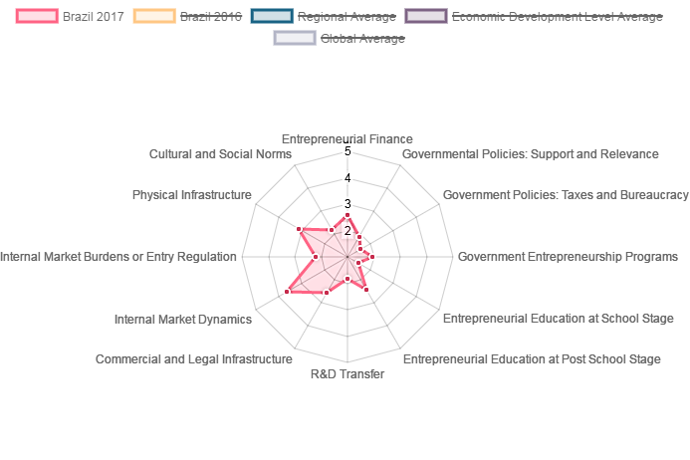
Sources: http://www.gemconsortium.org/country-profile/46

4.4.1 Political Evaluation
In terms of economic aspect in the entrepreneurial frame work conditions of Brazil, the internal market dynamics is the only thing worth mentioning, because it is true that the internal market of Brazil is much energetic than global average level. The strong market dynamics can bring the entrepreneurial activities in many opportunities.

4.4.2 Economic Evaluation
Apart from that the political aspects related to government policies, which consist of support and relevance, taxes and bureaucracy, and government entrepreneurship programs are not satisfying. Entrepreneurs or potential entrepreneurs in Brazil may lack the support from government and even have some obstructions in the above aspects.

4.4.3 Overall Evaluation
In cultural aspect, the entrepreneurial education is not sufficient; therefore people here may not have the idea and enough knowledge to carry out their entrepreneurial plans. What is more, the infrastructures both in physical and commercial and legal aspects are insufficient, so even though people there want to do their business, they cannot make it come true without the hardware support. On an overall perspective, the entrepreneurial conditions in Brazil are not remarkable at all. Brazil government needs to make more efforts to develop its entrepreneurial construction in order to carry the national economic development.

4.5 Bulgaria in Europe
Bulgaria is one of the southern Europe countries, with a population of 7.2 million. It is a developing country in Europe, with a GDP of US$ 49 billion. In general, it has an efficiency-driven economy and the conditions of all aspects are not very conductive to entrepreneurial activities.
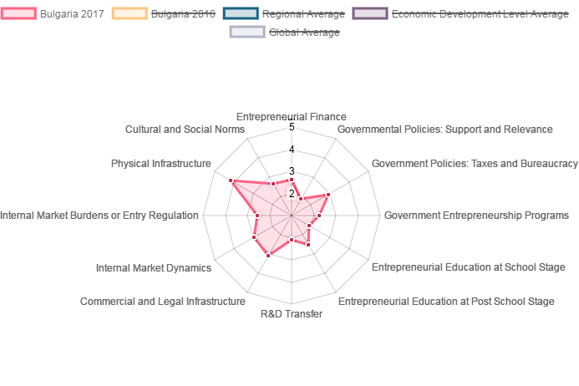
Sources: http://www.gemconsortium.org/country-profile/139

4.5.1 Political Evaluation
Firsty , with regard to political conditions, the governmental policies related to taxes and bureaucracy are advantageous to people who want to be an entrepreneurs. However, the support and relevance from government policies are insufficient, so entrepreneurs need to find resources and support on themselves mainly. What is worse, the government entrepreneurship programs are comparatively insufficient, which may also emphases the personal effort rather than that of group.

4.5.2 Economic Evaluation
Secondly, in economic aspect, as a result of collapse of the Soviet Union, Bulgaria’s internal market dynamics are not flourishing. As a consequence, the entrepreneurial finance is on a common level, very close to the global average level. However, the infrastructure of Bulgaria is outstanding all over the world, which offers a solid and reliable hardware condition for the development of entrepreneurial activities.

4.5.3 Overall Evaluation
Lastly, in other terms, entrepreneurial education is another shortage of Bulgaria, no matter the education at school stage or the education at post school stage. Its score of cultural and social norms is lower than the global average level. On top of that, only limited amount of investment of research and development can be transformed into income, which is a main reason why the Bulgaria cannot become an innovation-driven economy country. As for international corporations, the biggest problem for them to conduct commercial activities in a new market is to spend time and capitals on getting adjusted to the new system of the fresh country.
In a conclusion, Bulgaria has not become a good option to realize one’s entrepreneurial plan because of the shortage of political and cultural conditions. So if the Bulgaria government wants to develop national economy by the power of entrepreneurship, it is necessary to enhance the internal conditions comprehensively and urgently.

5.0 Recommendations
Firstly, upon all the five countries discussed above, it is obvious that the infrastructure is the basis of entrepreneurial activities. Without the hardware, it is very difficult for someone to make the idea come true. There are more and more multinational enterprises which largely determine the economic progress of the whole world. Only sufficient infrastructure can ascertain the efficiency of development.
Secondly, political factors do not only have the effect of pulling but also pushing. Reducing the tax and bureaucracy can decrease the unnecessary cost of time and energy, and the government of support and relevance especially the government entrepreneurship programs can pull the development of entrepreneurship.
Last but not the least, cultural factors are getting more and more important. As the innovation-driven economy is the highest level economy, one of the most obvious characteristics of these countries is noticeable cultural environment. Because each entrepreneurial activity comes from a good idea; and the idea is a fruit of an exuberant tree. Even though the entrepreneurial education cannot ascertain a successful entrepreneur, it can raise the possibility of success. After all, the success of an entrepreneurial case is like a basket, it is the shortest plank that determines how much water it can hold rather than the longest one. So this calls for a comprehensive development of entrepreneurial conditions.

6.0 Conclusions
This report takes advantage of theories and framework information of entrepreneurship, critically evaluates the 5 contrasting regions in the global communities concerning their social attitudes and government policies towards entrepreneurship and international entrepreneurship. . International entrepreneurship is defined as the pursuit of business opportunities without the boundaries of nations International entrepreneurship is the evolution format of entrepreneurship in a world which is more closely connected by means of international trades and collaborations. As the innovation-driven economy is the highest level economy, one of the most obvious characteristics of these countries is noticeable cultural environment. Because each entrepreneurial activity comes from a good idea; and the idea is a fruit of an exuberant tree. Given the increasing complexity and sophistication of international entrepreneurship in the current world, it is no longer merely affected by economic concerns, but also many other perspectives such as political and legal environment, social attitudes and norms, the different developing levels of technical advancements. As for international corporations, the biggest problem for them to conduct commercial activities in a new market is to spend time and capitals on getting adjusted to the new system of the fresh country. The natures of entrepreneurship can be learned with three stages-factor-driven economies, efficiency-driven economies and innovation-driven economies. It is not hard to find out that developed regions are usually innovation-driven, which cares most business sophistication and innovative developments. From the evaluation of 5 contrasting regions in the global communities, there are several key recommendations based on the analysis of statistics on GEM website. For instance, so as to encourage the prevalence of international entrepreneurship, nations are suggested to set up more entrepreneurial programs in order to support and promote the activities of entrepreneurs and potential entrepreneurs.

References
Acs,Z.(1996). Small Firms and Economic Growth. Edward Elgar Publishers Limited.
Acs,Z.(2008). Entrepreneurship: Economic Development and Institutions
GEM Website, (2018). Accessed on [http://www.gemconsortium.org/report]
Alon,I.(2004). Business Education and Emerging Market Economies. Perspectives and Best Practices.
Amemiya, T.(1981). Qualitative Research Models. Journal of Economic Literature.
GEM Website, (2018). Accessed on [http://www.gemconsortium.org/about/news]
Anderson,J.(2007). Innovation at the base of the economic pyramid. Journal of Business Strategy.
Autio,E.(2005). GEM: 2007 global report on high-growth entrepreneurship. London: Babson College. London Business School, and Global Entrepreneurship Research Consortium.
GEM Website, (2018). Accessed on [http://www.gemconsortium.org/country-profile/44]
Berger,B.(1991). The Culture of Entrepreneurship. San Francisco.
GEM Website, (2018). Accessed on [http://www.gemconsortium.org/country-profile/139]
CAF.(2013). Entrepreneurship of Latin America. Journal of Innovative Advancements.
Cameron,A.(2005).Microeconometrics:Methods and Apllications.
GEM Website, (2018). Accessed on [http://www.gemconsortium.org/country-profile/37]
Cassar, G.（2006）.Entrepreneurship opportunities costs. Journal of Business Venturing.
GEM Website, (2018). Accessed on [http://www.gemconsortium.org/country-profile/46]
Stevenson,C.(2013). What is Entrepreneurship. Harvard Business Review.
GEM Website, (2018). Accessed on [http://www.gemconsortium.org/country-profile/49]
GEM Website, (2018). Accessed on [http://www.gemconsortium.org/data]

