MODULE CODE: M4X01915
Hospitality and Guest Services

Student Name: CORINA ELENA DAMIAN
ID: 1908250

An Evaluation Report on Kip Hotel

Introduction
Guest services refers the provided services to the guests and the services are receiving telephone, welcoming the gusts, providing newspapers, giving information regarding the tourism related places, providing billing information and so on. Here, we will represent how the Kip Hotel provides services to the guests. In 2016, Mike and Ross Baxter established this hotel for the purpose of providing the low price and stylish hotel service in the UK. It is an independent hotel and it has started its operation in March 2016 (Kip Hotel London, 2019). It is a popular hotel for the lower price and for the business travellers for the wide ranges of services. The operational areas of the Kip hotel are up to the mark. They provide a quick solution to the customers for ensuring the trust and loyalty of the customers. The management of the Kip Hotel is very conscious of the rendered services.

The Kip Hotel’s service provision and quality management
There are lots of hotels in London, UK but many of them are very costly. At the time of the planning of the establishing of the Kip Hotel, the owner found that the hotel cost is very high in London.

Rendered services of the Kip Hotel
The authority of the Kip hotel has been decided to provide the services with lower costs. There are 105 rooms with different specifications. So, the customers can easily book their desired room by meeting their needs. The interior and the exterior design of the hotel is up to the mark and it is very attractive (O’Gorman, 2010). These identical services help the customers to choose the hotel and they become very much satisfied.
Table 1: Rendered services and facilities
Rendered services and facilities of the Kip Hotel
Supportive staff | The Kip Hotel maintains a group of supportive staffs. The staffs behave well with the customers (Evans, 2015). The consumers are easily convinced to adopt the services of the Kip Hotel.
Wi-Fi facilities | The Kip Hotel provides Wi-Fi facilities to the customers so that they can easily connect with the others. To cope up with the competition, the Wi-Fi facilities must be provided.
Help-desk | The Kip Hotel maintains 24/7 help desk services to serve the travellers. As a result, a good customer relationship can be maintained.
Kid zone | The Kip Hotel has a kid zone where the kids can play and pass their time.
Restaurant facilities | The Kip Hotel has a food court where the travellers can purchase food according to their desires.
Paid parking | The consumers can afford the parking facilities by paying a definite sum of money. They provide secured parking zone.
Security | The security system of the Kip Hotel is very well equipped. They have CC camera facilities.
Location advantage | The Kip Hotel is adjacent to the many renowned and historical places. They can utilise this advantage (Kotter, 2019).
Non-smoking room | The Kip Hotel encourages the travellers to stay away from smoking and it helps the Kip Hotel to maintain a non-smoking zone.
Family rooms | The Kip Hotel has family rooms, couple rooms and so on. It helps them to satisfy the different needs of the consumers.

The categorisation of the rendered services of the Kip Hotel
The Kip Hotel focuses on the niche market hence they have targeted different people with different needs. They maintain the best cost provider strategy by giving them more value than the price charged by the Kip Hotel. The Kip Hotel can maintain the best cost strategy by focusing on the several specifications of the customers (Kip Hotel London, 2019). The several specifications are stated below-
Table 2: Different specification of the consumers
Different specifications of the consumers
For fitness-oriented people | - Jim facilities  - Swimming pool facilities
For the kids | - Kids zone
For the family | - Couple room facilities  - Kitchen facilities  - Separate fresh room facilities  - Comfortable bedroom with the temperature control management  - Separate dining facilities
For the individuals | - Room cleaning facilities  - Salon facilities  - Meal facilities
For the business organisation | - Large conference room facilities  - Multimedia facilities  - Electronic facilities  - Meal facilities  - Catering services

Quality management in the hotel sector
Quality cannot be defined with a specific definition. The quality varies from person to person. So, quality also should be maintained by the hotel sector. As consumers are the main part of the hotel industry (Vallen and Vallen, 2012). The quality will be ensured when their needs and demands are satisfied. The demand and need of the consumer vary from situation to situation and time to time also. So, the Kip Hotel should focus on the behaviour of the consumers. As a result, the Kip Hotel can easily identify the characteristics of the consumers in the hotel industry. There are several phenomena which should be considered by the Kip Hotel. The phenomena are-

The identification of the current needs and the demands

The continuous changes

The Identification of the current trends

The changes of the political issues

The innovation of the technology

The development of the human resources
Figure 1: Quality management in the hotel industry
Source: (Batinic, 2016)
The hotel industry should identify the current needs and the demands of the consumers. There are continuous changes in the demand of consumers. It will help the hotel operators to make the offer to the consumers. The behaviour of consumers is not the same at all. As a result, consumers will be attracted to adopt the offer of a particular hotel. Identification of the current trends also helps the hotel operators to fulfil the particular needs of the consumers. The consumers want to book the hotel via online and it becomes a trend. The political changes should be considered by the hotel operators because the hotel business is affected a lot. The innovation of technology also has an impact on the regular operations of the hotel. The using of technology gives the advantage to the regular operations of the hotel. In the hotel industry, the skilled manpower is very much needed because direct interaction occurs with the consumers frequently (Besterfield, 2014).

Quality management in the Kip Hotel
The quality is a never-ending process. The quality ensures the attaining of the new customers as well as the retaining of the current customers. The quality helps the business organisation to expand the operation of the business by focusing on the increase of the market share (Sonnabend, 2013). In the context of the service providing business organisation, the maintaining of the quality is just because the customer can be easily satisfied after getting high-quality services from the Kip Hotel. In the following phase, the quality management process of the Kip Hotel is elaborated.
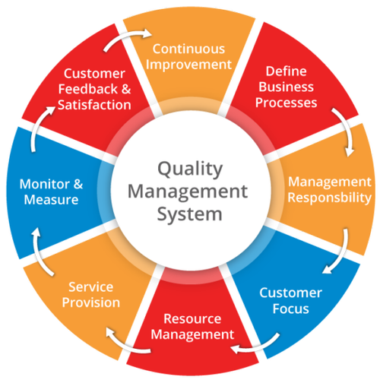
Figure 2: Quality Management System
Source: (Eliot, 2016)
The Kip Hotel can ensure the quality management system by focusing on the continuous improvement approach. The continuous improvement helps to develop the operations by focusing on the current trends and issues. As a result, consumers will be satisfied. The business process and the approaches of the Kip Hotel should be predefined. As a result, all the actions should be taken place in time. The responsibility of the management should be predefined. It ensures the accountability of the management. All the actions of the Kip Hotel should be consumer-oriented because they are the main element of the Kip Hotel. For rendering quality service, the resource should be managed (Tesone, 2014). The good resources enable the Kip Hotel to render good services. For satisfying the different needs of the consumers, the Kip Hotel provides different types of services by focusing on the different needs of the consumers. The cross-check should be performed to measure and to monitor the activities of the human resources of the Kip Hotel. It will help to maintain a balance of the activities of the Kip Hotel. The feedback from the consumers is given utmost importance by the Kip Hotel. It produces the way to solve the problem of the consumers.

Balancing with the changing consumer preferences
Customers are the key to the success of the business organisation. As the Kip Hotel is a service-based organisation, the customers’ preferences are given importance highly (Galante, 2016). The consumer preferences ensure that the complaint of the consumers is taken seriously by the Kip Hotel and the Kip Hotel takes sufficient measures to solve the problems of the consumers. The changes of the consumer preferences can be described in terms of the Kotter’s change model.
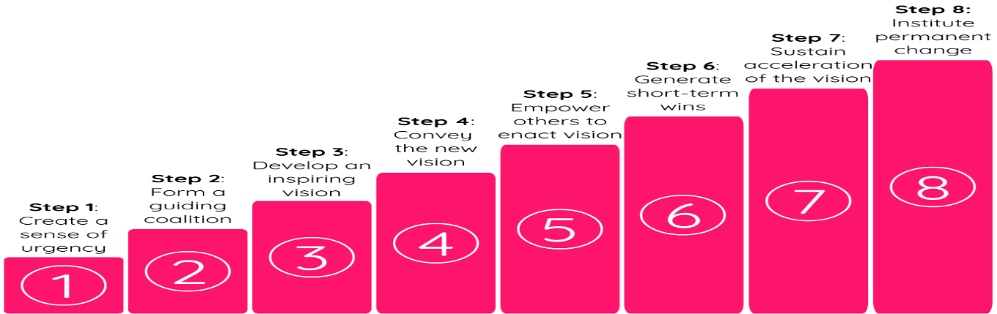
Figure 3: The change model
Source: (Kotter, 2019)
They create a sense of urgency ensures that the Kip Hotel needs to do something for making changes such as the inclusion of the electronic payment method. The real scenario is presented to the concerned parties. In the coalition stage, the Kip Hotel convinces the people to make the changes and it is necessary for the Kip Hotel. In the next phase, the clear vision should be established so that the concerned people can easily remember the vision. The development of the different ideas should be done in this stage. In the next, the vision should be communicated with the concerned parties and it will ensure the attaining of the success. In every situation, the vision and the required message and the information should be communicated with the concerned parties. In the implementation of the changes, the Kip Hotel will face some obstacles. The obstacles should be removed in the fifth stage. To remove the barriers, the employees should be empowered to make the necessary decisions. The objective and goal of the organisation should be performed on a short-term basis (Sonnabend, 2013). It will help the business firm to attain the goals and objectives very easily. The short-term target should be achievable. By rewarding the concerned personnel after the attainment of their target, the personnel will be motivated. What should be done to implement the activities is defined in this stage. The attaining of the vision of the is a long-term procedure and the Kip Hotel will get benefited for a long time. The Kip Hotel should continue the electronic payment operation for a long period. In this way, the permanent change will be taken place by the Kip Hotel.

The impact of the changes of the guest service management in the Kip Hotel
The Kip Hotel focuses on the demand of the consumers because they are the king of the business. The changes for rendering better services affect guest service management (Eliot, 2016). The better service ensures that the consumers are loyal to the Kip Hotel. There are several issues which would be affected due to the changes in guest service management.

The arrangement of the training

The customisation

The introduction of the lower cost

The inclusion of the different types of services

The revision of the current rules and regulations
Figure 4: The impact of the changes
Source: (Evans, 2015)
The employees should be properly trained for the purpose of the development. It will ensure the improvement of the services. The customisation should be performed by the Kip Hotel. It will help to attract more consumers. All the services should be rendered with the lower cost for attracting the consumer which is currently practised.

Recommendations
The Kip Hotel should follow some issues for effective and efficient operation. The recommendations for the Kip Hotel are-
- The Kip Hotel would arrange the training program for the development of the employees. The training program helps the employees to interact with the consumers properly.
- The Kip Hotel would introduce the electronic payment system. The electronic payment system is secured and safe and it is easy to keep a record. As a result, the consumers will be able to make the payment very quickly at any time.
- The Kip Hotel would introduce transportation facilities for the ease of the travellers to utilise the location advantage. As the Kip Hotel is situated near to the historical place and near to the stadium, the consumers may need to use the transportation facilities.
- The Kip Hotel would introduce different features and services with different price ranges. If the Kip Hotel introduces transportation facilities, the new service will be added in its regular operations.
- The Kip Hotel could provide free parking facilities. Currently, the Kip Hotel is providing parking facilities with a cost. But the Kip Hotel can render the services free to attract consumers.
- The Kip Hotel could focus more on security. The security should be provided not only the assists but also the information. The provided information should be kept secured by the Kip Hotel.
The Kip Hotel could follow the above recommendation for achieving the target of the organisation in an efficient and effective way. As a result, the target of the Kip Hotel will be easily obtained.

Conclusion
In the competitive business arena, the more customer-oriented the business, the more successful it will be. Currently, the Kip Hotel is providing the best services to the consumers and their business is expanding day by day. All the hotel business should address the problem of the consumers because the operation of the business depends on the consumers (Tan, 2017). By focusing on the needs of the consumers by the Kip Hotel will ensure the attaining of customer satisfaction as well as loyalty too. The Kip Hotel is providing the services with the lower cost. There are some lacking the Kip Hotel which should be solved as soon as possible to attract the consumers. The consumers’ problem should be properly solved by the hotel (Galante, 2016). The feedback from the consumers will convince the consumers to obtain the services. Above all the recommendations will help the Kip Hotel to perform the regular operations properly.

References
Batinic, I. (2016). Hotel management and quality of hotel services. Journal of Process Management. New Technologies, 4(1), pp.25-29.
Besterfield, D. (2014). Quality control. Pearson.
Eliot, G. (2016). The Mill on the Floss. Dinslaken: Anboco.
Evans, J. (2015). Total quality. Mason, Oio: Thomson/South-Western.
Galante, V. (2016). we need a change: the misguided science and practice of psychology. Changes, 14(4), pp.268-272.
Kip Hotel in London. (2019). Kip Hotel, London | A cool, affordable hotel in Hackney, Central London. [online] Available at: https://www.getsomekip.com/ [Accessed 14 Dec. 2019].
Kotas, R. (2017). Management Accounting for Hotels and Restaurants.
Kotter. (2019). The 8-Step Process for Leading Change | Dr John Kotter. [online] Available at: https://www.kotterinc.com/8-steps-process-for-leading-change/ [Accessed 14 Dec. 2019].
O’Gorman, K. (2010). The Origins of Hospitality and Tourism, Goodfellow, Oxford.
Sonnabend, R. (2013). Your future in hotel management. New York: Rosen Press.
Swarbrooke, J. and Horner, S. (2011). Consumer Behaviour in Tourism 2nd Ed, Oxford, Butterworth.
Tan, Y. (2017). Hotel-Specific, Industry-Specific and Macroeconomic Determinants of Profitability in London Hotel Industry: Structure-Conduct-Performance or Efficient-Structure Hypothesis?. SSRN Electronic Journal.
Tesone, V. (2014). Principles of Management for the Hospitality Industry, Butterworth Heineman, Oxford.
Vallen, G. and Vallen, J. (2012). Managing Hotel Operations, Pearson, London.
Walker, J. (2013). Introduction to Hospitality, Pearson, London.

