Operating systems
Module Name: Computer architecture & os
Module Code: ACCA 4022
Student Name: Haval Rahman
Student ID: 2441308
Lecturer Name: Md Shantanu Islam

Submission date:

Table of Contents
Introduction 4
Key functions of general Operating Systems 4
Task Management: 4
Application/Program Management: 5
File/Directory Management: 5
Device Management: 6
Security Management: 7
Use of Windows OS CLI commands 8
CLI shell 8
Example 1: 9
Example 2: 9
Example 3: 10
Example 4: 10
Rmdir for deleting folder 10
Example 5: 11
Example 6: 11
Example 7: 12
Example 8: 12
Example 9: 13
Example 10: 13
Use of Linux OS CLI commands 14
Example 1: 14
Example 2: 14
Example 3: 15
Example 4: 15
Example 5: 16
Example 6: 16
Example 7: 16
Example 8: 17
Example 9: 17
Example 10: 17
Use of Windows OS scripts 18
Example 1: 18
Example 2: 19
Use of Linux OS scripts 19
Example 1: 19
Example 2: 20
Conclusion 21
Appendices 22

Introduction

Key functions of general Operating Systems
An operating system (OS) is a program that manages computer hardware [1]. computer operating system (OS) developed by Microsoft Corporation to run personal computers (PCs). The first version of Windows, released in 1985, was simply a GUI offered as an extension of Microsoft’s existing disk operating system [2].

Task Management:
Task Manager, which was previously known as Microsoft Windows Task Manager, is a component of the Windows operating system (OS) that helps administrators and end users monitor, manage and troubleshoot tasks. A task is a basic unit of programming that an OS controls. In the context of Task Manager, a task might be an application, a Windows process or a background process, Task Manager provides information about hardware resource usage and performance as it relates to the system's individual apps and processes, including services. The information includes usage details about the system's CPU, memory, disk, network and, in some cases, graphics processing unit (GPU) resources [3].

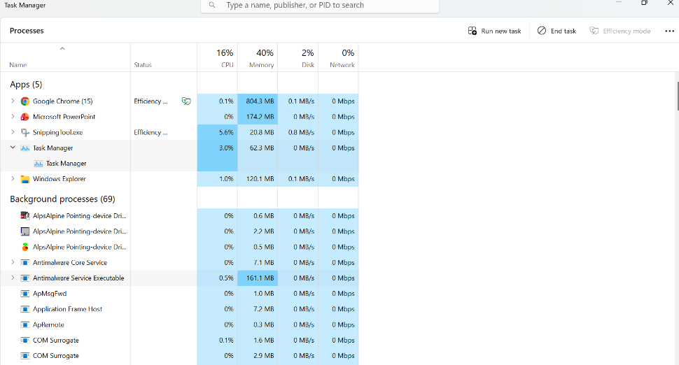
Figure 1: task management

Application/Program Management:
Windows devices power critical operations across industries. But as businesses grow and workplace models evolve, managing applications on these devices becomes a challenge that demands modern solutions.
Windows Application Management refers to managing and controlling applications’ deployment, configuration, maintenance, and security on Windows-based devices. It encompasses a range of tasks designed to ensure that applications are properly installed, updated, and optimized for performance while maintaining compliance with organizational policies.
With the increasing complexity of enterprise IT environments, Windows Application Management ensures employees access the tools they need while safeguarding the system. This includes managing licenses, enforcing security protocols, handling app updates, and ensuring the right applications are installed on the right devices [4].
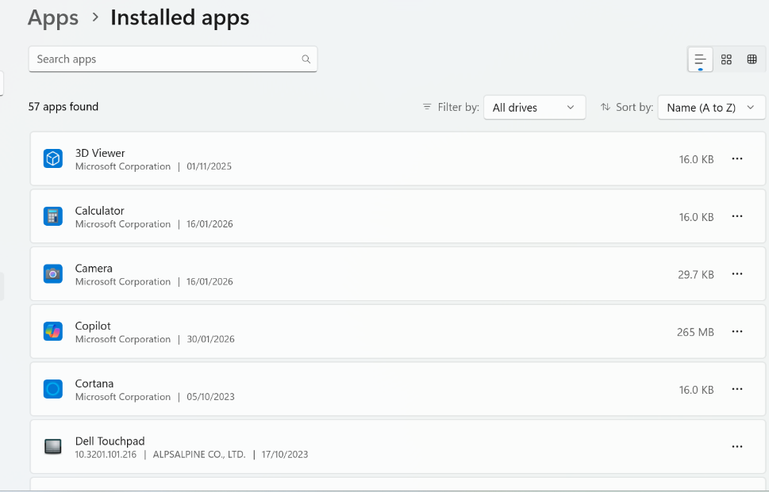
Figure 2: program management

File/Directory Management:
File management is the practice of organising, storing, naming, securing, and retrieving files to ensure easy and efficient access. It helps users locate information quickly, reduce errors, and save valuable time. Proper file management also improves data security, ensures better compliance, and supports smooth workflows across systems.
File management means keeping your digital files organised and easy to find. It includes saving them in the right folders, giving them clear names, and deleting ones you don’t need. You can also back up important files to avoid losing them and set permissions to keep private information safe. It saves time, helps you work faster, and keeps your computer neat and secure.
It becomes especially important in collaborative environments, where multiple people need access to the same files in an organised way. It saves time, boosts productivity, ensures data security, and helps maintain a clean digital workspace [5].

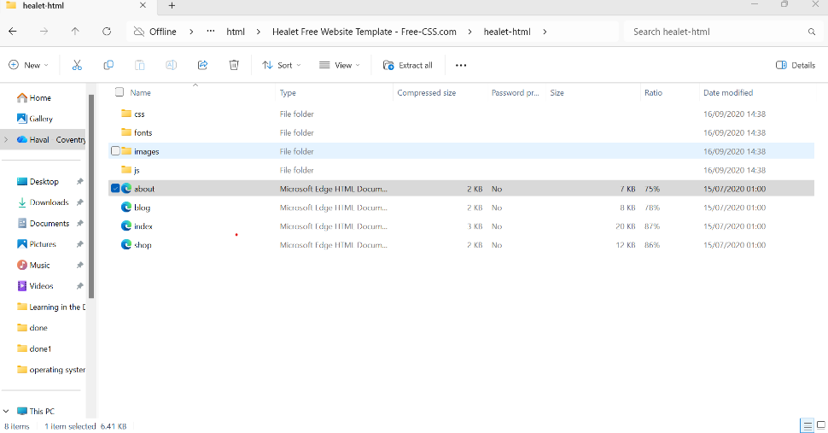
Figure 3: File manager

Device Management:
windows management is a staple of IT operations, yet the transition from legacy on-premises setups to cloud-native environments remains a significant hurdle. Relying on Group Policy Objects (GPOs) and local Active Directory often leaves remote devices unpatched and vulnerable when they aren't connected to the corporate network.
Modern Windows MDM solves this by shifting management to the cloud. It allows IT teams to automate configurations, enforce security protocols, and deploy software over the air, regardless of where the device sits. This shift doesn't just simplify the tech stack; it ensures that your security posture remains consistent across a distributed workforce without the manual overhead of traditional imaging or VPN-reliant updates [6].
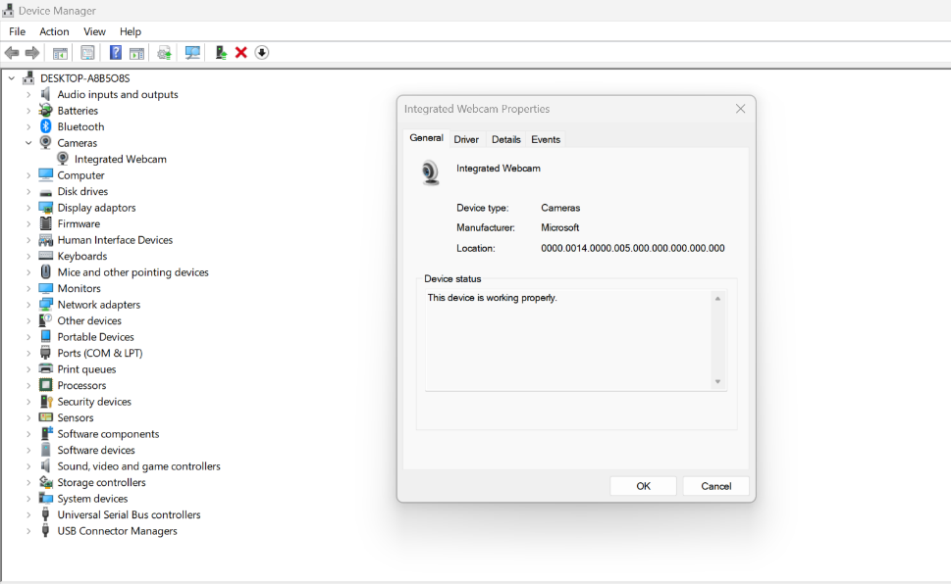
Figure 4: device management

Security Management:
Windows security refers to the built-in set of protection tools and controls included in Microsoft Windows operating systems. These tools are designed to safeguard devices, data, users, and networks against cyber threats.
Windows Security combines multiple security capabilities into a centralized interface, making it easier for users and administrators to manage protection without relying solely on third-party software.
The importance of windows security has grown significantly over the last decade.
1. Windows Is the Most Targeted OS
Because Windows dominates enterprise environments, attackers focus their efforts there.
2. Endpoints Are the Primary Attack Vector
Most breaches begin with:
- Phishing emails
- Malicious downloads
- Compromised credentials
3. Hybrid and Remote Work Expand Risk
Employees now access corporate systems from home networks and personal devices [7].

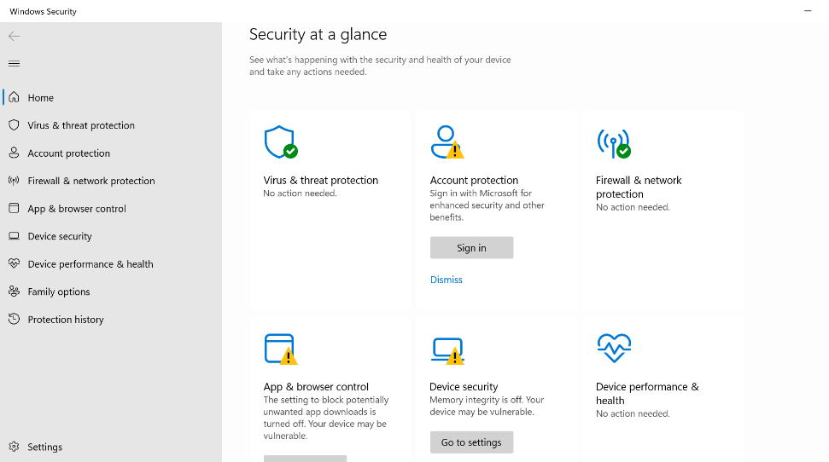
Figure 5: windows security

Use of Windows OS CLI commands
Windows CLI functions, A command line interface is a text-based way of communicating with your computer's applications by typing commands. The first CLI was created by Steve Bourne in the 60's for the early Unix systems, before the advent of graphical user interfaces (GUIs) [8].
A command line interface (CLI) is a text-based interface where you can input commands that interact with a computer’s operating system. The CLI operates with the help of the default shell, which is between the operating system and the user.

CLI shell
A shell refers to a program that is an intermediary between the user and the operating system. Examples include Bash, cmd.exe, PowerShell, and others for more specific functions.

Example 1:
Dir for showing the folders, we typed the user name > dir and it will act as a computer command in windows and after when we press enter it will list all the files and folders for us, we use dir for listing all the folders and files for us.
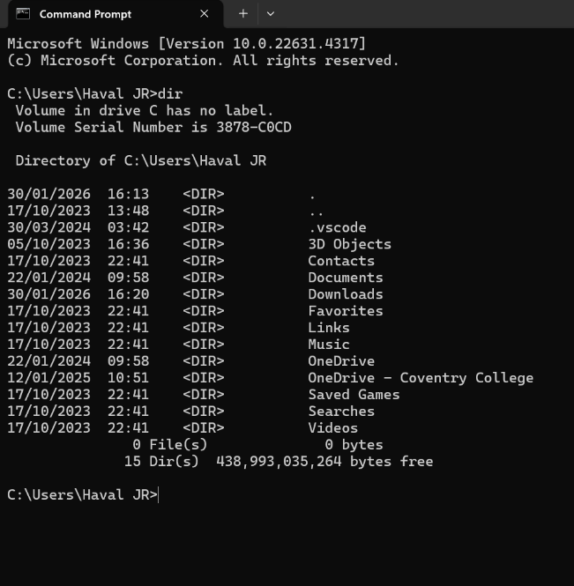
Figure 6: DIR

Example 2:
Cd for searching for documents or change directory it be used for moving between folder, cd and name of the folder then press enter it will open the folder for you, for going back we type cd.. and press enter it will take us to the previous folder

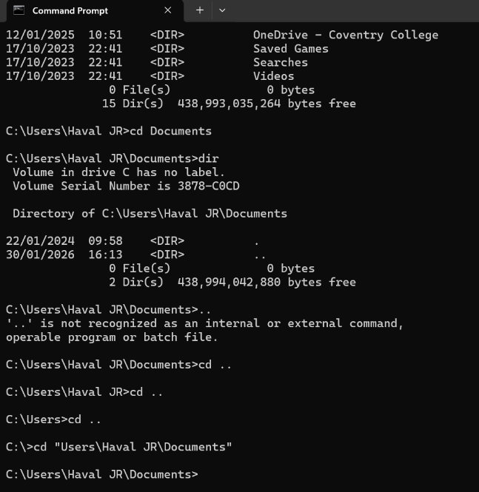
Figure 7: CD

Example 3:
Using mkdir for creating folders and when you want make multipole folders at once you just need give one space between each folders name, if you give 2 names for a folder will make 2 folders, so in this case you need put the name between “”.
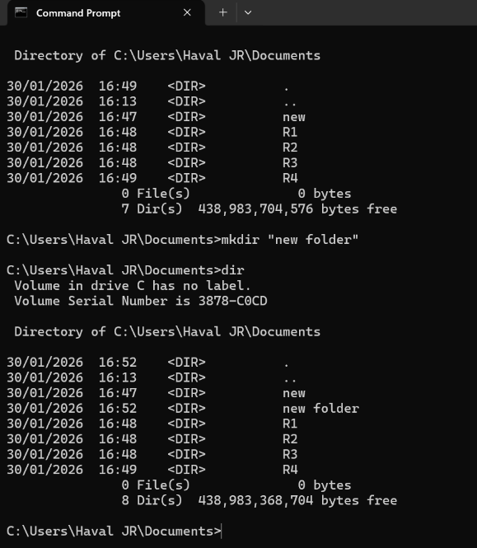
Figure 8: mkdir

Example 4:

Rmdir for deleting folder, when we want to delete a file or folder we need to type rmdir and name of the folder and press enter it will delete the folder for us, to make sure that the folder has been deleted we need to type dir and press enter it will show you all the folder and when the folder is not there you it has been deleted.

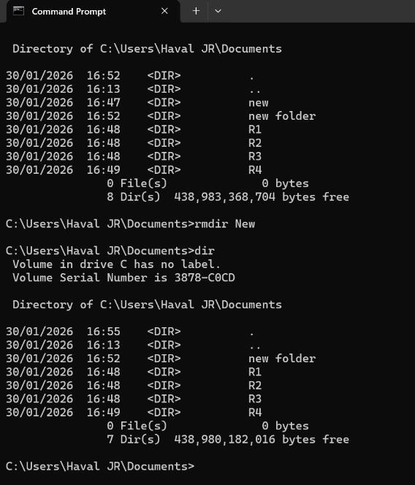
Figure 9: rmdir

Example 5:
WordPad is
a basic, free word processing program included with Microsoft Windows since Windows 95, designed for creating and editing text documents it offers more formatting options than Notepad (such as rich text, fonts, and image insertion) but is less advanced than Microsoft Word
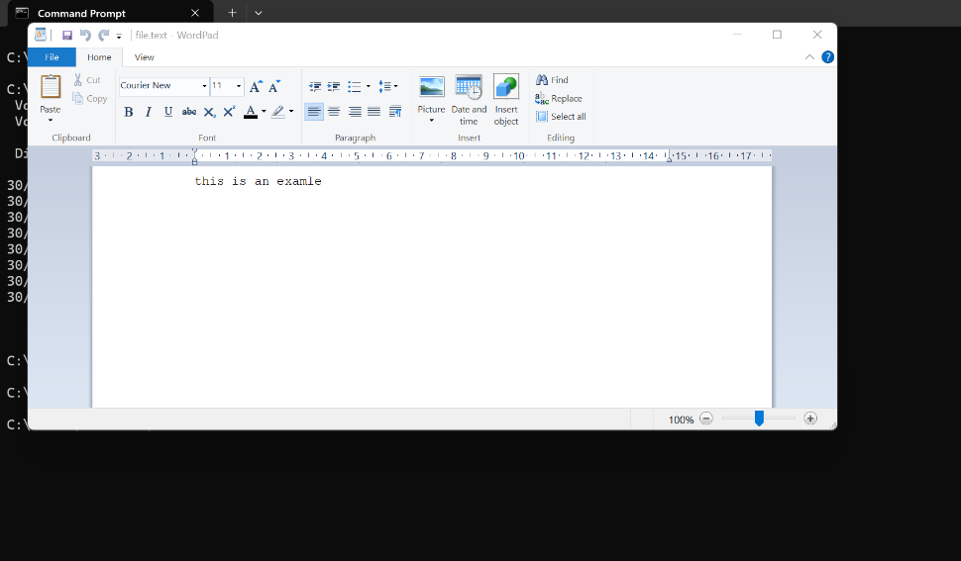
Figure 10: echo

Example 6:

Microsoft task list to list all the processes that are running and the memory usage, PID, we need to type the folder name >tasklist and press enter it will show us the image name, PID session name and memory usage.
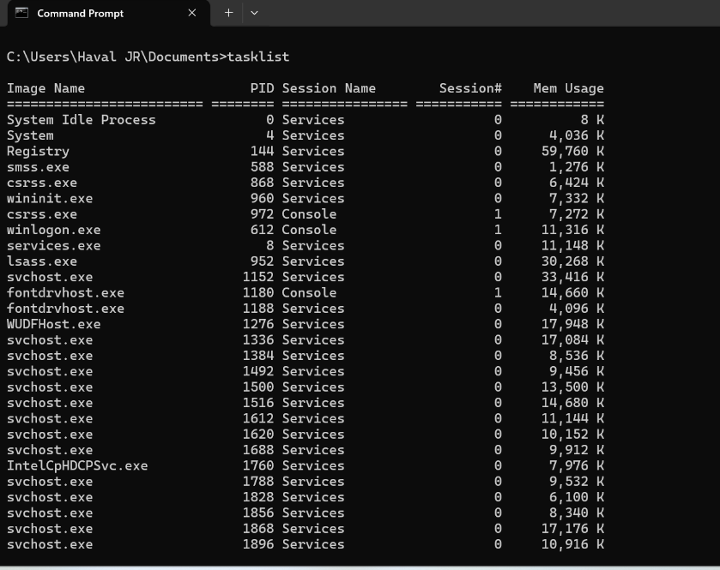
Figure 11: tasklist

Example 7:
Systeminfo will displays detailed information about a computer and operating system, for displaying all the information we need to type the folder name >systeminfo and press enter to show you all the information, including operating system configuration, security information, product ID, and hardware properties (such as RAM, disk space, and network cards).
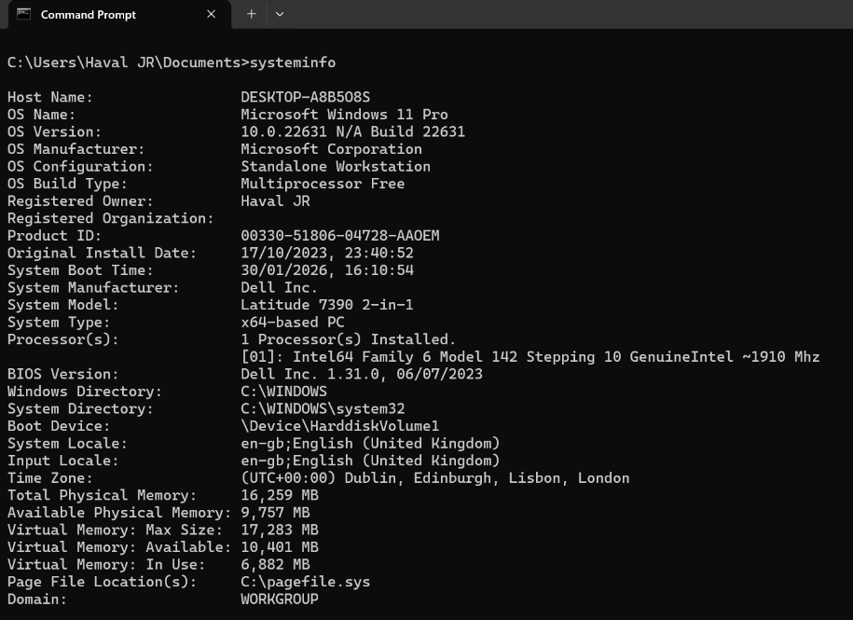
Figure 12: systeminfo

Example 8:
The ipconfig /all command is a Windows command-line utility that displays detailed network configuration information for all adapters, including active, inactive, and virtual ones. It provides essential data like IP addresses (IPv4/IPv6), subnet masks, default gateways, MAC addresses (Physical Address), DHCP status, and DNS servers.
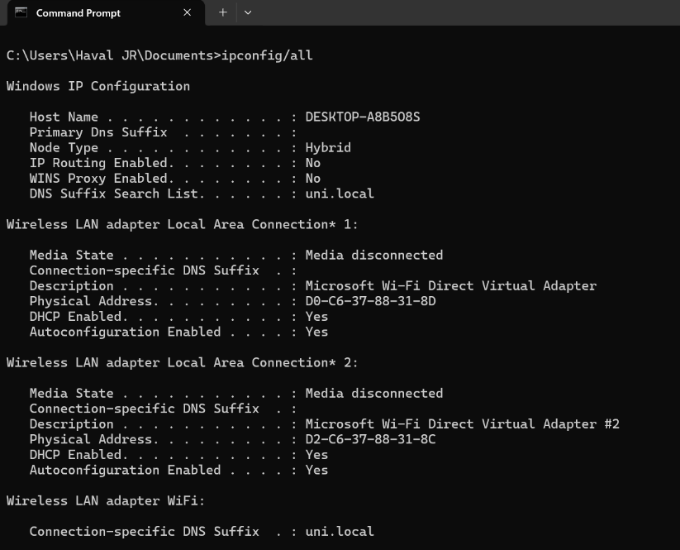
Figure 13: ipconfig

Example 9:
The ping command is a network utility tool used to test connectivity between a source and a destination IP address or domain name. It operates by sending ICMP Echo Request packets and measuring response times (latency) and packet loss, confirming if a device is reachable. It is available on Windows, macOS, and Linux.
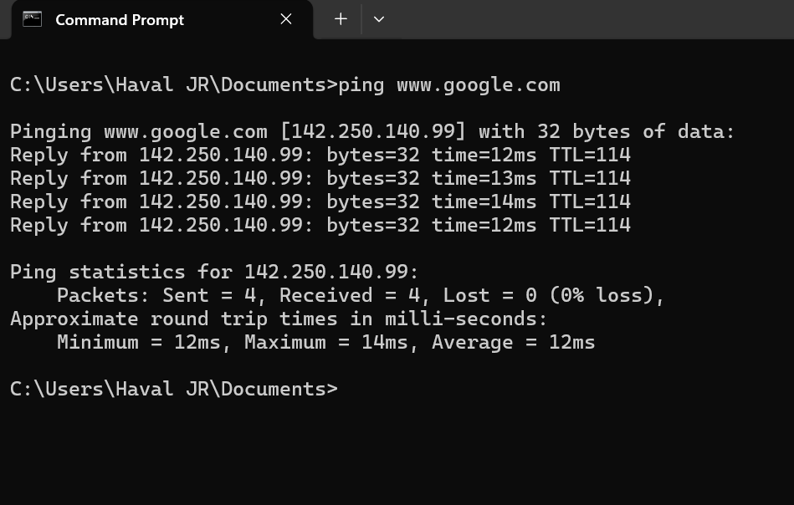
Figure 14: ping

Example 10:
The netstat command displays the contents of various network-related data structures for active connections. This netstat function shows the state of all configured interfaces.
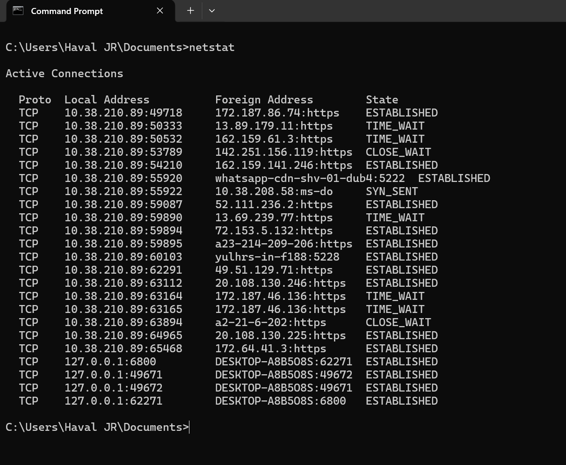
Figure 15: netstat

Use of Linux OS CLI commands

Example 1:
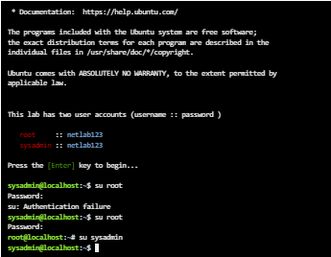
Figure 16: SU

Example 2:
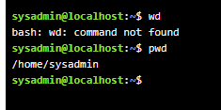
Figure 17: Pwd

Example 3:
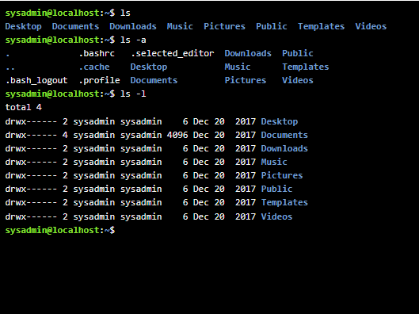
Figure 18: LS

Example 4:
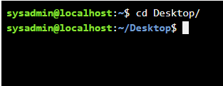
Figure 19: CD

Example 5:
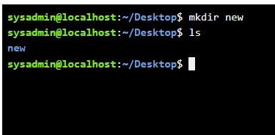
Figure 20: MKDIR

Example 6:
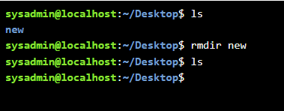
Figure 21: RMDIR

Example 7:
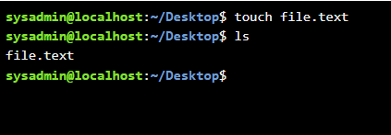
Figure 22: TOUCH

Example 8:
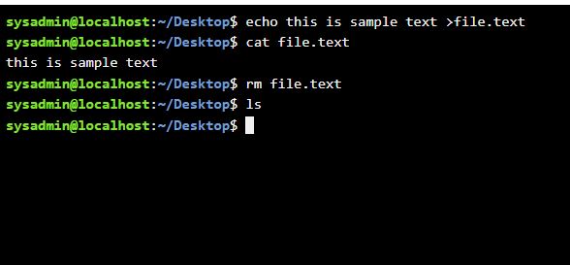
Figure 23: ECHO, CAT, RM

Example 9:
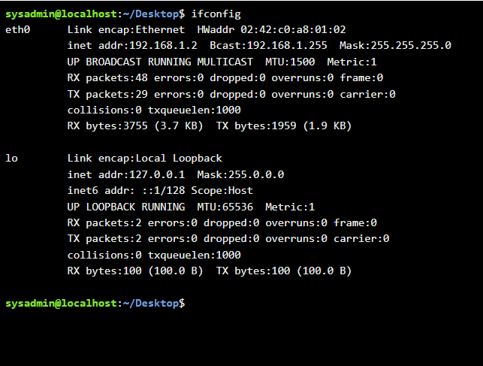
Figure 24: IFCONFIG

Example 10:
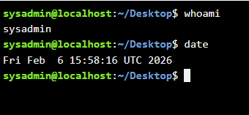
Figure 25: Whoami, date

Use of Windows OS scripts

Example 1:
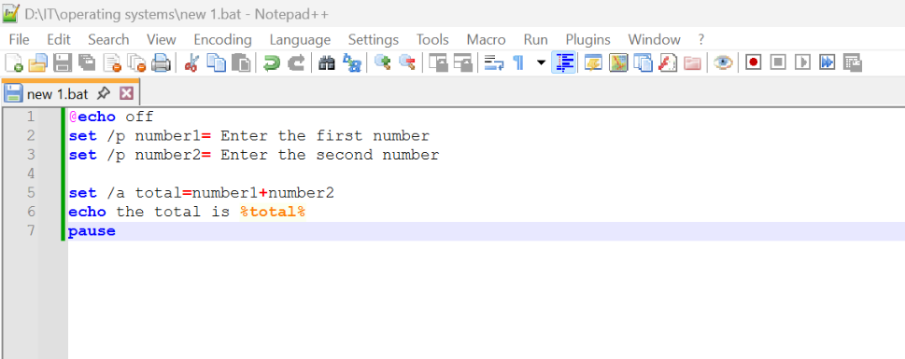
Figure 26: adding 2 number
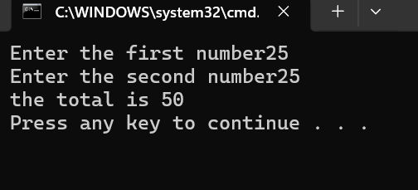
Figure 27: adding 2 number

Example 2:
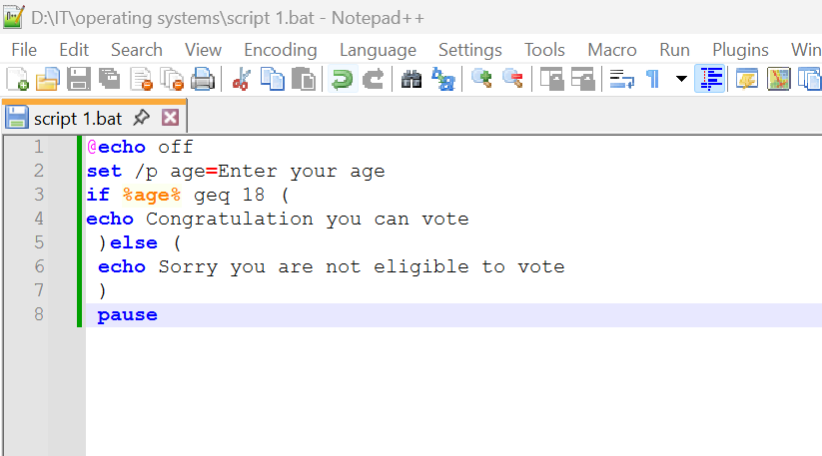
Figure 28: voting
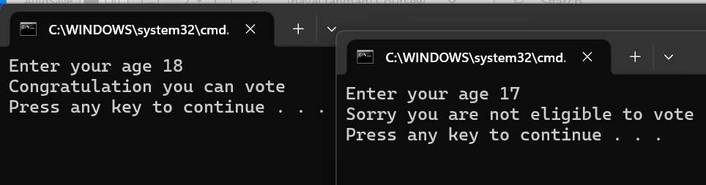
Figure 29: Description

Use of Linux OS scripts

Example 1:
Ferst go to cd Desktop/ then type nano script.sh as extension
To save the file control x the Y to save the file and enter
Then to give permission to use the file as app we write chmod +x script.sh then enter after write LS to see if its saved as app,
Then type ./script.sh and enter then it will ask you to enter the first number then enter the second number and enter then it will give the total of the 2 numbers0
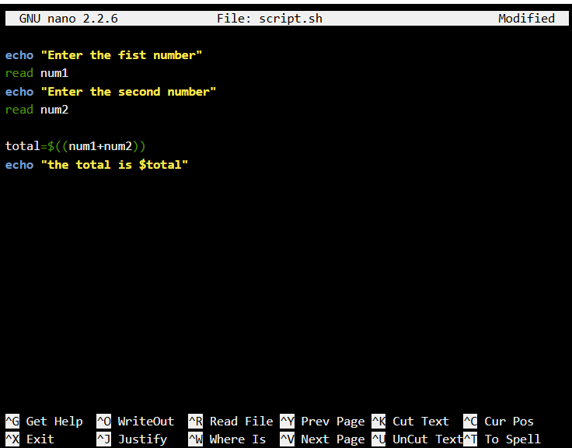
Figure 30: Bash crips to add 2 number
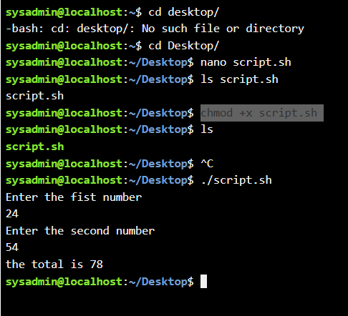
Figure 31: bash adding 2 numbers

Example 2:
For loop
Initial value
final value <= 10
increment =1
then put nano loop.sh to create new file ,then type, for ((i=1; i<=10; i=i+1)) ,then type do then echo “$i” then type done, to give permission by typing chmod +x loop.sh then LS and after /loop.sh

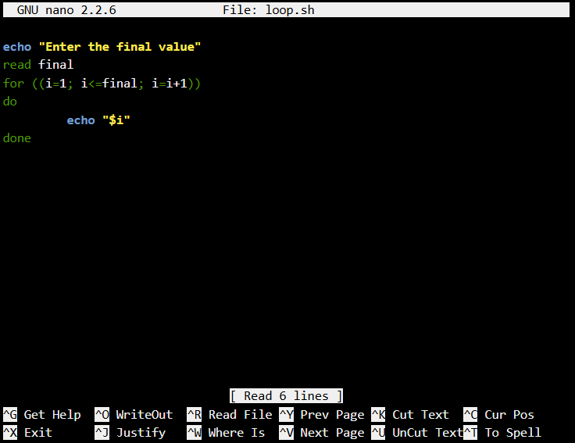
Figure 32: bash script for loop
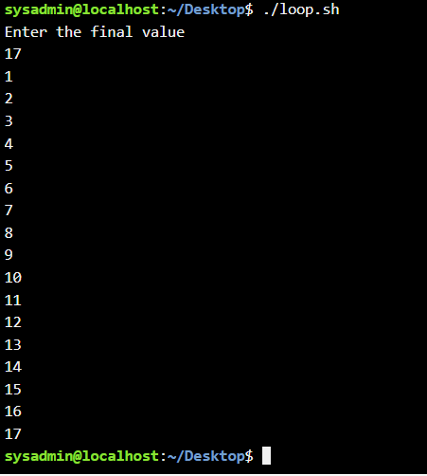
Figure 33: Description

Conclusion

Appendices
Online Course name: Operating Systems Basics
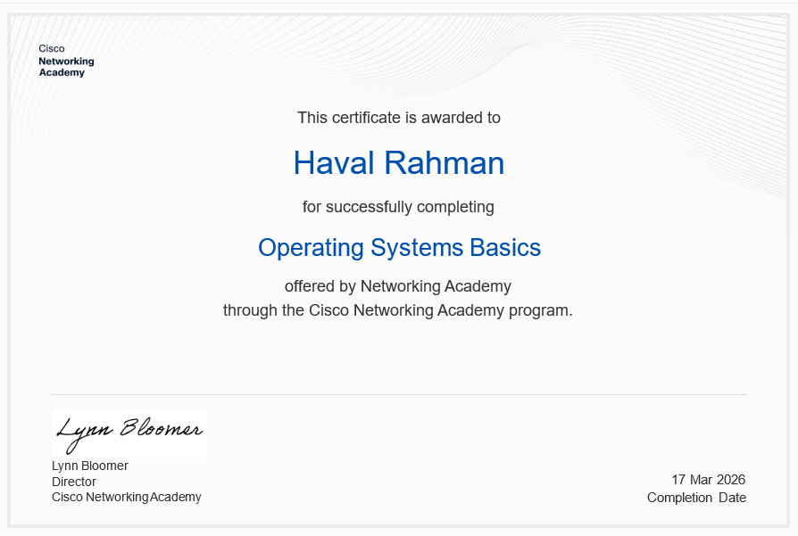
Figure 34: Certificate of completion

