Food and Beverage Operations (BMIH4002)

Cristian Florian Olaru (2025410)

Lecturer: Ryan Peters

Table of Contents
“The look of the menu” 3
“A limited number of dishes” 4
“Minimum of 2 wine pairings with specific dishes” 6
“A suitable price-point that reflects the location and offering” 7
"What information is needed on a menu (Allergens statement, vegetarian/vegan symbol etc., food hygiene statement, calories per dish). Some of these are legal requirements whilst others are recommended / optional" 10
“Contact details – how do they place an order? Telephone? JustEat or UberEats etc. / specific website” 11
"Instructions if a collection is an option – where does the guest need to go to collect? What are the collection guidelines considering Covid-19?" 11
“Contactless delivery? If this is an option, then you won’t be accepting cash” 12
“Payment Options – what are they?” 12
“Beverages – be sure to state the measurements along with descriptive text that helps to describe and sell the items” 12
“Menu planning fundamentals – Consider the menu engineering Typsy tutorials. Have you hidden your pricing? Have you included descriptive language to help sell your menu items? Have you considered the local element?” 13
Reference List 14

“The look of the menu”
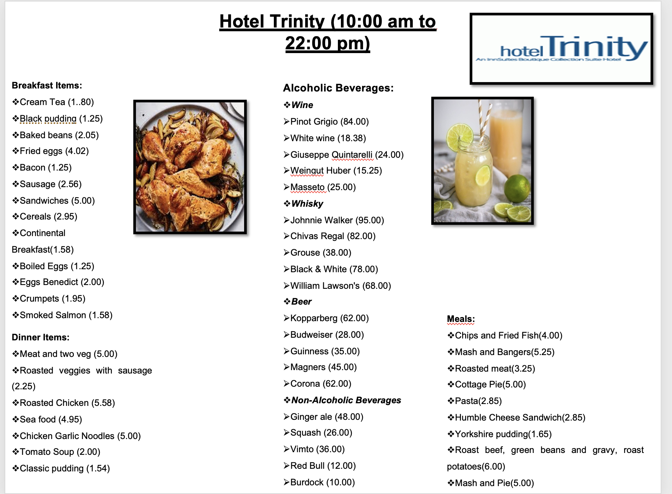

“A limited number of dishes”
Breakfast Items:
- Cream Tea
- Black pudding
- Baked beans
- Fried eggs
- Bacon
- Sausage
- Sandwiches
- Cereals
- Continental Breakfast
- Boiled Eggs
- Eggs Benedict
- Crumpets
- Smoked Salmon
Meals:
- Chips and Fried Fish
- Mash and Bangers
- Roasted meat
- Cottage Pie
- Pasta
- Humble Cheese Sandwich
- Yorkshire pudding
- Roast beef, green beans and gravy, roast potatoes
- Mash and Pie
Dinner Items:
- Meat and two veg
- Roasted veggies with sausage
- Roasted Chicken
- Seafood
- Chicken Garlic Noodles
- Tomato Soup
- Classic pudding
Alcoholic Beverages:
- Wine
- Pinot Grigio
- White wine
- Giuseppe Quintarelli
- Weingut Huber
- Masseto
- Whisky
- Johnnie Walker
- Chivas Regal
- Grouse
- Black & White
- William Lawson's
- Beer
- Kopparberg
- Budweiser
- Guinness
- Magners
- Corona
Non-Alcoholic Beverages:
- Ginger ale
- Squash
- Vimto
- RedBull
- Burdock

“Minimum of 2 wine pairings with specific dishes”
In order to maintain a huge consumer base, Hotel Trinity could provide some combo dishes with alcoholic beverages. Some of the combo dishes that could be delivered are listed below-
- Chips and Fried Fish with Smoked Salmon and Pinot Grigio
- Roasted Chicken with oregano and lemony potato with Giuseppe Quintarelli

“A suitable price-point that reflects the location and offering”
Considering the location, Swansea, South Wales, the price point of the items mentioned below-
Food Items | Price
Cream Tea | £1.80
Black pudding | £1.25
Baked beans | £2.05
Fried eggs | £4.02
Bacon | £1.25
Sausage | £2.56
Sandwiches | £5.00
Cereals | £2.95
Continental Breakfast | £1.58
Boiled Eggs | £1.25
Eggs Benedict | £2.00
Crumpets | £1.95
Smoked Salmon | £1.58
Chips and Fried Fish | £4.00
Mash and Bangers | £5.25
Cottage Pie | £3.25
Pasta | £5.00
Humble Cheese Sandwich | £2.85
Yorkshire pudding | £1.65
Mash and Pie | £1.00
Roast beef, green beans and gravy, roast potatoes | £6.00
Meat and two veg | £5.00
Roasted veggies with sausage | £2.25
Roasted Chicken | £5.58
Seafood | £4.95
Chicken Garlic Noodles | £5.00
Tomato Soup | £2.00
Classic pudding | £1.54
Pinot Grigio | £84.00
White wine | £18.38
Giuseppe Quintarelli | £24.00
Weingut Huber | £15.25
Masseto | £25.00
Johnnie Walker | £95.00
Chivas Regal | £82.00
Grouse | £38.00
Black & White | £78.00
William Lawson's | £68.00
Kopparberg | £62.00
Budweiser | £28.00
Guinness | £35.00
Magners | £45.00
Corona | £62.00
Ginger ale | £48.00
Squash | £26.00
Vimto | £36.00
RedBull | £12.00
Burdock | £10.00
Chips and Fried Fish with Smoked Salmon and Pinot Grigio | £64.00
Roasted Chicken with oregano and lemony potato with Giuseppe Quintarelli | £55.00
Table 1: Price-point of Items
(Source: Self-developed)

"What information is needed on a menu (Allergens statement, vegetarian/vegan symbol etc., food hygiene statement, calories per dish)? Some of these are legal requirements whilst others are recommended / optional”
Fried eggs: Fried eggs have a minimum of 109 calories. Considering the nutritional facts, fried eggs have “0.3g totals carbs, 0.3g net carbs, 5.6g fat, 4.7g protein” (Egginfo, 2022). Apart from that, Hotel Trinity also maintains hygiene statements such as “storing the eggs in a refrigerator with 10℃”.
Roasted meat: Roasted meat carries “0g total carbs, 0g net carbs, 1.8g fat, 5.9g protein, and 41 calories” (Healthyeating, 2018). Hotel Trinity maintains the hygiene statement like “store the meat in the refrigerator with 0°F (-17.8°C)”.
Smoked Salmon: Smoked Salmon carries “117 calories, 18 grams protein, and 4 grams fat” (Healthline, 2020). Hotel trinity produced the dish without heating or cooking in order to maintain the hygiene statement.
Bacon: Bacon carries “46 calories, 1.6g fat, 9 mg Cholesterol, and 0.1 g total Carbohydrate” (Calorieking, 2022). Hotel Trinity does not produce raw bacon as raw bacon does not maintain hygiene statements.
“Time availability – when is the menu available?”
The combo items of Hotel Trinity will be exclusive and henceforth, the hotel management will create time availability. Regarding the combos “Chips and Fried Fish with Smoked Salmon and Pinot Grigio” and “Roasted Chicken with oregano and lemony potato with Giuseppe Quintarelli", the time availability will be 18:00 pm to 22:00 pm. On the other hand, regarding the other fundamental menus, the time availability will be 10:00 am to 22:00 pm.

“Contact details – how do they place an order? Telephone? JustEat or UberEats etc. / specific website”
Regarding the order, Hotel Trinity will focus on online food delivery applications like JustEat or UberEats. Nowadays, considering the Covid-19 pandemic scenario, customers prefer the usage of different food delivery applications (Pal et al. 2021, p.1). On the other hand, Hotel Trinity will create an option of ordering the foods through their own food delivery website. However, considering some exclusive situations, the hotel will also make an option of telephonic order.

“Instructions if the collection is an option – where does the guest need to go to collect? What are the collection guidelines considering Covid-19?”
Hotel Trinity is highly concerned about the maintenance of Covid-19 guidelines. Henceforth, considering the scenario of Covid-19, the management of Hotel Trinity will develop a separate desk to maintain the food takeaways. In the context of the guideline, customers have to use masks as well as have to maintain social distance in the queue in order to collect the food. Moreover, before collecting the foods, customers have to sanitize their hands properly.

“Contactless delivery? If this is an option, then you won’t be accepting cash”
Considering the scenario of Covid-19, Hotel Trinity will focus on contactless delivery. In order to contactless delivery, Hotel Trinity will create a unique QR code for every room of the hotel. However, the QR codes will be properly linked with the digital menu and the R & D section of the hotel will incorporate the digital menu with the ordering system.

“Payment Options – what are they?”
The payment options in Hotel Trinity, a 4* star hotel could vary. One of the primary ways of getting paid would-be cash payment at the counter. However, the pandemic times have rendered hotels to go cashless. Therefore, in Hotel Trinity, payment via Paypal and Razorpay, will be the preferred modes of payment for the consumers. Moreover, payment through token systems and gift vouchers could help to promote offers to consumers.

“Beverages – be sure to state the measurements along with descriptive text that helps to describe and sell the items”
Alcoholic Beverages:
Wine
- Pinot Grigio: Lemon-lime, Apple, Citrus, Almond, Honeysuckle, Honey, apricot, and Stone fruit and the alcohol percentage are to 12.5% to 13.5%.
- White wine: White wine is mainly made with black or white grapes and the alcohol percentage is 5% to 14%.
- Giuseppe Quintarelli: A lot of ingredients such as “55% Corvina, 15% Rondinella, 30% Corvinone” and the alcohol percentage is 17%
Whisky
- Johnnie Walker: The whisky is made with a combination of grain whiskies and malt whiskies and the alcohol percentage is above 40%.
- Chivas Regal: Made with grain and malt Scotch whiskies and the alcohol rate is 43%.
- Grouse: It's a blend of exceptional and finest malts grain whiskies which have a natural character and the alcohol rate of the whisky is 40%.
Beer
- Guinness: The well-known beer made with “water, barley, roast malt extract, hops, and brewer's yeast”. The alcohol rate of the beer is 4.2%.
- Budweiser: “Water, barley malt, rice, yeast and hops” are the main ingredients and the alcohol rate is 5%.
- Corona: The beer is made with “filtered water, corn, yeast, hops and malted barley” and the alcohol percentage is 4.5%.

“Menu planning fundamentals – Consider the menu engineering Typsy tutorials. Have you hidden your pricing? Have you included descriptive language to help sell your menu items? Have you considered the local element?”
The 4* hotel, Hotel Trinity do not hide their pricing as consumers could comfortably order their menus based on their affordability. Hotel Trinity has kept a simple menu so that consumers from every income range can easily comprehend which products the hotel serves. In order to cut down on the cost of the product to maintain a lower pricing range, Hotel Trinity sources its resources locally. Considering the outbreak of the Covid-19 pandemic, which has negatively impacted the purchasing power of the local consumers, Hotel Trinity could devise a penetration pricing policy that provides the formation of products at a nominal pricing rate.

Reference List
Calorieking, 2022. Bacon, broiled or pan-fried [Online]. Available at: <https://www.calorieking.com/us/en/foods/f/calories-in-pork-bacon-broiled-or-pan-fried/zxhpcaQUQM-zCxyIqBtt-Q> [Accessed on: 3rd February 2022].
Egginfo, 2022. Calories in an egg [Online]. Available at: <https://www.egginfo.co.uk/egg-nutrition-and-health/egg-nutrition-information/calories-in-an-egg#:~:text=It%20is%20often%20recommended%20to,oil%20and%20not%20draining%20it.> [Accessed on: 1st February 2022].
Healthline, 2020. Everything You Need to Know About Smoked Salmon [Online]. Available at: <https://www.healthline.com/nutrition/smoked-salmon-calories> [Accessed on: 5th February 2022].
Healthyeating, 2018. Health Value of Roast Beef [Online]. Available at: <https://healthyeating.sfgate.com/health-value-roast-beef-4242.html> [Accessed on: 29th January 2022].
Pal, D., Funilkul, S., Eamsinvattana, W. and Siyal, S., 2021. Using online food delivery applications during the COVID-19 lockdown period: What drives University Students’ satisfaction and loyalty?. Journal of Foodservice Business Research, pp.1-45.

