Pupil Card 1
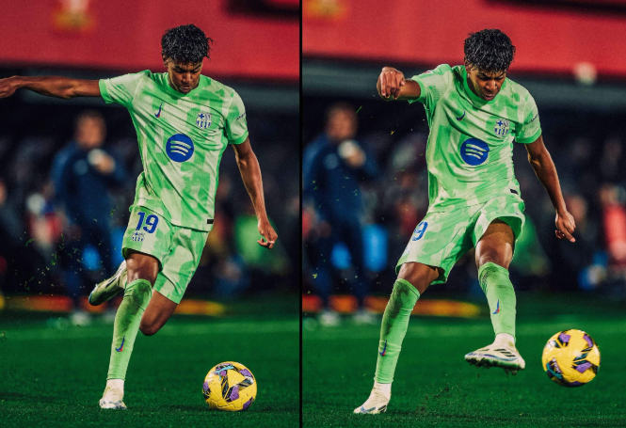

Skill | Directions | Performance Criteria | 1st | 2nd | 3rd
Trivela pass | - Kick football at target using the outside of your foot.  - Make sure to finish the movement with your leg up high.  - Tick the boxes of the criteria achieved.  - Perform the kick 3 times. | - Approach the ball from the side rather than the front.  - Plant non-kicking foot further away from ball to allow yourself enough space.  - Stike the outside of the ball with the outside of your foot, keeping your ankle locked upon contact.  - Follow through the ball with your leg finishing high to achieve the desired curve and power.

Teacher Card 1
Skill | Equipment | Directions | Performance Criteria | Score (0-5)
Trivela pass | - Large indoor/outdoor area with wall.  - Size 5 football | - Instruct pupils to kick football against a target on the wall.  - Ball should be hit on the outside with the outside of the foot.  - Looking for the leg to finish in a high position.  - Demonstrate activity, breaking down the mechanics. | - Keep eyes on ball for the full duration of the skill.  - Approach the ball from side angle.  - Non-kicking foot placed further away from ball  - Strike the outside of the ball with the outside of the kicking foot, ensuring that ankle is locked when making contact.  - Ball travels in a curved motion towards target with the kicking foot following through the ball and finishing high

Pupil Card 2

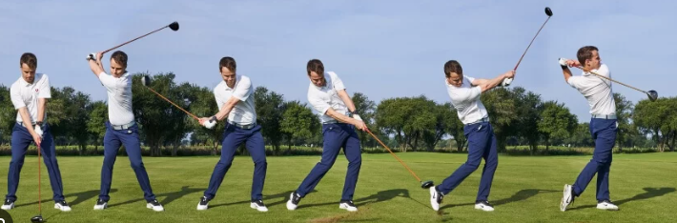

Skill | Directions | Performance Criteria | 1st | 2nd | 3rd
Driving off tee | - Stand over ball and use driver to hit ball off tee.  - Strike the center of the ball with the center of the club face  - Tick the boxes of the criteria achieved.  - Complete the shot 3 times | - Set up to the ball front foot adjacent to ball and back foot adjacent to shoulder.  - Grip the club with your dominant golf hand over the weaker one  - Bring the club back and high during the backswing  - Swing club towards the ball  - Follow through the ball, with your club finishing behind your head, front foot completely still and backfoot on its toes.

Teacher Card 2
Skill | Equipment | Directions | Performance Criteria | Score (0-5)
Driving off tee | - Large outdoor grass field  - Drivers  - Tees  - Golf balls | - Instruct pupils to hit a golf ball off a tee with a driver.  - Center of the ball should be struck with the center of the club face.  - Demonstrate action | - Stand over the golf ball with the correct foot position and grip on club.  - Look and aim club towards where the ball needs to go  - Perform a slow and controlled backswing, ensuring that the club has more of a curved path rather than a full vertical one.  - Once at the top of the backswing, swing down through the ball with power finishing with head down and backfoot on its toes.

Pupil Card 3

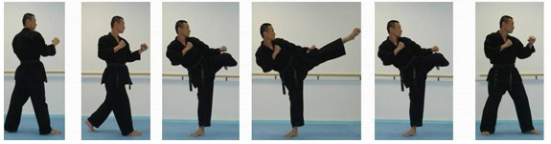

Skill | Directions | Performance Criteria | 1st | 2nd | 3rd
Rear leg roundhouse kick | - Get into your fighting stance.  - Bring knee up and kick through the target  - Tick the boxes of the criteria achieved  - Perform the kick 3 times | - Get into your correct fighting stance, with your strong leg further back than the weak leg in the front  - Raise your rear knee up bent and out to the side  - Extend your kicking leg and pivot your standing foot away from the target.  - Make contact with your kicking foot at the target  - Once the kick is completed bring your foot back into stance as it was before.

Teacher Card 3
Skill | Equipment | Directions | Performance Criteria | Score (0-5)
Roundhouse kick | - Safe controlled indoor or outdoor environment  - Partner  - Kickboxing pads | - Instruct pupils to kick a kickboxing pad held by their partner.  - Pad should be struck with either the top of foot or shin  - Demonstrate action slowly | - Start by standing in the correct fighting stance.  - Bring kicking knee up to prepare for kick  - Extend at the knee ensuring that standing foot has been pivoted  - Make contact with the pads with either foot or shin (depending on martial art)  - Bring kicking foot back into the correct stance.

Pupil Card 4

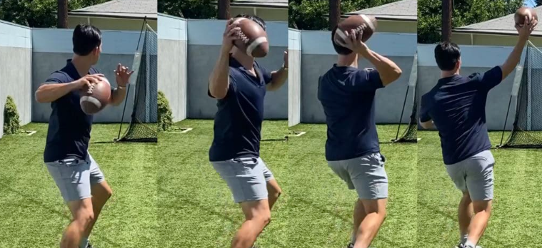

Skill | Directions | Performance Criteria | 1st | 2nd | 3rd
American football throw | - Stand with feet shoulder width apart and throw American football  - Throw hard using overhand action  - Tick the boxes of the criteria achieved  - Complete the throw 3 times | - Stand sideways with feet shoulder width apart and knees slightly flexed.  - Bring throwing arm back and through with a swift overarm motion  - When releasing ball, spin the ball with your fingers and utilize the whole body for power and distance.  - Follow through the ball to achieve the maximum distance you can

Teacher Card 4
Skill | Equipment | Directions | Performance Criteria | Score (0-5)
American football throw | - Large open outdoor space  - Size 9 American football | - Instruct pupils to throw an American football towards a target  - Ball should be thrown hard using their full body  - Demonstrate action clearly | - Eyes focused on the target ahead at all times.  - Stand side on with knees bent and feet shoulder width apart  - Bring ball behind head in preparation to throw.  - Bring ball to front of body and release  - Follow through the ball in target’s direction, using full body to generate power.

Pupil Card 5

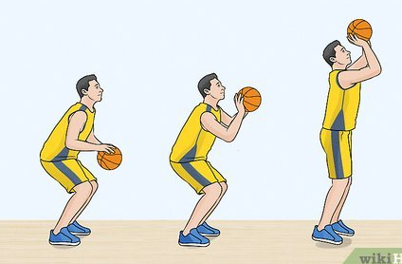

Skill | Directions | Performance Criteria | 1st | 2nd | 3rd
Free throw | - Stand with dominant side facing the center of the ring.  - Throw the basketball towards the hoop.  - Tick boxes of the criteria achieved  - Complete the throw 3 times | - Stand behind the free throw line, keeping eyes on the hoop at all times  - When shooting bend knees and extend them in preparation for the release of the ball  - Snap wrist to follow through the shot to propel the ball towards basket

Teacher Card 5
Skill | Equipment | Directions | Performance Criteria | Score (0-5)
Free throw | - Indoor or outdoor area  - Basketballs  - Basketball hoops | - Instruct pupils to shoot a free throw towards hoop  - Pupils should stand still, using their legs to spring up  - Demonstrate activity slowly | - Focus eyes on the hoop rather than the ball  - Bend at the elbows and knees when preparing to take the shot  - Extend the elbows and knees and exhale during the release of the ball  - Follow through the ball using your wrist to propel the ball towards the hoop.

