^{Student Name:- Jahangir Ali}
^{Student Number:- 1705535}
^{Lecturer:- Renuga Jayakumar}

Digital Skills and Research Methods

Total words 2091

Table of Contents
Introduction 1
1. Definition and Example of Modern Technologies 2
2. Effectiveness of the Use of Modern Technologies within the Workplace 3
3. Use of Social Media as a Tool for Marketing, Information Gathering and Communication 6
4. Creating Own Professional Online Presence 9
Conclusion 12
References 13

Table of Figures
Figure 1: Use of Modern Technology 2
Figure 2: E-Commerce Trend in UK 4
Figure 3: Marketing Technologies Used by the Marketers 5
Figure 4: Trend of Internet Users in UK 6
Figure 5: Online Marketing 7
Figure 6: Use of Social Media by Marketers 8
Figure 7: Online Communication with Customers 9
Figure 8: Social Networking 10

Introduction
Advancement in information and technology has changed the shape of business activities that it was in the previous. Modern business organizations are now most information and technology oriented in performing their day to day business activities (Walker, 2010). Main objective of modern businesses are to serve better services to the customers within a short time and achieving the highest level of consumer satisfaction. Modern technology has enabled the business organizations to serve flawless and prompt services to the customers (DeHayes et al., 2014). This paper has made to describe the advancement of modern technology and its use in the modern business world. For the purpose of this assignment, use of modern technology has been shown on an UK based retail organization Tesco. Usage of modern technology has also been described in this paper.

1. Definition and Example of Modern Technologies
Modern business organizations are more technology oriented that they were before. New discoveries have make business operations more easy and less time consuming (DeHayes et al., 2014). Modern technology means the innovation of new technology which is used in the place of previous one. And modern technologies remove all the pitfalls of the old technologies. New inventions have made individual and business activities easier and prompt (Bentley and Forkner, 2015). Internet is one of the greatest inventions of modern science. This has boosted communication and information system. A huge number of people use internet as their main communication tool. Modern technologies also served mankind by providing them with computers, mobile phones and other gadgets. Human life has now become more dependent on all of these modern inventions of science and technology (Laudon and Traver, 2017). People in the previous ages were not so technology oriented that they have become in this modern era.
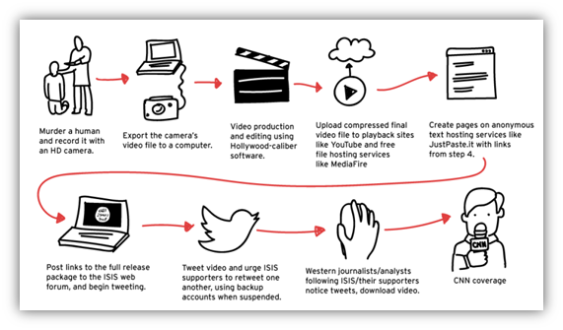
Figure 1: Use of Modern Technology
Source: (Laudon and Traver, 2017)
Activities of business organizations have greatly changed due to the new inventions in modern science and technologies (Boone, 2016). Following the marketing concept, business organizations now value their customers by providing the best quality services within less time consumption and less production cost (Ardalan, 2017). Modern technologies have made the business organizations able to do so. They can serve the customers in the best possible way to achieve the highest level of consumer satisfaction. Consumers become greatly satisfied with having the good quality product and service.
Modern technologies also have benefited the marketing activities of the business organizations. Business organizations can use online platform as their marketing tool (Munger, 2013). As a huge number of people are connected through internet, it facilitates the marketers to reach a huge number of potential customers (Nichols, 2012). For example, Tesco do their marketing their marketing activities through their website and other social networking sites. Tesco is one of the top retail organizations in United Kingdom. They also provide their customers with the opportunity of buying products online through their website. People can also contact with Tesco and give their feedback about Tesco in their websites and other social networking sites.

2. Effectiveness of the Use of Modern Technologies within the Workplace
Most of the business organizations in today’s business world are driven by the marketing concept. According to the marketing concept, it is believed that all the organizational operations, policies and strategies should be selected with a view to serve the customers in the best way (Ardalan, 2017). Consumers are considered as the king in the marketing concept. And modern technologies have enabled modern business organizations to serve the customers in the best possible way (Munger, 2013). They are using modern inventions of science and technology to achieve the highest level of consumer satisfaction which is the main target of operating modern businesses. Importance of modern technologies can be seen by focusing on the activities of modern business organizations. Most of the business organizations are now technology oriented (Nichols, 2012). Due to the advancement in science and technology, E-commerce and e-business activities as also flourished.
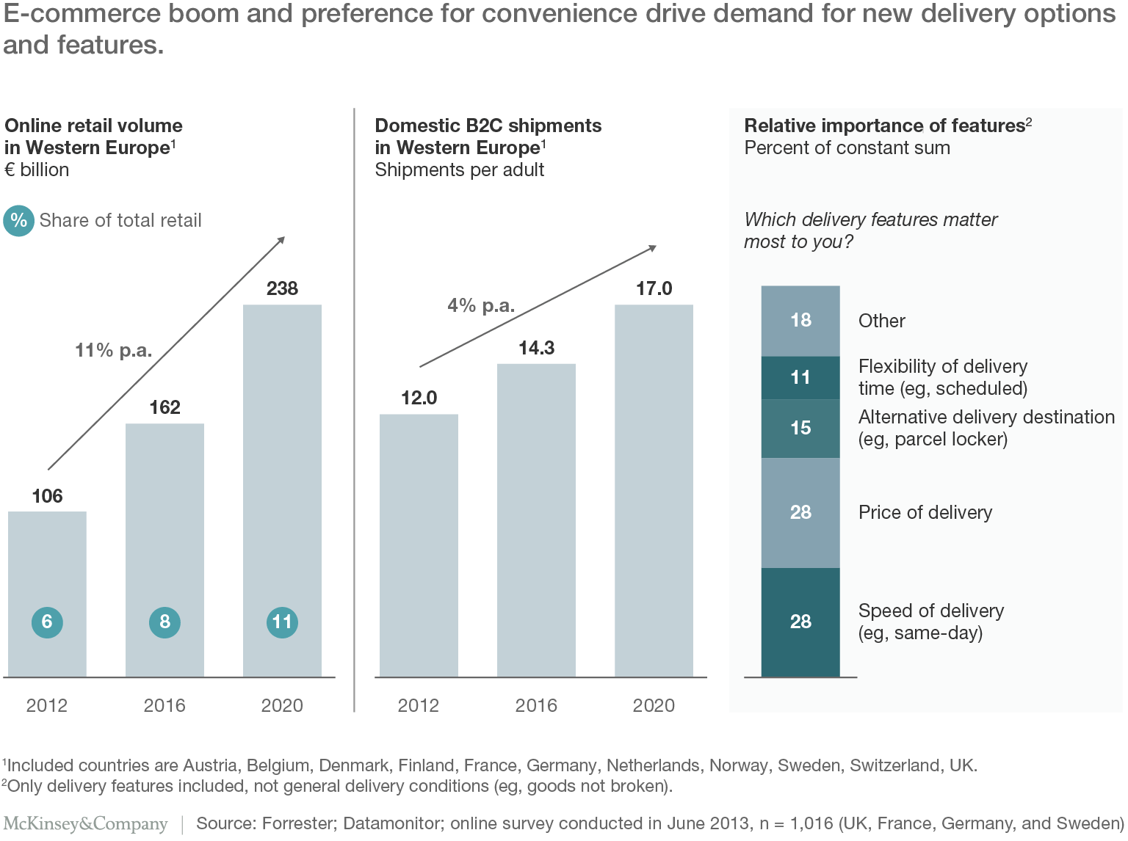
Figure 2: E-Commerce Trend in UK
Source: (the Guardian, 2017)
The above figure shows that there is an increasing trend in the e-business sector in the United Kingdom. And this trend is expected to be increased more in the upcoming years. The figure also shows the features and the reasons for which customers and other business parties are feeling interested in e-business. Modern technology has made it easier for the consumers to purchase any product or service (Nichols, 2012). By using internet, they can purchase products staying at home with a simple click rather than physically going to market.
Modern business organizations have found it necessary to use modern technologies in serving their customers. Using modern technologies make it possible for the firms to create their own brand name among its consumers (Walker, 2010). The below section has been evaluated the effectiveness of the use of modern technologies in the workplace.
Communication and Understanding
The most significant changes have been occurred in the field of communication due to the improvement in modern technology. Communication with several parties is one of the more important activities that modern business organizations do in day to day basis (DeHayes et al., 2014). Tesco as a retail organization uses telephone, email, websites and social Medias to communicate and to achieve better understanding with their customers, suppliers, employees and the other important business stakeholders.
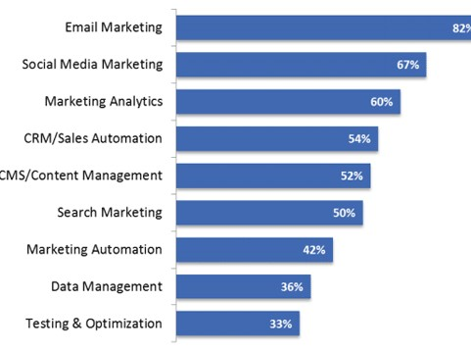
Figure 3: Marketing Technologies Used by the Marketers
Source: (Walker, 2010)
Employee Efficiency
Efficient employees can serve the customers in the best possible way. But efficiency level of all the employees is not the same. They need to be trained and educated related to their work. Inventions of modern technologies make the employers able to train the employees most efficiently (DeHayes et al., 2014). On the other hand, modern technologies also reduced the work load of the employees. Employees of Tesco can now serve their customers in the shortest possible time. They can take orders online from the customers and send products to their customers with minimum hassle.
Monitoring and Control
Success of business organization depends on proper monitoring and control. Modern technologies has made is it more easy for the managers to efficiently monitor and control the business operations (Bentley and Forkner, 2015). Tesco use modern technologies in collecting feedback from the consumers and then they make necessary improvements according to the consumer need. They take consumer feedback through their website and social media profiles. They also monitor the shifts in needs and demand of customers through social networking sites and control their product and service in that way.
Customer Service
Better service can be provided by the business organization using the modern technologies (Boone, 2016). Tesco can provide hassle-free and quick service to their customers by their online marketing system.

3. Use of Social Media as a Tool for Marketing, Information Gathering and Communication
In this age of information and technology, social Medias are being used in many ways by the business organizations as a tool for marketing, gathering information and communication (Laudon and Traver, 2017). A large number of people around the world are now using internet. Most of them are connected with their friends and family using social Medias. It has been found in statistics that about 4.5 billion people are using internet worldwide (the Guardian, 2017). And almost 3 billion of them use internet for being connected with one another through social Medias (BBC, 2017). Marketers can use this opportunity to grab a large number of customers by doing marketing activities through social media sites. Organization not only can advertise their product in social sites, but also communicate with different parties related to the business and gather information about them.
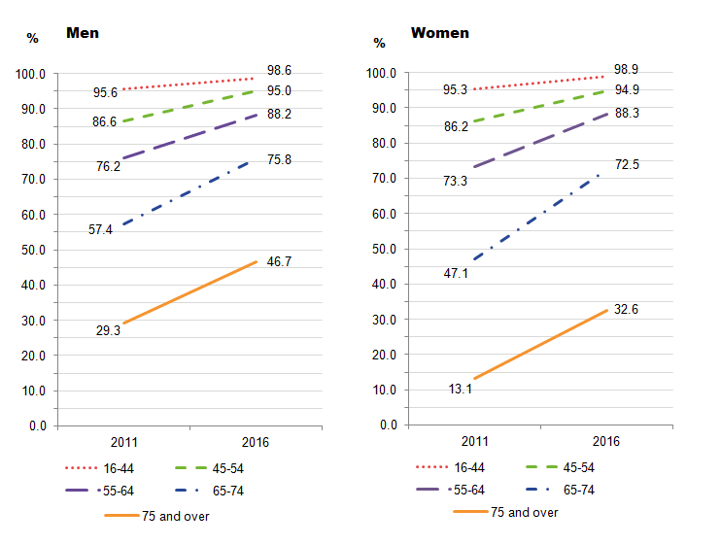
Figure 4: Trend of Internet Users in UK
Source: (Laudon and Traver, 2017)
The above figure shows that there exists an increasing trend in the use of internet among men and women in the United Kingdom. The number of internet users has been increased with a large number in the year 2016 than that was in the year 2011.
In this age of technology, customers are well aware about their needs and they know about the existing products that can fulfill their needs. They are well informed than they were in the previous time. Due to the change in technology and also for the globalization process, consumer demands also changes frequently (Bentley and Forkner, 2015). Business organizations have to be updated about the new trend in consumption and consumer behavior. Social Medias help organizations in this purpose (Ardalan, 2017). Tesco is one of the top retail organizations in the United Kingdom. They have become the market leader for providing the customers with the goods and services that they really want. In this case, social Medias can be a great tool for Tesco to gather information, and marketing process. They also can communicate with their customers, employees, suppliers, shareholders and the other important stakeholders by using social media. Importance of social media in marketing, communicating and information gathering process has been described in the following section.
Marketing
Using social Medias as a tool for marketing is not a new phenomenon. Many business organizations are using social sites to advertise their product (Ardalan, 2017). Tesco do their marketing activities using their website, Facebook, twitter and other social Medias.
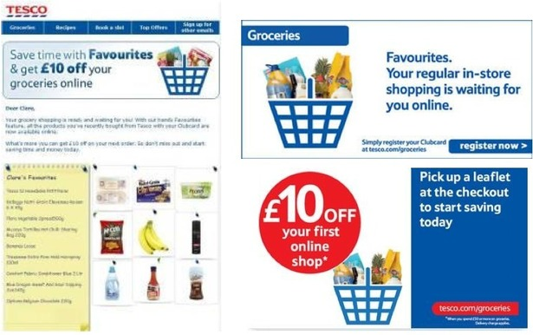
Figure 5: Online Marketing
Source: (Tesco, 2017)
The above picture is an example of Tesco’s online marketing. Tesco do online marketing to create need among customers and to pursue them to be a consumer of Tesco.
Information Gathering
Consumer needs and demands changes with different factors like social, economic, cultural and technological factors (Munger, 2013). It is unavoidable for the business organizations to regularly update their knowledge about consumer needs. Because, success of the business lies on the satisfaction of customers and that can be achieved by providing them with what the actually want (Boone, 2016).
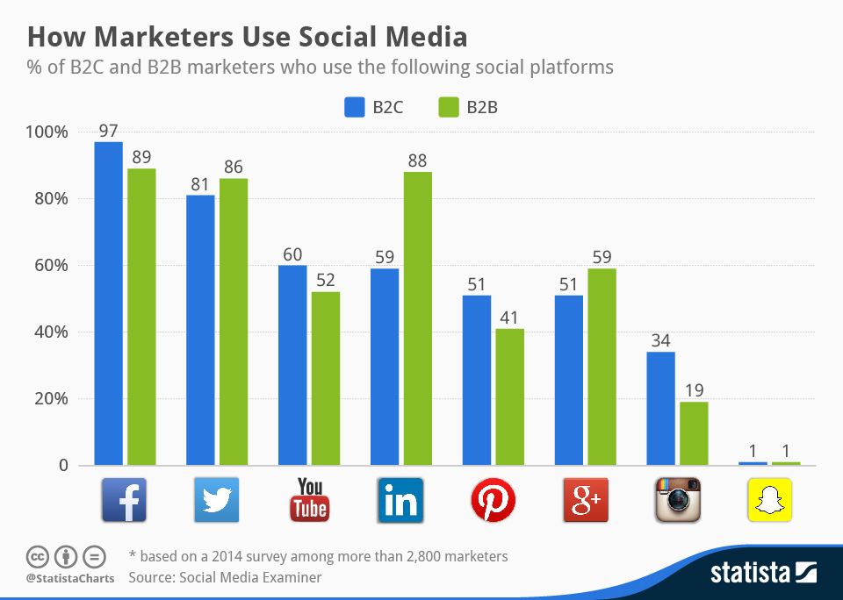
Figure 6: Use of Social Media by Marketers
Source: (BBC, 2017)
The above picture shows how marketers use different social sites in B2B and B2C information gathering process. Tesco uses social networking sites to gather information about consumers and other parties.
Communication
The main purpose of social media is to communicate with each other. Social Medias has made it easier to get connected with peoples living other corner of the world (DeHayes et al., 2014). Tesco maintain regular communication with several parties related to their business. Social Medias has made the communication process more efficient for Tesco. The following picture is an example of online communication of Tesco.
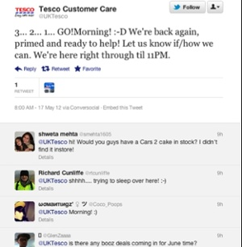
Figure 7: Online Communication with Customers
Source: (Tesco, 2017)

4. Creating Own Professional Online Presence
Because of the advancement in information and technology, it has greatly changed on the lifestyle of human being (DeHayes et al., 2014). People are more informed about their needs and demands. They want products and services from the business organizations that can meet their demand. A huge number of people are now using modern technologies in their day to day life. Statistics show that More than 4.5 billion people now use internet around the world (the Guardian, 2017). Most of the people use social networks to get connected with their family and friends. It has been Revealed from the recent studies that almost 2.5 billion people uses Facebook, Twitter, LinkedIn and other social sites to get connected with their friends and family (BBC, 2017). Most especially the young generation is most internets oriented. The following figure shows the popular social networking sites and the way people use them.
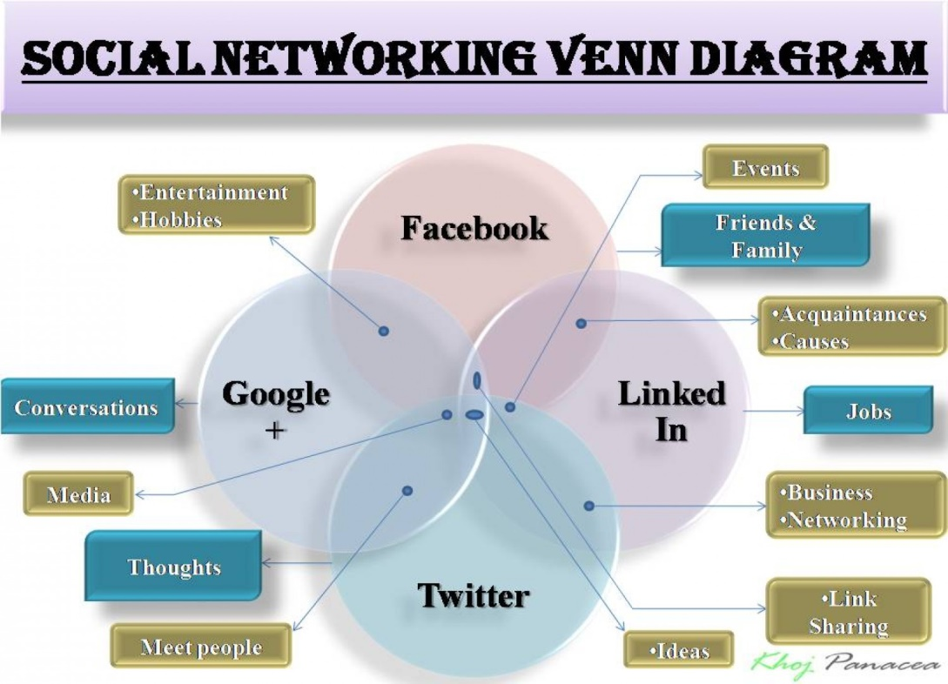
Figure 8: Social Networking
Source: (Bentley and Forkner, 2015)
Total 2 billion people are now using face book as a means for their communication with their friends and family (the Guardian, 2017). And 400 million people are using Twitter to make him updated with the current information of others (BBC, 2017). LinkedIn is another social networking site that enables people to be connected with others. Current studies show that total 500 million people are now using LinkedIn as a medium for their communication purpose (the Guardian, 2017). So, to reach this huge area of population and to make the business successful, it is crucial for the business organizations to ensure their online presence. Organizations can market their product within the huge area of targeted market. People within a vast geographic area will have come to know about the product. Employees need to have their own professional account to meet the need of online presence.
Here is a professional account on Facebook for this purpose.
Link: https://www.facebook.com/profile.php?id=100023191653362
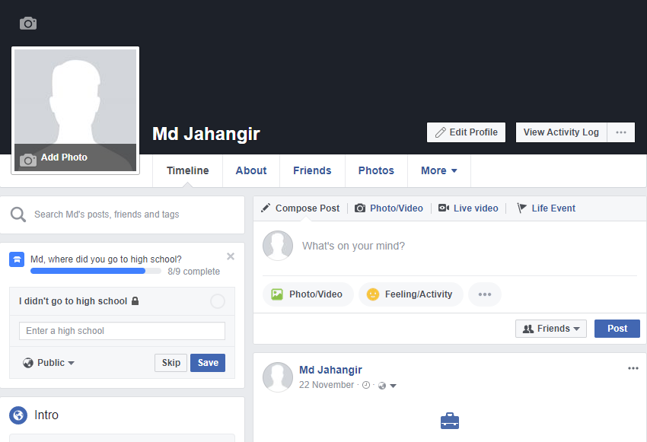
Here is a professional account in LinkedIn for this purpose.
Link: https://www.linkedin.com/in/Jahangir-45b93a285/
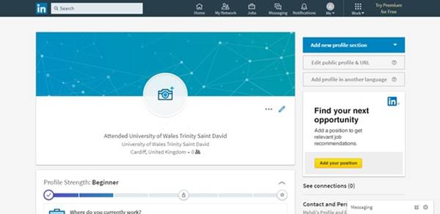
Jahangir

Conclusion
Advancement in modern information and technology system has brought a great change in the modern business activities. Business operations have become easier that was in the previous ages (Walker, 2010). Organizations can now do their marketing and distribution activities more easily with the help of internet, social medias, etc. Modern technologies have made the business firm enable to produce their products and perform their services flawlessly (Boone, 2016). Consumers are also benefited with quality products and services. Purchasing products and taking services has also become easy for the customers. It is important for an employee to make him efficient in use of advance technology.

References
Ardalan, K. (2017). The “modern” in “modern business”: A multi-paradigmatic look. Research in International Business and Finance.
BBC. (2017). Retail industry | Business | BBC. [online] Available at: https://www.BBC.com/business/retail [Accessed 11 Dec. 2017].
Bentley, T. and Forkner, I. (2015). Making information systems work for you. Englewood Cliffs, N.J.: Prentice-Hall.
Boone, L. (2016). Contemporary business. [Place of publication not identified]: John Wiley.
DeHayes, D., Hoffer, J., Martin, E. and Perkins, W. (2014). Managing information technology. Harlow, Essex: Pearson.
Laudon, K. and Traver, C. (2017). E-commerce. Boston: Pearson.
Munger, J. (2013). Retail Changes and Their Effects on Business-to-Business Markets. Journal of Business-to-Business Marketing, 10(2), pp.79-100.
Nichols, L. (2012). Retail intelligence in the UK. Business Information Review, 9(3), pp.2-17.
the Guardian. (2017). Retail industry | Business | The Guardian. [online] Available at: https://www.theguardian.com/business/retail [Accessed 14 Dec. 2017].
UK Business Forums. (2017). Retail. [online] Available at: http://www.ukbusinessforums.co.uk/forums/retail.123/ [Accessed 12 Dec. 2017].
Walker, W. (2010). Modern Business. New York: Alexander Hamilton Institute.
www.tesco.com. (2017). Tesco.com - Online Food Shopping, George, & more. [online] Available at: http://www.tesco.com/ [Accessed 15 Dec. 2017].

