

Name of Student: Mirabela Mutcu
Student Number: 2108200
Module code: BMSW 4003
Assignment Title: Component Two- Research Methods
Lecturer: Abdi Rahman



The following presentation is written with the main purpose of applying the DIKW pyramid and the Academic Grit information on the investigations that have been undertaken by the University of Wales Trinity Saint David and by the writer of this presentation too. Before data analysis, the audience will be introduced complexly to the meaning and background information of both academic grit and DIKW Pyramid as both are extremely important in the research industry. J k l p o I t y J k l p o I t y J k l p o I t y J k l p o I t y J k l p o I t y J k l p o I t y J k l p o I t y J k l p o I t y J k l p o I t y J k l p o I

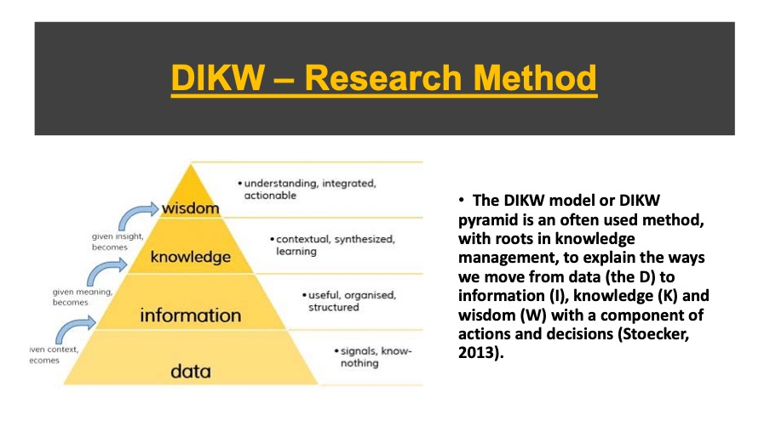
The truth is frequently something special. Information, for example, is significantly more than only a next phase of data. By and by, the DIKW model is as yet utilized in many structures and shapes to check out the extraction of significant worth and which means of information and data. This technique is very valued for its intricacy, and it will in general be applied as a rule of much examination. In any case, one of the primary reactions of the model is that it's a progressive one and misses a few critical parts of information and the new information and data reality in this time of enormous information, APIs and perpetually unstructured information and ways of catching them and transform them right into it, now and then bypassing the means in DIKW (ponder self-learning frameworks) (Stoecker, 2013). In general, it is an entirely dependable exploration technique that helps the analyst reach great determinations, which to be substantial as indicated by the information and data amassed. J k l p o I t y J k l p o I t y J k l p o I t y J k l p o I t y J k l p o I t y J k l p o I t y J k l p o I t y J k

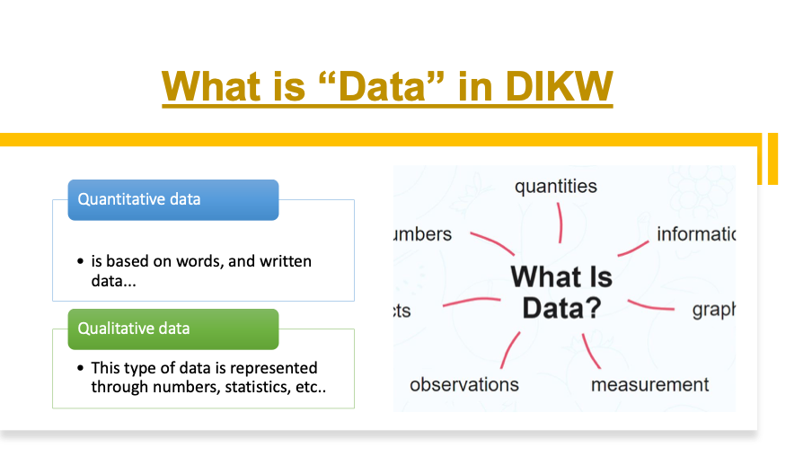
Examining the slide above, there are two primary kinds of information that can be aggregated all through the exploration. There is the quantitative information, and the subjective information. Beginning with the quantitative information, it is the sort of information communicated through words, where all that is being amassed is clarified utilizing key terms and other extra clarifications. This sort of information will in general be more utilized than the subjective information and this in light of the fact that there are a great deal of scientists thinking about that it is simpler to reach determinations after composed information. Going further to the subjective information, this is the kind of information addressed through numbers, as indicated by the slide over, these could be measurements, which in the majority of the subjective information research, the insights are the most well-known. J k l p o I t y J k l p o I t y J k l p o I t y J k l p o I t y J k l p o I t y J k l p o I t y J k l p o I t y J k l p o I t y J k l p o I t y J k l p o I t y J k l p o I t y J k l p o I t y J k l p o I t y J k l p o I t y J k l p o I t y J k l p o I t y J k l p o I t y J k l p o I t y J k l p o I t y J k l p o I t y J k l p o I t y J k l p o I t y J k l p o I t y J k l p o I t y
Viewing at information as a component of the DIKW model, notice that it is the primary component that is considered all through the examination, and this is the fundamental stage where information as per the speculation is amassed. The information collected, being important for the subsequent stage: data. J k l p o I t y J k l p o I t y J k l p o I t y J k l p o I t y J k l p o I t y J k l p o I t y J k l p o I t y J k l p o I t y J k l p o I t y J k l p o I t y J k l p o I t y J k l p o I t y
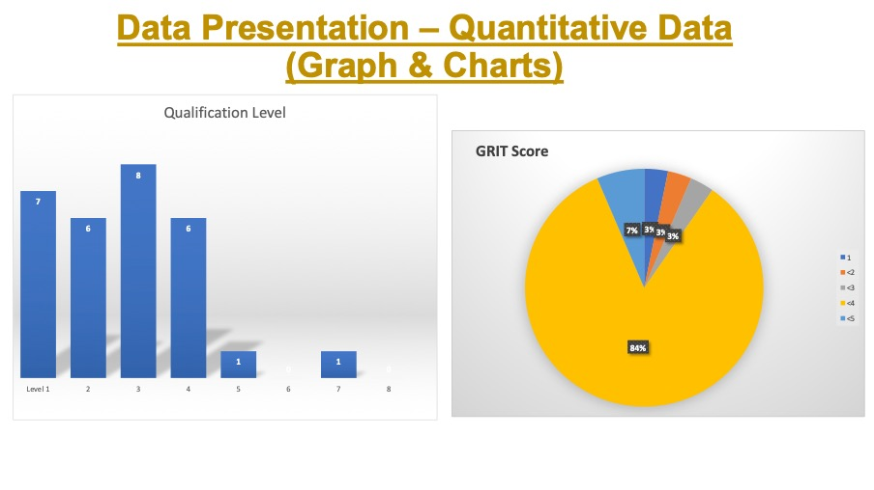
The University of Wales Trinity Saint David attempted an examination to explore the coarseness level of understudies relying upon their degree of capabilities. In the exploration there have been 29 members, and by examining the diagrams and graph connected in the slide above nete that there were 7 members with a Level one capability, there were 6 members asserting level two capabilities, there were 8 understudies guaranteeing level 3 capabilities, 6 with a level four capability, one with level 5, and one with a level 7. As per the information amassed, the college then, at that point, needed to move the information into data and understood that the understudies that have a more significant level of capability than level four had a higher coarseness (inspiration) towards every one of their exercises and further accomplishment. J k l p o I t y J k l p o I t y J k l p o I t y J k l p o I t y J k l p o I t y J k l p o I t y J k l p o I t y J k l p o I t y J k l p o I t y
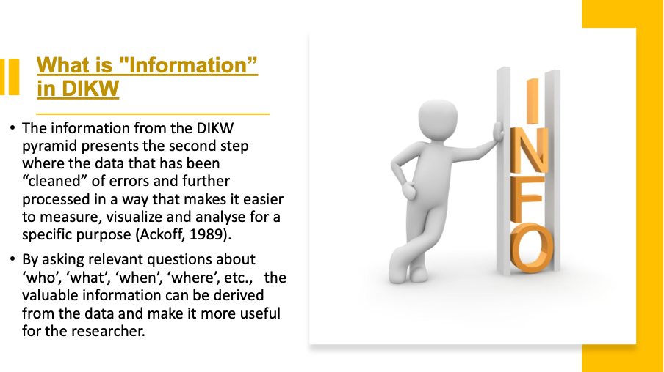
Considering the data referenced above, notice that data in the DIKW is the second component part of the examination where the information that has been gathered is being changed over into data, part were the inquiries "Who?" "What?" "Where?", "Why?" are offered an explanation to, utilizing the collected information. More to add, every one of the information that is changed over to data, is substantial to the analyst, which will then, at that point, utilize the data for the subsequent stages of the pecking order. Each snippet of data is similarly significant and this since they are for the most part coordinating to the insight, where the ends are drawn. J k l p o I t y J k l p o I t y J k l p o I t y J k l p o I t y J k l p o I t y J k l p o I t y J k l p o I t y J k l p o I t y J k l p o I t y J k l p o I t y J k l p o I t y J k l p o I t y

o I t y J k l p o I t y J k l p o I t y J k l p o I t y

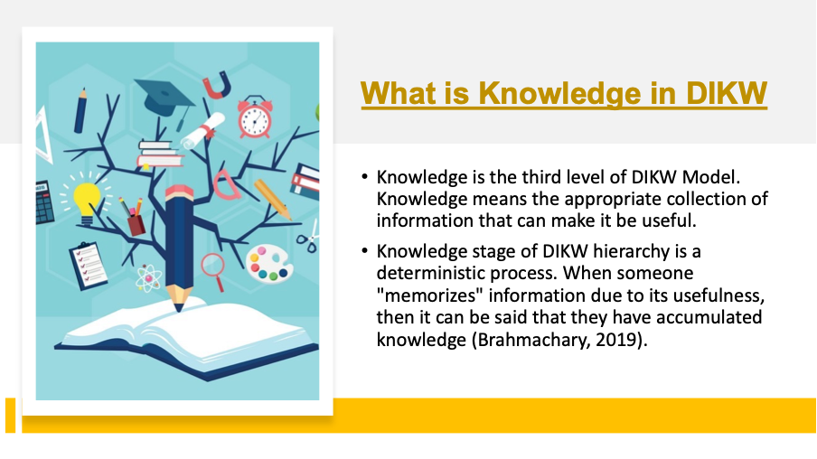
As illustrated in the slide above, Knowledge is the third period of the DIKW research technique, and this is the stage where the information and data are being changed into genuine information that the specialist has put away into their cerebrum, to use for the stage where ends and choices will be taken. The data that has been gathered is isolated, and for the information, just the fundamental and substantial data is being continued to stay away from disarray and inability to produce the best ends and choice.
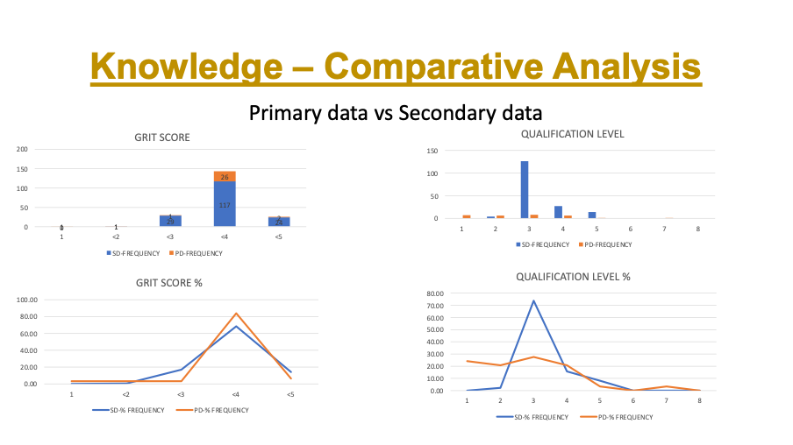

The diagrams and outlines joined above are looking at the information and data from two diverse explores that have been attempted for the precisely same viewpoints, in any case, there is a principle distinction that exist between the two investigates and this on the grounds that the exploration that has been embraced in 2020 has been framed by 171 members, though the one of every 2021 has been just shaped by 35 members, thing plainly showing that the outcomes are differing thinking about the states of every individual. J k l p o I t y J k l p o I t y J k l p o I t y J k l p o I t y J k l p o I t y J k l p o I t y J k l p o I t y J k l p o I t y J k l p o I t y
Having as a top priority all that has been referenced, it very well may be seen that the coarseness score of the 171 members has been higher, because of the expanded number of members that has a higher capability.

Going further to the Wisdom. It is the fourth and the last advance of the DIKW Hierarchy. It is a cycle to get the outcome by ascertaining through extrapolation of information, which has been amassed by the information and data of the exploration techniques. It considers the result from every one of the past degrees of DIKW Model and cycles them through exceptional kinds of human programming, in these being incorporate things like the moral, moral codes.
More to add, the Wisdom component can be thought as the interaction by which you can take a choice between the good and bad, great, and awful, or any improvement choices (Blokdyk, 2019).

The CRAAP test is used with the main purpose of evaluating the information that is being accumulated after research. As seen in the slide above, CRAAP is the acronym for Currency, relevance, authority, accuracy, and purpose. The currency refers to the time when the info has been found to evaluate if it is relevant to the present time. The relevance element reflects if the existing information is in accordance to the needs of the research. Thirdly, authority looks into the source that has been used to accumulate information. Then, accuracy reflects the reliability and correctness of the information found. Lastly, the purpose element reflects the reason why the existing information is actually existing.
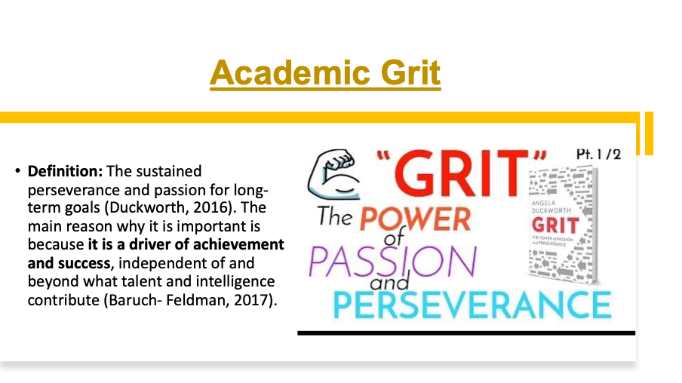
Regardless, the scholastic coarseness has been extraordinarily talked about by Angela Duckworth, which is the world's driving master on "coarseness," the much-advertised fixing in close to home achievement. As Duckworth characterizes it, coarseness is enthusiasm and supported diligence applied toward long haul accomplishment, with no specific worry for remunerations or acknowledgment en route. Duckworth examines about it saying that coarseness joins strength, desire, and restraint chasing after objectives that require months, a long time, or even many years. Duckworth's examination recommends that with regards to high accomplishment, coarseness might be pretty much as fundamental as insight. That is a critical finding on the grounds that for quite a while, knowledge was viewed as the way to progress. The definition and clarification that has been given by Angela is extremely valued by a many individuals embroiled in scholarly accomplishments and this since, it is so great to see the inspiration developing once with the achievements that are existent. Personally, I do not agree with Angela Duckworth because there are some people that can boost their grit without necessarily having high qualifications. There are very intelligent people from other countries for example, that did not have the financial opportunity to attend a higher education institute, but it does not mean that their grit is low.

Primary Research: Is the research undertook by the researcher that starts from a hypothesis and applies a research method to gain data which then to be converted into information.
Secondary research: is the research undertook based on the information that has already been published by someone.



