REPORT
AstraZeneca in the global market strategic approaches for Long-Term Success

Name: Mehwish Nawaz
Module: developing strategic capability
Lecturer’s Name: Christine joy

Submission date:31st of march 2025

Executive summary

This report has highlighted the strengths and weaknesses of the strategies initiated by AstraZeneca which has the possibility of making the business expansion sustainable in last 3 years. In addition, the opportunity and threats in the business strategy of AstraZeneca has also been mentioned in this report. Sustainable management of economic activities might face a struggle for AstraZeneca due to the financial recession of the UK economy. However, R&D expenditure by the UK government is offering research innovation for pharmaceutical firms and thus an opportunity for AstraZeneca. Meanwhile, the business mission of AstraZeneca needs quality focus improvements to ensure profit sustainability along with patient health-safety.

Table of Contents
1. Introduction 5
2. Main Findings 6
2.1 Major Development in the last 3 years within the organisation 6
2.2 Strategic analysis of the firm 10
2.3 PESTLE 10
2.4 Stakeholder Matrix 12
2.5 Boston Matrix 13
2.6 Current Strategy utilised by the firm 16
2.7 Advantage and disadvantage of the current strategy 17
2.8 Strength and weaknesses of current strategy 17
2.9 Current position of the firm in comparison to its competitors 18
2.10 Strategic direction adopted impacting Vision and Mission of the firm 19
2.11 Ways to ensure sustainability for Company 20
3. Conclusion 20
References 22

1. Introduction
Brief overview of case study organisation: AstraZeneca
This report is based on the strategic analysis of AstraZeneca, the global leader in the pharmaceutical sector, to ensure longevity and sustainability in competitive advantage amid constant changes in the marketplace. Operating through 11 “Research and Development (R&D) Centres” in 5 countries and 28 manufacturing sites in 16 countries, AstraZeneca has a sales network in 130 countries impacting around 100 million lives every year (The World Economic Forum, 2024). The multinational “patient-focused biopharmaceutical company” covers a diversified portfolio of biotechnology-based “research, development, and manufacture pipeline” with a pioneering legacy in oncology, “cardiovascular”, renal, metabolism, respiratory, “immunology” and rare diseases.
Capturing the globally resilient pharmaceutical demand for boosting organisational profits amid strict governmental regulations and a lack of financial support made AstraZeneca to diversify and expand outside the UK. AstraZeneca has cancelled the plan of “450-million-pound investment” for a “vaccine manufacturing plant”, indicating the failure of the agreement by Tories and lauded by Labour as a victim of cost-cutting (Financial Times, 2025). Adopting positioning strategy can be effective for AstraZeneca in this regard, by deploying diversification and expansion towards securing the benefits of “risk reduction”, “increased revenue-streams”, “market expansion” and “enhanced competitiveness”. In this regard, the “Mintzberg's 5 Ps of strategy framework” can be applied for understanding the applicability of strategic fields for organisations in terms of “Plan”, “Ploy”, “Pattern”, “Position” and “Perspective” (Khalifa, 2023). Hence, diversification and expansion of business proposition has remained the key strategic approach of AstraZeneca and last three-year business operations indicate its importance in ensuring a sustainable competitive advantage.
Concept of strategy and reasons of its utilisation in business
The high-level planning of course of action with respect to designing short as well as long-term objectives within uncertain environments and available means or resources can be considered as “strategy” (Luís et al. 2021). Driven by the strategy statement of “creating genuinely innovative medicines and improving access”, AstraZeneca has integrated “growth and therapy area leadership” along with people and sustainability for advancing the organisational pipeline (AstraZeneca, 2025). Utilising business strategy can provide clear direction to diversified organisations such as AstraZeneca for effective decision-making regarding resource allocation, adaptation to market changes and gaining competitive advantage (Iglesias et al. 2025). AstraZeneca has joined the “24/7 Carbon-Free Coalition” as a founding member, under its “2025 RE100 commitment”, to fulfil the “science-based net-zero target” by 2045 (The Climate Group, 2024). Aiming for more than half of its energy usage to be generated from “new-to-grid” sources, AstraZeneca’s sustainability strategy can reduce operational cost and improve brand image towards a resilient future. Responsible implementation of environmental management and sustainability initiatives significantly contributes to the proliferation of “economic globalization-energy diversification nexus” by allowing companies access to new markets and customer-groups (Shahbaz, 2024). Hence, strategic diversification and expansion can be impactful for AstraZeneca to deliver more innovative products and services aligned to the growing sustainability demand for better reputation, investor appeal and regulatory compliance.

2. Main Findings

2.1 Major Development in the last 3 years within the organisation
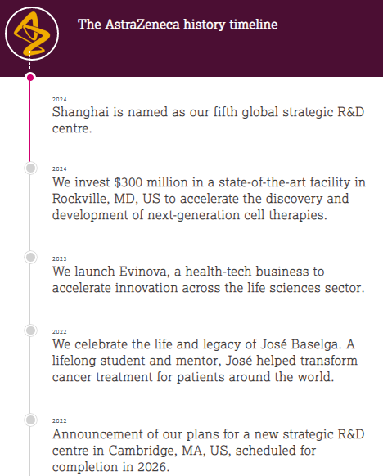
Figure 1: Major strategic development within AstraZeneca in the last 3 years
(Source: AstraZeneca, 2025)
The above figure implies the major strategic developments than took place within AstraZeneca by deploying diversification and expansion strategies within the last 3 years. As illustrated in the above timeline, AstraZeneca launched “Evinova” in 2023, a “health-tech business” for innovation acceleration in the “life sciences sector” as a major strategic development by the firm. AstraZeneca entered into licensing agreements with nine innovative Chinese biotech companies worth up to $6.5 billion from 2023 (China Daily, 2024). Specifically focusing on the strategies of business diversification and expansion, AstraZeneca reduced dependence on single product or market for gaining effective sales over the years. In 2024, AstraZeneca invested $300 million in a “state-of-the-art facility” in Rockville, US to develop “next-generation cell therapies” along with establishing the “fifth global strategic R&D centre” in Shanghai (AstraZeneca, 2025). The organisational intentions of creating independent drug supply-chains in the US signify AstraZeneca’s major developments towards strengthening its expansion drives outside the UK. However, the Chinese authorities launched an investigation probe on importing 2 cancer drugs manufactured in Britain and AstraZeneca needed to prove its commitment in the quest of rising profits in 2024 (Kollewe, 2024). Apart from the supply-chain issues, the “alleged medical insurance fraud”, “illegal importation of drugs” and “improper data collection” by employees are further tarnishing AstraZeneca’s footprint in China as a major development.
During 2022, AstraZeneca’s Forxiga was recommended for approval in the EU, based on the positive opinion by “Committee for Medicinal Products for Human Use” of “European Medicines Agency” (AstraZeneca, 2022). Tagrisso and the Covid-19 vaccine “Vaxzevria” followed this successful product performance, being identified among the highest revenue generators. However, Covid virus new variant emergence significantly decreased the sales of AstraZeneca’s key products “Vaxzevria” and “Evusheld” in 2023, causing it to withdraw from the segment after a near-complete fall. Additionally, AstraZeneca’s cancer drug portfolio including Tagrisso and “immunotherapy Imfinzi” generated significant profits in 2023, enabling the firm to set the organisational profit target of $80 billion by 2030 (Manalac, 2024). Hence, it can be commented that AstraZeneca’s performance has remained a mix of successes and missed opportunities, especially amid the regulatory challenges and geopolitical barriers of expansion in China.
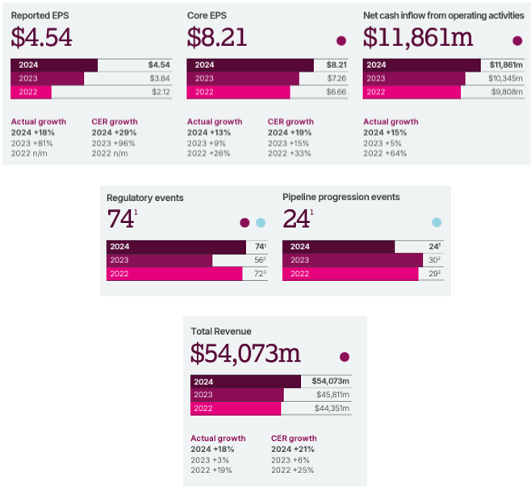
Figure 2: Financial and non-financial KPI-based performance of AstraZeneca throughout the last three years
(Source: AstraZeneca, 2024)
The Figure 2 is sourced from 2024 Annual Reports of AstraZeneca showcasing a constant growth throughout the last three years in terms of “Earnings per Share (EPS)”, net cash inflow and revenue. Improvements in the number of regulatory events from FY2023 can be considered as a major development, whereas depletion in pipeline progression events needs to be re-evaluated further (AstraZeneca, 2024). In this regard, diversification and expansion are the major strategies focused by AstraZeneca in terms of product portfolio. The views of Gupta et al. (2023) can be evidenced to support the “integrated product and geographical diversification trajectories” of AstraZeneca across its global supply-chain. Gaining directional implications from the market competitors such as “Abbott Laboratories”, AstraZeneca effectively met the diverse customer needs throughout the global supply networks. Hence, AstraZeneca is on the right track of strategic progress, based on overall discussions on the last three-year product innovation and financial growth, although addressing the supply-chain challenges is crucial.

2.2 Strategic analysis of the firm
AstraZeneca’s “diversification and expansion strategies” include growing the existing portfolio, investing in new technologies and launching new medicines for supporting productivity and global access. For instance, AstraZeneca entered into an “exclusive license agreement” with “CSPC Pharmaceutical Group” for the discovery and development of “pre-clinical novel lipid-lowering therapy” (AstraZeneca, 2024). This implies that AstraZeneca’s “diversification and expansion strategies” combine human needs with technology through “strategic alliances and licensing agreements” that can be considered as a success factor. Furthermore, AstraZeneca’s strategic compass is directed positively towards resolving the barriers to expand and strengthen its footprint in China despite geopolitical pressures. In this regard, AstraZeneca is expected to purchase the Chinese unit of long-time partner FibroGen for $160 million to gain rights to the anaemia drug for better capturing the local demands (Reuters, 2025). Hence, AstraZeneca’s “diversification and expansion strategies” can effectively contribute towards long-term organisational success, especially outside the UK.
Breaking conventions, on the other hand, by pioneering “novel deal structures” in organisational portfolio has several negative consequences upon strategic growth of AstraZeneca. “AstraZeneca Risk Supplement 2023” revealed that IP-related product risks and “macroeconomic volatility” can affect the anticipated rate of growth and put barriers in “global free-flow of medicines” (AstraZeneca, 2023). Further, AstraZeneca is facing operating challenges in the UK as it is accused of “accused of stockpiling vaccines” resulting in severe side effects among the patients taking Covid jab. Resultantly, AstraZeneca is shifting its vaccine manufacturing plants from the UK to the US due to the reduced state aid (Manufacturing Today, 2024). Moreover, the development of a negative stakeholder relationship of AstraZeneca with the UK government and regulatory bodies can be witnessed that can act as a factor of failure in strategic growth. For instance, AstraZeneca announced that it may cut jobs from its UK operational sites if the “biodiversity drug levy” is introduced (Greenfield, 2024). Hence, strategic analysis of AstraZeneca identified the challenges of macroeconomic volatility and local barriers faced in China alongside the operational issues requiring attention in the UK.

2.3 PESTLE
Factors | Description | Impact on AstraZeneca
Political | - The emergence of “far-right political” views is enhancing patriotic crime rates in the UK as BBC reported 21st January, 2025 (BBC, 2025).  - The political interest of X-owner Elon Musk is likely to impose changes in regulatory authorities of the UK as a new “online safety law” has been proposed (Borger, 2025). | Threat
Economic | - The “Bank of England” (BoE) has projected that England is already down with 40% “technical recession” as GDP fell by 0.01% in 2025 (Anghel and Rees, 2025).  - As of 2025 there is 4.4% unemployment rate in the UK for people aged over 16 years (The UK Gov, 2025). | Threat
Social | - 2.9 million People in the UK economy have been recorded to use “medicated drugs” within 2024 (The UK Gov, 2024).  - 22.1 million People equivalent to 27% of the UK population are going through ageing-population as a severe social issue requires effective medication and treatments (The UK Parliament, 2024). | Opportunity
Technological | - For the 2024-25 FY the UK government has enhanced their “research & development” (R&D) spending to £20bn regarding resilient innovation in pharmaceutical products (Haves, 2022).  - The “artificial intelligence” (AI) technology has projected to perceive a 42.68% market growth till 2030 within the pharmaceutical operations (Mordorintelligence, 2025). | Opportunity
Legal | - The UK-based pharmaceutical firms such as GSK has been sued with $2.2billion by the US court as its “Zantac” drug caused cancer (Silva, 2024).  - The “Human Medicines Regulations 2012” act enforced allows Pharma companies to sell medicines in the UK private market even though not marketing medicines in the NHS (Gotham and Barber, 2024). | Threat
Environmental | - The carbon-emission of the UK pharmaceutical industry is 55% higher than the other sectors (Bjgpopen, 2025).  - Around £300 million of industrial wastes are being generated by the UK pharmaceutical industry per year (Glover, 2025). | Threat
Table 1: PESTLE
(Source: Gotham and Barber, 2024)
Analysis
Political factor’s evaluation from the above table has drawn the insight that AstraZeneca might face business threats in the UK due to projection of democracy loss in emergence of “far-right political” views. Additionally, a long-lasting economic recession with a pressing 4.4% unemployment rate has been evaluated as an economic threat for industrial practices in the UK (The UK Gov, 2025). The growing utility of “medicated drugs” by the 2.9 million people in the UK has been considered as a business opportunity for AstraZeneca.

2.4 Stakeholder Matrix
High  P  O  W  E  R  Low | “Keep Satisfied”  - Customers spread in the global operations of AstraZeneca [External]  - Staff and executives of AstraZeneca [Internal] | “Closely Manage”  - Suppliers as well as “supplier advocacy groups” such as “HubZone National Council” and “Social Enterprise UK” (Astrazeneca, 2025). [Internal]  - Quality control auditors and drug manufacturing executives of AstraZeneca [Internal]
High  P  O  W  E  R  Low | “Keep Monitor”  - The legal and government authorities from the domestic as well as international premises [External]  - Local communities and groups from the domestic as well as international premises [External] | “Keep Informed”  - Owner of AstraZeneca “Pascal Soriot”. [Internal]  - Brand investors of AstraZeneca “BlackRock”, “The Vanguard Group” and “Wellington Management” (Marketscreener, 2025). [Internal]
Low INTEREST High
Table 2: Stakeholder Matrix for AstraZeneca
(Source: Astrazeneca, 2025)
Analysis
Table 2 above reflects on the “stakeholder analysis” of AstraZeneca involving clear representation of internal and external stakeholders. The “stakeholder theory” suggests involving each stakeholder’s views on business interest to achieve long-term success (Mahajan et al. 2023). Customers as well as brand investors and owners have been found to have greater power and interest in AstraZeneca’s business due to which the firm is needed to strategically manage them. However, the 2024 lawsuit case of AstraZeneca reveals the firm’s ignorance on patient safety which led to patient death due to side effects of “Covid-19” vaccine (McCarthy and Martin, 2024). A loss in business reputation has been faced by AstraZeneca; thereby improvement of stakeholder management is in sincere need for the firm that requires enhancement of quality control audits.

2.5 Boston Matrix
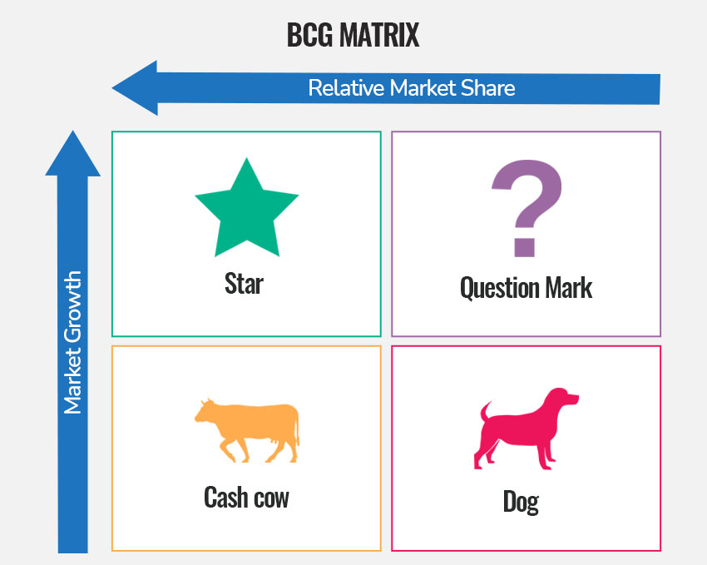
Figure 3: Boston Matrix
(Source: Adapted from Kuc and Borkowski, 2021)
The “Boston Consulting Group (BCG)”, is a strategic business tool that can be used by business leaders in prioritising the most demanded products based on their market share and growth rate (Kuc and Borkowski, 2021). The high “market share” of a product in a highly grown market is called a Star in the BCG matrix and low growth in low share is called Dog. The star in the Boston Matrix is considered an advantage and dog is the challenge that the business can face. In this regard, Farxiga is the star product of AstraZeneca and Vaxzevria is the dog in the Boston Matrix as per their market demands.
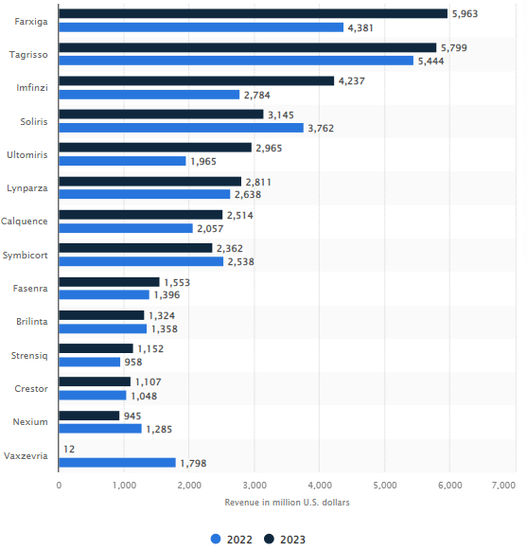
Figure 4: Demand of the current products of AstraZeneca
(Source: Mikulic, 2024)
The figure above shows the most demanded products manufactured by AstraZeneca in which Farxiga tops the position and Vaxzevria is the least demanded product (Mikulic, 2024). The high market growth of Farxiga makes it a Star product of this business that can further increase the business profitability in future. The USA approved Farxiga medicine for the treatment of diabetes, which can further increase its demand (Astrazeneca, 2024). On the other hand, Vaxzevria is primarily used to treat Covid-19, and demand for this medicine is decreasing due to fewer cases of Covid-19 which makes it Dog. Tagrisso manufactured by AstraZeneca has seen constant growth in the pharmaceutical sector, making it a Cash Cow for the company. According to “World Health Organisation” data nearly 32% of the global death occurs due to heart related issues (Who, 2021). This implies that Brilinta, which is a medicine for heart disease, can see a jump in the demand in future making it a Question Mark in BCG.

2.6 Current Strategy utilised by the firm
Currently, the leaders in AstraZeneca have taken a business expansion strategy by making strategic partnership with similar pharmaceutical companies that has the possibility of increasing the business visibility. The CEO of the firm has openly discussed that the current UK business environment needs improvement for business investment (Reuters, 2025). AstraZeneca is expanding in other global nations such as India and China to that seems favourable for business of this firm. AstraZeneca made a partnership with Earthbanc for the maintenance of climate sustainability (Earthbanc, 2024). AstraZeneca invested almost $71 million in “AZ Forest Commitment” to plant 200 million trees around 6 countries within 2030 (Astrazeneca, 2023). This unique business strategy used by AstraZeneca has the possibility of increasing the business reliability and reputation among the stakeholders.
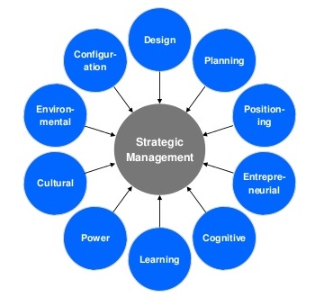
Figure 5: “Mintzberg’s 10 school of thoughts”
(Source: Adapted from Serrat and Serrat, 2021)
The “Mintzberg’s 10 school of thoughts” is a strategic framework that assists in strategy formulation by designing, planning, positioning and learning (Serrat and Serrat, 2021). Formulation of the business strategies in AstraZeneca related to expansion and diversification is based on the planning and designing stages of the “Mintzberg’s 10 school of thoughts”. The “Ambition 2030” of AstraZeneca highlights business investment in transformative technologies (Astrazeneca, 2024). This indicates that a business diversification of AstraZeneca in the transformative technology has the possibility of increasing the business presence in major business sectors such as healthcare and technologies. Moreover, the business partnership between AstraZeneca and Sodexo highlights the organisational intention in improving HRM and workplace experience (Sodexo, 2024). Maintenance of sustainability and staff safety of business is also highlighted in this partnership that can benefit both the businesses.

2.7 Advantage and disadvantage of the current strategy
AstraZeneca’s revenue in India has been increased by 44% in 2025, which shows a rapid business growth (Astrazeneca, 2025). Initiation of local partnership by indulging in social and environmental activities through “AZ Forest Commitment” and other initiatives are increasing the organisational revenue. For instance, AstraZeneca’s revenue has increased by 21% that indicates positive business growth in China (Thetimes, 2025). However, AstraZeneca admitted in the court that its Covid-19 vaccine can cause rare side effects (Telegraph, 2024). This suggests, the researchers in AstraZeneca neglected the safety concerns for people and only focused on rapid business expansion.

2.8 Strength and weaknesses of current strategy
The business expansion strategy by AstraZeneca can be strength for the business to compete with the existing competitors and increase market share. Increase in the sales of the products manufactured by AstraZeneca can be identified through the continuous business expansion. The Chinese pharmaceutical market is responsible for 13% of overall global sales of AstraZeneca (Fick, 2025). This indicates the strength of global expansion and maintaining a diversified business strategy by AstraZeneca. Partnership made by AstraZeneca with Sodexo has the possibility of increasing staff satisfaction in the business. A 4.1 ratting out of 5 regarding the staff satisfaction of AstraZeneca indicates the business capability in managing staff satisfaction (Ambitionbox, 2025). This highlights the strength of the business in managing staff satisfaction through business diversification and making strategic partnership with other suitable business firms.

2.9 Current position of the firm in comparison to its competitors
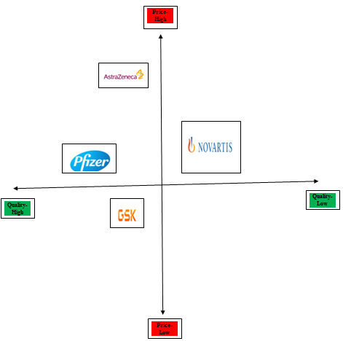
Figure 6: Position Map of AstraZeneca in respect to its competitors
(Source: Self Developed)
The figure above describes the “business positioning" of AstraZeneca in the UK market in respect to its key competitors such as GSK, Novartis and Pfizer. AstraZeneca has been found to lead the market penetration in the UK pharmaceutical industry till 2024 with a robust $242.15 billion market share (Statista, 2024). GSK has been able to hold the mounting second position in the UK market; though the existence of Novartis as well as Pfizer have been found missing. AstraZeneca can prefer to tackle competitive rivalry from GSK, although the market leading efficiency of the firm is well-established in the UK compared to other brands.

2.10 Strategic direction adopted impacting Vision and Mission of the firm
The business vision of AstraZeneca inherits the focus on transforming healthcare futures through advanced medical and innovative science solutions (Astrazeneca, 2025). The recent strategic direction adopted by AstraZeneca is hereby impacted on its vision focus as enforcement of the “Ambition 2030” target revealed business investment within “transformational technologies” (Astrazeneca, 2024). A business operational transformation towards industry need of “digital agility” can enable business resilience for the firm to embark on new scientific and innovative solutions to offer life-changing treatment to patients. Contextually, “transforming patients’ lives through curing rare diseases” is the ultimate business mission of AstraZeneca that also focuses on enabling scientific treatment using innovative solutions (Astrazeneca, 2025). However, the lawsuit's emergence in the context of “rare side effects” highlighted in use of “Covid-19” vaccine does not account with the business mission of AstraZeneca to transform people’s lives positively (McCarthy and Martin, 2024). Therefore, improvement of the leadership focus towards advanced quality standards to meet health and safety requirements can assist AstraZeneca to meet its vision and mission statement.
Vision and Mission contributing success or failure to the firm with respect to its reputation
The business mission involves short-time goals while vision requires fulfilment of long-term strategies, as business mission is struggling to achieve strategically hereby AstraZeneca can face issues to meet its vision as well. Although, from the above evaluations, the business vision of AstraZeneca is positively impacting the firm in respect to boosting an organic reputation among global customers. AstraZeneca has launched digital-disruptive technologies such as AI and “machine learning” (ML) (Astrazeneca, 2025). These agile technologies are offering “graph neural networks” usage for the firm that is significant in historical data-patterns mining and uncovering predictions with novel trends. Factors such as enhanced healthcare needs, emerging diseases, regulatory shifts as well as technological advancements are changing customer demands which are hard to detect in day-to-day operations. However, AstraZeneca business mission is no doubt in need of improvement to involve patient safety measures as top prioritising drugs quality over profitability. Contextually, the USA approved Farxiga medicine is helping AstraZeneca to cure chronic diseases such as Diabetes (Astrazeneca, 2024). Hence, AstraZeneca's business mission is imposing a mixed impact on its business reputation; that merely requires reformation in quality standards to ensure patient safety and embrace digital innovation and assisting sustainable profitability.

2.11 Ways to ensure sustainability for Company (Strategic options for future)
Leaders in AstraZeneca are required to maintain safety of the patients by cross checking the drug applicability, despite the pressure of business expansion. The WHO guidelines regarding drug manufacturing is categorised under “Good Manufacturing Practice (GMP)” that the pharmaceutical companies need to consider (WHO, 2025). Under this practice specified by the WHO, the pharmaceutical companies are required to check “cross-contamination” of the drugs and false labelling issue. Similarly, the researchers in AstraZeneca are solicited to check the possibility of cross contamination in the drugs manufactured by the company. Maintaining the safety protocols while manufacturing the essential drugs has the possibility of increasing the business reliability among the stakeholders. “21 CFR Part 210” is the current GMP that is even prescribed by the “Food and Drug Administration (FDA)” of USA (Tricentis, 2025). In addition to the maintenance of patient’s health, it is also important for the leaders in AstraZeneca to maintain staff satisfaction by securing their job. For example, ISO 45001 related to occupational safety suggests that business leaders are required to address stress related issues of the staff (Hse, 2025). Constant threat of job cuts can result in mental harassment for the staff that needs to be handled by the managers in AstraZeneca.

3. Conclusion
It can be concluded that diversification and expansion of business propositions are the core approaches of AstraZeneca’s organisational strategy to ensure long-term sustainable growth and profitability. Deploying positioning strategy as per the “Mintzberg's 5 Ps of strategy framework”, diversification and expansion have been impactful for the firm with respect to achieving global success. Concerning the “AstraZeneca history timeline”, accelerating innovation in health-tech R&D and next-generation treatment transformations are major strategic developments occurring within the organisation in the last three years. Conducting a strategic analysis of AstraZeneca’s business operations, performing “strategic alliances and licensing agreements” and investing in new-age biotechnology facilities act as success factors. However, the negative stakeholder relations growing between the UK government and AstraZeneca can significantly hamper its strategic success amid macroeconomic volatility and local barriers. The business diversification and expansion strategy initiated by AstraZeneca is benefiting the business by increasing its sales thereby increasing organisational revenue. Business exposure of AstraZeneca is also increasing, especially in the Asian countries due to the business expansion strategies. Increasing the business volume by expanding in international markets is a critical task that demands a higher organisational capability in paying the salaries.
The business expansion strategy initiated by AstraZeneca in Asian countries such as India and China has the possibility of increasing the sales of the medicines manufactured by the company. Aligning the concepts of BCG Matrix, Forxiga, the medication used to treat “Type-2 Diabetes Mellitus” has been identified as the best-selling product of AstraZeneca in 2022-23. Business visibility of AstraZeneca is also increasing due to the constant expansion in the international market. Improvement in AstraZeneca’s competitive position implies the reduced dependance on single product or market for gaining effective sales over the years. On the other hand, leaders in AstraZeneca mentioned that the company will consider job cuts if the UK government introduces the drug levy policy to share large amounts of organisational profit. This business growth has the possibility of providing strategic advantage to the company in competing with its other competitors.
On the other hand, the intention of increasing business expansion and having larger business profit in AstraZeneca is resulting in neglecting the safety protocols in drug manufacturing. This further suggests that the leaders in AstraZeneca are needed to abide by the global standards of drug manufacturing in order to maintain business sustainability. The recent claim of AstraZeneca regarding its Covid-19 vaccine that it can increase the risk of rare disease highlights the inability of this company in making reliable medicines. The possibility of job cuts due to changes in government decisions and sharing larger business profit also indicates the business inability of AstraZeneca in managing a larger workforce. Effective incorporation of GMP standards, abiding by the FDA, through “21 CFR Part 210” can be significant for AstraZeneca to address the challenges related to diversified product portfolio. Additionally, facilitation of a secure work environment to the employees has the possibility of increasing staff satisfaction and productivity.

References
Ambitionbox, (2025) AstraZeneca. Available at: https://www.ambitionbox.com/reviews/astrazeneca-reviews (Accessed: 24 February 2025).
Anghel, I. and Rees, T. (2025) UK Recession Fears Mount With Data Set to Show GDP Shrinking. Available at: https://www.bloomberg.com/news/articles/2025-02-12/uk-recession-fears-mount-with-data-set-to-show-economy-shrinking#:~:text=With%20surveys%20pointing%20to%20a,in%20just%20over%20a%20year. (Accessed: 23 February 2025).
AstraZeneca, (2022) Forxiga recommended for approval in the EU by CHMP for symptomatic chronic heart failure. Available at: https://www.astrazeneca.com/media-centre/press-releases/2022/forxiga-chmp-opinion-for-symptomatic-chronic-hf.html (Accessed 22 February 2025).
Astrazeneca, (2023) AstraZeneca commits $71 million to AZ Forest India project to fund the country’s largest biodiversity restoration project, in support of climate action and human health. Available at: https://www.astrazeneca.in/media/press-releases/2023/astrazeneca-commits-71-million-to-az-forest-india-project-fund-country-largest-biodiversity-restoration-project-support-climate-action-human-health.html (Accessed: 24 February 2025).
AstraZeneca, (2023) AstraZeneca Risk Supplement 2023. Available at: https://www.astrazeneca.com/content/dam/az/Investor_Relations/annual-report-2023/pdf/AstraZeneca_Risk_Supplement_2023.pdf (Accessed 24 February 2025).
AstraZeneca, (2024) AstraZeneca Annual Reports 2024. Available at: https://www.astrazeneca.com/investor-relations/annual-reports/annual-report-2024.html (Accessed 23 February 2025).
AstraZeneca, (2024) AstraZeneca strengthens its cardiovascular pipeline with agreement for a pre-clinical novel lipid-lowering therapy. Available at: https://www.astrazeneca.com/media-centre/press-releases/2024/astrazeneca-licenses-lipid-lowering-lpa-asset.html (Accessed 24 February 2025).
Astrazeneca, (2024) Chair’s Statement. Available at: https://www.astrazeneca.ca/content/dam/az/Investor_Relations/annual-report-2024/pdf/AstraZeneca_AR_2024_Chairs_Statement.pdf (Accessed: 24 February 2025).
Astrazeneca, (2024) FARXIGA approved in the US for the treatment of pediatric type-2 diabetes. Available at: https://www.astrazeneca-us.com/media/press-releases/2024/farxiga-approved-in-the-us-for-the-treatment-of-pediatric-type-two-diabetes.html (Accessed: 24 February 2025).
Astrazeneca, (2025) About Our Company. Available at: https://www.astrazeneca.com/our-company.html (Accessed: 23 February 2025).
Astrazeneca, (2025) Accelerating supplier diversity:. Available at: https://www.astrazeneca.com/media-centre/articles/2024/accelerating-supplier-diversity.html (Accessed: 24 February 2025).
Astrazeneca, (2025) AstraZeneca Pharma India Ltd Q3 Results Highlight Strong Momentum Across Therapeutic Areas; achieving 44% increase in revenue and total revenue from operations now increased by Rs. 1,345 Mn compared to corresponding quarter of previous year. Available at: https://www.astrazeneca.in/media/press-releases/2025/AstraZeneca-Pharma-India-Ltd-Q3-Results.html#:~:text=Board%20Of%20Directors-,AstraZeneca%20Pharma%20India%20Ltd%20Q3%20Results%20Highlight%20Strong%20Momentum%20Across,corresponding%20quarter%20of%20previous%20year. (Accessed: 24 February 2025).
Astrazeneca, (2025) Data Science & Artificial Intelligence - AstraZeneca. Available at: https://www.astrazeneca.com/r-d/data-science-and-ai.html#:~:text=Machine%20learning%20and%20AI%20applications,from%20our%20collaboration%20with%20BenevolentAI. (Accessed: 24 February 2025).
AstraZeneca, (2025) Our company. Available at: https://www.astrazeneca.in/our-company.html (Accessed 24 February 2025).
AstraZeneca, (2025) Our history. Available at: https://www.astrazeneca.com/our-company/history.html (Accessed 24 February 2025).
BBC, (2025) Far-right group exposed in undercover BBC investigation. Available at: https://www.bbc.com/news/articles/cn8xykr5v95o (Accessed: 22 February 2025).
Bjgpopen, (2025) Environmental impact ratings that could drive positive environmental changes in the manufacture and use of pharmaceuticals. Available at: https://bjgpopen.org/content/6/1/BJGPO.2021.0214#:~:text=The%20pharmaceutical%20industry%20plays%20a,toxic%20effects%20on%20aquatic%20ecosystems. (Accessed: 24 February 2025).
Borger, J. (2025) Elon Musk’s beef with Britain isn’t (only) about politics. It’s about tech regulation. Available at: https://www.theguardian.com/technology/2025/jan/25/elon-musk-uk-politics-tech-online-safety-act (Accessed: 23 February 2025).
China Daily, (2024) AstraZeneca announces plans for new innovations for China. Available at: https://www.chinadaily.com.cn/a/202409/30/WS66fa1b9ea310f1265a1c5b67.html#:~:text=Since%202023%2C%20AstraZeneca%20has%20entered,approximate%20value%20of%20%246.5%20billion. (Accessed 22 February 2025).
Earthbanc, (2024) AstraZeneca and Earthbanc Collaborate for Reforestation in India. Available at: https://earthbanc.io/2024/06/10/astrazeneca-and-earthbanc-collaborate-for-reforestation-in-india/#:~:text=The%20program%20not%20only%20supports,the%20risk%20of%20natural%20disasters.&text=In%20India%2C%20AztraZeneca%2C%20in%20collaboration,trees%20and%20plants%20in%20India. (Accessed: 24 February 2025).
Fick, M. (2025) AstraZeneca shareholders say they need clarity on China investigations. Available at: https://www.reuters.com/business/healthcare-pharmaceuticals/astrazeneca-shareholders-say-they-need-clarity-china-investigations-2025-02-05/#:~:text=China%20has%20long%20been%20a,of%20total%20sales%20in%202023. (Accessed: 24 February 2025).
Financial Times, (2025) The inside story of Britain’s failure to clinch £450mn AstraZeneca deal. Available at: https://www.ft.com/content/ffa44bea-e5f4-403e-af62-5ccab9abbcfc (Accessed 21 February 2025).
Glover, J. (2025) What Is Pharmaceutical Waste?. Available at: https://www.sharpsmart.co.uk/knowledge-centre/what-is-pharmaceutical-waste#:~:text=The%20exact%20amount%20of%20pharmaceutical,every%20year%20in%20England%20alone. (Accessed: 23 February 2025).
Gotham, D. and Barber, M. (2024) Pharmaceutical regulation in the UK. Available at: https://www.adalovelaceinstitute.org/resource/pharmaceutical-regulation-uk/#:~:text=Medicines%20can%20therefore%20have%20marketing,being%20available%20on%20the%20NHS.&text=Two%20key%20pieces%20of%20legislation,and%20Medical%20Devices%20Act%202021. (Accessed: 23 February 2025).
Greenfield, P. (2024) AstraZeneca ‘said it could cut UK jobs’ if biodiversity drug levy is introduced. Available at: https://www.theguardian.com/environment/2024/oct/25/astrazeneca-uk-jobs-biodiversity-drug-levy (Accessed: 24 February 2025).
Greenfield, P., 2024. AstraZeneca ‘said it could cut UK jobs’ if biodiversity drug levy is introduced. Available at: https://www.theguardian.com/environment/2024/oct/25/astrazeneca-uk-jobs-biodiversity-drug-levy (Accessed 24 February 2025).
Gupta, R., Gianchandani, M., Mejia, C., Gianchandani, Y.B. and Kajikawa, Y., (2023). Revealing Integrated Product and Geographical Diversification Trajectories in Multinational Pharmaceutical Enterprises. Businesses, 3(2), pp.231-250. Available at: https://www.mdpi.com/2673-7116/3/2/16
Haves, E. (2022) Research and development spending: Pharmaceuticals. Available at: https://lordslibrary.parliament.uk/research-and-development-spending-pharmaceuticals/#:~:text=%2C%20representing%203.2%25.-,6.,This%20includes%20measures%20to: (Accessed: 24 February 2025).
Hse, (2025) Health and safety management systems. Available at: https://www.hse.gov.uk/managing/management-system/iso45001.htm (Accessed: 22 February 2025).
Iglesias, I., Marinich, J.A., Anechina, L.R., Cortés, M. and Pérez Domínguez, A., (2025). Understanding the national healthcare ecosystem to position Medical Affairs as a strategic element: lessons learned from AstraZeneca Spain. Pharmaceutical Medicine, 39(1), pp.39-50. Available at: https://link.springer.com/article/10.1007/s40290-024-00542-x
Khalifa, A.S., (2023) Contesting Mintzberg's five Ps for strategy: it is time for a product recall. Journal of Strategy and Management, 16(1), pp.112-127. Available at: https://www.emerald.com/insight/content/doi/10.1108/JSMA-12-2021-0243/full/html
Kollewe, J., (2024) AstraZeneca says it takes China investigation 'very seriously'. Available at: https://www.theguardian.com/business/2024/nov/12/astrazeneca-china-investigation-pharmaceutical-profit-us (Accessed 24 February 2025).
Kuc, B.R. and Borkowski, S., (2021). ‘Hung Hau corporate business analysis using BCG matrix.’“. International Journal of Advanced Multidisciplinary Research and Studies, 1(1), pp.1-6. Available at: https://www.multiresearchjournal.com/admin/uploads/archives/archive-1639308840.pdf
Luís, A., Garnett, K., Pollard, S.J., Lickorish, F., Jude, S. and Leinster, P., (2021) Fusing strategic risk and futures methods to inform long-term strategic planning: Case of water utilities. Environment Systems and Decisions, 41(4), pp.523-540. Available at: https://link.springer.com/article/10.1007/s10669-021-09815-1
Mahajan, R., Lim, W.M., Sareen, M., Kumar, S. and Panwar, R., (2023). ‘Stakeholder theory’. Journal of Business Research, 166, p.114104. Available at: https://doi.org/10.1016/j.jbusres.2023.114104
Manalac, T., (2024) AstraZeneca Sets $80B Revenue Target, Goal of 20 New Drugs by 2030. Available at: https://www.biospace.com/astrazeneca-sets-80b-revenue-target-goal-of-20-new-drugs-by-2030 (Accessed 22 February 2025).
Manufacturing Today, (2024) UK Risks Losing AstraZeneca’s Vaccine Site as Funding Row Escalates. Available at: https://manufacturing-today.com/news/uk-risks-losing-astrazenecas-vaccine-site-as-funding-row-escalates/ (Accessed 24 February 2025).
Marketscreener, (2025) Company AstraZeneca PLC. Available at: https://uk.marketscreener.com/quote/stock/ASTRAZENECA-PLC-4000930/company/ (Accessed: 23 February 2025).
McCarthy, H. and Martin, D. (2024) Widow sues AstraZeneca after husband's Covid-19 vaccine death. Available at: https://www.bbc.com/news/uk-england-leicestershire-68285232 (Accessed: 24 February 2025).
Mikulic, M., (2024) AstraZeneca's top products based on revenue 2022-2023. Available at: https://www.statista.com/statistics/267807/astrazeneca-top-products-based-on-revenue/ (Accessed: 24 February 2025).
Mordorintelligence, (2025) Artificial Intelligence (AI) in Pharmaceutical Market. Available at: https://www.mordorintelligence.com/industry-reports/artificial-intelligence-in-pharmaceutical-market (Accessed: 23 February 2025).
Reuters, (2025) AstraZeneca boosts China presence with FibroGen'sanemia drug in $160 million deal. Available at: https://www.reuters.com/markets/deals/fibrogen-sells-china-unit-astrazeneca-deal-worth-160-million-2025-02-20/ (Accessed 24 February 2025).
Reuters, (2025) AstraZeneca CEO: UK must improve investment environment. Available at: https://www.reuters.com/business/healthcare-pharmaceuticals/astrazeneca-ceo-uk-must-improve-investment-environment-2025-02-06/ (Accessed: 24 February 2025).
Serrat, O. and Serrat, O., (2021). ‘Mintzberg’s model of managing: Random thoughts from an observation’. Leading Solutions: Essays in Business Psychology, pp.157-169. Available at: https://link.springer.com/chapter/10.1007/978-981-33-6485-1_18
Shahbaz, M., (2024) ‘Economic globalization-energy diversification nexus and implications for environmental management in China’. Journal of Environmental Management, 360, p.121174. Available at: https://www.sciencedirect.com/science/article/pii/S0301479724011605
Silva, J.D. (2024) UK firm GSK to pay $2.2bn over Zantac cancer claims. Available at: https://www.bbc.com/news/articles/c62r5nn94d7o (Accessed: 24 February 2025).
Sodexo, (2024) Sodexo and AstraZeneca extend global partnership for a further 5 years. Available at: https://uk.sodexo.com/newsroom/2024/astrazeneca-partnership-extension (Accessed: 24 February 2025).
Statista, (2024) Largest pharmaceutical companies by market capitalization in the United Kingdom (UK) as of October 15, 2024. Available at: https://www.statista.com/statistics/1345251/uk-largest-pharmaceutical-companies-by-market-capitalization/ (Accessed: 23 February 2025).
Telegraph, (2024) AstraZeneca admits its Covid vaccine can cause rare side effect in court documents for first time. Available at: https://www.telegraph.co.uk/news/2024/04/28/astrazeneca-admits-covid-vaccine-causes-rare-side-effect/ (Accessed: 24 February 2025).
The Climate Group, (2024) AstraZeneca: We want to enable a collective shift in corporate mindsets by demonstrating that 24/7 CFE is not only possible but brings many benefits. Available at: https://www.theclimategroup.org/247-astrazeneca#:~:text=AstraZeneca%20aims%20for%20more%20than,energy%20plants%20around%20the%20world. (Accessed 24 February 2025).
The UK Gov, (2024) Drug misuse in England and Wales: year ending March 2024. Available at: https://www.ons.gov.uk/peoplepopulationandcommunity/crimeandjustice/articles/drugmisuseinenglandandwales/yearendingmarch2024#:~:text=The%20Crime%20Survey%20for%20England%20and%20Wales%20(CSEW)%20estimated%208.8,compared%20with%20YE%20March%202023. (Accessed: 24 February 2025).
The UK Gov, (2025) Employment in the UK: February 2025. Available at: https://www.ons.gov.uk/employmentandlabourmarket/peopleinwork/employmentandemployeetypes/bulletins/employmentintheuk/february2025 (Accessed: 23 February 2025).
The UK Parliament, (2024) The UK's changing population - Commons Library. Available at: https://commonslibrary.parliament.uk/the-uks-changing-population/#:~:text=An%20ageing%20population,or%2027%25%20of%20the%20population. (Accessed: 23 February 2025).
The World Economic Forum, (2024) AstraZeneca - The World Economic Forum. Available at: https://www.weforum.org/organizations/astrazeneca/#:~:text=It%20has%2011%20R%26D%20centres,million%20patient%20lives%20each%20year. (Accessed 24 February 2025).
Thetimes, (2025) AstraZeneca reports 21% rise in revenue despite China troubles. Available at: https://www.thetimes.com/business-money/companies/article/astrazeneca-reports-21-percent-rise-in-revenue-despite-china-troubles-xdtzpdsh3#:~:text=Signs%20that%20AstraZeneca%20may%20avoid,the%20FTSE%20100%20company's%20shares. (Accessed: 24 February 2025).
Tricentis, (2025) A comprehensive guide to FDA 21 CFR Part 210. Available at: https://www.tricentis.com/learn/guide-to-fda-21-crf-part-210 (Accessed: 24 February 2025).
WHO, (2021) Cardiovascular diseases (CVDs). Available at: https://www.who.int/news-room/fact-sheets/detail/cardiovascular-diseases-(cvds) (Accessed: 24 February 2025).
WHO, (2025) Health products policy and standards. Available at: https://www.who.int/teams/health-product-and-policy-standards/standards-and-specifications/norms-and-standards-for-pharmaceuticals/guidelines/production (Accessed: 22 February 2025).

