
Skills for the Workplace
Module Assignment Submission
Student Name: | Emma Nightingale
Student Number: | 2008693
Module No: | BMSK4004
Module Title: | Problem Solving and Decision Making

Statement of Confirmation of Authenticity
By the act of making this submission, the student declares that this is the work of the student named above. The work has not, in whole or in part, been knowingly presented elsewhere for assessment, or where assessment has been built on a previous assessment, this has been identified. Where materials have been used from other sources it has been properly acknowledged. If this statement is untrue, the student acknowledges that an assessment offence has been committed.
Attention is drawn to the plagiarism and unfair practice policies of UWTSD.

Table of Contents
Define a complex problem in the workplace, including its scope and impact 3
Analyse information on the identified problem, to help inform the decision making process 3
Propose a range of alternative solutions to the problem 7
Using a decision making technique, evaluate a range of solutions to identify the most appropriate option 8
Develop a detailed plan for implementing the solution 11
Communicate the plan to relevant stakeholders 13
Assess appropriate monitoring and review techniques to ensure successful implementation of solution 15
References 17
Appendix 1 18
Appendix 2 18
Appendix 3 18
Appendix 4 19
Appendix 5 20
Appendix 6 20
Appendix 7 21

Define a complex problem in the workplace, including its scope and impact

The Office Manager in a Primary School wishes to improve the signing in process at the school. The School currently uses a paper signing in system for staff and visitors which has some disadvantages. The Office Manager wishes to conduct research and would consider the exercise as an improvement opportunity.
The next step would be to identify whom would be effected. The Officer Manager considered this and concluded all staff, visitors and administration staff would be directly affected from the outcome of the problem solving exercise and proposed solution. They would all need to be considered when considering the scope. The impact is on everyone who is considered within the scope. It will have an impact on the staff as they use the signing in system daily when arriving and leaving work. They are currently required to write down their arrival and departure times. This is used for monitoring staff's attendance, timekeeping skills and for fire safety procedures. All records are kept for 7 years. When visitors and contractors attend at the school they must sign in providing their full name, address, telephone number, vehicle registration number, details of who they are meeting or purpose of attendance. They also provide arrival and departure times. These details are used for monitoring all visitors and contractors attending the school and for fire safety guidelines whilst on site. More recently an additional purpose for collecting such details is to comply with Track, Trace & Protect (TTP) regulations due to Covid19. Administration staff are required to maintain the paper signing in system by creating the sheets and storing them. They must always ensure the staff sheets are updated for new starters or staff leaving. They undertake checks regularly to ensure they are up to date and accurate.

Whilst the current signing in system does in fact meet the current requirements of recording data the Office Manager wishes to explore a more professional and eco-friendly system.

Analyse information on the identified problem, to help inform the decision making process

At this stage it is important to understand and establish the root cause of the problem. In order to achieve the true root cause the Office Manager used a method known as the Five Why’s. Gangidi (2019) reports that Five Why’s technique was initially created by Sakichi Toyoda. It is extremely important to start with a clear question and you must ask enough questions to find the root cause otherwise you could be given the symptom only. You must keep asking until the root cause is identified.

During this exercise the Office Manager held two separate sessions with a number of the individuals identified in the earlier scope. The first was with staff that sign in on a daily basis. She started asking why aren't all staff signing in?, Staff indicated they forgot sometimes. The Office Manager asked why this was the case and they responded they were rushing on occasions. Once again they were asked why and they stated that sometimes there was a queue. The Office Manager felt they still had not reached the true root cause so proceeded to ask why again. The staff responded with a number of replies as listed below:-

- Everyone has the same start and finish time.
- Takes a long time to find their name and check the time.
- Staff recording times under incorrect name.
- Staff are reluctant to record time as other members of staff are able to look at this information.

This indicated the root cause of all staff not signing in were:-

- All staff signing in at the same time.
- Slow process.
- Human error.
- Lack of confidentiality.

In order to record to the process of the Five Why’s step by step and the information collected a diagram was created and attached below:-
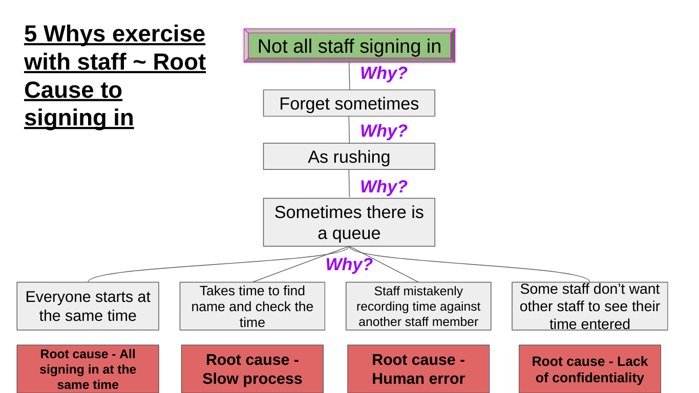

The Office Manager also took the administration staff through the same process of the Five Why’s to ascertain the root cause of why the visitors’ process is ineffective at times. They were identified as individuals who were directly affected by this process as they were part of implementing this process and preparing the signing in documentation.

They were asked why the paper signing in process was ineffective for visitors. They indicated that the process took too long and also there was a high use of paper during this process. The Officer Manager asked why this was the case and they replied that too much time was taken due to it being a slow process and the visitors needed to provide a lot of details at this stage. Again they were asked why this was the case and they replied that visitors were having to duplicate information. Once being asked why again they explained they were required to sign in and provide details on a separate sheet which was also required for TTP in order to meet Covid19 regulations. They were also required to read and sign that they fully understand and would comply with the risk assessment that is in place at the school. The two main root causes for the ineffective paper signing in system for visitors were reported as:-
- Duplicate information was needed.
- The system was not eco-friendly.
A visual record of the exercise was again recorded as below:-

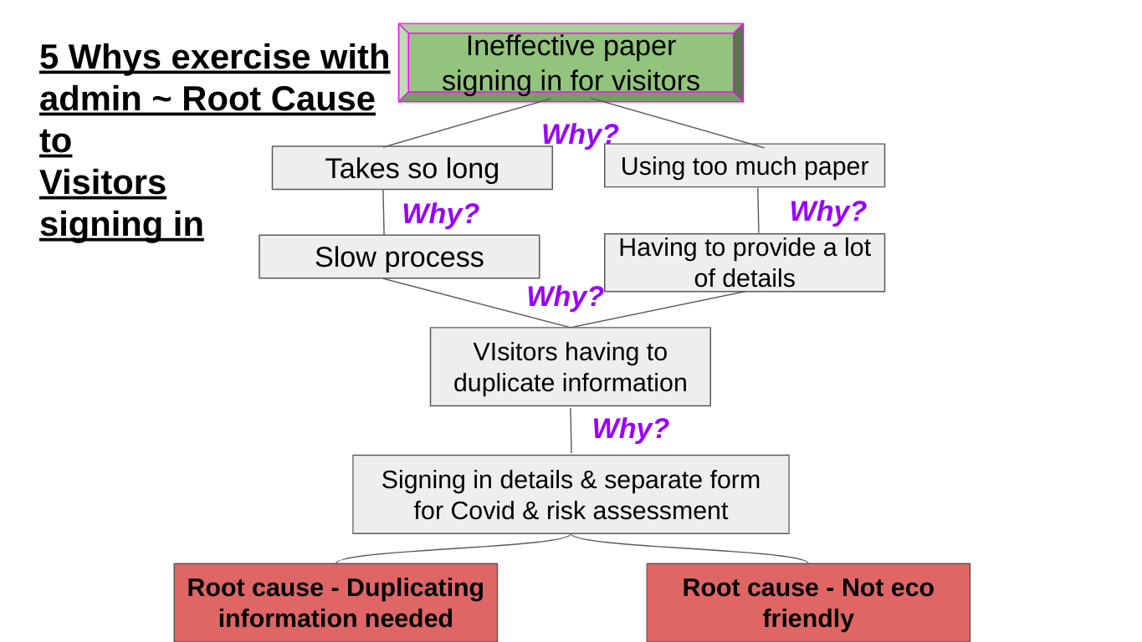

According to Coccia (2017) a fishbone diagram is a regularly used technique to reach the full cause and effect of a specific problem. Each major category can be further investigated but will all lead back to the main effect. It can be used as a visual tool outlining many causes and effects and shows if any causes are interlinked and related to the main element.

At this stage the Office Manager wanted to analyse the current signing in system and appreciated it was important to fully understand the cause and effect of the signing in system. The Office Manager undertook a fishbone diagram.

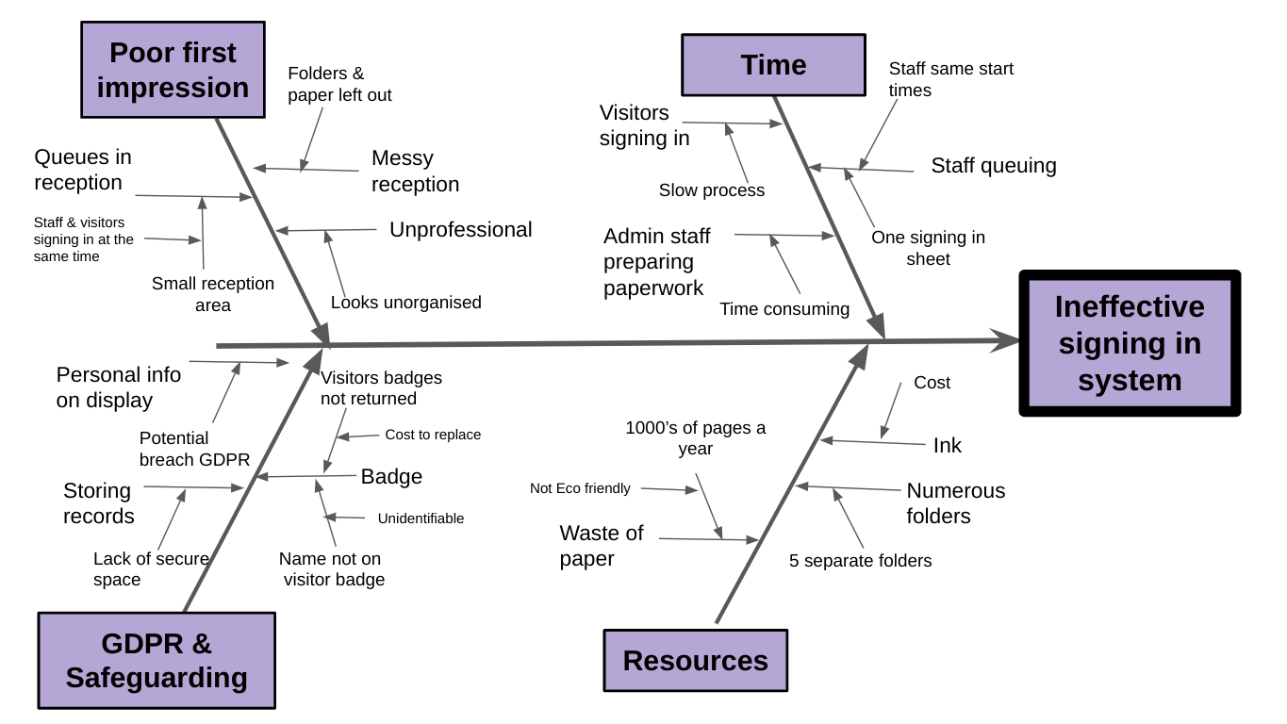

From the Fishbone diagram it is clear there were a number of causes identified. It highlighted it does not give the best first impression and having lots of paperwork out can make the reception area look untidy. Concerns regarding personal information of staff and visitors on display were also recorded and this could lead to a serious breach of GDPR. Another cause highlighted was the lack of secure storage space for such paperwork. Whilst looking into time it clearly highlighted it was a timely process for the administration staff when preparing the signing in sheets and storing them. It also state that staff and visitors found the process slow and often staff were queuing to sign in and out due to all staff starting and finishing at the same time. Resources was another area explored it noted the cost of purchasing paper, ink and folders. The school is recognised as a successful eco-friendly school and it has been identified that their current signing in system is not considered eco-friendly as many sheets of paper are used to produce these signing in sheets weekly.

Another tool that will be used to record each stage of the process will be mind mapping. See Appendix 7 for the completing mind map created. Williams (2021) suggests it’s a tool to visually record and document ideas all relating to one main topic. It has many benefits such as organising thoughts, notetaking, creating ideas, problem solving and assist in decision making.

Propose a range of alternative solutions to the problem

At this stage it would be appropriate to undertake a brainstorming session to help create ideas. According to Yazdani & Tavakkoli-Moghaddam (2012) this is best held within a team and should be led by one person. It is a paramount process that will give more ideas and these ideas should be recorded down for all to see. All ideas should be noted regardless of suitability at this stage.

With the above in mind the Office Manager held a brainstorming session with all staff members including administration staff as these were some of the individuals identified with the earlier exercise as part of the impact category and who would be affected within the scope of this improvement opportunity.

During the brainstorming exercise there were various ideas that came up.
- Paper signing in system remain the same
- Signing in APP
- Admin staff complete all signing in paperwork for staff and visitors
- Use a swipe card
- Digital Management system
The Office Management conducted Primary research using the local school within their school cluster Nightingale (2021). Upon reviewing the research it was clear that all 6 schools ensured all staff, visitors and late pupils had to sign in when entering the school (Appendix 1). Whilst 33.3% were using a paper signing in system, 50% were using a signing in APP and the remaining 16.7% were using a Visitors Management System (Appendix 2). It recorded only one positive from using a paper signing in system which was “Can clearly see who is in on a daily basis” but there were a number of disadvantages listed when using a paper signing in system such as, “Staff don't put correct arrival time” and “Messy” (Appendix 3). For the schools already using an electronic system for registering staff, visitors and late pupils they recorded 12 advantages to using these systems (Appendix 4) some of these included:-
- More professional.
- Quicker for staff & visitors
- Easier to use
- No breach of GDPR.
Whilst there were more advantages reported there were only 2 disadvantages reported which were “Must have internet access” and “cost” (Appendix 5). Out of the 50% already using an electronic system the 2 companies used were Signing in APP I-Teach and School Care visitor Management System (Appendix 6).

Using a decision making technique, evaluate a range of solutions to identify the most appropriate option

In order to fully analyse the Office Manager took three possible solutions through a non-financial Grid Analysis. The Office Management felt the 3 best proposed solutions were continuing with current paper signing in system, Signing In App and Digital Management System. These were collected from the brainstorming session. Five of the most important factors were added to the grid analysis GDPR, eco-friendly option, most professional impression for reception, quickest and fast process for staff, admin staff and visitors and cost element.

The information and feedback from the previous processes such as Five Why’s, Fishbone diagram and the brainstorming session assisted the Office Manager in added values of importance to each factor. This assisted during the grid analysis to give a true reflection of what factors are the most important in order to come up with a solution to the problem.

Scale
1 - Poor
5 - Extremely good
Factors: | GDPR | Eco-  Friendly | professional | Fast process | Cost effective | TOTAL
Weights: | 5 | 4 | 3 | 4 | 3
Paper signing in | 1 5 | 0 0 | 1 3 | 1 4 | 3 9 | 6 21
Signing in App | 5 25 | 5 20 | 4 12 | 4 16 | 3 9 | 21 82
Digital Management | 5 25 | 5 20 | 5 15 | 3 12 | 1 3 | 19 75
Upon close inspection of the Grid Analysis the clear and most viable solution is clearly the signing in App as it meets the criteria and scored the highest. For this reason the Office Manager will take the signing in app through a cost benefit analysis to ensure this is a financially beneficial solution.

The Office Manager listed all the costs associated with the signing in App for 5 years in total. For the first year they were required to pay out for the initial equipment of £700 and a one year subscription of £295. There was also a delivery charge of £15 for the said equipment. There was a cost for the administration staff time as they were still required to monitor the signing in process and print off visitors’ badges using the new equipment. The administration staff hourly rate is £12 an hour and it was predicted to take 30 minutes every working day for 39 weeks of the year giving a total annual cost of £1170. Staff training was also taken into account and our IT technician would be responsible for producing a detailed PowerPoint presentation training all staff how to use the system. This would take 2 hours at £20 an hour therefore total cost £40. This can be re-used for training new staff or providing a refresher session if needed hence only being highlighted as a cost for the first year. The cost benefit analysis listing the costs only. Please see below for fully details:-

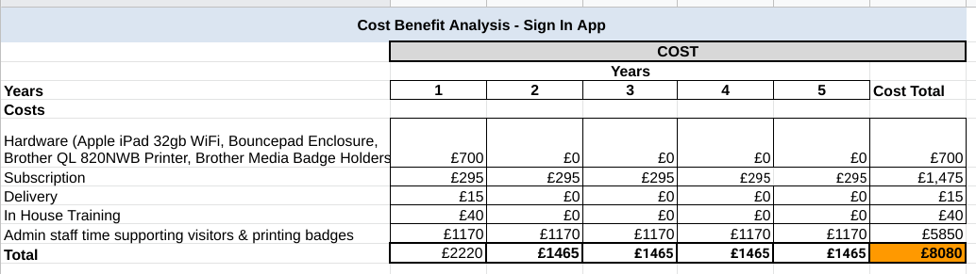

The Office Manager listed the cost benefits over a 5 year period for the proposed Signing In App. The first cost was the paper used to produce all signing in sheets for staff and visitors including the covid19 Track and Trace Forms. This produced a yearly cost of £45. There are also costs for folders and pens at a yearly cost of £25. On average 1 ink cartridge is used a year when printing the documentations out and ink costs £35 a year. Visitors badges are regularly lost or misplaced and the cost for replacing lanyards are estimated at £30 a year. The largest yearly cost occurred is the cost of admin staff producing all documents and also monitoring and storing the same. Admin staff spend 1 hour a day £12 an hour over 39 weeks a year creating an annual cost of £2340. The cost analysis listing the costs only has been attached below:-

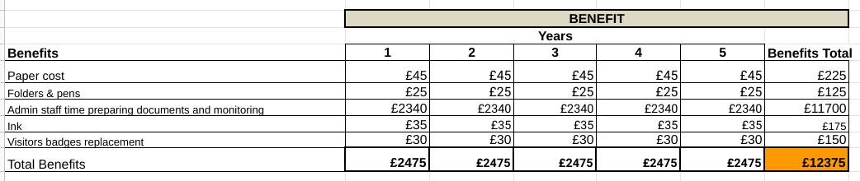

The total cost benefit over 5 years is £12,375 whilst the total cost over 5 years is £8080. This will be divided in order to produce the cost ratio benefit. This produced a cost ratio benefit of 1.5:1. This indicated that for every one pound spent the school will receive £1.50 of cost benefit. During the first year the school will have an initial spend of £2220 however the cost benefits saving will be £2475. This produces a first year annual savings of £255. The school will also benefit from purchasing and owning the following equipment:-

- Apple iPad 32GB
- Bouncepad enclosure
- Brother QL Printer
- Brother Media Badge Holder

The second year through to the fifth year will produce an annual savings of £1010 per year. Over 5 years the average annual savings is £895.

The ratio is attached below:-

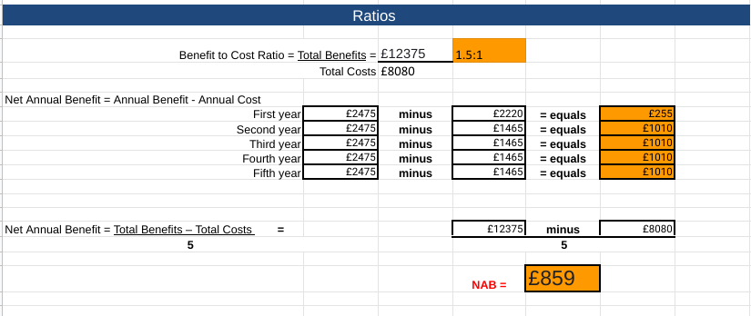

Therefore the solution of the Signing In App is an extremely good non-financial and financially variable solution.

Develop a detailed plan for implementing the solution

Geraldi and Lechter (2012) suggest that Gantt charts are a commonly used tool in project management. It has many positives as a tool to connect tasks and duration of each task. It provides a visual tool which highlights the time allocated to each task needed. It allows teams to remain focused and easily highlights if tasks are overrunning and allows for careful monitoring.

In order for the Office Manager to plan the implementation of the solution she listed all tasks that were required to get to the desired end results of an effective GDPR compliant and Eco-friendly signing in system. Approval was required from her Headteacher and Primary Support Officer (PSO) to ensure relevant funds were available within the current annual budget. These could run parallel with each other and it was estimated once presented with the evidence produced from brainstorming sessions, mind mapping, root causes, grid analysis and cost benefit analysis it would take up to a week to receive this. The next stage would be to seek approval from the Finance committee and Governing Body and this would run sequential to previous tasks and would take a week. Once all approvals were granted it would take a day for the Office Manager to place a Purchase Order and 2 weeks for delivery of said equipment. The IT technician would then take approximately 1 week to set up the software and another week to produce a powerpoint training session. The caretaker would be required to fix equipment to the wall and would take 1 day and run parallel with the IT Technician producing the training guide. The final stage would be for all staff to receive training that would take a week and could be delivered via email for staff to re-watch the training session virtually.

A list of tasks and Gantt Chart attached below for visual representation and would allow the Office Manager to monitor the timeframe at every stage to ensure it is kept on task:-
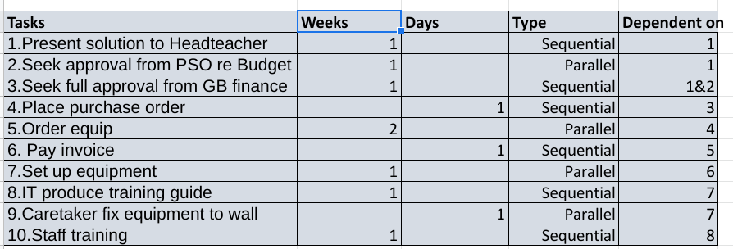

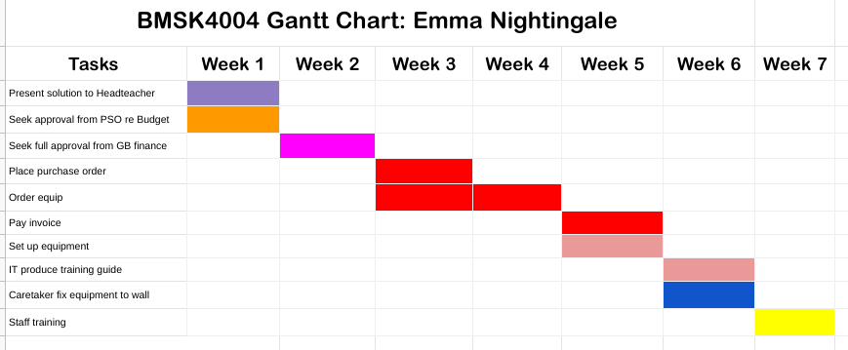
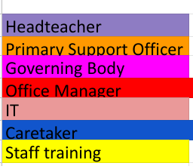
From producing the Gantt it is clear the Signing In App could be available for full use by the end of Week 7.

Communicate the plan to relevant stakeholders
According to Knowhow (2017) stakeholders are individuals or organisations that have an interest in your organisation. It’s important to identify direct stakeholders and intermediary stakeholder. Direct stakeholders are connected to your organisation whilst intermediary stakeholder interests can be different.
The Officer Manager firstly identified all the stakeholders affected by the solution. These were all staff, all visitors to the schools, Headteacher, full Governing Body, Finance Committee of the Governing Body, Local Authority, Primary Support Officer, Pupils, Parents and digital signing in system Company.
The next step the Officer Management was to investigate the named stakeholders’ interest and conducted a list below:-

All staff ~ day to day use of the solution
All visitors ~ when visiting the school
Headteacher ~ full interest all details to be disclosed
Full Governing Body ~ brief overview of the solution including finance
Finance Committee of the Governing Body ~ full interest of all details to be disclosed. Local Authority ~ brief overview
Primary Support Officer ~ financial interest only
Pupils ~ little interest if any
Parents ~ little interest only if entering the school for meeting
Digital signing in system Company ~ financial interest

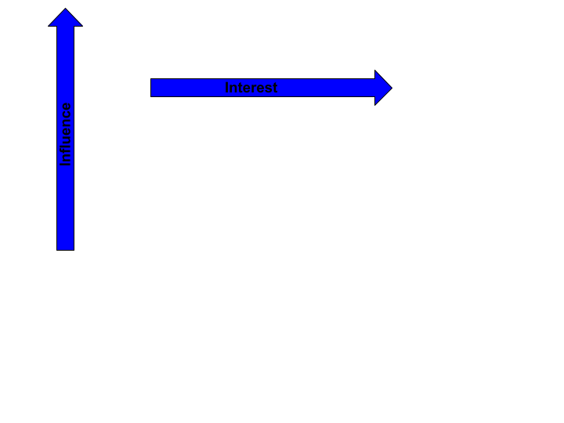
The next step was to understand the level of influence and interest that each stakeholder held. The Office Manager created an Interest/Influence Matrix which clearly categorises stakeholders into 4 categories of how much their interest and influences reflects the level of information that is needed to be supplied:-
Keep informed  - All staff | Manage closely  - Headteacher  - Finance Committee of Governing Body
Monitor  - Visitors  - Sign In App  - Pupils  - Parents | Keep satisfied  - Governing Body  - Primary Support Officer  - Senior Management Team  - Local Authority
After considering all the stakeholders that are linked to the school and current problem solving solution the Officer Manager created a Communication plan

Whom? | Why? | What? | When? | How?
Headteacher | Financial. Full decision making | Full details | Constantly | Verbally, email, telephone
Finance Committee | Financial | Full details | Initially and updated every terms (3 times a year) | Meeting
PSO | Financial | Costings only | Initially and updated every terms (3 times a year) | Meeting, Email or telephone
Governing Body | Decision making | Practical details & basic financial info | Initially & termly (3 times a year) | Meetings
Senior Management Team | Day to day use & supervision | Practical details & basic financial info | Initially and as and when after that | Meeting, email or telephone
Local Authority | Overall supervision | Basic info | Initially | Letter
Staff | Day to day use | Full details of practical use | Once set up and up running | training sessions, meeting with Headteacher
Visitor | Day to Day use | basic information | When using | face to face on visiting school
Sign In App | Service Provider |  | Yearly | Letter
Pupils | N/A | None required | Not required | Not required
Parents | If visiting school | Basic information | When visiting the school | Verbally by admin staff

Frost (2021) indicates that good clear communication plans are essential. It’s important to ensure there are no delays in the process. The form of communication and how often should be included to reflect the influence and interest each stakeholder represents. It is advisable to review communication plans regularly to ensure that stakeholder’s interests do not change.

Assess appropriate monitoring and review techniques to ensure successful implementation of solution

There are many monitoring tools available to allow for regular monitoring. Some of these are:-
- Gantt Charts
- Feedback
- Informal/formal meetings
- Action plans
- Run Charts

However in order for the monitoring tool to meet the needs of this particular solution the Officer Manager believes the Gantt Chart would be the most suitable. Please see the Gantt Chart above. It gives a good clear visual representation of the whole process and regular monitoring would allow the Officer Manager to step in and take action if there were any delays or complications along the way. It clearly shows who is responsible for each action and the length of time that is required to complete the task. To review the success of this particular solution feedback would be obtained from staff after 3 months of using the signing in app. This would be done by way of questionnaire and all staff would be encouraged to provide feedback. This in turn would be collected and evaluated to ensure that the new signing in App was successful and running as smoothly as anticipated.

The Office Manager will also monitor the detailed mind map created and added to at each step of the process. Attached below:-
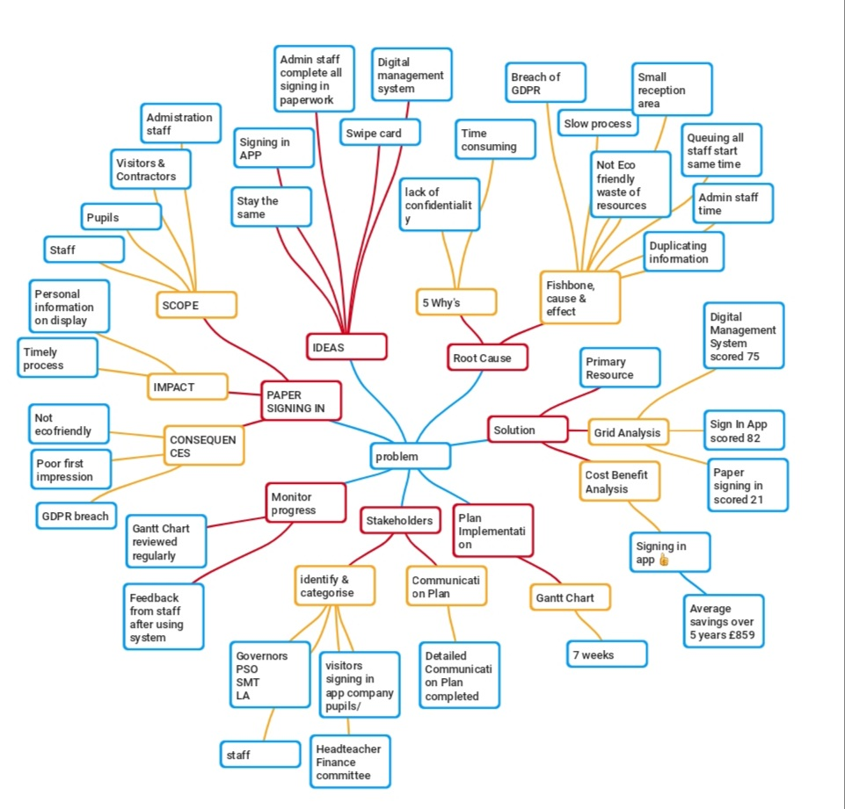

References

Coccia, M., 2017. The Fishbone diagram to identify, systematize and analyze the sources of general purpose technologies. Journal of Social and Administrative Sciences, 4(4), pp. 291-303.(Accessed 10.08.21)

Frost, S. (2021) How important are Communication Plan for Project Managers? [online] Available at: https://smallbusiness.chron.com/important-communication-plans-project-managers-37520.html (Accessed 22.08.21)

Gangidi, P., 2019. A systematic approach to root cause analysis using 3 × 5 why’s technique. International Journal of Lean Six Sigma, 10(1), pp. 295-310. (Accessed 22.08.21)

Geraldi, J. and Lechter, T., 2012. Gantt charts revisited. International Journal of Managing Projects in Business, 5(4), pp. 578-594. (Accessed 08.08.21)

Knowhow. (2017) Stakeholders Analysis [online] Available at: https://knowhow.ncvo.org.uk/organisation/strategy/directionsetting/stakeholder (Accessed 28.08.21)

Nightingale, E. (2021) Signing System https://docs.google.com/forms/d/1s_kpG3bQrQ3DGD95yeQWwU3M-fIAcFTRn-t4ALxz5to/edit [online] (Accessed 04.08.21)

Williams, D. (2021) Mind Mapping: A mental Tool for Generating Ideas and Solving problems [online] Available at: https://www.lawpracticetoday.org/article/mind-mapping-a-mental-tool-for-generating-ideas-and-solving-problems/ (Accessed 20.08.21)

Yazdani, A.-A., & Tavakkoli-Moghaddam, R. (2012). Integration of the fish bone diagram, brainstorming, and AHP method for problem solving and decision making—a case study. International Journal of Advanced Manufacturing Technology, 63(5), 651–657. https://doi.org/10.1007/s00170-012-3916-7 (Pg 3) (Accessed 02.08.21)

Appendix 1
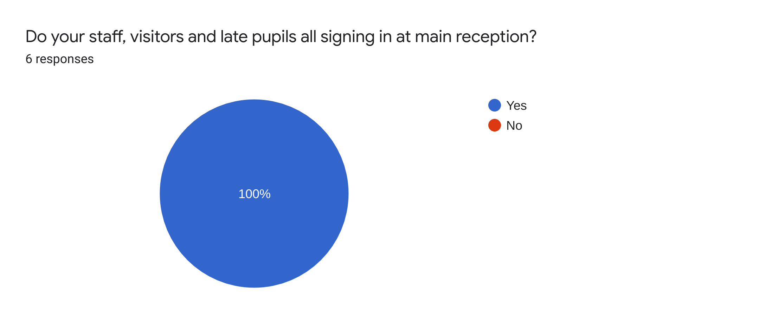

Appendix 2

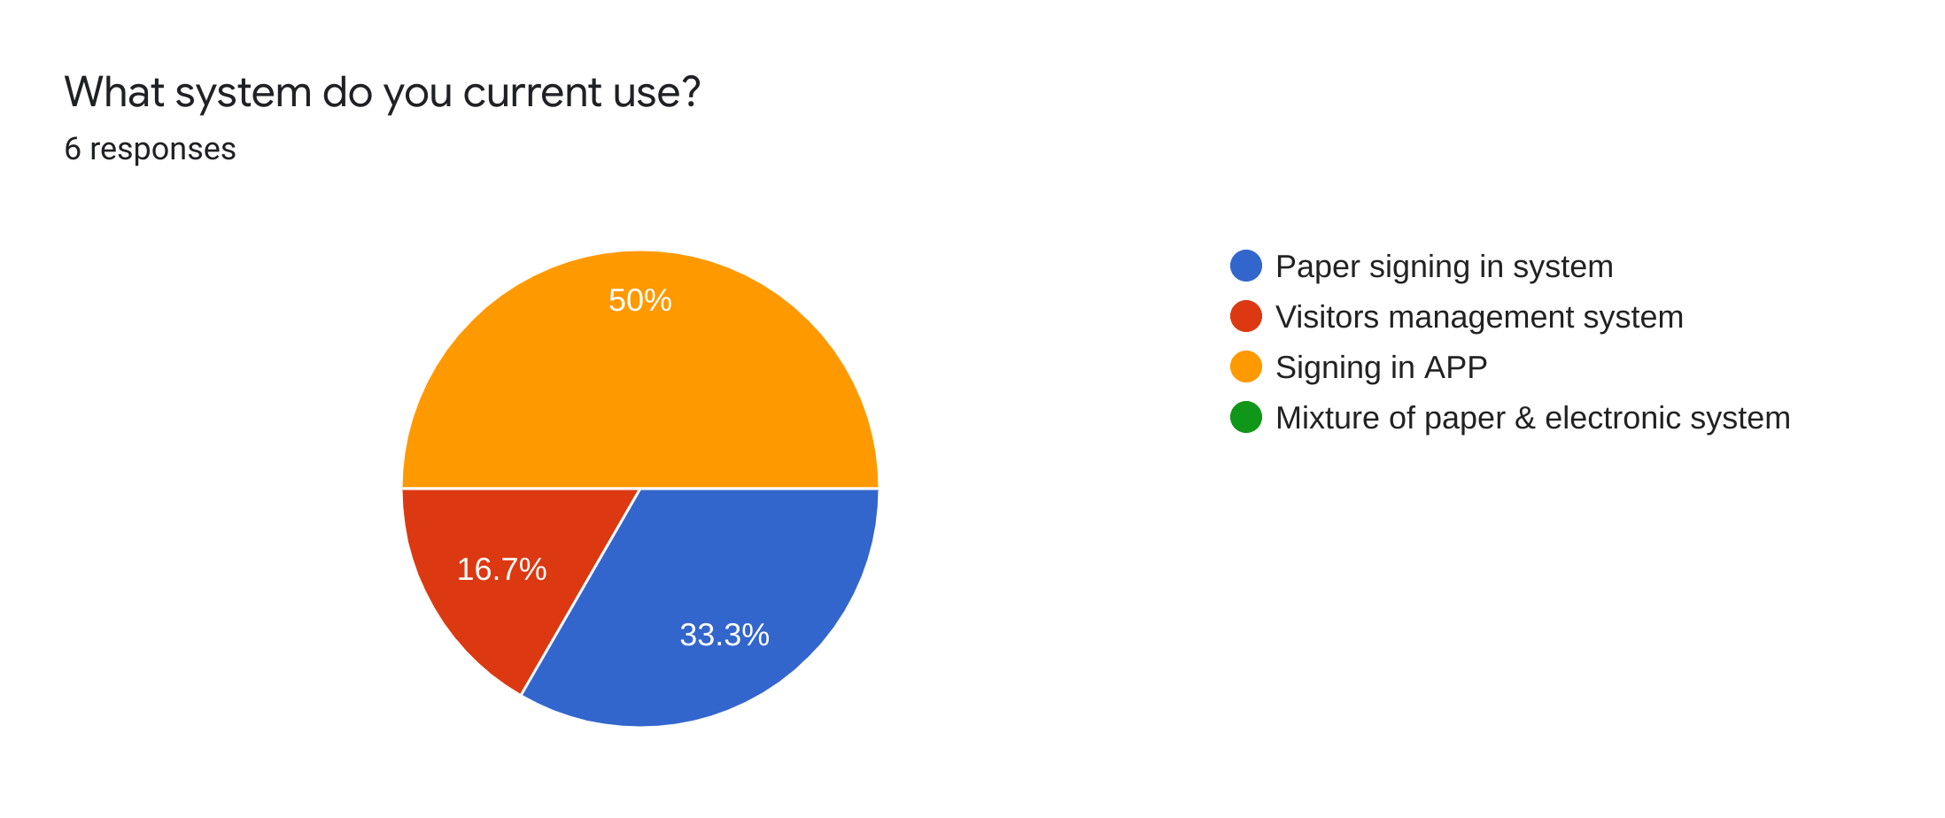

Appendix 3

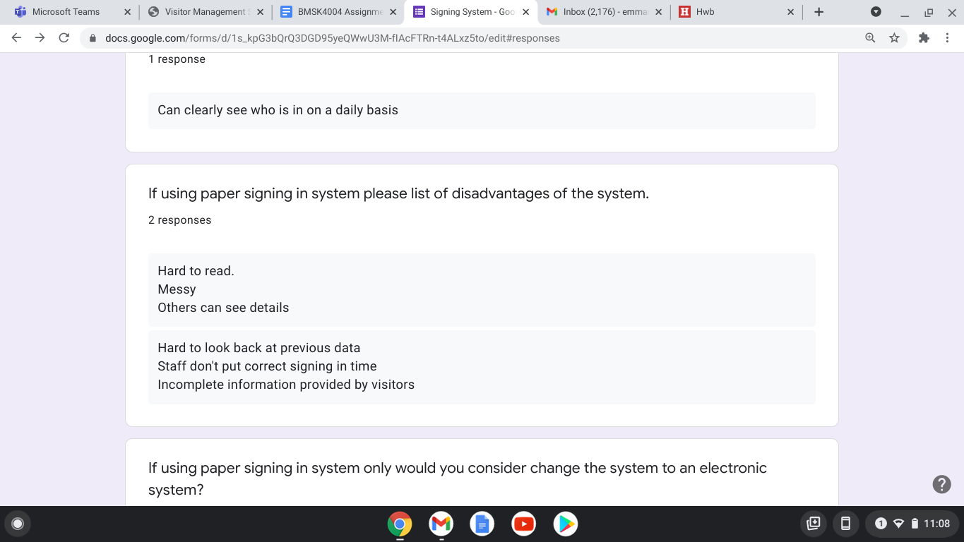

Appendix 4

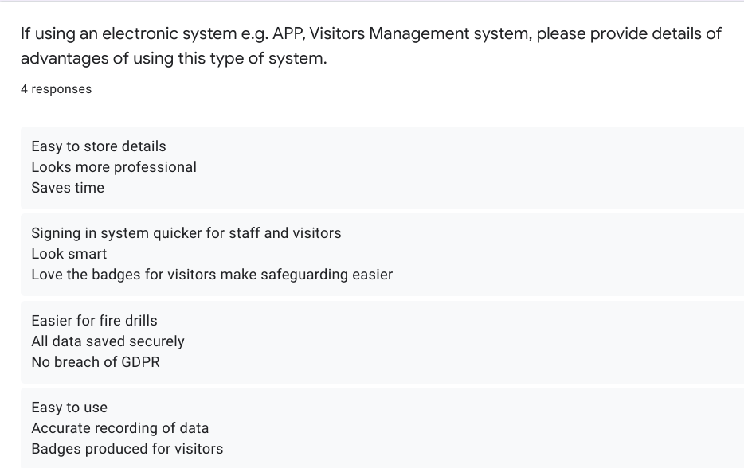

Appendix 5
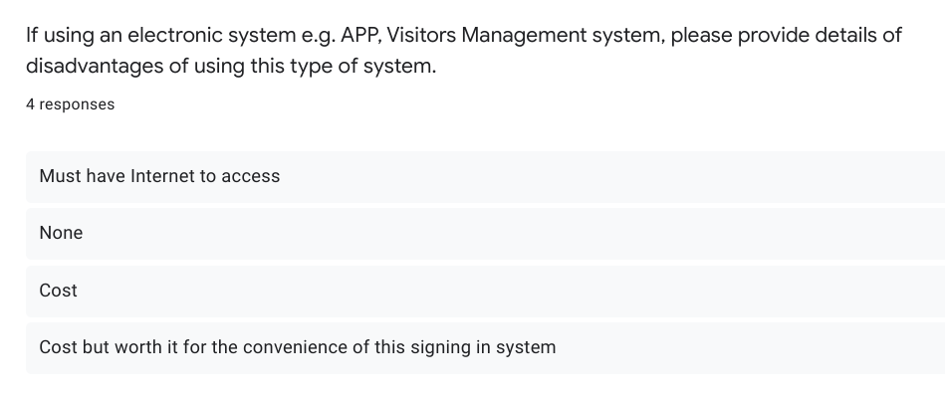

Appendix 6
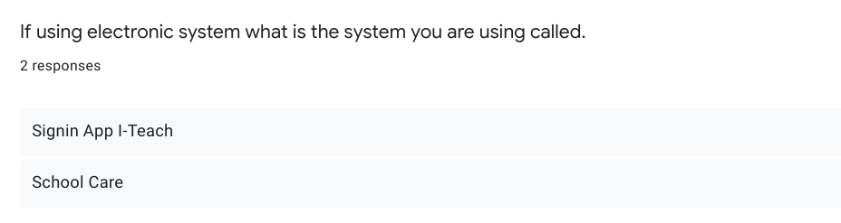

Appendix 7

