University of Wales Trinity Saint David
School of Engineering

Integrating Project

Alexander Penny – 1706431
Claudia Marques-Andre - 1704218
Hannah White – 1702206
Joseph Lockyear – 1701114
Lee Stewart – 1700860
Thomas Unwin – 1703582

Foundation Engineering



Contents
Introduction 1
Chassis 2
Design 2
Analysis 2
Steering and Wheels 3
Suspension and Brakes 4
Aerodynamics 5
Analysis 5
Conclusion 6
Materials and Costing 7
Analysis 9
Conclusion 10
References 11

Introduction

This report will discuss the design requirements and choices made by the group in the creation of a soapbox racer for use at Richard’s Castle Soapbox Derby. Design choices were made based on the regulations provided for the event, the driver’s own personal preference and research made into the subject.

The group divided into smaller sub-groups to each manage a part of the design, or complimentary parts that would work together. The division of design parts went as follows:

- Chassis – Joe and Tom
- Suspension, Steering, Wheels and Brakes – Alex and Lee
- Aerodynamics – Hannah
- Materials and Costing – Claudia

The further sections of this report will more thoroughly evaluate each group’s work, the design choices made, and will allow for analysis of each subdivision and discussion of possible alternatives to the chosen design.

Chassis

Design
The chassis is the whole skeleton of the racer. It needs to provide enough weight to initiate the racer’s movement, but not be so heavy as to impinge its ability to be competitive. The chassis must also be rigid to protect the driver, but flexible enough to absorb impacts without breaking and to cope with cornering forces. Finally, it must allow satisfactory mounting and operation of steering mechanisms, brakes and bodywork.
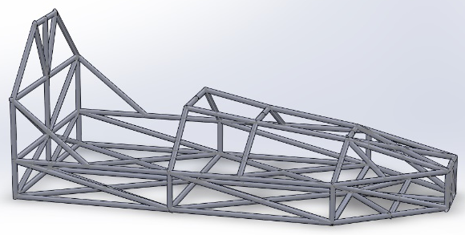
Initially, the chassis was to be made from steel that was 30mm in overall thickness, with a wall thickness of 2mm throughout the whole frame, stepping up to 2.5mm where the wheels would mount. While the extra thickness sounds helpful around the whole frame, the final design has had the wall thickness reduced from 2mm to 1.6mm, though the wheel mounting points have been left at 2.5mm. The new, lighter frame should still be sufficiently strong to withstand the course (Scottish Cartie Association, 2013).
Figure 1 - Right-hand view
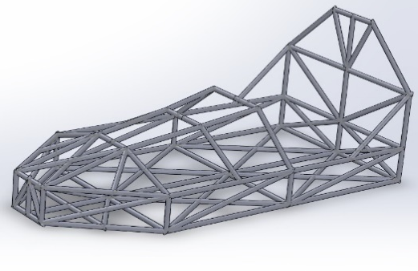
The measurements of the chassis were picked to provide enough space for our elected driver while keeping the wheelbase slightly shorter to allow for quicker turning. The event regulations were also accounted for.

The racer frame measures in at 1750mm x 800mm. These dimensions allow for comfortable placement of the driver and enables a taper toward the front, aiding in the aerodynamic design.
Figure 2 - Left-Hand view

A roll cage has been added as per the regulations (Richard's Castle Soapbox Derby, 2016).

Analysis

While a lot of reinforcement has been done for rigidity and safety, the number of cross-members in the design will have compromised weight.

Another thing to note is that, given enough time and funds, the ideal material picked for the chassis would have been carbon-fibre. It has good strength and rigidity whilst being lighter than the chosen steel. Difficulty of manufacture and the cost to purchase this material has prevented it’s use in this design.

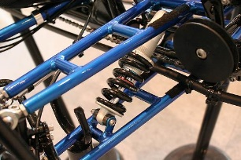
Suspension
Since a double trellis design is in place for the core chassis an equal length double wishbone setup is the best application. Using the pipe bender available in the workshops loops can be constructed minimising joints in the structure and the welding required.
(Atkinson, 2012)
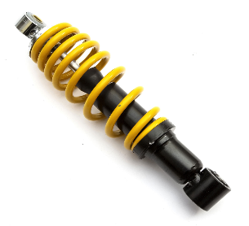
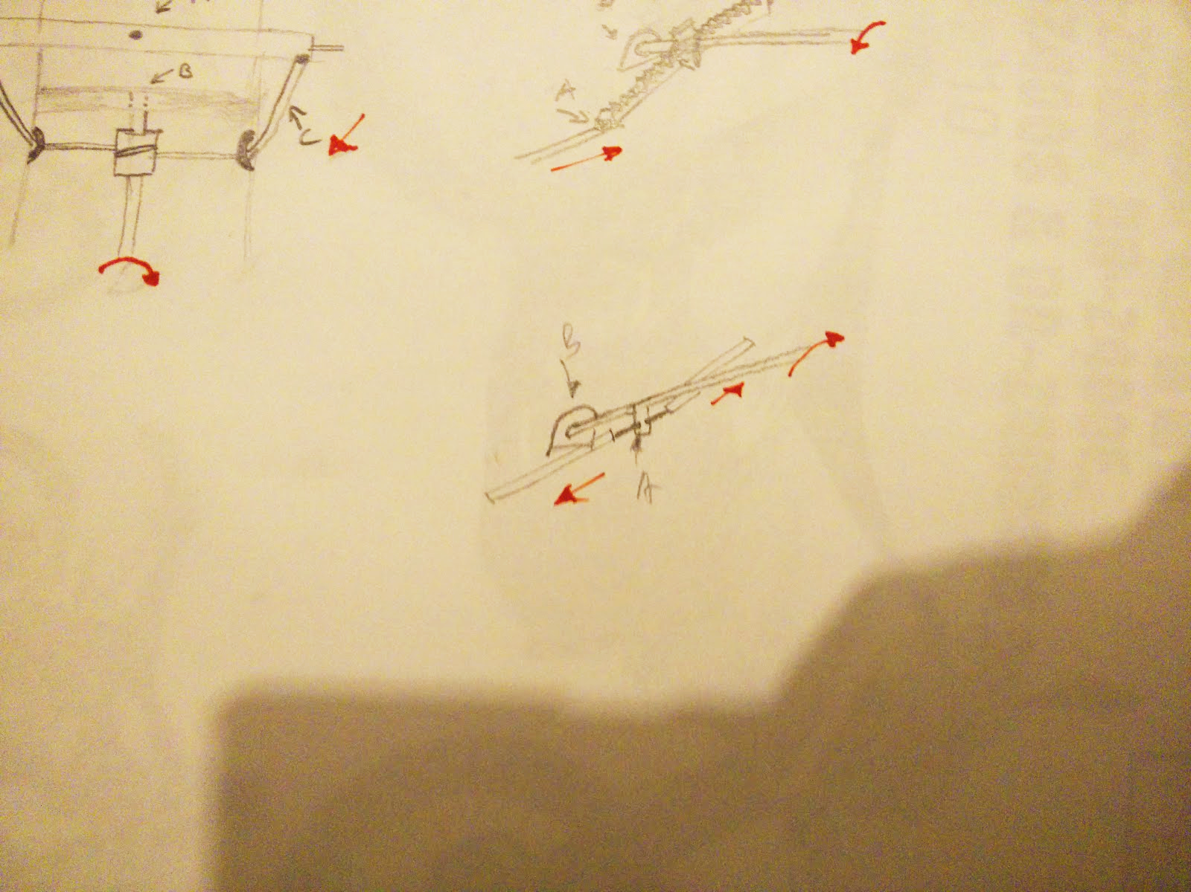
The shock itself has been changed from a remote reservoir motorcycle shock to a progressive emulsion shock from a quadbike. This decision was taken since the spring rate for a motorcycle would be excessive, on the other hand a quadbike is a very similar class of vehicle. The additional weight they are designed to hold will help with giving firm feedback during high G cornering. The progressive spring was also considered, there are a significant number of rusts etc. on the track. This low speed action should be absorbed by stage one nicely, the rest will be only active during cornering. Although emulsion shocks are typically inferior they suit this task nicely with a very low purchase cost and compact form. In a longer race the fade would be an issue but since it is only a two minute stage any effect will be nominal.
(Ebay, 2018)

Steering
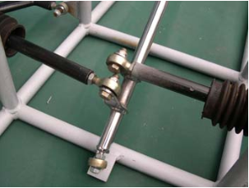
Using some rose bearings push rods can easily steer the front two wheels, since this is set to be manufactured by students the rose bearings will also help with any inacurcies in the construction. The rake on the steering column has been increased as the driver is set to sit more upright for better visibilty. Since the system is no longer open having a low areodynamic profile is less of a concern. The arches are to be left open as through opostion reaserch it has become clear the exposed profile detracts less than atempting to build a lemans style cart.
(Formula Gravity, n.d.)

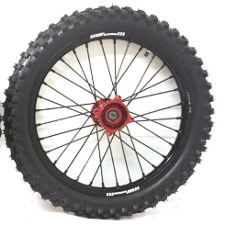
Wheels
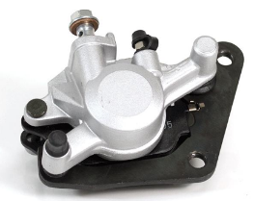
Pit bike wheels are the final selection, the 14” options are ideal for the decreased rolling resistance of a larger wheel without the fragility of bicycle rims. Although side loading is a concern the sturdy spokes and thick rims should be more than sufficient. An intermediate hard tire was been chosen to best handle the loose surface, they are not so large in profile as to impair the traction in moist conditions. In a downhill race friction is not desired on the long sections of strait tarmac, it’s the corners which the tires need to be selected for.
(Ebay, n.d.)

Brakes
Single piston callipers will provide more than adequate braking force, since the wheels have brake disks which can be so easily mounted it would be foolish to downgrade, the chassis has a some significant bracing which no doubt increases the amount of GPE that must be dissipated to slow the cart. Safety is a high priority for the team, hydraulic lines may be more work but the reliability is worth the investment.
(Formula Gravity, n.d.) (Lexmoto, n.d.)

Aerodynamics

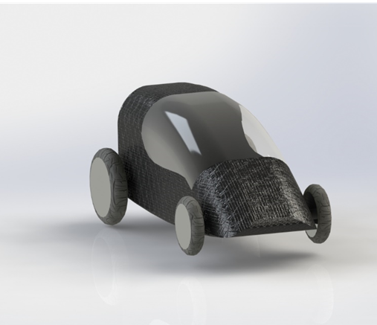
This section of the report will discuss the final design of the body of the soap box racer and discuss how suitable the final shape is in relation to designing it on solid works and how good the aerodynamics are on the body.
Figure 3 - Solidworks front view
In figure 1 and 2 you can see the final design of the body that has been made in Solidworks using the drawings that had been previously decided on by the group.
The main aim was to design a body with good aerodynamics, light weight, cheap to manufacture, good stability able to with stand a crash without the driver being injured, well-structured and driver comfort.
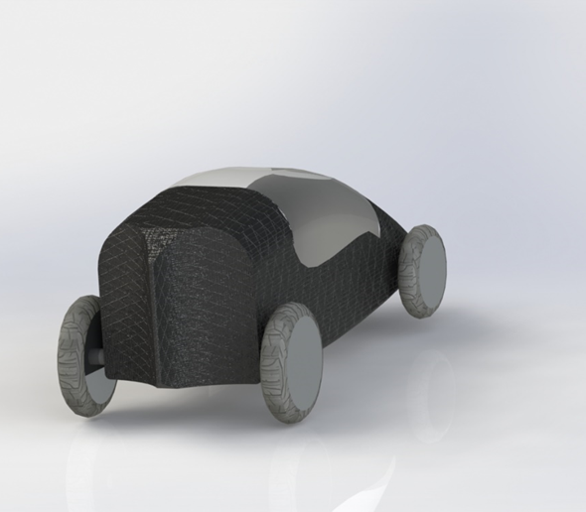
The measurements of the body were based on the size of the driver and slightly bigger than the chassis so there would be no wasted material to cut down the cost, also it was important to keep the size of the body in the requirements.
Material used for the body is fiberglass, the reason behind this is fibre glass is very strong, long lasting and light, pound for pound it is stronger than sheet metal and will never rust and is very resistant to corrosion. Fiberglass is also very cheap and easy to manufacture, it can be moulded into nearly any shape you want.
(Fibreglass Tech, 2017)
For the hatch Polyethylene terephthalate is used, same as fiberglass its very cheap and extremely light weight, strong and no chance of shattering and it has nearly glass like transparency (Encyclopaedia Britannica, 2015), so it will have near perfect visibility for the driver.
Figure 4 - Solidworks rear view

Analysis

The shape of the body Is very suitable in many ways such as, theoretically it’s a very good aerodynamic shape due the front of the racer being narrow and low there wouldn’t be too much stagnation pressure being applied to the racer. The body is also very smooth and streamlined and very little pressure would be applied to the body, so air resistance will have very little effect on it. As you can see from figure 4 there is a small smooth fin on the back of the racer, this has been added to control the effect of turbulence at the back of the racer. The fin will help stagger the turbulence which will help add stability to the racer (Hill, 2013).

Conclusion

With keeping to the constraints of the regulations of the soap box derby, the group has successfully manged to design a body for a soap box racer that will have good aerodynamics, good stability, cheap to manufacture and possible to manufacture within the university. Ideally the preferred material would have been carbon fibre as its very lightweight, very durable and easy to mould, but due to cost fibre glass is a better option. Also, if weight was saved in other parts of the soap box racer and, again, cost wasn’t an issue - a thicker plastic, like something you’d find on a visor of a motorcycle helmet, would have been a better option for the roof as it would be more durable, if there was a crash the driver would be less likely to be injured, and it would add slightly more stability to the racer.

Materials and Costing

The various materials used in the soap box construction have different qualities. When choosing them, we had in consideration three important aspects; cost, strength and weight.

Steel was chosen for the body because of its Strength, Toughness, Ductility, Weldability, and Durability. Steel is also comparatively cheap both to purchase and manufacture.

Ride quality and comfort of high quality steel is second to none.
Steel is corrosion resistant and, upon impact, will bend rather than snap. (BCSA, Steel for Life and the SCI, n.d.).
It is also relatively easy and cheap to repair if damaged. Depending on how it’s made, steel can either be very heavy or quite light and flexible.
The selected steel will be in the form of round tubes.

Alloy of aluminium for the wheels, alloy is a mixture of metals and other elements which can be a mixture of aluminium or magnesium.
Aluminium has a lower tensile strength than steel, typically 225-750 MPa, and a considerably lower modulus of about 54,000 MPa. It is much more prone to fatigue if badly used, but it is a third the weight of steel. All structural aluminium is alloyed with small percentages of other elements, in the same way as the high-grade steels. It is designated into groups that share a similar main additive. They run from the 1000 series which is pure, to 8000 which has lithium as the main addition. Another advantage of using aluminium is it’s lower manufacturing cost, making it cheaper to purchase.

Polyethylene terephthalate for the wind-screen (PETP) is a strong, dimensionally stable material that absorbs very little water. It has good gas barrier properties and good chemical resistance except to alkalis (which hydrolyse it) (Azom, 2003),
Chemical Resistance
Acids – concentrated |  | Good
Acids – dilute |  | Good
Alcohols |  | Good
Alkalis |  | Poor
Aromatic hydrocarbons |  | Fair
Greases and Oils |  | Good
Halogens |  | Good
Ketones |  | Good
Electrical Properties
Dielectric constant @ 1 MHz |  | 3.0
Dielectric strength ( kV.mm⁻¹ ) |  | 17
Dissipation factor @ 1 kHz |  | 0.002
Surface resistivity ( Ohm/sq ) |  | 10¹³
Volume resistivity ( Ohm.cm ) |  | >10¹⁴
Mechanical Properties
Coefficient of friction |  | 0.2 - 0.4
Hardness – Rockwell |  | M94-101
Izod impact strength ( J.m⁻¹ ) |  | 13 - 35
Poisson’s ratio |  | 0.37-0.44 (oriented)
Tensile modulus ( GPa ) |  | 2 - 4
Tensile strength ( MPa ) |  | 80, for biax film 190 - 260
Physical Properties
Density ( g.cm⁻³ ) |  | 1.3 - 1.4
Flammability |  | Self Extinguishing
Limiting oxygen index ( % ) |  | 21
Refractive index |  | 1.58 - 1.64
Resistance to Ultra-violet |  | Good
Water absorption - equilibrium ( % ) |  | <0.7
Water absorption - over 24 hours ( % ) |  | 0.1
Thermal Properties
Coefficient of thermal expansion ( x10⁻⁶ K⁻¹ ) |  | 20 - 80
Heat-deflection temperature - 0.45 MPa ( °C ) |  | 115
Heat-deflection temperature - 1.8 MPa ( °C ) |  | 80
Lower working temperature ( °C ) |  | -40 to -60
Specific heat ( J.K⁻¹.kg⁻¹ ) |  | 1200 - 1350
Thermal conductivity ( W.m⁻¹.K⁻¹ ) |  | 0.15 - 0.4 @ 23
Upper working temperature ( °C ) |  | 115 - 170
Properties Polyethylene Terephthalate Film
Property |  | Value
Dielectric Strength @ 25 µm thick | KV.mm⁻¹ | 300
Dissipation Factor @ 1 MHz |  | 0.016
Elongation at Break | % | 60 - 165
Initial Tear Strength | g.µm⁻¹ | 18 - 54
Permeability to Carbon Dioxide  @ 25 °C | x10⁻¹³ cm³.cm.cm⁻².s⁻¹.Pa⁻¹ | 0.07 - 0.11
Permeability to Hydrogen @ 25 °C | x10⁻¹³ cm³.cm.cm⁻².s⁻¹.Pa⁻¹ | 0.45
Permeability to Nitrogen @ 25 °C | x10⁻¹³ cm³.cm.cm⁻².s⁻¹.Pa⁻¹ | 0.0034 - 0.0038
Permeability to Oxygen @ 25 °C | X10⁻¹³ cm³.cm.cm⁻².s⁻¹.Pa⁻¹ | 0.015 - 0.04
Permeability to Water @ 25 °C | X10⁻¹³ cm³.cm.cm⁻².s⁻¹.Pa⁻¹ | 100 - 115
Specific Heat | KJ.kg⁻¹.K⁻¹ | 1.3
Thermal Conductivity @ 23 °C | W.m⁻¹.K⁻¹ | 0.13 - 0.15
Properties Polyethylene Terephthalate Fibre
Property |  | Value
Material |  | Medium | High tenacity
Specific Modulus | cN/tex |  | 700 - 800
Specific Tenacity | cN/tex | 36 | 70 - 80
Density | g.cm⁻³ | 1.39 | 1.39
Extension to break | % | 36 | 13 - 16
Modulus | GPa |  | 9 - 11
Shrinkage @ 100 °C | % | 4 | 1.5 - 6
Tenacity | GPa | 0.5 | 0.9 - 1.1
(Azom, 2003)

Fibre glass is being used for the shell because it is cheap and versatile. It has good chemical resistance, resisting most acids with the exceptions of hydrofluoric and phosphoric acids. It also has good dimensional stability with the nominal elongation break being 3-4 percent. The average linear thermal expansion coefficient of "E" glass is 5.4 by 10.6 cm/cm/°C. It cannot burn and is basically unaffected by curing temperatures used in industrial processing. It will retain approximately 50 percent of its strength at 700°F and as much as 25 percent at 1000°F.
Glass fabrics will dissipate heat more rapidly than asbestos or organic fibres. It has a high strength-to-weight ratio. Fiberglass yarn is twice as strong as steel wire and is good for electrical insulation purposes (BCSA, Steel for Life and the SCI, n.d.) (Lewco, 2018).

Analysis

While many materials were available to use, costs and ease of use restricted the selection. The materials chosen for fabrication of the racer will allow for ample lightness and strength while still being priced within a realistic margin. Carbon Fibre would have been an ideal material to use for the chassis, as an example, alas with a price 20 times that of steel (Jaguar Land Rover, 2015), it is unrealistic.

Conclusion

Though not perfect due to factors explained earlier in each section, the design for the racer should be able to be produced relatively easily without an unreasonable price-tag, whilst also remaining competitive in its performance.

The operation of the group hasn’t been perfect. Oftentimes communication between sub-groups could have been improved, and meetings more frequent with regular updates as to design tweaks and the reasoning behind it.

References
Azom, 2003. Polyethylene Terephthalate Polyester ( PET, PETP ) - Properties and Applications - Supplier Data by Goodfellow. [Online]
Available at: https://www.azom.com/article.aspx?ArticleID=2047
[Accessed 25 April 2018].

BCSA, Steel for Life and the SCI, n.d. SteelConstruction.info. [Online]
Available at: https://www.steelconstruction.info/Steel_material_properties
[Accessed 27 April 2018].

British Cycling, 2016. All Cycling Frame Materials. [Online]
Available at: https://www.britishcycling.org.uk/knowledge/article/izn20131118-All-Cycling-Frame-Materials-0#sKwFXl2edlxjsqkt.99
[Accessed 01 May 2018].

Encyclopaedia Britannica, 2015. Polyethylene Terephthalate. [Online]
Available at: https://www.britannica.com/science/polyethylene-terephthalate
[Accessed May 2018].

Fibreglass Tech, 2017. Fibreglass Tech. [Online]
Available at: http://www.fiber-techinc.com/
[Accessed April 2018].

Hill, D. J., 2013. Speed With Guy Martin [Interview] 2013.
Jaguar Land Rover, 2015. Carbon Fibre in Mass Automotive Applications. [Online]
Available at: http://www.ambafrance-uk.org/IMG/pdf/201504_fbscm15_s3p2_crow_dist.pdf
[Accessed 26th April 2018].

Lewco, 2018. Lewco. [Online]
Available at: http://www.lewcospecialtyproducts.com/reinforcement-fabrics/Properties-of-Fiberglass-Fabrics
[Accessed 03 May 2018].

Richard's Castle Soapbox Derby, 2016. Rules and Regulations 2016. [Online]
Available at: https://moodle.uwtsd.ac.uk/pluginfile.php/100260/mod_resource/content/0/RulesRegulations2016.pdf
[Accessed 18th February 2018].

Scottish Cartie Association, 2013. Chassis Build Help!. [Online]
Available at: http://scottishcarties.org.uk/node/326
[Accessed 12th February 2018].

