American Queen -website analysis

American’s Queen website-User name: CristinaIspas1905821@gmail.com, Password:15.05.1992cristina

The website is promoting the American Queen food van and the culinary history and is very imported to engage with customers (Stephanie D., 2008).

- Analysis of the home page of the website

The appearance of the home page is quite simple and with a straight ford message but in the same time attracting customers with the picture from the background and showing the part of the world that the products are coming from as well referring to the superiority of the taste (Adrian A.,2014).
It can clearly see the brand’s company American Queen that is written with capital letters (Sans serif), italic, bold style and in two different colors to attract future customers. The AMERICAN is writing with a dark blue (#3414f5) that is associated with depth expertise and stability, it is a preferred color for corporate America, and QUEEN is written with red color (#cc2034) that is associated with energy, power, determination as well as passion, desire, and love. The two-color is making a contrast on the website and is offering a pleasant view with the background picture with the main symbolistic of the business the famous American burger. The message from the text box is written italic and bold style with color white that represents the pure intention of the message. Both colors from the title and combine with the background are suggesting the country next to the message from the text box inviting customers to try the new flavors (Sreedhar G.,2018).

- Analysis of About us page of the website:

The headline is written with the style raleway in italic and bold with a blue color to symbolizes trust, confidence and faith and is producing a calm effect
The description of the ,, About us,, is using a hand-writing in architects daughter stile with a size 20 with a black color, and is used to highlight the old American traditional and to attract customers interest to read the description in the same time is representing an invitation to discover the culinary journey.
The main factors of the page are the pictures, the creator of the website chooses this picture to illustrate the wonderful way that the food
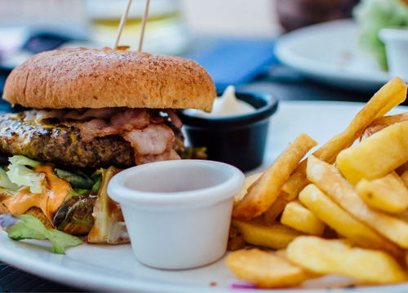
First picture is representing one complete menu that customers can enjoy.

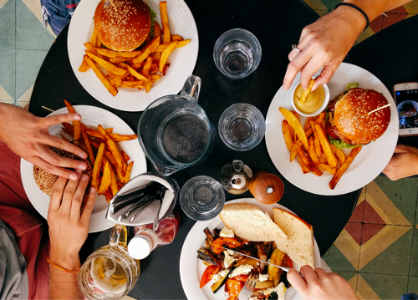
In the second picture is suggesting a that is a meal that you can enjoy with your family and friend well served satisficing everyone tastes.
Both of the titles of the text boxes are written in a droid serif style with a size 20 to make a contrast between the headlines and text from the boxes. For maintain a page continuity, the creator is using the same handwriting architects’ daughter.
All the page is keeping the simplicity way on the white background (#fafafafa), obtaining a contrast with the elements of the page and the handwriting.

- Analysis of the Contact us page of the website

The final page of the website is simple on the white background and is offering a map were the location of the food van plus the section were can people can leave a comment. The creator chooses a final picture to presented customers the image of food van to make it easy to recognize.
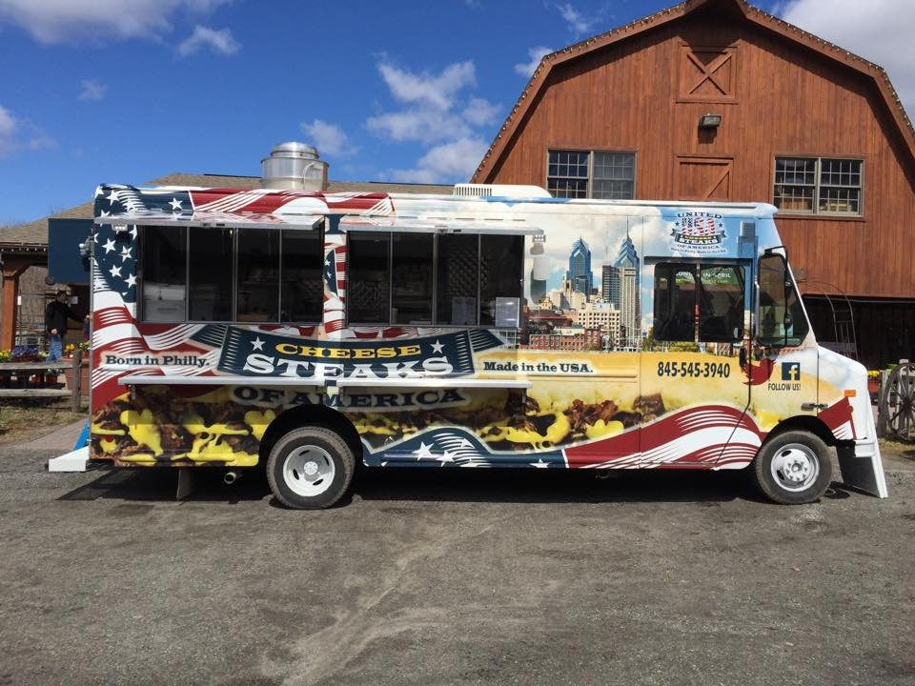

References:
- Stephanie D., 2008,Web Marketing for Small Businesses: 7 Steps to Explosive Business Growth, published by Sourcebooks INC.
- Adrian A.,2014, Website Marketing & Promotion, published by eBook edition.
- Sreedhar G.,2018,Web Data Mining and the Development of Knowledge-Based Decision Support Systems, published by IGI Global

