Comfort Musa E-Portfolio
Learning in the Digital Era June 2026 (ACCA4025
Student ID:2533315
Link to Portfolio: https://2544315.wixsite.com/my-site-4



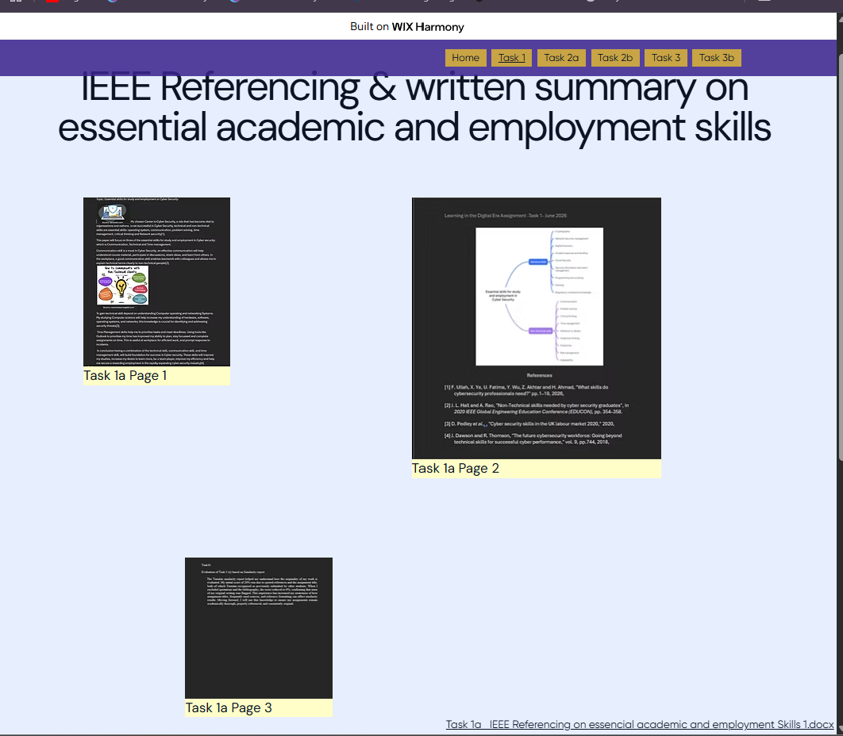

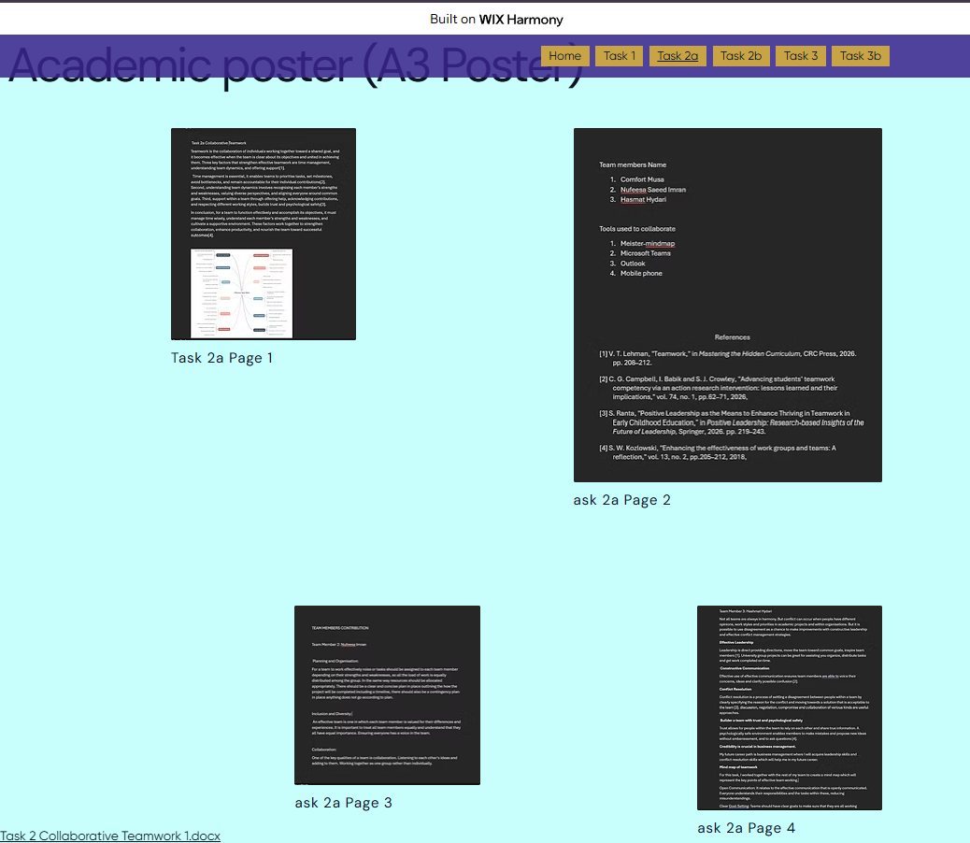

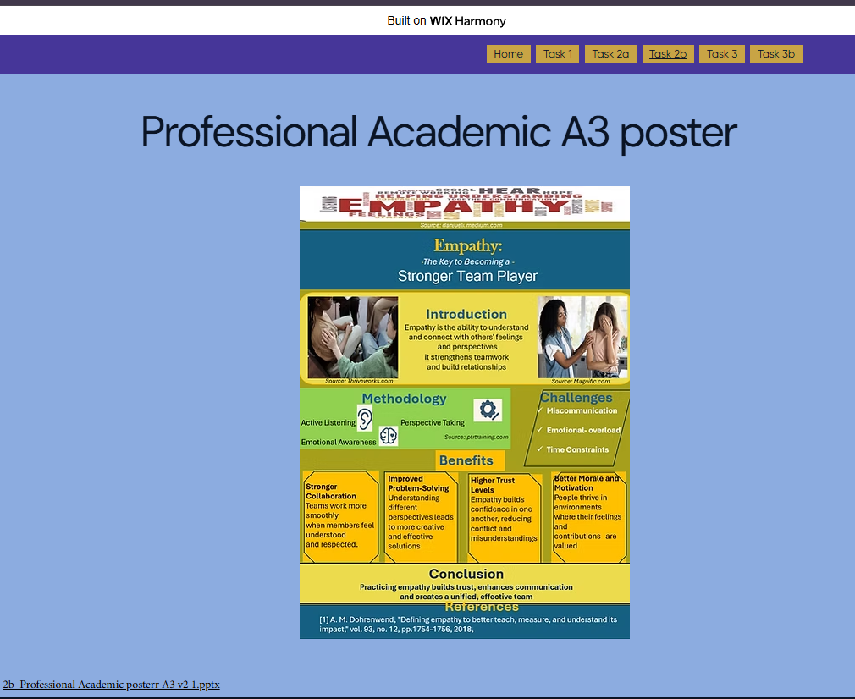

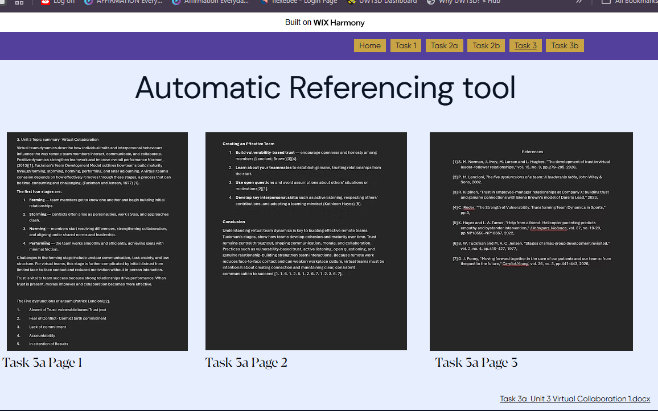

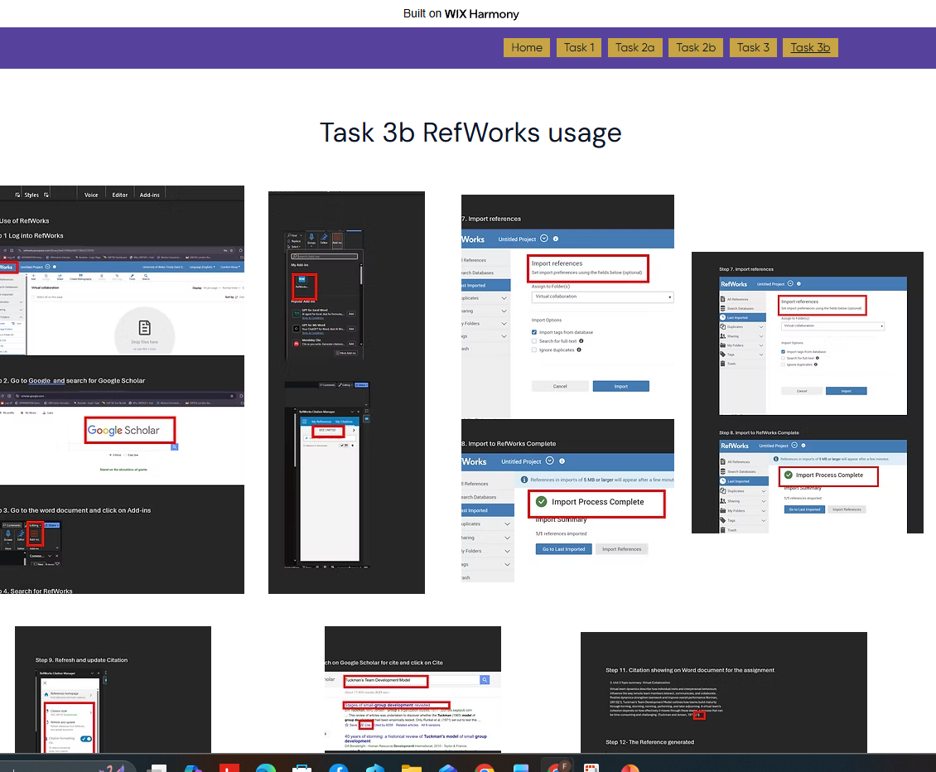

Links to Document

Task3b_Use of RefWorks 1.docx​

​Task 3a_Unit 3 Virtual Collaboration 1.docx​

​2b_Professional Academic posterr A3 v2 1.pptx​

​Task 2 Collaborative Teamwork 1.docx​

​Task 1a_ IEEE Referencing on essencial academic and employment Skills 1.docx​

