MARKETING MANAGEMENT ASSESSMENT 1
Student Name: Sandeep Kaur
Student ID: 2216581
Module Name: Marketing Management
Module Code: LCMB7001
Programme: MBA- Masters of Business Administration

Table of Contents
1. Introduction 3
2. Brief background of the company 3
3. The concept of communication 4
3.1. Definition of communication 4
3.2. A brief explanation of a communication model 5
3.3. Defining “Integrated Marketing Communications” 6
4. New promotion strategies that Apple can use to raise brand awareness 8
5. Branding, brand equity and brand value 9
6. Relating a Brand Equity model to the chosen company 11
6.1. Advantages and disadvantages of the model 13
7. Discussion of the customer journey and customer touchpoints 13
7.1. The customer touchpoints 13
7.2. Customer journey map 15
8. Conclusion 15
References 17

1. Introduction
In the 21st-century realm of business, companies are striving to maximize their customer services across all touchpoints. The rapidly intensifying competition in the global marketplace has made it crucial for brands to continuously innovate their marketing and customer management strategies to maximize sales and boost their profit margin. Likewise, communication has become an integral part of marketing management to accelerate the movement of ideas, products and services throughout an organization’s supply chain. Not only that, communication helps expedite the overall customer journey, right from the pre-purchase stage to the post-purchase services. In this regard, the current report provides a critical analysis and appraisal of different marketing strategies adopted by Apple Inc and suggests innovative strategies for the organization to increase their brand awareness and improve the customer journey.

2. Brief background of the company
Apple Inc, formerly known as “Apple Computer Inc”, is a US-based designer, manufacturer and seller of high-end electronic gadgets, mainly smartphones, tablets, and computers along with other accessories and wearables. Headquartered in Cupertino, California, Apple Computers Inc was founded by Steve Jobs and Steve Wozniak in 1976 with a vision to change the outlook of computers and electronics (Richardson, 2021). Beginning with an assembled circuit board with the name “Apple I”, the business venture rapidly gained popularity in the consumer electronics industry and is currently one of the most valuable brands in the world. The brand achieved a breakthrough in 1984 when it introduced the Macintosh, “the first successful mass-market personal computer” which sold “ more than three million units in the first three months” (Laricchia, 2022). Since then, the company has introduced a range of products and continues to be one of the most popular consumer electronic brands in the global market.
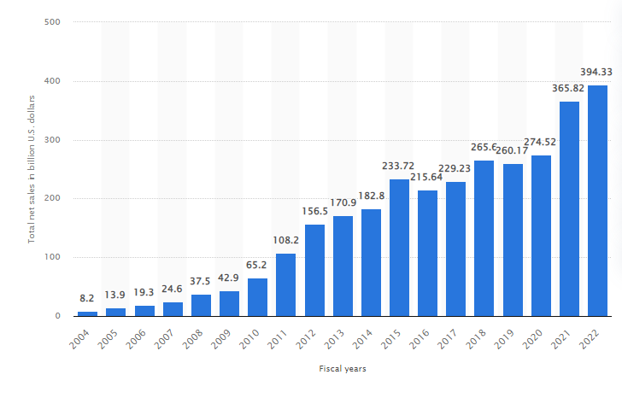
Figure 1: Apple’s global revenue (2004-2022)
(Source: Laricchia, 2022a)
Currently, Apple operates through major geographical segments across the globe including America, Europe, Japan, China and the “Rest of Asia Pacific” (Forbes, 2022). Over the years, the brand has established Apple stores with unique and minimalistic designs which have significantly contributed to its success margin. Apple has observed exponential growth in its global revenue in recent years with a historical record of US$274.52 billion revenue in 2020, which increased to “394.33 billion U.S. dollars” net sales in 2022 (Laricchia, 2022a). The company’s main mission is to amplify its customers’ user experience through innovative services along with high-end hardware and software.

3. The concept of communication

3.1. Definition of communication
The concept of communication entails a process of transmitting messages, knowledge and information through verbal and non-verbal means. In the context of marketing and business, communication takes place in the form of promotion sponsorships, presentations, public relations (PR) and social media. Through the use of different mediums, companies communicate their vision, mission and objectives with their target audience and stakeholders in accordance with the preferred communication modes for the desired markets (Kubota, 2019). Likewise, selecting a suitable mode of communication is key to accurately delivering a company’s message to the target audience.

3.2. A brief explanation of a communication model
Several theorists and professionals have postulated communication models out of which the Shannon and Weaver model is immensely popular. The “Shannon and Weaver model” of communication has been developed with the aim to increase the efficiency of message transmission between a sender and recipient through “noise”-causing elements that influence the interaction (Kubota, 2019, p. 55). The framework mainly covers communication elements such as “a sender, a receiver, a message, encode, decode, noise, and channel” (Kubota, 2019, p. 55). Feedback plays a crucial role in this model as it facilitates better transparency of message transmission.
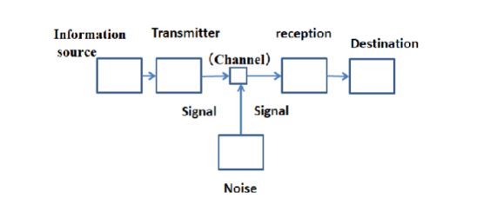
Figure 2: Shannon and Weaver’s communication model
(Source: Kubota, 2019, p. 55)
The following are the essential components of Shannon and Weaver’s communication framework:
Sender: also known as the “information source”, the sender is the entity that starts the communication process by choosing to transmit a desired message. The sender can transmit the message verbally, in writing or through non-verbal cues.
Encoder: the entity or machinery that transmits the message by converting the information into decipherable signals for the receiver.
Channel: the medium used to transmit information from the encoder to the decoder as well as the receiver, such as the internet and electrical wires in digital communication and sound waves in face-to-face communication.
Noise: it refers to the interruption that occurs during the transmission of a message between the sender and the recipient that could impede the interpretation of the message (Kubota, 2019). “Noise” can be categorized into internal and external depending on the type of interruption. “Internal noise” ensues when the receiver or transmitter fails to decode the message properly, such as misspelling a word or misinterpreting an email. On the other hand, “external noise” occurs when there is a hindrance in the transmission process due to external issues such as poor internet connectivity.
Decoder: this is the receiving end where the signal is converted into a message that is easily decipherable for the receiver.
Receiver: it is the final point of Shannon and Weaver’s model where the message is transmitted to the target entity. In marketing communication, the customer is the receiver whom the communication is designed for.
Feedback: this concept was added at a later stage by Norbert Wiener and became an integral component of Shannon Weaver model (Heaney, 2019). Feedback occurs when the recipient reacts to the information source to communicate whether the message is clearly received or thoroughly understood without noise, thereby completing the communication loop.
Regarding the efficacy of the model in modern marketing, Kubota (2019) opined that the framework is effective in improving general communication and can help businesses take effective measures to enhance message transmission via wired networks or the internet. However, Kuznar and Yager (2020) argued that while the Shannon Weaver model is effective in identifying “noise’- causing elements in a communication process, the framework is not as effective to interpret human communication. Nevertheless, the communication model can be applied to Apple to facilitate better introduction between the company and its target audience in the form of online customer support.

3.3. Defining “Integrated Marketing Communications”
As divulged by Tairova, Giyazova and Dustova (2020), “Integrated Marketing Communication” (IMC) is a process of combining different aspects of marketing communications such as analytics, social media, public relations, sales promotions and advertisements to engage with audiences in the target market. Through this approach businesses are enabled to provide their customers a smooth experience before, during and after the purchase. The IMC is a beneficial approach to forge meaningful connections with an organization’s stakeholders as well as shareholders while also helping to create a brand value in the market. The concept of integrated marketing has become highly relevant in the contemporary era as businesses are using different modes of communication to improve market engagement and enhance customer services. As per the words of Laurie and Mortimer (2019), the IMC approach is founded on the principles of coherence, cooperation and synergy. In order to ensure that a business is able to integrate all touch points of the customer journey, IMC involves continuous collaboration between individuals and entities from different departments of the organization and its numerous internal and external stakeholders. To achieve this goal the IMC requires four core elements: “media neutrality”, “consumer centricity”, “coordination” as well as “consistency” throughout a customer’s journey (Laurie and Mortimer, 2019, p. 231).
Being one of the most innovative brands in the global marketplace, Apple uses a variety of approaches to communicate with its customers through integrated marketing. Being at the forefront of the consumer electronics industry, Apple uses its advertising and marketing strategies to draw the curiosity, desire and interest of its target customers and retain brand loyalty (Razak et al. 2020). The brand uses a combination of traditional and advanced approaches to engage with the market. In the online domain, Apple promotes sleek photos of iPhone, iPads, MacBook’s and air pods across multiple social media portals and shopping websites. Using a variety of visually enticing content, the company advertises its products and creates a desire among its target customers to acquire the latest models that the company launches. In addition to television broadcasts and billboards, Apple also directly promotes its product launches on different social media websites as well as the company's own website. Other than the online modes of communication Apple uses its offline stores to non-verbally communicate the desire to check out its products through its minimal and neat store designs which draw on the attention of its potential buyers (Razak et al. 2020). In addition, the signature stores of Apple are strategically placed in upscale localities in areas of high footfall as the company mainly targets financially affluent customers for its premium products and services.

4. New promotion strategies that Apple can use to raise brand awareness
Apple is quite a popular electronics manufacturing brand in the global market, the company has quite effectively improved its business by taking effective business strategies. Apple mainly sells Smartphone as well as MacBook’s and the company has a good reputation in the global market. The company is mainly famous for its excellent technology as well as quality (Katsikeas et al. 2019). In terms of brand value Apple is the most valuable brand in the global market, however, the competition in the market is increasing in the world, for this reason, the company needs to improve its brand awareness in the world to improve its business effectiveness in the world market.
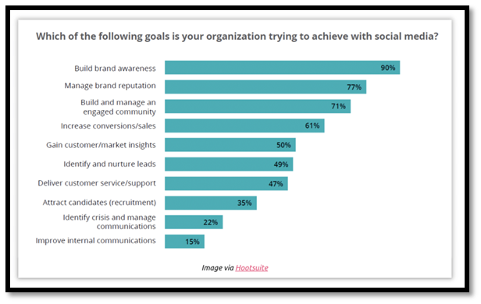
Figure 3: Brand Awareness improvement strategies
(Source: Katsikeas et al. 2019)
Online Advertisement
Apple is a quite popular brand in the global market; the company should improve its advertisement process in order to improve its brand awareness in the market. The company launched different Macbooks in different price ranges; however, the company should provide some effective ads through the online platform. In the advertisements, the company should provide all the important details regarding the products (Li et al. 2021). This way the company will also reach the customer in a short period of time, the company should use the online platform as it is the most popular as well as a used platform in the present day. In the present day, Apple is a quite developed as well as popular brand in the world market. Apple should need to promote its Macbook through different activities in the online platform. The company should organize some contests on various platforms Online where they can find a lot of people and they can also promote their products in this contest in an effective way.
The company should run its contest on popular platforms online. Through this contest, they can inform the people with their product description as well as pricing related information. This is an effective way that the company should consider in terms of enhancing its brand awareness in the market in the near future. Along with that, this process will also help them to improve their business effectiveness in the future.
Offline Advertisement
Through the offline platform, Apple can promote its new products in an effective manner. The company should use different offline stores to promote its products as well as the company should target some customers in the market through offline shop ads. Apple mainly provides its Macbook ads in its stores and local market (Hitsch et al. 2019). The company also needs to present its ads in its offline stores more attractively which can impress the customer about their products. Apple should also provide all the product ads in their retailer’s shops where they should provide all the details regarding their product and it helps the company to improve their brand awareness in the market. Along with that, the company will also able to improve its brand identity as well as effectiveness in the market in the upcoming days.

5. Branding, brand equity and brand value
Branding
Branding refers to the strategy undertaken by a company to stand out amongst its competitors and create a devoted customer base (Prachaseree, Ahmad and Isa, 2022). Using components such as visual appeal design, logo purpose mission and vision statements branding aims to create a strong and unique impression of a business in the target market to effectively engage with potential buyers and sustain competitive growth.
Apple uses an emotional approach to its branding strategy where it emphasises creativity, lifestyle and encourages individuals to reclaim their passion, ambitions, aspirations and freedom as well as powering people through technology. By emphasizing people-driven product creation and using minimalistic and sleek designs, the company has created a substantial customer base across the globe.
Brand equity and brand value
As suggested by Effah and Hinson (2022), brand equity entails a collection of liabilities and assets in the form of brand exposure, corporate connections and customer loyalty which helps determine the feasibility of a brand in terms of existing and projected products and services. On the other hand, brand value helps determine the financial worth of a business in its target market. Contrary to brand value that is fairly straightforward, measuring brand equity requires a collective approach of analyzing the companies visibility, customer loyalty and brand associations in the market.
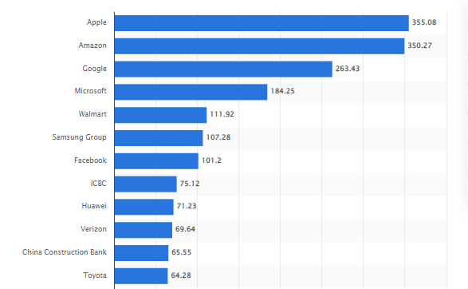
Figure 4: Most valuable brands in the world
(Source: Faria, 2023)
Regarding brand value, presently, Apple is the most valuable brand in the Global market with an estimated "brand value" of "355.1 billion US dollars" (Faria, 2023). The company’s brand equity will be analyzed in the following section using Aaker’s model.

6. Relating a Brand Equity model to the chosen company
David Aaker contends brand equity as a classification of a company's awareness in the market, its brand association loyalty, perceived quality and other proprietary assets. According to Aaker's brand equity model, the image of a brand is fundamentally created through “brand associations” which also serves as the foundation for consumers’ decisions to utilize certain services or purchase commodities and promote “brand loyalty” (Jia-yi et al. 2022, p. 590).
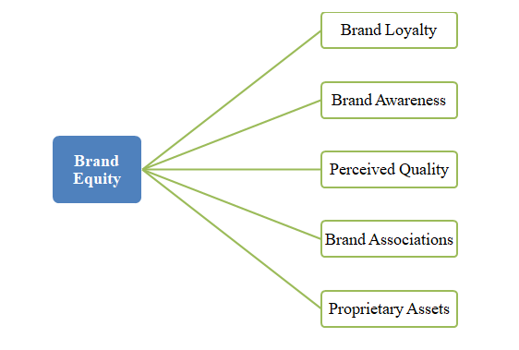
Figure 5: Aaker’s brand equity model
(Source: Author)
Relating the brand equity of Apple in the marketplace using Aaker’s framework:
Brand awareness
Aaker defines brand awareness as the degree to which the general public recognizes a brand in terms of how individuals associate the company and its products and services and the familiarity of the brand in the market (Jia-yi et al. 2022). Brand awareness essentially depends on the favorability of consumers' perception of the business. Being the most valuable consumer electronics company, Apple has a fairly high brand awareness across the globe. In the United States, Apple has a brand awareness of 92% with 49% of wearable gadget users using the brand (Kunst, 2022).
Brand associations
According to the framework, brand association can be evaluated by examining the extent to which a brand can extract connections from a customer's memory and stand out amongst the existing competitors in the market. It also identifies the perceptions and feelings that a brand raises when people see a logo or products in the market. Additionally, it can be examined by the extent to which the association fosters favorable sentiments or mindsets. Looking at Apple, the brand is mainly associated with style, simplicity and luxury. Any Apple user is immediately associated with these three components whenever they are seen in public or whenever the brand logo is visible to the potential audience.
Brand loyalty
Aaker suggest that the loyalty of customers towards a certain brand can be analyzed through reduced marketing expenses to attract potential clients. Having a loyal base of customers indicates that a business can leverage its customer base to improve trade through minimized expenses and increased bra and recognition (Jia-yi et al. 2022). In addition brand loyalty can essentially be identified by the extent to which customers are likely to switch or substitute brands, responding to threats from the increasing competition. Apple has a fairly loyal base of customers in the global market with about 88% of loyal users in the United States (Kunst, 2022).
Perceived quality
This element indicates the way existing and potential customers view a brand's overall quality. The perceived quality can be measured based on the proposed and actual quality of a company's products, the extent to which it differentiates from its competing brands, its product and service availability, pricing and brand extension strategies. Over the years, Apple has developed a significantly positive association in terms of quality as most of its products are perceived as classy and premium.
Proprietary assets
This aspect indicates the rights accumulated by a brand over time in terms of trade relations, intellectual property rights and patents. Being one of the most widely known brands in the world, Apple owns a large number of proprietary assets in the form of copyrights, trademarks, patents and intellectual property. The company's logo is protected and requires prior approval before using it on a keyboard for commercial purposes.. Any unauthorized usage of the Apple logo might be considered a breach of federal and state trademark laws and will be considered useless unless specifically permitted (Apple, 2022). Other than this, Apple uses the “fair, reasonable, and non-discriminatory” (FRAND) licensing principles for its “standard essential patents” (SEPs), along with owning certain rights and permissions (Apple, 2022a).

6.1. Advantages and disadvantages of the model
Advantages: Aaker’s brand equity model offers a comprehensive perspective regarding the long term growth of a brands position in the market taking into account the internal definition of the brand as well as the perception of customers. This model is a suitable framework to identify the extent to which the market is aware of a brand and its value propositions. As a result, this framework is suitable for businesses that focus on bulk production to help them stand out among computers.
Disadvantages: despite its advantages, this framework is not reliable to analyse the emotional reaction that a business phrases among the customers. As a result, it is not suitable for businesses dealing with fewer customers and small scale production.

7. Discussion of the customer journey and customer touchpoints

7.1. The customer touchpoints
In the customer journey, touchpoints indicate the several ways in which customers interact with a business through goods and services from the time they become aware of the brand to the purchase of products and the post purchase phase. Researchers highlight that the intention to stick to a company's products and services depends on a variety of reasons other than merely the essential qualities and benefits offered by competitors. The efficiency of a brand to maintain its loyalty margin depends on how well the business has mastered its touch points and identified issues that are generally overlooked by companies. Looking at Apple, the company has essentially mastered the following touchpoints:
- Easily navigable website
Apple stands out through its neatly designed clean and "easy to navigate" website that makes it easier for customers to locate stores, know about offers and set up appointments (Greenwald, 2014).
- Packaging
The high quality packaging creates a satisfactory experience when the customer finally unwraps a purchased Apple product. The company uses high quality shopping bags that also double as backpacks (Greenwald, 2021).
- Demo units
The company provides samples in its stores where employees guide customers in explaining products with simple marketing tactics.
- In-store customers support
Apple stores have highly skilled employees who are known for their smart patient and solution oriented approach that is not common in most retail establishments (Greenwald, 2021).
- Cleanliness and consistency
Every Apple Store has a uniform design and cheerful lighting which radiates a feeling of positivity and improves customer satisfaction.
- Store locations
The Apple stores are located in easy to p find locations where people are relatively well educated and economically affluent (Greenwald, 2021).
- The "genius bar"
Apple has genius bars located across cities that provide quick solutions to critical problems in its devices.
- One to one services
After purchasing Apple computers, customers are provided "one to one tutorials" for two consecutive years where customers are openly trained by software specialists to make them self-sufficient.
- Customer feedback
After every customer service Apple sends satisfaction survey to its customers to identify they are flowers and continuously improve their customer services.

7.2. Customer journey map
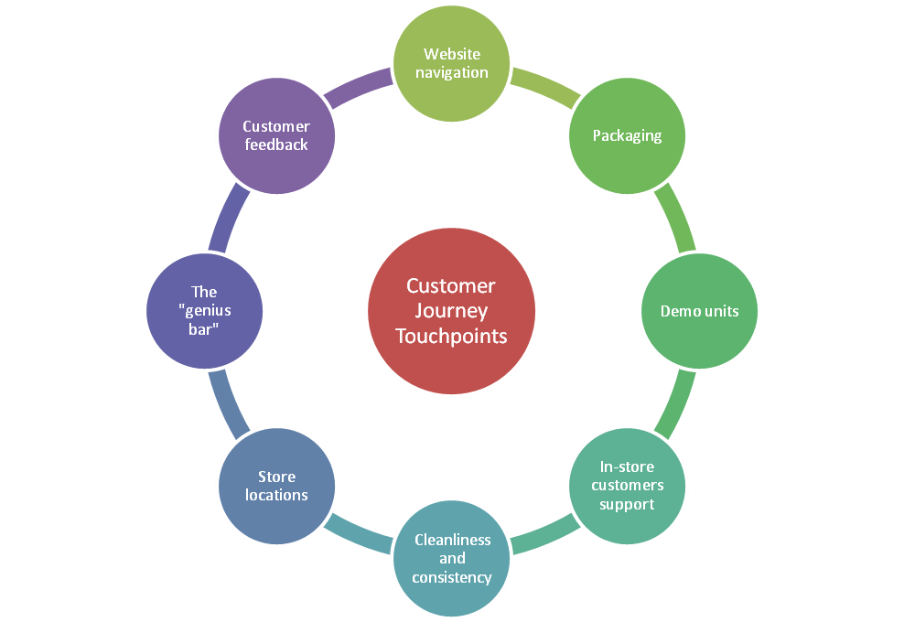
Figure 6: Customer journey map
(Source: Author)

8. Conclusion
In recent years, rapid advancements in technology have created numerous new opportunities to innovate a business’s marketing strategies, so as to enable excellent customer services and develop a competitive edge in the market. Corporate giants all across the globe are using advanced technology and innovative solutions to expand their brand presence and create a benchmark in the highly competitive domain. In this regard the current report has delt into the business strategies adopted by apple in it Global business and the different ways in which it developed a competitive positioning in the market through brand loyalty brand equity and value. The company has created an attractive portfolio of customers and employees along with creating a significant awareness in the global market. It has been gathered that mapping the customer journey by highlighting every minor touchpoint is crucial for brands to create a valuable impression in the market and strategically position themselves for the long run. Failing to manage the customer journey can generate adverse word of mouth and drive away existing as well as potential clients.

References
Apple, 2022. Guidelines for Using Apple Trademarks and Copyrights. Available at: https://www.apple.com/legal/intellectual-property/guidelinesfor3rdparties.html (Accessed January 7, 2023).
Apple, 2022a. Intellectual Property. Available at: https://www.apple.com/legal/intellectual-property/ (Accessed January 7, 2023).
Effah, E.A. and Hinson, R.E., 2022. Green Brand Equity in an Emerging Economy: Ghana in Perspective. In Green Marketing in Emerging Economies (pp. 193-224). Palgrave Macmillan, Cham.
Faria, J., 2023. Most valuable brands worldwide 2022, Statista. Available at: https://www.statista.com/statistics/264875/brand-value-of-the-25-most-valuable-brands/ (Accessed January 7, 2023).
Forbes, 2022. Apple | AAPL Stock Price, Company Overview & News. Available at: https://www.forbes.com/companies/apple/?sh=208827a65355 (Accessed January 5, 2023).
Greenwald, M., 2021. 20 Ways Apple Masters Customer Touchpoints And Why It's Great For Business. Available at: https://www.forbes.com/sites/michellegreenwald/2014/05/21/20-ways-apple-masters-customer-touchpoints-why-its-great-for-business/?sh=597668192b93 (Accessed January 7, 2023).
Heaney, C., 2019. The disparity between culture & technics. Culture, Theory and Critique, 60(3-4), pp.193-204.
Jia-yi, F., Yan-qiao, L., Qi-xing, Q. and Li, Z., 2022. Creating cultural brand equity from the perspective of consumer cognition–a case study of Chinese animation brands. Procedia Computer Science, 199, pp.589-596.
Kubota, M., 2019. What is “Communication”?―Beyond the Shannon & Weaver’s Model―. International Journal, 13(1), pp.54-65.
Kunst, A., 2022. Apple brand profile in the United States 2022, Statista. Available at: https://www.statista.com/forecasts/1335456/apple-wearables-brand-profile-in-the-united-states (Accessed January 7, 2023).
Kuznar, L.A. and Yager, M., 2020. The Development of Communication Models, Quick Look. Joint Staff J39, Strategic Multi-layer Assessment Washington, DC United States.
Laricchia, F., 2022. Apple - statistics & facts, Statista. Available at: https://www.statista.com/topics/847/apple/#topicHeader__wrapper (Accessed January 5, 2023).
Laricchia, F., 2022a. Global revenue of Apple from 2004 to 2022, Statista. Available at: https://www.statista.com/statistics/265125/total-net-sales-of-apple-since-2004/ (Accessed January 5, 2023).
Laurie, S. and Mortimer, K., 2019. How to achieve true integration: the impact of integrated marketing communication on the client/agency relationship. Journal of Marketing Management, 35(3-4), pp.231-252.
Prachaseree, K., Ahmad, N. and Isa, N.M., 2022. Reviews of Brand Equity for Online Retailers. ABAC Journal, 42(1), pp.52-72.
Razak, M., Hidayat, M., Launtu, A., Putra, A.H.P.A.K. and Bahasoan, S., 2020. Antecedents and consequence of brand management: empirical study of Apple’s brand product. Journal of Asia Business Studies.
Richardson, A., 2021. The Founding of Apple Computers, Inc. Available at: https://guides.loc.gov/this-month-in-business-history/april/apple-computers-founded#:~:text=and%20Photographs%20Division.-,Apple%20Computers%2C%20Inc.,in%20their%20homes%20or%20offices. (Accessed January 5, 2023).
Tairova, M.S.M., Giyazova, N.B. and Dustova, A.K., 2020. Goal and objectives of integrated marketing communications. Economics, 2, pp.5-7.
Katsikeas, C., Leonidou, L. and Zeriti, A., 2019. Revisiting international marketing strategy in a digital era: Opportunities, challenges, and research directions. International Marketing Review.
Li, F., Larimo, J. and Leonidou, L.C., 2021. Social media marketing strategy: definition, conceptualization, taxonomy, validation, and future agenda. Journal of the Academy of Marketing Science, 49(1), pp.51-70.
Hitsch, G.J., Hortacsu, A. and Lin, X., 2019. Prices and promotions in us retail markets: Evidence from big data (No. w26306). National Bureau of Economic Research.

