HNC mechanical engineering
Individual Project: Labelling Quality Control
Nicole Funning

Summary
The aim of the project was to decrease the number of units sent back from Amazon by 1%, this was done by designing a tool for case packers to ensure the appearance of the product met the quality standards. The project was split into four phases:
Phase one of the project (appendix 2) started off on week one with a team meeting with the quality co-ordinator Hayley see notes in appendix 3 , the problem was raised that the quality of the product appearance was not accurate and wanted help to come up with an idea to improve the accuracy and to relieve some pressure off the quality control team. A project proposal (appendix 3) was then drawn up and taken to the production manager for approval. The next step was to collect customer complaints for a 4-week time period to identify the common defect. Using the information gathered we generated some ideas to counteract the defects.
Phase two of the project ( appendix 4) run between week 7 and week 13, up to this point the were no delays in the project each step run as planned. Three ideas were developed to counteract the defects, there was then a meeting with quality control to discuss the three ideas. When one design was selected, the next step was to research different materials and create a cost analysis. A product design specification was developed (appendix 1) to cater for the need for a gauge, the materials were purchased with an ETA of 1 week. The materials had a major delay due to shipping issues and miscommunication; the materials took 3 weeks to arrive which pushed the project back by 2 weeks.
Phase three of the project (appendix 5) commenced on week 14 and finished on week 20, the manufacturing of the gauges did not take as long as predicted, one week was made up from the two weeks lost due to the material late delivery. A one-week training period to train the operatives how to use the gauges took place, then they were trailed for one week. During this phase one week was made up from the two-week delay.
The final phase (appendix 6) as you can see from the timing plan a decision was made to extend the trial of the gauges to 6 weeks, then the next step was to collect data over a 4-week period to see if the quality had improved from using the gauges. When the 4-week period was up the team was debriefed.
Overall the project was a success, the design met the criteria, it was under budget and the data proves the returns decreased after the gauges were made.

Contents
Summary i
Table of Figures 2
1. Acknowledgments 3
2.Introduction 4
3.Theory-Background Research 5
4.Project specification and testing plan 7
5.Project planning 8
6.Project solutions 10
7.Design and implement 11
8.Analysis, results and evaluation 13
9.Conclusion 14
10.Recommendations 14
11.Bibliography 15
12.Appendices 16
Appendix 1 – Product Design Specification 16
Appendix 2 – phase 1 19
Appendix 3 – project proposal and meeting notes 20
20
Appendix 4 – phase 2 22
Appendix 5 – Phase 3 23
Appendix 6 – phase 4 24
Appendix 7 – Technical drawings using CAD 25
7.1 1LTR gauge 25
7.2 500ml gauge 26
7.3 250ml gauge 27
7.4 100ml gauge 28
7.5 60ml gauge 29
Appendix 8 – Team debrief meeting 30

Table of Figures

Figure 1 In and out caliper (Seil, 2012) 6
Figure 2 Laser Diameter Gauge (puretronics, 2020) 6
Figure 3 Vernier caliper (express, n.d.) 6
Figure 4 Amazon shipment tracking 7
Figure 5 Initial timing plan 8
Figure 6 Criteria Analysis 10
Figure 7 Rough sketch of gauge 11
Figure 8 Finished gauges (left to right-1ltr,500ml,250ml,100ml,60ml) 12
Figure 9 Data collected before and after tool was manufactured 13

1. Acknowledgments
I would like to thank the following people; without these individuals the project would not have been completed. I would like to pay my special regards to the quality control coordinator Hayley Howells and the productivity manager Simon Ashby for their support and guidance throughout the project, Hayley’s feedback and constructive criticism helped design the gauges, Simon’s guidance helped with the material selection and tooling to make the gauges. I would like to express my appreciation for the production team for trialling the new gauges and participating in the feedback given at the meeting to discuss future improvements and finally thank you to Naissance trading for funding the project and allowing time in work to carry out the manufacturing of the gauges.

2.Introduction

The aim of this project was to improve the quality of the products leaving the production clean room. Naissance is a company that produces all-natural oils, butters and powders, it ships it produce globally and supplies amazon with stock. The company has three depots, one based in Neath, Berlin and California. Naissance prides itself on the quality of each product sold, this is where this simple design tool plays its part. The aim of the tool is every operative has a hand-held gauge to ensure the labels are applied straight on each bottle with a 1mm tolerance. The tool is easy to use, light weight and can be carried around in the operative’s pocket. After the project was completed and the gauge was in use, a team meeting with the operatives took place to see if any improvements were required to make using the tool easier or if using the tool was slowing them down when carrying out their daily tasks. The result of the meeting was that some operatives felt that it was slowing them down, as the gauge can only be used on one side of the bottle at one time, they would like the gauge to measure both sides at the same time. Taking this feedback on board, the next step to improve the gauge would be to design a new prototype that will enable them to measure both sides of the bottle the same time. The individuals involved in the project was Simon who is the productivity manager, his role was to give guidance on a design and materials that would be suitable for the end purpose, the operatives, their role was to trial the gauge whilst case packing the products off at the end of the line and to give feedback on the gauge. The main individual involved in the project was Hayley, as the quality control coordinator her input was very important as the gauge had to match her criteria.

3.Theory-Background Research
According to Marielle E.H Creuson of Delft university of technology, “Product design has been recognized as an opportunity for differential advantage in the marketplace. The appearance of a product influences consumer product choice in several ways. “ (Creusen, 2004). Naissance changed the look on all its products in 2018, from redesigning the labels to changing the packaging of the products. This change took an estimated time frame of 6 months, the new look of the labels introduced a numbering system where the company website would recommend a suitable product that blends well with the product the customer is viewing. This numbering system was a big hit with customers who have very little experience with aromatherapy oils. To make the product perfect the appearance has to be on par with the quality, since the production department created a quality control team there has been stricter tolerances put in place for end of line checks. The new tolerances are a results of Amazon becoming one of our biggest customers, Amazon has a very big reputation worldwide and if there are faults with a product they will reject a shipment from Naissance, a rejection costs the company money as they have to pay for the shipment to be returned. Naissance returns rate from Amazon is estimated around 3%, the range of problems with the products ranged from damaged packaging, leaking bottles and barcodes on the product label would not scan. A very small portion of that 3% was due to quality issues, labels that are not applied straight on the packaging can make the product look less appealing to the customer as it shows that not much effort or care was put into making the product. When training the case packers on the end of each line, they are trained visually. A team leader will show them the process, from making boxes, labelling the boxes to checking the products coming off the end of the line, after the team leader has spent some time explaining each part of the process and is happy that the trainee knows what to do the trainee is then supervised until confident they can do the job.
There are four main types of learning styles in the workplace, the student (visual and verbal), the independent (visual and non-verbal). The conversationalist (auditory and verbal learners) and the hands-on learner (tactile and kinaesthetic). In a production environment there are a lot of hands-on learners and the student learners, the student learners are taught best when presented with visual examples alongside concise information, the hands-on learners show they learn best in a trial and error situation, they take on board a set of instructions and learn whilst carrying out a task. Knowing and understanding the different types of learning styles can create a diverse working environment and can promote effective communication between colleagues. Using this information on learning styles helped create a solution to the current quality issues regarding the label height and if the label was straight on a bottle. The solution to the problem was to use a gauge with a 1mm tolerance, as this would be a visual aid for the case packer to ensure all labelled bottles coming off the production lines adhere to the quality standards set. There are many different types of mechanical gauges readily available such as Vernier caliper, caliper and laser measurement tools. The Vernier caliper is a precision gauge is used to measure small distances with precision accuracy, it is made up of two jaws one to measure the inside and the other to measure the outside dimensions, the measurement can be read off a manual scale or a digital screen. The caliper is similar to the Vernier but it doesn’t have two jaws the inner diameter and outer diameter requires two separate gauges to measure the distance, this type of gauge also requires an external scale to compare the distance measured. A laser measurement tool is an alternative to a traditional measuring tape, its used to measure distance and are considered accurate with a 3mm tolerance. They are mainly used by architects, carpenters and builders.
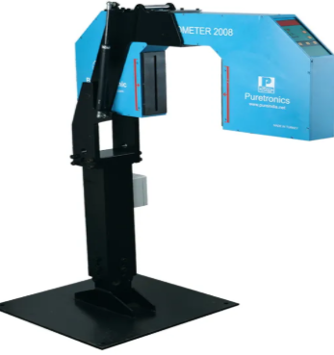
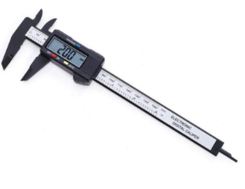
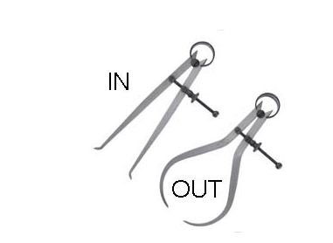
Figure 3 Vernier caliper (express, n.d.)
Figure 1 In and out caliper (Seil, 2012)
Figure 2 Laser Diameter Gauge (puretronics, 2020)

The gauges above come in a variety of sizes and have a varied price range, other types of gauges are also available but are not appropriate to this project.

4.Project specification and testing plan
The main specifications of the project are, the gauge to ensure accurate application of the label needs to be light weight, easy to use and cheap to manufacture. The material selected for the gauge was Perspex, the advantages of using this material are, it’s got a high shock/abrasion resistance for wear and tear, its lightweight and to comply with our company values its 100% recyclable. Referring to the Product Design Specification (PDS) appendix 1, section 19.1, the gauge has to “comply with food hygiene regulations” (FSA, 2020) this is very important as Naissance manufactures natural food oils and take pride in our food hygiene rating of 5.
The initial rejection from Amazon was measured to be estimated at 2%, with a small proportion of returns due to the appearance of the product. It is very difficult to calculate an accurate figure on how many returns there are within in a specific time period that are due to appearance defects as the stock shipped to Amazon might not be on sale straight away, they hold our stock in holding bays until the shelf stock goes below minimum stock level. For example we could ship a pallet of lavender 100mls, but as this is one of our top 20 biggest sellers, Amazon stock demand is high. A bottle of lavender could be produced in the January, sit in transit or storage for a few weeks then could potentially be returned to Naissance if there is a defect. The estimated 2% is over an 8week time period to allow stored stock to be turned around.
The end test will be to monitor all Amazon returns and investigate each rejection over a 4week period which will start on 20/02/2020. This will ensure products that have been stored before replenishing stock on shelves is turned around. A list of products sent to Amazon will be created AS SHOWN BELOW IN FIGURE 4 which will include product, size, quantity, date shipped and returns, this will allow close monitoring on any returns. There will also be an inhouse test involving the quality control team, this will ensure any defects are caught before the product has left the production department and defaults will be recorded.
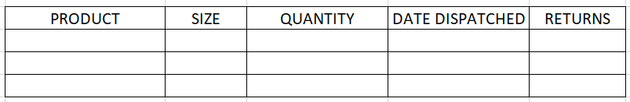
Figure 4 Amazon shipment tracking

5.Project planning
The initial timing plan below shows the project start date of 26/08/2019, the project is to run for 33 weeks. The timing plan has been split into two sections, one for work and one for college. The project was split into three phases, so it was easier to track the project.
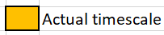
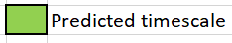
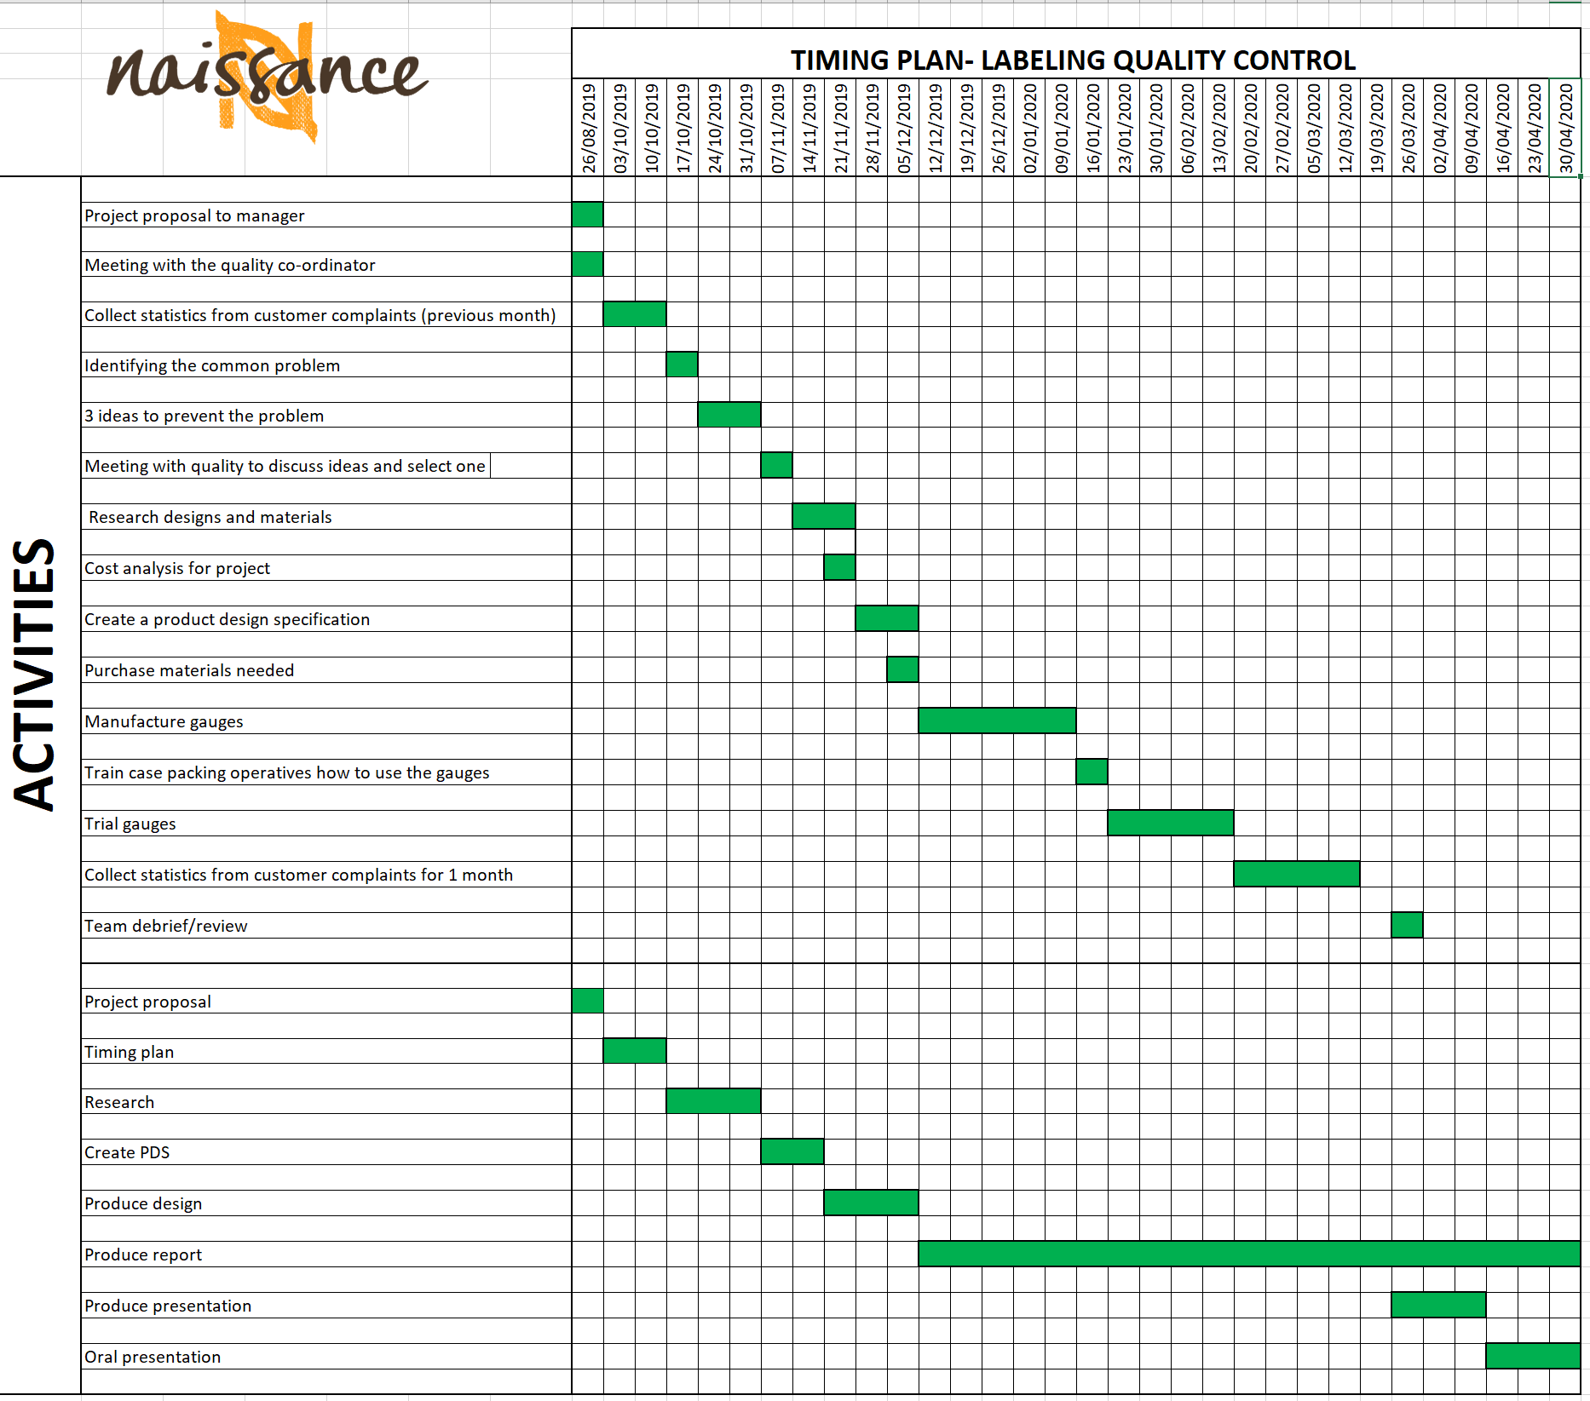
Figure 5 Initial timing plan
Phase one of the project (appendix 2) started off on week one with a team meeting with the quality co-ordinator Hayley see notes in appendix 3 , the problem was raised that the quality of the product appearance was not accurate and wanted help to come up with an idea to improve the accuracy and to relieve some pressure off the quality control team. A project proposal (appendix 3) was then drawn up and taken to the production manager for approval. The next step was to collect customer complaints for a 4-week time period to identify the common defect. Using the information gathered we generated some ideas to counteract the defects.

Phase two of the project ( appendix 4) run between week 7 and week 13, up to this point the were no delays in the project each step run as planned. Three ideas were developed to counteract the defects, there was then a meeting with quality control to discuss the three ideas. When one design was selected, the next step was to research different materials and create a cost analysis. A product design specification was developed (appendix 1) to cater for the need for a gauge, the materials were purchased with an ETA of 1 week. The materials had a major delay due to shipping issues and miscommunication; the materials took 3 weeks to arrive which pushed the project back by 2 weeks.
Phase three of the project (appendix 5) commenced on week 14 and finished on week 20, the manufacturing of the gauges did not take as long as predicted, one week was made up from the two weeks lost due to the material late delivery. A one-week training period to train the operatives how to use the gauges took place, then they were trailed for one week. During this phase one week was made up from the two-week delay.
The final phase (appendix 6) as you can see from the timing plan a decision was made to extend the trial of the gauges to 6 weeks, then the next step was to collect data over a 4-week period to see if the quality had improved from using the gauges. When the 4-week period was up the team was debriefed.
As shown on the timing plan for the college activities, they all ran as planned except for the oral presentation, this was scheduled for the 14th of May.
The two biggest constraints were time and budget as there was only 10 weeks set to manufacture and trial the gauges, this timeframe was set over the months of December to the beginning of February, this being our busiest time of the year due to Christmas demand and the shutdown period for staff over Christmas has a knock on effect on production. The budget given was maximum of £500 for materials and labour, research had to be done for cheap materials but with a reasonable quality.

6.Project solutions
The main points to consider whilst exploring the possible solutions were that it had to be easy to use, light weight and cost effective. The most important feature it had to have was it had to adhere to the food hygiene regulations as it a food manufacturing environment. The three potential design proposals were a plastic gauge, stainless steel gauge and a laser gauge that could be mounted onto a production line. A criteria analysis was developed to visualise what design would best fit the PDS. As shown below (figure 6) the criteria were ranked from 1-10, 1 being a low priority and 10 a high priority.
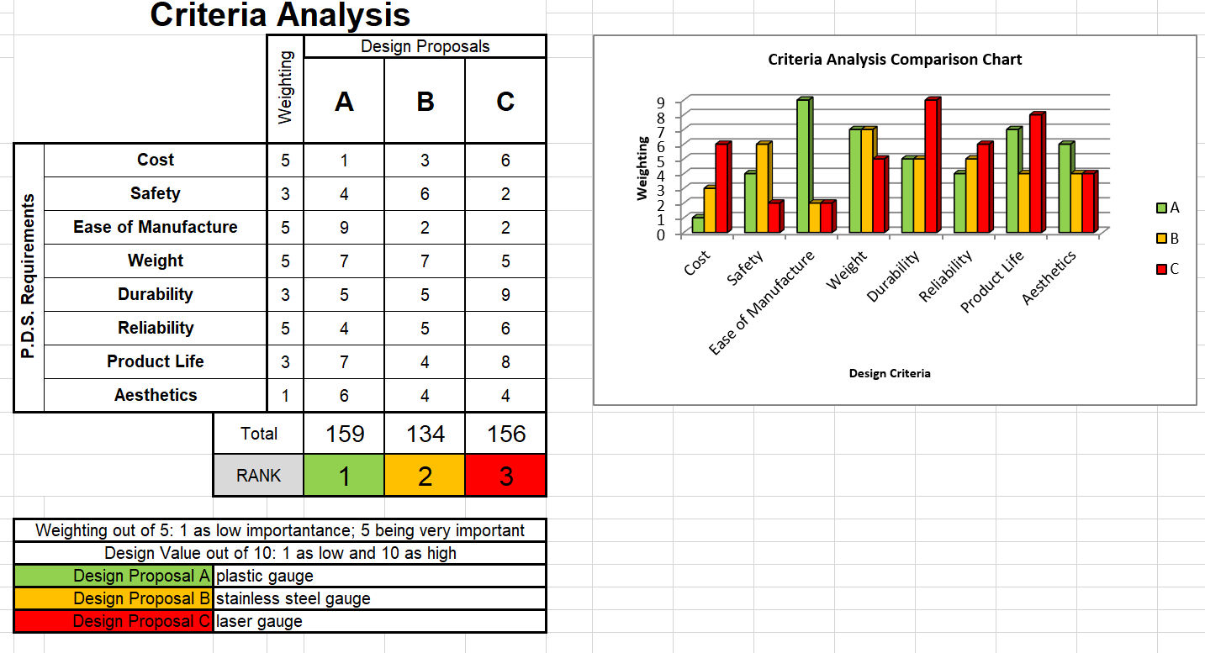Figure 6 Criteria Analysis
As shown in the graph and table above (figure 6) design proposal A best matched the PDS, proposal B- stainless steel gauge would have a nice finish and look good but would cost more and would need better tooling to cut the sheet into shape. Proposal C the laser gauge was out of the question due to high costs, installation would mean the line would be down and maintenance could be potentially a problem.

7.Design and implement
The design process was carried out by Simon the productivity manager as his background is engineering and the individual carrying out the project. A rough sketch of the final product was drawn (figure 7) and then a technical drawing was produced on Solidworks software package. Solidworks is a computer aided design/engineering software package which allows the user to convert 2D drawings to 3D shapes, the software allows the user to stress test and visualise how the end product will look, also if the user has a 3D printer the drawing can be sent to the printer and the component will be printed.
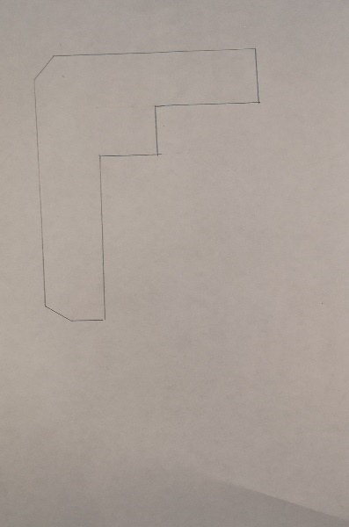
Figure 7 Rough sketch of gauge
The rough sketch was drawn up on Solidworks, measurements were added and adjusted to ensure they matched up with the bottle size intended and then the 2D drawing was converted to a 3D drawing. As shown in appendix 7.
The material selected was Perspex, its lightweight, reasonably priced and easy to work with. The initial cost of the Perspex sheet was £334 purchased from https://www.perspexsheet.uk/clear-000-perspex/, the full sheet measuring 1275mm width, 2180mm height and a 10mm thickness. This sheet was able to manufacture 5 sets of gauges with minimal waste. The Perspex sheet was cut to the correct measurements in the drawings using a bandsaw, when the cutting process was completed the edges were hand sanded down to create smooth edges for safety reasons. There were no photos taken of the manufacturing process due to work restrictions, but the end product can be seen in the image below (figure 8)
As mentioned in the timing plan the Perspex was delivered 2 weeks late which had a knock-on effect throughout the rest of the project. During this delay, time was spent case packing to ensure the design of the gauges would work.
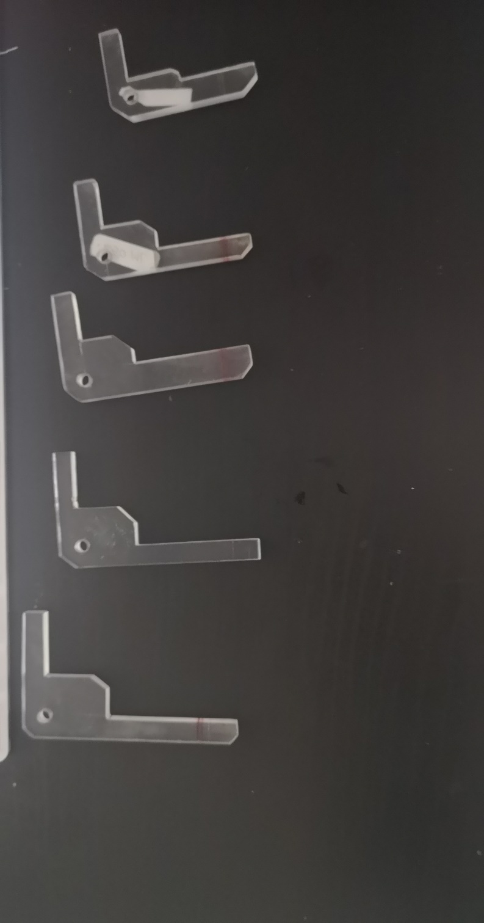
Figure 8 Finished gauges (left to right-1ltr,500ml,250ml,100ml,60ml)
As shown in figure 8 a hole was added to the top left-hand corner, this was to insert a keychain ring to attach all 5 gauges together to make it easier for the user to locate. The gauges were then trailed for a period of 6 weeks.

8.Analysis, results and evaluation
Comparing the data collected from the Amazon shipments between the dates of 22/07/2019 and 26/08/2019 total of 6 weeks, data of 136093 units was randomly selected to investigate how many units were returned due to appearance issues. Out of the 136093 units, 4550 units were returned and had to be reworked in order to achieve the quality standards set. This works out at 3% of the units shipped were returned, as initially said in the testing plan. The two tables below (figure 9) show the number of units shipped, the date and how many units were returned. The cells highlighted on yellow are the returned items.
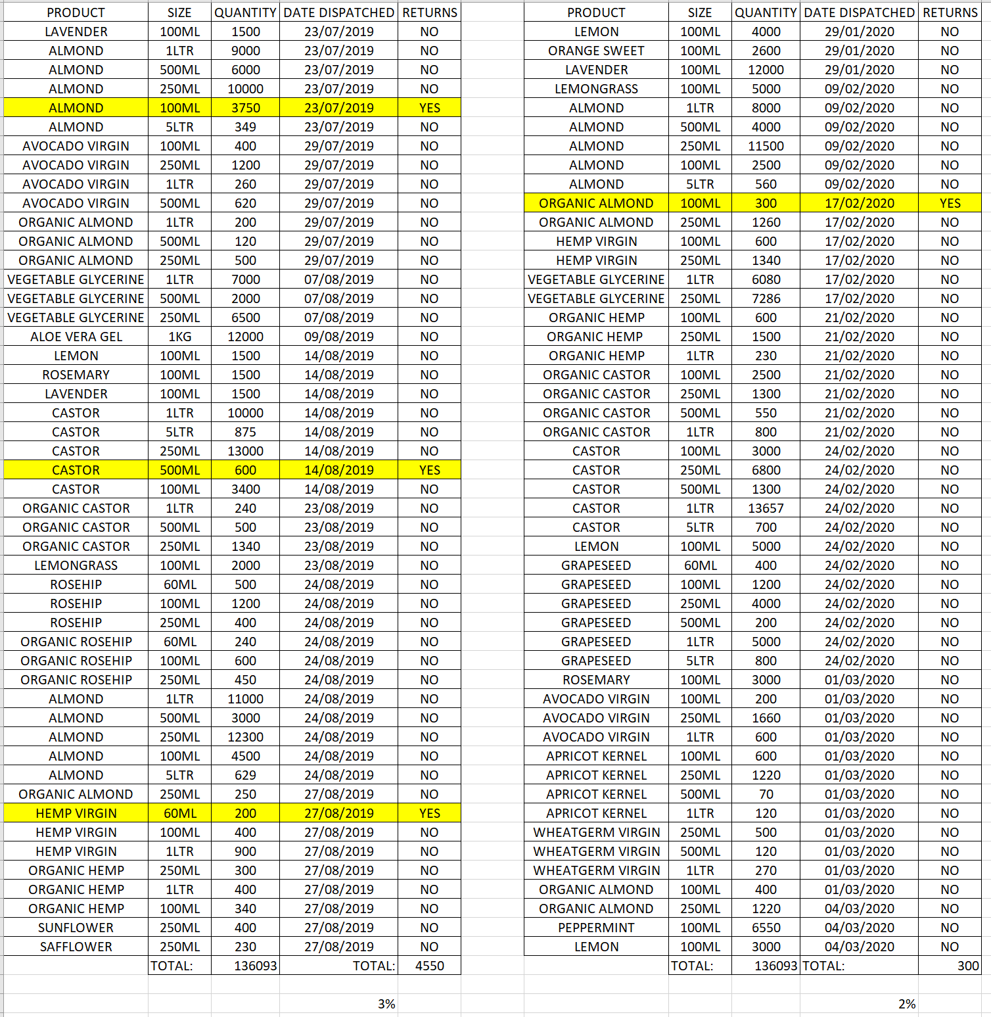
Figure 9 Data collected before and after tool was manufactured

The data collected after the gauge was manufactured showed an improvement, out of the 136093 units shipped only 300 units were returned for rework. The data shows that the percentage of returns has also decreased by 1%, which is an improvement from the initial data collected.
Evaluating the design chosen, the gauges meets the criteria of the PDS. In section 1.0 it requires the gauge to have a 1mm tolerance, adjustable to suit different bottle sizes, to be portable and lightweight. The material used was lightweight, it can be carried around, although one gauge doesn’t cover all sizes the decision to make one for each size was made and the gauge has marking of a 1mm tolerance. The target cost of the gauge as stated in point 6.0 should be £20 per gauge, the actual cost of material per gauge was £13.32.

9.Conclusion
The aim of the project was to create a visual aid to help case packers measure the height of a label applied to a bottle to ensure the label is straight and meets quality controls standards. The design chosen was a Perspex bespoke gauge with a 1mm tolerance marking on each unit, the time and cost constraint did put pressure on the project, but the project only overrun by 2 weeks and the project cost less than the budget allocated. The delay in the material delivery made time to spend more time with the case packers to ensure the design was sufficient. Comparing the results in the data collected, the product returns decreased by 1% which was the aim of the project. The design also met the majority of the PDS criteria such as the standards, safety, testing, documentation and disposal. There was one requirement that was not met in the maintenance criteria, no spare gauges were made due to time constraints, there was enough made for 1 set per case packer. Overall the project was a success, the design met the criteria, it was under budget and the data proves the returns decreased after the gauges were made.

10.Recommendations
When the project was finished there was a team debriefing meeting held, discussing any issues with the gauges and any improvements needed. As you can see in the meeting notes (appendix 8), there was no real issues, there were some suggestions for any future improvements, such as an ‘n’ shaped gauge as shown in a rough sketch on the meeting notes, another suggestion was to change the colour of the gauge to block out any surrounding and the label can be seen more clearer. These ideas will be taken into consideration for improvements.

11.Bibliography
Anish. (2020, January 10). Different Types of Mechanical Measuring Tools and Gauges Used on Ships. Retrieved from marine insight: https://www.marineinsight.com/tech/different-types-of-mechanical-measuring-tools-and-gauges-used-on-ships/
CLEAR PERSPEX 000. (n.d.). Retrieved from perspex sheet.UK: https://www.perspexsheet.uk/clear-000-perspex/
Creusen, M. E. (2004, December). The Different Roles of Product Appearance in Consumer Choice. Retrieved from researchgate: https://www.researchgate.net/publication/227604994_The_Different_Roles_of_Product_Appearance_in_Consumer_Choice
express, A. (n.d.). 6 inch 150mm Digital Caliper Electronic Vernier Caliper. Retrieved from efficient tool store: https://www.aliexpress.com/item/4000370249218.html
FSA. (2020, January 29). Safer food, better business. Retrieved from food standards agency: https://www.food.gov.uk/business-guidance/safer-food-better-business
howstuffworks. (2011, June 1). How does a laser tape measure work? Retrieved from howstuffworks: https://home.howstuffworks.com/laser-tape-measure.htm
KAEFLEIN, M. (2018, December 11). 14 Dissertation Acknowledgements Examples. Retrieved from londonproofreaders: https://londonproofreaders.co.uk/dissertation-acknowledgements-examples/
puretronics. (2020). Laser Diameter Gauge. Retrieved from puretronics: http://www.puretronics.net/laser-diameter-gauge-4604807.html
Seil, D. (2012, febuary 29). postheadericon VME CAL-4, 4" inside caliper, outside caliper, and divider 3 piece set. Retrieved from outsidecalipersshopping: http://outsidecalipersshopping.blogspot.com/2012/02/vme-cal-4-4-inside-caliper-outside.html
unknown. (n.d.). The 4 Different Types of Workplace Learning Styles. Retrieved from cornerstone: https://www.cornerstoneondemand.com/resources/articles/4-different-types-workplace-learning-styles
westport. (n.d.). Types of Mechanical Gauges. Retrieved from west port: https://westportcorp.com/blogs/precision-gages/types-of-mechanical-gauges

12.Appendices

Appendix 1 – Product Design Specification

Product Design Specification
Design specification for labelling quality gauges
Labelling gauge
Design brief
From team meetings with the production manager and quality control coordinator, it has been decided that the technician needs to design a labelling gauge. The gauge should be portable, easy to use and can be used on different size bottles.
1.0 Performance
  - Measure label height (+/-1mm)
  - Adjustable to suit bottle size
  - The gauge should be portable so it can be used on any production line
  - The weight of the product should be sufficient
2.0 Environment
N/A
3.0 Product life span
3.1 The product should be used with in production for minimum of 1 year
4.0 Life in Service
N/A
5.0 Shelf Life
N/A
6.0 Target Cost
6.1 The product should have an end-user cost of £20 per gauge
6.2 The cost of manufacture should be less than £10 per gauge
7.0 Quantity
7.1 1 unit per operative
8.0 Maintenance
8.1 Spares should be available
8.2 No special tool required for maintenance
9.0 Marketing
N/A
10.0 Packaging
N/A
11.0 Size and weight restrictions
11.1 Weight should not exceed 200g
11.2 Length should not exceed 500mm
11.3 Width should not exceed 5mm
11.4 Height should not exceed 500mm
12.0 Shipping
N/A
13.0 Manufacturing process
13.1 The material will be cut using a bandsaw with a plastic cutting blade
13.2 Sharp edges will be filed for safety reasons
13.3 A precision marking tool will be used to mark the 1mm tolerance
14.0 Aesthetics
14.1 The form can follow function
15.0 Ergonomics
15.1 One hand operation
15.2 Ambidextrous
16.0 Customer Requirements
N/A
17.0 Competition
N/A
18.0 Quality and Reliability
18.1 The gauge should not generally fail
19.0 Standards and Specification
19.1 Standards to be adhered to: Food standards agency (FSA)
20.0 Company Constraints
20.1 Time – during the busy period its difficult to produce the gauges due to the volume of work
21.0 Processes
21.1 Gauge to be of metric form
22.0 Safety
22.1 All rough edges should be filed to make smooth to avoid injury
23.0 Testing
23.1 Gauge should be tested on a production line for 3 days and results recorded
24.0 Legal
24.1 Possible litigation lies in the user injuring themselves
25.0 Installation
N/A
26.0 Documentation
26.1 The gauge should be supplied with a training session
27.0 Disposal
27.1 Plastic parts should be recycled

Appendix 2 – phase 1
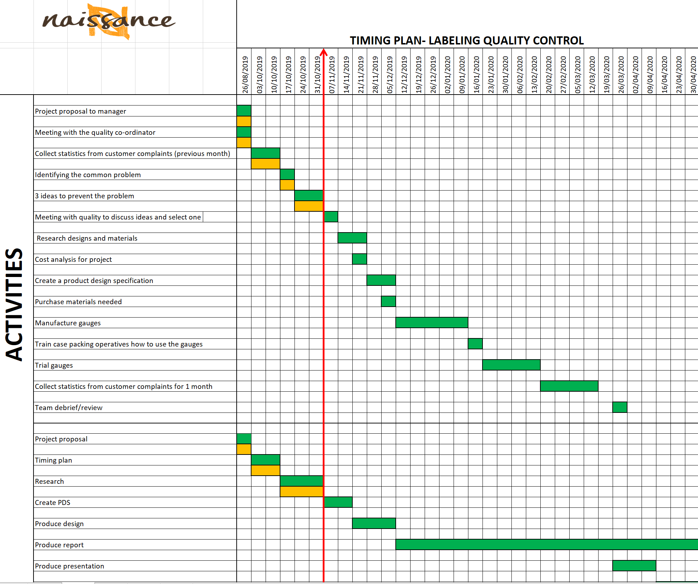

Appendix 3 – project proposal and meeting notes
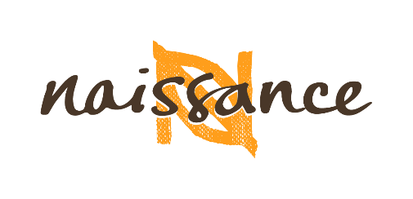

Title: Labelling quality control

Description:
Naissance trading is located in Neath, South Wales. As the company is approaching its busiest time of year, it is important that the standard of quality is maintained throughout production and is adhered to the standard that Amazon have set. The problem our Production department has, is the labels are not to standard and the defected labels are wasted prior to reworking the product. It is therefore necessary to become even more efficient in the way we work and manufacture.

Aim:
Due to quality control department being spread thin, the project will enable any case packer at the end of a production line to check the height of the labels applied to each bottle using a gauge. The aim of the project is to introduce the gauges, which will enable production operatives to check the label height with a 1mm tolerance. Currently the rework level is 3% the aim is to reduce it to 2%.

Start date: Week 1 (Sept. 2019) Completion date: Week 30 (March 2020)

Approval / Acceptance:
Student/s: Employer: Lecturer:
_ _ _ _ _ _ _ _ _ _ _ _ _ _ _ _ _ _ _ _ _ _ _ _ _
N. Funning S. Ashby J. Williams

Confidentiality:
This document together with all other documentation relating to the above project is confidential, and is the sole property of Naissance trading LTD. The documentation and / or associated information may not be used, copied or disclosed to any third party without prior written authority of Naissance trading Ltd.
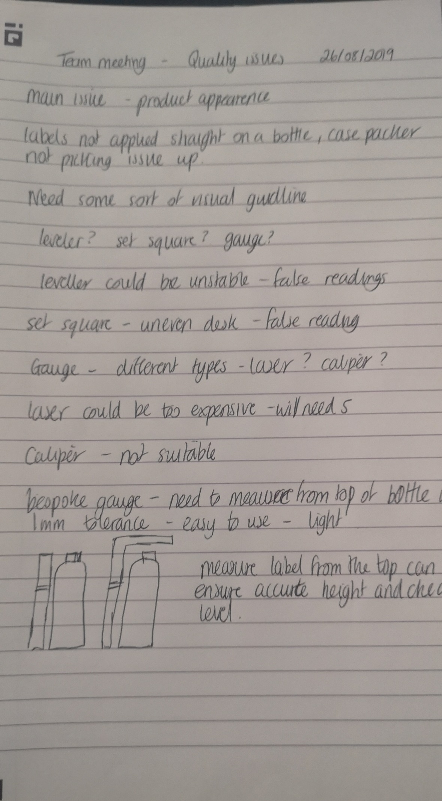

Appendix 4 – phase 2
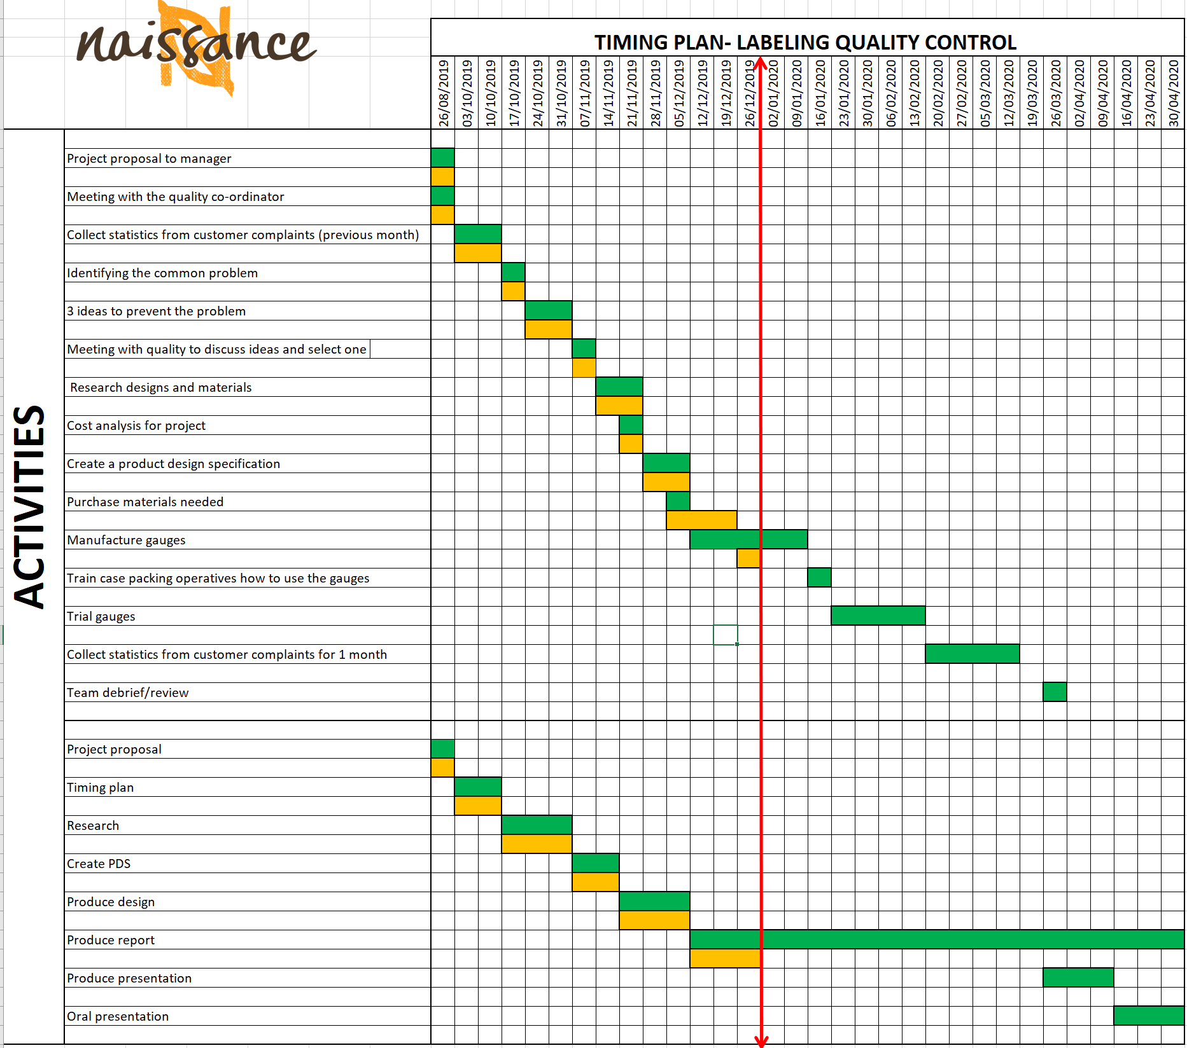

Appendix 5 – Phase 3
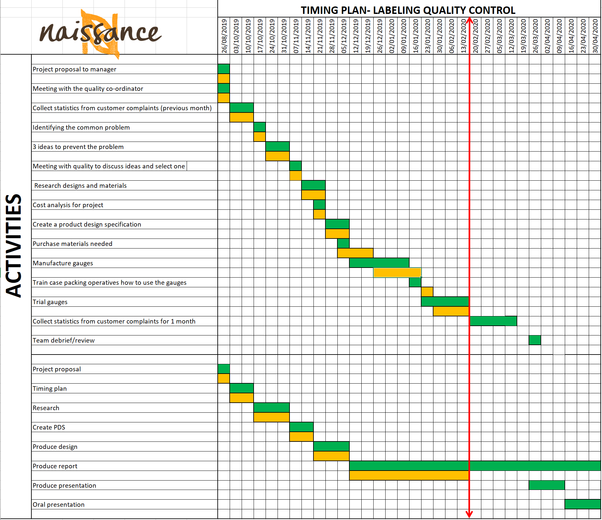

Appendix 6 – phase 4
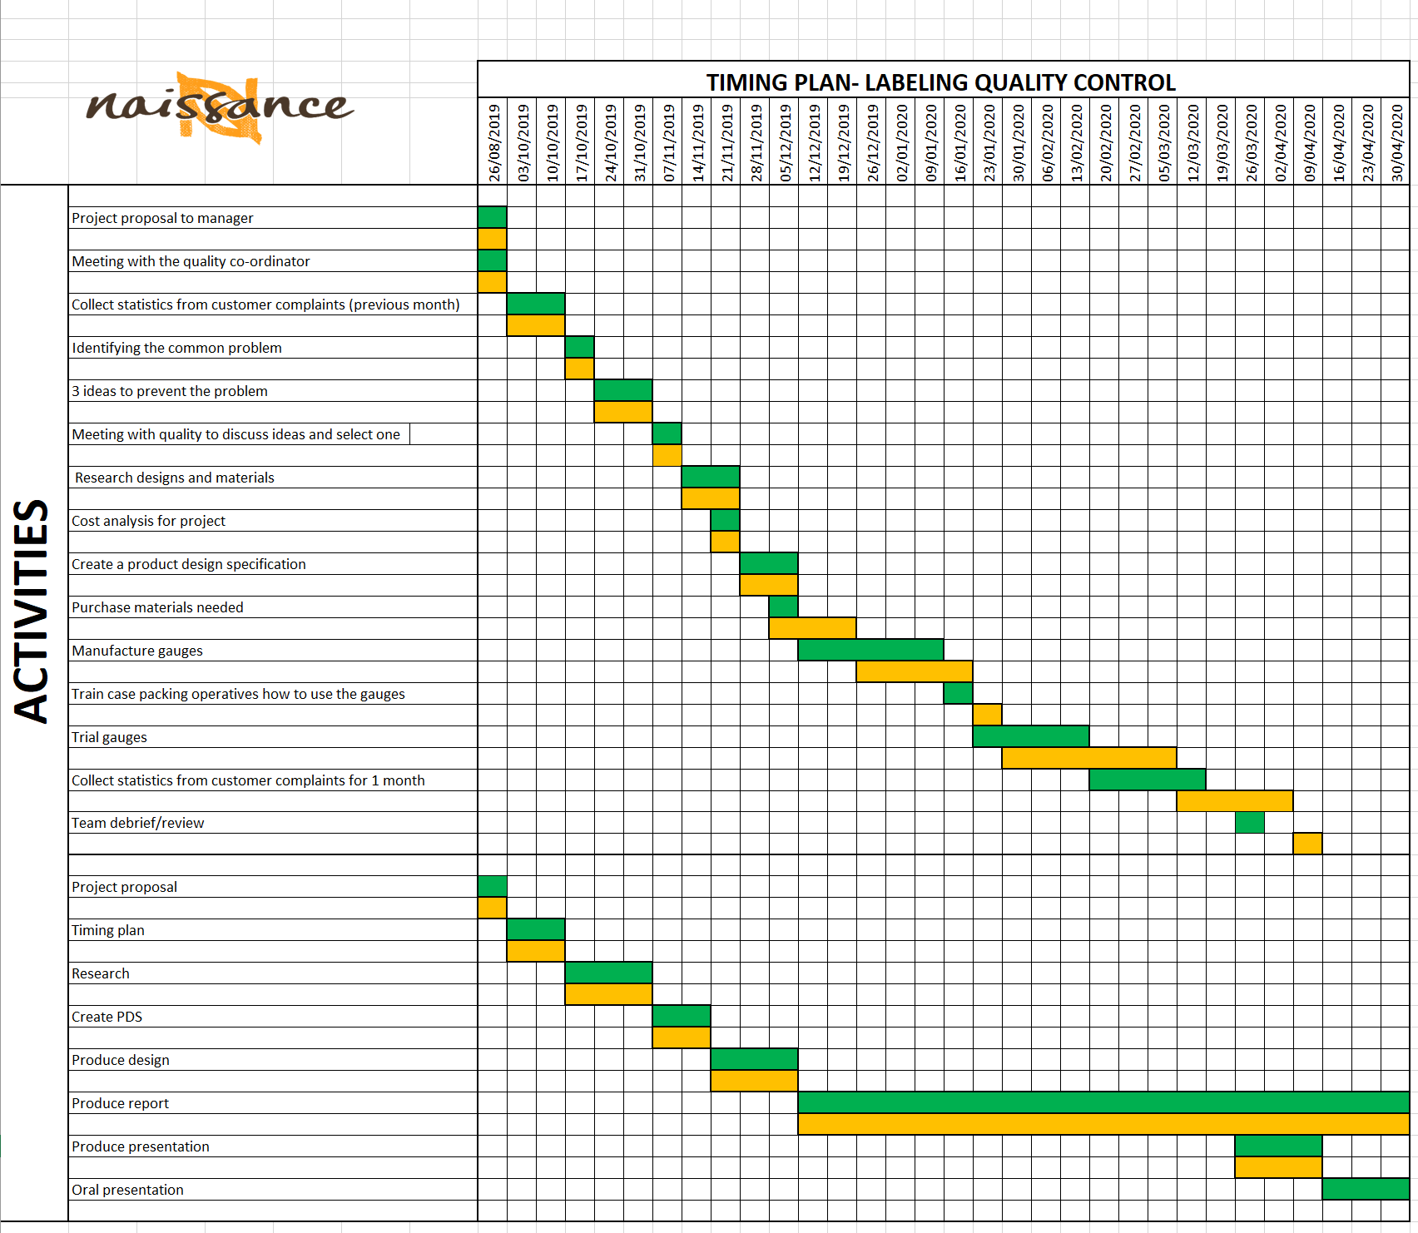

Appendix 7 – Technical drawings using CAD

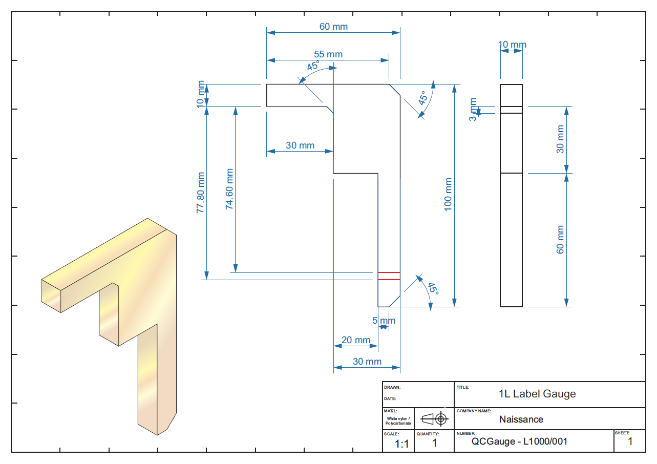
7.1 1LTR gauge

7.2 500ml gauge

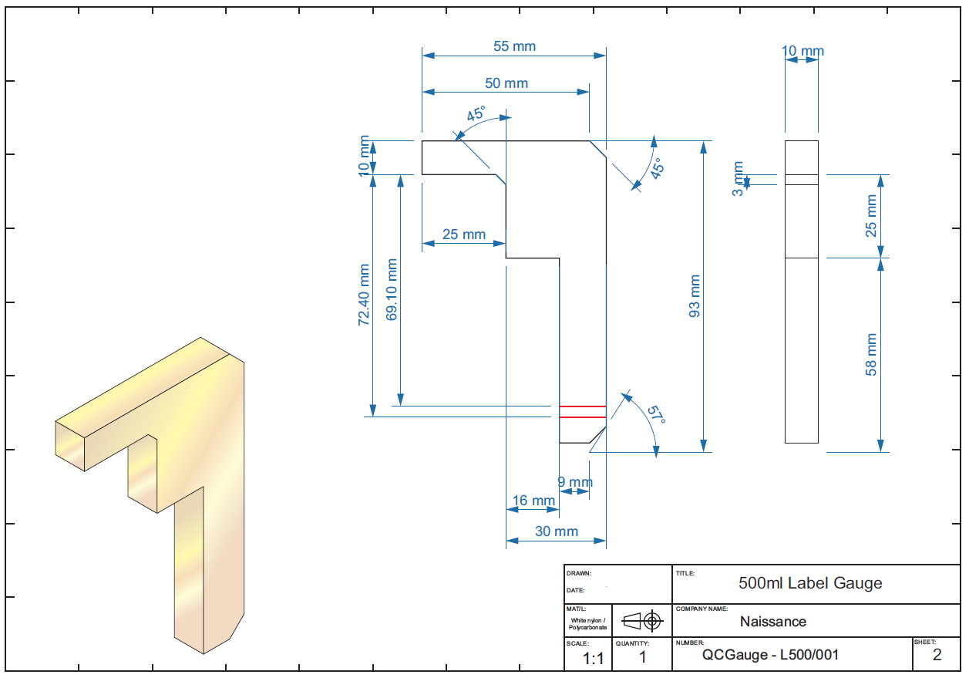

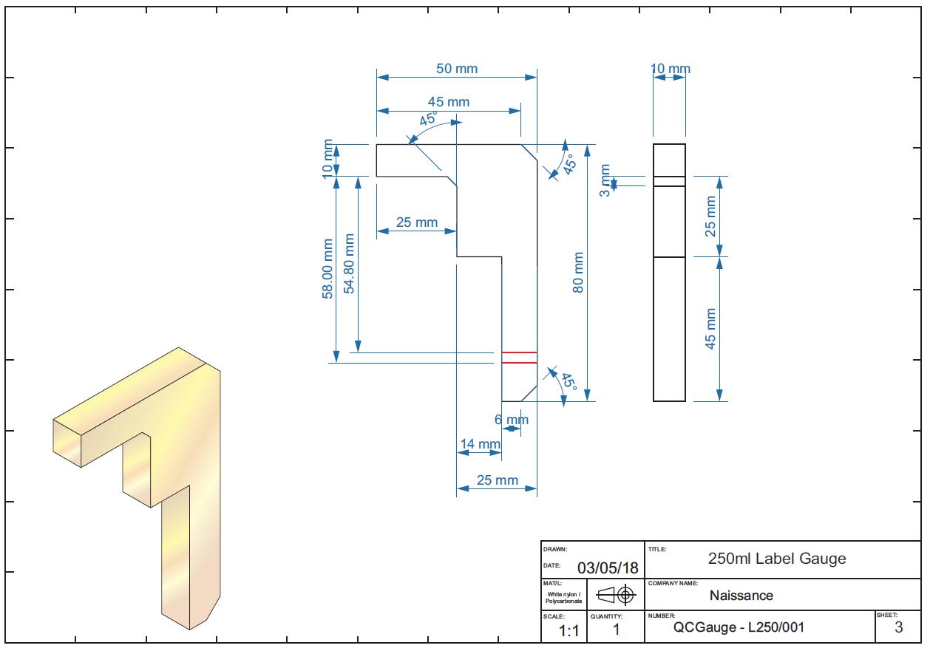
7.3 250ml gauge

7.4 100ml gauge

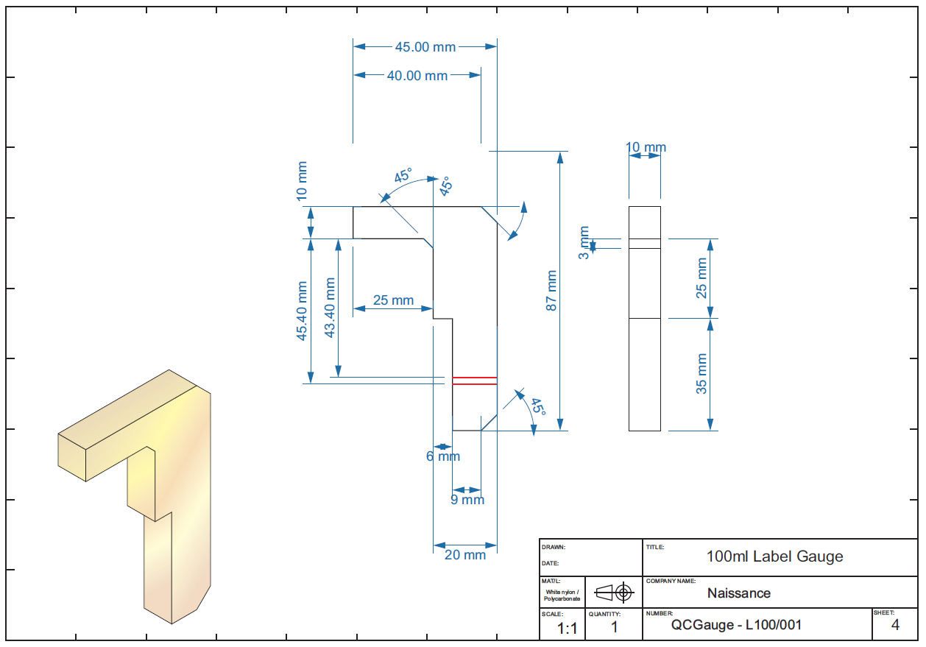

7.5 60ml gauge

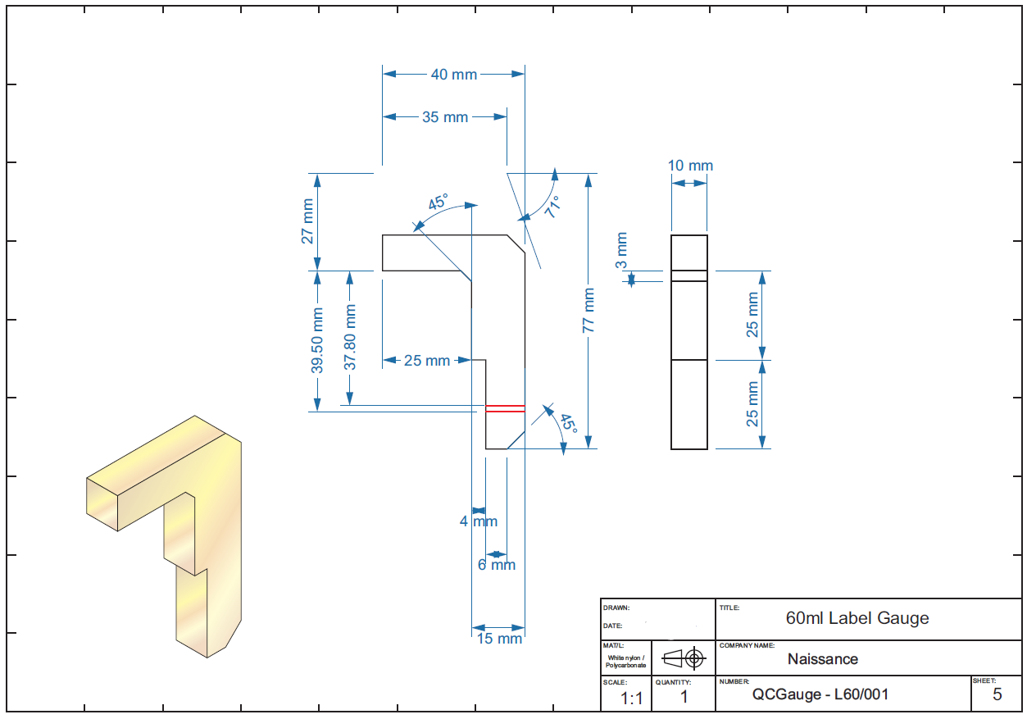

Appendix 8 – Team debrief meeting


