Student Name: | Rubeena Bibi
Student ID: | 1811821
Module Name: | Digital skills and research methods
Module ID: | BMSK4003
Lecturer: | Balan Kandasamy

1
Table of Contents
Introduction ………………………………………………………………………………………………………………………..3
Evaluating Modern Technology …………………………………………………………………………………………..4
Virtual Reality …………………………………………………………………………………………………………………. 4-5
Cloud Storage …………………………………………………………………………………………………………………..5-6
Exploring social media as a tool in healthcare …………………………………………………………………. 6-7
My online presence ………………………………………………………………………………………………………….8-9
Conclusion …………………………………………………………………………………………………………………………. 9
References ……………………………………………………………………………………………………………………10-11

2

Introduction:
Modern technology plays a key role in our everyday lives. In this essay, I will firstly be evaluating modern technology. The example that I will use is virtual reality. In this section of the essay, there will be information on what modern technology is, and their uses. The technology that is explained in depth is about healthcare. It discusses how VR helps to benefit this specific industry but also discusses the drawbacks to using VR. In the second part of the essay, we will be talking about cloud storage. This includes what cloud storage is, uses and concerns. After that it gives two examples of cloud storages that people use in everyday life and lists the advantages and disadvantages of each. In the next part, there will be information on marketing through social media for example consumers using social media to research healthcare brands. Also it involves using social media to gather information. Finally, it explains how social media communicates within the workplace.

3
Evaluating Modern Technology:
Virtual Reality
We are taught from a young age of the five senses: taste, touch, smell, sight and hearing. However, according to C.JoyBell C. “not to be overlooked are the senses of our souls,” (Hubble, 1954). Other senses include the sense of balance, space and more. We also have a special sensory processing function in our brain, which ensures a constant flow of information being inputted to our brain from the environment. Virtual reality creates a computer-generated, 3-dimentional environment which uses the concept of sensory input and our sensory organs to alter our perception of reality and enter virtual reality.

Virtual reality is used in many industries, for example the military use VR in their training, and sport companies use it for viewing pleasures. However, the main adopter of virtual reality is healthcare. Healthcare uses virtual reality in various ways, some of these include: Medical training and patient treatment.

One of the major trials that the healthcare industry face is the need to train their employees, so they are prepared in dire situations. Doctors and nurses are required to have experience in real life situations before being classified as a paramedic. Since the introduction of virtual reality, training paramedics have become a marvellously effective task. Training in virtual reality has the benefit of learning through experience, in a safe environment, rather than watching scenarios play out or learning under risky conditions. Real life scenarios can be recreated and adapted to benefit the training, and help nurses to make decisions (applying the knowledge they have gained to situations) and be more hands-on, “It’s a learning experience almost like putting a puzzle together,” (Harmon,2017). Moreover, experts are able to give the trainees immediate responses, which will prevent making life threatening mistakes in the future. Despite the advantages of using virtual reality in nurse training, there are some drawbacks. These include the incapability of recreating real-life scenarios completely, resulting in flawed training (when practicing for a certain task). Also, virtual reality is expensive especially when it comes to big projects, such as training nurses.

Furthermore, because VR has the capability of creating unique environments, the process of healing patients through (psychological/ physical) therapy becomes much more effective and simpler. Therapy is a key component in the recovery process of a patient. For example, soldiers who arrive back home from war become aggressive and start to enact violent behaviour, which they had experienced on the battlefield, on their family. This condition is called PTSD (Post Traumatic Stress Disorder) and can be treated through therapy. Sometimes, healing processes involve travelling to the place which we fear most (with the physical presence of a therapist), so we are able to overcome the trauma. According to Dr Jennifer Martin (from NIHR MindTech Med Tech Co-operative), “This is a fantastic opportunity to develop and evaluate a new treatment that has the potential to transform people’s lives,” (Martin, 2018). VR gives the patient the chance to safely achieve the same result without having to travel to the desired destination physically. This also eliminates

4
travel expenditures and makes the process much faster. On the other hand, VR technology
is expensive and can prove to be hard to program exactly to a real-life environment. This may result in the patient not being able to relate to the artificial environment; as a result the healing may become corrupted.

Virtual reality is a modern technology, which has a substantial impact in healthcare. Prior to the introduction of VR in healthcare, training nurses were a challenge especially since they required experience. Also, mistakes were only spotted after they were applied in real-life scenarios. These were huge problems in healthcare, considering they were done in such a delicate industry. However, since the introduction of VR in healthcare, nurses are able to acquire the required experience much more easily, and future mistakes are avoided to the best of their ability. VR is also used in patient treatment, which is proving to be very beneficial. “Our research shows that virtual simulation is as good as or better than traditional training methods” (Sheahan, 2018). In contrast to the positives, the use of virtual reality in healthcare has drawbacks, which hinder some tasks. For example, the cost of VR technology limits the use of it in healthcare, as a large amount of funding is required to carry out large tasks. Moreover, VR is not able to accurately recreate a scenario. In summary, Virtual reality gives the healthcare industry, a way to train their nurses and treat patients (among other possibilities). On the other hand, it costs the industry a lot of money and time, and because it is still experimental, it is limited to certain tasks.

Cloud Storage
Cloud storage is used to store data and can be accessed by anyone from specific devices through the internet. There are different types of cloud storage, the first is called personal cloud storage, this is also known as mobile cloud storage. It stores an individual’s data in the cloud and it allows the user to access their data from anywhere. The second type is public cloud storage, this is where individuals and organisations can edit and manage data. The third type of cloud storage is private cloud storage. This is similar to public cloud storage however the difference is that in private cloud you are responsible for the management of the cloud. The last type of cloud storage is called hybrid cloud storage which is the combination of a public and private cloud storage however important data is sent to the private cloud and all other data transfers into the public cloud storage.
Cloud storage is important because it backs up your files but also is a secure way to ‘remotely store data’ (Tejas Ambekar). It is used as a tool to prevent people from data theft or corruption. This is why companies spend a lot of money on security. Another major concern is reliability. People would not want to share their personal or financial data on an unsecure and unreliable server. If a company is financially unstable and if their server is prone to failure then users won’t use it. Moreover, there is physical security i.e. security guard. This is because many people are concerned of their data being hacked by thieves or
5
hackers physically stealing the hard drive in which the data is stored in, or hacker say find an electronic back door and access the data from there.
Here I have compared two different types of cloud storage providers: iCloud and one drive. These are the common examples of cloud storages. There are advantages and disadvantages for using both.
ICloud advantages:
- Apple has made the usability very simple for everyone
- Suits the needs wherever they are
- Does not take much storage
- Important data can be backed up
ICloud disadvantages
- Hackers are always trying to break in
- ICloud takes our private and personal information
- Users are concerned about their personal data being shared online
OneDrive advantages:
- Additional storage is automatically added to the devices main memory, this additional storage is the cloud itself so essentially the data is not taking away any storage from the devices main memory
- Easy to organise data and access them from anywhere
- Servers are more secure
- One drive can link itself to social media websites so this allows users to share data and information better
OneDrive disadvantages:
- Limits management of data
- There are privacy scans meaning that onedrive scans files for any copyrighted material or explicit images
- Onedrive is the number one targeting platform for hackers
- There may be confusion for the user because some files could be altered

6
Exploring Social Media as a Tool in Healthcare

Social media is a computer-based technology which uses the internet to allow the users to share ideas, thoughts and information, through virtual connections. Social media was originated as a way to communicate with friends and family. It has become very popular to about more than 3 billion social media users globally (Maya Dollarhide, 2019). Among the 3 billion users, businesses took advantage of social media and its immense number of users to market their ideas and products. For example, 97% of social advertisers chose Facebook as their most used and most useful social media platform (Jacqueline Zote, 2019). Social media has become a popular advertising tool for many businesses, including the healthcare industry. Statistics show that more than 40% of consumers say that information found via social media affects the way they deal with their health.

An example of social media that is used by the healthcare industry is Periscope. Periscope is a live-stream video app which allows the user to stream from the mobile devices. The video becomes available on the app for a short time after the live-stream, so the users can watch the video again. This social media app is used by healthcare such as, Dr Timothy Miller, an orthopaedic surgeon at OSU’s centre, who live-streamed his repair of a patient’s torn Achilles tendon (is a tear of the tendon that connects your calf muscles to your heel bones). During the live-stream Dr Miller walked the viewers through the procedure and answered any questions they asked. This is a type of marketing, which uses the system of live-streaming to build trust between the patient and the doctor. Through this method, the patients will be happy to visit Dr Miller in case of an Achilles tendon.

Another example of the social media, which is a good source of information gathering, is Instagram. Instagram is a free photo and video sharing app, for anyone who are over 13 years of age. Followers are also able to comment and like the photo and video shared. With the use of liking and commenting, businesses can gather information. For instance, quantitative information can be gathered for brand services through the number of likes the brand received on Instagram, e.g. 71% of consumers who have had a good social media service experience with a brand are likely to recommend it to others (Jeff Epstein, 2013). Much like the method in which quantitative information is gathered, qualitative can be gathered through the comments. This helps future products to become more adaptable to people’s needs and desires.

Lastly, communication is available between professionals in the healthcare industry through the use of social media, for instance, conducting a meeting through the use of periscope. Due to the unique ability of live-streaming that periscope allows, healthcare experts are able to attend important conferences when they are unable to physically be present. Another use of social media, such as periscope, to communicate within the workplace would be training individuals through a live-stream.

7
My online presence
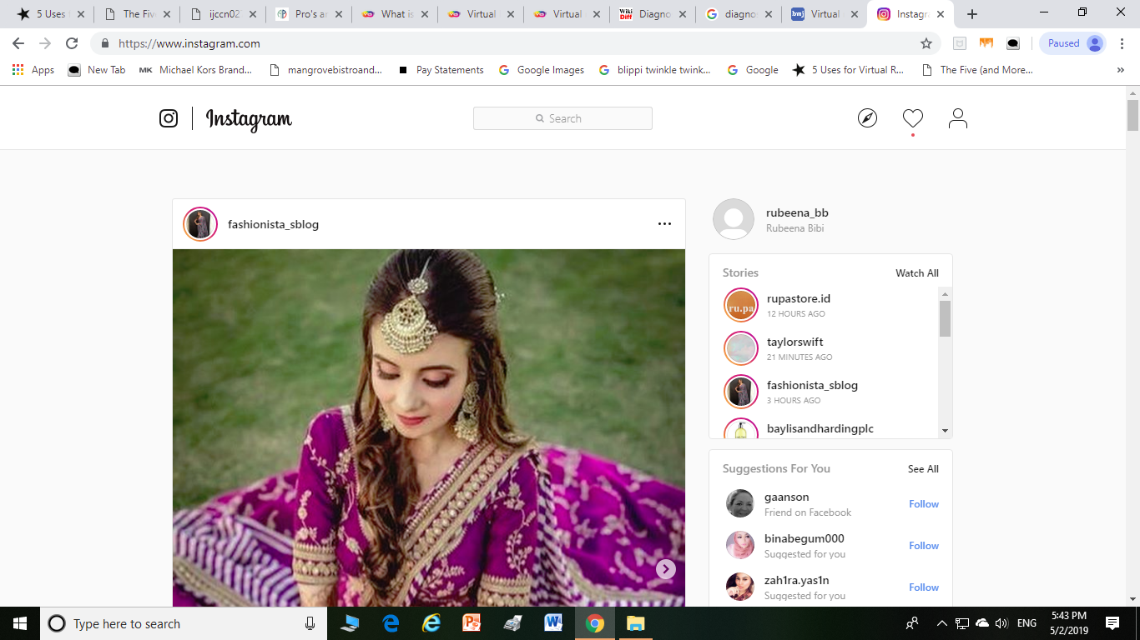
Facebook is good way of finding old friends or colleagues and communicating.
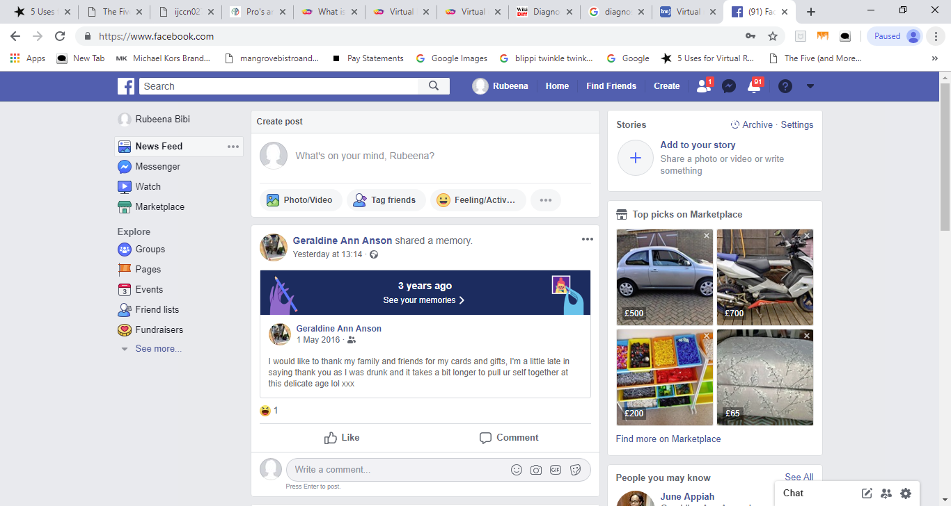
Instagram helps people to advertise their business and helps them to improve reputation of their brand.

8
Linkedin is a great opportunity to show off ones skills, employment history and search for jobs.

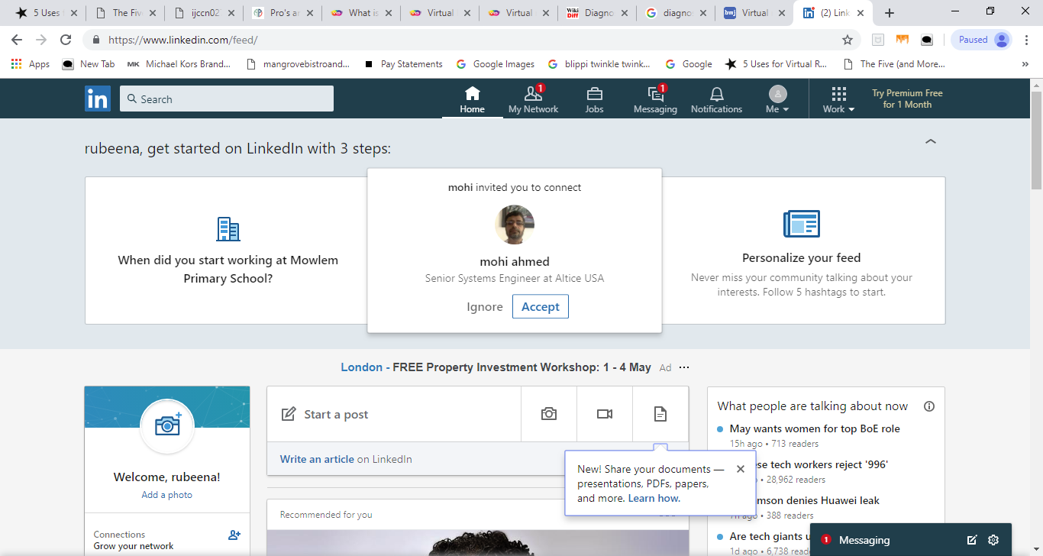

Conclusion:
To summarise this essay, the main concept was to understand how modern technology could be used to improve the lives of everyone in industries. Specifically in the healthcare industry, using VR as discussed above. Furthermore, using more examples of modern technology such as cloud storage and social media, we have discussed how they impact our everyday life and our future.

9
References
Alina Bradford (2017) The Five (and more) Senses. [online] Available from:

Alayna Mansell (2017) 5 Uses of virtual reality. [online] Available from:
https://www.fdmgroup.com/5-uses-for-virtual-reality/

Virtual Reality Society (2019) Virtual Reality in Healthcare. [online] Available from:
https://www.vrs.org.uk/virtual-reality-healthcare/

Virtual Reality Society (2019) Virtual reality in Healthcare. [online] Available from:
https://www.vrs.org.uk/virtual-reality-healthcare/nursing-education.html

How it works team (2019) Cloud Storage: What is it and does it work? [online] Available from:
https://www.howitworksdaily.com/cloud-storage-what-is-it-and-how-does-it-work/

Vangie Beal (2019) Different types of cloud storage. [online] Available from:
https://www.webopedia.com/TERM/C/cloud_storage.html

Tejas Ambekar, Webmaster at CloudCodes Software (2018). [online] Available from:
https://www.quora.com/What-is-cloud-storage-What-is-its-importance-in-the-modern-computer-world

(2019). [online] Available from:
https://easyphonetrack.com/news/display/icloud_pros_and_cons

(2019). [online] Available from:
https://www.reactcp.co.uk/pros-and-cons-of-onedrive/

Jacequeline Zote (2019) 65 social media statistics to bookmark in 2019 [online]. Available from:
https://sproutsocial.com/insights/social-media-statistics/

Referral MD (2018) 30 facts and statistics on social media and healthcare [online]. Available from:
https://getreferralmd.com/2013/09/healthcare-social-media-statistics/

MDG (2015) 3 Ways periscope is being used in healthcare [online]. Available from:
https://www.mdgadvertising.com/marketing-insights/3-ways-periscope-is-being-used-in-healthcare/

Webwise (2019) Explain what is Periscope? [online]. Available from:
https://www.webwise.ie/parents/explainer-what-is-periscope/

10
Dr Leon Creaney (2019) Achilles, tendon rupture[online]. Available from:
https://www.bupa.co.uk/health-information/muscles-bones-joints/achilles-tendon-rupture

Steve Onenski (2017) The impact of live streaming on influencer marketing [online]. Available from:
https://www.forbes.com/sites/steveolenski/2017/09/25/the-impact-of-live-streaming-on-influencer-marketing/

Technology (2015) Periscope: what’s the point of the new video app? [online]. Available from:
https://www.theweek.co.uk/64271/periscope-what-is-the-point-of-the-new-video-app

Instagram (2019) What is Instagram? [online]. Available from:
https://help.instagram.com/424737657584573

Liis Hainla (2019) 21 social media marketing statistics you need to know in 2019 [online]. Available from:
https://www.dreamgrow.com/21-social-media-marketing-statistics/

Joephine Borrilo (2019) How will healthcare professionals use periscope, twitters new streaming video app? [online]. Available from:
https://creation.co/knowledge/how-will-healthcare-professionals-use-periscope-twitters-new-streaming-video-app/

Edwin Powell Hubble (1954) [online]. Available from:
https://www.azquotes.com/quote/137758?ref=five-senses

Mitzi Baker (2017) How VR is revolutionizing the way future doctors are learning about our bodies [online] Available from:
https://www.ucsf.edu/news/2017/09/408301/how-vr-revolutionizing-way-future-doctors-are-learning-about-our-bodies

News and events (2018) NHS Mental Health Services to offer VR treatment [online]. Available from:
http://www.ox.ac.uk/news/2018-02-01-nhs-mental-health-services-offer-virtual-reality-treatment#

Alan Joch (2018) Healthcare treatment, training reaches new heights with VR [online]. Available from:
https://healthtechmagazine.net/article/2018/02/healthcare-treatment-training-reaches-new-heights-vr

11

