Effective Team Working and Communication
Component 1

Table of Contents
Executive summary 1
Introduction 1
Development of an effective team and use of theoretical model 2
Types of roles needed to create an effective team 4
Impacts of effective team working on the team success 6
Barriers to effective team working as identified in the given scenario 7
Conclusion 8
References 8

Executive summary
The report aims at providing the insights of building an effective team with the use of theoretical application along with the proper distribution of team roles to carry out for team success. Effective team building is much important for an organization to achieve its goals and objectives as effective team is more active towards working together to bring success. Effective team can be built through stages such as forming, storming, norming, performing and adjourning. Different roles including shaper, implementer, completer finisher etc are to be distributed properly in order to lead the team to success. The report further discusses the impacts of effective team on the success of team as the effective team increases team productivity and performance through collecting creative and innovative ideas, increase team member’s morale and motivation along with ensuring strong communication among the team members leading to the team success though there are different barriers to the effective team building such as providing more importance to personal interests, poor performance of team members and sense of domination towards other team members etc. These barriers are to be overcome with necessary steps to achieve organizational goals and objectives.

Introduction
Teamwork refers to the collaborative efforts of group of people for achieving common goals and completing a task in effective and efficient ways. Collaborative efforts of group in effective team are required for the achievement of such common goal. Effective team can lead the business organization like Next Plc towards achieving its business goals and objectives. Every team member should be aware of their roles and responsibilities in respect of effective teamwork to work together for achieving team goals. Every team member is to given clear directions and guidelines to make them understand their roles clearly. Effective teamwork helps the organization to bring success in its business functions and operations though there are different barriers to effective team building. In respect of building effective team for Next Plc to overcome the emerging challenges, the team members are to be given effective directions and guidelines along with developing the sense of collaborative working environment.

Development of an effective team and use of theoretical model
In accordance with the case study in context of Next Plc, effective team should be built in order to solve the problems such as misinterpretation, misunderstandings along with the background conversations generated from the team’s regular meetings. In this respect, Next Plc organization needs to emphasize building effective team that can be done with the application of Tuckman’s five stage model which helps in building team in structured ways.

Tuckman’s five theory of effective team building
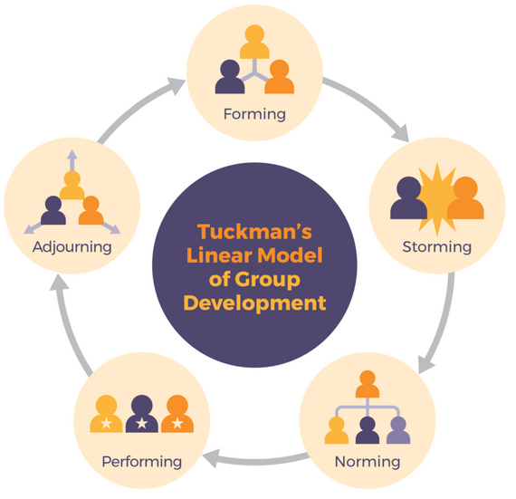
Figure: Tuckman’s Model of Team Building
Source: (Woodcock, 2017)

Forming: Forming stage is the initial stage of effective team building where the team members are busy in finding their places in the team and they cannot make out what they are going to do (Mathis, et al., 2016). The team’s members at this stage involve in working independently as their roles are responsibilities are not clarified to them and even the team goals and objectives are not known to them (Werner, 2021). This stage of effective team building in Next Plc organization requires discussing skills, background and interests of team members, the projects goals along with the rules and regulations.
Storming: The storming stage allows the team members to feel them a part of the team and the reality of work completion is now settled and the team members know about their roles and responsibilities (West, 2012). Suggestions, conflicts along with the confrontation emerge in this stage as the team members involve in providing their opinions emphasizing priority to their opinions (Peralta, et al., 2018). Lack of agreement emerges in respect of making group decisions as the team members try to position their thoughts over other team members though the clarity of team purpose and objectives increases.
Norming: At the norming stage, team members start to get together, develop processes along establishing ground rules and clarifying their duties and responsibilities (Werner, 2021). This stage is characterized with the sense of growing togetherness for working in a team collaboratively. Next Plc will see that agreement and consensus are largely formed among the team members having strong community and unity for working towards completion of particular tasks.
Performing: At the performing stage, the team is now independent to work as it increases strategic awareness and make it clear what the team is going to do (Sparrow, et al., 2016). The team members involve in making important decisions without the participation of team leaders and they focus on achieving team goals and objectives. Working together in an effective team in Next Plc organization, the team members involve in strong relationship to look after each other and work in a friendly environment.
Adjourning: The team members in Next Plc organization are strongly bonded with each other and the expertise and knowledge of the team are captured for the future use. This stage deals with the sense of loss among the members of team and identify where the established teams are being broken up.
Therefore, an effective team can be built through these stages in order to emerging problems in Next Plc organization.

Types of roles needed to create an effective team
At the launches of new line of children’s wear in different stores of Next Plc organization in different countries, effective team working is needed, and the roles of team members are to be allotted properly in order that every team member can play their role effectively and efficiently. In this respect, Belbin’s theory of team role can be the most effective model to distribute team roles in achieving Next Plc’s goals and objectives.
Belbin’s Team Roles
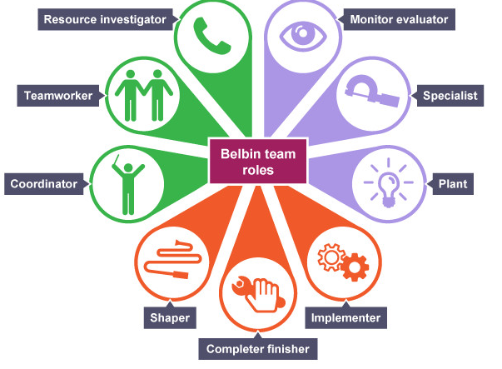
Figure: Belbin’s Team Role
Source: (Mello, 2014)

Shaper: The roles of shapers involve in driving the team to move forwards as they are considered to be action oriented and the team members in the role of shapers motivate themselves (Wilkinson & Dundon, 2021). As they are natural leaders, they are more eligible for the management role in a team.
Implementer: Implementers in the team of Next Plc are considered to be action oriented and involve in maintaining order in their environment with their practical knowledge and discipline. Implementers are regarded as the backbone of a team as they confidently provide supports to other teams.
Completer finisher: The roles of the completer finishers are also action oriented and love to notice fine details along with striving for perfection (Gruman & Saks, 2011). With this role, the team members in Next Plc become more introverted but work as valuable in their work environments.
Plant: The team members with the plant role are considered to be thought oriented, creative and innovative thinkers and involve in brainstorming and solidifying own ideas and thoughts before sharing with other team members (Werner, 2021). The team members with plant role in Next Plc organization will move the organization forward with their creative and innovative thoughts and ideas.
Monitor evaluator: Monitor evaluator is another thought oriented team role and the team members with this role can put aside their emotions to solve problems (Boxall & Purcell, 2011). Such team members can work their best with the projects required their advanced knowledge and strategic planning along with assessing the ideas for determining valuable and viable ideas.
Specialist: The team members with specialist role have deep knowledge and skills used to solve large problems and the specialist involve in working better alone other than working in a team.
Coordinator: Coordinator team role exists with great communication skills and such role plays leadership positions in order to promote collaboration to motivate the team members to accomplish goals and objectives of team.
Teamworker: Team workers are considered to be people oriented and their extroverted personalities help them function well along with listening to other team members (Bang & Midelfart, 2021). The team members with this role Next Plc organization will adapt then changes easily through creating harmony to rising conflicts.

Resource Investigator: The positive attitudes of the resource allocators make them natural networker along with the facilitators of new business. The individuals in the team with such roles involve in exploring new opportunities such as finding opportunities of potential marketing or chatting with stakeholders for the launch of new products.
Therefore, the above roles of the team members can turn a team to an effective team and works for the achievement of organizational goals and objectives.

Impacts of effective team working on the team success
Effective team work creates different positive impacts on the team success in respect of Next Plc organization. Effective team working helps the team to be successful in its operations along with helping the business organizations to achieve its goals and objectives successfully.
Increase of productivity: Effective team working in Next Plc organization in increasing its team productivity as effective team emphasizes sharing the workload with other that make it easy to compete the particular tasks within time. Distribution of workload among the team members builds employee satisfaction as all the team members involve in working in team collaboratively and in a friendly environment (Katzenbach & Smith, 2015). Generating creative thoughts and ideas of the team members leads to the completion of tasks with higher productivity.
Encouragement of strong communication: The members in an effective team involve in active discussion, brainstorming along with the open communication which creates an environment of strong communication (Boxall & Purcell, 2011). Strong communication among the team members in this respect leads the team success through collecting decision making among the team members.

Facilitation of idea generation and creativity: In effective team in Next Plc organization, the team members are allowed to generate their own creative ideas and thoughts towards solving particular problems that lead to the team success as all the team members generate diverse ideas and thoughts in order to solve the problem. Creative idea generation and creativity of employees leads to the success of team in completion of particular tasks.
Boosting employee morale and motivation: Working together in a team increases the overall satisfaction of the team members along with developing employee morale and motivation (West, 2012). With the increased morale and motivation, the team members in Next Plc organization will contribute more to the team success with the efforts and activities.
Therefore, effective team working leads the team to the success through increasing employee motivation level to work hard to achieve the team success along with the team goals and objectives.

Barriers to effective team working as identified in the given scenario
As effective team working is important for achieving organizational goals and objectives of Next Plc organization. Next Plc organization in launching new product line in the market involved in team building but it faces different problems as barriers.
Prioritizing personal interest than work: Providing priorities to the personal interests of team members is a potential barrier to the effective team building as it creates conflicts among the team members (West, 2012). As mentioned in the given scenario, the team members were more interested in background conversations and providing more importance to personal interests which interrupted the team meeting regarding solving problems.
Domination towards team members: The attitude of dominating other team members is another important barrier to effective team building as mentioned in the given scenario that the dominating proceedings over other team members were noticed among the team members at the meeting. Dominating personality or overbearing behavior can hurt the morale of other team members which discourage other team members to work together (Briscoe, et al., 2012). In this respect, Next Plc organization needs to ensure balance of participation that leads to the fair and equitable participation which increases the team member performance.
Poor performance of team members: Poor performance of team member is a potential barrier to the effective team building as the higher performers create the sense of rejecting the lower performance which creates imbalance workplace environment (Boxall & Purcell, 2011). This also leads to the creation of conflicts among the team members as mentioned in the given scenario that there conflicts rise due to the misunderstanding and misinterpretation.
Therefore, there can be different barriers in respect of building effective team which Next Plc organization is facing. These barriers are to be overcome through creating strategic and creative decision making.

Conclusion
Therefore, effective teamwork helps Next Plc organization needs to build effective team with the clarified roles and responsibilities of every team members to achieve organizational goals and objectives. Every member in the effective team in Next Plc organization should play their role properly in order to solve misunderstandings, misinterpretation etc and help the organization to have sustainable performance. Effective team play vital roles in bringing team success though there are many barriers to effective team building and these barriers are to be removed through different steps and strategic decision making.

References
Bang, H. & Midelfart, T. N. (2021) Effective Management Teams and Organizational Behavior: a research-based model for team development. 1st ed. New York: Routledge.
Boxall, P. and Purcell, J. (2011) Strategy and Human Resource Management. 3rd ed. London: Palgrave Macmillan Higher Education.
Briscoe, D., Schuler, R. and Tarique, I. (2012) International Human Resource Management: policies and practices for multinational enterprises. 4th ed. New York: Routledge.
Gruman, J. A. and Saks, A. M. (2011) Performance Management and Employees Engagement. Journal of Human Resource Management Review. Vol. 2(21). Pp. 123-136. Elsevier.
Harzing, A. W. & Pinnington, A. (2010) International Human Resource Management. 3rd ed. London: Sage Publications.
Katzenbach, J. R. & Smith, D. K. (2015) The Wisdom of Teams: creating the High-Performance Organization. Boston: Harvard Business Review Press.
Mathis, R. L., Jackson, J. H., Valentine, S. R. & Meglich, P. (2016) Human Resource Management. 15th ed. UK: Cengage Learning.
Mello, J. A. (2014) Strategic Human Resource Management. 4th ed. UK: Cengage Learning.
Peralta, C. F., Lourenco, P. R. & Lopes, P. N. (2018) Team Development: definition, measurement and relationships with team effectiveness. Journal of Human Performance. Vol. 2(31). Pp. 97-124. Taylor & Francis.
Sparrow, P., Brewster, C. and Chung, C. (2016) Globalizing Human Resource Management. London: Routledge.
Werner, J. M. (2021) Human Resource Development: talent development. 8th ed. UK: Cengage Learning.
West, M. A. (2012) Effective Teamwork: practical lessons from Organizational Research. UK: John Wiley & Sons.
Wilkinson, A. & Dundon, T. (2021) Contemporary Human Resource Management: text and cases. Sage Publication Ltd.
Woodcock, M. (2017) Team Development Manual. London: Routledge.

