

Strategic Management for SMEs

Module Code: BMSW6104

Student Name: MOHBUB ALI

Student Number:1711155

Lecture Name: Paul Bocij

Table of Contents
Introduction 3
Case Study 3
VMOST 4
Fig. 1 VMOST 4
The Organisations Vision 4
How their vision aligns with the plans and actions of the organisation and recent objectives 5
The mission of Pharmacy2U 6
How they are being accomplished 6
What resources are used to accomplish objectives and help the mission 6
Analysis of each department 7
SWOT Analysis of Pharmacy2U 8
Factors that shape the industry and how they relate to each other 9
Sustainability of the proposed strategy 10
What is strategic management and strategy? 10
Strategy explained using Minzberg’s 5Ps 11
Fig 2. Mintzberg’s 5 P’s of strategy 11
The four strategic managements 13
The Organisations current strategy 14
My proposed new strategy 14
Strategy sustainability and benefits 14
What is a stakeholder? 15
Stakeholder theory 15
Conduct a stakeholder analysis 15
Analysis: 16
My Personalised Stakeholder Analysis 17
Fig 3. Stakeholder Analysis 17
Assess current systems 17
Internal and external environments 18
Porters Five Forces and the long-term strategy 19
How competitors are dealt with 21
Conclusion 21
References 21

Introduction

What is an SME? In the UK, the definition of an SME is usually a medium or small sized enterprise which contains less than 250 employees. The Eu defines SME as a business which contains less than 250 employees while also having a turnover of less than 50 million euros, or a balance sheet that totals less than 43 million euros. In this umbrella, there are three different categories: micro, small and medium sized businesses. And they are defined by turnover and number of employees. SME’s make 99.9% of the businesses existing in the UK and are vital for the UK economy. Some examples of small to medium size enterprises are self-employed workers, contractors, sole traders, cleaners, caterers, photographers, shops, tradespeople, etc (Day, 2020).

Case Study

A Medium sized enterprise that I have chosen to speak about is named ‘Pharmacy2U’ which is a business that believes that managing medication should be made easy. What makes this business an SME is that over the past 12 months, Pharmacy2U has grown its customers by 212% which allowed for 32,000 new patients who have registered a month on average. In this large growth period, the company has made 40 million pounds round of investment which further helped the business continue to innovate and improve the experience of patients while developing the current technology. They believe that the benefits of using Pharmacy2U are two-fold which save patient time, money traveling, ques and waiting at GPs and pharmacy, also helping GP’s to save hours of paperwork each week and that represents a better value to the NHS (Nair, 2020).

VMOST

In a nutshell, VMOST is an analysis tool that lets a business evaluate its strategies and know if those strategies are being carried out. VMOST analysis answers this by segmenting five core elements, vision, mission, objectives, strategies and tactics.

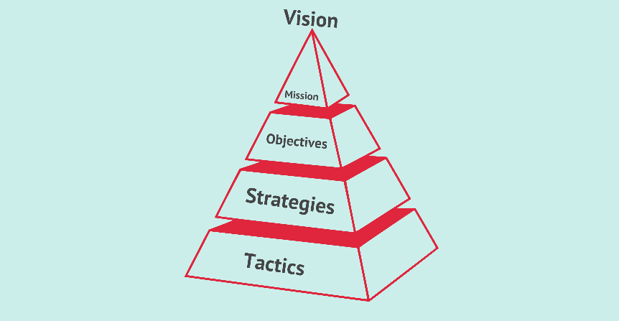
Fig. 1 VMOST (FourWeekMBA, 2020)

The Organisations Vision

Pharmacy2U believe they can offer a new type of pharmacy care where clinical excellence is able to meet a unique award-winning technology which allows for the lives of their patients to live a happier and healthier lives. Since 1999 and the founding the UK’s first online pharmacy, their team were able to redefine the pharmacy care by putting the patients at the heart of everything they do, and their constant focus on the patients has allowed them to become the UK’s largest online pharmacy.
Their business and services are able to avoid the ques of managing medication from the customers own home, free delivery for the patients on every order, a reminder service so medication isn’t running out and any queries are always answered by a team of friendly pharmacist (Pharmacy2U, 2020).

How their vision aligns with the plans and actions of the organisation and recent objectives

Their vision is to make sure all patients are able to use their services easily while making sure their lives are better off with their aid. Proof of this is when Pharmacy2U provides medication and free delivery so that their patients do not have to spend any money or waste time, allowing the patients to have a easier life. Pharmacy2U are able to provide a private prescription service, which lets the patient or customer fulfil their private prescriptions and help save the hassle of taking time out of their schedule to meet in person. Pharmacy2U also supports their vision by providing an online doctor service. Pharmacy2U can help treat a condition for a customer that is unable to make time in meeting with their GP, this online doctor service allows the customer to order medicine through a swift and confidential online consultation. One other way is by using NHS prescription service where if the customer receives regular medication of an ongoing medical condition, the business Pharmacy2U is able to help with NHS repeat prescription service. They can take the full responsibility of dealing with medication through arranging them to delivery through the customers door for free. This helps with money and time saving as well as any hassle (Pharmacy2U, 2020).
Pharmacy2U’s most valuable recent market/entrepreneurial oriented objective is making their customers make use of the online doctor idea. This is a great way of pulling brand new customers and audiences because due to the coronavirus pandemic, it will become increasingly hard to meet face to face with a doctor, and being able to quickly diagnose or at least get a peace of mind on an unknown condition will allow many patients to be reassured, which comes back to their vision: Pharmacy2U is dealing with people who could be frightened of coronavirus symptoms which in turn lowers the workload for GP’s and the NHS.

The mission of Pharmacy2U

Pharmacy2U has said that because of the securing of 40 million pounds investment into the repeat prescription service, the cash injection follows a great period of high growth. The capital will then be used to bring innovation to healthcare and digital transformation is needed to improve patient access to healthcare and that will in turn reduce strain on the NHS. They are passionate on showing patients how technology can be used to their advantage and help simplify and improve the way health and medication is managed. Their mission is to help improve the outcome of patients in partnership with the NHS through managing repeat prescriptions from delivery to request.

How they are being accomplished

Pharmacy2U’s overall capital and revenue is constantly being flown back into the business to increase innovation and improving the customer or patient experience. Pharmacy2U is able to use their 3.5-million-pound dispensing hub in Leeds which is able to dispense 700,000 prescription items per month. Pharmacy2U said that one of their investments allowed it to capitalise on current growth opportunity by the national rollout of EPS. In 2017 the proportion of GP practices in England that had made use of EPS-enabled systems increase from 70% to 90% and that helped begin national TV advertising campaigns which continued to accelerate growth and build the Pharmacy2U brand (Anekwe, 2018).

What resources are used to accomplish objectives and help the mission

The resources they use are the profit and revenue gained from prescription delivery, online doctor services, reminder services, etc. They are also backed by the NHS which means the government are able to help the large organisation to work towards their objectives and mission. Other resources would be the large facilities they take up, such as the dispensing hub and many transportation vehicles and ways of reaching their customers. Online servers are also a big resource that they use, as they are based and used a lot using online features. They will need a lot of technical engineers to deal with servers and web hosting. A lot of automation happens in the Pharmacy2U, so there will be resources of manpower being used to make sure dispensers are working properly.

Analysis of each department

Operations management (OM) is a very important aspect in the business organization, it helps with managing effectively, controlling goods, supervising goods, services and people. The operations department helps cut many sectors and industries as it may concern. Operations can check if the product is in good condition for durability and reliability, they manage quality. When the product is of quality, it gives and edge to your competitors. OMM ensures appropriate staffing of employees to get the best result, they ensure productivity (Exeed College, 2020).
The marketing department is just as important, where strategic marketing usually results in the growth of the business. If customers are educated, engaged and a strong reputation is made, you will be able to smartly sell to them. Most businesses thrive on gaining new customers, marketing is how you get those customers here in the first place. Marketing informs, it engages, builds up reputations and eventually sells. Customers can’t say no to a well-informed business, that engages the customer and allows a positive reputation in their minds which will eventually allow for profit (Humphrey, 2020).
Human resources or HR helps develop an engaged workforce. HR can shape the workplace and help create an engaging place in the workforce. This can range from hiring activities that let the correct people for each role to programs that will essentially give employees many opportunities and ways to collaborate and communicate. Employee morale is supported by human resources and allows employees to develop a better commitment to the company their goals. This as a whole increase’s organisation maximise value because if the employees are working better, it will cause for better efficiency and overall fast and better work towards goals, objectives and making the business to the best it can be (Nouri, 2019).

SWOT Analysis of Pharmacy2U

Strengths
Pharmacy2U is a large and formidable business that captures a large portion of the medical, delivery and online scene. Their hugest advantages are:
- Being able to be based online which is good for being able to obtain a domain and not have to invest a portion of money in trying to put their products in retail stores or owning more than needed plots of spaces
- Online based means that customers will be able to reach to the product and services easily without going out their way to go out
- Very good for being sustainable within the Coronavirus pandemic and lockdown procedures
- Backed by the NHS and has a good name, which allows for customers being building trust to the business

Weaknesses
- Free delivery means a loss of profit or revenue that could have been used
- Having lower margins, causing major loss in profit
- May be losing more money as new customers join and use their services
- Stripped out all human interaction, which may feel dull and not very trustworthy for the customers point of view
Opportunities
- Able to make many more online services as it is already a large established online pharmacy website
- Can use its large following to advertise and market their other products or can advertise other businesses products through e-mail marketing
- Manipulation of EPS, making use of EPS-enabled systems will increase growth and profit
- Increasing distribution costs can increase in turnover, turnover is linked to prescription rise
Threats
- Having to compete with many other pharmaceutical and online medication websites and services that invest much more into marketing and advertisement
- After lockdown, a significant amount of people using the services will decline, another way must be made to maintain customer engagement
- A lot of online reviews and customer feedback show that they should stay away from Pharmacy2U, if these ideas are not taken control of, it can drastically affect the business
- There are negative press and analysis of Pharmacy2U and their downfalls, if these are not correct it can cause backlash, uncertainties on using the services.

Factors that shape the industry and how they relate to each other

There are many factors that shape the industry, these include macroeconomic, technological, demographic, governmental and social influences.
Structural trends could have effects on demand for an industry’s services or products. Their sales and profitability can be impacted by credit availability, interest rates, gross domestic product or even inflation. New technology creates new/improved products that can change the industry by a large margin and change how the other industries use the products so they can carry out their own operation. Population size changes, distribution of gender and age, demographic characteristics could have effects on the growth on the economy and the types/amount of services and goods used. Governments could have an influence on industry as they can change and control tax rates, this is done by their status as major purchasers of services and goods from many big industries. The government can also indirectly empower other self-regulatory organizations, so they are able to govern the affairs of an industry. Finally, there are social influences that change how people work and spend their money, as people like spending their leisure time and liv their lives different which could affect the sales of many different industries.

Sustainability of the proposed strategy

As time progresses for the business Pharmacy2U, there is proof that Pharmacy2U is slowly losing its edge compared to its competitors. Recent news has shown they have used a 3.5-million-pound medication hub but at the same time they have made a 16 million pound lost in annual financial reports. Even though they had accumulated 330,000 new NHS patients, there is a great barrier that they need to overcome. Their strategy is to deliver for free whilst making some money back from online services and working with the NHS. This sustainability is not very good as it will eventually lead to higher costs compared to the profit gained. Pharmacy2U’s core strategy is focused on making a fully managed repeat prescription delivery service. Reports have shown that the profitability is expected to increase through years to come. If Pharmacy2U can make use of repeat prescription delivery service as a way of making profit, they will be able to bounce back, but the idea of free deliveries will be removed, which is what gave Pharmacy2U’s fame and reputation (PharmacyNetworkNews, 2019).

What is strategic management and strategy?

Strategic management is management of the organizations resources so they can reach other objectives and goals. Strategic management also includes making and setting up objectives, understanding analysing the competitive scene, understanding the internal organization, evaluation of strategies and to ensure that management rolls the strategies out properly across the organization.
Strategic management is put into several different categories of thought. The perspective approach to the strategic management outlines and shows how strategies should be developed, on the contrary, descriptive approach focuses on how the strategies should be put into play. These categories depend on if the strategies are developed by an analytic process, where all the threats and opportunities have been looked at, or if they are more like a general guiding principle that can be applied (Kenton, 2020).
The culture of business, skills and competencies of employees, structure of the organization are all factors that are important to influence how the organization can attain the objectives made. Companies that are inflexible will find it difficult to succeed in changing the business environment and adapting. This barrier that is created between development of strategies and the implementation will make it much harder for managers to see if the objectives have been met at an efficient manner.
An example of strategy and management: a for-profit technical college wants to increase new student enrolment and the enrolled student graduation rates for at least the next three years. Their purpose is to allow the college to be known for the best buy for a student’s money within five for-profit technical colleges in that region, and the main goal is increasing revenue. In this case, the strategic management is to make sure the school has enough funds so the high-tech classrooms and hiring of qualified instructors happens. The college will also invest in recruitment and marketing while also including strategies to keep student retention. The leadership of the college assesses if the goals are achieved within many periods.
Aiding a company in finding ways to become competitive is what the main purpose of strategic management is. In that sense, putting strategic management plans into action is important for the planning itself. When plans are put into practice, they involve identifying benchmarks, resources being realigned whether its human and financial and even putting leadership resources in the right place to oversee the deployment, sale and creation of services and products (Kenton, 2020).

Strategy explained using Minzberg’s 5Ps

In 1987, Henry Mintzberg distinguished five visions needed for strategy for organisations, known as 5 P’s of strategy. They stand for Plan, Position, Pattern, Ploy and Perspective. Manipulating these five components allows for organisational efficiency. This strategy aims for the future, concerning the long-term and sectors of the organisation.
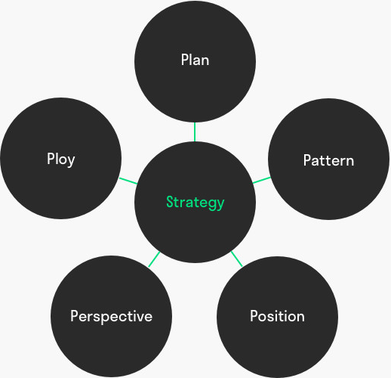

Fig 2. Mintzberg’s 5 P’s of strategy

Plan: A strategy plan is needed for dealing with situations, this plan must be made before actions can be taken and it is important the plan is followed effectively and consciously. Goals can be achieved with a great plan and let managers give teams clarity and work towards evaluations and results.
Pattern: Patterns are strategies that have already been implemented before. There are strategies that have achieved their result and on another hand some strategies need to be worked on in more detail. Earlier patterns are important in making a new strategy. It’s about a regular patten in decision-making flow. If past choices have been made, the organisation may pick those decisions again. Past behaviour is a pattern that is within strategy development. Consistent behaviour displayed by employees and teams are patterns. These patterns must become aware of and can include their strengths in making a strategy.
Position: This has to do with the organisations position in the market, the interaction between internal and external context. How does the organisation want to position? Its identity and does it match the idea of stakeholders? It can give a competitive advantage and gives the organisation a firm place in the market.
Perspective: This is to see how different target audiences perceive the organisation, how do employees regard their employer, what do the customers think of the organisation? The image on investors? This is a source of information that can be used for strategy.
Ploy: Ploy is something competitors don’t expect. Organisations surprise their environment by doing a plan nobody sees coming. A phone service provider can offer internet service and digital television suddenly, this puts them in the competition and outsmarts competition (toolshero, 2020).

The four strategic managements

Environmental scanning is the gathering of information of events and relationships with the organizations external/internal environments. Environmental scanning is to help manage the future direction of the organisation (Thomas Edison State University, 2020).
Strategy formulation means the process of choosing the most appropriate action for the realization of the organization’s objectives, goals and helps achieve the organizations vision. Strategy formulation involves six steps, and do not need to follow an order but are very rational and can be followed in this order. Step 1 is to set the organizations objectives; this is to find the long-term objectives and the strategy is usually a medium to understand the objectives. The strategy stresses the process on reaching the objective. When fixing the organizational objectives, it is needed that there is analyzation of factors that influence selection of objectives. Step 2 is evaluating the environment. This is done by reviewing the competitive position, to make sure the factors for competitive success are discovered and management can find strengths and weaknesses, and the competitors’ strengths and weaknesses. Step 3 is to fix the target values as the objectives. This is to compare with long term customers. Step 4 is aiming in context with divisional plans. Contributions are identified and analysis of macroeconomic trends are carried out. Step 5 is performance analysis, finding gaps and planned desires for performance, which is done by the organisation. Step 6 is choice of strategy, which is done after considering goals, strengths, limitations and opportunities (MSG, 2020).
Strategy implementation is when and organisation translates its strategy into plans and activities, steering the organisation in the direction set in the strategy and allow the organisation to achieve strategic objectives. This can usually be done by building a good leadership team, budgetary resources, algin people, communicate strategy or review and report on progress (CMI, 2020).
Strategy Evaluation involves analysing the strategic plan, address how well it is done against achieving the goals in the strategy. It is an internal analysis tool and should be used as a part of a bigger strategic analysis for the organization when decisions are involved in the strategy. The strategy evaluation process has questions such as:
- Progress made towards the vision
- Relevance of strategic focus areas
- What objectives aren’t needed
- Where targets have fallen short, why?
(Wright, 2019)

The Organisations current strategy

The biggest online-only pharmacy named Pharmacy2U has their own new strategy and advertising campaign which is allowing for more patients to be introduced and this also benefits the digital health services.
Pharmacy2U, as well as several other chemists and pharmacy businesses have appointed a roster of media specialists and leading brands, which will reinforce the position as providers and give better choices for convenient NHS repeat prescriptions as well as products over the counter. Pharmacy2U is able to use £40m merger with ChemistDirect so they are able to monopolize and become the digital-only leaders in the UK online pharmacy sector. Because of this merged business, they share a customer base that excess of 1.5 million people.
The two brands continue to go forth in business in their own ways, Pharmacy2U with NHS repeat prescriptions and online doctor services while ChemistDirect uses their competitive priced over the counter pharmacy products at the door (Donohue, 2017).

My proposed new strategy

My proposed strategy is to make use of their prescriptions and online doctor service, as well as branching out to other types of services that people would need. Similar to the online doctor, advise on therapy or mental health could also be an option. These days, mental health is crucial to keep healthy, and it would be a great way to make business while trained professionals only need to speak through their mic, webcam and computer screen. If Pharmacy2U really wants to make money without dipping into a profit loss, I suggest that they start charging on reminders or deliveries. This can be done through subscription as medication reminders could be very technical which makes it harder for customers to say no to. The cost of delivery is high and adding a one- or two-pound fee can make a significant difference.

Strategy sustainability and benefits

This strategy I made is sustainable, it benefits by being able to stay alive in the market and able to use the resources to further research marketing and how to improve profits. Mental health and online services are very sustainable as this is the age of technology and advancements. These strategies will help with being efficient, capitalizing on the online service brand, keeping the already existing customers and drawing in new ones due to easy accessibility and connecting with the community through feedback and support online.

What is a stakeholder?

A stakeholder is a group of people or person that are interested in a company that can affect or become affected by the business. Primary stakeholders in a normal business are the ones investing, suppliers, customers and the employees. As time moves on, communities, trade associations and governments have now been added to the definition of a stakeholder. These people are very interested in the business and want to know how well the business will perform. Stakeholders can either be external or internal for the business. Internal stakeholders are interested in the company by a direct means of relationship, which could range from employment, investment or ownership. External stakeholders do not directly work with them but affected through the business’s actions and the outcomes. Examples of these are suppliers, public groups and creditors (Chen, 2020).

Stakeholder theory

Stakeholder theory is viewing capitalism that has interconnected relationships between the employees, communities, investors, customers, suppliers and the business, the people who have a stake in the organization. This theory believes that the firm must be able to value all stakeholders and purely the shareholders. The quote from R. Edward Freeman who created the stakeholder theory of organizational management and business ethics says the 21st century is where there is management for stakeholders. The executives should be able to make as much value as possible for the stakeholders without needed to resort to any trade-offs. Successful businesses can endure due to managing the stakeholder’s interest and this is aligned up in the same direction.

Conduct a stakeholder analysis

All internal people or teams that are involved into a project or affect are previously named as stakeholders. Stakeholder analysis is a process which helps the business identify the people before any projects are begun; allowing for grouping and seeing the levels of participation, how much they influence and are interested in the project, determining the best route on communicating and involving the stakeholder groups. The purpose of this is to enlist help of players in the organization; gain an alignment among the goals and plans of the stakeholders and address issues early on (ProductPlan, 2020).

Analysis:

The stakeholders are:
- Director
- Contracts
- Director HR
- Services Sales
- IT support
- Event coordinator
- Non-sales ops
- Consulting admin
- VP sales
- Boss
- Lead Generation
- Colleagues
- Sales support
- Partner sales
- Consulting
- Etc.
The director is interested in seeing how he can bring success to the business, contracts must be met so the business follows regulations and plays fairly, the director HR is the same as the director but oversees the human resources department. Sales and IT support all want to make sure there are no errors in their department, its their interest problems and issues are fixed. The boss and colleagues must be adhered and listened to as they are people you work with and have the higher say. Admin, sales are all interested in their portion of business.

My Personalised Stakeholder Analysis

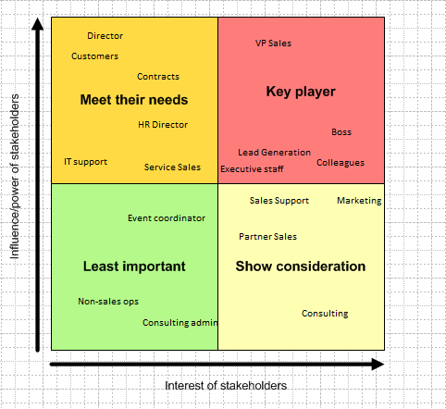

Fig 3. Stakeholder Analysis

Assess current systems

There are many reasons on implementing a business system and what it is. Business systems improve top-line performance, as part of the business system is implementing and developing strategy creation, planning and processes are thought out in the organization, and these elements lead to an insightful way of learning and growing for top-line revenue. This all comes together to let your customers’ expectations be met and improve the brand, and they will create a healthy business. A systematic approach will allow constant information in areas that need improving.
Using a systematic approach, analysing, measuring, comparing and testing will be done on customers to find out what they want and do not want. It will slowly start to feed information on why customers have certain needs and why they aren’t met.
If its safety, time-based jobs, quality, the business system is to give effective, repeatable and efficient results. Implementation of sound business system reduce costs, preventing the usage of shortcuts that creates erosion of profitability because of lower quality expectations/service levels.
In short, the systems goal is to educate and give opportunities to employees so work is efficient and don’t effectively. Ideas, creativity, personal engagement are increased and integrates new-hires, giving them the ability to see their role and bring new ideas (Waldo, 2020).

Internal and external environments

Businesses want to be successful in the marketplace. The positives and negative effects outside the company must be understood and strategies must be made to handle any sort of predicted situation. Internal and external factors are important for strategic marketing plan.
Internal factors are anything inside the company and are under control of the company, whether is tangible or intangible. The factors are figured out, grouped, and categorised as strengths or weaknesses of the company.
There are various internal factors, some are:
- Value proposition
- Plans and policies
- HR
- Marketing and financial resources
- Labour management
- Equipment/Physical assets
- Image and brand equity
- Financial forecast
- Quality/Size of infrastructure
- Founders decision making power and relationship
- Task operations/executions
- Relationships of employees
- Technology resources and dependencies
External factors are outside the company’s control, they must be considered to adjust so the business can adapt to the environment. The biggest outstanding and important factors are listed and change the economic situation, laws, customer demands and infrastructure.
Some external factors are:
- Customers
- Competitors
- Suppliers/Input
- Public
- Talent
- Media and Marketing
- Economy
- Legal/politics
- Social
- Natural
- Technology
(Vanessa, 2020)

Porters Five Forces and the long-term strategy

Porter’s Five Forces can be used to understand what makes up the competitive environment, what can erode your profitability and they are: Competitive rivalry, supplier power, buyer power, threat of substitution and threat of new entry. These are the five key sources that give competitive pressure in an industry, and they are permanent which will always be here no matter what. To understand this and use it as a strategy, you must understand which forces are in your favour or against you and depending if they are moderately or strongly in your favour or against.
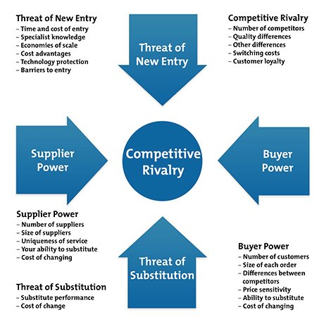Fig 4. Porter’s 5 Forces

The strategy can now be adjusted so that it fits the competitive environment and improve potential profit, this can be done by looking a supplier power, as their ability’s drive up the prices of your inputs, the buyer power which is the strength of the customers to take down the prices, competitive rivalry which is the competition strength, threats of substitution where products and services can replace your own and threats of entry where new competitors can enter the market if you are making a lot of profit (MindTools, 2020).

How competitors are dealt with

By following the five forces, I can use and understand what to do when interacting with new or existing competitors. Competitive rivalry will allow me to see how many rivals there are, what type of quality and services they have and how it compares to mine. Supplier power will help me see whether if I should increase my prices or not as I can see if it is easy for my competitors to increase prices or not. Potential suppliers, unique product and switching suppliers are ideas that factor into this. Buyer power allows for new strategies to see if my product can drive the competitors prices down, how many buyers they are and how big orders are. Threat of substitution will help with trying to stay unique and making it so that my product is the customers only option, either by making it cheaper or innovating. Threat of new entry must be considered, and I need to make my product big enough as a threat to make competitors realise that it isn’t worth time and money to compete (MindTools, 2020).

Conclusion

In conclusion, it is vital that a business strategy must be created, with many factors being played. Objectives, goals, visions, strategies must be constantly adapted. Competitors play a large aspect in this and they must always be considered because they are trying to outperform you in the market. Adhering the policies, rules while also outperforming competitors is a difficult job, but with research and planning, it is feasible. Stakeholders are important for this, if you can manipulate and keep all stakeholders happy, this will boost your business into the right direction. Once all these have been considered, a plan can be carried out with flexibility. It is always important to have back up plans and a way to move forward if the worst becomes possible.

References
Anekwe, L., 2018. How healthy is the Pharmacy2U business model?. [Online]
Available at: https://www.chemistanddruggist.co.uk/feature/how-healthy-pharmacy2u-business-model
[Accessed 12 11 2020].
Chen, J., 2020. Stakeholder. [Online]
Available at: https://www.investopedia.com/terms/s/stakeholder.asp
[Accessed 17 11 2020].
CMI, 2020. Implementing Strategy. [Online]
Available at: https://www.managers.org.uk/knowledge-and-insights/research/implementing-strategy/
[Accessed 15 11 2020].
Day, J., 2020. What is an SME? Here’s an SME definition. [Online]
Available at: https://www.simplybusiness.co.uk/knowledge/articles/2020/05/what-is-an-sme/
[Accessed 12 11 2020].
Donohue, S., 2017. Online pharmacy leader launches new brand strategy. [Online]
Available at: https://bdaily.co.uk/articles/2017/03/17/online-pharmacy-leader-launches-new-brand-strategy
[Accessed 17 11 2020].
Exeed College, 2020. Importance of Operations Management in Business Organizations. [Online]
Available at: https://exeedcollege.com/blog/importance-of-operations-management-in-business-organizations/#:~:text=Operations%20management%20is%20important%20in,industry%20as%20it%20may%20concern.
[Accessed 14 11 2020].
FourWeekMBA, 2020. VMOST. [Online]
Available at: https://fourweekmba.com/vmost-analysis/
[Accessed 14 11 2020].
Humphrey, A., 2020. 5 reasons why marketing is so important. [Online]
Available at: https://www.deluxe.com/sbrc/marketing/5-reasons-why-marketing-is-so-important#:~:text=Strategic%20marketing%20often%20results%20in,will%20most%20likely%20do%20well.&text=Marketing%20is%20how%20you%20attract%20those%20customers%20in%20the%20first%20place.
[Accessed 14 11 2020].
Kenton, W., 2020. Strategic Management. [Online]
Available at: https://www.investopedia.com/terms/s/strategic-management.asp
[Accessed 15 11 2020].
MindTools, 2020. Understanding Competitive Forces to Maximize Profitability. [Online]
Available at: https://www.mindtools.com/pages/article/newTMC_08.htm
[Accessed 17 11 2020].
MSG, 2020. Steps in Strategy Formulation Process. [Online]
Available at: https://www.managementstudyguide.com/strategy-formulation-process.htm
[Accessed 15 11 2020].
Nair, P., 2020. The best medium-sized businesses in the UK. [Online]
Available at: https://www.pharmacy2u.co.uk/whoarepharmacy2u.html
[Accessed 12 11 2020].
Nouri, C., 2019. Why HR is Important. [Online]
Available at: https://pingboard.com/blog/why-hr-is-important/#:~:text=HR%20Helps%20Develop%20an%20Engaged%20Workforce,-Though%20an%20estimated&text=From%20hiring%20activities%20that%20identify,the%20company%20and%20its%20goals.
[Accessed 14 11 2020].
Pharmacy2U, 2020. About Us. [Online]
Available at: https://www.pharmacy2u.co.uk/whoarepharmacy2u.html
[Accessed 12 11 2020].
PharmacyNetworkNews, 2019. Pharmacy2U posts £16m loss for 2018-19. [Online]
Available at: https://www.pharmacynetworknews.com/pharmacy2u-posts-16m-loss-for-2018-19
[Accessed 14 11 2020].
ProductPlan, 2020. Stakeholder Analysis. [Online]
Available at: https://www.productplan.com/glossary/stakeholder-analysis/#:~:text=A%20stakeholder%20analysis%20is%20a,of%20these%20stakeholder%20groups%20throughout.
[Accessed 17 11 2020].
Thomas Edison State University, 2020. Environmental Scanning. [Online]
Available at: https://www.tesu.edu/about/ir/environmental-scanning#:~:text=Environmental%20scanning%20is%20the%20process,future%20direction%20of%20the%20organization
[Accessed 15 11 2020].
toolshero, 2020. 5 P’s of Strategy (Mintzberg). [Online]
Available at: https://www.toolshero.com/strategy/5-ps-of-strategy/#:~:text=He%20calls%20them%20the%205,different%20facets%20of%20an%20organisation.
[Accessed 15 11 2020].
Vanessa, 2020. What Are Internal & External Environmental Factors That Affect Business. [Online]
Available at: https://www.mageplaza.com/blog/what-are-internal-external-environmental-factors-that-affect-business.html
[Accessed 17 11 2020].
Waldo, W., 2020. What Is a Business System and Why Do You Need One?. [Online]
Available at: https://leanmethods.com/resources/articles/what-business-system-and-why-do-you-need-one/
[Accessed 17 11 2020].
Wright, T., 2019. Strategy Evaluation - How To Do It Correctly. [Online]
Available at: https://www.executestrategy.net/blog/strategy-evaluation#:~:text=A%20strategy%20evaluation%20is%20an,we%20made%20towards%20our%20Vision%3F
[Accessed 15 11 2020].

