Student name :- rikinpuri swami
STUDENT NUMBER :- 2503602

Community Care and Management of Longer-term Conditions

Introduction
- Long-term health conditions remain one of the major challenges for both the health and social care systems due to their chronic nature, impact on quality of life, and complex management requirements. CHD is considered as one of the major leading causes of mortality and morbidity within the UK and across the globe (Conrad et.al 2024). The condition develops slowly through the blockage or narrowing of the coronary arteries, reducing the blood supply to the heart muscle and also increasing the risk of myocardial infarction and heart failure. As a lifelong cardiovascular condition, this disease requires proper lifestyle modification, coordinated multidisciplinary care, and continuous medical management.
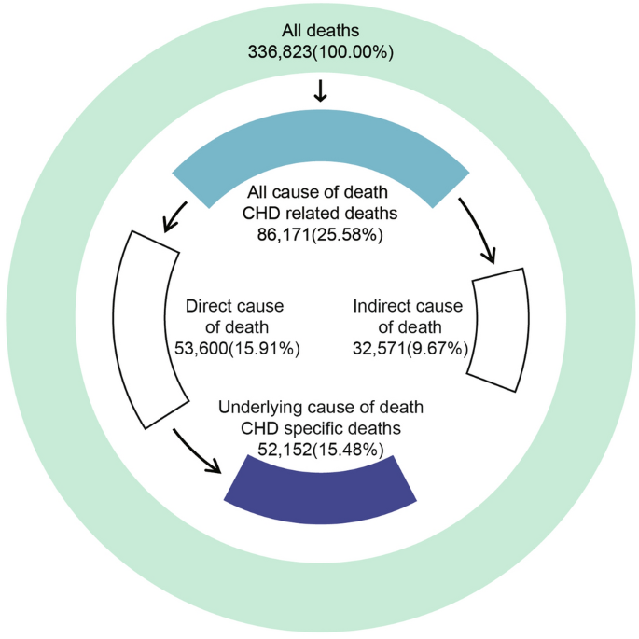
Figure 1: CHD related mortality
(Source: Xu et al., 2023)
- The present report provides an evidence-based overview of CHD, including its definition, risk factors, multi-dimensional impacts on families and individuals, and its prevalence. This report further evaluates theoretical models supporting long-term condition management; it also evaluates NHS treatment approaches, relevant UK health policies, and recommendations aimed at enhancing and improving person-centred as well as community-based care outcomes.

Explanation and Evaluation of the Condition
Definition
- CHD (coronary heart diseases) is referred to as coronary artery disease, which is a chronic cardiovascular condition caused by atherosclerosis, whereby fatty deposits known as plaques accumulate within coronary arteries (Dibben et.al 2023).
- Such a process highly restricts oxygen supply and blood flow to the myocardium, which can result in angina, causing sudden cardiac death or myocardial infarction. CHD progresses over numerous years and is highly associated with metabolic risk factors and modifiable lifestyle.
Prevalence and Burden
- Global perspective: Cardiovascular disease is considered one of the leading causes of death worldwide, and it accounted for more than 17.9 million deaths annually, with CHD being responsible for the largest proportion (WHO, 2025).
- In addition to that, ageing populations, rapid urbanisation, sedentary lifestyles, and poor dietary habits contribute significantly to increasing global prevalence. Low and middle-income countries of the world experience disproportionate mortality rates and the reason behind this is limited access to treatment services and prevention (Landeiro et.al 2024).
- Moreover, the economic burden includes productivity loss, long-term disability, and healthcare expenditure. So, it can be said that CHD cannot be recognised not only as a medical condition but can also be referred to as a global public health as well as socio-economic challenge.
- United Kingdom Context: Within the UK, CHD has affected more than 2.3 million people and remains one of the major causes of premature death despite improvements in treatment outcomes (BHF Press Office, 2024).
- Thus, CHD places substantial pressure on NHS services through surgical interventions, hospital admissions, long-term medication use, and rehabilitation programmes. Health inequalities persist, with higher prevalence observed among individuals from certain ethnic backgrounds and can be observed among socio-economically deprived populations.
- However, mortality rates have decreased due to advancements in medicine, rising diabetes and obesity rates threaten future progress (Shih et.al 2025).
- The burden of CHD is unevenly distributed across the population. On the other hand, high prevalence rates are observed among older adults, individuals, and people living in socioeconomically deprived areas.
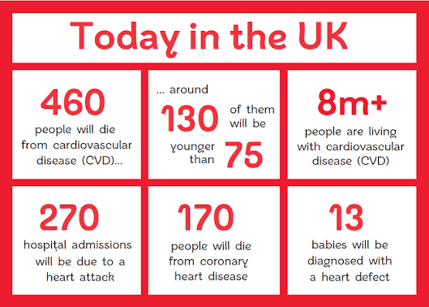
Figure 2: UK Cardiovascular Disease Factsheet, January 2026
(Source: British Heart Foundation, 2026)
Risk Factors / Aetiology: The development of CHD can result from the complex interaction between behavioural, social, and biological determinants. Some of the major modifiable risk factors may include hypertension, high cholesterol, smoking, unhealthy dietary patterns, and physical inactivity (Galimudi et.al 2023).
On the other hand, some of the major non-modifiable risks can include gender, age, and genetic predisposition. Socio-economic deprivation can highly influence disease risks through chronic stress, unhealthy living environments, and limited healthcare access.
Critically, it can be said that CHD reflects broader public health challenges, and this demonstrates that prevention requires a proper population-level intervention along with individual clinical management. Importantly, psychological stress, social deprivation, and occupational pressure have been increasingly recognised as contributors to cardiovascular risks through chronic stress responses as well as unhealthy coping behaviours.
Critically, while individual lifestyle choices are often emphasised in the prevention strategies, broader social determinants which include education level, income inequality, and environmental conditions and these factors play a critical role in shaping cardiovascular health (O’Neill et.al 2023). Effective CHD management and prevention, therefore, require integrated approaches that combine clinical treatment with population-level health interventions.

Impact of the Condition
Physical Impact
- CHD has long-lasting and profound effects on an individual’s functional capacity and physical health. CHD develops through a progressive narrowing of the coronary arteries, which results in a reduction of oxygen supply to the heart muscle. People commonly experience numerous symptoms such as shortness of breath, dizziness, chest pain, and reduced tolerance of physical activities (Blanchard et.al 2022). So, such symptoms can significantly limit daily functions as well as restrict engagement in routine activities, which can include mobility, self-care tasks, and employment.
- Numerous acute cardiac events, such as myocardial infarction, can cause irreversible damage to cardiac tissue, and this can lead to chronic complications that can include arrhythmias and heart failure. Various individuals can require a lifelong ongoing clinical monitoring and medication regimes to prevent progression of disease (Gonzalez-Jaramillo et.al 2022). Following a cardiac event, patients frequently experience decreased physical endurance as well as dependence on rehabilitation services to regain functional independence. In addition to that, CHD generally coexists with other long-term conditions such as diabetes, hypertension, and obesity, and this creates a complex multimorbidity that complicates the treatment management. Polypharmacy can increase the risk of medication side effects as well as adherence difficulties, which can further affect health outcomes. Recurrent hospital admissions and surgical interventions such as bypass surgery or angioplasty can also contribute to physical fertility, especially among older adults.
Psychological Impact
- The psychological consequences of CHD are substantially as well as frequently underestimated within clinical management. Surviving a cardiac event or receiving a diagnosis of heart disease often triggers anxiety, emotional distress, and fear related to disease recurrence and mortality. Various individuals develop heightened health anxiety due to future cardiac risk and due to uncertainty surrounding physical symptoms (Lear et.al 2025). Depression can commonly be reported among individuals living with CHD, especially following surgical intervention and myocardial infarction. Lifestyle restrictions and reduced physical ability can lead to loss of independence, feelings of helplessness, and diminished physical identity. In addition to that, psychological distress can negatively influence recovery by reducing motivation to engage in cardiac rehabilitation programmes or maintain established lifestyle changes.
- Moreover, numerous studies suggest a bidirectional relationship between cardiovascular health and psychological well-being. Chronic stress activates psychological responses including inflammation and elevated blood pressure can worsen cardiac outcomes (Javed et.al 2022). Despite growing recognition of mental health needs, counselling services and psychological assessments are not constantly integrated into routine cardiac care pathways within community settings. This gap also effectively highlights the essence of adopting holistic approaches that address both physical and emotional dimensions of long-term condition management.
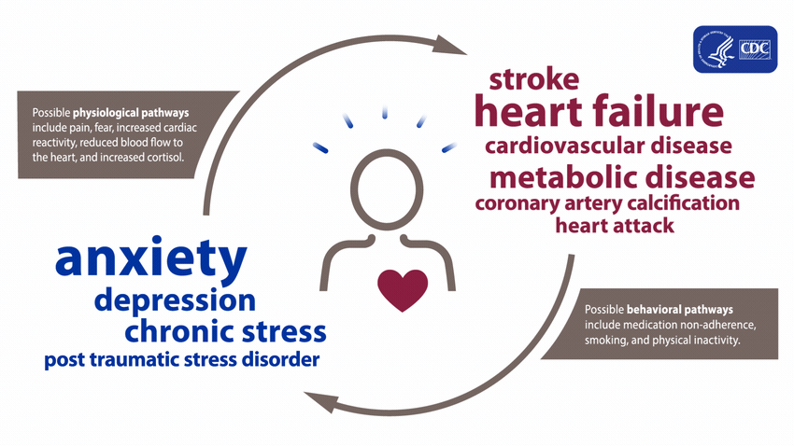
Figure 3: About Heart Disease and Mental Health.
(Source: Centres for Disease Control and Prevention , 2024)
Social Impact
- CHD can significantly affect broader socioeconomic well-being and social participation. Physical limitations that are associated with breathlessness and fatigue may restrict the ability of an individual to perform physically demanding roles and maintain employment. Reduced working hours and early retirement can also result in financial instability as well as reduced economic productivity. In addition to that, loss of employment can further contribute to social withdrawal and decreased self-esteem (Tran et.al 2022). To manage diseases, lifestyle adjustments, including smoking cessation, dietary restriction, and regulated physical activity, can alter cultural practices and social routines. Moreover, social gatherings can often involve alcohol or food consumption, and people with CHD can experience difficulty in maintaining participation without compromising health recommendations. So, such changes can result in reduced social interaction and feelings of exclusion.
- Health inequalities can also play a vital role in shaping social outcomes. People living in deprived communities can face limited access to health food options, rehabilitation programmes or safe exercise environments. Reduced health literacy and transportation barriers can further influence engagement with preventative services (Xu et.al 2023). Social isolation that follows a cardiac event has also been associated with poorer recovery outcomes as well as increased mortality risk, and focuses on the importance of community support networks within long-term management.
Family Impact
- CHD can impact beyond individuals, and it can highly affect family members as well as informal caregivers. Following hospitalization and diagnosis, family members generally assume caregiving responsibilities including emotional reassurance, lifestyle monitoring, medication management, and assistance with daily activities (Di Lenarda et.al 2024). However, proper family involvement can positively influence recovery as well as adherence to the treatment process; caregiving responsibilities can also create a practical and emotional strain.
- Relatives and partners generally experience anxiety considering a sudden deterioration in health or recurrent cardiac events. This constant vigilance can lead to sleep disturbance, reduced psychological well-being, and caregiver stress. This may also give rise to financial pressure where family members reduce employment commitments to offer care, as well as manage healthcare-related expenses (Tacy et.al 2022). Dynamics of the family can also change as the roles of family members shift, especially when the affected individual was socially or economically independent. Lifestyle and dietary changes required for CHD management can often impact the entire household, which needs collective behavioural adjustment. Essentially, family support can enhance rehabilitation adherence as well as long-term health outcomes, thus demonstrating the need for support intervention and family-inclusive education related to cardiac care services.

Evidence-Based Treatment in the UK (NHS)
Managing CHD in the UK can be guided by evidence-based clinical recommendations that has been developed by the NICE (National Institute of Health and Care Excellence) which is delivered mainly through NHS multidisciplinary services (Guleria et.al 2025). Treatment aims to prevent disease progression, relieve symptoms, reduce mortality, and enhance long-term quality of life through combined pharmacological, lifestyle, and interventional-based approaches.
a) Pharmacological Management
Pharmacological therapy represents the cornerstone of CHD management as well as secondary prevention. Antiplatelet medication such as aspirin is generally prescribed to prevent future cardiac events and reduce thrombus formation. In addition to that, statins are aggressively used to decrease low-density lipoprotein cholesterol levels and also stablise atherosclerotic plaques which can significantly reduce cardiovascular risks (Netala et.al 2024). Moreover, beta-blockers are also generally administered to reduce heart rate and myocardial oxygen demand, which can alleviate angina symptoms and can increase survival following myocardial infarction. ACE (Angiotensin-converting enzyme) inhibitors or angiotensin receptor blockers are prescribed to improve cardiac function and control blood pressure. However, in some patients, calcium and nitrates channel blockers are used to manage persistent angina (Narkhede et.al 2024). On the other hand, pharmacological treatments evaluate strong clinical effectiveness, and long-term adherence still poses a huge challenge. Complex medication regimes, side effects, and limited patient understanding can reduce compliance, which highlights the essence of patient education as well as ongoing monitoring in primary care settings.
b) Interventional Treatment
Intervention procedures are generally implemented when symptoms persist despite significant arterial obstruction being identified or optimal medical therapy. PCI Percutaneous Coronary Intervention, involving stent placement and balloon angioplasty, restores coronary blood flow and also reduces symptoms quickly. For some individuals with extensive coronary artery blockage, CABG (Coronary Artery Grafting) surgery can be recommended to enhance long-term survival outcomes (Narkhede et.al 2024). Thus, these procedures have significantly reduced the CHD mortality rate across the United Kingdom. On the other hand, interventional treatments can help in addressing structural abnormalities rather than underlying risk factors. If an individual fails to modify lifestyle and medical management, recurrence of the disease remains highly possible. Furthermore, post-procedural recovery may also require coordinated rehabilitation as well as long-term follow-up care.
c) Non-Pharmacological & Rehabilitation
Non-pharmacological interventions can play a critical role in the prevention of disease progression and supporting recovery. The cardiac rehabilitation programmes provided by NHS offers a structured multidisciplinary support which can include dietary education, supervised exercise training, psychological counselling, and smoking cessation assistance (Qian et.al 2024). It can be demonstrated from the evidence that participation in cardiac rehabilitation can decrease hospital readmissions and improve emotional and physical well-being. In addition to that, lifestyle modification remains central to CHD management.
d) Critical Evaluation of Service Delivery
Despite comprehensive NHS treatment pathways, variations in service accessibility continue to influence the outcomes of patients. Cardiac rehabilitation uptake remains inconsistent, especially among women, socially deprived populations, and older adults. In addition to that, limited awareness and geographical disparities also contribute to unequal participation rates (Abell et.al 2025). Furthermore, fragmentation between community follow-up care and hospital discharge services can disrupt the continuity of the management. Increasing demand for cardiovascular services and workforce pressure can present challenges to the delivery of personalised care. However, NHS strategies focused on integrated care, long-term behavioural support, and greater investment in community-based services can be required to achieve sustainable improvement in CHD outcomes.

Theoretical Models
Proper and effective management of CHD often requires an appropriate and structured framework that can promote person-centred, coordinated, and preventative healthcare delivery. The increasing prevalence of long-term cardiovascular conditions has shifted away the healthcare systems from acute episodic treatment towards integrated chronic disease management models (Burström et.al 2025). It has been stated by Nguyen et.al (2022) that one of the major and important UK framework supporting CHD management is the House of Care Model. This model has been developed within the NHS long-term condition strategies. This model effectively places the individuals at the centre of care through collaborative partnerships between proactive healthcare professionals and informed patients. This framework focuses on personalised care planning, self-management support, and shared decision-making, which is supported by community resources and organisational commissioning. Within the CHD management, the House of Care Model allows patients to actively participate in the risk reduction through medication adherence, rehabilitation engagement, and lifestyle modification (Sridharan et.al 2025). This model also effectively recognises the success of cardiovascular management depending not only on clinical intervention but also on social and behavioural support systems.
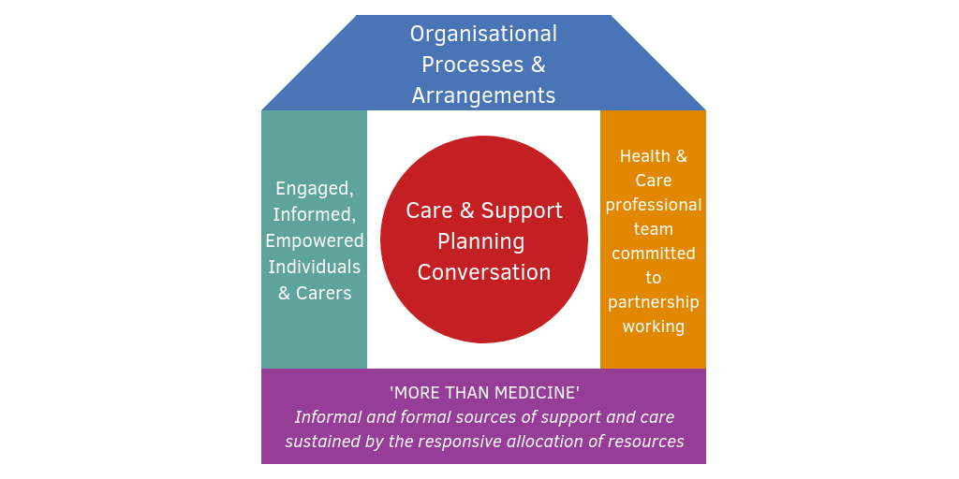
Figure 4: The House of Care Model.
(Source: Health and Social Care Alliance Scotland, 2026)
On the other hand, it has been stated by Abada and Altalafha, (2023) that Wagner's Chronic Care Model (CCM) offers a widely adopted framework for enhancing outcomes in chronic illness management. This model also highlights the six essential components, such as delivery system design, healthcare organisation, decision support, clinical information, community resource, and self-management. In CHD care, the CCM effectively promotes proactive monitoring, evidence-based clinical decision-making, and multidisciplinary teamwork (Goh et.al 2022). Structured follow-up, as well as coordinated communication between secondary and primary care services, can enhance the community of care as well as reduce avoidable hospital admissions.
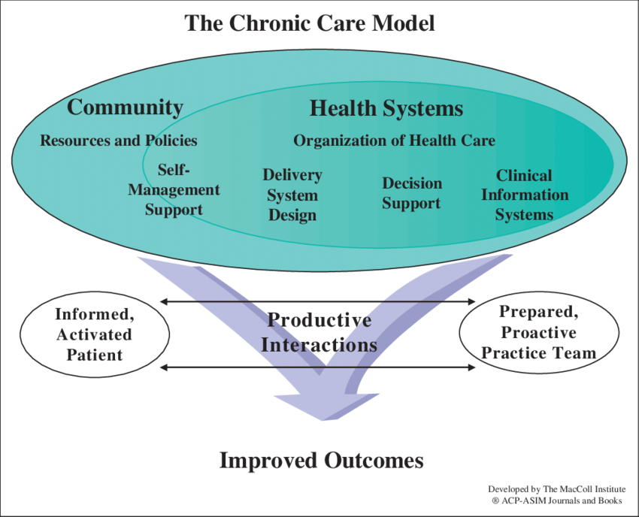
Figure 5: Chronic care model
(Source: Findley, 2014)
Both models share a patient-empowerment and preventive focus; however, the implementation of challenges still remains. Time constraints in primary care consultations, workforce limitations, and variations in allocation of resources may restrict effective personalised care planning (Grudniewicz et.al 2023). Moreover, patient engagement levels may differ depending on socioeconomic circumstances and health literacy. Both these frameworks offer strong theoretical guidance, and their effectiveness also depends on the integration across health and social care systems and organisational commitments. However, if these models are implemented successfully, they can improve rehabilitation adherence, supporting long-term behavioural changes, and enhance self-management capacities to reduce the progression of CHD.

Political and Policy Context
The prevention and management of CHD within the UK are strongly influenced by national social and health care policies which are designed to reduce cardiovascular mortality and enhance long-term population health outcomes (Lear et.al 2025). Government strategies highly focus on prevention, integrated care delivery, and early prevention to address the growing burden of chronic cardiovascular conditions. The NHS Long Term Plan has evaluated cardiovascular disease as a clinical priority area with an aim to prevent thousands of strokes and heart attacks through enhanced management and detection of risk factors such as high cholesterol, smoking, obesity, hypertension, and more. Primary care services of the UK play a vital role through NHS health checks, which assess cardiovascular risk among adults and support pharmacological interventions and early lifestyle (Pronk et.al 2026). Thus, these preventive initiatives reflect a shift from reactive hospital-based treatment towards proactive community care.
NICE (National Institute for Health and Care Excellence) guidelines offer evidence-based standards for CHD diagnosis, rehabilitation and treatment. Such guidelines helps in ensuring consistency in interventional procedures, pharmacological prescribing, and cardiac rehabilitation services across NHS organisations (Javed et.al 2022). In addition to that, Integrated Care Systems help in promoting collaboration between local authorities, healthcare providers, and social care services, thus helping in supporting coordinated management of long-term conditions across care settings. In addition to that, public health policies that address behavioural risk factors can further contribute to the prevention of CHD. National smoking cessation programmes, physical activity campaigns, and obesity reduction strategies aim to tackle modifiable determinants of cardiovascular disease at a population level (Sistrunk et.al 2022). However, despite proper and comprehensive policy frameworks, implementation challenges are still a major problem. Workforce shortages, increasing healthcare demand, and funding disparities can limit equitable service delivery. Moreover, socioeconomic inequalities continue to influence CHD outcomes and prevalence, especially within deprived communities. Implementation of such policies requires a sustained investment in community-based prevention programmes as well as cross-sector collaboration that can address wider social determinants of health beyond clinical healthcare provision alone.

Recommendations for Improvement
- It is recommended to expand access to community-based cardiac rehabilitation programmes to ensure equitable access across rural as well as socioeconomically deprived populations within the UK. This can be done by increasing the flexible delivery methods and this can include home-based and digital rehabilitation services and this can also help in improving long-term adherence and engagement (Hong et.al 2023).
- It is also recommended that psychological support needs to be constantly integrated into CHD pathways. Early screening for depression and anxiety following cardiac events can improve recovery outcomes, including treatment compliance. Moreover, multidisciplinary collaboration between nurses, psychologists, cardiologists, and social care professionals can prove essential for holistic care delivery.
- It can also be recommended that structured self-management education should be strengthened to empower people to manage their lifestyle risk factors. Here, culturally sensitive health promotion initiatives that target high-risk communities can improve prevention outcomes and behavioural change (Stone et.al 2023).
- Improved coordination between primary care follow-up and hospital discharge services is also necessary to ensure continuity of care and reduce hospital readmissions. Finally, higher investments in public health prevention strategies addressing obesity, smoking, and physical inactivity can support sustainable reduction in the prevalence of CHD and long-term healthcare burden.

Conclusion
It can be concluded that CHD still remains one of the major long-term health conditions with significant psychological, physical, and social consequences that affect families, individuals, and healthcare systems within the UK. Although advances in surgical intervention, pharmacological treatments, and cardiac rehabilitation have significantly improved survival rates. It can also be concluded that effective management needs person-centred and holistic approaches that integrate medical treatment with psychological, social, and behavioural support. Moreover, the application of national health policies and theoretical care models demonstrates progress towards coordinated chronic disease management; however, inequalities in service delivery and access remain a major challenge. However, improving rehabilitation accessibility, promoting self-management, and strengthening community-based prevention can prove essential for reducing disease burden. Furthermore, healthcare strategies must prioritise integrated multidisciplinary care and address wider social determinants of health to achieve sustainable improvements in cardiovascular outcomes.



References
Abada, A., and Altalafha, S. I. (2023). Chronic disease management in primary care setting. Sch Acad J Biosci, 2, 63-8.
Abell, B., Donovan, T., Eagleson, K. J., Justo, R., Auld, B., Riley, S., and McPhail, S. M. (2025). Family and health professional perspectives of the CHD LIFE cardiac developmental long-term care pathway: a qualitative evaluation. Pediatric Research, 1-13.
BHF Press Office., (2024). Early heart disease deaths rise to 14-year high. [Online]. Available through: <https://www.bhf.org.uk/what-we-do/news-from-the-bhf/news-archive/2024/january/early-heart-disease-deaths-rise-to-14-year-high#:~:text=The%20number%20of%20people%20dying,trend%20for%20almost%2060%20years.>. [Accessed on: 1st March 2026].
Blanchard, J., McCrindle, B. W., and Longmuir, P. E. (2022). The impact of physical activity restrictions on health-related fitness in children with congenital heart disease. International Journal of Environmental Research and Public Health, 19(8), 4426.
British Heart Foundation (2026) UK Cardiovascular Disease Factsheet, January 2026. London: BHF Health Analytics Team. Available at: https://www.bhf.org.uk/-/media/files/for-professionals/research/heart-statistics/bhf-cvd-statistics-uk-factsheet-jan26.pdf (Accessed: 8 July 2026).
Burström, Å., Saarijärvi, M., Skogby, S., Brorsson, A. L., Bratt, E. L., and Sparud-Lundin, C. (2025). Evaluation of person-centred care within the Stepstones transition program for adolescents with congenital heart disease–a document analysis. International Journal of Nursing Studies Advances, 8, 100308.
Centers for Disease Control and Prevention (2024) About Heart Disease and Mental Health. Atlanta, GA: CDC. Available at: https://www.cdc.gov/heart-disease/about/about-heart-disease-and-mental-health.html (Accessed: 8 July 2026).
Conrad, N., Molenberghs, G., Verbeke, G., Zaccardi, F., Lawson, C., Friday, J. M., ... and McMurray, J. J. (2024). Trends in cardiovascular disease incidence among 22 million people in the UK over 20 years: population based study. bmj, 385.
Di Lenarda, F., Balestrucci, A., Terzi, R., Lopes, P., Ciliberti, G., Marchetti, D., ... and Conte, E. (2024). Coronary artery disease, family history, and screening perspectives: an up-to-date review. Journal of clinical medicine, 13(19), 5833.
Dibben, G. O., Faulkner, J., Oldridge, N., Rees, K., Thompson, D. R., Zwisler, A. D., and Taylor, R. S. (2023). Exercise-based cardiac rehabilitation for coronary heart disease: a meta-analysis. European heart journal, 44(6), 452-469.
Evidence-Based Treatment in the UK (NHS)
Findley, P. A. (2014). Social work practice in the chronic care model: Chronic illness and disability care. Journal of Social Work, 14(1), 83-95.
Galimudi, R. K., Mudigonda, S., Gantala, S. R., and Hanumanth, S. R. (2023). Impact of Epidemiological and Clinical Risk factors in the Patho-genesis of Coronary Heart Disease.
Goh, L. H., Siah, C. J. R., Tam, W. W. S., Tai, E. S., and Young, D. Y. L. (2022). Effectiveness of the chronic care model for adults with type 2 diabetes in primary care: a systematic review and meta-analysis. Systematic Reviews, 11(1), 273.
Gonzalez-Jaramillo, N., Wilhelm, M., Arango-Rivas, A. M., Gonzalez-Jaramillo, V., Mesa-Vieira, C., Minder, B., ... and Bano, A. (2022). Systematic review of physical activity trajectories and mortality in patients with coronary artery disease. Journal of the American College of Cardiology, 79(17), 1690-1700.
Grudniewicz, A., Gray, C. S., Boeckxstaens, P., De Maeseneer, J., and Mold, J. (2023). Operationalizing the chronic care model with goal-oriented care. The Patient-Patient-Centered Outcomes Research, 16(6), 569-578.
Guleria, R., Singh, A., Majmudar, H. P., Ang, Z. Y., and Awasthi, P. (2025). Evidence-Based Management of Heart Failure: Clinical Impact and National Health Service Implications. Cureus, 17(9), e92735.
Health and Social Care Alliance Scotland (2026) The House of Care Model. Glasgow: The ALLIANCE. Available at: https://www.alliance-scotland.org.uk/past-work-and-projects/scotlands-house-of-care/the-house-of-care-model/ (Accessed: 8 July 2026).
Hong, S. J., Lee, Y. J., Lee, S. J., Hong, B. K., Kang, W. C., Lee, J. Y., ... and Hong, M. K. (2023). Treat-to-target or high-intensity statin in patients with coronary artery disease: a randomized clinical trial. Jama, 329(13), 1078-1087.
Javed, Z., Haisum Maqsood, M., Yahya, T., Amin, Z., Acquah, I., Valero-Elizondo, J., ... and Nasir, K. (2022). Race, racism, and cardiovascular health: applying a social determinants of health framework to racial/ethnic disparities in cardiovascular disease. Circulation: Cardiovascular Quality and Outcomes, 15(1), e007917.
Landeiro, F., Harris, C., Groves, D., O’Neill, S., Jandu, K. S., Tacconi, E. M., ... and Luengo-Fernández, R. (2024). The economic burden of cancer, coronary heart disease, dementia, and stroke in England in 2018, with projection to 2050: an evaluation of two cohort studies. The Lancet Healthy Longevity, 5(8), e514-e523.
Lear, S. A., McKee, M., Hystad, P., Walker, B. B., Murphy, A., Brauer, M., ... and Yusuf, S. (2025). Social factors, health policy, and environment: implications for cardiovascular disease across the globe. European heart journal, 46(30), 2959-2973.
Narkhede, M., Pardeshi, A., Bhagat, R., and Dharme, G. (2024). Review on emerging therapeutic strategies for managing cardiovascular disease. Current Cardiology Reviews, 20(4), 86-100.
Netala, V. R., Teertam, S. K., Li, H., and Zhang, Z. (2024). A comprehensive review of cardiovascular disease management: cardiac biomarkers, imaging modalities, pharmacotherapy, surgical interventions, and herbal remedies. Cells, 13(17), 1471.
Nguyen, L. T., Nantharath, P., and Kang, E. (2022). The sustainable care model for an ageing population in vietnam: evidence from a systematic review. Sustainability, 14(5), 2518.
O’Neill, D. G., Blenkarn, A., Brodbelt, D. C., Church, D. B., and Freeman, A. (2023). Periodontal disease in cats under primary veterinary care in the UK: frequency and risk factors. Journal of Feline Medicine and Surgery, 25(3), 1098612X231158154.
Pronk, N., Arena, R., Zimmerman, F. J., and Woodard, C. (2026). Driving physical activity policy for improved population health demands political action. British Journal of Sports Medicine, 60(4), 300-301.
Qian, Y., Tan, J. Y., Wang, T., Bressington, D., Zhou, H. J., Li, M. Y., and Liu, X. L. (2024). Quality appraisal and descriptive analysis of clinical practice guidelines for self-managed non-pharmacological interventions of cardiovascular diseases: a systematic review. Journal of Translational Medicine, 22(1), 215.
Shih, K., Herz, N., Sheikh, A., O'neill, C., Carter, P., and Anderson, M. (2025). Economic burden of cardiovascular disease in the United Kingdom. European Heart Journal-Quality of Care and Clinical Outcomes, 11(5), 678-690.
Sistrunk, C., Tolbert, N., Sanchez-Pino, M. D., Erhunmwunsee, L., Wright, N., Jones, V., ... and Seewaldt, V. L. (2022). Impact of federal, state, and local housing policies on disparities in cardiovascular disease in Black/African American men and women: from policy to pathways to biology. Frontiers in cardiovascular medicine, 9, 756734.
Sridharan, S., Whynot, J., Antflick, J., Shah, N., Macdougall, I., and Nakaima, A. (2025). Building a House of Care: Movements Toward an Integration of Neuroscience and Community Solutions. In A New Blueprint for Brain Health: How Community-Led Evaluations will Construct a Healthier Future (pp. 213-233). Cham: Springer Nature Switzerland.
Stone, P. H., Libby, P., and Boden, W. E. (2023). Fundamental pathobiology of coronary atherosclerosis and clinical implications for chronic ischemic heart disease management—the plaque hypothesis: a narrative review. JAMA cardiology, 8(2), 192-201.
Tacy, T. A., Kasparian, N. A., Karnik, R., Geiger, M., and Sood, E. (2022, June). Opportunities to enhance parental well-being during prenatal counseling for congenital heart disease. In Seminars in Perinatology (Vol. 46, No. 4, p. 151587). WB Saunders.
Tran, R., Forman, R., Mossialos, E., Nasir, K., and Kulkarni, A. (2022). Social determinants of disparities in mortality outcomes in congenital heart disease: a systematic review and meta-analysis. Frontiers in Cardiovascular Medicine, 9, 829902.
Wang, J., Yuan, S., Qi, J., Zhang, Q., and Ji, Z. (2022). Advantages and prospects of optical coherence tomography in interventional therapy of coronary heart disease. Experimental and Therapeutic Medicine, 23(4), 255.
WHO., (2025). Cardiovascular diseases (CVDs). [Online]. Available through: <https://www.who.int/news-room/fact-sheets/detail/cardiovascular-diseases-(cvds)>. [Accessed on: 28 February 2026].
Xu, W., Fang, L., Bai, H., Ke, K., Li, W., Huang, H., ... and Chen, C. (2023). The influence of psychological factors on coronary heart disease: A review of the evidence and implications for psychological interventions. Medicine, 102(27), e34248.
Xu, Y., Wang, Q., Zou, J., Chen, Y., Zhou, J., Dai, W., ... & Jiang, S. (2023). CHD-related/specific mortality of 3.17 million people in a transitioning region: trends, risk factors, and prevention. Aging Clinical and Experimental Research, 35(12), 3147-3156.

