Programme: Certificate of Higher Education in Business Skills for the Workplace
Module: Academic Skills
Module code: LCLM 4001_Lon
Assignment Title: Task 3 - Reflective report
Student Name: Ewa Szczesna
Student ID:2335560
Table of Contents
Introduction 1
How academic skills aided me in progressing the learning of the precise module 1
Conclusion 4
Reference List 5

Introduction
I have remained engaged in the Academic Skills module to accomplish and learn about academic skills. While participating in the “Academic Skills” module, I have gone through various methods to ensure the learning that can help me to get a comprehensive way to make my module better and make it easier to understand (Centeno and Villar, 2019). The module helped me gain some academic skills that helped me to acknowledge my academic skills such as academic writing skills, note-taking skills, research skills, paraphrasing skills and many more. The reflective report will further evaluate how the learning module helps me to accomplish my knowledge in academic skills.

How academic skills aided me in progressing the learning of the precise module
Many models define how to write the reflective model for someone but the Gibbs reflective model is the formulating one that can help people learn the way they can express their words and regulate a framework of examining experience. Graham Gibbs formed the structure of the reflective cycle in 1988 (Gibbs and Andrew, 2017). This reflective cycle helped many to write about their feelings and how things went for the further module facilitated them to identify the areas where they need improvements, the areas where they are doing great, and in some part how one can do better in future for the personal and professional development (Gilbert, 2017). I am writing about my personal opinion here to recognise how I can do on my module and what I could do better.
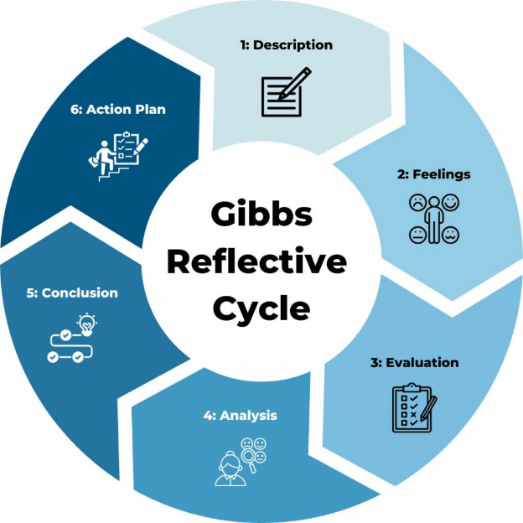
Figure 1: Gibbs Reflective Cycle.
Source: (Gibbs and Andrew, 2017).
Description
In the module, I was introduced to many opportunities that have given the part of me to do the work alone or with my peers or professors (Hancock, 2019). In this module, I have expanded my comprehensive knowledge of doing work better in my academic sessions and creating a collaborative environment for others which helped me in various ways to learn about academic skills successfully. Numerous academic skills such as academic writing skills, note-taking skills, research skills and many more skills are developed throughout the module (Hopkins and Reid, 2022). My peers and the professors helped me a lot with the presentation which encouraged me to do better in this module. Also, those academic skills are vital for me to adapt for further enhancements in my professional and personal areas (Palardy, 2019). Throughout this module, I have gained some valuable lessons that aided me in where to implement the employment of my future modules.
Feelings
In terms of my learning experience during this module, I was very excited about the outcome that helped me to comprehend knowledge of my whole study. This module has related to all the emotions of my recent study that helped me to get the topic done with doing the all assessments (Sutherland, Badger and White, 2022). Also, gathering the information was tough for me. Sometimes it takes my mental health at its peak to get things done in my way. I felt angry when I could not find the precise information, I was looking for many times (Swales and Feak, 2019). Conversely, I felt content when I got help from my peers and instructors. Sometimes, I break down because of the outcomes that I am expecting not to have. Participating in this module was an emotional roller coaster ride for me to endure. At last, with a lot of joy and cheer on my face, I finished my paper (Centeno and Villar, 2019). The moment I was finished with the paper was the best moment of my life and I cannot describe it in any words.
Evaluation
While engaging in this module, I was relatively making the progression in my academic writing. In academic writing, I have tried to make the whole paper into a formal tone (Gilbert, 2017). For example, the presentation task looks so representative when I write it in this tone. Then about taking notes, I have taken details of the small and valuable information. Collecting information from my peers and professors makes me take notes and insert them through the presentation where needed (Hancock, 2019). My classmates along with my professors helped me a lot to find the accurate information for my presentation. The information that goes well with my presentation I have input in the speaker notes. On the other hand, researching gives me a comprehensive knowledge of my academic assignments and more work as well as progressing my research skills (Hopkins and Reid, 2022). In managing time, I have some lacking that gets me through many difficulties. When I was trying to concentrate on the academic writing of my one paragraph, I lost time for the other essential parts where I needed to focus. Also, with my research skills, I did not try to find the information with more sincerity (Palardy, 2019). Albeit I needed accurate information on some detailed parts which I missed in the one-to-one sessions.
Analysis
In engaging with this module all of the academic skills were thoroughly interconnected. The formal tone of the writing occurred because of my note-taking capability and research ability (Sutherland, Badger and White, 2022). These skills worked best for me to make the academic tasks with a decent and formal tone with eye-catching design. However, I integrate my knowledge into my whole task. Furthermore, managing time was a challenge for me and I need perfection in my work. So, I lacked the management time and learned to give every detail a quick look (Swales and Feak, 2019). These challenges made me comprehend that sometimes I can compromise to do better in the effective management of time and with more efficiency in my work. This made me realise that I can easily write a quick draft with speaker notes and revise it later for further improvements (Centeno and Villar, 2019).
Conclusion
In sum, participating in this module made me a great researcher along with a great writer. I have learned some valuable lessons that made me think of my future endeavours where I can do better (Gilbert, 2017). Although my academic writing skills and note-taking skills give me a whole lot of prospects to comprehend my knowledge within a module that I was working on (Swales and Feak, 2019). If I get the chance to do projects or presentations like this in future, I would value the management of my time to make it all happen in a time with more responsibility (Hancock, 2019). Also, I would use my research skills to make the academic tasks in detail to conduct my knowledge. I would adopt a detailed note that I am taking all the relevant information related to the work.
Action Plan
Going forward, I intend to take my academic writing skills to another level by taking on more tasks in future (Hopkins and Reid, 2022). I will ask for feedback from my peers and professors to make my academic writing skills better for the future. I also take part in workshops or other activities to practice taking notes with small details that add valuable lessons to my future projects (Palardy, 2019). I was struggling with managing the time further. I will ensure that I am scheduling the balanced time for each task to make the project look more real, informative, better and comprehend (Sutherland, Badger and White, 2022).

Conclusion
In conclusion, the reflective report is important to observe professional and personal advancement. The report helped me to concur with the areas where I did and the areas where I need improvement. Furthermore, this report helped me gain extensive knowledge that I can progress for my future projects or tasks. Also, a reflective report ensures that the person knows the precise areas of themselves and writes a detailed and all-inclusive reflective report.

Reference List
Centeno, A. and Villar, M. (2019). Research. Academic Skills, 77(5), pp.462–463.
Gibbs, G. and Andrew, C. (2017). Learning by Doing. 2.
Gilbert, C. (2017). Rethinking technical services: new frameworks, new skill sets, new tools, new roles. Australian Academic & Research Libraries, 47(3), pp.176–176.
Hancock, J. (2019). The study book: essential skills for Academic Success. London: John Murray Learning.
Hopkins, D. and Reid, T. (2022). The Academic Skills Handbook. SAGE Publications Limited.
Palardy, G.J. (2019). School Peer Non-academic Skills and Academic Performance in High School. Frontiers in Education, 4(6).
Sutherland, P., Badger, R. and White, G. (2022). How New Students Take Notes at Lectures. Journal of Further and Higher Education, 26(4), pp.377–388.
Swales, J.M. and Feak, C.B. (2019). Academic Writing for Graduate Students: Essential Tasks and Skills. College Composition and Communication, 47(3), p.443.

