
Skills for the Workplace
Module Assignment Submission
Student Name: | Sione Mitchell
Student Number: | 1911100
Module No: | BMSK4003
Module Title: | Digital Skills and Research Methods

Statement of Confirmation of Authenticity
By the act of making this submission, the student declares that this is the work of the student named above. The work has not, in whole or in part, been knowingly presented elsewhere for assessment, or where assessment has been built on a previous assessment, this has been identified. Where materials have been used from other sources it has been properly acknowledged. If this statement is untrue, the student acknowledges that an assessment offence has been committed.
Attention is drawn to the plagiarism and unfair practice policies of both the University and of ILM.
Permission for ILM to use this script
ILM uses learners’ submissions – on an anonymous basis – for assessment standardisation. By submitting, both the centre and the learner agree that ILM may use this script on condition that identifying information is removed. However, if you are unwilling to allow ILM use this script, please refuse by ticking the box: □

Table of Contents
What has been the impact of 21st Century Technologies on the modern workplace? 3
Part 1 3
An Overview of the 21st Century Workplace 3
An in-depth look at technologies used in own workplace 3
Part 2 4
An exploration of the use of social media in the workplace generally 4
An in-depth look at the use of social media in own workplace 4
The use of social media to enhance networking and career prospects 4
LinkedIn Profile 4
Conclusion 5
References 6
Appendix 1 7
Appendix 2 8

What has been the impact of 21st Century Technologies on the modern workplace?

Part 1

An Overview of the 21st Century Workplace

There are 3 areas that are highly used within the workplace, these are Wi-Fi, mobile devices and cloud storage. The use of these 3 technologies separately or altogether make the use of most modern technologies possible.
Cloud-based programs can be used at any time on almost any device with an Internet connection. There are many different ‘Cloud’ services, to name a few are Google drive, pCloud, Dropbox, Mega and Tresorit. But the list goes on. They all have individual benefits, for example some services are free so that appeals to a lot of smaller businesses. Others are paid services but offer more storage space. Some have better security features so are more desirable to businesses handling more sensitive information. There are many different variations so people or businesses can find one that suits their individual needs. See example in Appendix 1.
Mobile devices are making communication with colleagues, patients, clients etc much easier. People can do this through Skype (Allowing web conferencing) and larger organizations can subscribe to skype for businesses, included in Office 365 for Business Premium packages. There are other platforms like this also. Businesses can communicate through apps such as WhatsApp and Messenger. There are now apps specifically designed for the workplace, workforce applications allow employees, especially remote and mobile workers, to access their organisation’s/businesses systems, such as scheduling, shift management and attendance. Workforce apps are becoming more popular and are growing in demand, as millennials enter the workforce and expect to have access to technology for their work lives, just as they do for their personal lives.
Internet has come a long way. Here are examples of how far internet has come along. Dial-up Internet connects users to the Internet through a telephone line, Dial-up Internet is available almost everywhere and even people living in more remote areas can typically get dial-up. But users cannot talk on the phone and be online at the same time. Dial-up does not deliver high-speed Internet. It can take several minutes just to load a single webpage. Then there is Digital subscriber line (DSL) internet. Unlike the dial up internet even though you are connecting to a phone line you still have the ability to use the telephone at the same time, so that is progress. But unfortunately, the speed isn’t always consistent but is an improvement on the speed of dial-up. Then there is Satellite Internet, this involves using a satellite thousands of miles above the Earth to connect to the Internet. Like the dial up this is beneficial and can reach people living in rural areas. Although satellite Internet can provide high-speed Internet, the speeds are not extremely fast. It might be ok to use for standard browsing but impossible to do tasks that require high speeds, like video calling or gaming. Then we have Fibre-optic internet this entails cables transmitting data through laser-generated pulses of light. The signal is understood by your computer because it is converted by an Optical Network Terminal. The average speed is 6.7 Mbps. Speed that fast allow you to use multiple devices at home without your download or upload time being compromised. Fibre-optic locations are limited and determined by your provider, so you might not be able to get fibre-optic Internet in your area.
Wi-Fi then is a wireless connection to high speed internet, that could be at home, at work or on the move. You can connect to Wi-Fi through computers, laptops, tablet devices or mobile phones. This does not need a physical wire connection. It does this by using radio signals to transmit information to and from an internet source. You can use this on any device that has the appropriate technology. Devises that don’t come equipped with this technology you can usually get an additional device or card to get the connection as long as it has a USB port. This device is called a ‘Dongle’.
Today most devices require an internet connection to work at optimum capacity. Businesses now use wireless printers, card machines booking systems. People like to have the ability to look up a business via social media or have correspondence through email or message.
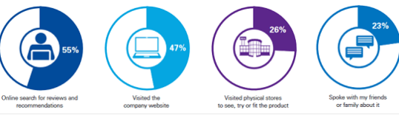
44.1% of people use laptops and desktops, 51.6% use mobile phones, and 4.2% use tablets so businesses now have to make their presence known in the world and get their brand out there.

An in-depth look at technologies used in own workplace
In my workplace we use a vary wide variety of technologies. Staring with our booking system it is a dental specific system called exact software of excellence, it is a dental specific system that allows us to book appointments, process payments, send patients reminders and has many other features whilst being highly secure. It is run through internet and inaccessible not being connected to our specific server. We then go on to take radiographs that are digital, this is highly convenient for practitioner and patient due to time effective nature. Clinipads (Android tablets) are used to gain patients consent and update medical history, it is much more secure for data protection and greener as reducing the use of paper where possible. Patients have treatment plans and pre-op and post-op pictures sent to them at their request also. We have a website that enables patients to book appointments with ease and can look at reviews, the team and what services we provide. A further benefit of new technologies within my workplace is the use of digital radiographs. The use of this system is beneficial to the patient and clinician. Using this the level of electromagnetic waves is reduced therefor even less risk to health taking these vital radiographs. For the clinician the benefit is time efficiency, the ability to edit the resolution and colour tones along with many other beneficial features. The disadvantage on the other hand is that if there is ever a problem with the system and the images aren’t saved, they will be lost, making the electromagnetic radiation a waste. Another new technology is digitally scanning teeth, this enables us to take detailed scans of the teeth and from the images we gather and send digitally to the laboratory to get retainers, crowns, inlays, dentures and many more items constructed without having to take messy impressions that also have a risk of distorting in transit to the laboratory. But again, if the system fails then we would have to get the patient to return and retake the scan or take impressions.
I collected raw data on how people in my workplace feel the impact of 21st Century Technologies on the workplace has affected them. 8 statements were made, and 10 colleagues ticked the statements that felt applied to them (see Appendix 2). I then made an informative chart giving us knowledge on how people feel they have been affected by technology in this workplace. The original questionnaire is in Appendix A (No personal details have been asked in accordance with equal rights and GDPR).

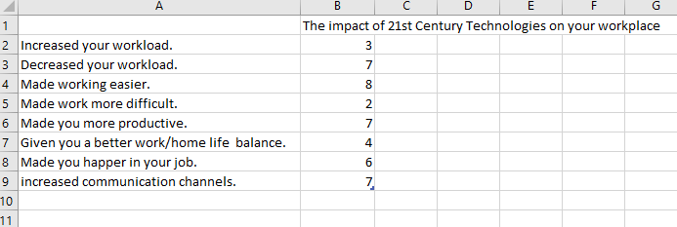

A further benefit of new technologies within my workplace is the use of digital radiographs. The use of this system is beneficial to the patient and clinician. Using this the level of electromagnetic waves is reduced therefor even less risk to health taking these vital radiographs. For the clinician the benefit is time efficiency, the ability to edit the resolution and colour tones along with many other beneficial features. The disadvantage on the other hand is that if there is ever a problem with the system and the images aren’t saved, they will be lost, making the electromagnetic radiation a waste. Another new technology is digitally scanning teeth, this enables us to take detailed scans of the teeth and from the images we gather and send digitally to the laboratory to get retainers, crowns, inlays, dentures and many more items constructed without having to take messy impressions that also have a risk of distorting in transit to the laboratory.

Part 2

An exploration of the use of social media in the workplace generally

In 2018 90% of businesses are using social media actively. Businesses use social media to Promote the name of your brand and business, also to inform customers about your goods and services. Find out what customers think of your business by getting people to write reviews and give feedback. People can also check on this feedback to have an insight to the quality of product or services provided.
Build stronger relationships with existing customers and to hopefully gain new customers. There are many advantages and disadvantages of broadcasting your business on social media. Some of the advantages can include there may be free advertisement or low costing advertisement. Through this it can reach millions of people around the world, having such a large reach. You can also target specific groups (i.e. ages, locations cookie history) through certain platforms, like Facebook, Twitter and Instagram. It also allows people to make enquiries or queries through certain platforms making communication easier in some instances. It is also a very easy way to get your brand or business out there and seen without having to be a ‘computer whiz’ or employing someone to do it for you. Particularly easier for smaller businesses trying to keep things cost effective.
On the downside of using social media is also the wrong image being portrayed if not being used correctly. Once that information has been put out onto the internet, there is no retrieving it. Sometimes the information or posts gone obtain the following businesses desire, so it ends up being a waste of time, and money if a site has been paid for. When advertising online businesses are subject to following certain laws and legislations, such as. Copyright Laws, General Data Protection Regulation 2018 and Online Marketing Legislation.

An in-depth look at the use of social media in own workplace
In my workplace social media allows us to advertise services provided, all posts are within copyright laws, in accordance with GDPR and online marketing legislation. Through social media we are able to reach a wide range of potential new patients and gain reviews to show the high level of services and care we provide. Specifically using Facebook, Google and Instagram to showcase treatment we have provided (See Appendix 3). Through Facebook we gain many new patients seeking cosmetic dentistry. Through this platform we are able to show pictures displaying before and after treatment (With written consent of the patient – Not disclosing any of their personal information). We can respond to messages and inquires through the messenger aspect of the site. They can also have a brief look at the services we provide and look at the reviews left by other patients. We also pay for a business service with Facebook, so we are a sponsored advertiser. The intention of this is to increase the page reach to a larger audience, who are beyond the existing orbit to gain more patients.
On google we ensure the practice comes up when dentist is searched for the ‘Cardiff’ area, along with our correct contact details, opening hours, address, website and other social media sites. Everything we put on Google is verified and studies show that businesses are twice as likely to be considered reputable by consumers if they are verified by google. Through google we can read and respond to reviews. Google is also useful because you can find information like how many people called your business directly from the phone number displayed on local search results in Search and Maps. So you know people are searching for your business and how useful it is to have an active google page.
Instagram is a networking and communication platform. It allows us to showcase our brand and make people aware with images of actual patients and work we have carried out (again all within the correct laws and legislations). Using Instagram can grossly increase brand recognition. Every comment that is made, every post that is shared and each like that we receive introduces our brand a new network of individuals. It can introduce our brand to boundless audiences and specifically targeted groups based on different demographics, interests of users, consumer behaviours and even where they are located.

The use of social media to enhance networking and career prospects
According to a survey carried out in 2016 52% of employers admitted using social media to screen candidates. It was also revealed that 59% of employers said they use search engines to research candidates. And out of these, 21% of employers that were surveyed were looking for reasons to dismiss the applicant, where 60% of these employers are looking for something like a professional portfolio that supports their qualifications.
Knowing these figures, you should take into account what details you publicise and the image you create of yourself. Firstly. you should have a professional email address as it’s usually one of the first things an employer will see. Be professional and truthful with the things you post about yourself. If you aren’t truthful with what you post it may contradict something that is on your curriculum vitae. Display good communication skills and be respectable.
Whilst it may sometime be easy to delete everything of your profile that you don’t feel is appropriate for the eyes of everyone you do have the ability to alter your settings and limit what certain people can see or only select a selection of people to see certain aspects of your profile.
LinkedIn is a professional social media site that you highlight your current position and past positions along with the qualifications you have obtained, what you feel your skills are and demonstrate your ethics and values. You can connect with colleagues, classmates and anyone else of interest that you can build a network with that could possibly further your career.
You can join groups that are in the same field of yourself, this is a quick way to find new connections. That could possibly lead to aiding your career or company. The app allows you to be indorsed, so if an employer is looking for someone with a certain skillset that could even seek you out. Current or previous employers can even leave a recommendation on your profile so if a potential employer looks you up its already there for them to see. Possibly giving you an advantage over a competitor.
By connecting to other users that are relevant in your line of work you can access job posts, discussions about your area of work or industry news. To keep you relevant within your field and up to date what happenings.

LinkedIn Profile
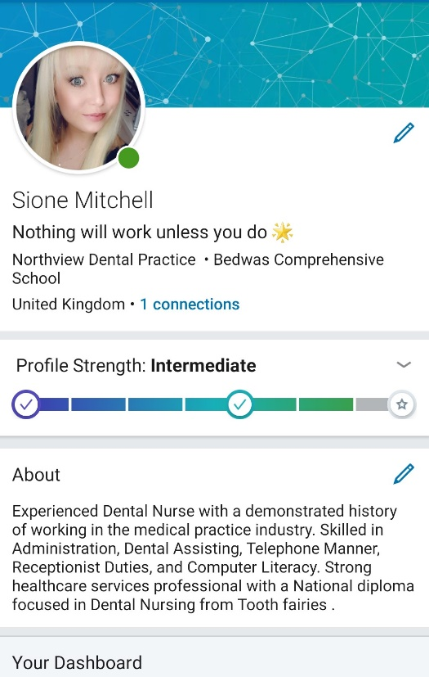

Here I have created my own LinkedIn profile. It is free to subscribe and easy to do so. You simply have to enter an email address and password and follow the step by step on screen instructions. Firstly, it asks for your country and post code. Then the details of your employer. You have to give a genuine email address because the site sends a conformation code to your email account. You can then piece by piece create your profile with all your qualifications and employment history. You can then start to connect to people, follow groups, follow hashtags and the job board.

Conclusion
Overall in my conclusion I feel there are many benefits from the evolution of technology in the modern workplace. This be from the ease of internet connection through Wi-fi to connect to the cloud through our remote devices.
The benefits of Wi-fi are that we are able to use devices any time, anywhere. Even though this is a great advantage, especially to remote workers. But this can also be a downfall to people’s social lives. Creating an unbalanced, homelife work life balance and not being able to switch off from work in some cases creating pressure and stress.
Cloud storage also has many advantages and makes sharing documents between businesses and people a lot more efficient. Also having the back up of this data in case any hard copies are misplaced. This does come with its risks also. Such as loosing data if there are any malfunctions with the system or even security errors if the service isn’t used properly.
Mobile devices are particularly beneficial to businesses, if working correctly and functioning to a high standard. Especially with businesses trying to be greener and going paper free. It saves the need of having to store hard copies of things for a long time, using the cloud in this instant also.
Technology that has been developed in the 21st century has changed the way we work and deliver services. Usually at a more time effective and cost-effective manner in the long run. According to the survey I carried out overall people were positive about the changes these technologies have made to the workplace. Making people happier and more productive in the workplace. With ease of communicating with colleagues or clients or patients. I think if people are trained in using these technologies correctly then more people would be more positive with the ever-evolving technology, we have access to now.
I believe social media if used correctly can have a massive effect on the success of a business. As long as your displaying the correct information and publicising your brand correctly and doing so lawfully following the correct legislations. Businesses must keep in mind what information is put out on the internet cannot be retrieved. It is also very beneficial to see what competitors are broadcasting and what they are doing to draw people in and gain new customers or patients. If there are any new services that are able to be given. Keep yourself informed.

References
American Express Open (2011) ‘6 ways cloud computing helps businesses save time and money, [online] accessed Mar 2018
Baker, J (2018) What is Wi-Fi? [online] available at https://3g.co.uk/guides/what-is-wi-fi-explained-in-simple-terms
Business Queensland (2018) Using social media to market your business: the basics, [online] available at https://www.business.qld.gov.au/running-business/marketing-sales/marketing-promotion/online-marketing/social-media accessed Mar 2018
Casserly, M. (2018) Here are the best cloud storage services to use, [online] available at https://www.techadvisor.co.uk/test-centre/internet/best-cloud-storage-services-3614269 accessed Mar 2018
Liberty, D (2015) What are workforce apps?, [online] available at https://www.clicksoftware.com/blog/what-are-workforce-apps/
Maund, et al. (2017) Certificate in Higher Education: Skills for the Workplace Student Yearbook. PP.106 -129 London: Sage Publications Ltd.
Nations, D. (2017) What is LinkedIn and why should you be on it?, [online] available at https://www.lifewire.com/what-is-linkedin-3486382 accessed Mar 2018
(Online) http://www.bloomberg.com/news/2012-12-27/u-s-internet-users-pay-more-for-slower-service.html
(Online) http://www.enterprisenetworkingplanet.com/netsysm/global-average-connection-speed-on-the-internet-up-by-25-percent.htmlhttp:/www.enterprisenetworkingplanet.com/netsysm/global-average-connection-speed-on-the-internet-up-by-25-percent.html
(Online) http://ezinearticles.com/?The-Pros-and-Cons-of-DSL-and-Cable-Internet-Services&id=2428477
(Online) https://wpforms.com/the-ultimate-list-of-online-business-statistics/

Appendix 1
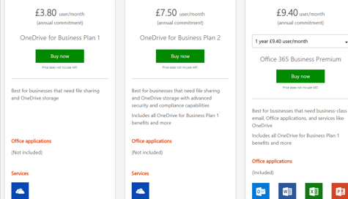
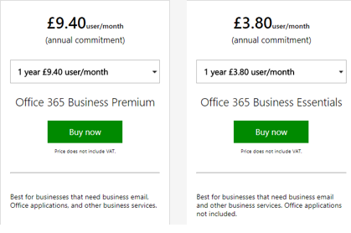

Appendix 2
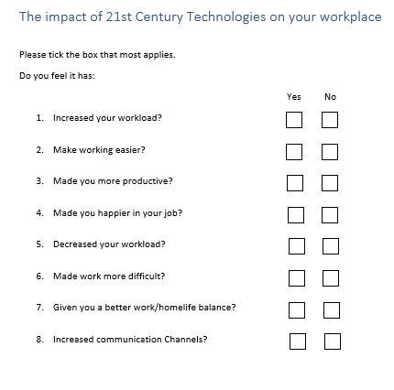

Appendix 3


