

Evaluating Costco’s Proposed Market Entry into Indonesia: Strategic Opportunities, Challenges and Entry-Mode Considerations
Programme: Master of Business Administration
Module: International Business Concepts

Lecturer: Gladius Kulothungan

Student Name: Mohammod Belal
Student ID: 2432635

Submission Date: 14-08-26

AI Use Acknowledgement
I recognize the use of AI tools in the preparation of this report, albeit in limited manner. AI has been utilized as an additional learning tool to make things clearer about some concepts of the module, such as Bartlett and Ghoshal's international strategy framework, Dunning's OLI paradigm, and Root's entry-mode framework. For clarity purposes, it was also employed to explain some international business terms as desired. The research, selection, and assessment of sources, the interpretation of evidence, the application of the theories to Costco and Indonesia, as well as the strategic judgements were conducted by me. All of the information included in the report has been independently verified with relevant academic, company, governmental, and other reliable sources before being used in the report.

Contents
AI Use Acknowledgement 2
Section 1 10
1. Organisational Classification and Global Strategy 10
1.1 Company and Industry Positioning: Costco Wholesale Corporation 10
1.1.1 Company profile 10
1.1.2 Industry and Business model 11
1.2 Strategic Categorisation: Bartlett and Ghoshal Framework 11
1.2.1 Global Integration 11
1.2.2 Local Responsiveness 12
1.3 Global Configuration and Value Creation 12
1.3.1 Geographic Footprint and International Scale 12
1.3.2 Contribution to Competitive Advantage 13
2. Macro-Environmental Appraisal and Market Attractiveness 14
2.1 Political Environment 14
2.1.1 Political Stability and Investment Climate 14
2.1.2 Foreign Investment and Retail Regulation 14
2.1.3 Trade Policy and Local Regulatory Exposure 15
2.1.4 Strategic Implications for Costco 15
2.2 Economic Environment 16
2.2.1 Market Size and Economic Growth 16
2.2.2 Income, PPP and Affordability 17
2.2.3 Inflation and Consumer Behaviour 17
2.2.4 Strategic Implications for Costco 18
2.3 Logistics and Geographic Environment 18
2.3.1 Geographic Fragmentation and Distribution 18
2.3.2 Logistics Efficiency and Cost Implications 19
2.3.3 Strategic Implications for Costco 19
2.4 Legal Environment 20
2.4.1 Foreign Ownership and Retail Regulation 20
2.4.2 Import and Product Compliance 20
2.4.3 Strategic Implication for Costco 20
2.5 Cultural Environment 21
2.5.1 Consumer Culture and Costco's Membership Model 21
2.5.2 Localisation of Food and Product Assortment 22
2.5.3 Competitive Shopping Behaviour 22
2.5.4 Strategic Implications for Costco 22
2.6 Competitive Environment 23
2.6.1 Direct Wholesale Competition 23
2.6.2 Costco's Potential Competitive Advantage 24
2.6.3 Strategic Implications for Costco 25
2.7 Market Attractiveness for Costco in Indonesia 25
2.7.1 Market Opportunity 25
2.7.2 Strategic Fit and Constraints 26
2.8 Dunning's OLI Framework: Costco's Proposed Entry into Indonesia 27
2.8.1 Ownership Advantages 27
2.8.2 Location Advantages 28
2.8.3 Internalisation Advantages 29
3. Entry Mode Strategy and Strategic Synthesis 29
3.1 Historical Pattern Recognition: Costco's International Entry 29
3.1.1 Evolution of Ownership Structure 30
3.1.2 Critical Implication for Indonesia 30
3.2 Strategic Fit: Application of Root's Entry-Mode Framework 30
3.2.1 Initial Screening of Entry Modes 31
3.2.2 Joint Venture versus Wholly Owned Subsidiary 31
3.2.3 Strategic Choice 32
3.3 Conclusion and Recommendations 33
3.3.1 Strategic Conclusion 33
3.3.2 Recommendations 34
SECTION 2 35
4. Reflective Account Using Gibbs' Reflective Cycle 35
4.1 Description: Initial Approach and Research Process 35
4.1.1 Selecting the Case 35
4.2 Feelings: Developing My Initial Understanding 36
4.3 Evaluation: Research Strengths and Limitations 36
4.3.1 What Worked Well 36
4.3.2 What Required Improvement 36
4.4 Analysis: Developing My Strategic Understanding 36
4.5 Challenges and How I Overcame Them 37
4.5.1 Establishing Country Eligibility 37
4.5.2 Moving Beyond Descriptive Analysis 37
4.5.3 Separating Evidence from Assumptions 38
4.6 Applying Module Learning 38
4.7 Action Plan 38
References 40

List of Figures
Figure 1: Costco Revenue (Costco, 2025) 9
Figure 2: Costco's Existing Markets (Qian, 2026) 12
Figure 3: Indonesia's foreign-retail investment pathway (UNCTAD, 2026) 14
Figure 4: Indonesia GDP (World Bank, 2026) 15
Figure 5: Indonesia Inflation Rate (World Bank, 2026) 17
Figure 6: Proposed Logistics Network and Phased Distribution Model for Costco's Entry into Indonesia (Author) 18
Figure 7: Hofstede Dimensions for Indonesia (The Culture Factor, 2025) 20
Figure 8: Costco Competitors (Permana et al., 2023) 22
Figure 9: Internet Users in Indonesia (Statista, 2026) 24
Figure 10: Indonesia GDP Per Capita (World Bank, 2026) 25
Figure 11: OLI Framework (Salem et al., 2026) 26
Figure 12: Root Entry Framework (Sharma & Klein, 2026) 30
Figure 13: Gibbs Reflective Cycle (Jauregui et al., 2026) 34

List of Tables
Table 1: Costco's FY2025 Business Model Indicators (Author) 10
Table 2: Bartlett & Ghoshal application to Costco's proposed Indonesian entry (Author) 11
Table 3: Costco's Geographic Configuration and Strategic Contribution (Author) 13
Table 4: Indonesia Policy Regulations and Implications for Costco (Author) 15
Table 5: Indonesia's Economic Attractiveness for Costco (Author) 17
Table 6: Key Indonesian Regulations and Implications for Costco (Author) 20
Table 7: Hofstede cultural profile of Indonesia (Author) 22
Table 8: Competitors' Matrix for Costco (Author) 23
Table 9: Costco Indonesia Market Attractiveness Matrix (Author) 26
Table 10: Costco–Indonesia OLI Decision Framework (Author) 28
Table 11: Costco's Historical Ownership Evolution (Author) 29
Table 12: Entry Modes for Costco (Author) 32

Section 1

Organisational Classification and Global Strategy

Company and Industry Positioning: Costco Wholesale Corporation

Company profile
Costco Wholesale Corporation is an American membership warehouse club chain that opened its first store in Seattle in 1983. Its model is a mix of paid membership and limited product selection, high volume buying, and low margin pricing. Costco had net sales of $269.9 billion and membership-fee revenue of $5.323 billion in 2025, while 81 million paid members worldwide had a renewal rate of 89.8% for the year. As of May 2026, it had 928 warehouses in 14 countries; however, it did not have a warehouse in Indonesia (Costco, 2025).
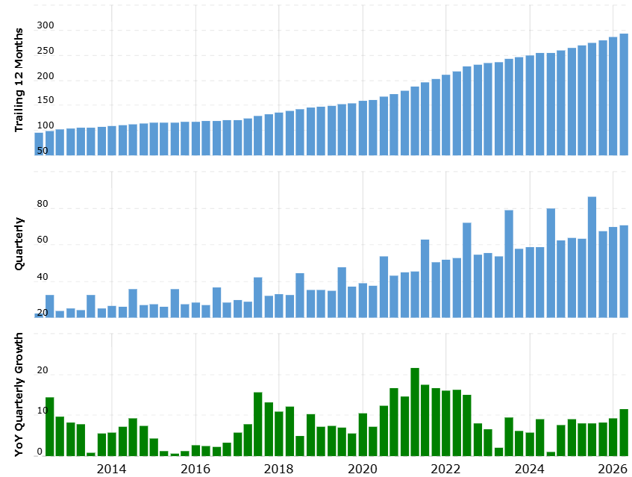
Figure 1: Costco Revenue (Costco, 2025)

Industry and Business model
Costco competes in the membership warehouse retail industry, selling food, household goods, electronics, apparel, appliances, and other products alongside its Kirkland Signature private label. Its competitive logic is unique: membership fees build customer loyalty, it has a limited number of SKUs, bulk sales, an efficient distribution system, and a fast inventory turnover enable Costco to keep its gross margins lower than those of conventional retailers (Johnson, 2025). This model creates a potential ownership advantage for entry into Indonesia, but its success would depend on whether Indonesian consumers adopt paid membership and whether Costco can reproduce its scale efficiencies in a geographically fragmented market.
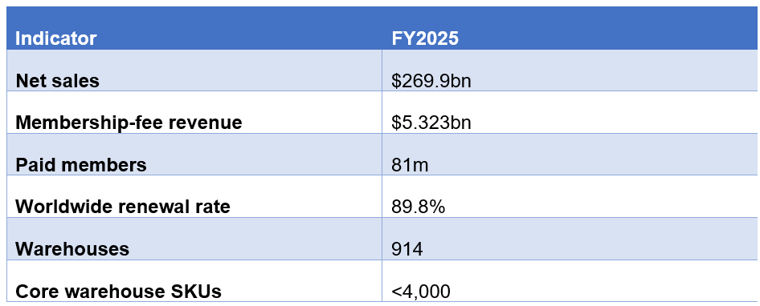
Table 1: Costco's FY2025 Business Model Indicators (Author)

Strategic Categorisation: Bartlett and Ghoshal Framework

Global Integration
Costco is best viewed as predominantly global with selective local responsiveness, rather than fully transnational. Its central model is very standardized: membership warehouses keep a limited set of products, have centralized purchasing, sell more, and rapid inventory turnover to sustain low prices. Costco clearly has very similar operating models throughout most of its foreign operations, which facilitates global integration. Strategically, this is significant for Indonesia as Costco would have to maintain the scale of procurement and the low margin business strategy to maintain competitive position (Kumar et al., 2022).

Local Responsiveness
However, complete standardisation would be unsuitable for Indonesia. Costco already applies some of the elements of their international business, but maintains a core warehouse model. For Indonesia, product assortment, halal requirements, local suppliers, and payment practices and consumer purchasing patterns would be highly relevant to adapting. Thus, Costco's approach seems more like a global strategy with adaptations at a local level than a purely global strategy (Pokharna, 2025).
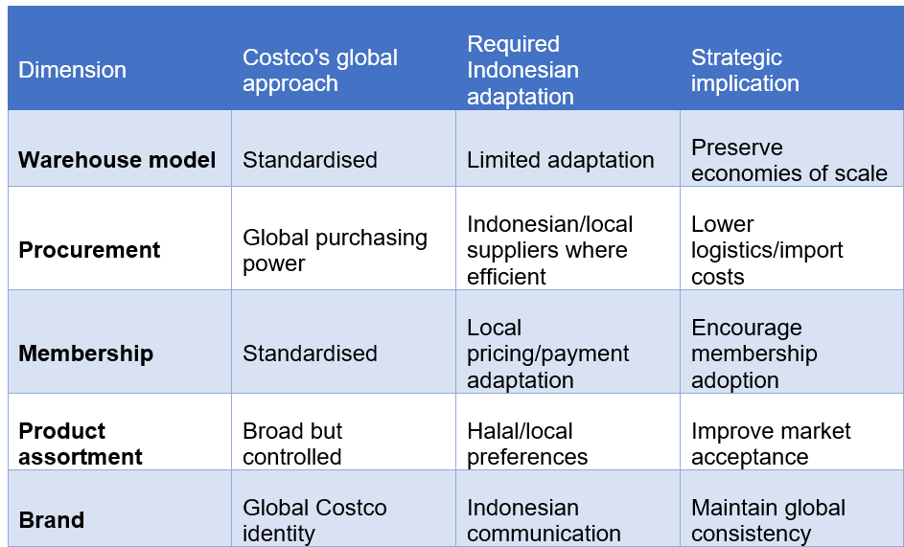
Table 2: Bartlett & Ghoshal application to Costco's proposed Indonesian entry (Author)

Global Configuration and Value Creation

Geographic Footprint and International Scale
Costco's international footprint is not limited to North America, but has also made its way into Mexico, Japan, Korea, Taiwan, China, Australia, and Europe, boasting 931 Costco locations in 14 markets in 2026. Its footprint is, however, very localized in the U.S. and Canada and not the same across the board (Qian, 2026).
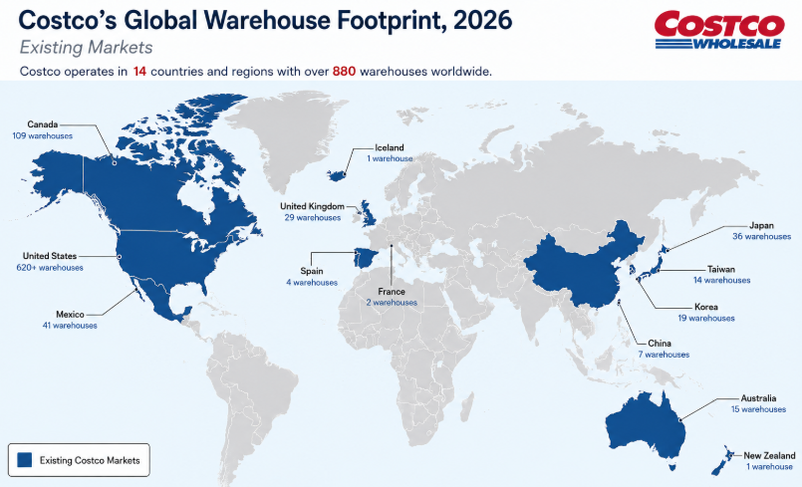
Figure 2: Costco's Existing Markets (Qian, 2026)

Contribution to Competitive Advantage
This network strengthens Costco through purchasing scale, supplier relationships and knowledge transfer. Its standardised warehouse model allows Costco to replicate procurement and inventory practices internationally while retaining local product selection. The higher distribution cost caused by the spatial dispersion of Indonesia is important, in which scale can be a solution to mitigate it. But Costco's international experience is not eliminating the hurdle: Indonesia is its first market in Southeast Asia, and the fragmented logistics network might undermine the economies of scale that have proved successful in other countries (Abyaneh et al., 2025). Hence, the reason for entering Indonesia will be contingent on Costco's ability to replicate its international advantage in procurement and developing its local expertise in both procurement and distribution.
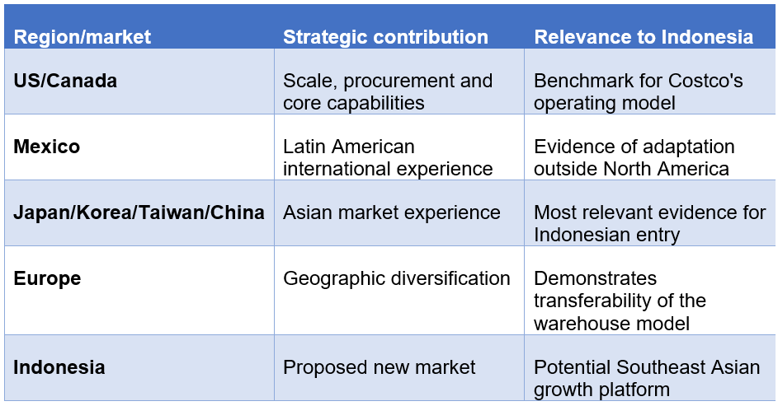
Table 3: Costco's Geographic Configuration and Strategic Contribution (Author)

Macro-Environmental Appraisal and Market Attractiveness

Political Environment

Political Stability and Investment Climate
Indonesia offers a pretty good investment climate, but the regulatory environment may hinder foreign investment. In 2025, the realised investment amounted to IDR1,931.2 trillion, which is above the government target by 1.3% (Meliana et al., 2025). Costco helps illustrate how a long-term investment in a warehouse can be feasible in Greater Jakarta, but high investment returns in one country does not ensure regulatory certainty for a foreign large-format retailer.

Foreign Investment and Retail Regulation
The Positive Investment List, established through Presidential Regulations No. 10/2021 and 49/2021, permits up to 100% foreign ownership where sector restrictions do not apply. Foreign investors may set up a PT PMA via the Online Single Submission (OSS) risk-based licensing system (UNCTAD, 2026). This might enable Costco to have more control over its operations without relying on a local partner. However, Costco needs to have the right KBLI classification and licences for its very large retail operations. As a result, the level of ownership liberalisation is not a substitute for the value of Indonesian regulatory expertise, but it does help to decrease the need for a JV.
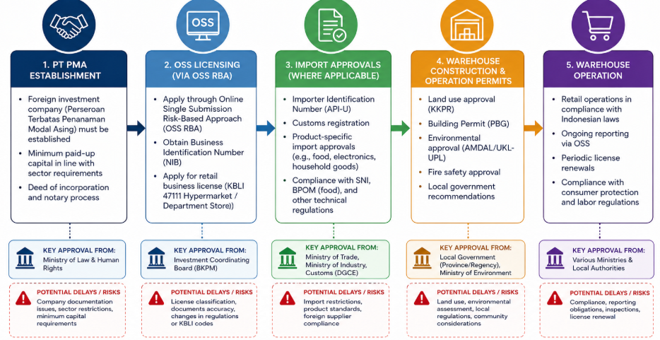
Figure 3: Indonesia's foreign-retail investment pathway (UNCTAD, 2026)

Trade Policy and Local Regulatory Exposure
The use of imported merchandise makes Costco more vulnerable to the import regime in Indonesia. Consumer-goods imports are regulated by Minister of Trade Regulations No. 23/2025 and 37/2025 (UNCTAD, 2026). Compliance may lead to higher landed cost and erosion of Costco's price advantage. Then, Costco would have to do a mix of global sourcing and finding appropriate suppliers in Indonesia.

Strategic Implications for Costco
A JV is strategically preferable initially because it can provide regulatory and local-market expertise while Costco retains control over core operations.
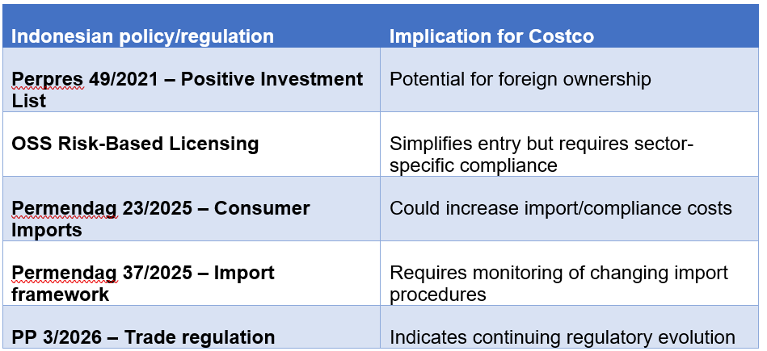
Table 4: Indonesia Policy Regulations and Implications for Costco (Author)

Economic Environment

Market Size and Economic Growth
Indonesia's 285.7 million population, US$1.45 trillion GDP and 5.1% real GDP growth in 2025 indicate strong consumption potential, with private consumption also growing by 5.1% (World Bank, 2026).
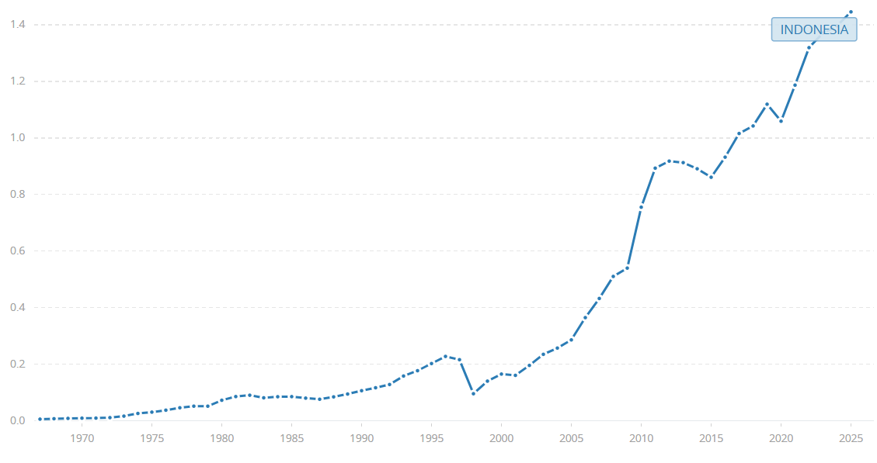
Figure 4: Indonesia GDP (World Bank, 2026)
However, these numbers are not necessarily reflective of Costco's addressable audience. In FY2025, Costco attracted 81 million paid members who contributed $269.9 billion in sales, highlighting the critical importance of high volume of customers (Costco, 2025). Indonesia's expansion thus offers opportunities, but Greater Jakarta is more relevant than national population as Costco needs customers who can make high volume purchases in a concentrated area.

Income, PPP and Affordability
Indonesia's US$5,060 GDP per capita in 2025 was substantially below the US level of approximately $90,027, despite Indonesia's much larger population (World Bank, 2026). This is important because Costco has a well-established US market that has much higher consumer purchasing power. While Indonesia's GDP per capita in PPP terms is around $17,660, only 17.25% of the population in Indonesia is considered middle-class in 2024 (BPS, 2025). Therefore, Costco cannot assume that population size will translate into equivalent membership penetration or basket values.

Inflation and Consumer Behaviour
As of May 2026, the inflation rate stood at 3.1%, and food inflation was at 4.9% (World Bank, 2026).
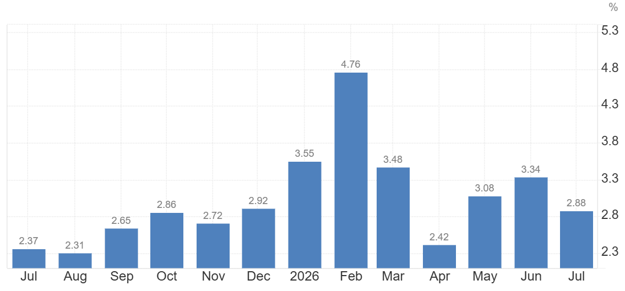
Figure 5: Indonesia Inflation Rate (World Bank, 2026)
For Costco, this creates a mixed effect: as bulk buying can help bolster its value proposition, but also food price pressure can lessen consumers' willingness to pay for membership and buy a lot of food.

Strategic Implications for Costco
Indonesia is therefore attractive for long-term growth rather than immediate mass penetration. The expansion of Costco in greater Jakarta should be done first to see if the conversion of its membership and renewal and average basket value can sustain the volume-based model.
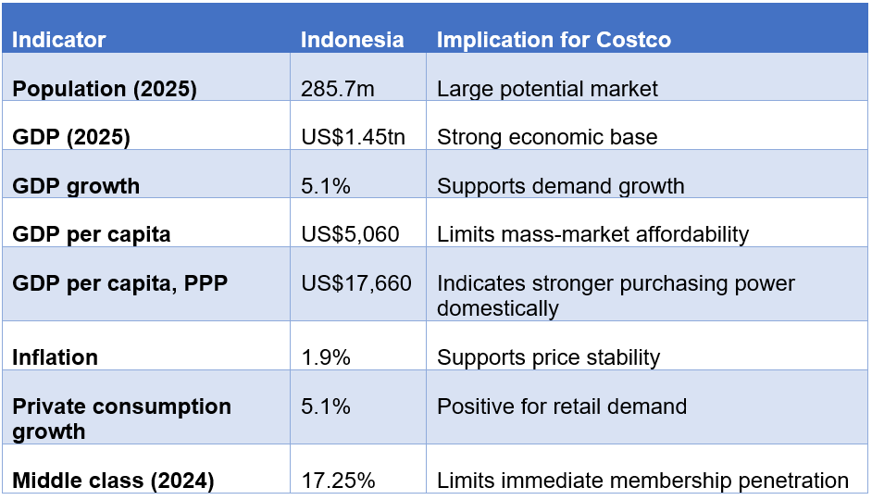
Table 5: Indonesia's Economic Attractiveness for Costco (Author)

Logistics and Geographic Environment

Geographic Fragmentation and Distribution
Indonesia's 17,000+ islands make logistics more complex than the well-developed North American markets that Costco has. The model of Costco's operation relies on the concept of centralised buying, fast inventory turnover, and economies of scale, so warehouse in Greater Jakarta can initially focus on the demand by protecting these advantages (Judijanto et al., 2024). But, if they expand into other islands, the transportation needs between islands would grow. This establishes a critical balance between economies of scale in procurement at Costco and distribution diseconomies in Indonesia.
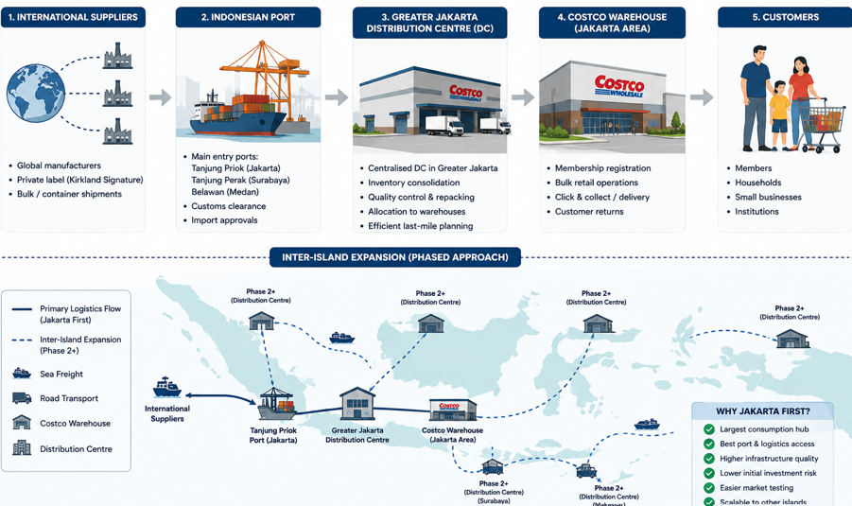
Figure 6: Proposed Logistics Network and Phased Distribution Model for Costco's Entry into Indonesia (Author)

Logistics Efficiency and Cost Implications
The logistical constraint measured by LPI (World Bank, 2025) is 3.0 for Indonesia, the rank 61 among 139 economies, which Costco needs to consider. Costco can't just push its North American distribution system model over in the United States. While global sourcing can offer purchasing benefits, delays at ports, inland congestion, and inter-island transportation can raise landed costs. Such sourcing from Indonesia may mitigate this, but there is a risk of losing Costco's global sourcing edge if there is too much localisation.

Strategic Implications for Costco
Therefore, a Jakarta-first entry is strategically better as it focuses initial demand on Greater Jakarta, thereby reducing inter-island exposures. Costco needs to continue to grow only after proving that warehouse size, logistics expenses, and profits are in line with the low-price model.

Legal Environment

Foreign Ownership and Retail Regulation
Presidential Regulation No. 10/2021 and Presidential Regulation No. 49/2021 have implemented the Positive Investment List, which allows 100% foreign investment in sectors that are not limited (UNCTAD, 2026). This is the great benefit for Costco, it eliminates the need for the local partner and allows for a PT PMA. But still, Costco has to determine the proper retail classification and licences for the OSS risk-based system before investing.

Import and Product Compliance
The reliance on imported products puts Costco at more risk of compliance issues than a retailer that has primarily domestically sourced goods. In accordance with the requirements for halal assurance, the covered food, beverages, and slaughtered products will be halal in PP No. 42/2024, including the applicable requirements for imports (Rahmad, 2026). Costco may face higher costs with certification, supplier verification, and import compliance, which might negatively affect the price benefits of imported products.

Strategic Implication for Costco
The legal framework sets up a trade-off between control and local expertise. In contrast to markets where foreign ownership is limited, Indonesia doesn't require the participation of a JV, but a partner might offer useful knowledge in regulatory and compliance matters (Analiansyah, 2025). Thus, it is more suitable to have a phased JV instead where Costco can buy more shares after easing regulatory uncertainty.
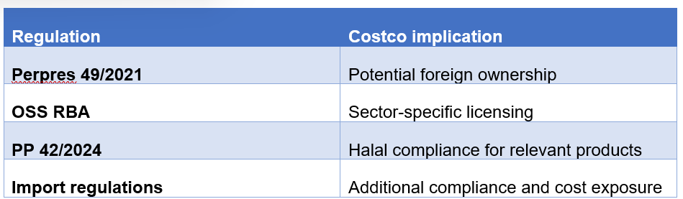
Table 6: Key Indonesian Regulations and Implications for Costco (Author)

Cultural Environment

Consumer Culture and Costco's Membership Model
Indonesia's Power Distance (78) and very low Individualism (5) suggest a stronger group-oriented social context than Costco's US home market, where individualism is substantially higher (The Culture Factor, 2025).
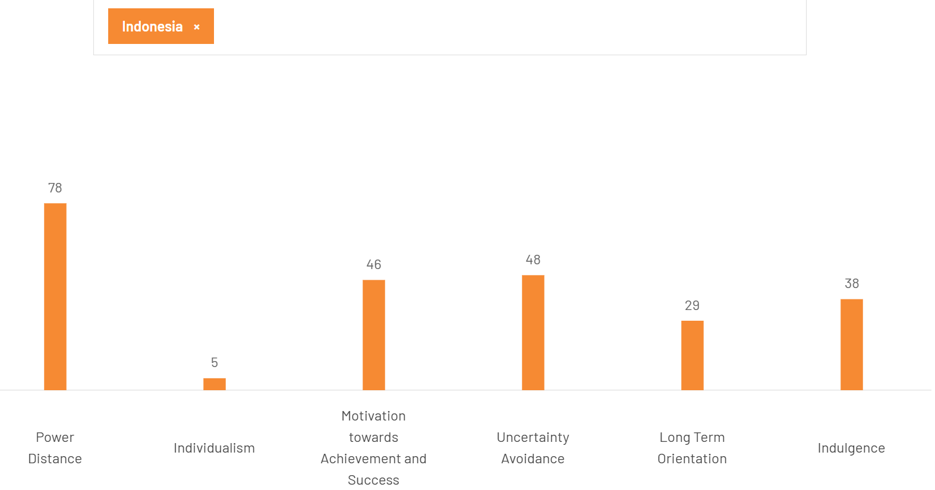
Figure 7: Hofstede Dimensions for Indonesia (The Culture Factor, 2025)
The scores, however, do not indicate a desire to buy in large quantities or to pay membership fees (Khairurrahman et al., 2023). The key question for Costco is whether Indonesians see the membership fee and bigger baskets as worthwhile for them when compared with other retail channels.

Localisation of Food and Product Assortment
Unlike Costco's US operation, where its established assortment can be applied with limited religious adaptation, Indonesia requires greater attention to halal certification and labelling under PP No. 42/2024 (Ashari et al., 2026). Costco then would have to modify the categories in the food department, the suppliers, and the product descriptions, instead of taking the American inventory of products overboard. Too much adaptation, however, might cause procurement inefficiency.

Competitive Shopping Behaviour
Furthermore, there is already an alternative solution to Costco in the form of price and bulk purchasing by Indogrosir and ecommerce (Mujianto et al., 2022). This is more of a challenge than just attracting customers to membership since they are more likely to join than to leave.

Strategic Implications for Costco
Costco should adopt a standardised membership, warehouse, and procurement system with a selective approach to localising its products and ensuring products are compliant with the halal standard. This aligns with Bartlett and Ghoshal's approach of having a global strategy but selective local responsiveness.
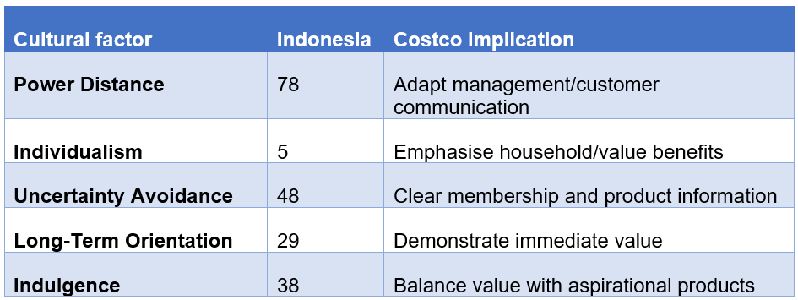
Table 7: Hofstede cultural profile of Indonesia (Author)

Competitive Environment

Direct Wholesale Competition
Costco would enter Indonesia without a unique membership-wholesale proposition. Indogrosir has 32 outlets, approximately 350,000 MSME partners, 600 distributors, and provides about 6000 products (Permana et al., 2023). As a result, the sourcing power of the local supply chain, as well as the distribution and local customer knowledge is stronger in Indogrosir than in Costco.
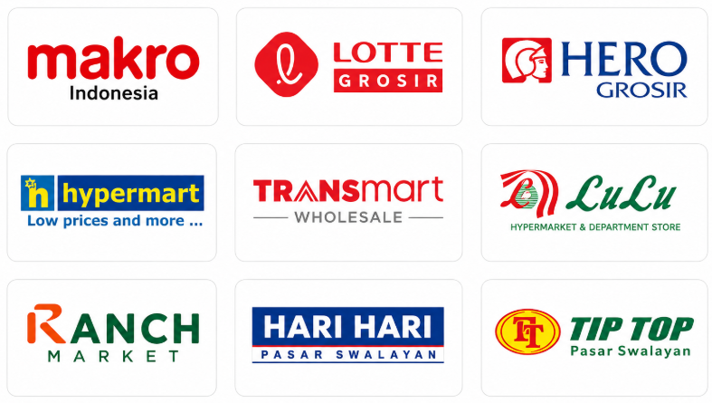
Figure 8: Costco Competitors (Permana et al., 2023)
Lotte Grosir offers an even closer comparison as it is also owned by foreign capital, has a wholesale retail operation, and has membership via LotteMart Point, as it does with Costco, but it also serves retailers, traders, and HORECA customers (Ulfanora & Almaududi, 2024). Therefore, Costco cannot be differentiated based solely on ownership or membership by foreign ownership.
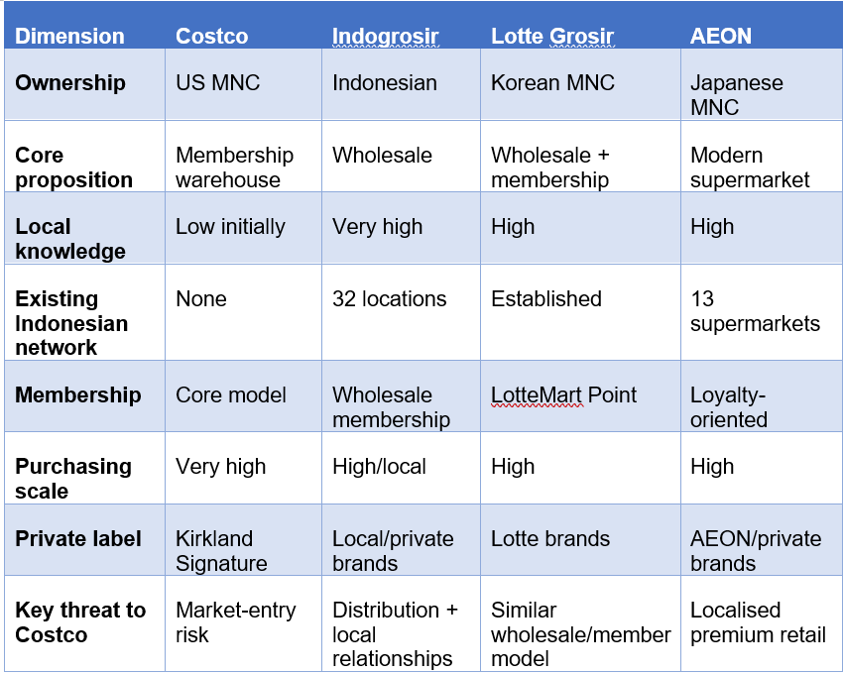
Table 8: Competitors' Matrix for Costco (Author)

Costco's Potential Competitive Advantage
Costco's stronger differentiator would be its global purchasing scale, Kirkland Signature and tightly integrated low-price/high-volume model, rather than membership itself. In addition, 13 supermarket openings by AEON in 2025 can also be seen as an international retailer's ability to localize its Indonesian assortment (Meliana et al., 2025). For Costco, it would require a hybrid model of global procurement benefits and local product adaptation in Indonesia.

Strategic Implications for Costco
Costco needs to focus on cost/value, procurement economies of scale, leverage local knowledge to beat the entrenched advantages of Indogrosir and Kirkland/Lotte.

Market Attractiveness for Costco in Indonesia

Market Opportunity
Costco has a significant but targeted growth opportunity in Indonesia. The country has a highly developed consumption market with 285.7 million people, $1.45 trillion GDP, and a real GDP growth rate of 5.1% in 2025 (World Bank, 2026); and the penetration rate of the Internet is 73% (Statista, 2026), which will support Costco's physical and digital membership model.
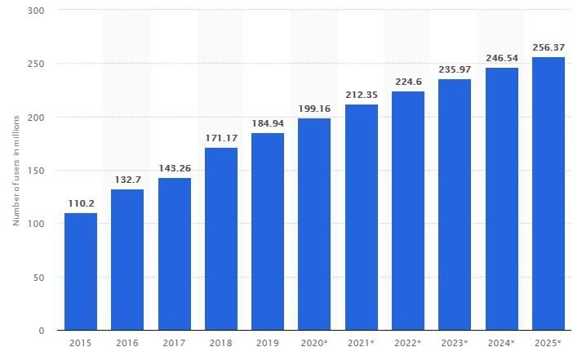
Figure 9: Internet Users in Indonesia (Statista, 2026)
The average GDP per capita of Indonesia is $5,060 (World Bank 2026), however, significantly lower than Costco's established-market benchmark of about $11,530, which in turn has an impact on the percentage of consumers who can afford annual memberships and Costco-size shopping carts. Hence, the national market size may not be considered as a sufficient demand.
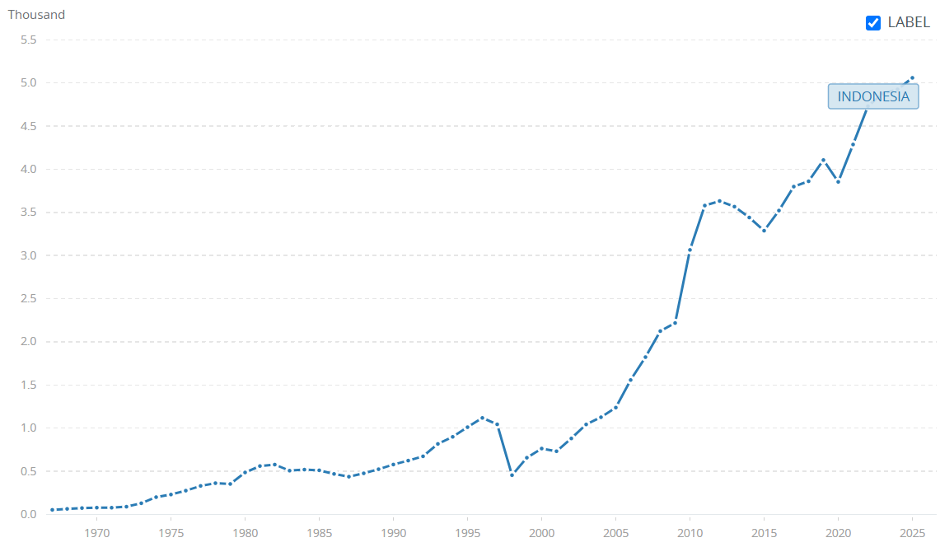
Figure 10: Indonesia GDP Per Capita (World Bank, 2026)

Strategic Fit and Constraints
Greater Jakarta is the best target for entry, as Costco will be able to focus on purchasing power, avoiding inter-island logistics exposure. But Costco would have to contend with the local expertise and distribution system of the Indogrosir's and Lotte Grosir's as well as import and regulation costs in Indonesia. The presence of Costco in Asia—with 37 Japanese, 20 Korean, 14 Taiwanese and seven Chinese stores as of May 2026—mitigates the risk of execution uncertainty (Costco, 2026), but doesn't eliminate the need to adapt to Indonesian conditions. The overall strategic interest of the market is high, but conditional: entry is only viable if Costco can penetrate the market sufficiently, increase their basket size and operating efficiency.
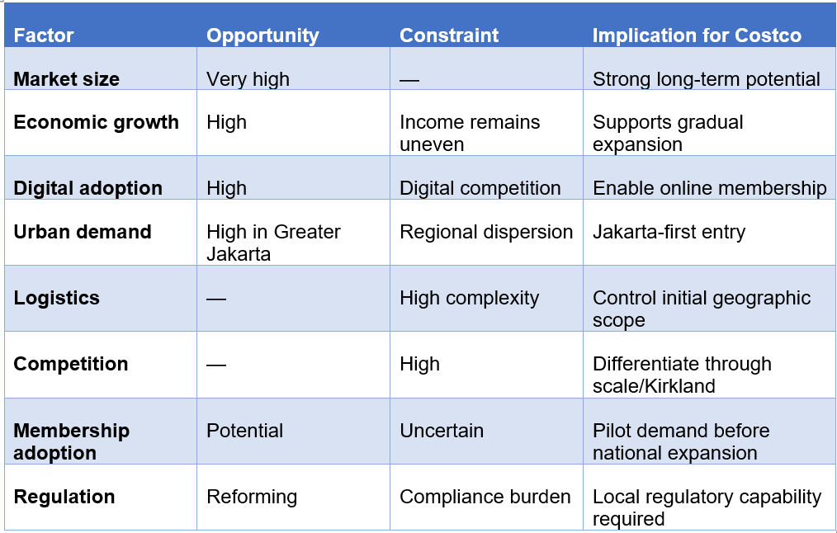
Table 9: Costco Indonesia Market Attractiveness Matrix (Author)

Dunning's OLI Framework: Costco's Proposed Entry into Indonesia
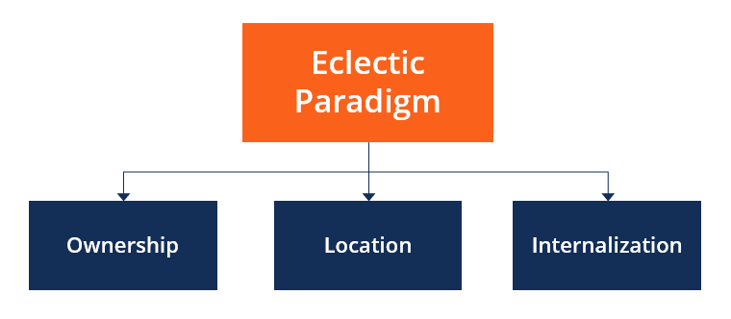
Figure 11: OLI Framework (Salem et al., 2026)

Ownership Advantages
Ownership advantages that Costco can be translated into entering Indonesia, but it is not automatic. It has a membership of 81 million paid members, resulting in $5.323 billion in membership-fee revenue, with an 89.8% gglobal renewal rate in 2025 (Costco, 2026). The low-price/high-volume proposition is further strengthened by Kirkland Signature, global supplier relationships, and procurement scale, as well as warehouse expertise. These benefits, however, are more pronounced in Costco's existing markets than they would be in Indonesia. The 89,8% renewal rate indicates existing customer base, and cannot be assumed for Indonesian consumers (Salem et al., 2026). Likewise, Costco’s purchasing power is based on volume while a new Indonesian store would have a small membership and purchasing power of suppliers at first.
This correlates with the previous Bartlett and Ghoshal analysis; Costco should maintain the same membership, procurement, and warehouse structure but tailor their products to fit Indonesian market demands. As such, its ownership value can be transferred; its economic value depends on successful local adaptation, and membership acquisition.

Location Advantages
The location advantage that Indonesia has is potentially attractive, but the evidence is stronger for a concentrated market than for nationwide entry. It has a population of 285.7 million; a real GDP of $1.45 trillion; and a real GDP growth of 5.1%, which represents market-seeking potential (World Bank, 2026). But the average purchasing power of $5,060 per capita suggests a far lower level than Costco's US market. Thus, the location advantage of the relevance is not the population of Indonesia, but the proportion of high-income consumers in Greater Jakarta that is concentrated at Costco.
Other location benefits such as the manufacturing base in Indonesia and its location within Southeast Asia, could facilitate the development of local sourcing and regional supply. But Indonesia's logistics and 17,000+ Islands should considered for these advantages. ndonesia ranked 61st among 139 economies in the Logistics Performance Index (World Bank, 2025). This could lead to higher distribution expenses, and make it harder for Costco to pass on global purchasing benefits to lower prices for customers. Other factors also demand local market adaptation, including legal requirements, and halal certification, as well as the presence of established players like Indogrosir and Lotte Grosir, which makes Indonesia an uncompetitive market.

Internalisation Advantages
Costco has significant internalisation benefits, as running the Indonesian market would protect the membership system (Kirkland Signature), the pricing, customer information, and standards. The down side to licensing would be a loss of investment, but it would also result in information asymmetry and a diminished ability to manage the operating model for Costco (da Cruz et al., 2023). Wholly-owned subsidiary would consequently ensure maximum control.
But OLI analysis is not a justification for a 100% ownership option. Full internalisation would only leave Costco with the risk of not being able to achieve widespread adoption as a member of the state, transportation, and logistics expenses, and a significant investment in a warehouse in Indonesia. As such, the OLI results suggest that a phased JV approach should be pursued to enable Costco to gain local knowledge, reduce uncertainty, and minimize risk to its core business.
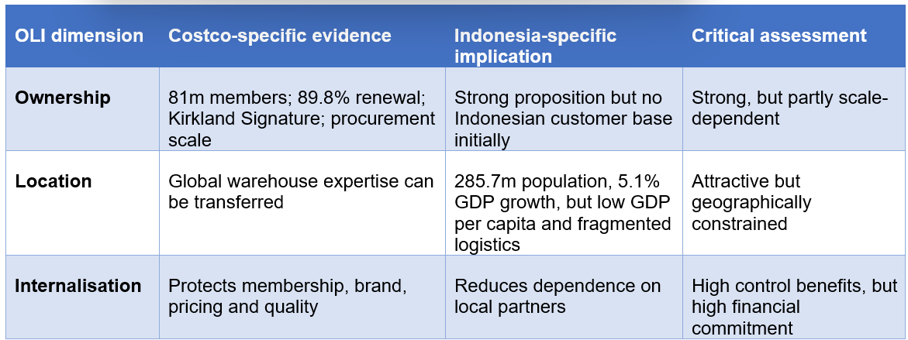
Table 10: Costco–Indonesia OLI Decision Framework (Author)

Entry Mode Strategy and Strategic Synthesis

Historical Pattern Recognition: Costco's International Entry

Evolution of Ownership Structure
Costco's global growth is a development of local participation to an increasing level of ownership control rather than a commitment to joint ventures. Costco's initial businesses in Mexico were a 50:50 joint venture with the Mexican company Controladora Comercial Mexicana, with Costco conducting the operations. Costco purchased the remaining 50% stake in 2012 for MXN10.65 billion ($760.4 million) and the operation became a wholly owned subsidiary (Kumar et al., 2022). Likewise, when Costco acquired the remaining stake of Costco Taiwan in 2022, it became 100% owned by Costco (Kuok et al., 2023). These cases suggest that local partnerships can provide initial market access and learning before greater control becomes economically justified.

Critical Implication for Indonesia
But Mexico and Taiwan are not direct evidence for Indonesia's need for a JV. Costco's past history suggests a route, but not a strategy. Indonesia is different because of its 17,000+ islands, the relatively low GDP per capita around $5,060 and the complex regulatory environment (Li, 2026). So, a phased JV might be a good thing to reduce uncertainty, but ownership needs to be increased if the growth of Indonesian membership, operating margin, and logistics result in added value to the company.
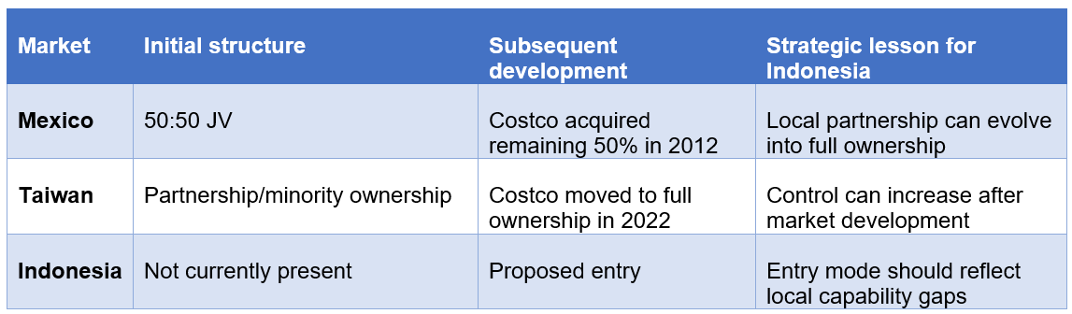
Table 11: Costco's Historical Ownership Evolution (Author)

Strategic Fit: Application of Root's Entry-Mode Framework
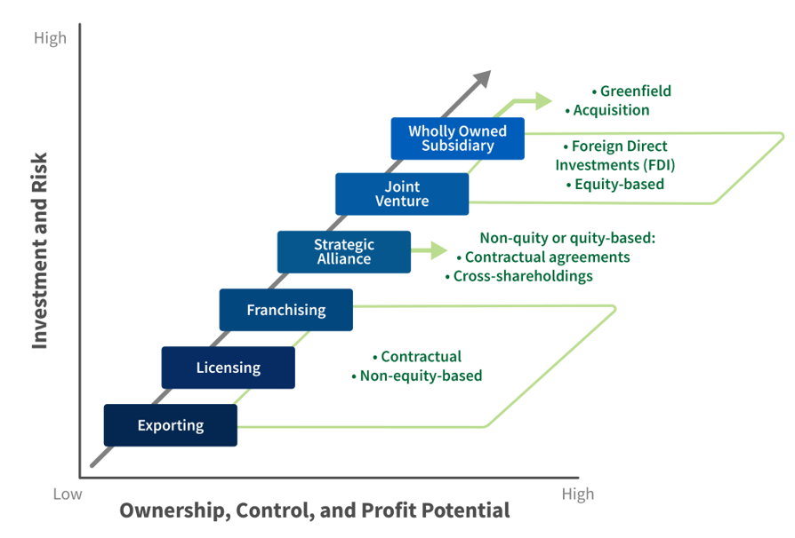
Figure 12: Root Entry Framework (Sharma & Klein, 2026)

Initial Screening of Entry Modes
The Root framework suggests that Costco's proposed strategy to enter Indonesia by exporting/licensing and franchising may not be a strategic fit. Exporting would mean that Costco would be subject to the cost of imports and logistics into Indonesia without building the warehouse scale that it needs to operate in its business model. A licensing or franchising effort would lower the capital investment required but also decrease Costco's influence on the membership program, on the store's pricing and quality of service (Sharma & Klein, 2026). These constraints make it more suitable to have a local operation.

Joint Venture versus Wholly Owned Subsidiary
There are two viable options, a joint venture (JV) or wholly owned subsidiary (WOS). A WOS would enable Costco to gain maximum control of the membership records, procurement, the standards of the products, and their price, while retaining all profits (Wan, 2025). This is especially useful because Costco's competitive advantage relies on the integration and not the separation of these activities. Despite these factors, Indonesia has still $5,060 GDP per capita, 17,000+ islands, and LPI ranks of 61st out of 139 economies (World Bank, 2026), which makes for major demand and logistics uncertainties. If Costco's membership penetration and store traffic were lower than anticipated, that would be the full cost to Costco.
A JV provides initial commitment and knowledge of the regulatory, supplier, and logistics sector in Indonesia which Costco would not have as a new player. This is especially important because the distribution of Costco is not yet eliminated as a cost due to its global distribution scale. These risks can be moderated by contractual protections for the Kirkland standards, pricing, membership processes, and procurement.

Strategic Choice
Despite Costco's strong internalisation advantages under OLI, a JV is more appropriate initially because Indonesia's uncertainty makes maximum control less valuable than access to capabilities Costco does not yet possess. This follows a pattern of Costco's gradual transition from a partnership to increased ownership in Mexico. The JV should instead be seen as a way to learn and not as a loss of control (Kim & Jung, 2026). If membership growth, renewal, basket size, logistics costs and operating margins meet agreed targets within three to five years, Costco should increase ownership.
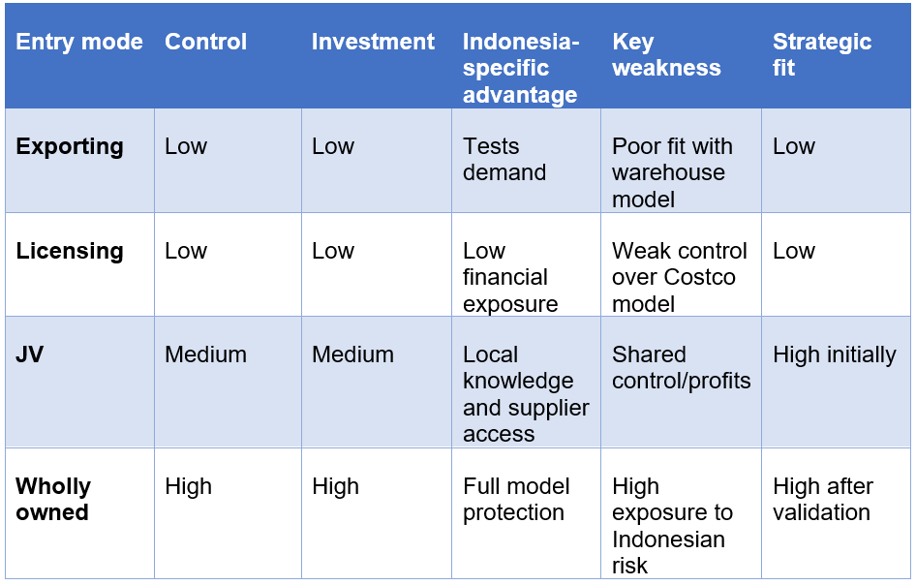
Table 12: Entry Modes for Costco (Author)

Conclusion and Recommendations

Strategic Conclusion
The strategic appeal of Indonesia for Costco is there, albeit with an uncertain approach. With its 285.7 million population, $1.45 trillion GDP, and 5.1% real GDP growth, it has the market potential, but its $5,060 GDP per capita and just 17.25% of its population in the middle class limit immediate entry into the fold. Indonesia's 17,000+ islands and LPI ranking of 61st out of 139 economies also create distribution costs that Costco's more concentrated established markets do not face (Sirait et al., 2025). Such conditions imply that Costco will not be able to export its US product without adaptation.
The integrated analysis supports a phased approach. Bartlett and Ghoshal indicates that Costco should retain its globally integrated membership, procurement and warehouse model while selectively adapting products. OLI recognizes good ownership advantages but Indonesian location advantages are diminished by logistics, cost, and regulatory uncertainty. Local capabilities thus make a JV a more suitable first step than outright ownership, and this is why it is better to seek a JV in the first place with Root's framework. The Mexican venture, which saw Costco acquire 100% ownership from a JV for about $760.4 million (Johnson, 2025), is a positive sign to later expand the ownership of Costco in Indonesia, not that the market needs a JV.

Recommendations
- Enter through a phased JV with a partner providing demonstrable Indonesian logistics, supplier and regulatory capabilities, while Costco retains control over membership, Kirkland Signature, pricing and procurement standards.
- Introduce first in Greater Jakarta, to focus demand and minimise first exposure to the inter-island distribution channel.
- Review the performance of the product for 3–5 years, based on paid membership, renewal rate, average annual spending, warehouse sales, operating margin, logistics cost per unit, percentage of sourcing from Indonesia, ROI, and payback period.
- If targeted KPIs are met, then increase ownership. Expansion should be reconsidered if membership and/or margin and/or logistics criteria are not being met.
- Gradually increase amount of Indonesian sourcing, if supplier can provide the same price, quality, and halal standards to Costco, and still maintain the cost effectiveness of global sourcing.

SECTION 2

Reflective Account Using Gibbs' Reflective Cycle
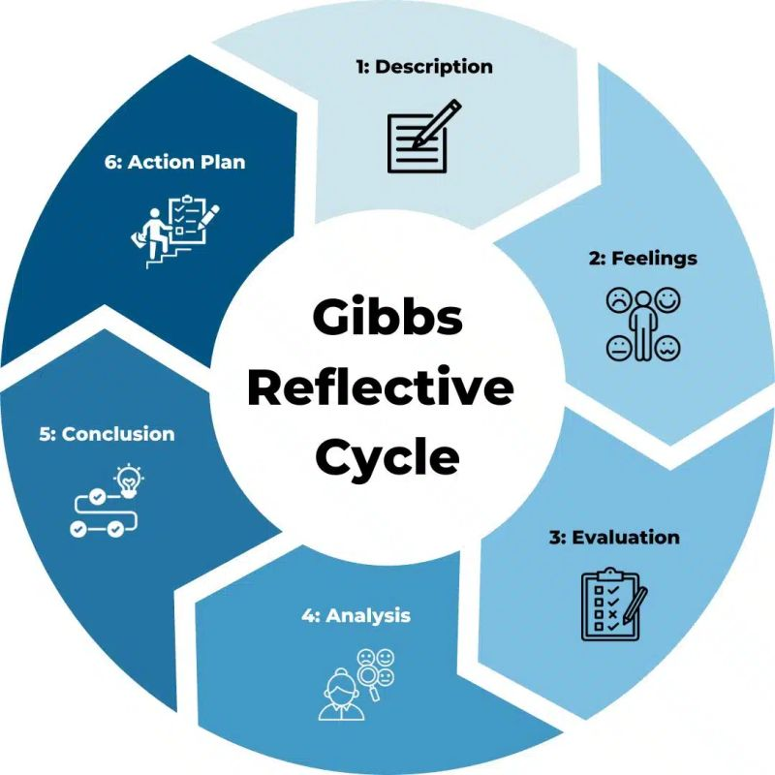
Figure 13: Gibbs Reflective Cycle (Jauregui et al., 2026)

Description: Initial Approach and Research Process

Selecting the Case
The first step was to find a company that could be classified as an MNC, a selected industry, and a nation with no major scope for the business. I chose Costco in Indonesia because their membership-warehouse business structure led me to ask myself the question: can Costco's scale advantage be replicated in Indonesia? I first explored Costco's International strategy and geographic presence, then I conducted a thorough study on the political, economic, logistical, legal, and cultural landscape of Indonesia and on the current wholesale players in Indonesia. Then I shifted from environmental research to strategic analysis using Bartlett & Ghoshal model, Dunning's OLI framework and Root's entry-mode framework. Finally, the proposed entry mode was tested as an extension of Costco's existing JV-to-ownership program and a scenario-based financial analysis was conducted to determine if the proposed entry was feasible and not just because of the size of the market.

Feelings: Developing My Initial Understanding
At first, I was attracted to the fact that there was a large population in Indonesia, a growing economy, and an expanding consumer market which I thought would be a great market place to enter into. However, this assumption changed when I considered Costco's dependence on paid membership, high-volume purchases and sufficient customer spending to support its low-margin model. I realized that there are other factors to be considered when comparing the markets of Indonesia to the more established Costco. In addition, I became more aware of Indonesia's 17,000+ islands, and the distribution costs associated with them, because these might undermine Costco's procurement economies. The OLI and Bartlett and Ghoshal, then, changed my perspective from market size to strategic fit and economic transferability.

Evaluation: Research Strengths and Limitations

What Worked Well
I was able to use information from the annual reports on Costco to get reliable evidence of membership, revenue, margins, capital expenditure, and international operations. Evaluation of economic conditions, logistics, and investment needs were useful from government, World Bank, and regulatory sources for Indonesia. The mix of this helped me to apply Root's entry-mode framework with evidence and not just based on theory.

What Required Improvement
However, some information differed across commercial websites, requiring additional verification. A key restriction was the lack of financial and membership data specific to Indonesia from Costco. That meant that I couldn't simply apply what I knew about Costco's performance in its existing market to the Indonesian market.

Analysis: Developing My Strategic Understanding
Applying the models changed how I evaluated Costco's proposed entry into Indonesia. At first, I thought of Costco as a global firm where I could simply take the model of a warehouse, membership, and buying and selling, and replicate it with some variations. But, when applied Bartlett and Ghoshal was applied, it taught me that consistency across the globe can indeed be combined with selective responsiveness locally. I thus understood that the Indonesian preferences and halal guidelines can be aligned while not altering the core operating model of Costco.
OLI also altered my thinking. At first, the size of the population and the economic development of Indonesia seemed to be enough. Later, I realised that these factors do not necessarily imply a strong location advantage as Costco also needs to have sufficient purchasing power, membership demand, and manageable logistics costs.
Finally, Root's framework challenged my initial preference for wholly owned entry. I got to know that the need for control is a delicate balance at Costco, because of limited exposure to the Indonesian market and risk exposure. Therefore, a phased JV started gaining traction as priority action.

Challenges and How I Overcame Them

Establishing Country Eligibility
One of the biggest hurdles was proving that Costco didn't have a substantial business in Indonesia, rather than assuming this from its international footprint. Thus, I checked the Costco's warehouse stores and corporate data before I moved onto the Indonesian case. It was crucial due to the fact that an inaccurate picture of the presence of Costco would cast doubt on the viability of the entire entry analysis.

Moving Beyond Descriptive Analysis
The first thing I noticed is how easy it was to gather the economic, political, and logistics data from Indonesia in comparison with examining the implications of the data for Costco. To overcome this, I asked myself what the implications of each finding were for Costco's business model. For instance, the fact that Indonesia is a decentralized country was correlated to Costco's centralized procurement system and its low margins: extra logistics expenses might diminish the price gap that is the nucleus of Costco's value proposition. This helped me to go from describing Indonesia to assessing the strategic fit.

Separating Evidence from Assumptions
Another challenge was that there was no real data available about membership, warehouse cost, and ROI in Indonesia. For this reason, I have detached what Costco reported in terms of financial data from my scenario assumptions for Indonesia. This avoided the appearance of an estimate being the forecast from Costco and thus gave the financial analysis more credibility.

Applying Module Learning
The module changed how I interpreted Costco's expansion decision. Bartlett and Ghoshal helped me recognise that Costco does not have to choose between complete standardisation and complete localisation; its core procurement and membership model can remain consistent while Indonesian merchandise is selectively adapted. OLI transformed my assessment of Indonesia from population-led opportunity to a location consideration for the presence of adequate purchasing power, logistics efficiency, and strategic value. With Root's framework, I then saw that the desire of Costco not to lose control does not inevitably mean that it should have full control now when local knowledge is still important and there is uncertainty in the market. The phased JV made them more defensible when combined with the frameworks.

Action Plan
I would check earlier for company presence and eligibility of the country where I would collect a lot of market evidence in future. I would also make a distinction at the start of the research process between what is actually there and what is assumed. Importantly, I would get from collecting facts to assessing their meaning to the company's strategic decision quickly. Lastly, when making important claims, I would use company, government, and academic sources, especially when there is conflicting evidence from commercial sources. This would enhance the reliability and critical depth of the future international business analysis.

References
Abyaneh, A.G., Movahed, A.B., Abyari, A., Nodehfarahani, A. and Khakbazan, M. (2025). Evaluating the RFID technology in Costco Company: A focus on logistics and supply chain management. Applied Innovations in Industrial Management, 5(2), pp.34–51. doi: https://10.63630/aiim.52.34
Analiansyah, A. (2025). Sustainability of halal assurance post-certification: A normative legal analysis of Indonesia’s halal governance framework. Proceeding of International Conference on Finance Business and Banking, pp.347–360. Available at: https://proceeding.uinmataram.ac.id/index.php/icfbb/article/view/312
Ashari, A.F., Adi Sudiro, A. and Machmud, A. (2026). Separation of halal and non-halal food product places by retail business actors: Comparative study of PP number 42 of 2024 with the dubai food code. Dame Journal of Law, 2(1), pp.41–53. doi: https://10.64344/djl.v2i1.88
BPS (2025). Understanding the Differences in Poverty Rates Reported by the World Bank and Statistics Indonesia (BPS). [online] Available at: https://www.bps.go.id/en/news/2025/05/02/702/memahami-perbedaan-angka-kemiskinan-versi-bank-dunia-dan-bps.html?utm_source=chatgpt.com
Costco (2025). Costco Wholesale Corporation reports fourth quarter and fiscal year 2025 operating results. [online] Costco.com. Available at: https://investor.costco.com/news/news-details/2025/Costco-Wholesale-Corporation-Reports-Fourth-Quarter-and-Fiscal-Year-2025-Operating-Results/default.aspx
Costco (2026). Costco wholesale. [online] Costco.com. Available at: https://www.costco.com/
da Cruz, C.B.B., Eliete Floriani, D. and Amal, M. (2023). The OLI paradigm as a comprehensive model of FDI determinants: A sub-national approach. International Journal of Emerging Markets, 17(1). doi: https://doi.org/10.1108/IJOEM-07-2019-0517
Jauregui, A., Fallah, M. and Curry, J. (2026). O Costco, where art thou going? A firm’s intra-city relocation effects on house prices. Journal of Real Estate Practice and Education, 28(1). doi: https://10.1080/15214842.2026.2687930
Johnson, S. (2025). Investment analysis of Costco: A comprehensive strategic and financial evaluation.
Judijanto, L., Asniar, N., Kushariyadi, K., Utami, E.Y. and Telaumbanua, E. (2024). Application of integrated logistics networks in improving the efficiency of distribution and delivery of goods in Indonesia a literature review. Sciences du Nord Economics and Business, 1(01), pp.1–10. doi: https://10.58812/09cy0n26
Khairurrahman, A.L., Badriah, L.S., Sambodo, H., Rahajuni, D., Kadarwati, N., Pudjianto, H., Setiarso, O., Supriadi, D. and Priyono, R. (2023). Informative industrial analytic for effective retail business performance: A case of emerging economy. WSEAS TRANSACTIONS ON SYSTEMS, 22, pp.170–179. doi: https://10.37394/23202.2023.22.16
Kim, H. and Jung, Y.-S. (2026). From cultural wave to retail infrastructure: A stage-based model of global retail expansion. korean management review, 55(1), pp.447–475. doi: https://10.17287/kmr.2026.55.1.447
Kumar, A., Kar, S.K., Mishra, S.K., Bansal, R. and Harichandan, S. (2022). Costco wholesale: The global expansion dilemma. Emerald Emerging Markets Case Studies, 12(1), pp.1–28.
Kuok, W.K., Au, C.H. and Dori, A. (2023). The internet architype “karen” as an enabler of consumer online brand defending – A case study on Costco Taiwan. AIS Electronic Library (AISeL). [online] Available at: https://aisel.aisnet.org/digit2023/10/
Li, J. (2026). Capital structure, weighted average cost of capital and corporate valuation: A case study of Costco Wholesale Corporation. Advances in Economics, Management and Political Sciences, 292(1), pp.None-None. doi: https://10.54254/2754-1169/2026.ld35840
Meliana, D., Riswati, J. and Astuti, D. (2025). Analysis of Retail Business Development in Indonesia. Journal of Management and Business Review, 1(1), pp.25–31.
Mujianto, M., Hartoyo, H., Nurmalina, R. and Yusuf, E.Z. (2022). Strategies for increasing traditional retail stall loyalty to suppliers in the era of digital transformation. Indonesian Journal of Business and Entrepreneurship. doi: https://10.17358/ijbe.8.3.452
Permana, M.J.H., Tomohardjo, I. and Mona Ganiem, L. (2023). Strategi Integrated Marketing Communication dalam Mendukung Reputasi Merek Indogrosir. Journal of Economics and Business UBS, 12(5), pp.3249–3267. doi: https://10.52644/joeb.v12i5.663
Pokharna, S. (2025). Costco’s business strategy. SSRN Electronic Journal. doi: https://10.2139/ssrn.5287001
Qian, L. (2026). Costco wholesale. Purposeful Capitalism, pp.73–86. doi: https://10.1007/978-3-032-18330-9_7
Rahmad, M. (2026). Mandatory halal certification and MSME viability in Indonesian tourism: Economic impact assessment post-october 2024 enforcement. HALAL — Journal of Halal & Muslim-Friendly Tourism,1(01), pp.168–188. Available at: https://halaljournal.id/index.php/halal/article/view/9
Salem, M., DOURAID, A. and LARADI, M. (2026). The evolution of the eclectic paradigm: A review of the OLI framework in international business research. Revue Marocaine de Publication des Recherches, (15).
Sirait, M., Charnsethikul, P. and Paoprasert, N. (2025). A multi-type ship allocation and routing model for multi-product oil distribution in Indonesia with inventory and cost minimization considerations: A mixed-integer linear programming approach. Logistics, 9(1), p.35. doi: https://10.3390/logistics9010035
Sharma, V.M. and Klein, A. (2026). Managerial decision-making: Entry modes in global markets. Management Decision, pp.1–33. doi: https://10.1108/md-02-2025-0535
Statista (2026). Topic: Internet usage in Indonesia. [online] Statista. Available at: https://www.statista.com/topics/2431/internet-usage-in-indonesia/?srsltid=AfmBOoqTUSOhcjPeWPvcQSv4Ej36JuodPMqbE3vJv66wMz0ax31kEhqo
The Culture Factor (2025). Country comparison tool. [online] Theculturefactor.com. Available at: https://www.theculturefactor.com/country-comparison-tool?countries=indonesia
Ulfanora, U. and Almaududi, A. (2024). West Sumatra’s retail policies on the perspective of competition and Islamic law. Diponegoro Law Review, 9(2), pp.241–257. doi: https://10.14710/dilrev.9.2.2024.241-257
UNCTAD (2026). Indonesia - new businesses closed for FDI | investment policy monitor | UNCTAD investment policy hub. [online] Unctad.org. Available at: https://investmentpolicy.unctad.org/investment-policy-monitor/measures/3731/indonesia-new-businesses-closed-for-fdi
Wan, X. (2025). When Costco comes to town, can adjusting product variety shield incumbent stores from sales loss? Insights from retail collocation, category, and preexisting competition. Production and Operations Management, 34(8), pp.2471–2485. doi: https://10.1177/10591478251319989
World Bank (2025). Home. [online] Worldbank.org. Available at: https://lpi.worldbank.org/en/home
World Bank (2026). GDP (current US$) - Indonesia | data. [online] Worldbank.org. Available at: https://data.worldbank.org/indicator/NY.GDP.MKTP.CD?locations=ID

