
Module Title: Researching and Analysing Data (EMPL4012)
Assignment Title: ONLINE SHOPPING AND THE HIGHSTREET
Module Instructor : Mr. Mushfiqur Rahman
Student Name: Loide Braghin
Student ID:1605698

Table of Contents
1. Introduction 3
2. Presentation of Required Information to Answer the Question 4
3. Findings and Conclusion 8
References 9

List of Figures
Figure 1: Number of Retail Stores in UK 4
Figure 2: Annual Growth of Online Shopping 4
Figure 3: Opening and Closer of High-Street Retail Units 5

Introduction
Online retail sales in UK and around the world are increasing as internet has become the destination of choice for shoppers. This has increased pressure on brick and mortars based high street retailers as they are struggling to survive from stiff competition they are facing from online shopping sites. It is also projected that online sales will become the primary driver of like-for-like growth in sales that will eventually lead to structural change in business patterns from brick and mortar based fixed cost business to internet shopping. Research conducted by PWC on total retail has shown that in 2013 there were 50% increase in weekly online shoppers while there was decline in visit to stores. Customers preferred multichannel connected experience that is provided by internet based shopping over physical stores that provide one-way experience to the customers (www.pwc.co.uk, 2014). Major competitors in UK retail business are focusing more on online shopping over high street physical stores. For instance, in 2013, John Lewis decided to extend its online empire through networking more than 5000 corner shops through joining Collect+ scheme (O'Carroll, 2013). Kingfisher chief Ian Cheshire has warned that tax disparity between physical retail stores and online shops is affecting business and the company could have closed quarter of its total stores unless they were not on long term lease. That would mean that the government would make a revenue loss of £120 million (Harvey, 2017). In UK, digital business has contributes 8% of total GDP and US based giants like Amazon and Google are taking majority of the revenues with local digital companies having lower share in the market (Bradshaw, 2017).
All those information presented above clearly indicates that future of retail business is not physical retail stores. Instead online shops are new destination which is preferred by customers in UK and across the world. The assignment will focus on finding answer of the following question:
Why there is increase in customer preference for online shopping over paying visit to high-street retail stores in UK?
In order to find answer of the question mentioned above, the writer will analyse the trend of change in customer preference over the years, and go through journals and articles related to the question as part of secondary investigation for the assignment.

Presentation of Required Information to Answer the Question
Over the years, high-street retails stores in UK are losing their market due to suspension of operation through retailers in those stores. Historically it is observed that in last 60 years, number of high-street physical stores has followed a declining trend. The graph presented below shows that in 2012, the number of high-street retail store has declined to half of what it was in 1950.
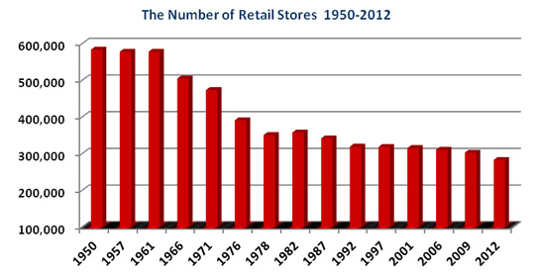
Figure 1: Number of Retail Stores in UK
Source: (Turner and Gardner, 2014).
In the meantime online retail business has taken the place of retail stores and the growth of online retail stores in UK has seen an upward trend after the recession of 2007-08. The graph presented below regarding annual growth rate of online retail shopping indicates that the customer preference for online shopping is expected to grow in coming periods.
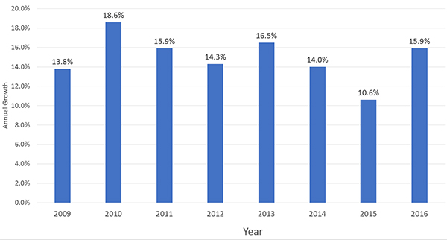
Figure 2: Annual Growth of Online Shopping
Source: (Ahmed, 2016).
There is an inverse relationship between growth of online retail shopping and growth of high-street retail stores. As the number of online retail shopping increases number of high-street retail stores decline. In the last ten years, while online shopping has observed growth above 10% each year, inversely physical retail stores have observed shut down of operation. £133 billion were spent by customers on online shopping in 2016. A study has found that in 2017, an average of 15 retail stores have been closed because of increased popularity of online shopping in UK. The graph presented below shows the number of openings and closers of high-street retail stores and the graph indicates that more stores were closed in last 6 years than opened across UK.
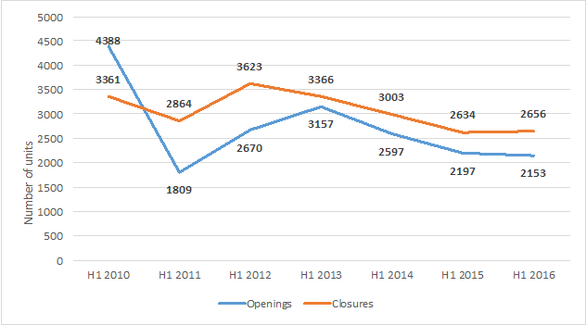
Figure 3: Opening and Closer of High-Street Retail Units
Source: (Hubbard, 2016)
The data presented above clearly indicates high-street retail stores are losing their attractiveness to the customers while online shoppers are gaining popularity in UK market. Forecasts made by popular market research organizations also indicates that there will be further decline in number of high-street retail stores and increase in number of online shoppers (Resnick et al., 2014).
Potential reasons behind such a scenario are presented below found from different researches conducted in the past:
The first and foremost reason is shift in customer purchase behaviour from high-street retail stores to online stores. The change did not come in a day. Instead this was a gradual development supported by decrease in income level of customers, increase in working hour, and increase in national living cost (Hubbard, 2017). After the recession of 2007-08, the consumers became more aware of their spending pattern and looked for alternative mediums to purchase daily necessaries, clothing and other products and services at a reduced rate. This is the time when the discounters emerged and started selling products and services using the internet. The products were sold at reduced price and delivered directly at home which increased customer convenience and therefore customers started making decision in favour of online shops and started skipping visit to high-street retail stores (Fletcher et al., 2016).
Second reason behind the decline of high-street stores in UK is increased government taxes and fees charged by owners who provide lease for those stores. The online stores and high-street stores are subject to different tax bracket that is in favour of online stores but against the high-street stores (Rhodes, 2014). As a consequence, the retailers are forced to make further investment in high-street stores. For instance, Marks and Spencer has decided in 2014 that they would stop building new clothing store and instead they will go online that has low government taxation and no fee is needed to be paid to landlord (Dawes and Nenycz-Thiel, 2014).
Third reason is the price difference between high-street retail stores and online shops. For a similar product the customer has to usually pay more in a high-street retail store than one has to pay in an online shop (Bradshaw, 2017). This is because the retail store has to adjust fixed costs associated with the maintenance of the retail stores, pay the employees and provide fees to the landlord which is not required in case of an online store. Online stores only pay the employees which are very low in number in comparison to number of employees working in a physical retail store. Hence increased cost forces high-street retailers charge more for similar product. But changed customer purchase behaviour increased popularity of online stores as people became more prone to savings. Fixed cost of setting up a new high-street store was also on the rise (Retaileconomics.co.uk, 2017).
Fourth reason is the changed business strategy of most retailers. Major retailers like Tesco, Asda, Marks and Spencer and Sainsbury’s have undertaken businesses strategies focusing more on internet based business to counter the threats emerging from discounters who are major beneficiaries of rising popularity of internet based business. Besides, the cost of operating online business is much less expensive and more customer oriented and therefore the business strategies of major retailers were in support of closing high-street units and focus more on online shopping to cope with changing purchase behaviour of the consumers (Imrg.org, 2017).
Fifth reason is the increased digital awareness of customers is making it difficult to attract and bring customers directly to the stores. Most customers nowadays have access to the internet and they are well aware of the offers, promotions and availability of products and services online. Besides, the facility to order 24/7 and collect products and services according to the preference of the customers has made online shopping an attractive way of managing time to shop efficiently. The customers are well aware of their purchase behaviour and shops they visit which makes it easy for them to make purchase decision in favour of online stores as they can easily know whether the product or service they are seeking available or not. This reduces both time and cost of shopping (Ruddick, 2017).
Sixth reason is the lack of adequate space in city centres and commercially and economically viable business areas for the high-street store owners. It was found that in important city centres, there is lack of adequate parking space, raising charges of parking and increased demand for those spaces by motorists and fellow competitors. This is forcing the companies to move business out of city centres and establish stores in less attractive places which do not generate adequate revenue for the company. Physical stores are also subject to high decoration and other fixed cost which is not required in case of online stores as a well-designed website is all needed to conduct business online. Therefore the competitors are shifting their preference towards online business (Hall, 2017).
Seventh reason is the frequency of discounts and promotional offers made by online stores are higher than that of high-street stores. This is done to attract more customers. Customers are made aware of such promotional offers through e-mails and messages by online shops as they have the customer data. This is not possible in case of most physical stores as they have to take longer time to make such decision and undertake marketing action to let the customers know about such offers. As a result, customers remain well aware of discount offers and promotional offers offered by online stores more than in case of high-street stores (Bradshaw, 2017).
These are the major reasons explained above why there is increased popularity of online stores among the customers while are paying less visit to high-street retail stores.

Findings and Conclusion
From the discussion made above through presenting facts and figures related to increased popularity of online stores and decreased visit of customers to high-street retail stores, the writer has found that online shopping is replacing high-street stores through providing more customer value for the time and money spent by customers on online stores. Increased popularity of online shopping is supported by increased customer purchase behaviour in favour of online shopping that is the outcome of changed income and saving pattern in UK after the recession of 2007-08. Besides, online shopping provides more flexibility to the customers through giving them the opportunity to order anytime they want and chose any form they would prefer to receive the products and services they order. The study also found that online shopping is less costly and promotional offers made are much attractive in comparison to high-street stores. On the other hand, high-street stores are closing down at a rapid rate and the shutdown is expected to continue in coming days due to increased cost of establishing and maintaining such stores and lack of government support through tax incentives and other benefits offered to the online stores. Besides, major retailers are also changing their business strategy in favour of online shopping that is accelerating the decline in number of high-street stores across UK.
Hence the writer can conclude that, completion of the assignment has provided a greater understanding of why there is increase in customer preference for online shopping over paying visit to high-street retail stores in UK through the information provided in the assignment.

References
- Hubbard, P., (2017). The ‘Death’of the High Street. In The Battle for the High Street (pp. 15-44). Palgrave Macmillan UK.
- Ahmed, U., (2016). Marks & Spencer: A Global Expansion to Acquire Lost Momentum?. In Market Entry in China (pp. 61-72). Springer International Publishing.
- Hubbard, P., (2016). The Battle for the High Street: Retail Gentrification, Class and Disgust. Springer.
- Fletcher, G., Greenhill, A., Griffiths, M. and McLean, R., (2016). The social supply chain and the future high street. Supply Chain Management: An International Journal, 21(1), pp.78-91.
- Rhodes, C., (2014). The retail industry: statistics and policy. House of Commons Library www. parliament. uk/briefing-papers/sn06186. pdf.
- Turner, J.J. and Gardner, T., (2014). Critical Reflections on the Decline of the UK High Street: Exploratory Conceptual Research into. Handbook of Research on Retailer-Consumer Relationship Development, p.127.
- Resnick, S., Foster, C. and Woodall, T., (2014). Exploring the UK high street retail experience: is the service encounter still valued?. International Journal of Retail & Distribution Management, 42(9), pp.839-859.
- Dawes, J. and Nenycz-Thiel, M., (2014). Comparing retailer purchase patterns and brand metrics for in-store and online grocery purchasing. Journal of Marketing Management, 30(3-4), pp.364-382.
- Bradshaw, J. (2017). Online retail booms as high street struggles. [online] The Telegraph. Available at: http://www.telegraph.co.uk/business/2017/01/08/online-retail-booms-high-street-struggles/ [Accessed 5 Nov. 2017].
- Butler, S. (2013). John Lewis to extend online shopping empire via thousands of corner stores. [online] the Guardian. Available at: https://www.theguardian.com/business/2013/feb/21/john-lewis-online-shopping-collect?INTCMP=ILCNETTXT3487 [Accessed 5 Nov. 2017].
- Hall, J. (2017). The real reason our shops are shutting up. [online] Telegraph.co.uk. Available at: http://www.telegraph.co.uk/finance/newsbysector/retailandconsumer/10084175/The-real-reason-our-shops-are-shutting-up.html [Accessed 5 Nov. 2017].
- Harvey, F. (2017). Kingfisher chief warns of store closure over online firms' tax advantage. [online] the Guardian. Available at: https://www.theguardian.com/business/2013/mar/04/kingfisher-warns-of-store-closures [Accessed 5 Nov. 2017].
- Imrg.org. (2017). UK online sales exceed £130 billion in 2016, fuelled by sales growth on smartphones - IMRG. [online] Available at: https://www.imrg.org/media-and-comment/press-releases/uk-online-sales-in-2016/ [Accessed 5 Nov. 2017].
- O'Carroll, L. (2013). City must wake up to digital growth, says tech investor. [online] the Guardian. Available at: https://www.theguardian.com/business/2013/mar/01/city-wake-up-digital-investor [Accessed 5 Nov. 2017].
- Retaileconomics.co.uk. (2017). UK Retail Stats and Facts | Retail Economics. [online] Available at: https://www.retaileconomics.co.uk/library-retail-stats-and-facts.asp [Accessed 5 Nov. 2017].
- Ruddick, G. (2017). Britain's high streets under strain as 15 shops close every day. [online] the Guardian. Available at: https://www.theguardian.com/business/2016/oct/25/britains-high-streets-under-strain-as-15-shops-close-every-day [Accessed 5 Nov. 2017].
- www.pwc.co.uk. (2014). UK Total Retail Survey Findings 2013 Overview. [online] Available at: http://www.pwc.co.uk/industries/retail-consumer/total-retail/uk-total-retail-survey-findings-2013-overview.html [Accessed 5 Nov. 2017].

