Catherine Angharad Ford

Student ID 1650242

Course Illustration BA

“If we insist on telling children that everything in the garden is lovely, we’re doing them a disservice.” (Browne quoted in Crown, 2009,p.12). Analyse the work of the illustrators and, particularly, author illustrators who tackle difficult, sensitive and sometimes shocking themes.

Word Count - 2464

Children’s books are almost always drowning in sunshine and rainbows, and everyone is always happy. At the end of each story is a happy ending, where the prince saves the princess, and they live happily ever after in a castle surrounded by maids and piles of gold and jewels. Or when the toad crosses the road in Toad’s Road Code and safely gets to the other side in one piece, skipping and jumping out of the way of the oncoming traffic. In the real world, that is simply not the case. In reality, the princess wouldn’t be saved by the prince. It instead would be from the help of a highly paid lawyer. The toad would not have crossed the road safely to the other side, he would instead be squished into the tread of a vehicles tyre. This focus on the positive can give an unrealistic look into how difficult and hard life can be for some many people. It could cause children to ask the question of why their life is not like it is these books.
I will be focusing my research on how picture books help children to deal with grief. A topic that even as adults is a difficult subject, it is even more so when it comes to children and helping them comprehend the death of a loved one and to then deal with those emotions.
“Children assume, as we all do, that our everyday life will continue with its familiar routines. However, when their world is turned upside down by bereavement, their lives are irrevocable changed and will never be the same again”
(Mallon, 2018, p8)
For decades the range of emotions that we go through when grieving were set into five stages of grief created by Elisabeth Kubler-Ross “The five stages – denial, anger, bargaining, depression and acceptance- are a part of the framework that makes up our learning to live with the one we lost” (Kubler-Ross and Kessler, 2014 p7) Kubler set the initial structure of the stages of grief and how we should deal with it. There was a lot of criticism surrounding this structure in later years. “The theory could neither be empirically validated nor did it prove useful in making care plans for hospice patients” (Klass,2005).
There is now a better understand of the emotions that people go through when grieving and that there are no set stages. Pearce discusses this in The Public and Private Management of Grief after speaking to both councillors and those being counselled for grief she states. “Furthermore, emotions and grief were described as having a life of their own and be resistant to being managed.” ( Pearce, 2019, p123). Thus far discussion is based on how grief is dealt with from an adult’s point of view but when discussing the issue with a child this make the issue a lot more complicated. When it comes to children a softer approach needs to be taken. “So often adults rely on the prevailing myth that children are too young to grieve. When a child is capable of loving, he is capable of grieving.” ( Goldman et al , 2017, p19). What better way to discuss grief with a child than to use a book. Using both text and illustration to help them come to terms with what they are going through.

Focusing on two different books, the first being Susan Varley’s Badgers Parting Gifts, the second Tom Tinn-Disbury’s Lost In The Clouds. These two books approach dealing with grief in similar ways, that the person who has passed is still with you. Lost In The Clouds looks as the emotions that come with grief and how the child ties those feelings in with the weather. Badgers Parting Gifts depicts Badger’s realisation that he will soon die and how his friends learn to come to terms with his death through the things Badger taught them, Badger living on through them because of the knowledge and teaching he bestowed upon them. Although both books are similar and look at how the person has passed lives on through memory and teachings, they approach the subject in slightly different ways, both through the text and the illustrations.
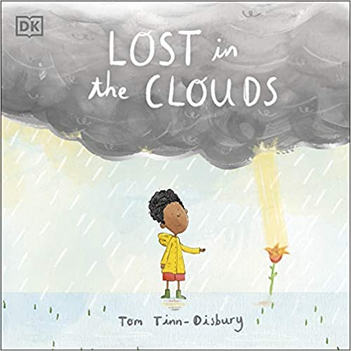
Fig. 1. Lost in the Clouds, Tom Tinn-Disbury, 2021.
The cover of Lost in the Clouds encapsulates the entirety of the book, and the mess of the emotions which comes with grieving. The darkness of the clouds that are above them appear heavy and daunting. Only slightly above his head as if they were almost crushing. Just underneath the cloud is a sky which appears as a soft blude but already a hint of yellow making the sky appear not so stormy after all. Then there is a slight break in the clouds with a beam of sunlight which hits a flower in full bloom. Illustrating that there is a growth and beauty in what is happening. There is a silver grey detail added across the bottom of the clouds, this shows a silver lining in all of the emotions that the child is feeling. There is no doom and gloom which looms on the cover, no use of any words relating to death or grief which could be helpful if the subject is very hard to initial approach.

In Molly Bang’s Picture This: How Pictures Work, Bang investigates how the same shape can evoke a different emotional reaction depending on the context. Band states “We feel very differently about the triangle if we see it as a sailboat than we do if we see it as a shark’s fin” (Bang, 2016). The same shape but with different context changes the emotion we can feel towards that shape. Tinn-Disbury uses a similar theory for the weather in Lost In The Clouds. A small change in the colour of the weather completely changes not only the child figures mood but the dad’s mood also. When the weather is clear and bright the child feels that his mum has created this weather for him to have fun with his dad. In the illustration you can see that the father and son are both very close together both physically and emotionally. Both are engaging in the same activities together. This is shown in the illustration on pages five and six, comparative to pages seven and eight.

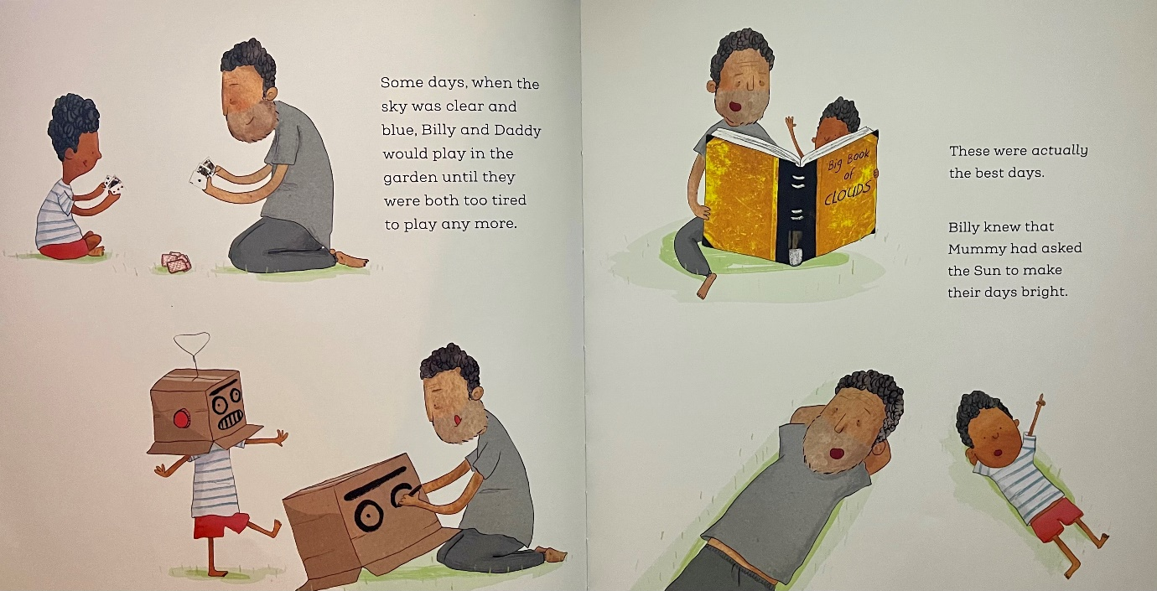
Fig.2 Lost in the Clouds, Tom Tinn-Disbury, 2021, pp 5-6.
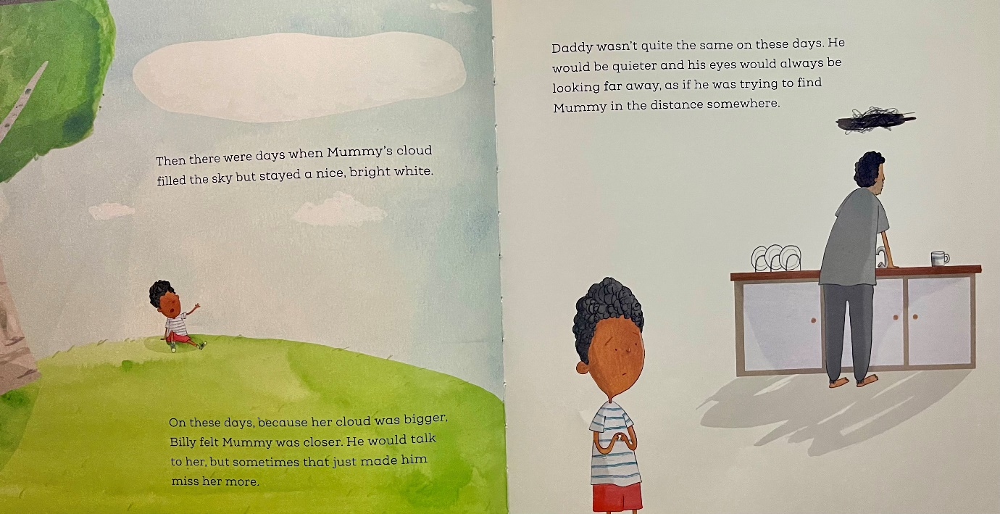
Fig.3. Lost in the Clouds, Tom Tinn-Disbury, 2021, pp 6-7.
Compared to when the weather is sunny, the father and son appear to have a hard time spending time together. This creates the feeling of there being this unspoken sadness that is separate to the grief that they are both feeling. The child is looking at his dad from distance in page seven. The boy is illustrated with his arms close to his chest and playing with his fingers, creating a feeling of anxiousness. This illustration also creates the sense of longing to be comforted by his dad, with the dad looking away from the child. There is a lot of empty space in the illustration compared to the other pages which are filled with either the landscape and surrounding environment in the illustrations, or with multiple different illustrations of the father and son together. This empty space again creates even further space between the two characters in the book. Although you cannot see the dad’s face, there is a black scribble above his head. This shows that although the dad is looking away there is a lot that is racing through his mind. The scribble also holds resemblance to a black cloud which again ties in the weather to how the dad is feeling. This black scribble is used again when Tinn-Disbury is showing that the child is having experiencing similar emotions to his dad.
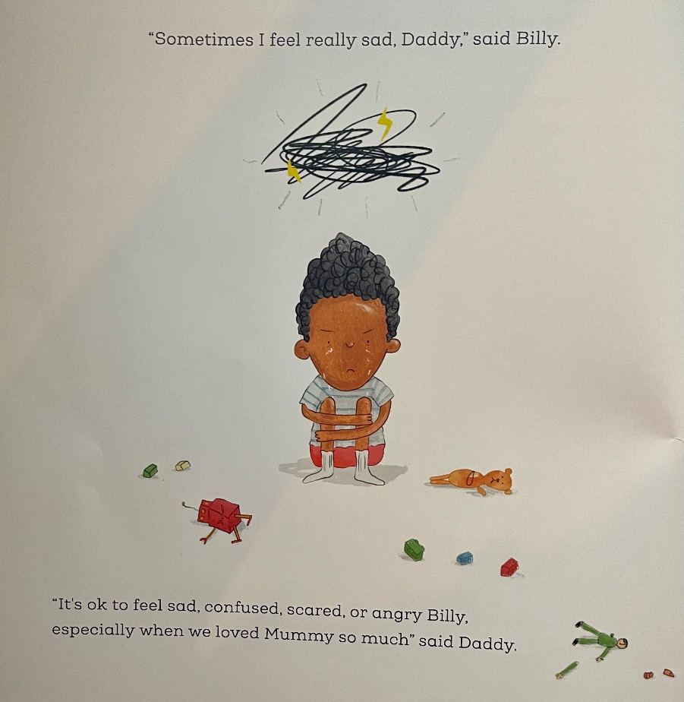

Fig.4. Lost In The Clouds, Tom Tinn-Disbury, (2021) pp23
These similar scribble illustrations create an unspoken connection in between the father and son, which may have been harder for a younger reader to pick up through words. They would be able to notice the similarities in the illustrations creating that emotionally connection. Again, showing the lack of illustration that is surround the boy whilst he is feeling this way is very similar to how we see the dad earlier on in the book, however in this illustration of the boy we can see that there are toys scattered around him on the floor, appearing to have been thrown around him in a display of emotion. These toys are not close to him, and neither is he holding onto them in a way most children would for possible comfort, further expressing a feeling of loneliness.
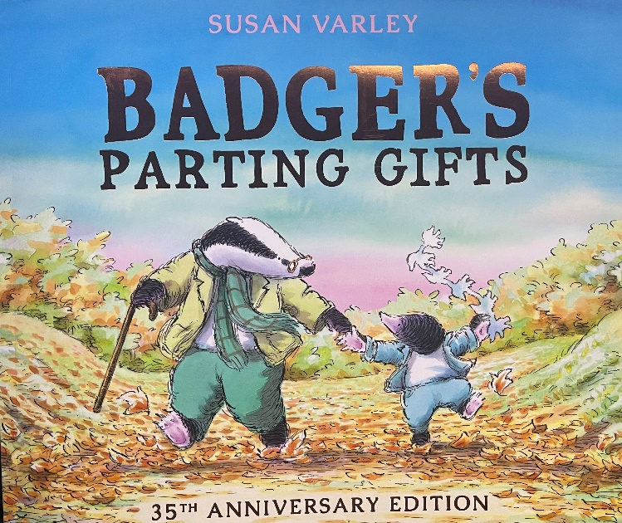

Fig.5. Badgers Parting Gift, Susan Varley, (2013) pp Cover
As with Lost In The Clouds, the cover for Badgers Parting Gift, has not got any negative illustrations on the cover of the book to suggest that the book is in fact about death. The cover is quite the opposite. There is a bright blue sky with a possible soft pink sunset, this leaning towards to fact that the sun is setting on Badgers life, but there is again no negativity surrounding that. We can see Mole holding onto Badgers hand, skipping along the path. In his other hand there is a paper chain, we later learn in the book that it was in fact Badger who taught Mole how to create paper chains. Just from the cover we can tell that Mole and Badger are very good friends and there is a lot of happiness that is created through the use of the colour palette being very soft and colourful. Varley has created this soft and appealing cover to be inviting towards children.
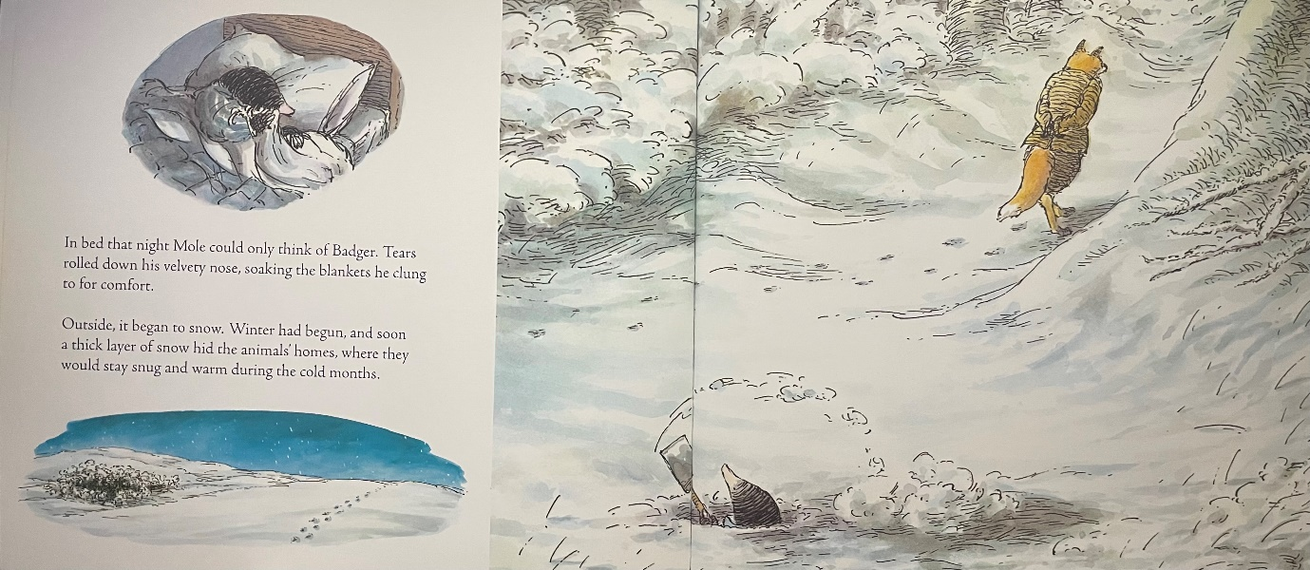
Fig.6. Badgers Parting Gift, Susan Varley, (2013) pp 10-11.
In the above pages we start to see Varley’s use of the changing seasons to describe the characters grieving process. The winter months being very cold, and often lonely for everyone. The illustration on these pages shows Mole on his own with Fox walking away from him. Varley explains the use of the seasons in an article written for the with Book Trust.
“In the book, I used the seasons to emphasise the passage of time. Having grieved in the dark days of winter, the spring – a time for new beginnings – heralds the start of the animals beginning to remember and celebrate the life of their much-loved friend”
(Varley, 2019)
Due to the winder months the and the snow covering the ground we can see that there is one set of footprints walking away from where mole is. This again furthering that sense of being alone, there are no footprints then coming back to visit. Also, although mole is illustrated as being tucked up in an attempt to keep warm from the harsh weather, it can also be seen as a way of him trying to comfort himself in the form of a hug and a closeness from the blanket. A closeness that he has lost since the passing of his friend.

More recently children have been impacted not just by the changes that have come with the COVID-19 pandemic lockdowns, but with the many deaths that have come with it. In a writing for the Journal of Psychosocial Nursing & Mental Health Services Sullivan explains that
“Storytelling allows children to gain an understanding of emotional reactions. In a tale, a character’s response allows children to gather insight into the way others might respond.”
(Sullivan, M 2021)
The books detailed above do that by being able to speak to the reader about the difficulties whilst using something that they know such as the weather in Lost In The Clouds, or with he use of the seasons in Badger’s Parting Gifts. Children are taught about the weather very early in their education. This can provide a sense of understanding through a familiarity that is otherwise not seen to be connected to the death of a loved one. Salisbury and Styles discuss the difficulty in communicating topics with children through picture books in Children’s Picturebooks: The Art Of Visual Storytelling stating “The younger the child, the harder it is for them to express the nature of their response” (Salisbury and Styles 2012). From the use of the weather and seasons there it creates a simplicity to the grieving process for younger children. Instead of using terms such as denial and depression as Kubler-Ross originally did decades ago. Tinn-Disbury and Varley use the simplicity of the change in weather from a clear beautifully sunny day to the cold harsh months of winter to help children understand the way they are feeling and that those feelings are normal and do pass, as well as come back around again. Creating a sense of understanding and being able to make the child who is grieving feel normal and more of an understanding of the process that is grieving for a loved one.
There is great importance to children’s pictures discussing death and grief to being easily accessible to children. There is a feeling that comes with grief that you are the only one feeling that way and being unsure on how to express those emotions. Books such as the two above, create a starting point for those difficult discussions. Through the illustrations they can find similarity and inclusion in how they are feeling.

Bibliography
Mallon,B. (2018) Building Continuing Bonds For Grieving and Bereaved Children. London: Jessica Kingsley Publishers.
Kubler-Ross,E and Kessler, D (2014) On Grief and Grieving: Finding the Meaning of Grief Through the Five Stages of Loss. UK: Simon and Schuster
Klass,D. (2005) Elisabeth Kubler-Ross : Facing Death. Volume 45, Issue 3, pp 426-428 Available at: https://academic-oup-com.ezproxy.uwtsd.ac.uk/gerontologist/article/45/3/426/553201 (Accessed: 2 December 2021)
Pearce,c. (2019) The Public and Private Management of Grief. London : Palgrave Macmillan
Goldman,L . et al. (2017) Creating Inclusion and Well-Being for Marginalized Students. London : Jessica Kingsley Publishers
Fig. 1. Tinn-Disbury,T. (2021) Lost In The Clouds. London: DK Children, Cover Page , illus.
Bang,M. (2016) Picture This : How Pictures Work. San Francisco: Chronicle Books LLC
Fig. 2. Tinn-Disbury,T. (2021) Lost In The Clouds. London: DK Children, pp 5-6, illus.
Fig. 3. Tinn-Disbury,T. (2021) Lost In The Clouds. London: DK Children, pp 6-7. illus.
Fig. 4. Tinn-Disbury,T. (2021) Lost In The Clouds. London: DK Children, pp 23. illus.
Fig.5. Varley,S. (2013) Badgers Parting Gift. UK: Andersen Digital, pp Cover. illus.
Fig.6. Varley,S. (2013) Badgers Parting Gift. UK:Andersen Digital, pp 10-11. Illus.
Varely,S. (2019) ‘I Just hope that it can help’: Susan Varley on her iconic book about grief, Badger’s Parting Gifts. Available at: https://www.booktrust.org.uk/news-and-features/features/2019/march/i-just-hope-that-it-can-help-susan-varley-on-her-iconic-book-about-grief-badgers-parting-gifts/ (Accessed: 4 December 2021)
Sullivan, M. (2021) The Use of Storytelly With Grief Reactions in Children During the Covid-19 Pandemic. Available at https://www.proquest.com/docview/2482760081/fulltext/A4F5F24CE22949C0PQ/1?accountid=130472 (Accessed on 5 December 2021)
Salisbury, M and Styles,M. (2012) Children’s Picturebooks : The Art of Visual Storytelling. UK: Laurence King Publishing.

