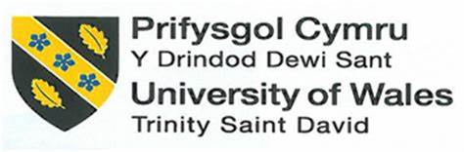

REFLECTION ON MY LEARNING IN THIS MODULE

Student Name | Bianca Ioana Terza
Student Number | 2009067
Module Number | BMSW4001_LON
Module Title | Academic and Employability Skills
Lecturer Name | Barbara Chinyani
Date on submission | 4th of January 2021

Table of Contents:

- Introduction page 3
- Reflection Model page 3
- Academic and Employability skills page 4
- Topic A; Reflection page 4
- Topic B; CV Writing page 5
- Topic C; Analytical and Critical Thinking skills page 7
- Conclusions page 8
- Appendix page 9
- References page 10

1.Introduction
In this report, I will be analysing my understanding of three different topics examined in class during the first term at the University Trinity St. David. I will start with an investigation about Reflection, followed by a research on CV Writing, concluding with a study on Analytical and Critical Thinking Skills. This is a reflection where I will be comparing my knowledge before attending the course to the one I gained and I will consider which is the impact that the findings have on my professional development by using Gibbs model of reflection.
2.Reflection Model
The reflection model I will be using for writing this report is Gibb's Reflective Cycle.

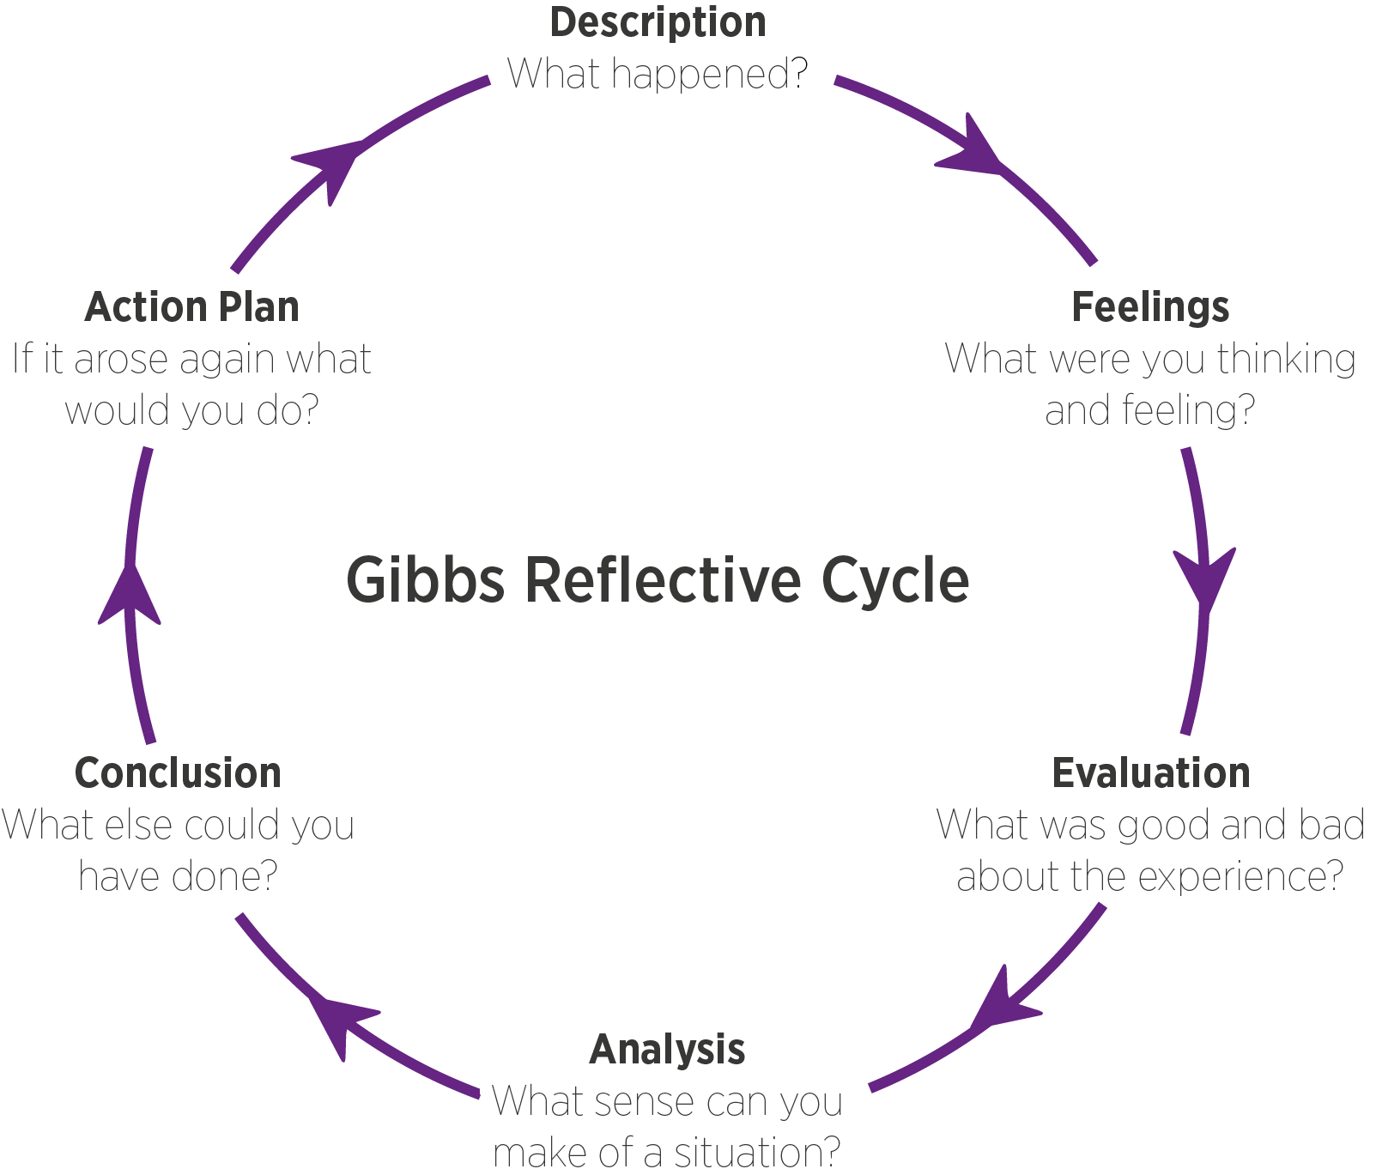
In 1988 Graham Gibbs affirms that “it is not sufficient simply to have an experience in order to learn. Without reflecting upon this experience it may quickly be forgotten, or its learning potential lost. It is from the feelings and thoughts emerging from this reflection that generalizations or concepts can be generated. And it is generalizations that allow new situations to be tackled effectively.”
He created a 6-stage reflection model to analyse the experience itself and the feelings which took place during and after the event, studying the fact in depth. We start with an evaluation of the episode and how we felt and thought about it. We consider all the outcomes and give an analysis of the situation, we determine what could have been done differently and at the end, we elaborate an action plan for future necessities.
This will be the module of reflection I will use for the report due to its structure, easy to understand and apply. The emphasis given to the feelings would help me to understand how situations can be influenced by emotions and the suitability makes it applicable to all the topics I will be analysing.

3.Academic and Employability skills
The academic skills encourage the students and give them the confidence to face the challenges introduced by the institutions, they are highly transferable and necessary for future careers (Cleeve, 2018). The employability skills are those needed in every job, considered general skills, they include the soft skills (which facilitates the interaction with others) and the professional skills (which helps your professional development). These skills are also transferable due to the suitability in any industry (Doyle, 2020).
In this report I will be focusing on Reflection, analysing how it helps the self-awareness, CV Writing, providing my one using the structure I will study in the specific paragraph, and I will conclude with Analytical and Critical Thinking Skills, the ensemble of skills that brings to a judgment through a mental process.

4.Topic A; Reflection
In one of his works Dewey (1933, .118) define reflection as an “active, persistent and careful consideration of any belief or supposed form of knowledge in the light of the grounds that support it and the further conclusions to which it tends”. That led to the creation of different models which helps the personal development through an analysis of an experience (the University of Leeds, n.d.). There are different models of reflection beside Gibbs’, which I already discussed.
Name | Stage number | Names of stages | Positive aspects | Negative aspects
Kolb (1984) | 4 | - Concrete experience  - Reflection  - Conceptualisation  - Active experimentation | The module is focused on the development and it encourages in-depth self-reflection. | May be considered too simplistic and based only on the learner’s perspective.
Schon (1991) | 2 | - Reflection in action  - Reflection on action | It is flexible and less time-consuming, suitable for practitioners. | Being a two-stage module, it does not provide guidance for in-depth reflection.
Driscoll (1994) | 3 | - What?  - So what?  - Now what? | The module is easy to apply and remember. | It focuses more on the analysis of the situation and not on the learner.
Johns’ Model (2006) | 5 | - Description of the experience  - Reflection  - Influencing factors  - Could I have dealt with it better?  - Learning | The internal/external analysis allows a better understanding of the experience. | The set of questions in each group may not be enough for the study of the event and it can be time-consuming.
(Essay Writing Service, n.d.). (OT MSC Student, 2016).

My concept of reflection was quite limited and vague. I was trying to understand what happened and what was the cause for it to avoid facing the same problem, or an akin one in the future. I felt uncomfortable when I learned about the variety of modules which allows a deeper investigation of the event and feelings I experienced. Now I am relieved, the reflection is a fundamental step in a personal growth journey. It allows us to have a deep consideration of our surroundings, it makes us reflect on the facts and our perceptions, thoughts, and our behaviour after the situation. It gives us the chance to come to a conclusion and create a plan of action for the time being, in order to get prepared for a similar event and prevent it.

5.Topic B; CV Writing
In one of his articles, Gerencer (2020) explains that CV (Curriculum Vitae) is an acronym for “Course of” and “Life”. In Europe, a CV should not be longer than two pages and it should include the contact details, a profile (the persons’ key attribute and career aims), the education, the work experiences, the skills and achievements, and, if relevant, the interests. The CV should be tailored for the different circumstances and in general look professional, clean. It is important to be concise and free from spelling mistakes, the CV writer should be honest, avoid being generic and if there are any, explain the gap years. (Smith, 2019)

Type of CV | Description of the CV
Chronological CV | The chronological CV matches the candidate’s work experiences with the job role they are applying for. To facilitates the employer selection the applicant’s background should be in reverse order, with the most recent position first listed. It is important to specify the dates, qualifications, and skills. The candidate should avoid the gap years or explain them if present.
Skills-based CV | A skills-based CV, also known as a functional CV, can be used to cover gap years in the employee’s work history. It can be used if the candidate has limited experience or is applying for a position that is not related to their degree. The CV focus on the candidate skills and developments.
Academic CV | The academic CV shows the candidate’s educational achievements. It should be including teaching experience, research activities, or publication roles; it is suitable for research-based roles. It should also highlight specialist skills and future developments.
Teaching CV | The teaching CV should include all the teaching experience of the candidate, counting the volunteer positions as well. There should be listed relevant skills like IT knowledge, leadership, or language skills, but also relevant roles in campuses.
Technical CV | In the technical CV, the introduction paragraph should mention all the technical experiences and the candidates’ skills. The employee should have knowledge of the existing software but also be able to develop a new one thanks to their technical abilities. Problem-solving skills and communication skills are also required for IT positions.
Law CV | Also known as a legal CV, this CV is useful for training contract positions, it should include relevant electives and awards but also highlight the work experiences in legal or/and commercial roles. The legal CV should have attached the cover letter where the career ambitions are explained.
Video CV | Mainly used for customer-facing positions or creative roles in marketing, media, and sales, the Video CV helps the candidate to stand out by showing their personality and creativity, it should be between two and three minutes long and show proofs of the employee’s works. It may be time-consuming, and it requires technical equipment but it will demonstrate the candidate’s skills during the process.
(Smith,2019)
The CV is the first impression that employers have on the candidates, it must be professional and tailored for the role in order to get noticed by recruiters and employers. In the beginning, I was struggling to create an efficient CV, gathering the appropriate information was stressful and laborious yet the main difficulty was structuring the resume. It was complicated to organize the facts I collected into a CV that would have drawn attention to my abilities. Now, with all the material and advice I received during the course I am able to identify what is useful and create a CV that helps me with job hunting.

6.Topic C; Analytical and Critical Thinking skills
Critical Thinking is the ability to think logically, understanding the connection between the events, and come to conclusions via a mental process. (Skills you need, 2020)
Critical thinking | Critical Thinking is the mental process that allows one to evaluate information and interprets them to make a judgment.
Analytical thinking | Analytical Thinking is the ability to break down difficult information into basic principles.
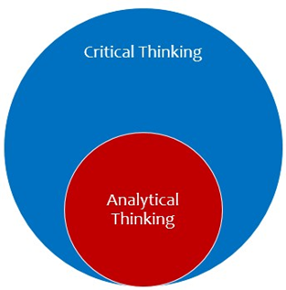
(The Peak Performance Center, 2020)

As we can see, while Critical Thinking is an ensemble of skills necessary for personal development, they include Analytical Thinking skills, which allows deeper analysis of the problems to find solutions.
In her article, Doyle (2020) explains the difference between Critical and Analytical Thinking comparing them to inductive and deductive reasoning. She says that “inductive reasoning is an approach to logical thinking that involves making generalizations based on specific details”. An inductive argument supports the conclusion thanks to detailed information. (The Critical Thinking Co. Staff, 2008). The inductive reasoning requires different skills, like attention to detail, the ability to make predictions, and the ability to understand the emotions that leads people to act (Doyle, 2020). These skills are included in the Analytical Thinking skills. Deductive reasoning typically moves from general truths to specific conclusions (The Critical Thinking Co. Staff, 2008), some of the skills needed are, teamwork, customer service, and problem solving, (Indeed Career Guide, 2020) which are considered Critical Thinking skills.
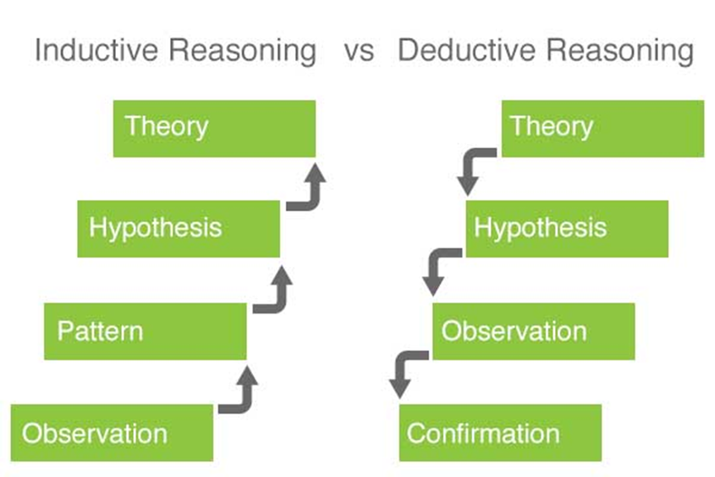

Inductive Reasoning is considered a Bottom-Up reasoning while Deductive Reasoning is a Top-Down reasoning.
Before starting this module, I found difficulties in making a distinction between Critical Skills and Analytical skills, when I started learning about them, I felt ashamed, for that, I start researching about the differences coming across the Inductive/ Deductive Reasoning which helped the comprehension of the topic. Both Critical and Analytical Skills are fundamental for any professional career, they allow an understanding of the problems and lead to a solution and support personal development.

7.Conclusion
After analysing in detail the topics, I gained extra knowledge on them. I learned that using a reflective method allows me to get a deeper understanding not only of the situation I am analysing by also of the feelings I had during and after the process. I discovered the huge impact that emotions have on the intellectual development each of us has. I gained experience in CV writing, I get the foundation in order to master the creation of a good and professional summarizing of my abilities, and I understood how to structure all the information resulting competent and skilful. I then realized the meaning of Critical and Analytical skills, which were mixed up in my mind, allowing me to classify them when and which I should use depending on the situation.

8.Appendix
Here is a copy of my current CV.
Bianca Ioana Terza
07366282842 ¦ terza.bianca.25@gmail.com
Professional goals
Expand my knowledge, train in different sectors and gain experiences thanks to my enthusiasm and my motivation.
Education
University of Wales, Trinity Saint David (2020 – 2021) Certification in Higher Education: Skills for the Workplace (Health and Social Care)
ITC-Gobetti Marchesini-Casale-Ardino (Turin, Italy; 2014)
Experience
PMC Wellington Hospital | London (2019 – 2021)
I have worked as catering assistant in the hospital, taking care of the patient’s needs.
Kettner’s Townhouse |London (2018 – 2019)
I have worked as a waitress in the restaurant, improving the interaction with the customers.
Tax Advice | Italy (2014 – 2015) School Training

I have worked as assistant and secretary for the office’s employees, learning about the tax politics.
Personal Skills
- Romanian and Italian fluently spoken.
- Good knowledge of French.
- Basic knowledge of Spanish.
- Good computers skills.
- Basic knowledge of business and political economy.

9.References
- Cleeve, R (2018), 5 academic skills to prepare your students for higher education, available at: https://www.english.com/blog/academic-skills-for-higher-education/ [Accessed on 29.12.2020]
- Doyle, A. (2020), What Are Employability Skills, available at: https://www.thebalancecareers.com/employability-skills-list-and-examples-4143571#:~:text=Employability%20skills%20are%20sometimes%20called%20foundational%20skills%20or,solve%20problems%20and%20fit%20into%20any%20work%20environment. [Accessed on 29.12.2020]
- Doyle, A. (2020), What is Inductive Reasoning?, available at: https://www.thebalancecareers.com/inductive-reasoning-definition-with-examples-2059683 [Accessed on 30.12.2020]
- Essay Writing Service UK, (n.d.), Driscoll Model of Reflection, available at: https://essaywritingserviceuk.co.uk/advice-and-guidance/driscoll-model-of-reflection {Accessed on 29.12.2020]
- Essay Writing Service UK, (n.d.), Johns’ Model for Structured Reflection, available at: https://essaywritingserviceuk.co.uk/advice-and-guidance/johns-model-of-reflection [Accessed on 29.12.2020]
- Essay Writing Service UK, (n.d.), Kolb Reflective Model, available at: https://essaywritingserviceuk.co.uk/advice-and-guidance/kolb-reflective-model [Accessed on 29.12.2020]
- Essay Writing Service UK, (n.d.), Schon Reflective Model, available at: https://essaywritingserviceuk.co.uk/advice-and-guidance/schon-reflective-model [Accessed on 29.12.2020]
- Gerencer, T. (2020), What Is a CV? Definition (Curriculum Vitae Meaning and Use), [Blog] Zety, available at: https://zety.com/blog/what-is-a-cv [Accessed on 30.12.2020]
- Indeed Career Guide, (2020), Deductive Reasoning: Definition and Examples, available at: https://www.indeed.com/career-advice/career-development/deductive-reasoning [Accessed on 30.12.2020]
- My World of Work, (n.d.), How to write a CV, available at: https://www.myworldofwork.co.uk/getting-job/building-cv [Accessed on 30.12.2020]
- OT MSC Student, (2016), Guide to models of reflection – when & why should you use different ones?, available at: https://lifelonglearningwithot.wordpress.com/2016/05/02/different-models-of-reflection-using-them-to-help-me-reflect/ [Accessed on 29.12.2020]
- Roberts, C. (n.d.), Using Reflective Writing in Your Teaching: A workshop for STEM Disciplines WORKSHOP NOTES, available at: https://www.heacademy.ac.uk/system/files/downloads/hea_guide_-_using_reflective_writing_in_your_teaching.pdf [Accessed on 29.12.2020]
- Skills You Need, (2020), Critical Thinking Skills, available at: https://www.skillsyouneed.com/learn/critical-thinking.html [Accessed on 30.12.2020]
- Smith, J. (2019), Create a great video CV, available at: https://www.prospects.ac.uk/careers-advice/cvs-and-cover-letters/create-a-great-video-cv [Accessed on 30.12.2020]
- Smith, J. (2019), Example CVs, available at: https://www.prospects.ac.uk/careers-advice/cvs-and-cover-letters/example-cvs [Accessed on 30.12.2020]
- Smith, J. (2019), How to write a CV, available at: https://www.prospects.ac.uk/careers-advice/cvs-and-cover-letters/how-to-write-a-cv [Accessed on 30.12.2020]
- Smith, J. (2019), Top 7 CV mistakes, available at: https://www.prospects.ac.uk/careers-advice/cvs-and-cover-letters/top-7-cv-mistakes [Accessed on 30.12.2020]
- The Critical Thinking Co. Staff, (2008), Guide To Inductive & Deductive Reasoning, available at: https://www.criticalthinking.com/articles/induction-vs.-deduction [Accessed on 30.12.2020]
- The Peak Performance Center, (2020), Analytical Thinking and Critical Thinking, available at: https://thepeakperformancecenter.com/educational-learning/thinking/critical-thinking/analytical-thinking-critical-thinking/ [Accessed on 30.12.2020]
- University of Leeds, (n.d.), What is Reflection?, available at: https://www.sdduonline.leeds.ac.uk/reflection/what-is-reflection/ [Available at 29.12.2020]
- University of Leeds, (n.d.), Why Reflect?, available at: https://www.sdduonline.leeds.ac.uk/reflection/why-reflect/ [Accessed on 29.12.2020]

