
INTERNATIONAL MARKETING

MODULE CODE: LCMB7006
STUDENT ID: 2133400
NAME OF THE STUDENT: RUPAL PATEL
LECTURER: TUSHARA BALENDRAN

Table of Contents
Introduction 2
Company Background 2
Macro Environment 2
PESTLE Analysis 3
Environmental Scanning 8
Environmental Analysis 8
Porter’s Five Forces 9
SWOT Analysis 11
STP 14
Marketing Mix 17
Directional Development Strategy (DDS) 22
BCG Matrix 22
Product life cycle 24
Strategies in the Maturity stage of the PLC 25
Conclusion 26
Recommendations 27
TOWS Analysis 27
References 28

Introduction
Czinkota, et al. (2011) explained that international marketing is the process of planning, marketing and trading goods and services across different countries to fulfil individuals and organisations' needs. It not only includes export and import of products and services but also joint ventures, strategic alliances, management agreements, business operations, direct investment and collaborations of companies operating at national and international levels (Gillespie and Swan, 2022).
The focus of this assignment is to evaluate the similarities and differences in the market, marketing strategies and directional development of Marks and Spencer (M&S) and its fast fashion product-line present in two different countries, i.e., in the United Kingdom (UK) and in India.

Company Background
Marks and Spencer Group Plc is a leading British retail brand that was established in 1884 by Michael Marks and Tom Spencer in Leeds, UK. In this market, it offers excellent quality and great value apparel, food and home décor and furnishing products to its customers across the globe (M&S, n.d.). In addition, the company also provides banking and financial service and renewable energy service through its M&S Bank and M&S Energy divisions respectively (Global Data, n.d.). There are over 1487 stores of M&S operating in 100 international markets around the globe (M&S, n.d.). Further, it operates as a retail and franchise business both in the national market of the UK and in the international market of Europe and Asia (Forbes, n.d.).
M&S had penetrated the Indian market in 2001 and had formed a joint venture with Reliance Retail in 2008. In this market, the company mainly offers clothing and homeware products to its Indian customers. Currently, there are 96 stores of M&S functioning in 33 cities across India (LinkedIn, n.d.).

Macro Environment
According to Gamble, et al. (2014), the macro environment comprises all the broader forces that are present in the external or outer environment of the organisation and that either provides major opportunities or pose threats to that organisation. It is important for the management of M&S to analyse these forces, as shown in Fig. 1, when making strategic decisions related to marketing on a global platform (Hooley, et al., 2012).
Figure 1: Macro- Environment of M&S
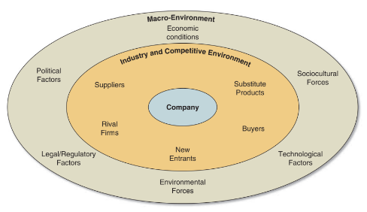
M&S
P
E
E
S
T
L
Source: Hooley, et al. (2012).

PESTLE Analysis
PESTLE analysis is a strategic framework that can be used by the marketers of M&S to examine the Macro-environment and to identify the potential risks and opportunities present in that environment (CIPD, 2021). As shown in Fig. 1, PESTLE stands for -
Political factors
According to the UK fashion and textile association [2022], Brexit is a major political force that has significantly impacted the business of M&S. Due to it, the brand had to close 11 out of 20 franchise stores in France, pull out 600 range of products from its Ireland stores, and suffer increasing costs related to tariff, administration and supply chain (McCambridge, 2022; Gowans, 2021; Daily Sabah, 2021). As a result, British-based M&S had to face huge losses making the international European business unfavourable for the business.
Political corruption and bribery are the major issues in India with a corruption index of 60 and 30% bribery share in 2022. Further, India had ranked 86 in comparison to 180 countries in Transparency International Corruption Perceptions Index of 2021 (WorldData.info, 2022; Gov.UK, 2021). These factors make the Indian market unfavourable for M&S as they may not only hinder the establishment and effective development of the business but may also impose additional business risk which may require careful management (Singh, 2021).

Economic factors
Increasing rate of inflation (10.4% in February 2023) and high cost-of-living crisis in the UK has resulted in denting sales, high energy bill, and increased price of goods and raw materials, along with 7% fell in market shares of M&S (House of Commons Library, 2023; Linsell, 2022; Onita, 2022; Denton, 2022). Additionally, making the current UK economic situation highly unfavourable for the business.
On the other hand, The World Bank (2022) had forecasted that India’s economy will grow by 6.5% for 2023 which can prove favourable for M&S to conduct business in the Indian market.

Social/Cultural factors
In order to analyse whether the social factors, in the UK and Indian market, are favourable or unfavourable for the business of M&S, this report will consider the Hofstede model. According to Usunier and Lee (2013), this model is an effective tool to understand the cultural differences across the UK and India and their impact on the organisational setting and functioning. Additionally, Hofstede Insight (2022) explained that cultural differences exist between different segments due to differences in cognitive thinking and social control.

Hofstede Model
Figure 2: Hofstede Cultural Dimension: Comparison between the UK and India
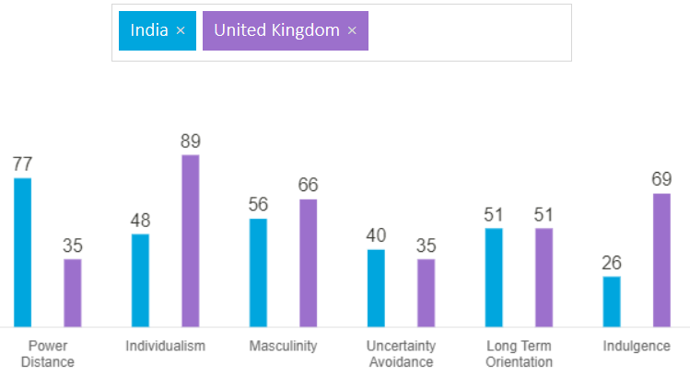
Source: Hofstede Insight (2022)
Hofstede model helped to analyse cultural differences between the UK and India based on 6 parameters (See Fig. 2). Based on the outcomes of the model, it can be analysed that power distance is the highest influential factor (77) in India. This indicates that within an organisation, the major power is held by the managers at the higher designation and the employees are expected to follow them. The communication is one-way (from management to employees) and no feedback is considered from employees to management (Hofstede Insight, 2022). However, this parameter is lowest (35) among the British employers as they believe in equal and fair treatment of all the employees. This shows that employees of M&S may have a favourable work environment in the UK than in India.
In terms of individualism, India scored 48 whereas the UK had scored 89. This indicates that Indians are both collective and individualistic, while British are highly individualistic and private people. The decisions of Indians are majorly influenced by their friends and family members, whereas British prefer making their own decisions based on their unique needs (Hofstede Insight, 2022). Therefore, when designing marketing strategy in India, M&S can focus on word of mouth advertising, whereas in the UK the company needs to cater to each customer’s needs based on his/her persona (Keller, 2013).
The masculinity score of both the countries illustrate that they have high scores (India-56 and UK-66) on masculine parameter and low on feminine. According to Hofstede insights (2022) the important aspect here is that both British and Indians are highly competitive, goal oriented and work towards achieving success. In such masculine society, M&S can rely on its workforce to achieve organisational success.
Similarly, with regards to uncertainty avoidance, both India and the UK have a medium low (40) to low score (35) respectively. As explained by Hofstede Insight (2022) both Indians and British are not rigid people and instead look forward to innovation and new ways of doing things, especially the British. Thus, there is a high probability that the innovative fashion products of Marks and Spencer will be readily accepted in both the Indian and the UK market.
India as well as the UK are normative countries and this is evident from their equal score (51) on long-term orientation parameter. This means that both the countries believe in their own culture and are highly attached to their traditions and norms. Therefore, when designing the marketing strategy as well as the product-line, M&S should take both the countries’ culture into consideration.
With regards to indulgence parameter, British (69) scored higher than Indians (26) which signifies that the former tries to control their desires and needs more than the latter ones. As a result, it may be difficult for M&S to identify the needs and wants of its UK customers which may further make it difficult for them to satisfy their needs (Todorova, 2015). On the other hand, Indians can be easily attracted and persuaded towards M&S fashion products as their needs will be readily satisfied by the company (Todorova, 2015).
Overall, the Hofstede model is an effective tool to understand different cultures and diversity across borders. It helps marketers to overcome any culture-related barriers when expanding their business. Further, it helps people to build a strong bond and work in collaboration on national and international platforms for increased business stability (Li, 2010). However, this model overlooks ethics and therefore it is not considered accurate by most researchers. Also, the Hofstede model is outdated and it may not fit the current technologically advanced world where the perspectives and behaviours of people have revolutionised (Li, 2010).

Technological factors
Currently, technology is advancing at a fast pace in the external market of both the UK and India (Science and R&D Industry, 2022; Sabanoglu, 2022). Disruptive innovations, such as artificial intelligence, machine learning, virtual and augmented reality, etc. are bringing in new ways of doing businesses (Perri, 2022). Using these technologies M&S can offer seamless buying experience to its customers, improve its products and services, and optimise business operation and processes (Yili, 2023). Thus, the current technological advancement is highly favourable for M&S operating in the UK as well as the Indian market.

Legal factors
In the UK, there are strict laws pertaining to consumer data protection, marketing, and human rights and equality (Gov.UK, n.d.; Equality and Human Rights Commission, n.d.). It may prove unfavourable, if M&S fails to adhere to these regulations and if there is any breach in consumer data, unlawful marketing practice and inequality or discrimination practiced by M&S, it may have to face heavy penalty and even the closure of the business in extreme case (HM Revenue and Customs, 2023).
In the Indian market, starting a new store or expanding the business may be unfavourable and challenging for M&S due to hostile government regulations for the foreign businesses with regards to expanding or obtaining a property (Brannon, 2021).

Environmental factors
According to McFall-Johnson (2020), the fashion industry globally contributes 10% of carbon emissions. They produce an increasing volume of clothes that negatively affects the planet. In the UK, 2 tonnes of clothes are imported every minute which produces around 50 tonnes of emissions (Algamal, 2019). While in India, around 7800 kilo tonnes of waste is generated annually by the fashion industry (Fashion for Good, 2022). Furthermore, it is anticipated that emissions from the fashion industry would increase by 2030 to 50% (Ellen MacArthur Foundation, n.d.). Therefore, it is important for M&S, in both the UK and India, to follow sustainable business practices, like reducing waste and saving their resources, in order to increase the sustainability of their business, community and environment as a whole (Algamal, 2019).
Although PESTLE analysis is an effective tool to analyse the favourable and unfavourable factors affecting a business, the marketers should know that these factors constantly change with the change in the external environment (Alon, et al., 2020). Therefore, it is essential for M&S’s marketers to continuously scan and analyse its external environment in order to design effective responsive strategies that can increase its success and sustainability in the fluctuating market condition (Blythe and Martin, 2019).

Environmental Scanning
Czinkota, et al. (2011) described environmental scanning as a process of reviewing the factors in the external environment that directly impacts the internal business operations so that effective business decisions can be made. By scanning the external environment, M&S can gain constant information about the political, economic and social matters in the national and the international environment, changes in the attitude and behaviour of the consumers and possible opportunities in the global market (Alon, et al., 2020). Hollensen (2013) further explained that the accuracy and precision of the environmental scanning is based on the purpose of the scanning, like just to gain information or to increase the profitability of the business. With regards to M&S, it should constantly scan the data from World Bank, United Nation and US Census Bureau to get real-time and trustworthy information about the social, economic, political and other demographic factors of the international market (Czinkota, et al., 2011).

Environmental Analysis
According to the Indeed Editorial Team (2023), environmental analysis is a strategic method used by the marketers to identify internal and external factors in the surrounding environment of an organisation that impacts its performance. Internal factors refer to the existing strengths and weaknesses of the organisation, whereas external factors are the potential opportunities and threats in the external environment of the organisation. M&S can conduct environmental analysis to examine the market attractiveness so that it can create effective future marketing strategies for its national and international businesses (Doole and Lowe, 2012). M&S can use various tools like PESTLE (as described before, Porter’s 5 forces analysis and SWOT analysis to thoroughly analyse external and internal factors.

Porter’s Five Forces
This is another effective tool that M&S can use to understand the industry where it operates, to identify the profitability of that industry so that appropriate market entry and exit decisions can be made, and to analyse the impact of five forces (See Fig. 3) on the industry’s profitability so that necessary changes can be made to increase the profitability (Hollensen, 2014).
Figure 3: Porter’s Five Forces
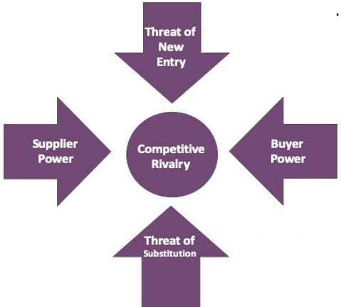
Source: Adapted from Hollensen (2014)
Threat of New Entry (medium): In both the UK and Indian market, new entrants in fashion retail industry may set-up new ways of doing things or introduce new innovation or enter the market with low products which can put pressure on the well-established business of M&S (Ramdass and Pretorius, 2011). However, to give tough competition to M&S, the new entrants may require huge capital (around £50,000 in the UK and at least 100,000 rupees or £1,000 in India) to start a new business (Company House, n.d.; Nagi, 2017). Although, in Indian market, it is possible for the new entrants to start home-based business and avail cheap labour which gives them pricing advantage, M&S, on the other hand, has gained considerable brand recognition and customer loyalty which may be difficult for the new entrants to match (India Filings, n.d.; Ainsworth, 2018).

Threat of Substitute (low): In the UK, the substitute for M&S’s fashionable garments include vintage apparel, whereas in India, the company’s products can be substituted for sarees and kurtas (Ahmed and Faroque, 2017). However these products may not be able to completely replace the uniquely designed fashion products offered by M&S. In addition, M&S uses environment-friendly materials, like recycled polyester and nylon as well as 100% cotton to manufacture their apparel and this can help to meet the current consumers’ demand for sustainable products (Jordan, 2022). According to McKinsey’s survey, 67% of consumers prefer purchasing eco-friendly fashion products (Granskog, et al., 2020).

Supplier Power (medium): M&S has a large number of suppliers (105 in India and 17 in the UK) which gives the power to the company to negotiate over price (Smith, 2022). However, the company completely relies on the key suppliers for its good quality fast fashion products which increases their bargaining power (SAID Business School, 2017). Nevertheless, the growing fast fashion trend, which is expected to globally raise over $200 billion by 2030 (Adegeest, 2021), pressurises the suppliers to create products quickly and at low cost, and this further reduces the bargaining power of the suppliers.

Buyer Power (high): Customers in both the UK and Indian market have considerable options, on both online and offline platforms, for buying fashion apparel (Rita, et al., 2019). Due to this, it is easy for them to find a good deal, compare costs, and make appropriate buying decisions as per their needs and requirements. Moreover, due to high social media usage (61.67 million in the UK and more than 900 million in India in 2022), consumers can share information and influence other customers with regards to products and price and this further gives them high power to bargain (Dixon, 2022; Basuroy, 2022; Tian and Jiang, 2018).

Competitive Rivalry (high): In the UK, M&S faces tough competition from Primark, Zara, Next, New Look, Matalan, River Island, Asos, etc., whereas in India its biggest competitors are H&M, Zara and the local brands like Pantaloons and Max (The Guardian, 2020; Rai, 2019). In both the markets, there is intense competition between the fashion brands to increase their market share. In addition, the growth of online channels have further intensified the competition, as brands on the e-commerce platform can reach global audiences with their vast product-line (Rosário and Raimundo, 2021). Besides, the rise in fast fashion, that continuously introduces new style and fashion, contributes to the competitive rivalry in the industry (Adegeest, 2021).

SWOT Analysis
SWOT analysis can help M&S to analyse its internal strengths and weaknesses and to identify the significant external elements that can affect it and its market (See Table. 1). In addition, by aligning the internal strengths and weaknesses with the external opportunities and threats, M&S can formulate effective marketing strategies (Hooley, et al., 2012).
Table 1: SWOT Analysis
Strengths
UK | India
- Supermarket of the year 2022’ by @WhichUK Magazine (Clarke, 2022)  - Well-recognised and reputed brand  - Strong omnichannel strategy (multiple communication and buying options) (M&S, n.d.)  - Diversified business dealing in food, clothing, and home division, as well as in banking and energy segment (Global Data, n.d.)  - Committed to sustainability (M&S Group PLC, 2022)  - History of innovation, example, textile research lab (1934), innovative garments requiring minimal washing and ironing (1950), range of loyalty card schemes (World Business Research, 2023) | - ‘India's Best Companies to Work for 2023’ by Great Place to Work (GPTW) Institute (GPTW, n.d.)  - Well-recognised and reputed brand\  - strong omnichannel strategy (Indian Retailer Bureau, 2022)  - Business segment consists of apparel and homewares only (LinkedIn, n.d.)  - Committed to sustainability (M&S, 2022)  - Partnership with Tata Consultancy Services (TCS) to improve core business and to increase resilience (Indian Retailer Bureau, 2023)
Weaknesses
UK | India
- Increasingly rely on the UK market may affect business during economic fluctuation and change in consumer behaviour  - Brand perception affected as young generation regard it as old-fashioned and unappealing (Hardcastle, 2021)  - Decline in profit before tax (24%) in the Half-Year 2022 (Davey, 2022) | - Less presence in India (96 stores) as compared to the UK (1,035) and European market (430 stores) in 2022 (LinkedIn, n.d.; Smith, 2022; M&S, n.d.)  - Youngsters has a perception that the brand is for ‘mommies’ (Sahni, 2019)  - No food segment present in India (Indian Retailer Bureau, 2022)  - Expensive brand for Indian consumers (Qamar, 2018)
Opportunities
UK | India
- Expansion in international market across UK and Ireland  - Maximise growth in e-commerce business  - Introduce more sustainable and innovative fashion products and business process  - Opportunity to partner and collaborate with different companies to expand business and customer base | - Expansion in many cities across India  - Maximise growth in e-commerce business  - Introduce more sustainable and innovative fashion products and business process  - Besides TCS and Reliance, opportunity to partner and collaborate with different companies to expand business and customer base
Threats
UK | India
- Face tough competition from well-known fast fashion brands like H&M, Primark, Zara, etc. (The Guardian, 2020)  - Increase inflation (9.1%) and cost-of-living crisis post Covid-19 and Brexit (Partington, 2022)  - Supply chain disruption may occur due to political issues, increased taxation, or natural catastrophe  - Wrong perception of the brand amongst youngers may decrease their young customer base  - Change in consumer behaviour and demand for increasing sustainable products at affordable price (Jordan, 2022) | - Face tough competition from well-known fast fashion brands like H&M, Primark, Zara, etc. as well as from local brands like Pantaloons, Zudio and Max (Rai, 2019)  - Labour shortage in India (Mohanty, 2022)  - Supply chain disruption may occur due to political issues, increased taxation, or natural catastrophe  - Wrong perception of the brand amongst youngers may decrease their young customer base  - Change in consumer behaviour and demand for increasing sustainable products at affordable price (Jordan, 2022)

Source: Author’s Creation

STP
STP is an acronym for Segmentation, Targeting and Positioning and it is a framework (See Fig. 4) used by the marketers to effectively position a company’s products and services in a specific market in order to target the right customers (Doole and Lown, 2012).
Figure 4: STP Model
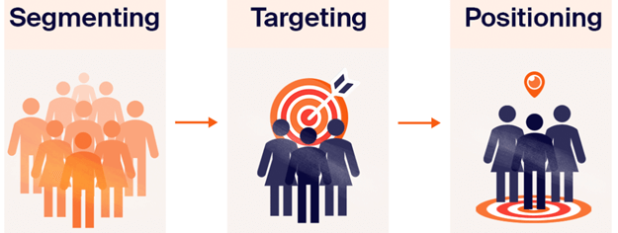
Source: Doole and Lown (2012)
Segmentation
Segmentation is a marketing strategy to separate the market into different segments or groups of customers based on their common characteristics (Hollensen, 2013).
The customer base of M&S, across its UK and Indian market, was identified as those over 50 years and specifically women population (58%) (Rigby, 2017; M&S, n.d.). In the UK, M&S customers are segmented into ‘occasional’ (22 million), ‘core’ (7 million), and ‘top’ (3 million) categories, along with an additional ‘super group’ of customers that purchase M&S clothing 86 times annually (Sky News, 2017). Furthermore, there were around 406 million customers in the year 2021/22 that visited M&S for clothing and home purchase (Smith, 2022).
In India, M&S focuses on customers over 35 having high income status and in executive position. In addition, the company also targets Gen Z and millennial groups by reducing the price (Kumar, 2019).

Targeting
Targeting is a marketing practice to focus on that particular segment of consumers with the company's resources and marketing efforts to gain maximum market penetration (Hollensen, 2013).
In the UK as well as the Indian market, M&S uses differentiated targeting strategy. According to (Wheeler, 2017), in this strategy a company designed distinctive marketing activities to target two or more segments or groups of customers that have high potential value for the company. Using this strategy, M&S targets customers, especially women over 30 years, as well as the millennial and Gen Z crowd for its fashion clothing segment (Rigby, 2017, Smith, 2022).

Positioning
Positioning is an approach taken by the marketers to create a perception or an image of the brand or its offerings in the minds of the target audiences (Doole and Lown, 2012).
M&S follows a competitive positioning strategy in both the UK and Indian market. Indeed Editorial Team (2022) stated that competitive positioning is the marketing approach used to distinguish or differentiate a brand or its offering from its competitors. M&S uses the ‘exceptional quality’ and ‘style’ as the most distinguishing factor to position its fashion products in both the UK and the Indian market. The main focus of the company is on the quality of its product (M&S, n.d.) Its fashion products are made from excellent fabrics and 100% cotton, for instance, its cotton t-shirt has ‘STAYNEW’ finish feature that requires less washing. Additionally, ‘Ascolite’ button technology is used across its coat and jacket range that prevents it from falling off (M&S, n.d.). With regards to style, the brand introduced new editions based on the season and the current fashion trend in both the markets.
Moreover, in India the ‘premium price’ of a brand's quality products is another key factor that distinguishes it from the local (Pantaloons, Zudio and Max) and global fast fashion brands like Zara and H&M.
M&S’s competitive positioning in comparison to its competitors in the UK as well as in India can be illustrated through following perceptual maps:
Perceptual Maps for M&S Competitive Positioning
Figure 4: Competitive Positioning in the UK market

High Price





High Quality
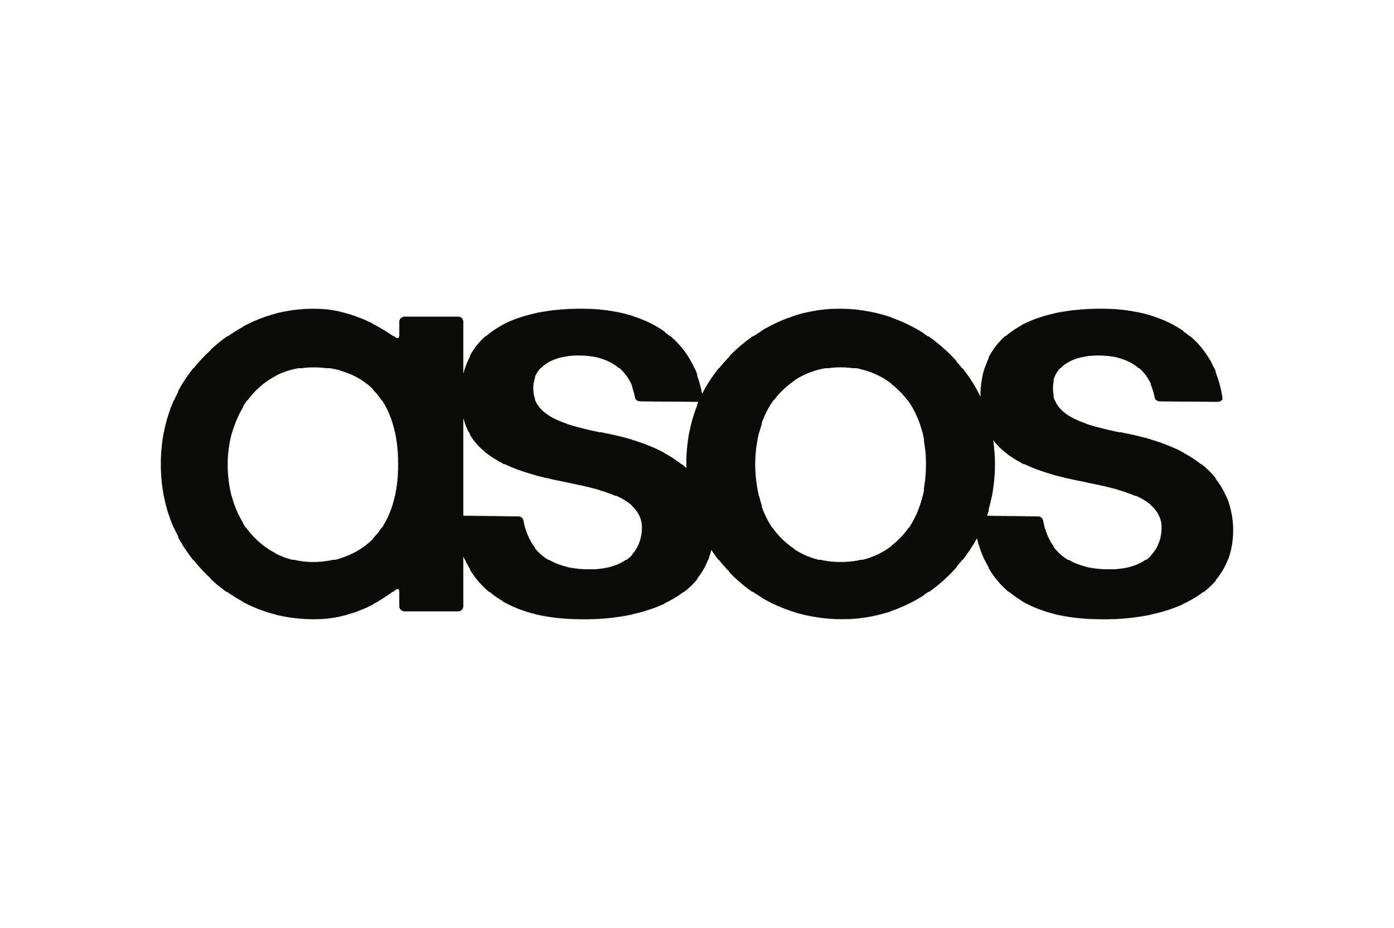
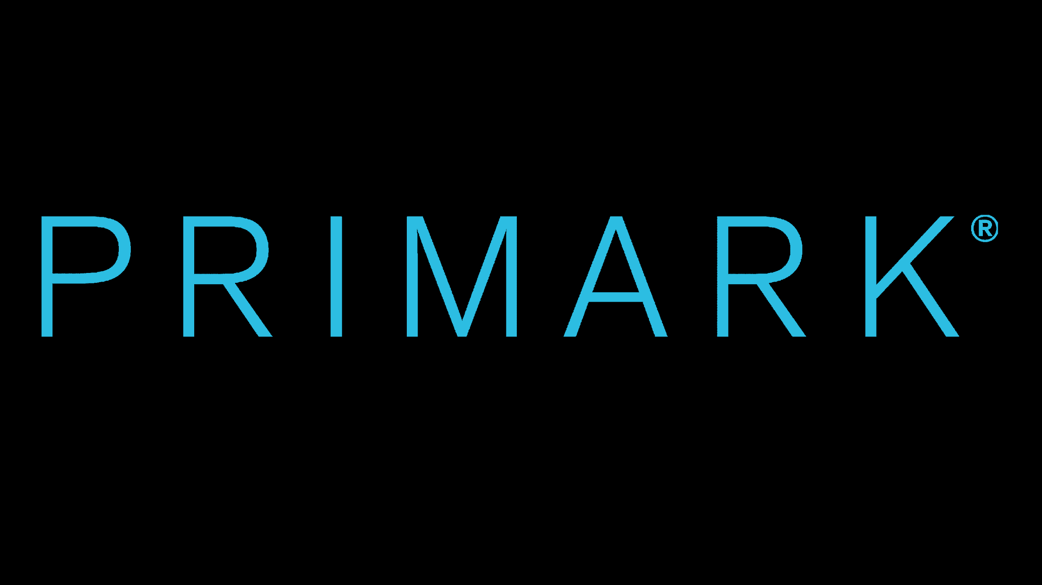
Low Quality


Low Price

Source: Author’s Creation

Figure 5: Competitive Positioning in Indian market
High Price


Low Quality
High Quality




Low Price

Source: Author’s Creation

Marketing Mix
Marketing mix is a combination of 7Ps marketing elements (See Fig. 5) which the company uses to convert its marketing strategies into actions (Hooley, et al., 2012). Considering these elements when planning marketing activities can help M&S to attract more consumers and to increase its sales (Goi, 2009).
Figure 5: 7Ps of Marketing Mix
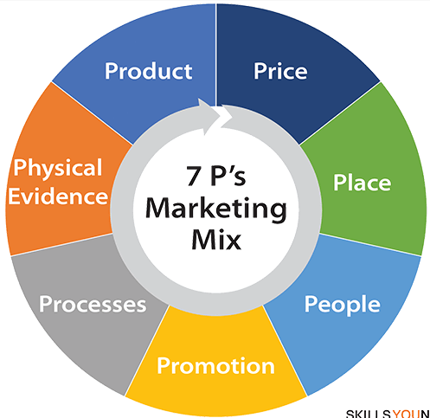
Source: Goi (2009)

Product
M&S uses family branding or corporate umbrella branding strategy, in both the UK and Indian market. This means that it uses a single brand name, as a differentiator, for its wide product range (Czinkota, et al., 2021), which includes women’s and men’s wear, children apparel, home accessories and lingerie. Additionally, M&S uses brand extension strategy in the UK, which refers to using its well-recognised brand name for its new product categories (Czinkota, et al., 2021), consisting of food products, and energy and banking services.

Price
Competitive pricing and price skimming are the two effective strategies considered by M&S in the UK as well as the Indian market. According to Pride and Ferrell (2021), competitive pricing is when a company sets high or low prices for its products based on the pricing of the competitor’s products. Although, M&S does not offer low prices for its products, they closely observe the competitors’ price and accordingly set a strong value proposition, as a main differentiator from its competitors (Innes, 2022). Pricing skimming strategy is used more frequently by M&S in India, wherein the company initially sets high prices for its fashion products and then gradually lowers the price over time to gain maximum customers’ attention (Schindler and Schindler, 2011). For example, to attract young consumers, M&S in India had once lowered the price of its women’s and men’s wear by 20% (Kumar, 2019).

Place
It refers to the location where the company’s products are distributed or made available for the customers to find and purchase (Deshmukh, 2023). In the UK market, M&S mostly uses a direct distribution channel which allows its customers to directly purchase its fashion products from M&S stores or websites (M&S, 2023).
Further, Deshmukh (2023) stated that place also refers to the geographical location, like city, state or international market from where the consumer can avail the brand’s products. In order to distribute the products to the Indian customers, M&S had first entered the market in 2001 through a franchise agreement with Planet Sports India (Bhardwaj, 2001). According to Wirtz and Lovelock (2016), such agreements occur between two independent and legal companies, wherein the franchisee (Planet Sports India) gets the right to promote and sell franchisors (M&S) products and services under its (M&S) brand name. However, later in 2008, M&S had formed a joint venture (JV) with Reliance Retail to start ‘Mark and Spencer Reliance India Private Limited wherein 51% stakes remained with the parent company (M&S) (M&S, n.d.). Guo (2015) explained that a JV is a business agreement between two or more companies that work together and share their resources to achieve a common goal.
In the Indian market, M&S distributes its fashion products through direct as well as indirect channels. Ferrell, et al. (2021) explained that indirect distribution happens when the products are transferred or sold from the manufacturer to the wholesaler or the retailer before it finally reaches the customers. Direct channels of M&S’s product distribution include its offline as well as the online stores, whereas indirect channels include online third-party distributors, such as Myntra, Amazon, Ajio and Flipkart. This shows that the company uses a selective distribution strategy and focuses on distributing its fashion products through specific online retailers (Ferrell, et al., 2021).

Promotion
The promotional activities of M&S, in both India and the UK, majorly includes advertising, digital marketing and sales promotion.
In the UK, M&S did not invest in advertisement until 2000 when its first television campaign was aired (Cozens, 2000). Since 2018, the company has aggressively focused on digital marketing strategy and has promoted its brand and the fashion clothing on various digital channels, like TikTok, Instagram, Twitter, Facebook, etc (Dutta, 2020). It also promotes on various customer channels, such as print media, newspapers, and billboards on high streets of the UK (M&S, n.d.).
Similarly, in India M&S’s first campaign, “rethink”, was launched in 2019. It also publishes digital content on various social media platforms, like Facebook, Instagram, and so on (Crossley, 2019).
Sales promotion is frequently used by M&S in India as well as the UK. The company in both the countries run seasonal sales, special offers and discounts on its clothing-line (The Hindu, 2023; M&S, n.d.).

The extended marketing mix
Apart from the above-mentioned 4Ps of marketing mix, Kaushik (2018) explained that there are 7 elements (7Ps) in the extended marketing mix that aid marketers in achieving their marketing objectives (See Fig. 5).

People
People are at the core of M&S’s business and there are around 65,000 people globally working in stores, supply chain, customer service centres and warehouses serving more than 30 million customers annually (M&S, 2022).
In the UK, M&S offers customer service training, vocational training and on-the-job training to the employees, through the TrainingMark program, so that they can deliver outstanding customer service (M&S, n.d.).
In India, Marks and Spencer ensures that the employees have a great place to work and are offered necessary leadership training that will help them to deal professionally with all its customers and promptly attend to their needs and requirements (M&S Plc, 2015).

Process
M&S in India and the UK have digitised its business processes and have enhanced their omnichannel capabilities through software solutions to offer seamless customer shopping experience, for fast delivery of their products, and to manage the call centres. The software also ensures real-time visibility of inventory level so that products are quickly replenished and are available to the customers at all time (Indian Retailer Bureau, 2022; M&S, n.d.).
In the UK, the marketing team of the company constantly researches market opportunities to identify customer needs. Furthermore, helpline services, social media platforms and in store feedback collection processes are used in both India and UK, to better understand the customer needs (Hammett, 2018).

Physical evidence
In both India and the UK, M&S constantly introduces unique and fancy carrier bags with the company’s trademark that not only helps to promote the brand but also to attract customers to the business. For example, in the UK the company had recently introduced stylish and durable 60p bags to carry 15kg of shopping. The colourful new carrier bag had been successful in grabbing the attention of the UK customers (Collis, 2023).
Moreover, Marks and Spencer constantly updates its store layout to help customers easily locate the desired items. For example, M&S stores in the UK and India have separate sections for men, women and kids’ wear as well as for other items, like lingerie, homeware, etc. which makes it easy for customers to navigate through the store (Jefferson, 2022; DFU Publication, 2022).

Directional Development Strategy (DDS)
DDS is defined by (Johnson, et al., 2017) as a plan that a company executes to develop its business, boost its profit and to achieve its goals and objectives. Every organisation, whether large or small, can design its own DDS based on its core business and strategic objectives (West, et al., 2015). There are various DDS that a company can choose to develop in the market. These include Ansoff matrix, BCG matrix, and Porter’s Generic Strategy model (Drummond, et al., 2007). However, for the purpose of this assignment, the BCG matrix will be taken into consideration.

BCG Matrix
This matrix was developed by Boston Consulting Group to analyse the strategic position of a company’s product portfolio and its potential (Lynch, 2006). Lamb, et al. (2011) explained that under this matrix a company’s product portfolio can be divided into 4 quadrants (See Fig. 5) depending on the market growth rate (industry’s attractiveness) and relative market share (competitive position). Wagner (2014) explained that M&S can use a portfolio management strategy or BCG matrix to assess its fashion product-line and to identify if there are any under-valued products that can be developed to maximum potential in order to gain increased profitability.
Figure 5: M&S Product Portfolio Analysis on BCG Matrix
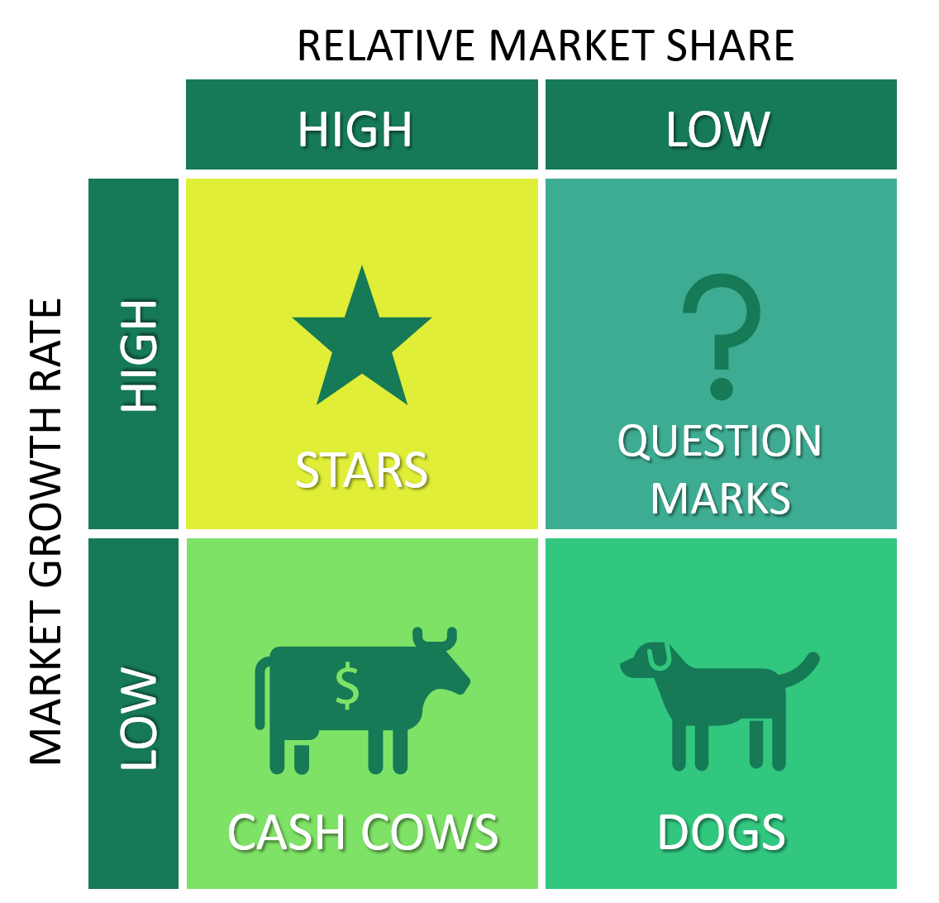
Women’s and men’s wear
Kid’s wear
Lingerie
Premium priced clothes
Source: Adapted from Lamb, et al. (2011)
On the basis of the above analysis, it can be identified that the women’s and men’s wear of M&S occupies ‘Stars’ position due to its high growth rate and high market share in both the UK and Indian market. In India, the apparel market is projected to grow by 3.34% by 2027 (Statista, n.d.), whereas in the UK, it is estimated to reach over £65 billion by 2026 (Smith, 2022). In relation to growth rate, M&S clothing sales in the UK had risen by 8.6% in 3 weeks to December 2022, whereas in India the online sale of the company was around 25% in 2022 (Eley, 2023; Mukherjee and Malviya, 2022).
Like women’s and men’s wear, even children’s wear is anticipated to grow annually by 3.15% in the UK and 2.53% in India (Statista, n.d.). However, currently the children apparel of M&S have relatively low market share and are therefore positioned in the ‘Question Marks’ quadrant. To broaden the growth of this segment, the company needs to revamp them by bringing in new style and design (Abdulla, 2020).
As stated by Kantar World Panel Report, M&S’ bras has a biggest market share of 37.5% in the UK and every 3 in 1 women purchases its bras (Sutherland, 2020). In India, M&S’s lingerie had a significant sales between 2015 and 2017 and are constantly in demand among the Indian consumers (Tandon, 2018). Since these ‘Cash Cows’ products are the backbone of M&S, the company should constantly introduce appealing sets of lingerie to further increase its market share and utilise that fund to develop the Question Marks products to convert them into Cash Cows.
Premium priced clothes of M&S occupies ‘Dogs’ position as in the current market where Primark and H&M (in the UK), and Max and Zudio (in India) are offering affordable and trendy fast fashion clothes, M&S needs to divest high-priced clothes segment as it may not be able to generate enough returns and may even drain the existing resources (Vizard, 2019).

Product life cycle
According to Kotler, et al. (2020) product life cycle (PLC) describes different development stages (Fig. 6) that a product or services navigates through from being new in the market until it becomes old and unsold.
Figure 6: M&S Apparel Products’ Development Stages

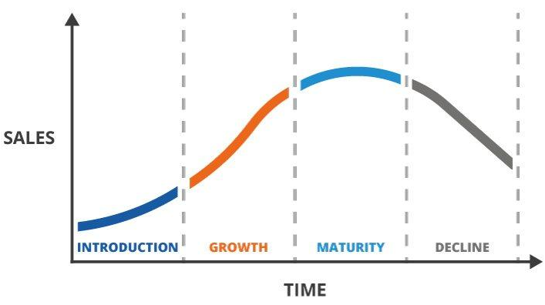
M&S
Source: Adapted from Kotler, et al. (2020)
M&S apparel products in both India and the UK can be regarded as being in their maturity stage as this stage is characterised by increased sales and competition as well as saturation of the market (Spragg, 2017). The sustainable and fast fashion apparel products of M&S offer tough competition to competitors in both the markets in terms of quality (The Guardian, 2020; Rai, 2019). The company achieves quality advantage by using eco-friend raw materials, like cotton and recycled polyester and nylon, for manufacturing its wide range of apparel products (Jordan, 2022). Hodgson (2022) stated that in the UK, quality conscious customers are ready to pay premium price for M&S products as they prioritise good quality over the price and sustainable business practices.
Furthermore, with regards to growth in sales, there was an increase of 8.6% in 3 weeks to December 2022 in the UK, where Indian M&S had seen an increase of 25% in its online sales in 2022 (Eley, 2023; Mukherjee and Malviya, 2022). However, according to the KR Couture report (2020), the Indian market is highly saturated with global fashion brands selling westernised clothes and as a result these brands are making huge profits. Additionally, Chevalier (2022) published that the UK fashion retailers sell their products across different channels making the clothing market highly saturated in the country. In such a situation of increased market saturation, there are high chances of decrease in product demand and sales (Liu and Yang, 2009). Therefore, M&S needs to adopt effective and sustainable marketing strategies to prevent its products from reaching the decline stage in the product life cycle.

Strategies in the Maturity stage of the PLC
To ensure increasing sustainability in the maturity stage of the PLC, M&S needs to adopt increased market penetration and global market expansion strategies (Mosca and Gallo, 2016).
Market penetration strategy
Through market penetration, M&S can attract maximum target audiences and gain their loyalty by offering excellent quality fashion products and good customer service (Mosco and Gallo, 2016). In order to attract price conscious customers, M&S can introduce various offers and discounts from time to time (Meyer and Tran, 2006). Additionally, to attract various market segments the company can use different targeting strategies. For example, to attract the young adults and millennials, M&S can use celebrity endorsement techniques and content promotion on the social media platform as these platforms are highly used by the youth globally (Moreno-Gavara and Jimenez-Zarco, 2016). Further, the company needs to bring an increasing variety of fast fashion that are highly in demand among the current consumers (Mosca and Giacosa, 2016).
Global market expansion strategy
Using this strategy, M&S can enter more international markets and increase the reach of its business amongst global segments (Doole and Lowe, 2012). However, before entering the global market, the marketers of M&S need to thoroughly research the international market and identify the needs, preferences, cultural differences, and various other PESTLE factors in the external environment of the international market that may offer either opportunities or threats to M&S (Paul, 2013). Furthermore, when expanding the business, M&S needs to identify the price consciousness of the market segment since its products are regarded as premium both in terms of price and quality (Hodgson, 2022).

Conclusion
Overall, this assessment helped to gain an in-depth understanding of the Indian and the UK market through PESTLE and Porter’s five forces analysis tools. Using SWOT analysis, a better understanding of M&S internal strengths and weaknesses and external opportunities and threats was gained. The assessment also identified through the STP model that M&S segments its customers based on their demographic characteristics and uses differentiated targeting strategy to segment each individual segment and follows a competitive positioning strategy with major emphasis on the quality of its premium products. Through 7Ps of marketing mix, the brand’s strategy for each of the marketing elements were identified. Further, BCG matrix helped to identify various products of M&S that have high market share value and growth rate and those that are low in these parameters. Lastly, against the PLC stages, M&S’s apparel products were identified in the maturity stage in both the UK and the Indian market.

Recommendations
This section will consider the TOWS analysis tool to offer recommendations to M&S for future growth and profitability.

TOWS Analysis
McGruer (2020) explained that TOWS analysis (See Table 2) is an effective tool through which marketers and companies can first identify and analyse threats and opportunity present in the external environment and assess their internal weaknesses and strengths to make strategic choices on how to minimise the weaknesses/threats and maximise strengths/opportunities.
Table 2: TOWS Analysis of M&S
Internal Factors
External factors |  | Strengths | Weaknesses
External factors | Opportunities | - M&S can use its strength brand recognition and increased brand reputation in other markets as an opportunity to expand in more international markets  - The company’s history of innovation and commitment to the sustainability can aid in designing and introducing more sustainable and innovative fashion apparels  - Its diversified product range and knowledge in the area can be used as an opportunity to partner and collaborate with international companies dealing in same product-line | - Increasing the growth in e-commerce platforms can help M&S to overcome its negative brand perception (old-fashioned and unappealing) amongst the young audiences  - By introducing more sustainable and innovative apparels, M&S can improve its declining sales that was experienced in second half of 2022  - Expansion in more market can reduce the increasing reliance on the UK market
External factors | Threats | - Strong omnichannel strategy and commitment to sustainability can help M&S to face the competitors and achieve a leading position  - Introducing innovative apparel that would appeal the younger segment can help to change their wrong perception about the brand  - Constantly improving the quality and sustainability and offering seasonal discount can help to attract both price conscious and environment conscious customers | - Omnichannel strategy can help to avoid supply chain disruption and minimise the negative impact on profitability  - Global entry strategy can help to minimise increasing reliance on the UK market and use increased brand recognition as a competitive advantage to beat the tough global competitors.

Source: Author’s Creation

References
- Abdulla, H. (2020) ‘M&S shakes up kidswear in effort to grow sales’, Just Style. Available at: https://www.just-style.com/news/ms-shakes-up-kidswear-in-effort-to-grow-sales/ [Accessed 21 April 2023].
- Adegeest, D. (2021) ‘Report: Fast fashion to be worth over 200 billion dollars by 2030’, Fashion United. Available at: https://fashionunited.uk/news/fashion/report-fast-fashion-to-be-worth-over-200-billion-dollars-by-2030/2021112559600 [Accessed 15 April 2023].
- Ahmed, J.U. and Faroque, A.R. (2017) ‘Swadeshi: The strategic collaborative approach between eight competitors in the fashion industry’, Journal of Strategic Contracting and Negotiation, 3(1), pp.20-37.
- Ainsworth, P. (2018) ‘Brand Loyalty Index: M&S Voted Customers’ Favourite Supermarket’, Customer Experience Magazine. Available at: https://cxm.co.uk/brand-loyalty-index-ms-voted-customers-favourite-supermarket/ [Accessed 15 April 2023].
- Algamal, A. (2019) ‘New Shocking Facts about the Impact of Fast Fashion on Our Climate’, Oxfam. Available at: https://www.oxfam.org.uk/oxfam-in-action/oxfam-blog/new-shocking-facts-about-the-impact-of-fast-fashion-on-our-climate/ [Accessed 12 April 2023].
- Alon, I., Jaffe, E., Prange, C. and Vianelli, D. (2020) Global Marketing: Strategy, Practice, and Cases. 3rd edition. New York: Routledge.
- Basuroy, S. (2022) ‘Social media usage in India - statistics & facts’, Statista. Available at: https://www.statista.com/topics/5113/social-media-usage-in-india/#topicOverview [Accessed 15 April 2023].
- Bhardwaj, N. (2001) ‘Marks & Spencer makes debut in Delhi, Mumbai’, The Times of India. Available at: https://timesofindia.indiatimes.com/business/india-business/marks-spencer-makes-debut-in-delhi-mumbai/articleshow/2098963214.cms [Accessed 19 April 2023].
- Brannon, I. (2021) ‘India’s Hostility to Foreign Investment Threatens Long-Term Growth ‘, Forbes. Available at: https://www.forbes.com/sites/ikebrannon/2021/04/12/indias-hostility-to-foreign-investment-threatens-long-term-growth/?sh=2fa401ac4d1f [Accessed 12 April 2023].
- Chevalier, S. (2022) ‘Online clothing market in the UK - Statistics & Facts’, Statista. Available at: https://www.statista.com/topics/5499/online-clothing-market-in-the-uk/#topicOverview [Accessed 21 April 2023].
- CIPD (2021) PESTLE analysis. Available at: https://www.cipd.co.uk/knowledge/strategy/organisational-development/pestle-analysis-factsheet#gref [Accessed 11 April 2023].
- Clarke, J. (2022) ‘M&S voted UK’s favourite in-store supermarket in annual Which? Survey’, Independent. Available at: https://www.independent.co.uk/business/m-s-voted-uk-s-favourite-instore-supermarket-in-annual-which-survey-b2022940.html [Accessed 16 April 2023].
- Collis, E. (2023) ‘Over 1,000 M&S shoppers rush to buy 60p ‘first of its kind’ carrier bag’, Birmingham Live. Available at: https://www.birminghammail.co.uk/whats-on/shopping/over-10000-ms-shoppers-rush-25957687 [Accessed 20 April 2023].
- Company House (n.d.) Glossary. Available at: https://ewf.companieshouse.gov.uk/help/en/stdwf/glossaryHelp.html [Accessed 15 April 2023].
- Cozens, C. (2000) ‘M&S bares all in first TV ad campaign’, The Guardian. Available at: https://www.theguardian.com/media/2000/sep/04/advertising [Accessed April 2023].
- Crossley, I. (2019) ‘Marks & Spencer launches first ever India-specific campaign’, Fashion Network. Available at: https://in.fashionnetwork.com/news/Marks-spencer-launches-first-ever-india-specific-campaign,1067261.html [Accessed 19 April 2023].
- Czinkota, M. R., Kotabe, M., Vrontis, D. and Shams, S. M. R. (2011) Marketing Management Past, Present and Future. 4th edition. Tokyo: Springer.
- Czinkota, M.R., Ronkainen, I.A., and Zvobgo, G. (2011) International marketing. Hampshire: Cengage Learning.
- Daily Sabah (2021) UK's Marks & Spencer to shut over half its stores over Brexit fallout. Available at: https://www.dailysabah.com/business/economy/uks-marks-spencer-to-shut-over-half-its-stores-over-brexit-fallout [Accessed 11 April 2023].
- Davey, J. (2022) ‘Britain's M&S warns of 'gathering storm' of higher costs and weak consumer’, Reuters. Available at: https://www.reuters.com/business/retail-consumer/britains-ms-says-higher-costs-weak-consumer-dent-full-year-profit-2022-11-09/ [Accessed 16 April 2023].
- Denton, J. (2022) ‘M&S shifts focus from town centre stores 'failed' by government policy as profits jump but it warns the cost of living crisis will dent sales ‘, This is Money. Available at: https://www.thisismoney.co.uk/money/markets/article-10852319/M-S-warns-dwindling-sales-ahead-amid-cost-living-crisis.html [Accessed 11 April 2023].
- Deshmukh, P. (2023) Basics of Marketing Management. 1st edition. New Delhi: Bluerose Publishers.
- DFU Publication (2022) Marks & Spencer opens large formats. Available at: https://www.dfupublications.com/news/retail/marks-spencer-opens-large-formats [Accessed 19 April 2023].
- Dixon, S. (2022) ‘Social media usage in the United Kingdom (UK) - Statistics & Facts’, Statista. Available at: https://www.statista.com/topics/3236/social-media-usage-in-the-uk/#topicOverview [Accessed 15 April 2023].
- Doole, I. and Lowe, R. (2012) International marketing strategy. 6th edition. London: Cengage Learning.
- Drummond, G., Ensor, J. and Ashford, R. (2007) Strategic marketing: planning and control. 2nd edition. Massachusetts: Routledge.
- Dutta, S. (2020) ‘Marks & Spencer's Digital Marketing Strategy’, Amity Research Centers. Available at: https://www.thecasecentre.org/products/view?id=171715 [Accessed 19 April 2023].
- Eley, J. (2023) ‘M&S clothing sales hit Christmas high after years of pain’, Financial Times. Available at: https://www.ft.com/content/aca7d3c5-4a67-4f77-8aca-a55d16157214 [Accessed 20 April 2023].
- Ellen MacArthur Foundation (n.d.) Publications. Available at: https://ellenmacarthurfoundation.org/publications [Accessed 12 April 2023].
- Equality and Human Rights Commission (n.d.) Human rights and business. Available at: https://www.equalityhumanrights.com/en/advice-and-guidance/human-rights-and-business [Accessed 12 April 2023].
- Fashion for Good (2022) Wealth in Waste: India’s Potential to Lead Circular Textile Sourcing. Available at: https://fashionforgood.com/our_news/wealth-in-waste-indias-potential-to-lead-circular-textile-sourcing/ [Accessed 12 April 2023].
- Ferrell, O.C., Hartline, M. and Hochstein, B.W. (2021) Marketing strategy. Boston: Cengage Learning.
- Forbes (n.d.) Marks & Spencer. Available at: https://www.forbes.com/companies/marks-spencer/?sh=262d6d257de1 [Accessed 10 April 2023].
- Gamble, J., Thompson, A. and Peteraf, M. (201) Essentials of Strategic Management. 4 edition. New York: McGraw Hill Education.
- Gillespie, K. and Swan, S. (2022) Global Marketing. 5th edition. New York: Routledge.
- Global Data (n.d.) Marks and Spencer Group plc Company profile. Available at: https://www.globaldata.com/company-profile/marks-and-spencer-group-plc [Accessed 10 April 2023].
- Goi, C.L. (2009) ‘A review of marketing mix: 4Ps or more’, International Journal of Marketing Studies, 1(1), pp.2-15.
- Gov. UK (n.d.) Marketing and advertising: the law. Available at: https://www.gov.uk/marketing-advertising-law [Accessed 12 April 2023].
- Gov.UK (n.d.) Data protection. Available at: https://www.gov.uk/data-protection [Accessed 12 April 2023].
- Gowans, G. (2021) ‘Brexit sees M&S lose £16.1m due to tariffs as well as admin and supply chain costs’, Trans.Info. Available at: https://trans.info/brexit-costs-m-s-16-1m-in-admin-supply-chain-costs-and-tariffs-238702 [Accessed 11 April 2023].
- GPTW (n.d.) Why Marks and Spencer Reliance India Private Limited is a Great Place to Work. Available at: https://greatplacetowork.in/great/company/marks-and-spencer-reliance-india-private-limited [Accessed 16 April 2023].
- Granskog, A., Lee, L., Magnus, K. and Sawers, C. (2020) ‘Survey: Consumer sentiment on sustainability in fashion’, McKinsey & Company. Available at: https://www.mckinsey.com/industries/retail/our-insights/survey-consumer-sentiment-on-sustainability-in-fashion [Accessed 15 April 2023].
- Guo, R. (2015) Cross-border management: Theory, method and application. London: Springer.
- Hammett, E. (2018) ‘M&S is transforming its marketing team into specialists rather than generalists’, Marketing Week. Available at: https://www.marketingweek.com/ms-marketing-team-specialists/ [Accessed 20 April 2023].
- Hardcastle, K. (2021) ‘Out Of Touch, Out of Time? Some Marks & Spencer Customers Think The Retailer Has Made A ‘Mom’entous Error Of Judgement’, Forbes. Available at: https://www.forbes.com/sites/katehardcastle/2021/02/26/out-of-touch-out-of-time-some-marks--spencer-customers-think-the-retailer-has-made-a-momentous--error-of-judgement/?sh=102d15ab489b [Accessed 16 April 2023].
- HM Revenue and Customs (2023) Businesses that have not complied with the regulations. Available at: https://www.gov.uk/government/publications/businesses-not-complying-with-money-laundering-regulations-in-2018-to-2019/list-of-businesses-for-tax-year-2019-to-2020-that-have-not-complied-with-the-2017-money-laundering-regulations [Accessed 12 April 2023].
- Hodgson, S. (2022) ‘Quintessentially British brands: It’s not just branding, it’s Marks & Spencer branding’, Fabrik. Available at: [Accessed 21 April 2023].
- Hofstede Insight (2022) Country Comparison. Available at: https://www.hofstede-insights.com/country-comparison/india,the-uk/ [Accessed 12 April 2023].
- Hollensen, S. (2014) Global Marketing. 6th edition. Harlow: Pearson Education Limited.
- Hooley, G.J., Piercy, N. and Nicoulaud, B. (2008) Marketing strategy and competitive positioning. 4th edition. Essex: Pearson Education.
- Indeed Editorial Team (2022) What is a competitive positioning marketing strategy? Available at: https://uk.indeed.com/career-advice/career-development/competitive-positioning [Accessed 18 April 2023].
- Indeed Editorial Team (2023) What Is an Environmental Analysis? Available at: https://www.indeed.com/career-advice/career-development/environmental-analysis [Accessed 12 April 2023].
- India Filings (n.d.) How to start a Home-based Business? Available at: https://www.indiafilings.com/learn/how-to-start-a-home-based-business/ [Accessed 15 April 2023].
- Indian Retailer Bureau (2022) How is Marks & Spencer Reliance India Scaling its Omnichannel Capabilities. Available at: https://www.indianretailer.com/article/technology/digital-trends/how-is-marks-spencer-reliance-india-scaling-its-omnichannel-capabilities.a7830 [Accessed 16 April 2023].
- Indian Retailer Bureau (2022) How is Marks & Spencer Reliance India Scaling its Omnichannel Capabilities. Available at: https://www.indianretailer.com/article/technology/digital-trends/how-is-marks-spencer-reliance-india-scaling-its-omnichannel-capabilities.a7830 [Accessed 20 April 2023].
- Indian Retailer Bureau (2022) Marks and Spencer Has No Plans To Foray into Food Biz in India. Available at: https://www.indianretailer.com/news/marks-and-spencer-has-no-plans-foray-food-biz-india#:~:text=The%20company%20denied%20reports%20of,the%20home%20category%2C%20launched%20recently. [Accessed 16 April 2023].
- Indian Retailer Bureau (2023) How M&S is looking to modernize its Core Business Systems and Enable Continuous Innovation. Available at: https://www.indianretailer.com/news/how-ms-looking-modernize-its-core-business-systems-and-enable-continuous-innovation [Accessed 16 April 2023].
- Innes, M. (2022) ‘M&S ramps up value proposition ahead of Christmas despite profit slump’, Marketing Week. Available at: https://www.marketingweek.com/marks-spencers-value-profit-slump/ [Accessed 19 April 2023].
- Jefferson, M. (2022) ‘‘We’ve fixed the basics, let’s shape the business’: M&S on the next stage of its transformation’, Marketing Week. Available at: https://www.marketingweek.com/ms-next-stage-transformation/ [Accessed 20 April 2023].
- Johnson G, Whittington R, Regnér P, Scholes K and Angwin D (2017) Exploring Strategy. 12th edition. London: Pearson Education
- Jordan, D. (2022) ‘Is Marks & Spencer Ethical and Sustainable?’, Wear Next. Available at: https://wear-next.com/sustainable-fashion/is-marks-spencer-ethical-and-sustainable/ [Accessed 15 April 2023].
- Kaushik (2018) Available at: [Accessed 19 April 2023].
- Kaushik, A., 2018. 7P's of marketing mix in MOOCs environment. International Journal of Information Dissemination and Technology, 8(2), pp.57-61.
- Keller K. L. (2013) Strategic brand management. 4th edition. Essex: Pearson Education Limited.
- Kotler, P. and Armstrong, G., Harris, L. C. and He, H. (2020) Principles of marketing. 8th edition. Harlow: Pearson Education Limited.
- KR Couture report (2020) How the Indian market is profiting from Western Apparels? Available at: https://krcouture.co.in/2020/05/23/how-the-indian-market-is-profiting-from-western-apparels/ [Accessed 21 April 2023].
- Kumar, M. (2019) ‘Marks & Spencer revises prices in India to attract younger customers’, Fashion United. Available at: https://fashionunited.in/news/retail/marks-spencer-revises-prices-in-india-to-attract-younger-customers/2019040520978 [Accessed 17 April 2023].
- Lamb, C., Hair, J. and McDaniel, C. (2011) Essentials of Marketing. 7th Edition, Mason: South-Western Cengage Learning.
- Li, W. (2010) ‘Virtual knowledge sharing in a cross‐cultural context’, Journal of Knowledge Management, 14 (1), pp. 38-50.
- LinkedIn (n.d.) Marks and Spencer Reliance India Private Limited: Overview. Available at: https://in.linkedin.com/company/marks-and-spencer-reliance-india-private-limited [Accessed 10 April 2023].
- Linsell, K. (2022) ‘M&S Falls as Food Stores Knocked by Inflation and Margins Narrow’, Bloomberg. Available at: https://www.bloomberg.com/news/articles/2022-11-09/m-s-s-food-division-sees-margins-narrow-amid-inflation-surge#xj4y7vzkg [Accessed 11 April 2023].
- Liu, Y. and Yang, R. (2009) ‘Competing loyalty programs: Impact of market saturation, market share, and category expandability’, Journal of Marketing, 73(1), pp.93-108.
- Lynch, R. (2006) Corporate Strategy. 4th Edition, Indiana: Financial Times Prentice Hall Publishers.
- M&S (2022) Annual report. Available at: https://corporate.marksandspencer.com/investors/our-performance-updates/2022-annual-report [Accessed 19 April 2023].
- M&S (2022) Sustainability report 2022. Available at: https://corporate.marksandspencer.com/sites/marksandspencer/files/marks-spencer/sustainabilty-at-M-S/sustainability-report-2022.pdf [Accessed 16 April 2023].
- M&S (n.d.) ‘Anything But Ordinary’: M&S Launches New Campaign To Showcase Reshaped Ranges. Available at: https://corporate.marksandspencer.com/media/press-releases/anything-ordinary-ms-launches-new-campaign-showcase-reshaped-ranges [Accessed 19 April 2023].
- M&S (n.d.) About us. Available at: https://corporate.marksandspencer.com/about-us [Accessed 10 April 2023].
- M&S (n.d.) M&S Expands International Online Business to Over 100 Markets. Available at: https://corporate.marksandspencer.com/media/press-releases/ms-expands-international-online-business-over-100-markets [Accessed 16 April 2023].
- M&S (n.d.) M&S Shines a Spotlight on Quality & Style as It Launches Its Autumn / Winter Collections. Available at: https://corporate.marksandspencer.com/media/press-releases/ms-shines-spotlight-quality-style-it-launches-its-autumn-winter-collections [Accessed 17 April 2023].
- M&S (n.d.) Marks & Spencer to Build a Leadership Position in India. Available at: https://corporate.marksandspencer.com/media/press-releases/marks-spencer-build-leadership-position-india [Accessed 19 April 2023].
- M&S (n.d.) Marks & Spencer’s Customer Service Training Achieves Landmark Accreditation Standard. Available at: https://corporate.marksandspencer.com/media/press-releases/marks-spencers-customer-service-training-achieves-landmark-accreditation [Accessed 19 April 2023].
- M&S (n.d.) Offers. Available at: https://www.marksandspencer.com/c/offers [Accessed 19 April 2023].
- M&S (n.d.) Omnichannel Advantage: Stepping up Local Fulfilment This Festive Season Supported by Our 3,000 Support Centre Colleagues. Available at: https://corporate.marksandspencer.com/omnichannel-advantage-stepping-local-fulfilment-festive-season-supported-our-3000-support-centre [Accessed 20 April 2023].
- M&S Group Plc (2022) Shaping the future: Annual Report & Financial Statements 2022. Available at: https://corporate.marksandspencer.com/sites/marksandspencer/files/marks-spencer/m-and-s_ar22_strategic-report.pdf [Accessed 18 April 2023].
- M&S Plc (2015) Working with us. Available at: http://marksandspencerindia.careersitemanager.com/why-work-with-us/ [Accessed 19 April 2023].
- McCambridge, J. (2022) ‘Marks and Spencer boss: Brexit forced us to withdraw 600 lines from Irish stores’, Independent. Available at: https://www.independent.co.uk/news/uk/marks-and-spencer-brexit-northern-ireland-ireland-republic-of-ireland-b2076859.html [Accessed 11 April 2023].
- McFall-Johnson, M. (2020) ‘These facts show how unsustainable the fashion industry is’, World Economic Forum. Available at: [Accessed 12 April 2023].
- McGruer, D., (2020) Dynamic digital marketing: Master the world of online and social media marketing to grow your business. 1st edition. West Sussex: John Wiley & Sons.
- Meyer, K.E. and Tran, Y.T.T. (2006) ‘Market penetration and acquisition strategies for emerging economies’, Long range planning, 39(2), pp.177-197.
- Mohanty, P. (2022) ‘Indian economy’s great dichotomy: Labour shortage amidst job losses’, Fortune. Available at: https://www.fortuneindia.com/opinion/indian-economys-great-dichotomy-labour-shortage-amidst-job-losses/107979 [Accessed 16 April 2023].
- Moreno-Gavara, C. and Jimenez-Zarco, A. (2016) ‘Strategies for Luxury Fashion Brands’ Targeting the Young Audience: How to Link Celebrity Endorsements and Brand Extensions with Social Media’, Global marketing strategies for the promotion of luxury goods. 8th Chapter. Hershey, PA: IGI Global.
- Mosca, F. and Gallo, R. (2016) Global marketing strategies for the promotion of luxury goods. Hershey, PA: IGI Global.
- Mukherjee, W. and Malviya, S. (2022) ‘Online shoppers turn in big business for top fashion brands’, The Economic Times. Available at: https://economictimes.indiatimes.com/industry/services/retail/online-shoppers-drive-e-commerce-in-post-pandemic-india/articleshow/95721588.cms [Accessed 20 April 2023].
- Nagi, T. (2017) ‘Private limited company’, The Economic Times. Available at: https://economictimes.indiatimes.com/small-biz/resources/startup-handbook/private-limited-company/articleshow/59349857.cms?from=mdr [Accessed 15 April 2023].
- Onita, L. (2022) ‘Higher energy bills to force M&S food and clothing costs higher ‘, The Telegraph. Available at: https://www.telegraph.co.uk/business/2022/03/20/higher-energy-bills-force-ms-food-clothing-costs-higher/ [Accessed 11 April 2023].
- Partington, R. (2022) ‘Brexit is making cost of living crisis worse, new study claims’, The Guardian. Available at: https://www.theguardian.com/politics/2022/jun/22/brexit-is-making-cost-of-living-crisis-worse-new-study-claims [Accessed 16 April 2023].
- Perri, L. (2022) What is New in the 2022 Gartner Hype Cycle for Emerging Technologies. Available at: https://www.gartner.co.uk/en/articles/what-s-new-in-the-2022-gartner-hype-cycle-for-emerging-technologies [Accessed 12 April 2023].
- Pride, W. M. and Ferrell, O. C. (2021) Foundations of Marketing. 9th edition. Massachusetts: Cengage Learning.
- Qamar, A. (2018) ‘The 2018 Retail Crisis Catches Up With Marks and Spencer’, University of Birmingham. Available at: https://blog.bham.ac.uk/cityredi/the-2018-retail-crisis-catches-up-with-marks-and-spencer/ [Accessed 16 April 2023].
- Rai, A. (2019) ‘Marks & Spencer knows what women want’, Financial Express. Available at: https://www.financialexpress.com/industry/marks-spencer-knows-what-women-want/1511643/ [Accessed 15 April 2023].
- Ramdass, K. and Pretorius, L. (2011) ‘Implementation of modular manufacturing in the clothing industry in Kwazulu-Natal: A case study’, South African Journal of Industrial Engineering, 22(1), pp.167-181.
- Rigby, C. (2017) ‘Marks & Spencer: reaching core customers’, Internet Retailing. Available at: https://internetretailing.net/research-articles/marks-amp-spencer-reaching-core-customers/ [Accessed 17 April 2023].
- Rita, P., Oliveira, T. and Farisa, A. (2019) ‘The impact of e-service quality and customer satisfaction on customer behavior in online shopping’, Heliyon, 5(10), pp.1-14.
- Rosário, A. and Raimundo, R. (2021) ‘Consumer marketing strategy and E-commerce in the last decade: a literature review’, Journal of Theoretical and Applied Electronic Commerce Research, 16(7), pp.3003-3024.
- Sabanoglu, T. (2022) ‘Retail technology in the United Kingdom (UK) - Statistics & Facts’, Statista. Available at: https://www.statista.com/topics/5425/retail-technology-in-the-uk/#topicOverview [Accessed 12 April 2023].
- Sahni, A. (2019) ‘Is Marks and Spencer riding the eCommerce wave in India?’, LinkedIn. Available at: https://www.linkedin.com/pulse/marks-spencer-riding-ecommerce-wave-india-ashima-sahni/ [Accessed 16 April 2023].
- SAID Business School (2017) Marks & Spencer: Sustainability scorecard for Suppliers. Available at: https://www.sbs.ox.ac.uk/sites/default/files/2018-06/marks_and_spencer_-_mutuality_case_study_13.10.17.pdf [Accessed 15 April 2023].
- Schindler, R.M. and Schindler, R. (2011) Pricing strategies: A marketing approach. London: SAGE Publications, Inc.
- Science and R&D Industry (2022) Science and Technology Development in India. Available at: https://www.ibef.org/industry/science-and-technology [Accessed 13 April 2023].
- Singh, A. (2021) ‘An analytical study on political corruption in India in the last 10 years’, Pleaders. Available at: https://blog.ipleaders.in/analytical-study-political-corruption-india-last-10-years/ [Accessed 11 April 2023].
- Sky News (2017) M&S boss Steve Rowe has clear plan to boost clothing and home sales. Available at: https://uk.sports.yahoo.com/news/m-boss-steve-rowe-clear-122700156.html [Accessed 17 April 2023].
- Smith, P. (2022) ‘Apparel market in the United Kingdom (UK) - statistics & facts’, Statista. Available at: https://www.statista.com/topics/3348/apparel-market-in-the-uk/#topicOverview [Accessed 20 April 2023].
- Smith, P. (2022) ‘Key e-commerce figures of the clothing & home division of Marks & Spencer in the financial year 2021/22’, Statista. Available at: https://www.statista.com/statistics/1261459/key-ecommerce-figures-of-marks-and-spencer/ [Accessed 17 April 2023].
- Smith, P. (2022) ‘Marks & Spencer clothing & home revenue in the United Kingdom (UK) from financial year 2009/10 to 2021/22’, Statista. Available at: https://www.statista.com/statistics/413526/general-merchandise-sales-marks-and-spencer-mands-united-kingdom-uk/ [Accessed 17 April 2023].
- Smith, P. (2022) ‘Number of clothing and home supplier factories of Marks & Spencer as of January 2022, by country’, Statista. Available at: https://www.statista.com/statistics/1102485/number-of-suppliers-of-marks-and-spencer-by-country/ [Accessed 15 April 2023].
- Spragg, J.E. (2017) ‘Articulating the fashion product life-cycle’, Journal of Fashion Marketing and Management, 21 (4), pp. 499-511.
- Statista (n.d.) Apparel – India. Available at: https://www.statista.com/outlook/cmo/apparel/indi [Accessed 20 April 2023].
- Statista (n.d.) Children's Apparel - India. Available at: https://www.statista.com/outlook/cmo/apparel/children-s-apparel/india#:~:text=Revenue%20in%20the%20Children's%20Apparel,(CAGR%202023%2D2027) [Accessed 21 April 2023].
- Statista (n.d.) Children's Apparel - United Kingdom. Available at: https://www.statista.com/outlook/cmo/apparel/children-s-apparel/united-kingdom [Accessed 21 April 2023].
- Sutherland, E. (2020)’M&S vs Next: The battle for the UK lingerie market’, Drapers. Available at: https://www.drapersonline.com/news/ms-vs-next-the-battle-for-the-uks-lingerie-market#:~:text=There%20is%20no%20question%20that,market%2C%20Kantar%20World%20Panel%20reports. [Accessed 21 April 2023].
- Tandon, S. (2018) ‘Marks & Spencer’s runaway hit in India: lingerie’, Quartz. Available at: https://qz.com/india/1240560/marks-spencers-runaway-hit-in-india-lingerie [Accessed 21 April 2023].
- The Guardian (2020) Five reasons Marks and Spencer is struggling against its competitors. Available at: https://www.theguardian.com/business/2020/aug/18/five-reasons-marks-spencer-is-struggling-against-its-competitors [Accessed 15 April 2023].
- The Hindu (2023) Marks and Spencer Coupon & Promo Codes for May 2023. Available at: https://www.thehindu.com/coupons/marksandspencer-deals-offers [Accessed 19 April 2023].
- The World Bank (2022) India Better Positioned to Navigate Global Headwinds Than Other Major Emerging Economies: New World Bank Report. Available at: https://www.worldbank.org/en/news/press-release/2022/12/05/india-better-positioned-to-navigate-global-headwinds-than-other-major-emerging-economies-new-world-bank-report [Accessed 11 April 2023].
- Tian, L. and Jiang, B. (2018) ‘Effects of consumer‐to‐consumer product sharing on distribution channel’, Production and Operations Management, 27(2), pp.350-367.
- Todorova, G. (2015). Marketing communication mix. The Journal of Supercomputing, 13(1), 368-374.
- UK Fashion and Textile Association (2022) Brexit bureaucracy hits UK fashion and textile companies hard. Available at: https://www.ukft.org/brexit-bureaucracy-survey-july-2021/#:~:text=01%2F07%2F2021&text=98%25%20of%20UK%20fashion%20and,92%25%20experienced%20increased%20freight%20costs [Accessed 11 April 2023].
- Usunier, J. and Lee, J. A. (2012) Marketing across culture. 6th edition. Harlow: Pearson Education Limited.
- Vizard, S. (2019) ‘M&S boss: We must get back to being a value’, Marketing Week. Available at: https://www.marketingweek.com/ms-boss-we-must-get-back-to-being-a-value-retailer/ [Accessed 21 April 2023].
- Wagner, J. (2014) ‘Is export diversification good for profitability? First evidence for manufacturing enterprises in Germany’, Applied Economics, 46(33), pp.4083-4090.
- West, D.C., Ford, J.B. and Ibrahim, E. (2015) Strategic marketing: creating competitive advantage. 2nd edition. Oxford: Oxford University Press.
- Wheeler, A. (2017) Designing brand identity: an essential guide for the whole branding team. 5th edition. New Jersey: John Wiley & Sons.
- Wirtz, J. and Lovelock, C. (2016) Services marketing: People, technology, strategy. 8th edition. London: World Scientific Publishing.
- World Business Research (2023) How the Marks & Spencer Loyalty Card Upgrades In-Store Fulfilment & Personalisation. Available at: https://etaileurope.wbresearch.com/how-the-marks-spencer-loyalty-card-upgrades-in [Accessed 16 April 2023].
- WorldData.info (2022) Corruption in India. Available at: https://www.worlddata.info/asia/india/corruption.php [Accessed 11 April 2023].
- Yili, W. (2023) ‘Here's how artificial intelligence can benefit the retail sector’, World Economic Forum. Available at: https://www.weforum.org/agenda/2023/01/here-s-how-artificial-intelligence-benefit-retail-sector-davos2023/#:~:text=Artificial%20intelligence%20can%20support%20retail,chains%20and%20increase%20customer%20satisfaction. [Accessed 12 April 2023].

