Dissertation Proposal:

Proposed research question:

The constructed separation of man from nature has led to a dysfunctional relationship, damaging to both. Is it possible to reconcile this separation through critical post-correlationist analysis? Can existing structural symbols be repurposed to become self-affirming?

By Benesek Monk
P150710
Photography in the Arts
Research Practices (M5X01571)

List of Illustrations

- Ash Dome, David Nash, 1977
- Branch Hill Pond, Hampstead Heath, with a Boy Sitting on a Bank, John Constable, circa 1825
- The Rhine II, Andreas Gursky, 1999
- Wrapped Coast, Little Bay, Australia, One million square feet, Christo and Jeanne-Claude,1968-69
I intend to explore the notion that significant concepts underpinning social and cultural life are based around fundamental errors in thinking. For the purpose of this proposal I shall focus on the idea of Nature. This shall be examined in relation to ideas of self, control and cognitive bias; speculative realism/object oriented ontology and will touch upon Illich’s idea of the culture of escalation.

Notable thinkers used will include Timothy Morton, Ivan Illich, Guy Debord and Roland Barthes.

Biophilia is the innate tendency to project ourselves into nature. I contend that this stems from a deep seated disconnect in our perception of what nature is and how we relate to it. This false separation of self from the world leads to what Timothy Morton refers to in his book, Ecology without Nature, thus:

“Putting something called Nature on a pedestal and admiring it from afar does for the environment what patriarchy does for the figure of Woman. It is a paradoxical act of sadistic admiration.” (Morton, 2007 : 5)

It is the collective attempt by man to manage nature that has led to our current state of ecological crisis. Everything from fossil fuels and mining to animal husbandry and environmental conservation are symptomatic of this. There is a constant philosophical clash within the environmental movement regarding conservation - attempting to hold a dynamic system in a static state does seem like a perverse position for those who claim to hold a deep affection for, and knowledge of, the land - a very neat example of Morton’s sadistic admiration.

Whilst it’s already become a cliché to talk about the ecological impact of industrialisation and capitalism, what’s less commonly acknowledged is the symptomatic representation of the same mode of thinking within culture. Celebrated environmental artists such as David Nash still produce their work through a direct imposition of their will onto the world around them. Works such as his Ash Dome (Atlas Obscura, 2018) are the perfect example of man’s drive to make his mark on the

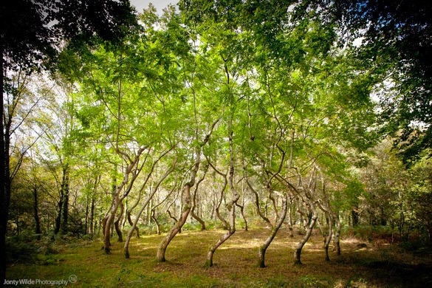
world. The deliberate thigmomorphogenic act to create an artificial pattern from a natural process is not so dissimilar from the actions of the groundskeeper on a golf course, yet removed to a secret, natural location, and therefore removed from any pretence of access or functionality, the work can exist as a meditation on man’s relationship with the world; whilst perpetuating the same flawed attitude toward it.

In his book, Being Ecological, Morton proposes the term anticipatory fear in his analogy of Ecological PTSD as a factor within the climate change debate.“The PTSD sufferer, Freud argued, is simply trying to install herself, through her dreams, at a point in time before the trauma happened. Why? Because there is some safety or security in being able to anticipate. Anticipatory fear is far less intense than the fear you experience when finding yourself, all of a sudden, in the middle of a trauma” - (Morton, 2018 : 14)

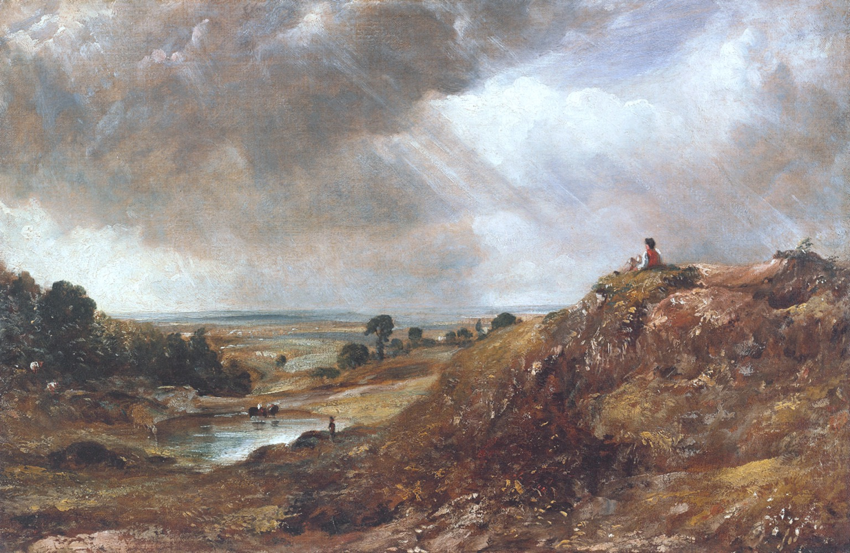
He draws a parallel between this tendency for humans to seek a false sense of control rather than face a traumatic reality with the relative collective inaction and preference for prevarication and debate in the face of the daunting facts regarding the impact of human activity on a global scale. Interestingly, he goes on to discuss the ubiquity of the picturesque landscape as the most popular image in the world. Connecting the components of the landscape to the symbolic meeting of primitive needs, Morton concludes: “The picturesque is keyed to a fundamental human-centred way of looking at things: it is anthropocentric.” (Morton, 2018 : 24)

It follows therefore that our most common and popular visual representation in culture is a codified image of security and control - a sop to primitive anxieties, a pre-emptive balm to calm those discomforted by the friction of urban life. The application of the anthropocentric to assuage the angst of the Anthropocene.

Moving from the romantic to the postmodern, artists working with landscape such as Gursky and Christo still fall within the overarching primacy of man. At one level, it could be argued that Gursky’s erasure of the urban landscape from Rhine II is an act rooted in a kind of primitivism, that extols the virtue of a nature untainted by man. It resonates with the picturesque, meeting many of the criteria one would look for in a classically pleasing landscape image (Tate, 2018). The geometry and manicured nature of the elements retained, however, serve as palimpsests pointing still to the need to assert control, to shape nature to a more palatable aesthetic.
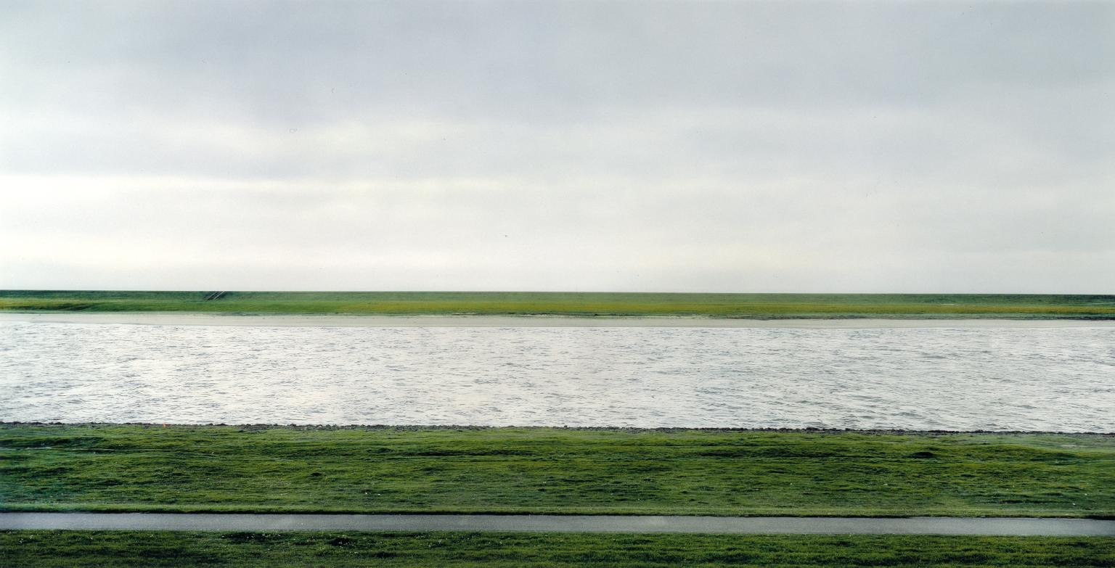

Christo in his wrapping of the landscape, proffers a simple action layered with possibilities for interpretation (Claude, 2018). He is simultaneously making his mark on the land, erasing what was there before, wrapping the land as a gift implying and imbuing ideas of ownership, value and commoditisation (ownership without the ability to separate oneself would count more as stewardship) and mimicking an act of protection both functional and absurd - it protects the landscape from the elements - a counterintuitive act that finds pragmatic realisation through items as mundane as the greenhouse or the umbrella (if one counts oneself as a part of the landscape).

“The spectacle appears at once as society itself, as a part of society and as a means of unification. As a part of society, it is that sector where all attention, all consciousness, converges. Being isolated and precisely for that reason this sector is the locus of illusion and false consciousness; the unity it imposes is merely the official language of generalized separation.” - (Debord, Debord and Knabb, n.d. : 3)

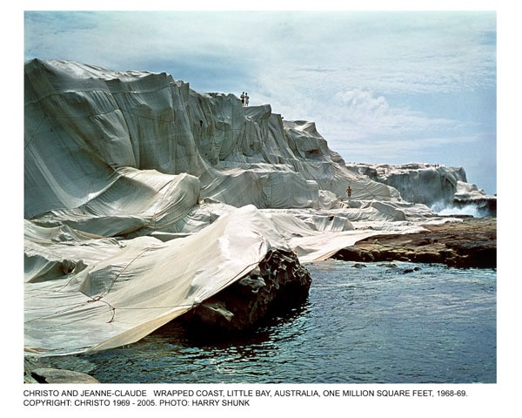
To diverge from the art world, psychological studies also directly inform this notion that we are increasingly not ourselves. What Debord would term the Spectacle is referred to as illusory pattern perception, but the meaning remains.

“We present six experiments that tested whether lacking control increases illusory pattern perception, which we define as the identification of a coherent and meaningful interrelationship among a set of random or unrelated stimuli. Participants who lacked control were more likely to perceive a variety of illusory patterns, including seeing images in noise, forming illusory correlations in stock market information, perceiving conspiracies, and developing superstitions. Additionally, we demonstrated that increased pattern perception has a motivational basis by measuring the need for structure directly and showing that the causal link between lack of control and illusory pattern perception is reduced by affirming the self. Although these many disparate forms of pattern perception are typically discussed as separate phenomena, the current results suggest that there is a common motive underlying them.” (Jennifer A. Whitson, et al., 2008)

Where Morton talks about anticipatory (false control) versus traumatic (genuine experience) fear, it could be suggested that another way to view these states could be what Whitson refers to as structure (external/false control) and self-affirmation (genuine experience). When one is denied opportunities for self-affirmation, one is increasingly likely to direct one’s energies into those activities that are not actually beneficial to self or community (the Spectacle). Structures of control that oppose self-affirmation are, arguably, many and varied. Forms such as education, professionalism, gender and class roles are common culprits when seeking negative influences upon society. It is my suggestion that as a result of the ontological error previously mentioned in our view of Nature, the natural world has itself become an instrument of structure. In the words of Graham Harman, “Nature is not natural, and can never be naturalized” (Harman 2005 : 251)

Consider if our very conceptualisation of nature is flawed, and therefore all of our actions and attitudes surrounding it suspect, how can this be corrected?

“There is only one way left to escape the alienation of present-day society: to retreat ahead of it: every old language is immediately compromised, and every language becomes old once it is repeated. Now, encratic language (the language produced and spread under the protection of power) is statutorily a language of repetition; all official institutions of language are repeating machines: school, sports, advertising, popular songs, news, all continually repeat the same structure, the same meaning, often the same words: the stereotype is a political fact, the major figure of ideology.” - (Barthes, 1975: 40)

Ivan Illich in Tools for Conviviality, discusses a model of a culture of escalation. He suggests that there is a fundamental issue with trying to solve a problem by applying the same thing to it that caused it. Easy contemporary illustrations of the idea of escalation could be things like borrowing money to repay debt, or the use of the military to enforce peace.
“It has become fashionable to say that where science and technology have created problems, it is only more scientific understanding and better technology that can carry us past them. The cure for bad management is more management. The cure for specialized research is more costly interdisciplinary research, just as the cure for polluted rivers is more costly nonpolluting detergents. The pooling of stores of information, the building up of a knowledge stock, the attempt to overwhelm present problems by the introduction of more science is the ultimate attempt to solve a crisis by escalation.” (Illich, n.d : 16)

This fits to Barthes’ idea of encratic language and symbolism being one of repetition. It also justifies artistic attempts to escape it. Conceptual approaches such as Kenneth Goldsmith’s uncreative writing or Brion Gysin and William Burrough’s cut-up technique serve to try to repurpose existing encratic language into new contexts. Impressionist art, avant-garde jazz and parts of sound and beat poetry were attempts to escape it through the creation of new forms - the creation of new language. It also dovetails with Debord again:
“The reigning economic system is founded on isolation; at the same time it is a circular process designed to produce isolation. Isolation underpins technology, and technology isolates in its turn; all goods proposed by the spectacular system, from cars to televisions, also serve as weapons for that system as it strives to reinforce the isolation of "the lonely crowd." The spectacle is continually rediscovering its own basic assumptions and each time in a more concrete manner. “ (Debord, Debord and Knabb, n.d. : 28)
So how does this relate to the idea of Nature? Is it possible to find a new language to talk about it? If so, don’t we also need to redefine ourselves? Also, if Barthes is to be believed, how can we create something sustainable if we must avoid repetition? Is it possible that there is a form of repetition that is not encratic? Can the distinction between reality and representation be resolved, or must we come to an acceptance of a state of flux, and perhaps modify our scales of measurement and value?
In the full dissertation, I intend to develop these themes, drawing in more of the thinking of Illich in terms of Tools for Conviviality and his idea of the Epimethean Man, Dawkins and his idea of the extended phenotype, Deleuze’s Difference and Repetition, ‘Pataphysics and looking at Bakhtin and artists that are trying to break away from encratic symbolism through the carnivalesque and particularly anthropomorphism.

I propose the following research question: The constructed separation of man from nature has led to a dysfunctional relationship, damaging to both. Is it possible to reconcile this separation through a critical post-correlationist analysis? Can existing structural symbols be repurposed to become self-affirming?

Reference List

Books

Barthes, R. and Miller, R. (1975). The pleasure of the text, tr.. [Place of publication not identified]: [publisher not identified].
Debord, G., Debord, G. and Knabb, K. (n.d.). The society of the spectacle.

Harman, Graham. Guerrilla Metaphysics : Phenomenology and the Carpentry of Things. New York : Open Court, 2005.

Illich, I. (n.d.). Tools for conviviality.

Morton, T. (2018). Being ecological. Penguin.
Morton, T. (2007). Ecology without nature. Harvard University Press.

Papers

Lacking Control Increases Illusory Pattern Perception
Jennifer A. Whitson, et al.
Science 322, 115 (2008);
DOI: 10.1126/science.1159845

Websites

Atlas Obscura. (2018). Ash Dome. [online] Available at: https://www.atlasobscura.com/places/ash-dome [Accessed 9 May 2018].

Claude, C. (2018). Christo & Jeanne Claude. [online] Artsy-inspirations.blogspot.co.uk. Available at: http://artsy-inspirations.blogspot.co.uk/2012/03/christo-jeanne-claude.html [Accessed 9 May 2018].

Tate. (2018). ‘The Rhine II’, Andreas Gursky, 1999 | Tate. [online] Available at: http://www.tate.org.uk/art/artworks/gursky-the-rhine-ii-p78372 [Accessed 9 May 2018].

Bibliography

Books:

Barthes, R. (1977). Rhetoric of the image.
Barthes, R. and Miller, R. (1975). The pleasure of the text, tr.. [Place of publication not identified]: [publisher not identified].
Benjamin, W., Eiland, H. and McLaughlin, K. (2003). The arcades project. Cambridge, Massachusetts,: Harvard University Press.

Benjamin, W. (2015). On Photography. London: Reaktion Books.

Calvino, I. and Weaver, W. (1969). [Le Cosmicomiche.] Cosmicomics. Translated ... by William Weaver. Pp. 153. Jonathan Cape: London.
Debord, G., Debord, G. and Knabb, K. (n.d.). The society of the spectacle.

Deleuze, G. (n.d.). Cinema I.
Deleuze, G. and Guattari, F. (1987). A thousand plateaus. Minneapolis: University of Minnesota Press.
Gooley, T. and Gower, N. (n.d.). The walker's guide to outdoor clues and signs.

Griffiths, J. (2000). Pip pip. London: Flamingo.

Harman, Graham. Guerrilla Metaphysics : Phenomenology and the Carpentry of Things. New York : Open Court, 2005.

Heidegger, M., Stambaugh, J. and Schmidt, D. (2010). Being and time. Albany: State University of New York Press.

Illich, I. (n.d.). Tools for conviviality.

Mabey, R. (n.d.). Nature Cure.
Morton, T. (2018). Being ecological. Penguin.
Morton, T. (2007). Ecology without nature. Harvard University Press.
SOLNIT, R. (2017). FIELD GUIDE TO GETTING LOST. [S.l.]: CANONGATE CANONS.

Papers:

Alweiss, Lilian; Heidegger and ‘the concept of time’, 2002
Volume: 15 issue: 3, page(s): 117-132
Issue published: July 1, 2002
https://doi.org/10.1177/0952695102015003928

Nimbalkar, Namita. “John Locke on Personal Identity.” Mens Sana Monographs 9.1 (2011): 268–275. PMC. Web. 3 Apr. 2018.

Lacking Control Increases Illusory Pattern Perception
Jennifer A. Whitson, et al.
Science 322, 115 (2008);
DOI: 10.1126/science.1159845

Websites:

Atlas Obscura. (2018). Ash Dome. [online] Available at: https://www.atlasobscura.com/places/ash-dome [Accessed 9 May 2018].

Claude, C. (2018). Christo & Jeanne Claude. [online] Artsy-inspirations.blogspot.co.uk. Available at: http://artsy-inspirations.blogspot.co.uk/2012/03/christo-jeanne-claude.html [Accessed 9 May 2018].

Tate. (2018). ‘The Rhine II’, Andreas Gursky, 1999 | Tate. [online] Available at: http://www.tate.org.uk/art/artworks/gursky-the-rhine-ii-p78372 [Accessed 9 May 2018].

