Managing Projects in the Organization

Ruhena Rahman
1714535
BMSW5104

Contents
Introduction and Case overview 4
Critical analysis of project management tools and techniques 5
Implementation of the project 9
Project initiation document 9
Implementation of the project 10
Project appraisal techniques 12
Stakeholder analysis and communication of the project needs with appropriate colleagues 13
Risk analysis 15
Critical evaluation of managing project 15
Identifying strengths and weaknesses 17
Self-development plan for improving performance 17
Conclusion 19
References 20

Table of figures
Figure 1: Table of criteria to choose project management tool 5
Figure 2: Waterfall technique 7
Figure 3: Project implementation phases 10
Figure 4: Gantt chart 12
Figure 5: Project appraisal methods 12
Figure 6: Stakeholder analysis 14
Figure 7: Characteristics of a project manager 16
Figure 8: Self-development plan 18

Introduction and Case overview
British Broadcasting Corporation (BBC) was established in 1922 and headquartered in London. Organizations take several projects to improve their performance and beat the competitors. As BBC noticed that its overhead cost and cost of internal resources outweigh the benefits, it decided to take a new project named Producer choice. BBC has taken producer choice projects to reduce bureaucracy by implementing a rational system. It wants to divide BBC into buyers and sellers groups to create an internal market. It wants to set a fixed price for its service. As BBC wanted to reduce its cost of internal resources and overhead head cost, it wants to introduce the producer choice plan. The key stakeholders of this project are the UK government, license fee payers, production sector, and employees. The stakeholders need to be communicated properly to implement the project successfully. That is why the company will arrange training, seminars, and meetings to communicate the plan and the estimated budget for this project is £50,000. This report explores how the BBC will implement the project using the Gantt chart. This also includes project management tools and techniques analysis, stakeholder and risk analysis, and self-development plan to improve deficiencies.

Critical analysis of project management tools and techniques
Today’s organizations are bombarded with difficult scenarios and projects while operating in their respective industry. Without an effective mindset and leadership, they cannot wrap their heads around these complexities (Tinnirello, 2018). There are several tools and techniques necessary to make a project successful. BBC had to take a change management project to improve its business condition. Effective tools and techniques help in creating an efficient strategy to deliver top-notch projects. Before describing the project management tools, the table of criteria of BBC’s project is constructed below:

Figure 1: Table of criteria to choose a project management tool
Source: (Tinnirello, 2018)
The following techniques will be useful to manage the project within the BBC.
Program evaluation and review technique (PERT): PERT is a software management technique and widely used in managing projects successfully. This technique works so well to visualize a complex project and see the result using PERT charts (Tinnirello, 2018). The team can keep track of all of the activities and fix the weaknesses immediately. This was developed by the USA Navy to increase efficiency during the cold war. This suits best for long-term projects that have non-routine tasks. There are three-time estimations that are pessimistic, optimistic, and most likely. By assigning probabilities to these estimates, the expected value is calculated. Time management is important to complete a project on time. As most of the projects require high investment, it needs to be completed within the set budget (Simister, 2013). The longer it takes, the more financing is required. Estimating time is not an easy task. It breaks the whole project into detailed activities and from the data an illustrative map is created. The Project manager needs to utilize the available resources within a specific period to get the fastest result. Thus he will be at the top of gain as he has achieved efficiency compared to the rivals. But the disadvantage of these tools is it assumes a tradeoff between money and time (Tinnirello, 2018). But the cost can be fixed rather than variable. If more activities are included, the chart will be complicated. As there will be many fixed expenses such as training cost, seminar cost, rearrangement cost, etc. in the producer choice project of BBC, this tool will be less useful to manage the project of BBC. Moreover, this tool does not it with BBC’s organizational culture and it is difficult to implement within the organizational system of BBC.
Gantt chart: Gantt chart was developed by Laurence Gantt in 1910. This provides graphical scheduling of a project's planning and control. It uses bar charts to represent the project schedules over a timeline (Wysocki, 2014). The progress of every activity is outlined using a different color that helps the project manager to identify the delays or overruns. A large amount of data is represented using a compact graphical form. This chart is used to plan time scale, estimate required resources, plan, and track specific tasks. But the disadvantage of this tool is the bar charts do not indicate the number of tasks (Simister, 2013). Moreover, this is applicable for simple projects. Despite these weaknesses, this tool is useful for managing the project of the BBC. This visual representation will help the managers of the BBC to identify the scheduled activity. They can easily develop a what-if scenario and promote clear communication. This is also used as a negotiation tool and shows the actual progress of the project against the planned project. Results are reported at appropriate levels and multiple projects can be compared to determine the required resources. This fits with BBC’s organizational culture and it is easy to understand. Thus this tool is useful for managing the Producer Choice project of BBC.
Waterfall technique: Waterfall technique is a traditional tool to manage projects and it is built based on project management tasks. This indicates a sequential form and one task will be completed when its precedent task has completed. Just like the waterfall, the workflows will be smoothly heading towards the direction. All the steps are held accountable to ensure that the process is seamless (Simister, 2013). This is best applicable for complex projects. But the disadvantage of this technique is it is a rigid work-structuring technique. It also does not allow for revision and once a task is in the testing phase, it is not possible to go back and mend the process. This is subject to a huge amount of risk and uncertainties. If managers do not get a chance to revise the project, there is a high probability that the errors will prevail in the system (Wysocki, 2014). As BBC has taken a sensitive project and employees will show resistance to change, this rigid technique will not give fruitful result to BBC
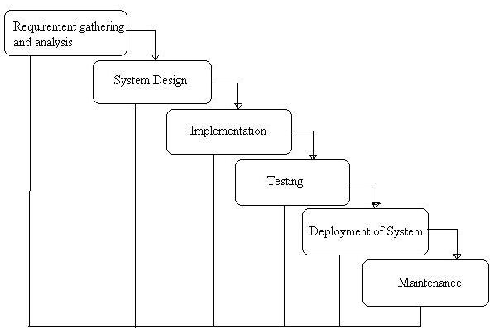
Figure 2: Waterfall technique
Source: (Leybourne and Kanabar, 2014)
Agile project management: Agile project management technique deals with the project differently from other traditional techniques. This crushes the big steps of a project into the shorter sprint. This helps in the detailed analysis of the development phase. This analysis assists in adaptive planning following the project needs. Thus this results in a continual improvement in the development phase. This framework includes Scrum, FDD, etc. (Ponnappa, 2014). But the technique does not enforce enough emphasis on documentation and designing. Projects can easily fall off track and it requires more time. This is relatively a new technique and employees of BBC will get afraid when this tool will be used as they are not familiar with the system. They will show resistance to the change management project and if this project requires a new technique, it will be difficult for the leaders to make them understand. Moreover, the BBC has decided to implement the change quickly, this long-term project management technique will not work in this case. Moreover, this tool does not conform to the organizational culture of the BBC as there is less predictability in using the system. As there is no baseline, a different solution may arise that will add complexities rather than making it simple. This system does not emphasize effective communication (Mikkelsen, 2017). If employees are not communicated well, they will end up engaging in a divergent solution that will create chaos in the system. For these reasons, this system will not work for the BBC.
Work breakdown structure (WBS): WBS is a project planning tool that defines the project scope and required deliverables. If project details are communicated with the relevant stakeholders, they can develop a common understanding and each team will know exactly what should be developed. WBS defines the project works into more manageable components (Leybourne and Kanabar, 2014). Lowest level items of WBS are called word packages. Work packages are monitored and controlled by the project manager. When large projects are broken into smaller items, this becomes more planned and manageable. This is used for risk management. The main purpose of using this tool is to reduce complicated activities. Thus project managers can oversee the activities well. The chart does not include any non-project work. The project managers are well-aware of the fact that many things may go wrong despite successful planning and execution. Project failures can be traced using the WBS structure. But if WBS is constructed poorly, the results will disastrous. But if an effective WBS is used as a starting point, this will simplify the situation. All the deliverables can be double-checked (Mikkelsen, 2017). As BBC is taking a crucial change management project, there will be several stages to implement the project. That is why it is crucial to break down each activity in a detailed way to communicate with the stakeholders, especially with the employees. This tool is easy to use and employees can easily crack the problem while taking the training. If the managers of BBC prepare a well-constructed WBC, this will help in the successful implementation of the project. This will help in allocating resources effectively within the organization.

Implementation of the project

Project initiation document
PEINCE2 is a constant and consistent approach for the effective management of a project. This flexible method guides through the core tasks of the project regardless of scale (Leybourne and Kanabar, 2014). This is tailored to specific project needs. The project initiation document is given below:
Project summary: BBC wants to introduce a radical organizational change that is driven by fluctuating business conditions. The produce choice project will divide the BBC into two groups that are buyers and sellers. Thus it will create an international market. On the open market, program producers will procure goods/services. Internal providers will compete with external suppliers. Funding will be channeled to the program maker and if departments do no attract the producers, it will be shut down. There are two distinct components of this project and that is the trading system and the actual program.
Project aim and objectives: This project aims at formalizing the producer and resource department relationship by introducing a fixed price. This project has two objectives. It will allow BBC to accumulate overhead cost information and it will also allow it to benchmark the internal resource costing. Thus it will reduce cost and ensure value for money.
Budgetary information and timescale: Approximately, the implementation of the producer choice project will incur £50,000. This will also include the cost of the training program of the employees. BBC wants to implement the project within 18 months.
Approach: The Producer choice program is based on the Burke-Litwin model. This facilitates change by linking external and internal factors with organizational performance. A workshop will be arranged to communicate the plan with the stakeholder. Meeting, training, and brochure distribution will be arranged too. The project manager will prepare a Gantt chart to monitor the activities by creating a visual representation of project tasks.
Key staff: A project does not become successful without including the key staff in the context. One person cannot manage the whole project (Ponnappa, 2014). Different groups of people will contribute to this project execution. The key staffs of this project are managers and employees of the BBC.

Implementation of the project
A smoothly run project can get black eyes if problems arise during the implementation period. These problems crop up because the project manager does not anticipate the complexity of the scenario. To implement the producer choice plan, the following steps will be followed:

Figure 3: Project implementation phases
Source: (Ponnappa, 2014)
Before implementing the producer choice plan, a project manager has to prepare the infrastructure. He will review the training program and a communication plan. As the plan is going to change the regular operational activities of the BBC, the higher authority has decided to arrange a training program for the employees and hire external consultants. This plan will be communicated with the employees. Before the successful execution of the project, employees need to understand the changed scenario and how this new project is going to change their working scope (Simister, 2013). That is why the training program will be executed in advance. If the company makes a delay in giving the training program, employees will take more time to understand the new system. After that, the new solution for reducing costs will be implemented. But before the final implementation of the solution, the process should be verified using the Gantt structure. Thus a new plan will be implemented and this will be monitored by the project manager. The manager wants to finish the project within 18 months. The actual implementation process will be managed by external consultants. Coppers group will help the company to implement the change within the timeframe, as the BBC does not have internal skills available to bring the changes (BBC.com, 2020). The trading guidelines will be available to support the technical system. The company has arranged adequate funding for the project and the finance system is managed using the correct information. Thus the employees will get enough time for training in advance. If these steps are followed properly, the project will be implemented successfully. The Gantt chart of producer choice project is given below:
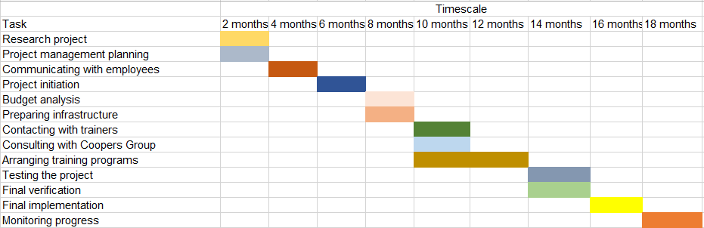
Figure 4: Gantt chart
Source: (Author)

Project appraisal techniques
Project appraisal techniques are used in assessing the options available to the organization so that the success/failure of the project can be measured (Ponnappa, 2014). There are 5 methods available. These are illustrated below:
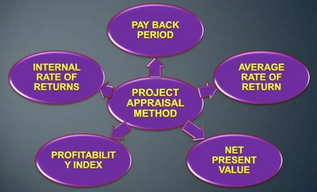
Figure 5: Project appraisal methods
Source: (Ponnappa, 2014)
Before undertaking any project, managers should conduct a feasibility analysis to demonstrate whether the project will add value to the organization or not (Tinnirello, 2018). There are some quantitative techniques illustrated above that can help to identify the attractiveness of the project. NPV of the project is found by subtracting the initial outlay from the present value of discounted cash flow. The manager of the BBC anticipated the project cost will be £50,000. As the NPV is greater than zero, the project is accepted. IRR is another technique of project appraisal. If the IRR of the project is greater than its discount rate, the project is accepted. The payback period is the time when the initial investment will be recovered and the lower the payback period, the greater the attractiveness of the project (Ponnappa, 2014). The criteria of the average rate of return are if the rate of return is greater than the expected return, the project is accepted. If the profitability index is greater than, the project benefit outweighs the cost and this accepted.

Stakeholder analysis and communication of the project needs with appropriate colleagues
Stakeholder analysis includes three-step that are identifying stakeholders, prioritizing stakeholders, and building a strategy to reach the stakeholders (Leach, 2019). The relevant stakeholders of the project are the UK government, license fee prayers, employees, production sector, etc.
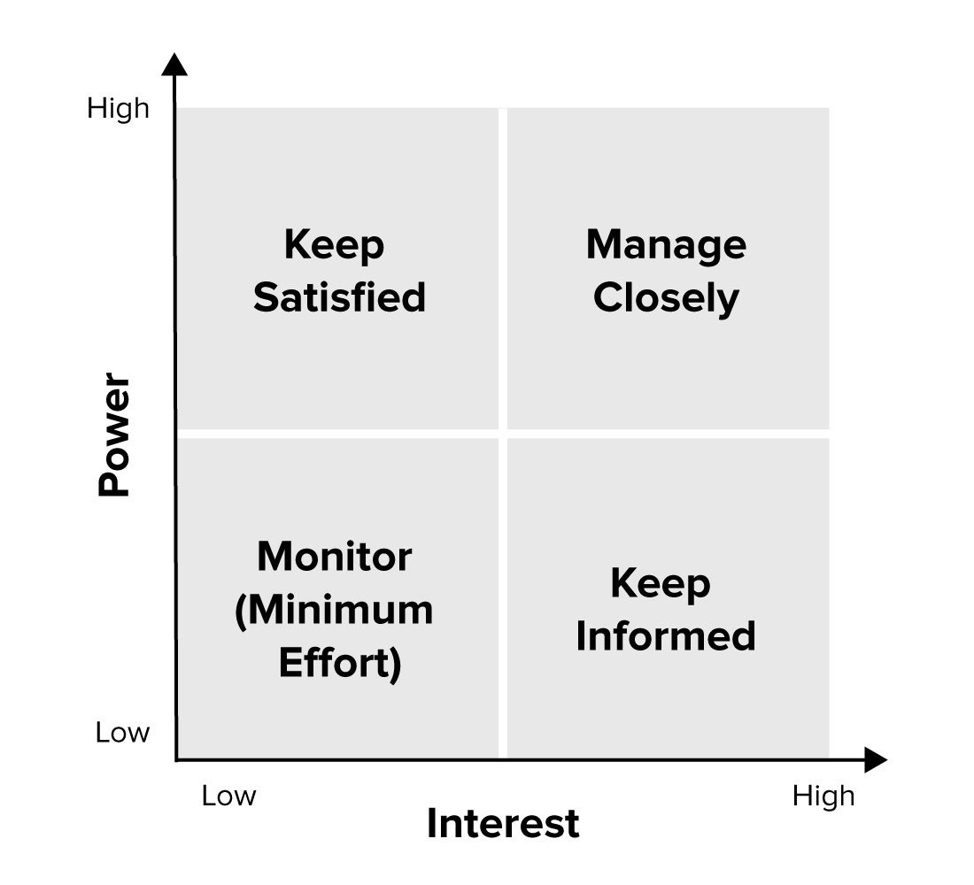
Figure 6: Stakeholder analysis
Source: (Flick, 2014)
The UK government has considerable power on the drivers of the project but has little interest in implementing the project. BBC should be engaged to satisfy the government. The company will maintain communication with the government using its legal authorities. License fee payers exert a high level of power and have a great interest in implementing the project. They should be managed closely. They will be communicated using the website advertisement and Email. The production sector has a high interest in the project but cannot influence the implementation of the project. They should be kept informed. The production sector will receive information from senior management via formal meetings. Employees have low power and low interest in this project but they should be monitored properly. Though they do not hold high power and they have less interest in implementing the project, they are the key stakeholders. If they do not understand the need for changing the system, the project will not be implemented successfully (Leach, 2019). That is why the company will arrange the training program, sessions, seminars, etc. to communicate the plan with the employees. Employees need to be updated on a timely basis so that no conflicts arise during the project implementation.

Risk analysis
Risk analysis helps in assessing the relevant risk f the project and analyzing the strategies to mitigate the risk. If the risk factors are not analyzed properly, the project objective will not be achieved (Flick, 2014). The producer project is exposed to both financial and physical risk. The estimated budget for the project is £50,000. If the actual cost exceeds the budgeted cost the company will be exposed to financial risk. This can be mitigated if the budget factors are analyzed closely. Conflicts among the employees can arise physical risk (Leach, 2019). They need to be communicated properly and training should be arranged quickly to mitigate the risk. Exceeding training costs can also give rise to financial risk. The company should make a contract with the Coopers Group so that no conflicts arise during the project period. Employees' resistance to change can give rise to financial risk. If employees do not want to execute the plan, the company will incur losses. Employees will show resistance as the agent, strategy, and company policy will be changed. But the effective leadership style can reduce the change. These risk factors need to be taken care of to implement the project successfully.

Critical evaluation of managing project
The project manager is the key personnel in implementing a project. If the project manager does not perform his/her responsibilities, the project will not be implemented successfully (Leach, 2019). The project gets the responsibility of preparing the budget, allocating resources, monitoring timescale, managing the team, and project progress. A project manager needs to have good communication, technical negotiation, time management, team management, and problem-solving skill (Flick, 2014). The project manager alone cannot implement the project. Employees need to help the project manager to implement the project effectively. After completing a project the project manager can ask for feedback from his/her colleagues so that he/she can develop the deficiencies. Feedback is provided using the employee survey questionnaire and arranging formal meetings. If a project manager does not collect feedback from the colleagues, he will not able to understand the strengths and weaknesses of him. If a person does not know what hos major strengths and weaknesses are, he will not be able to improve his skill and knowledge further (Davidson, 2014). If proper feedback is given to him he will focus on his deficiencies and work hard to improve this lacking to deliver successful projects in the future. Characteristics of a good project manager are depicted below:

Figure 7: Characteristics of a project manager
Source: (Davidson, 2014)
I was given the responsibility to manage the change project. After, the implementation of the project, I ask for feedback from my respective colleagues. I prepared a questionnaire for them and told them to fill-up the form. From the survey, I've found that they appreciated my negotiation, communication, and time management skills. But I lack good team management and problem-solving skill. During the project period, team members engage in conflict while selecting a consultancy group. Different people suggested different groups and they engaged in conflicts. During that time, I could not come up with an effective plan to resolve the problem. That is why from the project inception, there were two schools of thought; one of them favoring the Coopers group, and another team favoring the linkage group. Another problem they identified that I have a deficiency in problem-solving skills. As the business environment has become dynamic, it is not possible to expect a smooth working environment (Deeprose, 2015). While managing a project, several challenges come into the light and a successful project manager needs to tackle the situation with his/her problem-solving skill. If a project manager does not how to handle dynamic situations, he will never be able to execute the plan accordingly.

Identifying strengths and weaknesses
I asked for feedback from my respective colleagues to identify my ability to manage a project. From the given feedback, I realized that I am good at managing negotiation with third parties. I also effectively communicate the plan with relevant parties so that no conflicts arise during the project implementation. A project manager needs to have good communication skills. Effective communication is the key to the successful implementation of a project. Another strength of mine in managing projects is having good time management skills. If the project is not completed timely, the company will incur financial losses. This feedback has helped me to identify some weaknesses too. I am not good at handling my team conflicts and I do not have good problem-solving skills. So I decided to take the self-development plan to improve my deficiencies. The self-development plan will be made by considering SMART objectives.

Self-development plan for improving performance
A self-development plan is an action plan that is designed to improve certain skills and knowledge. This helps in achieving what one wants to become in the future. Objectives should be specific, measurable, achievable, and relevant (Bredillet, 2017). The long term goal of the self-development plan is to develop the capabilities to manage the complex program in the future within the budget and timescale. The short term goal of this self-development plan is to certify as the professional project manager. This will also help in gaining experience in managing complex future projects. Another short term goal of this self-development plan is to improve leadership and project management capabilities. The above-discussed goals are specific. The objectives of making the self-development plan are completing project management training and certification process, successfully delivering the future project, and getting prepared for delivering at least 5 presentations in front of senior managers. The resources required for this plan are training, advice from senior managers, dummy project management, etc. This plan will be considered if the training program is completed and successfully certified by professional authority. Schedule variance, budget variances, and further feedback collection from the stakeholders will help in measuring the success/failure rate. This self-development plan will be 3 months long and within this period, the above-mentioned objectives should be achieved.
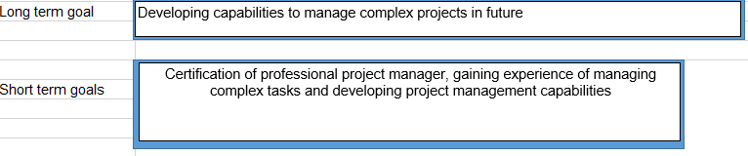
Goal | Objective | Resource | Measurement | Target date
Certification of professional project manager | Completion of certification training | Training | Successful completion of the training program | 02.05.20-02.06.20
Gaining experience | Successful delivery of large projects | Dummy projects | Schedule and budget variance | 03.06.20-03.07.20
Improving project management abilities | Preparation of giving at least 5 presentations | Opportunities are given by senior managers | Feedback from senior managers | 04.07.20-05.08.20
Figure 8: Self-development plan
Source: (Author)

Conclusion
The project manager is the key personnel in managing a project successfully. If the project manager does not emphasize the successful execution of a project, the project will not be implemented. Organizations need to undertake several projects to sustain their operations in the dynamic market. They aim at improving organizational performance, profitability, increasing organizational efficiency, improving employees ‘productivity, etc. that has the project manager needs to have good communication skill, time management, team management, negotiation, critical-thinking ability skills, etc. to manage complex projects. If they have deficiencies in this area, they can adopt the self-development plan to improve their deficiencies.

References
BBC.com. (2020). BBC - Home. [online] Available at: <https://www.bbc.co.uk/> [Accessed 26 April 2020].
Bredillet, C. (2017). Exploring Research in Project Management: Nine Schools of Project Management Research (Part 2). Project Management Journal, 38(3), pp.3-5.
Davidson, J. (2014). Reconstructing Project Management. Project Management Journal, 45(1), pp.34-46.
Deeprose, D. (2015). Project Management. Oxford, U.K.: Capstone Pub.
Flick, U. (2014). Introducing Project Methodology: A Beginner’s Guide to Doing a Research Project. London: SAGE.
Leach, L. (2019). Critical Chain Project Management Improves Project Performance. Project Management Journal, 30(2), pp.39-51.
Leybourne, S. and Kanabar, V. (2014). Is project management the new management 2.0?. Organizational Project Management, 1(1), p.16.
Mikkelsen, H. (2017). Quality of project work and project management. International Journal of Project Management, 8(3), pp.138-143.
Ponnappa, G. (2014). Project Stakeholder Management. Project Management Journal, 45(2), pp.322-333.
Simister, S. (2013). Managing Project Risk and Uncertainty. International Journal of Project Management, 22(3), pp.269-270.
Tinnirello, P. (2018). Project Management. Boca Raton: Auerbach.
Wysocki, R. (2014). Project Management Process Improvement. Norwood: Artech House.

