Module: Computer Architecture and Operating Systems.

Module code: ACCA4022.

Assignment title: Operating Systems.

Submission date: Friday, 15th April 2024.

Student name: Shaun James Davies.

Student number: 2317135.

Contents
Introduction 5
Key Functions of general OS 5
Introduction 5
File Management 5
Process Management 5
Memory Management 5
User Interface 6
Networking 6
Conclusion 6
Use of Windows OS CLI Commands. 7
List of contents in the current directory 7
Display help information for the dir command 7
Create a new folder named 'createnewdirtest' 8
Create files within directory 8
List directory (alternative: Ls) 9
Remove files 10
Clear the window (cls) 11
Display a message 11
Get processes that are running 11
Export process information to a CSV file 12
Get the computer's IP address 13
Get detailed IP configuration 13
Use of Linux OS CLI commands. 14
Print the present working directory 14
Change directory 14
List 14
Make a new directory/ Enter a new directory 14
Create a new file/ Give permission to user. 15
Display a message 15
Enter Text into file 15
Display Text from a file 15
Delete directory 15
History 16
Clear 16
Ping packets from your machine 17
Display network information, tables, statistics, and other network-related information. 18
Export to a file 18
Open file in nano text editor 19
Use of Windows OS scripts. 20
Code Snippet 20
Variables 21
If Statement 21
Case Statement 22
A loop 23
Array 23
Function 24
User Input 24
Networking code 25
Use of Linux OS scripts 26
Variables 26
If statement 27
Case statement 28
A loop 29
Array 29
Function 30
Networking Commands 31
Conclusion 32
References 33
Appendix A 34
Windows OS CLI commands 34
Get the computer's IP address 36
Get detailed IP configuration 36
Appendix B 36
Use of Linux OS CLI commands. 36
Appendix C 37
Use of Windows OS scripts. 37
Appendix D 40
Use of Linux OS scripts 40
Appendix E 42
Tutorial Activity 42
Microsoft learn course: Learning PowerShell 44

Introduction
Throughout this assignment, I will explore the features and uses of operating systems (OSs) from general purpose OS to quantum OS (QOS). It is important to comprehend OS features as it can enable optimisation for system performance, troubleshooting capabilities, control and customisation options. These features allow OSs to adapt to specific needs and environments.

Key Functions of general OS

Introduction
A present-day OS is powerful software that is the foundation of computing devices, enabling functions for everyday operation. The OS allows us to use and manage computing devices, allocating resources effectively [1]. Windows, macOS, Linux, and other OS are designed for hardware resource management, building and displaying a user interface, and supporting applications and functionalities.

File Management
File management is a core feature of any OS, involving actions like creating, deleting, relocating, and structuring files and directories. A graphical file explorer provides users with a visual portrayal of their file system, facilitating easy manipulation of files and folders. Whether it's creating new documents, reorganizing documents or whole directories, users engage with their data via this interface, while the OS manages the underlying file tasks [2].

Process Management
OSs allocate resources like CPU time and memory to guarantee seamless operation, scheduling and managing operations. When several processes are competing for resources in a multitasking environment, the OS uses scheduling algorithms to prioritize and schedule them effectively. Users can monitor running processes, their resource usage, to prioritize or terminate them as necessary by using task managers or system monitors [3, pp. 126-127].

Memory Management
Effective memory management is vital for resource optimization in OS. As highlighted by William Stallings, it is the most significant and intricate OS operation. The OS ensures optimal utilization and prevents memory leaks by allocating and deallocating memory to processes. Virtual memory systems extend RAM using secondary storage like hard drives, increasing accessible memory for active processes. Memory management units (MMUs) handle address translation, maintaining system stability and security, including segmentation and paging techniques [3, p. 322].

User Interface
The main method of communication between users and the OS is through the user interface. Users may browse the system, run apps, and personalize their computing experience with the help of the user interface (UI), which comes in many forms: command-line interface (CLI), graphical desktop environment, and touch-based interface.

Networking
An OS acts as a conduit between computer hardware and users, offering a user benefical interface. Likewise, a network OS (NOS) connects devices, facilitates resource sharing, and manages user accounts. It comes in peer-to-peer and client/server types, with features like resource sharing and security. NOS advantages include stability, security, and upgradability [4].

Conclusion
OSs perform tasks that are crucial for the operation of computer systems, from managing hardware resources to supplying user interfaces and assisting with software development. Other functions of OS include system and performance management, device management, system recovery, error detection and system security management [5].

Use of Windows OS CLI Commands.
Please see Appendix A for code [12].

List of contents in the current directory
Evidence: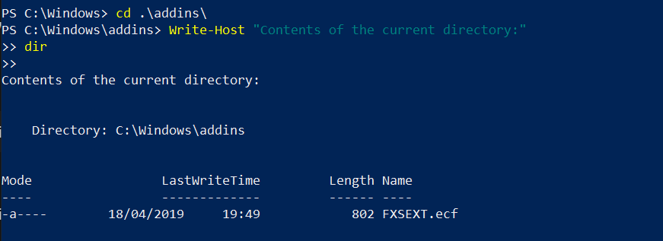

Display help information for the dir command
Evidence:
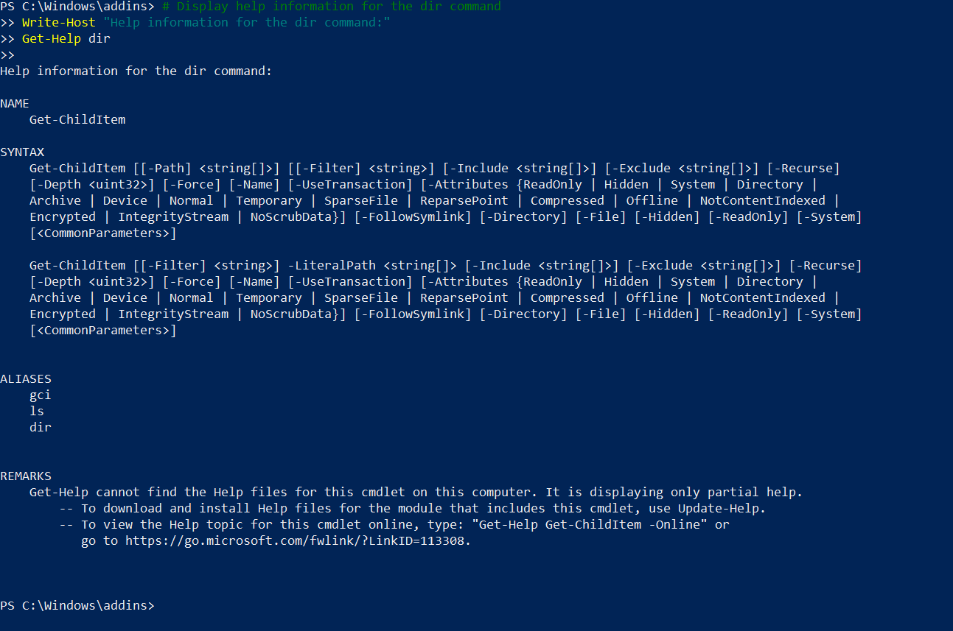
The code navigates to "addins" directory, displays its contents, then provides help information for the "dir" command.
Components:
- cd .\addins\: Changes directory.
- `Write-Host "Contents...": Displays message.
- Dir: Lists directory contents.
- `Write-Host "Help...": Displays message.
- Get-Help dir: Retrieves help information for the "dir" command.
This code performs directory navigation, content listing, and command help display, enhancing user interaction and assistance within PowerShell environment [6].

Create a new folder named 'createnewdirtest'
Evidence:
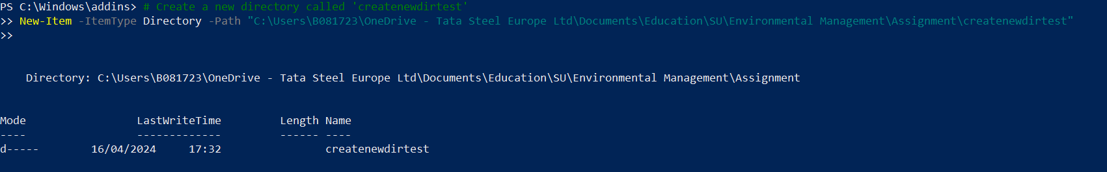Change directory to the 'createnewdirtest' folder
Evidence:
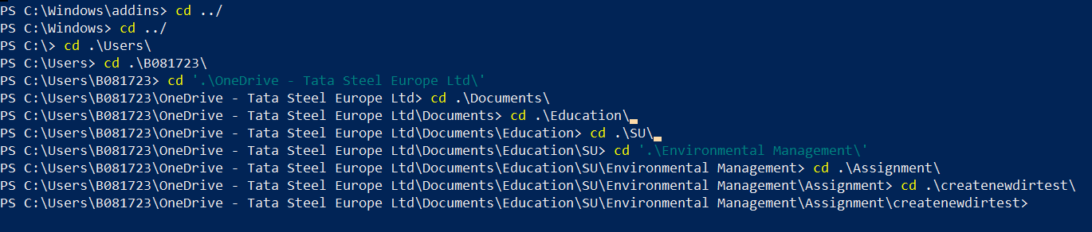

Create files within directory
Evidence:
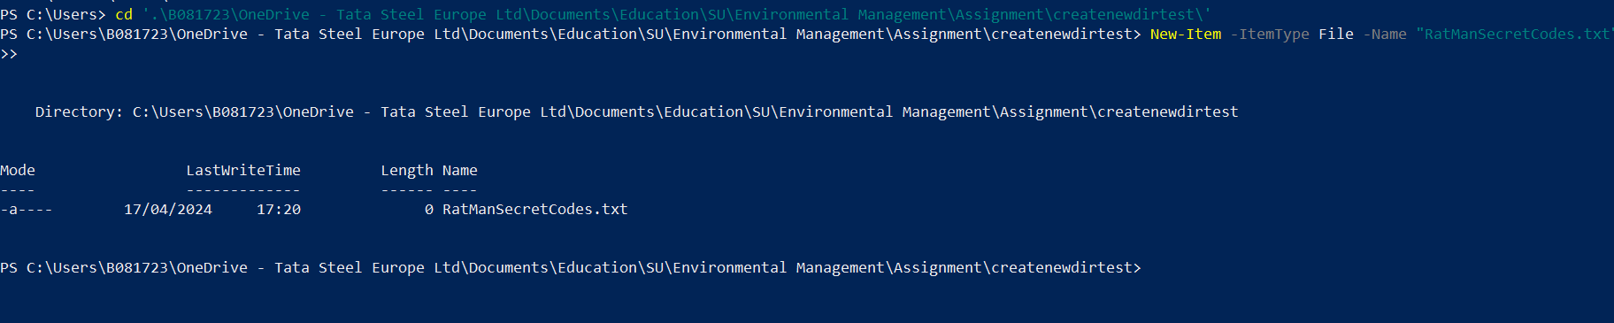
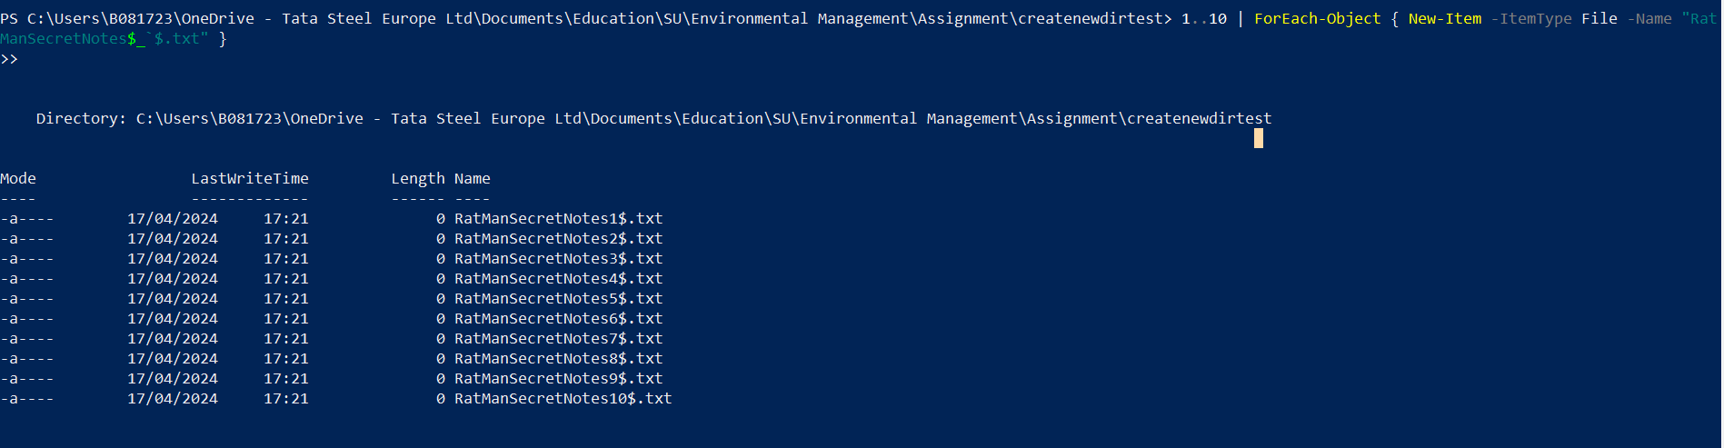
The code creates a new folder named "createnewdirtest," navigates to it, and creates files within it.
Components:
- Create folder: New-Item -ItemType Directory -Path C:\Users\B081723\OneDrive - Tata Steel Europe Ltd\Documents\Education\SU\Environmental Management\Assignment\createnewdirtest
- Display creation message: Write-Host "Creating a new folder named 'createnewdirtest'"
- Change directory: cd '.\Users\B081723\OneDrive - Tata Steel Europe Ltd\Documents\Education\SU\Environmental Management\Assignment\createnewdirtest\'
- Create single file: New-Item -ItemType File -Name "RatManSecretCodes.txt"
- Create multiple files: 1..10 | ForEach-Object { New-Item -ItemType File -Name "RatManSecretNotes$_$.txt" }`
This code successfully executes folder creation, directory navigation, and file creation, aiding in managing files and directories in PowerShell [6].

List directory (alternative: Ls)
Evidence:
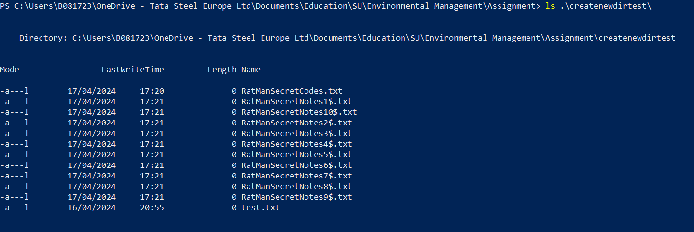

Remove files
Evidence:

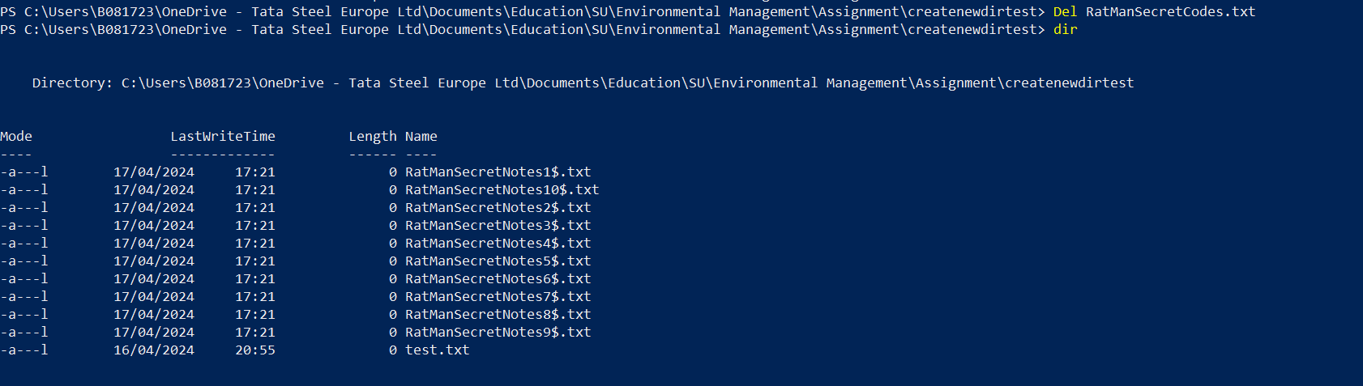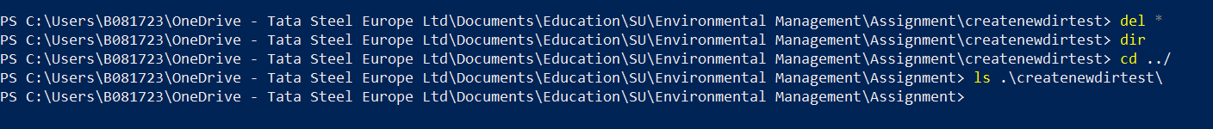
The code lists contents of "createnewdirtest," removes files, lists directory contents, and navigates up one directory.
Components:
- List directory: ls .\createnewdirtest\ (or dir .\createnewdirtest\)
- Remove single file: Del RatManSecretCodes.txt
- Remove all files in current directory: Del *
- List directory: Dir
- Change directory: Cd ../
This code displays contents, removes files, and navigates directories within PowerShell [6].

Clear the window (cls)
Evidence:
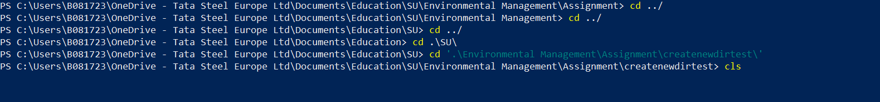

Display a message
Evidence:

Get processes that are running
Evidence:
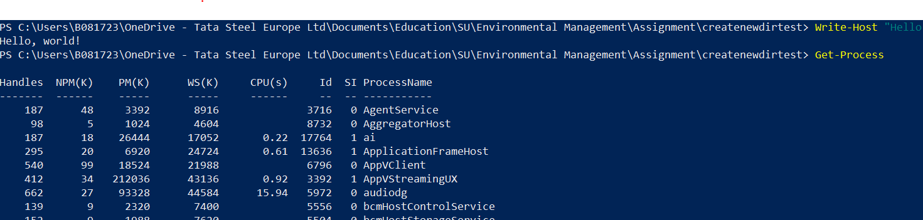
The code clears the window, displays a message, and retrieves running processes on the Windows OS.
Components:
- Clear window: Cls
- Display message: Write-Host "Hello, world!"
- Retrieve running processes: Get-Process
This code clears the users screen, provides a user message, and retrieves running processes [6].

Export process information to a CSV file
Evidence:
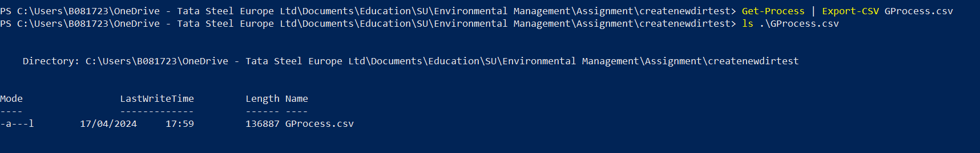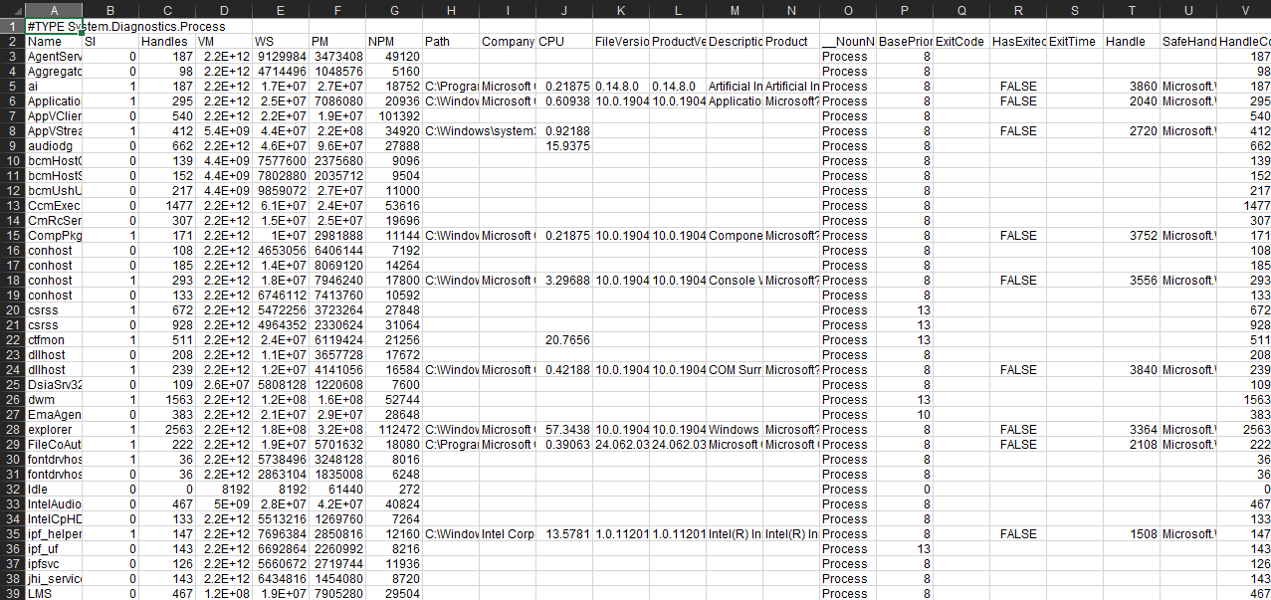

Get the computer's IP address
Evidence: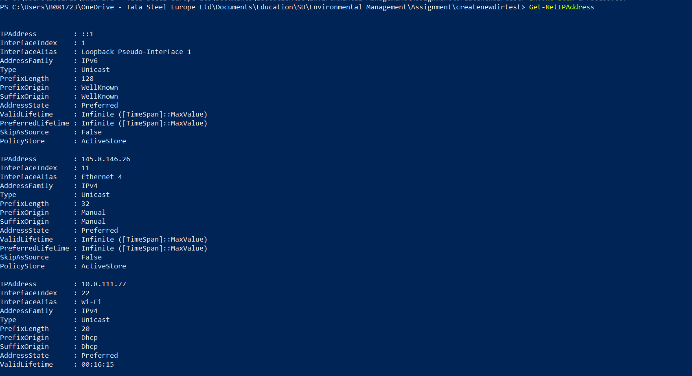

Get detailed IP configuration
Evidence:
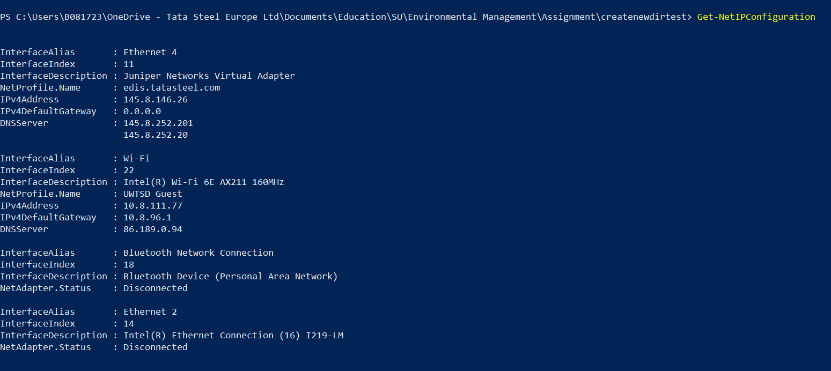
The code exports process information to a CSV file, lists the file, opens it, and retrieves computer's IP address and detailed IP configuration.
Components:
- Export process info to CSV: Get-Process | Export-CSV GProcess.csv
- List CSV file: ls .\GProcess.csv
- Open CSV file: Invoke-Item GProcess.csv
- Retrieve computer's IP address: Get-NetIPAddress
- Get detailed IP configuration: Get-NetIPConfiguration
This code manages process data by exporting to CSV, interacts with files, and retrieves network information, showcasing system monitoring capabilities in PowerShell [6].

Use of Linux OS CLI commands.
Please see appendix B for code [13]

Print the present working directory
Evidence:
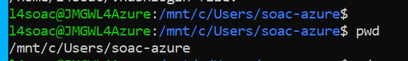

Change directory
Evidence:
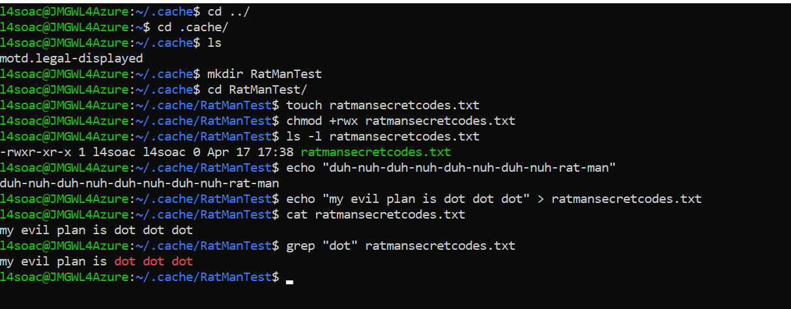

List
Evidence:

Make a new directory/ Enter a new directory
Evidence:

Create a new file/ Give permission to user.
Evidence:

Display a message
Evidence:

Enter Text into file
Evidence:

Display Text from a file
Evidence:

Delete directory
Evidence:
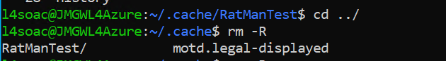
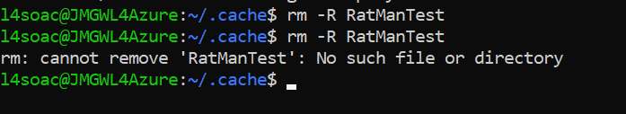

History
Evidence:
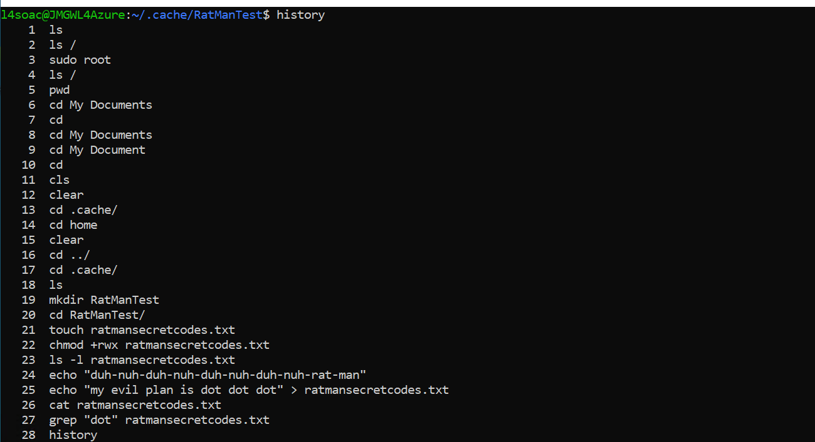

Clear
Evidence:
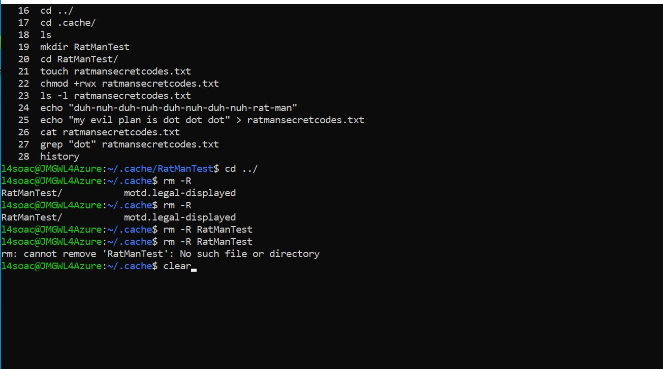
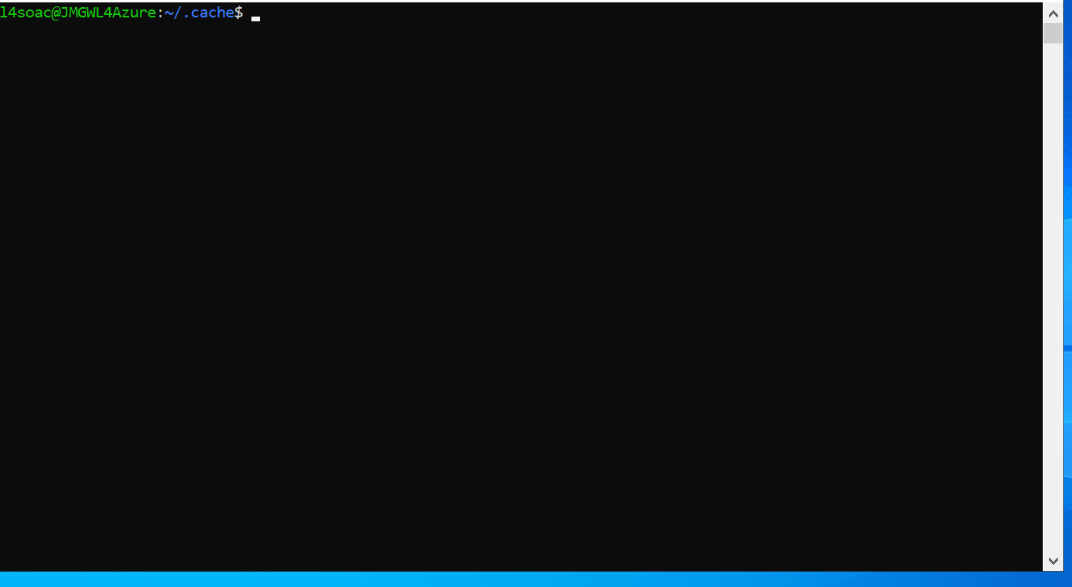

Ping packets from and your machine
Evidence:
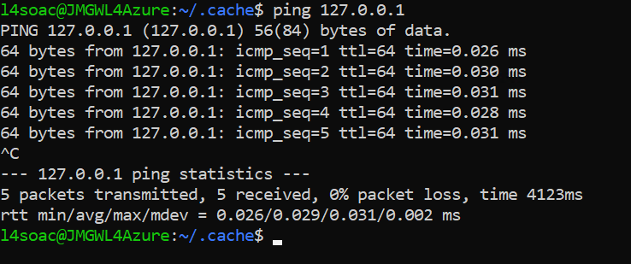

Display network information, tables, statistics, and other network-related information.
Evidence:
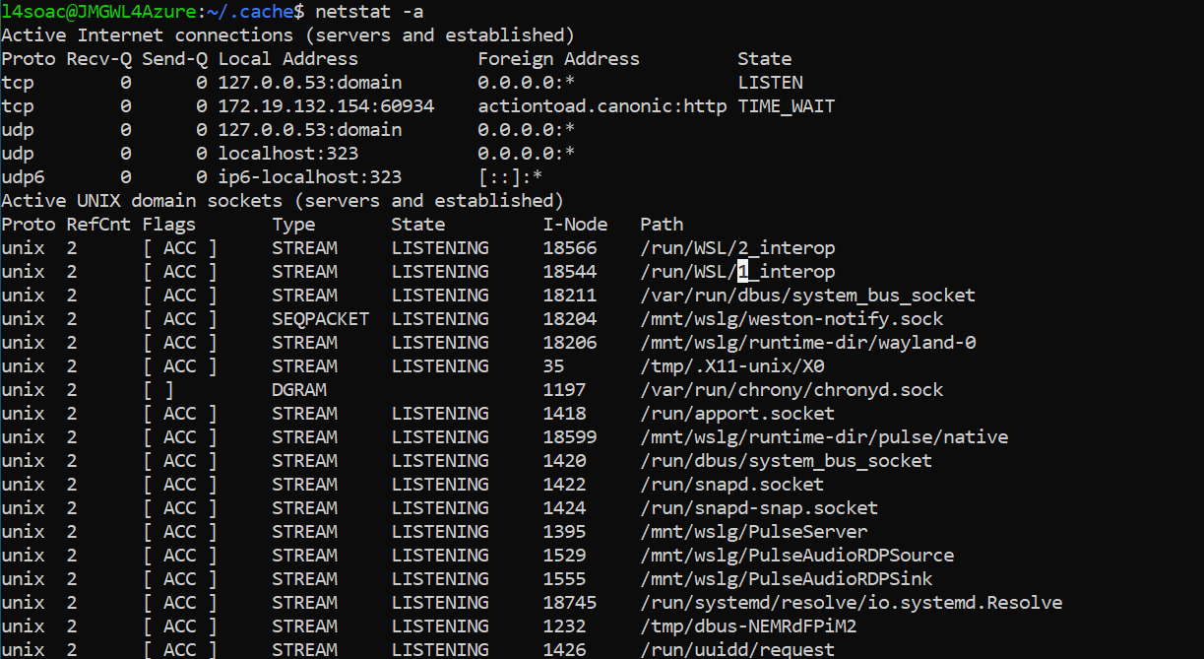

Export to a file
Evidence:
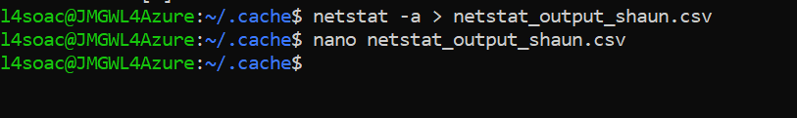

Open file in nano text editor
Evidence:
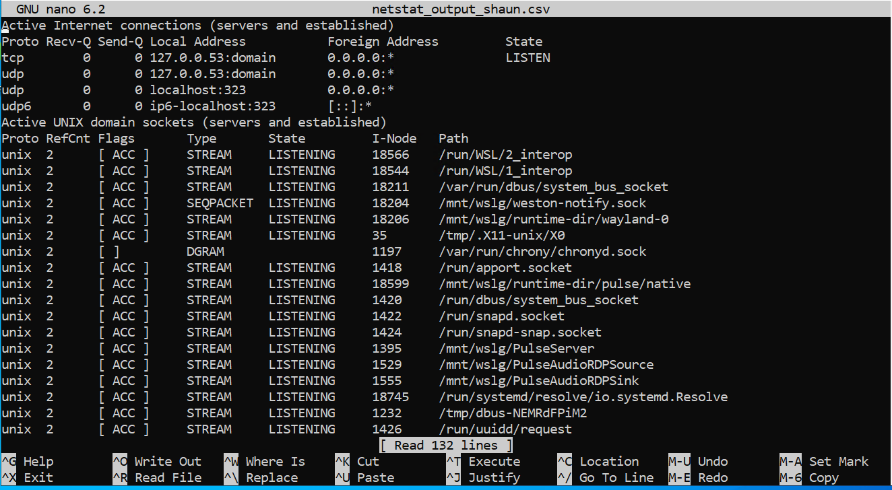

The code displays the present working directory, changes directories, lists contents, creates a directory, enters it, creates a file, grants permissions, displays messages, reads from files, and executes network commands.
Components:
- Display present working directory: pwd
- Change directory: cd ../ and cd .cache/
- List contents: ls
- Make new directory: mkdir RatManTest
- Enter directory: cd RatManTest/
- Create new file: touch ratmansecretcodes.txt
- Grant permissions: chmod +rwx ratmansecretcodes.txt
- Display message: echo "duh-nuh-duh-nuh-duh-nuh-duh-nuh-rat-man"
- Write to file: echo "my evil plan is dot dot dot" > ratmansecretcodes.txt
- Read from file: cat ratmansecretcodes.txt
- Search file text: grep "dot" ratmansecretcodes.txt
- Remove directory: rm -r RatManTest/
- Display command history: history
- Clear screen: clear
- Ping loopback: ping 127.0.0.1
- Display network connections: netstat -a
- Export network connections: netstat -a >netstat_output_shaun.csv
- Open file in nano text editor: nano netstat_output_shaun.csv
This code performs file and directory management, displays messages, and executes network commands [7].

Use of Windows OS scripts.
Please see appendix C for code [14].

Code Snippet
Evidence:
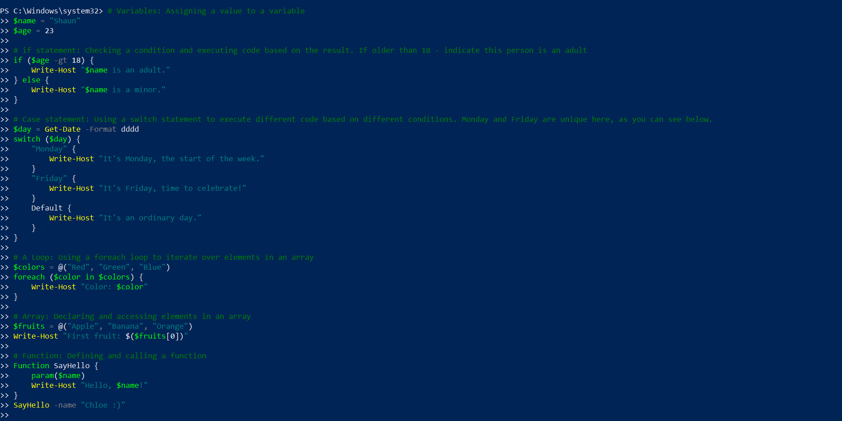

Variables
Variables are used in many coding languages to assign values. Variables can hold different types of information: “integers, strings, arrays, and hash tables. And, objects that represent processes, services, event logs, and computers”. You can include any kind of object in a variable [8].
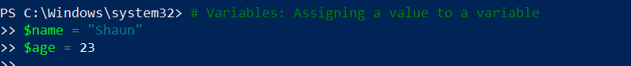

If Statement
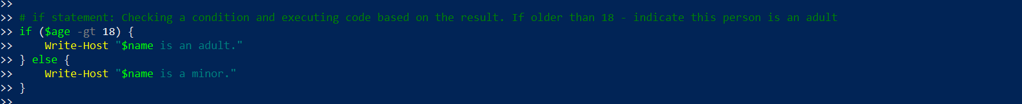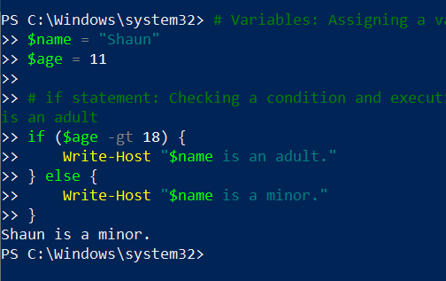
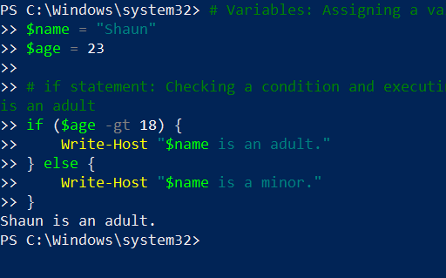
This code snippet uses an if statement in PowerShell to check if a person's age is over 18, then indicates whether they are an adult or younger/minor.
Components:
- If statement: if ($age -gt 18)
- If condition true: Write-Host "$name is an adult."
- If condition false: Write-Host "$name is a minor."
This code employs conditional logic to determine a person's status as an adult or a minor based on their age in the script.

Case Statement
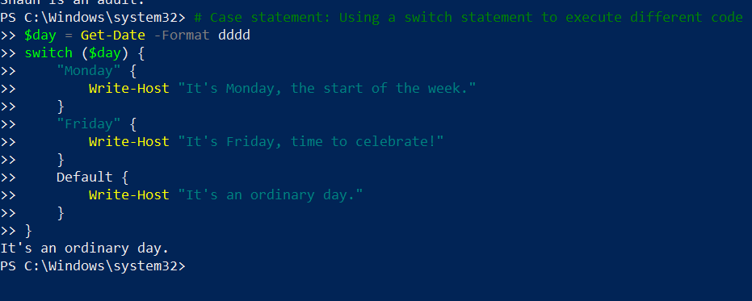
This PowerShell script uses a switch statement to execute different code based on the day of the week, with special cases for Monday and Friday.
Components:
- Get current day: $day = Get-Date -Format dddd
- Switch statement: switch ($day)
- Case "Monday": Write-Host "It's Monday, the start of the week."
- Case "Friday": Write-Host "It's Friday, time to celebrate!"
- Default case: Write-Host "It's an ordinary day."
This code handles different actions based on the day of the week, if Monday, Friday or other the code will run. Providing customized messages for Monday, Friday, and other days.

A loop
Evidence:
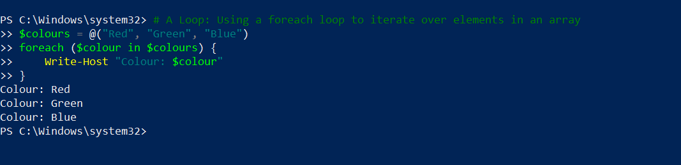

Array
Evidence:
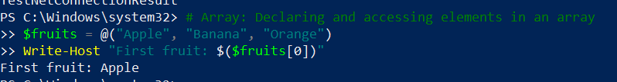
This script demonstrates using a foreach loop to iterate over elements in an array of colours and accessing elements in another array of fruits.
Components:
- Foreach loop:
  - Array declaration: $colours = @("Red", "Green", "Blue")
  - Loop through colours: foreach ($colour in $colours) { Write-Host "Colour: $colour" }
- Array access:
  - Array declaration: $fruits = @("Apple", "Banana", "Orange")
  - Access first element: Write-Host "First fruit: $($fruits[0])"
A foreach loop to iterate over colours array and access elements in the fruits array, showcasing array manipulation.

Function
Evidence:
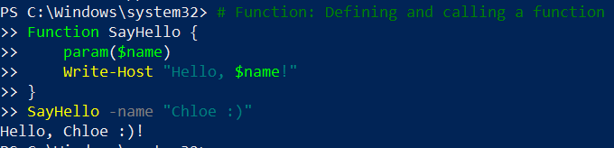

User Input
Evidence:
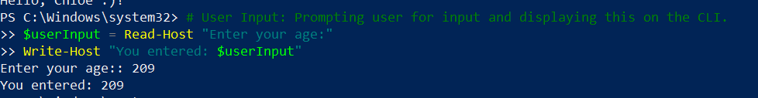
This PowerShell script defines a function to greet a user by name and prompts the user for input, displaying it on the command-line interface.
Components:
- Function definition:
  - Function SayHello { param($name) Write-Host "Hello, $name!" }
  - Calling the function: SayHello -name "Chloe :)"
- User input:
  - Prompting for input: $userInput = Read-Host "Enter your age:"
  - Displaying input: Write-Host "You entered: $userInput"
Defines and calls a function to greet the user and prompts for user input, demonstrating interaction with users.

Networking code
Evidence:

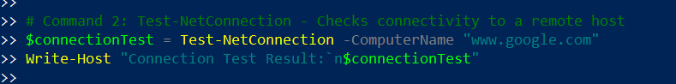
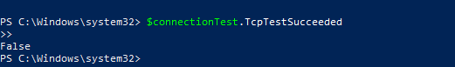

This script executes two commands: one to retrieve IP address configuration information and another to check connectivity to a remote host.
Components:
- Command 1: Get-NetIPAddress
  - Retrieving IP configuration: $ipConfig = Get-NetIPAddress
  - Displaying configuration: Write-Host "IP Configuration:n$ipConfig"`
- Command 2: Test-NetConnection
  - Testing connectivity: $connectionTest = Test-NetConnection -ComputerName "www.google.com"
  - Displaying test result: Write-Host "Connection Test Result:n$connectionTest"`
This code uses commands to retrieve IP address configuration and test connectivity to a remote host, providing network diagnostic capabilities.

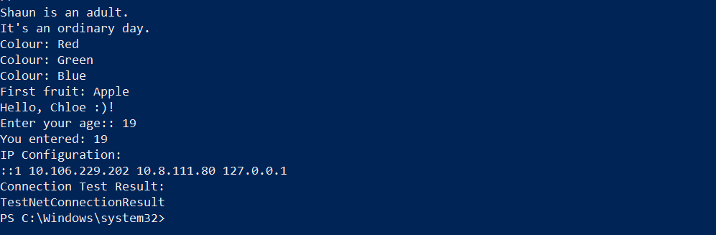

Use of Linux OS scripts
Please see appendix D for code [15].

Variables
Evidence:
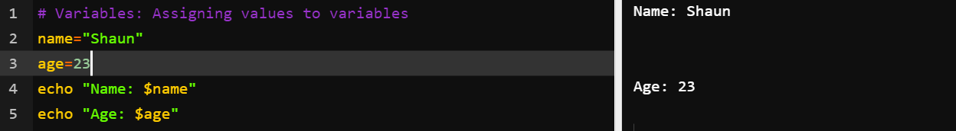

If statement
Evidence:
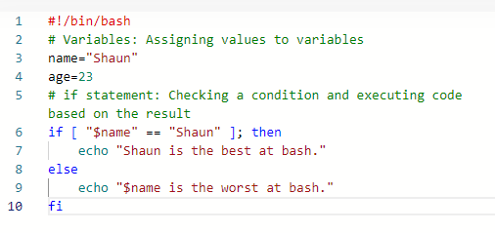
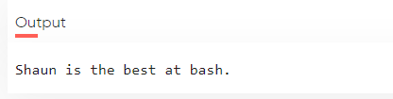
This Bash script assigns values to variables, checks a condition using an if statement, and outputs messages accordingly.
Components:
- Variable assignment: name="Shaun" and age=23
- Condition check: if [ "$name" == "Shaun" ]; then
- Output message for true condition: echo "Shaun is the best at Bash!"
- Output message for false condition: echo "$name is the worst at Bash!"
This code manages variables and conditionally executes code, demonstrating fundamental Bash scripting skills with conditional logic [7].

Case statement
Evidence:
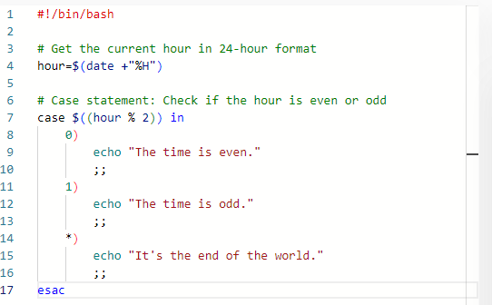
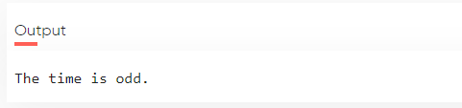
This script retrieves the current hour in 24-hour format, then determines if it's even or odd using a case statement.
Components:
- Get current hour: hour=$(date +"%H")
- Case statement: Checks if hour is even or odd.
- Case 0: Outputs "The time is even."
- Case 1: Outputs "The time is odd."
- Default case: Outputs "It’s the end of the world."
This code retrieves current time and performs conditional logic to determine if the hour is even or odd [7].

A loop
Evidence:
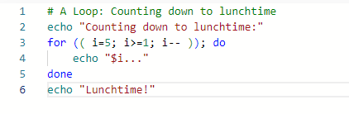
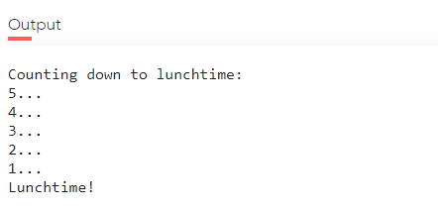
This script implements a loop to count down from 5 to 1.
Components:
- Loop initialization: for (( i=5; i>=1; i-- ))
- Loop body: Outputs the current countdown value with "..." appended.
- Loop termination: done
- Output after loop: echo lunchtime [7].

Array
Evidence:
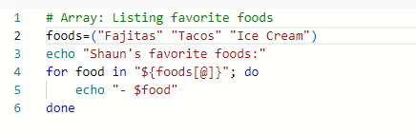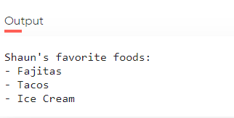
This script creates an array of favorite foods, then lists them in a sentence format.
Components:
- Array initialization: foods=("Fajitas" "Tacos" "Ice cream")
- Output prompt: echo -n "Shaun's favorite foods: "
- Loop through array: for food in "${foods[@]}"; do
- Display each food: echo -n "$food " [7].

Function
Evidence:
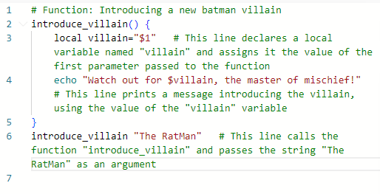
This script defines a function to introduce a new Batman villain and then calls the function with the villain's name.
Components:
- Function definition: introduce_villain() { ... }
- Local variable assignment: local villain="$1"
- Output message: echo "Watch out for $villain, the master of mischief!"
- Function call: introduce_villain "The RatMan" [7].
This function allows the code to be reused and run again multiple times with different parameters.

Networking Commands
Evidence:
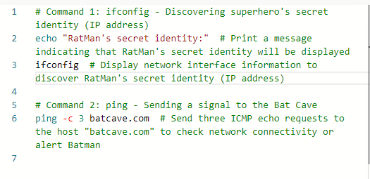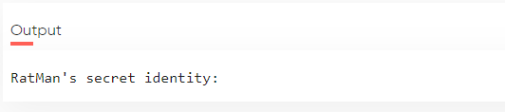
This script executes two commands to discover RatMan's IP address and pings batcave.com for network connectivity.
Components:
- Command 1: ifconfig
  - Print message: echo "RatMan's secret identity:"
  - Display network info: ifconfig
- Command 2: ping -c 3 batcave.com
  - Send ICMP echo requests: ping -c 3 batcave.com
These commands discover RatMan's IP and ping an address [7].

Conclusion
Throughout this assignment, I have explored key functions of general OSs, demonstrated CLI commands and scripting capabilities: PowerShell, Bash. From this, I can now optimize system performance, enhance secrurity and streamline processes using OSs.

References

[1] | A. Tanenbaum, “WHAT IS AN OPERATING SYSTEM?,” in Modern operating systems, Pearson Education, 2009, pp. 3-7.
[2] | F. Hafeez, “Role of File System in Operating System,” International Journal of Computer Science and Innovation, vol. 2016, no. 3, pp. 121-123.
[3] | W. Stallings, Operating systems : internals and design principles, Upper Saddle River, N.J:: Pearson Prentice Hall, 2005.
[4] | nishant0073, “What is a Network Operating System?,” Geeks For Geeks, 03 November 2023. [Online]. Available: https://www.geeksforgeeks.org/what-is-a-network-operating-system/. [Accessed 18 04 2024].
[5] | “Functions of Operating System,” Geeks For Geeks, 19 January 2024. [Online]. Available: https://www.geeksforgeeks.org/functions-of-operating-system/. [Accessed 18 April 2024].
[6] | Windows, “Windows Commands,” Windows, 26 April 2023. [Online]. Available: https://learn.microsoft.com/en-us/windows-server/administration/windows-commands/windows-commands. [Accessed 18 April 2024].
[7] | “SS64,” SS64, 14 April 2024. [Online]. Available: https://ss64.com/bash/. [Accessed 18 April 2024].
[8] | M. sdwheeler, “about_Variables,” Microsoft, 3 July 2024. [Online]. Available: https://learn.microsoft.com/en-us/powershell/module/microsoft.powershell.core/about/about_variables?view=powershell-7.4#short-description. [Accessed 18 April 2024].
[9] | “What is an operating system?,” GCFGlobal, [Online]. Available: https://edu.gcfglobal.org/en/computerbasics/understanding-operating-systems/1/#. [Accessed 18 April 2024].
[10] | akash1295, “Geeks For Geeks,” 16 April 2024. [Online]. Available: https://www.geeksforgeeks.org/types-of-operating-systems/.
[11] | G. SARA, “Quantum Computing: What It Is, Why We Want It, and How We're Trying to Get It,” Frontiers of Engineering: Reports on Leading-Edge Engineering from the 2018 Symposium., 28 January 2019. [Online]. Available: https://www.ncbi.nlm.nih.gov/books/NBK538701/. [Accessed 18 April 2024].

[12] Shaun Davies, “Computer Architecture and Operating Systems – Operating Systems”, Appendix A
[13] Shaun Davies, “Computer Architecture and Operating Systems – Operating Systems”, Appendix B
[14] Shaun Davies, “Computer Architecture and Operating Systems – Operating Systems”, Appendix C
[15] Shaun Davies, “Computer Architecture and Operating Systems – Operating Systems”, Appendix D

Appendix A

Windows OS CLI commands
Display the list of contents in the current directory
cd .\addins\
Write-Host "Contents of the current directory:”
Dir
Display help information for the dir command
Write-Host "Help information for the dir command:"
Get-Help dir
Create a new folder named 'createnewdirtest'
Write-Host "Creating a new folder named ‘'createnewdirtest'
New-Item -ItemType Directory –Path C:\Users\B081723\OneDrive - Tata Steel Europe Ltd\Documents\Education\SU\Environmental Management\Assignment\createnewdirtest
Change directory to the 'createnewdirtest' folder
cd '.\Users\B081723\OneDrive - Tata Steel Europe Ltd\Documents\Education\SU\Environmental Management\Assignment\createnewdirtest\'
Create files within directory
New-Item -ItemType File -Name "newfile.txt"
1..10 | ForEach-Object { New-Item -ItemType File -Name "RatManSecretNotes$_`$.txt" }
List whole directory (alternative: Ls)
ls .\createnewdirtest\
Remove files
Del RatManSecretCodes.txt
Del *
Dir
Cd ../
Clear the window (cls)
Cls
Display a message
Write-Host "Hello, world!"
Get processes that are running
Get-Process
Use of Windows OS scripts.
Export process information to a CSV file
Get-Process | Export-CSV GProcess.csv
ls .\GProcess.csv
Invoke-Item GProcess.csv

Get the computer's IP address
Get-NetIPAddress

Get detailed IP configuration
Get-NetIPConfiguration

Appendix B

Use of Linux OS CLI commands.
Print the present working directory
pwd
Change directory
16 cd ../
17 cd .cache/
List
18 ls
Make a new directory
19 mkdir RatManTest
Enter a new directory
20 cd RatManTest/

Create a new file
21 touch ratmansecretcodes.txt
Give permission to owner/user.
22 chmod +rwx ratmansecretcodes.txt
23 ls -l ratmansecretcodes.txt
Display a message
24 echo "duh-nuh-duh-nuh-duh-nuh-duh-nuh-rat-man"
25 echo "my evil plan is dot dot dot" > ratmansecretcodes.txt
Text from a file
26 cat ratmansecretcodes.txt
27 grep "dot" ratmansecretcodes.txt
History
28 history
29 clear
Ping
Ping 127.0.0.1
Display
Netstrat -a
Export previous
Netstrat -a >netrat_output_shaun.csv
Nano netstrat_output_shaun.csv

Appendix C

Use of Windows OS scripts.
# Variables: Assigning a value to a variable
$name = "Shaun"
$age = 23

# if statement: Checking a condition and executing code based on the result. If older than 18 - indicate this person is an adult
if ($age -gt 18) {
Write-Host "$name is an adult."
} else {
Write-Host "$name is a minor."
}

# Case statement: Using a switch statement to execute different code based on different conditions. Monday and Friday are unique here, as you can see below.
$day = Get-Date -Format dddd
switch ($day) {
"Monday" {
Write-Host "It's Monday, the start of the week."
}
"Friday" {
Write-Host "It's Friday, time to celebrate!"
}
Default {
Write-Host "It's an ordinary day."
}
}

# A Loop: Using a foreach loop to iterate over elements in an array
$colours = @("Red", "Green", "Blue")
foreach ($colour in $colours) {
Write-Host "Colour: $colour"
}

# Array: Declaring and accessing elements in an array
$fruits = @("Apple", "Banana", "Orange")
Write-Host "First fruit: $($fruits[0])"

# Function: Defining and calling a function
Function SayHello {
param($name)
Write-Host "Hello, $name!"
}
SayHello -name "Chloe :)"

# User Input: Prompting user for input and displaying this on the CLI.
$userInput = Read-Host "Enter your age:"
Write-Host "You entered: $userInput"

# Networking PowerShell commands:

# Command 1: Get-NetIPAddress - Retrieves IP address configuration information
$ipConfig = Get-NetIPAddress
Write-Host "IP Configuration:`n$ipConfig"

# Command 2: Test-NetConnection - Checks connectivity to a remote host
$connectionTest = Test-NetConnection -ComputerName "www.google.com"
Write-Host "Connection Test Result:`n$connectionTest"

Shaun is an adult.
It's an ordinary day.
Colour: Red
Colour: Green
Colour: Blue
First fruit: Apple
Hello, Chloe :)!
Enter your age:: 19
You entered: 19
IP Configuration:
::1 10.106.229.202 10.8.111.80 127.0.0.1
Connection Test Result:
TestNetConnectionResult

Appendix D

Use of Linux OS scripts
#!/bin/bash

# Variables: Assigning values to variables
name="Shaun"
age=23

# if statement: Checking a condition and executing code based on the result
if [ "$name" == "Shaun" ]; then
echo "Shaun is the best at Bash!"
else
echo "$name is the worst at Bash!"
fi
# Get the current hour in 24-hour format
hour=$(date +"%H")

# Case statement: Checking if the hour is even or odd
case $((hour % 2)) in
0)
echo "The time is even."
;;
1)
echo "The time is odd."
;;
*)
echo "It’s the end of the world."
;;
esac
#!/bin/bash

# Loop: Counting down from 5 to 1
for (( i=5; i>=1; i-- )); do
echo -n "$i..."
done

echo "Lunchtime"
# Array: listing favorite foods
foods=("Fajitas" "Tacos" "Ice cream")
echo -n "Shaun's favorite foods: "
for food in "${foods[@]}"; do
echo -n "$food "
done
# Function: Introducing a new batman villain
introduce_villain() {
local villain="$1"
echo "Watch out for $villain, the master of mischief!"
}
introduce_villain "The RatMan"
# Command 1: ifconfig - Discovering superhero's secret identity (IP address)
echo "RatMan's secret identity:" # Print a message indicating that RatMan's secret identity will be displayed
ifconfig # Display network interface information to discover RatMan's secret identity (IP address)

# Command 2: ping - Sending a signal to the Bat Cave
ping -c 3 batcave.com # Send three ICMP echo requests to the host "batcave.com" to check network connectivity or alert Batman

Appendix E

Tutorial Activity
Operating Systems
An OS is a computerised system that organises computer resources; “processors, memories, and I/O” (input/output) “devices” and divides responsibly their use “among the various programs competing for them”. This establishes organisation” and, in summary, “its primary tasks is to keep track of which programs are using which resource to grant resource requests, to account for usage, and to mediate conflicting requests from different programs and users” [1].
Alternatively put, operating systems are essential software that; manages “memory”, “processes”, “hardware” and allows for user to computer interation. Without it, a computer is non-functional [9].
Batch OS
Similar jobs are grouped “together into batches” and overseen by an operator using a batch operating system. To reduce idle times, it queues jobs for CPU time.
Benefits include managing repetitious tasks, supporting many users, and effectively utilising resources. However it needs skilled operators, is “hard to debug”, and can cost money and cause delays if something goes wrong. “Examples of Batch Operating Systems: Payroll Systems, Bank Statements, etc.” [10]
Multi-programming system
This OS allows multiple programs to reside in “main memory”, enabling efficient resource utilization. It enhances system throughput and reduces response time. However, it lacks user interaction with system resources. [10]
Multi-tasking OS
Multi-Tasking Operating Systems enable concurrent use of many programs using “Round-Robin Scheduling Algorithm”, enhancing system performance.
Two types exist: Pre-emptive and Cooperative. They offer efficient memory management but may lead to system overheating [10].
Time-sharing OS
Time-Sharing Operating Systems allocate CPU time to tasks for smooth operation, promoting “resource sharing”, “improved productivity” and a better “user experience”. However, they pose reliability and security challenges. Distributed Operating Systems connect autonomous computers through a shared network, enhancing data exchange speed and scalability. Despite benefits, they face network failure risks or “data communication” problems and the complexity requires “advanced software to manage”. [10].
Network OS
Network Operating Systems facilitate centralized data management and resource sharing over private networks, but they require costly servers and regular maintenance. Examples include Windows Server, UNIX, and Linux [10]
Quantum OSs (QOSs)
Typical every day computing is different from quantum computing; “Superposition and entanglement” are principles of quantum mechanics which is used within QOSs to leverage these principles to create compution speed increases over classical methods (CMs). CM use the principle of transitors being on or off. QOSs have an “ability to be in superpositions with varying probabilities that can be manipulated by quantum operations during computations” which increases computational speed [11].

Microsoft Learn course: Learning PowerShell
Figure 1: Automate administrative tasks by using PowerShell

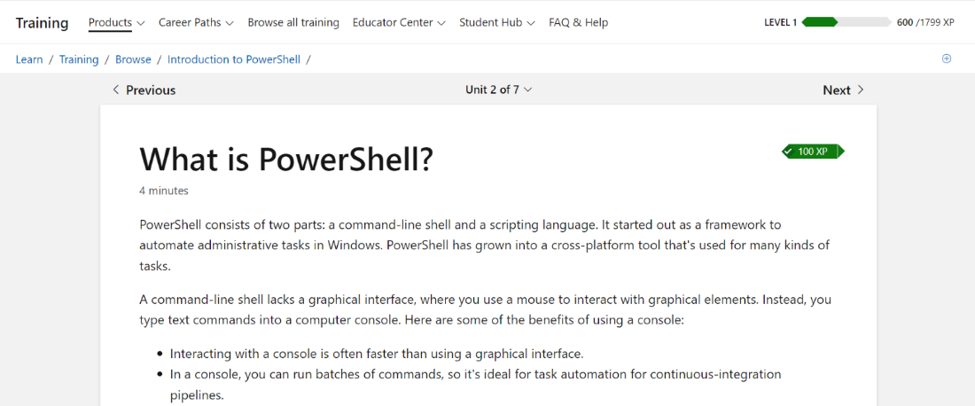
Figure 2: Automate administrative tasks by using PowerShell 3 of 6 Modules completed. I will complete this course throught my time at university.


