Name: Abdulla Al Mamun
ID: 1606019

Contents
Introduction 4
Provide a critical assessment of the usefulness of project management tools and techniques 4
1.1 Project Initials 4
1.2 Work Breakdown Structure (WBS) 4
1.3 Gantt Charts 4
1.4 Critical path analysis 5
1.5 Project Evaluation and Review Technique (PERT) 5
1.6 Resources 5
1.7 Milestone 5
1.8 Project Planning Document (PID) 6
1.9 Risk Assessment 6
2) Prepare a plan for the implementation of the project 7
Project Aim: 7
Project Activities 7
Reason of the project 7
Role and responsibilities of the project manager 7
Work Breakdown Structure (WBS) 7
Gantt chart 8
Network Diagram: 9
Critical Path 9
Longest Path 9
Resources 9
Milestone 10
Project Planning Document (PID) 10
Part 2 16
Risk Assessment: 16
Project Evaluation Technique 16
Identify Financial Savings 16
Identify the financial savings 17
Communicate the Project Plan with colleagues and Stakeholders 17
3. Critically evaluate your ability to manage a project. 17
Own ability of managing a project 17
Strength and weaknesses of the project implementation 17
Personal Development Plan 18
Conclusion 19
References 20

Introduction
Project management is known as one of the most significant business tools which overall provides the shape of moving towards the ultimate destination. With the help of the project management the business organization will be able to develop as well as implement new strategies and also remove or minimize the organizational complexity (Biafore et al, 2017). Continuous development there are several tools and technique which are used by the business organization. For establishing a good growing business operation it is very important to maintain a constant control over the activities by the project manager. The detail brief of the project planning from the starting point to end point is known as milestones. The completion of the project stages within the time can be ensured by the milestone (Heagney et al, 2012).

“Provide a critical assessment of the usefulness of project management tools and techniques”

1.1 Project Initials
The project initials need to be identified and developed initials are the key factor for performing (Dalcher, 2016). The proper selection of project initials can make the project accomplished within the respective time and budget which is main concern for the project manager. The personal development plan works for improving the skills and talents and also for enhancing the future as well. The personal development plan of mine has been following below which will allow me to conduct the project in a proper way.

1.2 Work Breakdown Structure (WBS)
The work breakdown is considered very effective in the small projects where all the tasks are so limited in scope and need to be completed within the time frame and budget as well. The main advantage of work breakdown is it helps the project manager to manage the whole project at a same point. The best usage of the resources and within the time the project can be conducted. The Cinderella coffee shop has been serving their customers for a long time. Now the business owner has decided to implement a live music show within the coffee shop which will attract more customers.

1.3 Gantt Charts
Gantt chart which has been established for scheduling the Project Properly. Every activities will be conducted according to the time factor and this will maintain the proper continuation as well. Gantt chart is used mainly for the time component (Schwalbe et al, 2015). The main target of Gantt chart is to maintain the continuation and Coordination among the tasks and also to perform the specific tasks within the time (Heagney et al, 2012). While conducting the small projects the Gantt chart play the most effective role in performing and establishment of all of the tasks whereas this chart is not found so much.

1.4 Critical path analysis
With the Help of Critical path analysis the estimated time for accomplishment of the Projects have been detected (Biafore et al, 2017). Apart from this, critical path mainly ensure the best and most usage of the available Resources for the project. While using the Gantt chart it is seen that all of the tasks are interrelated and the next level cannot be started before the prior level has been completed (Dalcher, 2016). That's why the critical path clearly provides the exact time for the completion of the project maintaining the interrelation and dependency among the tasks.

1.5 Project Evaluation and Review Technique (PERT)
By using the pert diagram the project can be conducted within the project time and it will also determine the uncertainty of the project. With the pert diagram the project manager can get the best and worst time frame for completion of the project and also can take the required steps. The financial factors need to be determined by the project manager which will decide the success ratio of the project (Biafore et al, 2017). Some tools and techniques need to be followed for the analysis of the financial condition which are NPV, internal rate of return and so on (Schwalbe et al, 2015).

1.6 Resources
When the Project manager can determine the Resources properly only then the best usage of the Resources will be possible. Moreover, it is necessary to maintain the interrelation among the activities of the project and a successful planning will ensure the most usage of available resources. The project manager need to maintain a proper report on the daily achievement and will also make the presentation with the advanced tools and techniques and will also present to the higher authority of the coffee shop.

1.7 Milestone
The detail brief of the project planning from the starting point to end point is known as milestones. The completion of the project stages within the time can be ensured by the milestone (Heagney et al, 2012). The project manager must contact the company's marketing team. Moreover, it is necessary to maintain the interrelation among the activities of the project and a successful planning will ensure the most usage of available resources.

1.8 Project Planning Document (PID)
This explained the project business case with details of the project selection's rationale. While planning for the project, the project managers do not have any idea of team members or the subordinates. If the team members are so not cooperative and expert at their own field it will have a great impact over the completion of the project planning and the available resources will also not be used at the best of that (Heagney et al, 2012). The main target of Gantt chart is to maintain the continuation and Coordination among the tasks and also to perform the specific tasks within the time (Heagney et al, 2012).

1.9 Risk Assessment
Project management is always correlated with the risk that could cause the project to fail: expense, time, quality, resources, etc (Dalcher, 2016). Project manager has to provide instruction to the organization's staff to ensure that all job tasks in the company are carried out correctly (Heagney et al, 2012). Continuous development there are several tools and technique which are used by the business organization. For establishing a good growing business operation it is very important to maintain a constant control over the activities by the project manager.

2) Prepare a plan for the implementation of the project

Project Aim:
The aim of the research is to implement the strategies for establishment the live music within the Cinderella coffee shop, London.

Project Activities
- The live music system need to be established by end of March, 2020.
- To create the customer attraction towards this trend.
- To build the chain of live music coffee shop in North London.

Reason of the project
The Cinderella coffee shop has been serving their customers for a long time. Now the business owner has decided to implement a live music show within the coffee shop which will attract more customers. Project management is known as one of the most significant business tools which overall provides the shape of moving towards the ultimate destination. With the help of the project management the business organization will be able to develop as well as implement new strategies and also remove or minimize the organizational complexity (Biafore et al, 2017). The project planning will be proved profitable for the coffee shop owner as it will make the consumers attracted to the shop (Dalcher, 2016).

Role and responsibilities of the project manager
Gantt chart is the horizontal Bar chart which has been established for scheduling the Project Properly. Every activities will be conducted according to the time factor and this will maintain the proper continuation as well. Gantt chart is used mainly for the time component (Schwalbe et al, 2015). Proper training and guidelines form the project manager will help to reduce the faults of the employees as well as team members (Heagney et al, 2012).

Work Breakdown Structure (WBS)
The work breakdown structure of Cinderella coffee shop implementing live music show has been provided below:
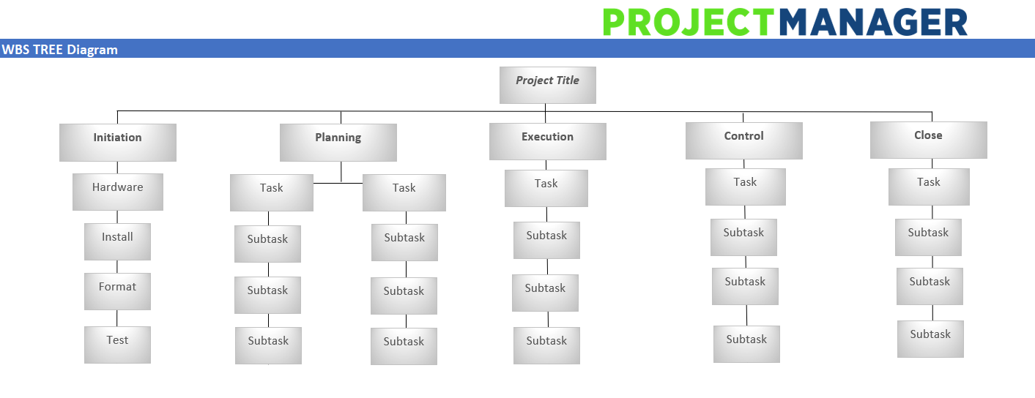

Gantt chart
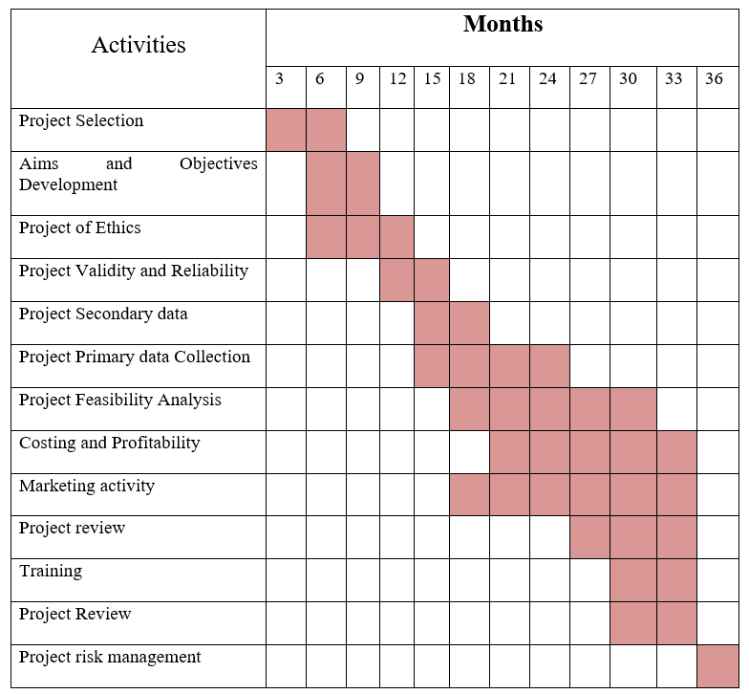

Network Diagram:
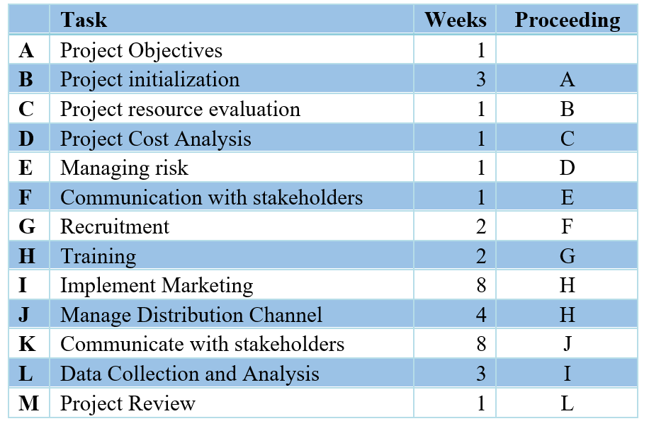

Critical Path
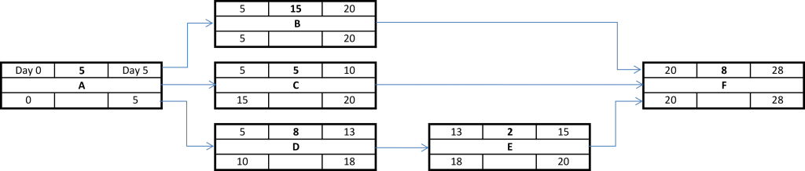

Longest Path
A+B+C+D+E+F+G+H+I+L+M = 1+2+1+1+1+1+2+2+6 +3+1 = 21 Weeks

Resources
Continuous development there are several tools and technique which are used by the business organization. For establishing a good growing business operation it is very important to maintain a constant control over the activities by the project manager. The main target of Gantt chart is to maintain the continuation and Coordination among the tasks and also to perform the specific tasks within the time (Heagney et al, 2012). The financial factors need to be determined by the project manager which will decide the success ratio of the project (Biafore et al, 2017). Some tools and techniques need to be followed for the analysis of the financial condition which are NPV, internal rate of return and so on (Schwalbe et al, 2015). The project manager must coordinate with the organization's HRM department and assign the right number of organizational employees to preform operational activities (Schwalbe et al, 2015). Project manager has to provide instruction to the organization's staff to ensure that all job tasks in the company are carried out correctly (Heagney et al, 2012).

Milestone
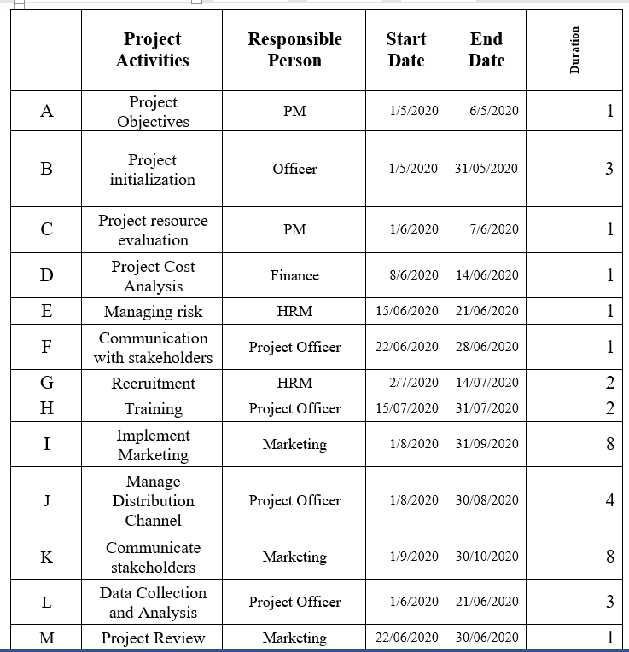

Project Planning Document (PID)
Section 1 – What is the project all about?
Project Title:
“Cinderella Coffee Shop, London – Implementing Live Music System”
Background:
Cinderella coffee shop is situated in North London, which is flourishing day by day. Now-a-days the shop owner has decided to implement the live music within the coffee shop (Biafore et al, 2017). This coffee shop has also six branches through all over the London.

Purpose
The research objective for this topic is to determine the possibilities and profitability ratio for the live music system at Cinderella coffee shop.
Objectives
- To attract more customers with the live music and standard quality coffee
- To become the first live coffee shop owner of the North London which will be expanded later on.
- The whole project will be conducted within the end of March, 2020.
Project scope
For that reason, the customer relationship management and the marketing department need to study and research at the market before starting the project. This explained the project business case with details of the project selection's rationale. The project manager need to monitor the whole implementation of live music and also to identify the number of customers increased visiting to the coffee shop daily (Schwalbe et al, 2015). With the Help of Critical path analysis the estimated time for accomplishment of the Projects have been detected (Biafore et al, 2017). Apart from this, critical path mainly ensure the best and most usage of the available Resources for the project.
Deliverables
The Planning also should be reported to the shop owner daily for the continuous supervision. For conducing any kind of task it is necessary for an individual to determine the strength and weakness factors which will ensure the success and prosperity (Schwalbe et al, 2015). And while conducting the project planning it is one of the most significant concern to identify the expertise and weakness for the better accomplishment (Heagney et al, 2012).
Constraints
The proper selection of project initials can make the project accomplished within the respective time and budget which is main concern for the project manager. It is important for the project manager to measure the customers numbers daily visited at the stores frequently and to evaluate the performance level of the live music project (Dalcher, 2016). While conducting the small projects the Gantt chart play the most effective role in performing and establishment of all of the tasks whereas this chart is not found so much effective for the lengthy and complex projects.

Section 2: Why should this project go ahead?

Business case: Project Benefits
The day to day update and customers numbers are also should be recorded in the report. A project manager need to have the capability of judging the situation and deriving the best alternative from that situation (Biafore et al, 2017). If the project manager is capable of having well judgmental ability it will help to face and also handle any kind of unwanted situations. The communication skills is also required for the proper continuation of the project.
Options
Cinderella coffee shop will make the chain of live music in the coffee shop. As a result more customers will be attracted toward the coffee shop. For establishing the live music in the coffee shop can be turned out into a risk factor if the customers do not get attracted towards the whole news process (Heagney et al, 2012). While using the Gantt chart it is seen that all of the tasks are interrelated and the next level cannot be started before the prior level has been completed (Dalcher, 2016). That's why the critical path clearly provides the exact time for the completion of the project maintaining the interrelation and dependency among the tasks.
Cost and Timescale
Cost and Benefit Analysis
 | Year 01 | Year 02 | Year 03
Sales | 100,000.00 | 110,000.00 | 121,000.00
Rent | 3,000.00 | 3,300.00 | 3,630.00
Development | 10,000.00 | 11,000.00 | 12,100.00
Information Technology | 7,000.00 | 7,700.00 | 8,470.00
Marketing | 6,000.00 | 6,600.00 | 7,260.00
Training and development | 3,000.00 | 3,300.00 | 3,630.00
Personal Relation | 2,000.00 | 2,200.00 | 2,420.00
Benefit | 69,000.00 | 75,900.00 | 83,490.00

Risk Analysis: Risk Identification
The customer service department of the coffee shop need to work harder for attracting more customers and also to make the system popular among the whole market (Biafore et al, 2017). That’s why it is very significant to implement the proper strategies for the specific tasks. The project manager has to coordinate with the organization's HRM department and assign the right number of corporate employees to preform operational activities (Dalcher, 2016).

Risk prevention
Proper training and guidelines form the project manager will help to reduce the faults of the employees as well as team members (Heagney et al, 2012). The Cinderella coffee shop has been serving their customers for a long time. Now the business owner has decided to implement a live music show within the coffee shop which will attract more customers. Project management is known as one of the most significant business tools which overall provides the shape of moving towards the ultimate destination.
Risk Monitoring
The project manager need to monitor the whole implementation of live music and also to identify the number of customers increased visiting to the coffee shop daily (Schwalbe et al, 2015). If the project manager is capable of having well judgmental ability it will help to face and also handle any kind of unwanted situations. The communication skills is also required for the proper continuation of the project. With the help of the project management the business organization will be able to develop as well as implement new strategies and also remove or minimize the organizational complexity (Biafore et al, 2017). The project planning will be proved profitable for the coffee shop owner as it will make the consumers attracted to the shop (Dalcher, 2016).
Section 3: Who will work on the project?
Roles and Responsibilities
The update of the project planning also should be reported to the shop owner daily for the continuous supervision. A project manager need to have the capability of judging the situation and deriving the best alternative from that situation (Biafore et al, 2017).
Names of: Project Sponsor
“Senior Management Team”
Section 4: How and when will the project are delivered?

Initial Project Plan
The starting date of the project is 01/01/2020 and it will end on 31/03/2020.
Human Resource Requirements
The project manager must coordinate with the organization's HRM department and assign the right number of organizational employees to preform operational activities (Schwalbe et al, 2015). Project manager has to provide instruction to the organization's staff to ensure that all job tasks in the company are carried out correctly (Heagney et al, 2012).
Support Staff
Project manager will need more team members for the completion of the project for serving more customers. And while conducting the project planning it is one of the most significant concern to identify the expertise and weakness for the better accomplishment (Heagney et al, 2012).
Additional Staff
Again for directing exploration work venture supervisor needs to draw in representatives staff individuals for leading review and gather information for the examination work. For conducing any kind of task it is necessary for an individual to determine the strength and weakness factors which will ensure the success and prosperity (Schwalbe et al, 2015).
Project Control: Monitoring mechanisms
If the team members are so not cooperative and expert at their own field it will have a great impact over the completion of the project planning and the available resources will also not be used at the best of that (Heagney et al, 2012). The project manager need to monitor the whole implementation of live music and also to identify the number of customers increased visiting to the coffee shop daily (Schwalbe et al, 2015).
Communication channels and schedules
The day to day update and customers numbers are also should be recorded in the report. While planning for the project, the project managers do not have any idea of team members or the subordinates. If the project manager is capable of having well judgmental ability it will help to face and also handle any kind of unwanted situations. The communication skills is also required for the proper continuation of the project.
Quality Control
The attraction and feedback from the customers after the live music show will help the business owner to understand the project development (Schwalbe et al, 2015). The customer service department of the coffee shop need to work harder for attracting more customers and also to make the system popular among the whole market (Biafore et al, 2017). That’s why it is very significant to implement the proper strategies for the specific tasks.

Part 2

Risk Assessment:
For establishing the live music in the coffee shop can be turned out into a risk factor if the customers do not get attracted towards the whole news process (Heagney et al, 2012). For that reason, the customer relationship management and the marketing department need to study and research at the market before starting the project. The personal development plan works for improving the skills and talents and also for enhancing the future as well. The personal development plan of mine has been following below which will allow me to conduct the project in a proper way.

Project Evaluation Technique
When the Project manager can determine the Resources properly only then the best usage of the Resources will be possible.

Identify Financial Savings
The financial factors need to be determined by the project manager which will decide the success ratio of the project (Biafore et al, 2017). Some tools and techniques need to be followed for the analysis of the financial condition which are NPV, internal rate of return and so on (Schwalbe et al, 2015). Proper training and guidelines form the project manager will help to reduce the faults of the employees as well as team members (Heagney et al, 2012). The project manager has to coordinate with the organization's HRM department and assign the right number of corporate employees to preform operational activities (Dalcher, 2016).
NPV: Net present value is the amount which shows difference between the cash inflow and cash outflow.
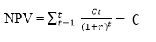
Internal rate of return:

Identify the financial savings
The project manager must coordinate with the organization's HRM department and assign the right number of organizational employees to preform operational activities (Schwalbe et al, 2015).
- The coffee shop need modification in lighting and air ventilation and proper sound maintenance system also should be implemented. (Dalcher, 2016)
- The size of the coffee shop need to be expanded as live music system will be implemented.

Communicate the Project Plan with colleagues and Stakeholders
The project manager need to maintain a proper report on the daily achievement and will also make the presentation with the advanced tools and techniques and will also present to the higher authority of the coffee shop. The organization's department that needs to be engaged is: IT department, R&D department, finance department to distribute the company's budget, HRM department to assign the correct number of people to the project (Biafore et al, 2017). For establishing the live music in the coffee shop can be turned out into a risk factor if the customers do not get attracted towards the whole news process (Heagney et al, 2012).

3. Critically evaluate your ability to manage a project.

Own ability of managing a project
A project manager need to have the capability of judging the situation and deriving the best alternative from that situation (Biafore et al, 2017). If the project manager is capable of having well judgmental ability it will help to face and also handle any kind of unwanted situations. The communication skills is also required for the proper continuation of the project. Cinderella coffee shop will make the chain of live music in the coffee shop. As a result more customers will be attracted toward the coffee shop.

Strength and weaknesses of the project implementation
For conducing any kind of task it is necessary for an individual to determine the strength and weakness factors which will ensure the success and prosperity (Schwalbe et al, 2015). And while conducting the project planning it is one of the most significant concern to identify the expertise and weakness for the better accomplishment (Heagney et al, 2012). The strength and weakness regarding the ability, implementation and evaluation of the project has been discussed below:
While planning for the project, the project managers do not have any idea of team members or the subordinates. If the team members are so not cooperative and expert at their own field it will have a great impact over the completion of the project planning and the available resources will also not be used at the best of that (Heagney et al, 2012). Project manager has to provide instruction to the organization's staff to ensure that all job tasks in the company are carried out correctly (Heagney et al, 2012). For that reason, the customer relationship management and the marketing department need to study and research at the market before starting the project. The personal development plan works for improving the skills and talents and also for enhancing the future as well. The personal development plan of mine has been following below which will allow me to conduct the project in a proper way.

Personal Development Plan
The personal development plan works for improving the skills and talents and also for enhancing the future as well. The personal development plan of mine has been following below which will allow me to conduct the project in a proper way. The financial factors need to be determined by the project manager which will decide the success ratio of the project (Biafore et al, 2017). Some tools and techniques need to be followed for the analysis of the financial condition which are NPV, internal rate of return and so on (Schwalbe et al, 2015). The project manager need to maintain a proper report on the daily achievement and will also make the presentation with the advanced tools and techniques and will also present to the higher authority of the coffee shop. Moreover, it is necessary to maintain the interrelation among the activities of the project and a successful planning will ensure the most usage of available resources. For establishing the live music in the coffee shop can be turned out into a risk factor if the customers do not get attracted towards the whole news process (Heagney et al, 2012).
The performance development objectives | Needs to perform to achieve objectives | Duration | Need resources for achieving objectives | Understand the achievement of objectives | Barriers
Develop decision making ability | I needs to read books, journals, and gain ability of taking decision | 01 – 03 – 2020 to 30 – 06 - 2020 | Need to gain access to library and find online books over internet | When I will gain confident for taking my own decision | Allocating time for reading books is a challenge for me
Gain Data management skills | Needs to attend training session | 01 – 03 – 2020 to 30 – 06 - 2020 | Need to have good finance to attend training programs | I will able to rightly manage information | Allocating time for reading books is a challenge for me
Research Skills | Needs to gain ability of performing research activities. Data collection and analysis | 01 – 03 – 2020 to 30 – 07 - 2020 | Need to read books and gain knowledge on data collection and analysis process | When I will able to set methods of the research and perform all research activities properly | Needs time for gaining knowledge and less time will not make me able to gain knowledge properly
IT Skill Development | I needs to gain knowledge on different IT skills from attending training programs | 01 – 03 – 2020 to 30 – 06 - 2020 | I needs to attend training programs for gaining knowledge | I will find myself confident for operating IT tools appropriately | Lack of finance and limited time is an obstacle of performance development
Gain knowledge on different culture | Need to perform discussion with people from different culture and gain knowledge from reading books | 01 – 03 – 2020 to 30 – 08 - 2020 | I needs to communicate with different people from different culture and attend training programs for gaining knowledge | I will find myself confident when I will communicate with different people from different culture. | Lack of time will be an obstacle for learning

Conclusion
The proper selection of project initials can make the project accomplished within the respective time and budget which is main concern for the project manager. It is important for the project manager to measure the customer’s numbers daily visited at the stores frequently and to evaluate the performance level of the live music project (Dalcher, 2016). While conducting the small projects the Gantt chart play the most effective role in performing and establishment of all of the tasks whereas this chart is not found so much effective for the lengthy and complex projects. The project manager need to maintain a proper report on the daily achievement and will also make the presentation with the advanced tools and techniques and will also present to the higher authority of the coffee shop. Again my own strength and weakness evaluation was crucial part of the repot as I got able to identify my ability and finally developed a plan for my performance development. The plan will make me able to improve my knowledge and ability within the determined time. It will make me confident in my further life.

References
- Alam, M. D., Guhl, U. F., (2016) Project-Management in Practice: A Guideline and Toolbox for Successful Projects: Springer
- Biafore, B. J., (2017) Practical Project Management with Microsoft Project 2016: MonteVista Solutions
- Dalcher, D., (2016) Further Advances in Project Management: Guided Exploration in Unfamiliar Landscapes: Taylor & Francis
- Heldman, K., (2010). Project Manager's Spotlight on Risk Management, London: John Wiley & Sons
- Heagney, J., (2012) Fundamentals of Project Management: AMACOM Div American Mgmt Assn
- Morris, P. W. G., (2013). Reconstructing Project Management, London: John Wiley & Sons
- Maley, C. H., (2012). Project Management Concepts, Methods, and Techniques, London: CRC Press
- Mahmood, Z., (2017)., Software Project Management for Distributed Computing: Life-Cycle Methods for Developing Scalable and Reliable Tools: Springer
- Schwalbe, K., (2015) Information Technology Project Management: Cengage Learning
- Yuri, R., (2016.) Handbook of Research on Leveraging Risk and Uncertainties for Effective Project Management: IGI Global

