Fundraising Strategy and Implementation
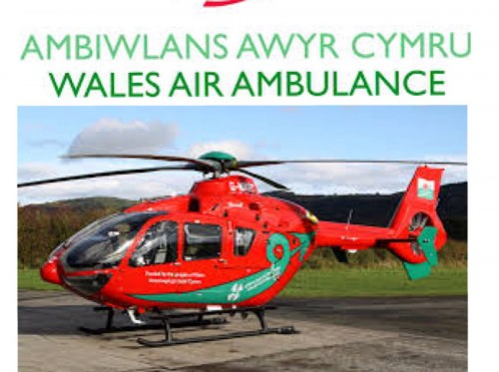
Our project management strategy was heavily influenced by the Iron Triangle framework. According to Atkinson (1999), "The Iron Triangle is a simple way of demonstrating that the relationship between time, cost, and scope is a fundamental part of project management". Additionally, “the iron triangle criteria, which is delivering on time, budget, and quality, scope, is the traditional perspective to assess the success of infrastructure projects. Delivering on cost and time is significant, but particularly for infrastructure, there are more relevant success criteria” (Locatelli, 2023).
We established clear timelines for each fundraising activity, ensuring timely execution. Social media campaigns were scheduled in advance, and merchandise production was planned to align with our event dates.
Budget management was crucial. We kept a close eye on production costs for merchandise and allocated funds efficiently to maximize our reach. Our partnerships with local businesses helped offset costs through in-kind donations and sponsorships.

We defined the scope of our fundraising efforts to include a variety of activities, ensuring a broad reach while maintaining focus on our primary objectives. By clearly outlining what we aimed to achieve, we avoided scope creep and kept our project on track.
Ensuring the quality of our activities was also a priority. For example, during merchandise production, Allison and I worked closely with suppliers to review sample products and ensure they met our standards before production. This attention to detail helped maintain the high quality of the items, making them more attractive to potential donors.
.
The Iron Triangle framework facilitated a balanced approach, ensuring that we met our fundraising goals without compromising on quality or exceeding our budget.
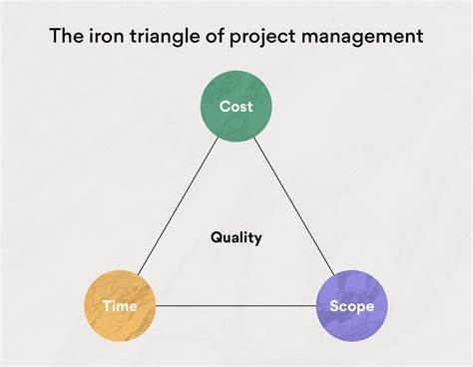
However, it is important to acknowledge the limitations of the Iron Triangle. As criticized by Shenhar and Dvir (2007), "focusing exclusively on the traditional time, cost, and scope constraints can lead to project management myopia, where the broader impact and long-term benefits of the project are overlooked."
Our comprehensive fundraising strategy, supported by effective team dynamics and guided by the Iron Triangle framework, has positioned us to make a significant impact for the Welsh Air Ambulance. This combination of strategic planning and dynamic teamwork ensures that our fundraising efforts will provide vital support to Welsh Air Ambulance, helping them continue their life-saving work.


Reference List
Atkinson, R. (1999). Project management: cost, time, and quality, two best guesses and a phenomenon, it is time to accept other success criteria. International Journal of Project Management, p.337-342.
Locatelli, G., Paravano, A., Terenzi, M. and Trucco, P., 2023. Yes, construction cost, time, and scope are important, but there is more: a new action plan for infrastructure success. Management Decision, 61(13), pp.413-424.
Shenhar, A. J., & Dvir, D. (2007). Reinventing Project Management: The Diamond Approach to Successful Growth and Innovation. Harvard Business Review Press.

