UNIVERSITY OF WALES TRINITY SAINT DAVID
MSc Cybersecurity and Digital Forensics

ASSESSMENT REPORT

Developing an Integrated Data Security, Governance and Compliance Approach for AeroLink Logistics
Applying data security, governance and compliance principles to the AeroLink Logistics scenario

Module | Data Security, Governance and Compliance
Module code | ACCA7028
Assignment Weighting | 50% of the overall module assessment
Lecturer | Dr Ayman El Hajjar
Student Name | Dhaval Rami
Student ID | 2528086
Word Count | 3112
Submission Deadline | Wednesday, 12 August 2026, 2:00 pm
Submission Date | Wednesday, 12 August 2026, 2:00 pm

Abstract
The report reviews several issues like security, governance and compliance issues that the company is facing as cloud services, IoT tracking, AI analytics and remote access are important part of AeroLink Logistics' operations. It critically reviews the frameworks: COBIT 2019, ISO/IEC 27001 and 27002, NIST Cybersecurity Framework 2.0 and ITIL 4 and contends that none of them can on their own address the governance, operational and compliance shortcomings of AeroLink. It is proposed that an integrated model be developed, with COBIT controlling the enterprise, ISO creating an auditable security management system, NIST organizing the operational cyber security, and ITIL managing services and suppliers. The design focuses on accountability, risk-based controls, vendor assurance, resilience and continuous improvement. It also emphasizes the need for the review of the rules and standards in accordance with changes in technologies, threats and international data-processing arrangements.
Table of Contents
Abstract i
List of Figures iii
List of Tables iv
1. Introduction 1
2. Organisational context, Security Gaps and Assumptions 1
2.1 Organisational context 1
2.2 Security and governance gap analysis 2
2.3 Assumptions 3
3. Critical Evaluation of Security Frameworks and Models 3
3.1 NIST Cybersecurity Framework 2.0 3
3.2 ISO/IEC 27001 and ISO/IEC 27002 3
3.3 COBIT 2019 4
3.4 ITIL 4 4
3.5 Comparative Evaluation and Framework Selection 4
4. Proposed Integrated Security, Governance and Compliance Approach for AeroLink Logistics 6
4.1 Design Principles and Architecture 6
4.2 Governance, Risk Management and Compliance 7
4.3 Policies, Protection Mechanisms and Access Controls 9
4.4 Vendor Management, Incident Response and Resilience 10
4.5 Implementation and Performance Measurement 11
5. Critical Analysis of Continuous Updates to Regulations and Standards 12
5.1 Emerging Technologies and Evolving Threats 12
5.2 Global Compliance and Ethical Responsibilities 13
5.3 Risk-Based Change Management 13
6. Conclusion 14
Reference List 15

List of Figures
Figure 1: AeroLink Digital Operating Environment and Attack Surface 2
Figure 2: AeroLink Integrated Security Governance and Compliance Model 7

List of Tables
Table 1: Principal Security and Governance Gaps 2
Table 2: Comparative Evaluation of the Selected Frameworks 4
Table 3: Priority Risks and Integrated Treatments 8
Table 4: Critical Supplier and SLA Requirements 10
Table 5: Condensed Implementation Roadmap 12

1. Introduction
The digital transformation has made global logistics faster, more visible and more efficient than before, but it has also increased dependence on external cloud platforms, IoT devices and remotely accessed systems that make data distribution and security responsibilities beyond traditional organisational boundaries. The involvement of third parties in breaches has risen to 30% in Verizon's 2025 Data Breach Investigations Report, highlighting the increasing importance of supply-chain and service provider exposure (Liu and Babar, 2026).
This risk environment is reflected in AeroLink Logistics. Its IT infrastructure is mostly outsourced with IaaS and SaaS solutions and its employees, suppliers and partners rely on internal resources from unmanaged devices. Unauthorized access to shipment information and customer personally identifiable information has been experienced by the organisation, but the organisation does not have a single security structure, central risk process, formal compliance auditing and formalised security responsibilities.
These weaknesses require an organisational response rather than isolated technical measures. NIST CSF 2.0 supports this approach by placing Govern alongside Identify, Protect, Detect, Respond and Recover, linking cybersecurity with leadership, accountability and enterprise risk. This report therefore evaluates NIST CSF 2.0, ISO/IEC 27001 and 27002, COBIT 2019 and ITIL 4 before combining their complementary strengths into an integrated approach for AeroLink. The proposed model covers governance, compliance, risk, access control, supplier assurance, incident response and business continuity and highlights the need for regulatory and standards-based requirements to be continually updated.

2. Organisational context, Security Gaps and Assumptions

2.1 Organisational context
Employees and external partners, including users working from unmanaged devices, connect to AeroLink’s cloud-, IoT- and AI-enabled logistics environment. With about 88% of its infrastructure outsourced, previous unauthorised access to shipment information and customer PII indicates material security, continuity and compliance exposure.
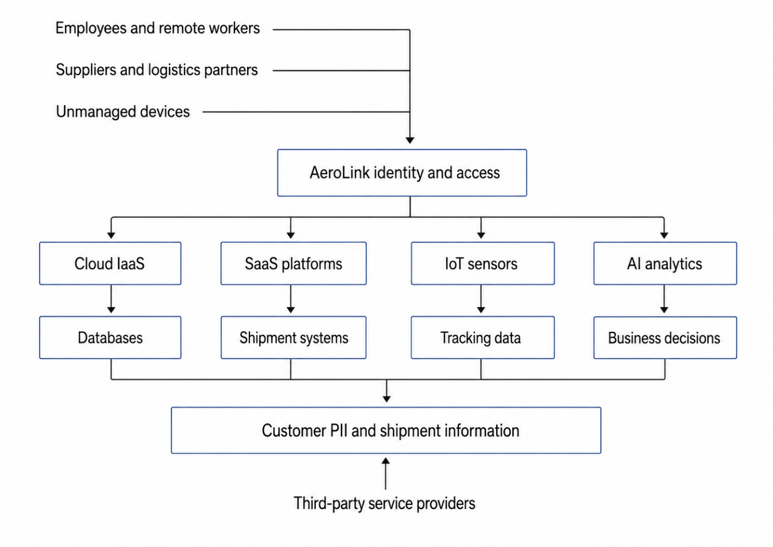
Figure 1: AeroLink Digital Operating Environment and Attack Surface

2.2 Security and governance gap analysis
Technical controls are only one part of AeroLink’s wider security problem. It lacks formal compliance assurance, clear risk ownership, mature supplier oversight and clearly assigned security responsibilities. Consequently, controls may be applied inconsistently, critical vendors may not be monitored adequately, and incidents may be handled without timely legal, operational or executive coordination.
Table 1: Principal Security and Governance Gaps
Area | Principal gap | Design implication
Governance | No unified framework or central risk process | Establish board oversight, named owners and one enterprise risk register
Outsourcing | Extensive dependence on external providers | Apply due diligence, security SLAs and continuous supplier assurance
Access | Remote access from unmanaged devices | Introduce MFA, conditional access and least privilege
Compliance | No formal compliance audit | Establish a compliance register, DPIAs and assurance reviews
Resilience | Weak incident response and continuity planning | Define recovery priorities and test response and backup arrangements

2.3 Assumptions
For this design, it is assumed that AeroLink processes personal data about people in the UK or EEA (European Economic Area), that the shipment tracking and warehouse systems need to be highly available, and that there are some existing security controls, but they are scattered. It is also assumed that critical cloud providers operate in multiple jurisdictions and that management is willing to invest in a gradual improvement program. Such assumptions are justified as the scenario does not detail the actual legal scope, cost, technology, certification or security level of AeroLink.

3. Critical Evaluation of Security Frameworks and Models

3.1 NIST Cybersecurity Framework 2.0
NIST CSF 2.0 organises cybersecurity through Govern, Identify, Protect, Detect, Respond and Recover (Yang et al., 2025). Govern is particularly relevant because AeroLink’s weaknesses concern accountability, supplier risk and executive oversight as well as technology. The current and Target Profiles can help identify gaps and prioritise improvements across cloud, IoT and remote-access environments (Ajayi, 2025). NIST can be adapted to different services and regions; however, it sets cybersecurity outcomes rather than detailed controls or certification requirements. If an organisation has unclear ownership, this may lead to inconsistent implementation.

3.2 ISO/IEC 27001 and ISO/IEC 27002
ISO/IEC 27001 provides requirements for establishing and continually improving an Information Security Management System, while ISO/IEC 27002 supports control implementation (Kitsios, Chatzidimitriou and Kamariotou, 2023). Their combined efforts would give AeroLink a risk-based, auditable basis for policies, access control, supplier management, cryptography, incident management and continuity.
Their main strength is traceability between risks, controls, owners and evidence through mechanisms such as the Statement of Applicability. However, certification does not guarantee effective security. If the scope is too narrow or focus too much on documentation, it may be possible that it does not include critical suppliers or regional systems. ISO should therefore provide AeroLink’s management and assurance foundation rather than operate as its complete security framework.

3.3 COBIT 2019
COBIT 2019 links the governance and management of information and technology with organisational objectives. It distinguishes between governance (sets direction and monitors outcomes) and management (plans and operates activities) (Rambau et al., 2026). COBIT can be used to optimize risk, ensure security, monitor continuity and compliance. It is also more comprehensive than a cybersecurity control framework, and the goal of implementing all of the objectives could lead to undue complexity. The greatest impact is in board level accountability, strategic alignment and performance oversight.

3.4 ITIL 4
ITIL 4 focuses on managing and continually improving technology-enabled services. Its supplier, service-level, incident, problem and change-management practices are highly relevant because AeroLink depends extensively on IaaS and SaaS providers (Shidqi, 2023). ITIL can translate security requirements into measurable service obligations, including incident-notification periods, recovery objectives and supplier reviews. However, it is not a complete security or compliance framework. Its value lies in embedding governance and security requirements within daily service operations.

3.5 Comparative Evaluation and Framework Selection
Table 2: Comparative Evaluation of the Selected Frameworks
Framework | Primary strength | Limitation if used alone | Proposed AeroLink role
COBIT 2019 | Governance, accountability and strategic alignment | Limited detailed technical controls | Enterprise governance layer
ISO/IEC 27001 and 27002 | Auditable ISMS and risk-based control selection | May become documentation-led or narrowly scoped | Management and assurance foundation
NIST CSF 2.0 | Flexible cybersecurity lifecycle and maturity improvement | Does not prescribe implementation or certification | Operational cybersecurity structure
ITIL 4 | Service, supplier, incident and change management | Not a complete security or legal framework | Service-management integration

No single framework addresses AeroLink’s combined governance, operational and compliance needs (Aerolink, 2026). COBIT should provide strategic direction and accountability, ISO/IEC 27001 and 27002 should establish the ISMS and control-assurance foundation, NIST CSF should structure operational cybersecurity outcomes, and ITIL should integrate requirements into services and supplier relationships. AeroLink should avoid operating four separate programmes by maintaining one risk register, control library and assurance schedule mapped across the frameworks.

4. Proposed Integrated Security, Governance and Compliance Approach for AeroLink Logistics

4.1 Design Principles and Architecture
The proposed integrated model instead assigns each framework a distinct role within one risk-based system. The design follows five principles: prioritising controls according to business impact; assigning accountability to board, business, system and supplier owners; applying zero-trust and defence-in-depth access; requiring evidence-based supplier assurance; and using incidents, audits, regulatory developments and technology changes to drive continual improvement.
For instance, unmanaged-device access would be controlled via COBIT accountability and assessed and treated through the ISO/IEC 27001 risk process, implemented through NIST Protect and Detect outcomes and enforced via ITIL supplier and service-management practices.
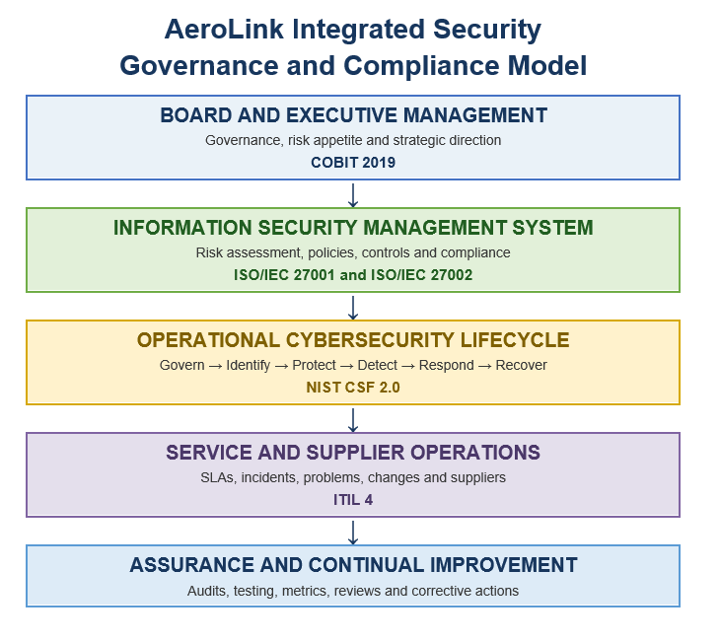
Figure 2: AeroLink Integrated Security Governance and Compliance Model

4.2 Governance, Risk Management and Compliance
AeroLink's security strategy and risk appetite, as well as material risks, should be approved by the Board of Directors. A Board Risk and Audit Committee should be responsible for watching for major incidents, high-risk suppliers, audit results and remediation that is overdue. Co-ordination of operations should be facilitated by an Information Security Steering Committee of security personnel, legal, privacy, procurement, IT, business continuity and logistics operations.
The CISO should be the driver of the security programme, but business and service owners should retain responsibility for any risks to their systems. A privacy lead or Data Protection Officer should advise on personal-data processing, Data Protection Impact Assessments and breach-notification obligations where applicable (De-Yolande, Doh-Djanhoundji and Constant, 2023). This separates strategic direction from operational implementation while preventing unclear security ownership.
AeroLink needs to have a single Enterprise risk register for internal systems, cloud services, IoT platforms, AI processing and critical vendors. The risks should be evaluated in terms of the probability of them occurring and the effects they may have on confidentiality, integrity, availability, legal requirements, customers and logistics operations (Marhavilas et al., 2022). Treatment options should include mitigation, avoidance, sharing and formally approved acceptance.
Table 3: Priority Risks and Integrated Treatments
Priority risk | Principal treatment | Accountable owner
Stolen credentials used from an unmanaged partner device | MFA, conditional access, device verification and behavioural monitoring | CISO and service owner
Cloud misconfiguration exposes customer PII | Secure baselines, automated posture monitoring, encryption and review | Cloud service owner
Critical SaaS provider suffers ransomware or prolonged outage | Tested recovery, exportable backups, alternative procedures and exit planning | Business service owner
IoT sensors transmit manipulated location data | Unique device identity, authenticated communication, segmentation and anomaly detection | IoT platform owner
AI analytics produce manipulated or unreliable operational decisions | Validate data, monitor model performance, control changes and require human oversight | Analytics service owner

Risk management should be linked to a compliance obligations register with details of relevant legislation, contracts, standards, owners, evidence required and when to review it. The register shall include the processing of data in compliance with the law, the minimisation of data, retention, notification of data breaches, transfers of data and contractual obligations with other entities with regard to the data. AeroLink should complete a DPIA before implementation in cases where there is likely to be a high privacy risk involved in the processing, for example if the processing involves large-scale tracking or AI analysis. Then, internal audits, supplier audits, access recertification, technical testing and recovery exercises should be used to verify whether controls operate effectively rather than merely exist as policies.

4.3 Policies, Protection Mechanisms and Access Controls
AeroLink should establish a policy hierarchy, which includes an enterprise information-security policy, topic-specific policies, technical standards and operational procedures. Data classification, identity and access management, cloud security, supplier security, encryption, remote access, IoT, AI governance and incident response and business continuity are among the priority areas that require consideration. Ownership of each policy, its approval date, its review cycle and time-limited exception process should be required.
Access should follow a zero-trust approach in which no user, device or connection is trusted automatically because of its location or organisational relationship (Lund et al., 2024). AeroLink should prioritise:
- Multifactor authentication for remote, supplier and privileged access.
- Least privilege and role-based access.
- Time-limited vendor accounts.
- Separate administrative accounts.
- Regular privileged-access reviews.
- Immediate removal of access following termination.
- Restricted access from unmanaged devices.
A complete ban on unmanaged devices could disrupt legitimate logistics operations. AeroLink should therefore provide controlled alternatives, such as browser-isolated portals or virtual desktops, while requiring managed devices for access to customer PII, cloud administration and other high-risk resources.
Sensitive information needs to be classified and encrypted when stored and shared. API secrets and certificates (as well as keys) must be restricted, kept separate and rotated. This is because even if the information is encrypted, it can still be accessed from the compromised authorised accounts. It should then be a part of the identity controls, monitoring and data-loss prevention.
Cloud services should be configured using approved configuration baselines, central logging and automated public exposure/privilege detection. Unique identification, segmentation and updating of IoT devices, where feasible, should be achieved. An inventory of IoT devices should be unique identified, segmented and updated if technically feasible. Unsupported devices should be replaced or isolated by the use of compensating controls. AI systems that provide support should be clearly defined for their purpose, sourced with well-documented data, and assigned owners, with human oversight and monitoring for incorrect or manipulated results.
Any unusual privilege escalation, authentication, security control disabling, data transfer, modification of the cloud or IoT interaction should be prioritized when central monitoring.

4.4 Vendor Management, Incident Response and Resilience
Vendor management is central to the proposed model because about 88% of AeroLink’s infrastructure is outsourced. Suppliers should be classified according to data sensitivity, privileged access, service criticality, subprocessor use, jurisdiction and replaceability (Opara-Martins, Sahandi and Tian, 2016). Critical suppliers should undergo detailed due diligence and periodic reassessment. Contracts and security SLAs should define measurable obligations rather than use vague terms such as “industry-standard security.”
Table 4: Critical Supplier and SLA Requirements
Requirement | Required evidence
Incident notification within an agreed maximum period | Notification and incident records
Critical vulnerability remediation within defined deadlines | Vulnerability reports and closure evidence
Encryption and controlled privileged access | Configuration and access-review records
Tested recovery objectives | Backup restoration and disaster-recovery reports
Data return, deletion and exit support | Tested exit plan and deletion confirmation

Critical contracts should also provide right-to-audit provisions, prior notification of subprocessor changes and restrictions on unapproved data locations.
Concentration risk also needs to be considered by AeroLink, given that multiple seemingly distinct SaaS services could rely on the same cloud, identity and network provider. Exit planning should ensure that data can be exported in a meaningful way, and that access to data can be terminated in a secure manner with the supplier.
Incident response team shall be coordinated among the cross-functional team including security, IT, privacy, legal, communications, business continuity and the affected service owners (Gnanasekaran et al., 2025). It should include steps for preparation, detection, triage, containment, investigation, eradication, recovery, notification and lessons learned. This operational impact should be taken into account when making containment decisions. Containment decisions must consider operational impact. Disconnecting a compromised platform may restrict attacker activity but could also interrupt global logistics.
A Business Impact Analysis is a component of Business Continuity Planning that helps identify critical services and dependencies, and acceptable disruption. The shortest recovery times are likely to be for identity, shipment tracking, and warehouse systems. Each critical service should have Recovery Time Objectives and Recovery Point Objectives defined in the Business Impact Analysis. Backups should be encrypted, isolated from production credentials and tested through restoration rather than assumed to be usable. Include ransomware, provider outage, loss of communication services and simultaneous failures with providers in exercises.

4.5 Implementation and Performance Measurement
Implementation should be phased so that immediate exposure is reduced before formal certification or advanced automation is pursued.
Table 5: Condensed Implementation Roadmap
Phase | Priority actions
0 - 90 days | Investigate previous breaches, enforce MFA, review privileged and supplier accounts, test backups and establish the central risk register
3 - 6 months | Approve governance roles, define ISMS scope, classify data and suppliers, establish policies and conduct business-impact analysis
6 - 12 months | Deploy privileged-access management, centralise monitoring, strengthen contracts, conduct DPIAs and test incident and recovery plans
12 - 18 months | Introduce continuous control monitoring, strengthen IoT and AI governance, test supplier exits and assess ISO/IEC 27001 readiness

A named owner and approved resources should be identified for each phase along with dependencies and evidence-based completion criteria prior to moving to the next phase.
Limited decision-focused metrics such as overdue critical vulnerabilities, privileged-access reviews, supplier assurance coverage, incident detection and containment time, successful recovery tests and overdue high-risk audit findings are recommended for measuring performance. Care needs to be taken with metrics as a low number of incidents could be due to deficiencies in detection; policy completion does not mean policy implementation. Targets should be set following baseline measurement and be related to AeroLink's appetite for risk, risk tolerance and escalation thresholds.

5. Critical Analysis of Continuous Updates to Regulations and Standards

5.1 Emerging Technologies and Evolving Threats
Cloud services, IoT devices and AI analytics continually alter how information is collected, processed and shared. Existing policies may therefore fail to address new issues such as AI training data, model manipulation, automated decisions, shadow AI and unsupported IoT devices. The phased application of the EU Artificial Intelligence Act demonstrates how obligations can emerge at different times and require continuing interpretation and implementation rather than a single compliance exercise.
Threats also develop faster than normal policy-review and certification cycles. ENISA’s 2025 threat assessment analysed 4,875 incidents and identified continued exploitation of vulnerabilities, reuse of attack techniques and emerging attack models. A control may therefore remain formally documented while becoming ineffective against credential compromise, ransomware, supply-chain attacks or AI-assisted social engineering.

5.2 Global Compliance and Ethical Responsibilities
Changes to hosting location, supplier ownership or processing purpose may alter applicable transfer, contractual and notification requirements. The ICO’s updated 2026 guidance on international data transfers demonstrates that regulatory interpretation and compliance expectations continue to evolve even when the underlying legislation remains in force. It is important for AeroLink to be able to differentiate between binding law, binding contracts, certifiable standards and voluntary frameworks. Tracking on a large scale, or decisions based on AI could be legal, but have privacy, transparency or fairness concerns. In reviews, not only should there be a technical possibility of processing, but also the necessity and proportionality as well as the possible harm.

5.3 Risk-Based Change Management
The expense of ongoing updates is incurred in training staff, renegotiating contracts, making technical changes, additional audits, and the replacement of unsupported equipment. However, if action is delayed, teams may be exposed to legal and security risks, and responding to each and every development might result in control fatigue, duplication of effort and disruption of operations. AeroLink should, therefore, employ a risk-based approach to change, not just a change for change's sake.
The legal, privacy and security teams should keep an eye on regulatory guidance, standards, technologies and threats. Prior to the update of policies, contracts, controls, and training, a material change should be evaluated for applicability and business impact/urgency. Implementation should then be assessed and documented in the ISMS as evidence and reviewed. A serious breach, new deployment of an AI, cloud-region move or appointment of a critical subprocessor should be reviewed outside of the annual cycle.

6. Conclusion
It would be impossible to resolve AeroLink's security and governance issues with individual technical fixes. It is dependent on third-party cloud providers, unmanaged-device access, IoT tracking and AI-supported analytics. Thus, it needs to be held accountable, to have a coordinated risk management and increased supplier management. In the proposed model, every framework has a specific function to play. The ability to support strategic governance is furthered by COBIT 2019, while ISO/IEC 27001 and 27002 help define the ISMS and control-assurance foundation, and NIST CSF 2.0 helps with operational cybersecurity, and ITIL 4 supports service and supplier management.
AeroLink should start implementation with identity protection, named risk owning, supplier assurance and tested recovery plans. Once these controls are in place and seem effective, it should implement certification and continued monitoring. AeroLink can also provide linkage of risk, controls, owners and evidence in a system so that oversight can be improved and duplication can be minimised.

Reference List
Aerolink (2026) AeroLink — Post-Quantum Secure Airspace Coordination Infrastructure. Available at: https://aerolink.dev/governance (Accessed: 30 July 2026).
Ajayi, R. (2025) ‘Integrating IoT and cloud computing for continuous process optimization in real time systems’, International Journal of Research Publication and Reviews, 6(1), pp. 2540–2558. Available at: https://www.researchgate.net/publication/388082333_Integrating_IoT_and_Cloud_Computing_for_Continuous_Process_Optimization_in_Real_Time_Systems (Accessed: 30 July 2026).
De-Yolande, M.H., Doh-Djanhoundji, T. and Constant, G.Y. (2023) ‘Breach Notification in the General Data Protection Regulation’, Voice of the Publisher, 09(04), pp. 334–347. Available at: https://www.researchgate.net/publication/376816376_Breach_Notification_in_the_General_Data_Protection_Regulation (Accessed: 30 July 2026).
Gnanasekaran, V. et al. (2025) ‘A Model-Based Framework for Developing Security-Safety Incident Response Plans’, International Journal of Information Security 2025 24:6, 24(6), pp. 229-. Available at: https://link.springer.com/article/10.1007/s10207-025-01147-4 (Accessed: 30 July 2026).
Kitsios, F., Chatzidimitriou, E. and Kamariotou, M. (2023) ‘The ISO/IEC 27001 Information Security Management Standard: How to Extract Value from Data in the IT Sector’, Sustainability 2023, Vol. 15, Page 5828, 15(7), p. 5828. Available at: https://www.mdpi.com/2071-1050/15/7/5828 (Accessed: 30 July 2026).
Liu, C. and Babar, M.A. (2026) ‘Corporate cybersecurity risk and data breaches: A systematic review of empirical research’, Australian Journal of Management, 51(1), pp. 62–92. Available at: https://www.researchgate.net/publication/388406170_Corporate_cybersecurity_risk_and_data_breaches_A_systematic_review_of_empirical_research (Accessed: 30 July 2026).
Lund, B.D. et al. (2024) ‘Zero Trust Cybersecurity: Procedures and Considerations in Context’, Encyclopedia 2024, Vol. 4, Pages 1520-1533, 4(4), pp. 1520–1533. Available at: https://www.mdpi.com/2673-8392/4/4/99 (Accessed: 30 July 2026).
Marhavilas, K. et al. (2022) ‘Developing a Risk Analysis Strategy Framework for Impact Assessment in Information Security Management Systems: A Case Study in IT Consulting Industry’, Sustainability 2022, Vol. 14, Page 1269, 14(3), p. 1269. Available at: https://www.mdpi.com/2071-1050/14/3/1269 (Accessed: 30 July 2026).
Opara-Martins, J., Sahandi, R. and Tian, F. (2016) ‘Critical analysis of vendor lock-in and its impact on cloud computing migration: a business perspective’, Journal of Cloud Computing, 5(1). Available at: https://www.researchgate.net/publication/301334572_Critical_analysis_of_vendor_lock-in_and_its_impact_on_cloud_computing_migration_a_business_perspective (Accessed: 30 July 2026).
Rambau, T.M. et al. (2026) ‘Evaluating cyber resilience frameworks for e-government: applicability of NIST CSF, ISO/IEC 27001 and COBIT 2019 in developing country contexts’, in Information and Computer Security. Emerald Publishing, pp. 1–22. Available at: https://www.emerald.com/ics/article/doi/10.1108/ICS-09-2025-0376/1357446/Evaluating-cyber-resilience-frameworks-for-e (Accessed: 30 July 2026).
Shidqi, S.A. (2023) ‘Analysis of Information Technology Service Management Using ITIL V3 Domain Service Operation at Company XYZ’, IJIIS: International Journal of Informatics and Information Systems, 6(4), pp. 159–168. Available at: https://www.researchgate.net/publication/376859838_Analysis_of_Information_Technology_Service_Management_Using_ITIL_V3_Domain_Service_Operation_at_Company_XYZ (Accessed: 30 July 2026).
Yang, J. et al. (2025) ‘An Evaluation Framework for Cybersecurity Maturity Aligned with the NIST CSF’, Electronics 2025, Vol. 14, Page 1364, 14(7), p. 1364. Available at: https://www.mdpi.com/2079-9292/14/7/1364 (Accessed: 30 July 2026).

