+

Graduate Diploma Professional Police Practice

LEVEL 6 - 40 Credits

Workbook title: Competency Based Workbook 2 (DHEP)

(SOUTH WALES POLICE, GWENT POLICE AND UWTSD)

Learner name: Olivia Joy

Learner’s University Registration Number:2319909

FACULTY OF BUSINESS AND MANAGEMENT
PUBLIC SERVICE PROGRAMME

Module title: Policing in the Workplace 3 (DHEP) - BMPP6009D

Workbook Guidance

Please read these notes carefully. They provide essential information. The documents you will use in developing your workbook are on the following pages.

What is the workbook for?

The purpose of this workbook is to enable learners to demonstrate and provide evidence of how they meet the learning outcomes set by the College of Policing, for the Graduate Diploma in Professional Policing Practice. You are being asked to outline your experiential learning based upon your theoretical understanding in a range of operational situations.

- Wellbeing and Resilience
- Criminal Justice
- Conducting Investigations
- Decision making and discretion
- Maintaining Professional Standards
- Leadership and Team working
- Policing the roads
- Information and Intelligence

You may wish to use the same incidents as you have outlined in the Occupational Competence Portfolio.

How should the workbook be presented?

Blank electronic copies can be found on Moodle of this workbook. You must submit this document electronically therefore it is important that you save your work regularly and upload the final typed version through Turnitin on Moodle.

Word count policy can be found in chapter 7 of the Academic Quality under section 7.7 (this applies to presenting work above and under the specified word count).
(https://www.uwtsd.ac.uk/media/uwtsd-website/content-assets/documents/academic-office/aqh-chapters/chapters---en/Chapter_07_Assessment_Taught_Programmes_Pages_72-79-UPDATED-05-11-2019.pdf)

Reflective practice is a core aspect for your workbooks and although there is a variety of useful resources on Moodle, there is one particular book, that is specifically based on reflective practice in policing, here is a link to one chapter from Selina Copley’s Reflective Practice for Policing Students:
https://moodle.uwtsd.ac.uk/pluginfile.php/298870/mod_resource/content/1/Reflective%20Practice%20for%20Policing%20Students%20-%20Selina%20Copley%20Chapter5.pdf

How is the workbook assessed?

Advice and support about the completion of this workbook is available to you. Please contact Kelly Andrews direct using k.andrews@uwtsd.ac.uk with any questions or queries you may have.

Dates of workbook submission can be located within the General information tile within Moodle.

Once submitted your workbook will be assessed and marked independently. You will be provided with individual feedback once the work has been marked.

Confidentiality

It is important that no individual can be identified either directly or indirectly from the information in the workbook. However, you must:

- adhere to guidance in the Candidate Handbook about confidentiality.
- not identify individuals including witnesses, victims, or offenders by name.
- not write information that enables any individual to be identified indirectly through the description you provide. This includes references to names, colleagues, places (including hospitals, schools, town, villages, streets) specific incidents which were high profile and could be identified due to past publicity, other professionals or any other personal information including medical or other conditions.
- take personal responsibility for adhering to confidentiality rules.
- not include any dates of any incidents or anything that specifically identifies an actual incident.

Please be aware that any content that is deemed to be inappropriate, disrespectful, or abusive will not be tolerated. Following review of any content of this nature the information will be shared with the employer of the student responsible.

Should any health and wellbeing concerns be raised because of disclosures made by the student within this workbook, the employer of the student will be informed.

NOTE

Your workbook will be submitted electronically via Turnitin on Moodle. Guidance on this is in the Candidate Handbook.

Remember that the workbook is YOUR responsibility you must not rely on the assessor or anyone else to pick up any confidentiality breaches as this is your work and you must accept full responsibility for confidentiality. Meeting all the confidentiality requirements is particularly important.

Dyslexia and other special circumstances

If you have any condition that you feel may affect your ability to deal with any part of the programme, please see the Candidate Handbook for further guidance. The University has a Student Services Unit that may be able to help but it is the learner’s individual responsibility to contact them.

Competency Based Workbook 2 - Learner Workbook

Guidance:

- Your workbook must contain items 1 - 5 below (in the order given).
- You should use the pro-forma to insert your text within each section.
- Note that this module has 2 components with each weighted at 50% of the overall 100% marks total.
- You should upload your completed document as a saved pdf file of this workbook; if this is not possible then a Word Doc file is acceptable. Do not send a scanned file from a photocopier, an apple.dot file, or a Microsoft publisher file as Turnitin will not be able to assess them, despite you being able to upload them.

Contents

Component 1  50% | Area of Professional Practice | Word count
Task 1 | Vulnerability and Risk  Evidence-based policing | 2000
Task 2 | CHOOSE ONLY 1 OF THESE 'ADVANCED LEARNING AREA’ OPTIONS. IT SHOULD BE ONE THAT HAS BEEN AGREED WITH THE FORCE TO STUDY IN YEAR 2. | All options are 2000 words
Task 2  Option 1  Option 2  Option 3  Option 4  Option 5 | Response Policing  Policing Communities  Road Policing  Information and Intelligence  Conducting Investigations | 2000
 | Bibliography

Task 1

Relevant areas of the National Policing Curriculum:
Vulnerability and Risk, Evidence-based policing

You must choose a policing incident in which you played a significant role with a victim of crime or anti-social behaviour and reflect on what happened.

Give a brief description of the incident including social and legislative contexts and any relevant cultural, ethnicity and language issues.

Critically evaluate the appropriateness of different approaches (by professionals and the police) in supporting or managing vulnerable people or people at risk of harm.

Explore what works in relation to tackling repeat victimisation and repeat offending. Consider the use of evidence-based policing.

2000 words (+/- 10%: include your actual word count at the end of each section)

ANSWER:

In this essay I will provide an example of an Anti-Social behaviour (ASB) incident that occurred during my tour of duty. The call came from the victim of crime stating that her property had been extensively damaged by a person throwing bricks through her living room window and into her car windows. She was made aware of a large group of what seemed to be youths running away from her property as her car alarm was set off. This assignment will cover the approaches taken to support the victim and to prevent from anything similar happening to her again. Discussing the importance of using methodologies that have proven to work in similar circumstances to reduce crime and anti-social behaviour. This is known as evidence-based policing, by applying methods previously used to reduce crime. Finally, to discuss repeat victimisation based on these methodologies and the use of neighbourhood watch within rural areas of Cardiff.
Firstly, my priority was to ensure the victim was safe, she was in distress from the incident which was expected however felt reassured by police presence. We ensured her that patrols would be conducted throughout the night and around the forestry as this was the direction of travel by the youths/suspects. With a unit around conducting an area search and on the lookout for any signs of other Anti-social behaviour (ASB). The criminal damage committed against this victim was a clear sign of ASB in the area. It was believed to be a missed identity attack on her address however with this being the first ASB incident against her it was important to put a stop to any chain of events. ASB is defined by the Metropolitan Police (2024) as “behaviour by a person which causes, or is likely to cause, harassment, alarm or distress to persons not of the same household as the person”. The criminal damage caused significant alarm and distress to our victim as well as putting her out of pocket for the damage caused.
Support was offered to the victim at the initial scene by myself as it was clear that the female was vulnerable due to her living alone and having no CCTV or lighting outside her property. CCTV and outside lightening can deter criminals away from committing crime due to them being aware there is a higher chance or being caught or seen by neighbours. This would be a use of POP policing which is highlighted below. CCTV and lightening are supplied and offered to previous victims of similar crimes by our target hardening teams and it was clear that this would also benefit the victim at this call, again applying EBP methods.
Evidence based policing or EBP is using the “best available evidence to inform and challenge policing policies, practices and decisions”, as stated by College of Policing, (2024). EBP is then used in scenarios best suited to lower crime levels whereby methods have previously worked in similar situations. EBP can be used and adapted to different but similar situations however this perception is more of a trial-and-error method to see “what works”. As stated by Bullock, (2022) “good methods of EBP can adopt problem-orientated policing (POP) principles” to have a good mix of adapting experimentation and reusing what officers know has previously worked.
POP is the problem-orientated policing strategy developed by Herman Goldstein who focused on reducing crime and enhancing community safety. His method was for police to be more “proactive and search root causes of crime” with that then developing “tailor-made responses” (Hinkle,2020).
Furthermore, a development was made in POP from Eck and Spellman’s, (1987) SARA model. The model is an acronym of the four-step process which all officers now use within policing when problem solving. The four steps are as follows; Scanning to identify problems, analysis to analyse data and information, response where officers deliver the intervention and finally assessment where the issue is assessed if the problem has been eliminated or reduced. If the process has not worked it can be repeated with a different response (Hinkle,2024).
The victim was asked if she wished to be taken to a family members/friend’s house for the evening so that she would not be left alone. She claimed that she wished to stay home and knew that the suspects would not return back as she felt police presence was enough to deter.
After the initials were completed and the house was boarded up by officers for security, support was provided in a sense of reattendance for target hardening. Vibration alarms were fitted within the next few days to target harden the property. This is also to prevent repeat victimisation as the victim did not know of anyone who would target her specifically. She was provided with a personal safety alarm if she was retargeted and to provide some security due to her living alone. The victim did not believe she was targeted as such as she would have no connection to anyone within the area, she claimed she had moved to the area recently. It was assumed then that this was a random attack which would align with the suspects being a group of youths.
Target hardening is “used to describe the process of increasing the security of a property to make it more difficult to burgle.” (Newton, 2008). Even though the crime wasn’t a burglary the suspects had caused considerable damage to the victims’ property by throwing large bricks through her windows. The same principles apply to target harden this victim’s property to deter people from crime.
Multiple organisations were notified of the incident to provide support to the victim, she was referred to South Wales Victim Focus for advice and support as well as our local Neighbourhood Policing Team aware to provide reassurance. This support was applied to reduce victimisation and to provide security to the victims’ home since the incident.
The College of Policing, (2022) states that Neighbourhood Watch schemes (NWS) also provide evidence that reduces crime within areas. NWS can deter offenders as they may be “more cautious of neighbours in areas watching out for suspicious activity”. Neighbourhood watch is not always run and organised with the Police however they do work in partnership with them to improve relationship with the community and to reduce their fears of crimes taking place. NWS enhances community support and intelligence spread from the public to the police (College of Policing, 2022). Which is both a positive for police engagement and to those living in the area. The better the relationship with the public the easier it is to police the area. Participates of neighbourhood watch within the local area assists the police and its neighbourhood policing teams by sharing information and providing safety to its members (Bullock, 2017).

People who are vulnerable are more susceptible to being harmed by ASB according to Innes and Weston, (2010). To tackle this, police need to focus on these individuals who are most vulnerable, to lower ASB levels. It is important to support the victims of crime efficiently alongside multi-agency partnerships, including neighbourhood watch schemes. Victims require updates and information regarding their case and there is strong evidence to suggest that keeping in touch with the victim and them feeling supported will provide them with a positive outlook on policing (Wedlock, 2016). With this they are more likely to want to work with police and their neighbourhood teams to address ASB and crime levels in their area. Without this support and feeling listened to the victim may be less likely to want police involvement and report any crime at all.
The Anti-Social Behaviour, Crime and Policing Act 2014 allows police to tackle ASB by identifying the importance of the impact it can have on victims and utilising different ways of dealing with the suspects, The act involves methods such as criminal behaviour orders and community protection notices to name a few (Wales safer communities, 2024). According to the Anti-Social Behaviour Action Plan that was launched March 2023 South Wales Police has the highest perceived level of ASB within Wales. With Gwent and North Wales in between and Dyfed Powys at a lower level of the Welsh forces.
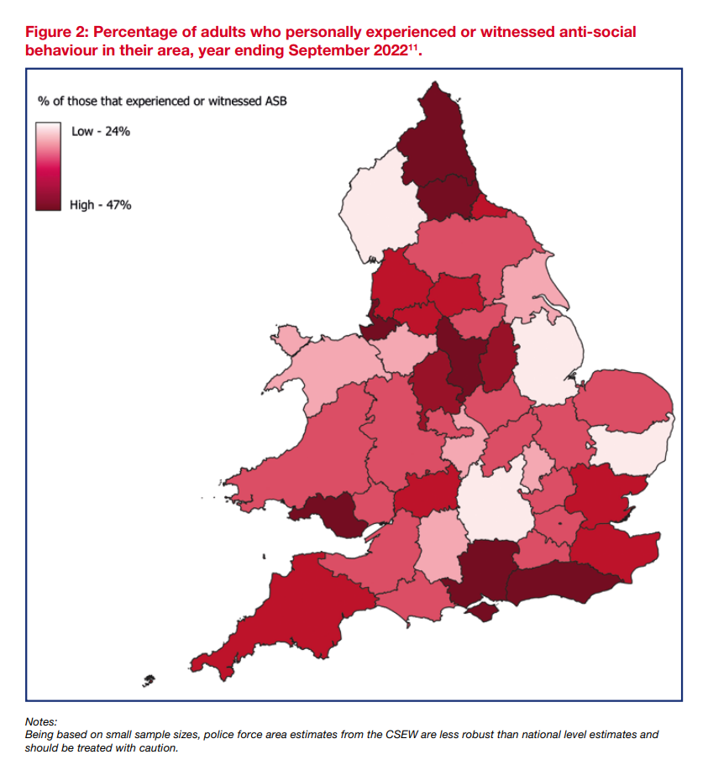

Diagram come from HM Government Anti-Social Behaviour Action Plan of 2023.
In terms of this incident attended the approach would benefit from the use of using evidence of what has previously worked to deter revictimization. To reduce the opportunity for a further incident taking place of criminal damage to her property. The SARA model of problem solving would be efficiently used to look at the crime levels in the area where the incident took place, see if criminal damage is an issue in the area and address it. Ensuring that hot spot policing is applied where needed to lower revictimization as it is proven to work. According to the Home Office, (2024) the aim of policing in England and Wales is to “expand evidence base on hot spot policing”. Another source states a method well used by police is to pinpoint hot spots by using “crime pattern analysis” (Pease, 1999) which suggests research into the victim themselves, and the area of crime committed to suggest the likelihood of the crime reoccurring. In this case the female was living in a well-known area to my team for ASB, which immediately raised our concerns to why the victim was targeted or whether it was a random attack. With little information on the suspects police did not have a lead on who to search and gather information on. However, our neighbourhood policing team did some analysis and found that there was a group of youths out committing crime that night. My colleague and I went to two incidents similar within a 5-mile radius which to us made it clear that there was a link. Because of this officers were patrolling the area to deter any further crimes being committed, police presence can deter further offences due to the risk of being caught being higher. Our response to this reoccurring ASB had worked previously in our area so it was reapplied on the night of this incident. This is common across policing to show a higher police presence, to deter and provide confidence in the public. The use of problem-solving ideas is often used without realising in policing; however, it is important to understand and use the models as it encourages effective policing as shown on this night shift (College of Policing, 2022).
Clarke and Eck, (2003) highlights the acronym CHEERS; community, harm, expect, events, recurring and similar. This acronym helps police understand is the issue their facing is suitable for problem solving methods such as POP and EBP. Where questions can be asked to prepare for the correct problem-solving technique used. This acronym can help apply EBP techniques for officers attending a similar or further call.
To face lowering crime levels, police need to be made aware of what crimes are being committed as highlighted by Ashby, (2012). With poor relationship between the community and police its less likely for crimes to be reported and making it difficult to work with the community to get justice and support others. Multi-agency organisations can work together to ensure the community feels supported and have trust in police. With citizen trust and support were able to identify the issues and prevent revictimization. Our neighbourhood policing teams are often engaging with members of the public, schools and addressing neighbour complaints which supports good community trust and engagement. Woodland, (2024) highlights just some of the important roles that a neighbourhood police officer does, by promoting community safety and building trust to share information. This allows police to be proactive with any emerging issues and to respond and prevent threats and crimes in the area.
Overall, forces across Wales can tackle ASB by using methods and techniques that have previously worked and reapply them to similar scenarios. These methods may not work in the same way it did previously however there is another way to get around that obstacle by using techniques such as SARA. As mentioned within this assignment POP and EBP have proven its benefits which is why it is still used in today’s policing, stated by Hinkle, (2024). Years of research has proven that assessing and understanding the crime level in specific areas gives officers the benefit of knowing how to go around prevention. To support the victim and provide a good public service to members of the public, as Woodland, (2024) mentions that building good community relationships allows officers to identify issues before escalation. EBP and POP both have their potential to reduce ASB within the South Wales area, it is to response police officers to take out the methods they’ve previously used and learn from what hasn’t. All to the documented and addressed alongside the Neighbourhood Policing teams. During the call out discussed in this assignment I had applied methods previously used at ASB victim calls and victims of criminal damage, I had tried to support the victim in all ways without forcing her out of her home. Not forgetting to maintain that repour with the community and my victim at the time to minimise any revictimization.

Word Count: 2188

Task 2

Choose 1 of these 5 options to answer

(Note for officers who have an interest in becoming a detective and wish to specialise in this role, you MUST choose option 5)

  - Response Policing.
  - Policing Communities.
  - Road Policing.
  - Information and Intelligence.
  - Conducting Investigations.

Task 2 Option 1:

Relevant areas of the National Policing Curriculum:

Response Policing

A core part of the policing mission is to prevent crime and disorder. Domestic abuse causes both serious harm and constitutes a considerable proportion of overall crime

You should choose a domestic abuse incident that was of a complex nature, in which you played a significant role in providing a response.

Critically assess the challenges associated with a domestic abuse incident that you have attended, and the strategies developed for effective policing in such challenging situations.

2000 words (+/- 10%: include your actual word count at the end of each section)

ANSWER:

In this assignment I will discuss the challenges first attending officers face when approached with domestic violence. Expressing the importance of double crewing officers taking positive action when dealing with these types of incidents and using techniques to manage a high-pressured emotional call. As police officers it can be difficult to understand and get involved in someone’s personal life for instance a married couple whose going through a tough time. As humans we must remain emotionally professional to show the victims and witnesses that we are more than locking up the “bad people”. With the recent exposure from body worn video worn by first attenders this is important for any evidence that may not get to paper from the victim for whatever their reasoning (Barrow-Grint, 2022). Regardless, domestic violence or DV is how I will commonly refer to, is a growing concern for crime levels in the UK. It is important that police officers know how to face the issue and protect the vulnerable by providing support and advice on how to spot signs of DV and abuse.
Domestic abuse is defined by Section 1 of the Domestic Abuse Act 2021; 1(2) Behaviour of a person ('A') towards another person ('B') is domestic abuse if -
(a) A and B are each aged 16 or over and are personally connected to each other, and
(b) the behaviour is abusive.
With the definition including behaviour that is abusive, this includes physical or sexual abuse, violent or threatening behaviour, controlling or coercive behaviour, economic abuse, psychological, emotional or other abuse. Mentioned throughout will be the consideration and application of Kolbs experiential learning cycle (1984), whereby there are four steps based on social, environment and emotional experiences.
Firstly, I must mention the statistics for DV in the UK, with the figures seeing no statistically significant change in the prevalence of DV experienced in 2024 stated by the Office for National Statistics, (2024). No change in these statistics show that there may not be enough support and awareness for victims and vulnerable persons. With the number of high-profile cases involving domestic related crimes, it must be priority for first responders to be aware of techniques and strategies to support and prevent reoccurring events.
This assignment will involve details of a call a colleague and I attended as the public service centre received a 999-emergency call from a female. The call had limited information to provide us as first responders and we were unaware of what we would walk into. The line from the female dropped as she confirmed was there a man in her home whilst her children were heard crying in the background. It was clear she feared this man by the phone call and the background noise, so officers were alert and quick to respond. The response included myself, a female officer and my colleague a male officer. This can be important to mention as some domestic cases require different genders in order to get a rapport from the victim. The College of Policing, (2024) identifies the approach officers must include when attending these types of calls, including building rapport, identifying risk and to ensure safety. Having a “friendly face” or someone the victim may feel more comfortable around may help build a trusting relationship where they feel able to share details about the incident. This can prevent revictimization by ensuring the victim stays clear from the abuser.
On arrival my colleague and I split up to ensure the victim was separated from the other persons within the household. As the female of the crewing, I took the female victim into the living room with her children who were in distress. She had some visible injuries, and my body worn video captured this as well as her initial disclosures. My body worn video was used as evidence when this case went to the crown prosecution service. My colleague searched the property for any other persons and located a male in the bedroom, as soon as I gathered enough information from the female of what had occurred, I ensured her safety by informing her that we would be removing her ex-partner from the property. I had informed my colleague of the disclosures given and the male was arrested for domestic related crimes. Another unit attended the scene to take the accused to custody whilst I remained with the victim to gather evidence and provide support. It was best to gather more units that were available to ensure the safety of the victims and to gather the golden hour principles. It was important that further units were able to convey the arrested, so the first attending officers were able to gather information and evidence. At the time response officers are found to be tied up with other calls with a lack of officers to deal with incidents that are in high demand. Unfortunately, this is one of the many battles faced with response policing. It can be challenging to enforce positive action with minimal officers across sectors.
According to Gibbs, (2019) police officers have a duty to take positive action when dealing with domestic abuse incidents, with this often this meaning making an arrest. If an arrest is not made due to lack of grounds officers, ensure the parties are separated for the evening to allow a cool off period.
According to Hibbitt, (2023) the first hour/s after a crime is committed should be used to gather the most important evidence, such as first accounts, statements and gathering CCTV opportunities. This may be due to victims not wishing to go ahead with police prosecution with a delay in response and witnesses leaving the scene. Ensuring gathering this evidence as soon as possible also shows a positive response for police rather than leaving the scene with the arrested and coming back from a delayed wait in custody. With myself left at the scene I prioritised gathering golden hour evidence. CCTV was obtained from the victim’s home and next-door neighbours, house to house enquiries were completed and all photographs were obtained from the scene and injuries caused. In terms of DV, it is police protocol to obtain a form titled “The Domestic Abuse Stalking and Harassment (DASH)” to share to other agencies for support (Barrow-Grint, 2022). This form is shared (with the consent of the victim) to agencies such as Women’s Aid and social services. These forms include the details of the victim, aggressor and any children connected to the two. All containing evidence from the incident and shared for support reasons if consented by the victim.
Once a statement was obtained and the relevant support forms were submitted it was mentioned if the victim wished for a restraining order in the future, with the accused also being given bail conditions if granted bail. All these questions would provide a level of safety to the victim if granted, to prevent victimisation and prioritise THRIVE.
HMICRFS, (2019) highlights first attending officers being aware if revictimization is a risk, with domestic abuse being one of the most risk impending factors to revictimization. The THIRVE (threat, harm, risk, investigation, vulnerability and engagement) approach was adopted to prioritize the victim and to spot any clues that are associated with vulnerability related risk (College of Policing, 2021). I had identified that with her engaging with me initially it was important to continue a good repour with her throughout the investigation to protect her from revictimization in the future. THRIVE was considered throughout the call allowing us to deal with the call. The complex nature of the male being father to the children and emotions being at a high meant my emotional professionalism had to adapt from the victim to the children when explaining the situation and going forward. The victim was able to get a family member to come to the address to provide further support and allow breathing space from the children. Whilst dealing with the initial incident the experimental learning cycle was applied to touch all bases. According to Kolb, (1984) Learning is the process whereby knowledge is created through the transformation of experience. Expanding on when attending a call that may appear different to reflect on the response applied to create better more suited application to dealing and managing DV cases. The four-stage learning process is explained in the graph below, (Simply Psychology, 2025).
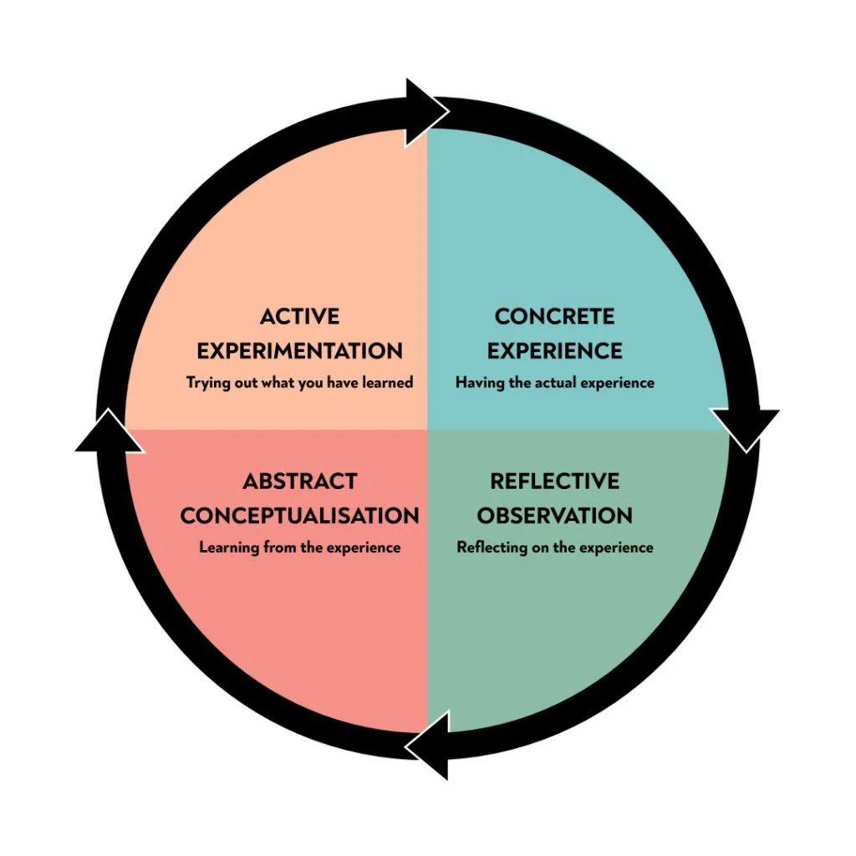
The victim was provided with support from Live Fear Free and a domestic violence support apps for her mobile device, Bright Sky. According to Hestia, (2023) Bright Sky is an app available on smartphones which allows users to record any evidence and can be sent via a safe email, it can provide advice and guidance on experiencing abuse or previous experience. The victim felt at ease with this app downloaded as she felt she was able to get 24/7 support and read up on what she had been victim too as well as confidently write her feelings and thoughts down. Even with this support in place victims can too often become reluctant to support police investigation with the fear that their abuser will find out. Which is why support is so important and building that initial repour to get them to trust police. Victims can be provided with an independent domestic violence advocates (IDVA) and serve as a victim’s primary point of contact. According to HMICRFS, (2023) victims can receive a IDVA by local council services, a police referral or a self-referral. IDVAs provide a trained individual to support the victim, they can explain the process and continue that repour whilst the officer in case is maintaining the case file for the crown prosecution service.
Throughout the victim was updated with the release and outcome by me as the officer in the case. The defendant was given a non-molestation orders (NMOs) which is designed to protect victims and are issued by the court (Gov.uk, 2022). This stopped him from being within a certain distance within her and the children’s home, it also meant he was unable to contact her directly. The victim was supported throughout and was happy with the result of her case, a third-party person was put in place for the care of the children with their father and there had been no further issues. With this result we have lowered the risk for revictimization as our victim is now aware of the red flags of DV. The result of this case may not have been the same if it wasn’t for first responders to gather the evidence as soon as they could and another unit conveying the prisoner. The case may have lost evidence if the victim became unsupportive if she did not build a repour with me from the first instance or if she was not appointed an IDVA. Alternatively, with the loss of officers across Wales due to the working conditions, officer levels and work satisfaction these results are far and few (Police federation, 2024). It is not often we get a positive outcome from DV cases, which would result in loss in public trust and more crimes overall. With this result it was important to use the skills further by adapting them for other victims.
Identified by Kolb, (1984) reflection from this case can be applied to other cases that hold similar circumstances with this one mentioned throughout. By learning from this case and its outcomes we can create more positive outcomes.
Overall, it is important to attend high pressured emergency calls with the knowledge and techniques in mind for what were about to face. The College of Policing, (2024) highlights the factors of a first attending officer and the importance of building that community trust to provide safety to our victims. This incident I attended was made easier to build trust by gathering more officers and dealing with the suspect and victim separate. Positive action was taken against the suspect, and he was arrested as a result. She was supported by South Wales Police and other agencies which prevented any retraction of her evidence provided also a better chance of her becoming victim to this again by the same individual. She was protected by South Wales Police and Women’s Aid by working as a team. Finally, with the use of Kolb’s experimental learning cycle (1984) Police can lower DV levels by reflecting on methods used and worked throughout and applying these adapted methods and learning styles to new cases.

Word count: 2064

Authentication signature: Olivia Joy

Please sign to confirm that the work submitted is your own and has not been copied from another:

Signed: Olivia Joy

Date : 27/04/25
Bibliography
The bibliography should only include sources referenced within the workbook using the Harvard referencing system. Information about referencing in written assignments and how to avoid plagiarism can be found on Moodle. It is important that you are aware of the importance of ensuring that the work submitted is your original work.
References:
Ashby, M. Chainey, S. (2012). “Problem Solving for Neighbourhood Policing”. The UCL Jill Dando Institute of Security and Crime Science.
Barrow-Grint, K., Sebire, J., Turton, J. and Weir, R., (2022). “Policing Domestic Abuse: Risk, Policy, and Practice”. Routledge.
Bullock, K. et al. (2022) ‘Police perceptions of problem-oriented policing and evidence-based policing: evidence from England and Wales’, Police Practice and Research, 23(6), pp. 775–791.
Bullock, K. and Bullock, K. (2014) “Neighbourhood Watch. Citizens, Community and Crime Control”, Crime Prevention and Security Management. Palgrave Macmillan, London.
Clarke RV and Eck J. (2003). 'Become a problem-solving crime analyst: In 55 small steps.' Jill Dando Institute of Crime Science. London: University College London.
College of Policing, (2021). “Introduction to vulnerability-related risk”. Available at: https://www.college.police.uk/guidance/vulnerability-related-risks/introduction-vulnerability-related-risk Assessed on: 07/03/25.
College of Policing, (2022). “Interventions for situational crime prevention”. Available at: https://www.college.police.uk/guidance/neighbourhood-crime/interventions-situational-crime-prevention Assessed on: 05/10/24.
College of Policing, (2022). “Problem-solving policing”. Available at: https://www.college.police.uk/guidance/problem-solving-policing Assessed on: 08/10/24.
College of Policing, (2024). “Evidence based policing”. Available at: https://www.college.police.uk/research/evidence-based-policing-EBP Assessed on: 06/10/24.
College of Policing, (2024). “First response”. Available at: https://www.college.police.uk/app/major-investigation-and-public-protection/domestic-abuse/first-response Assessed on: 05/03/25
Eck, J.E and Spelman, W. (1987). “Problem solving: Problem -Oriented Policing in Newport News. Washington, DC: Police Executive Research Forum.
Gibbs, P. (2019). “Should all domestic abuse suspects be arrested?”. Available at: https://www.transformjustice.org.uk/news-insight/should-all-domestic-abuse-suspects-be-arrested/#:~:text=In%20fact%20College%20of%20Policing%20guidance%20calls%20for,and%20it%20is%20a%20necessary%20and%20proportionate%20response. Assessed on: 12/03/25.
GOV.UK, (2022). “A duty to protect: Police use of protective measures in cases involving violence against women and girls”. Available at: https://www.gov.uk/government/publications/police-use-of-protective-measures-in-cases-of-violence-against-women-and-girls/a-duty-to-protect-police-use-of-protective-measures-in-cases-involving-violence-against-women-and-girls Assessed on: 07/03/25
Hestia, (2023). “Bright Sky”. Available at: https://www.hestia.org/brightsky Assessed on: 07/03/25.
Hibbitt, S. & Shaw, G. (2023,). “Initial Stages of an Investigation”. Blackstone's Police. Third Edition.
Hinkle, C.J. et al. (2024). “When is problem-oriented policing most effective? A systematic examination of heterogeneity in effect sizes for reducing crime and disorder.” Policing: A Journal of Policy and Practice, Volume 18.
Hinkle, C.J. et all. (2020). “Problem-orientated policing for reducing crime and disorder: An updated systematic review and meta-analysis.”. Campbell Syst Rev.
HM Government, (2023). “Anti-Social Behaviour Action Plan”. Available at: https://assets.publishing.service.gov.uk/government/uploads/system/uploads/attachment_data/file/1157028/Anti-social_Behaviour_Action_Plan_March_2023.pdf Assessed on: 08/10/24.
HMICFRS, (2019). “The police response to domestic abuse – An update report”. Available at: https://assets-hmicfrs.justiceinspectorates.gov.uk/uploads/the-police-response-to-domestic-abuse-an-update-report.pdf Assessed on: 07/03/25
Home Office, (2024). “Evaluation report on grip and bespoke-funded hot spot policing”. Available at: https://www.gov.uk/government/publications/hot-spot-policing-in-england-and-wales-year-ending-march-2022/evaluation-report-on-grip-and-bespoke-funded-hot-spot-policing Assessed on: 06/10/24.
Innes M. and Weston, N. (2010). “Re-thinking the policing of anti-social behaviour”. London: Her Majesty’s Inspectorate of Constabulary (HMIC).
Kolb, D. A. (1984). “Experiential learning: Experience as the source of learning and development.” (Vol. 1). Englewood Cliffs, NJ: Prentice-Hall.
Metropolitan Police, (2024). “What is Anti-social behaviour”. Available at: https://www.met.police.uk/advice/advice-and-information/asb/asb/antisocial-behaviour/what-is-antisocial-behaviour/ assessed on: 08/10/24.
Newton, A. Rogerson, M. Hirschfield, A. (2008). “Relating Target Hardening to Burglary Risk”. University of Huddersfield. The British Society of Criminology. Vol 8 Pages: 153-174.
Office for National Statistics (ONS), (2024). “Domestic abuse in England and Wales overview: November 2024.” Available at: https://www.ons.gov.uk/peoplepopulationandcommunity/crimeandjustice/bulletins/domesticabuseinenglandandwalesoverview/november2024 Assessed on: 05/03/25
Pease, K. Laycock, G. (1999). “Revictimisation: Reducing the heat on hot victims”. Trends and Issues in Crime and Criminal Justice.
Police Federation, (2024). “Challenges faced by police demand urgent attention and reform”. Available at: https://www.polfed.org/news/latest-news/2024/challenges-faced-by-police-demand-urgent-attention-and-reform/ Assessed on: 12/03/25.
Simply Psychology, (2025). “Kolb’s Learning Styles and Experiential Learning Cycle”. Available at: https://www.simplypsychology.org/learning-kolb.html Assessed on: 21/04/25.
Wales safer communities, (2024). “Anti-social Behaviour and Disorder”. Available at: https://safercommunities.wales/anti-social-behaviour-disorder/ Assessed on:08/10/24.
Wedlock, E. Tapley, J. (2016). “What works in supporting victims of crime: A rapid evidence assessment”. University of Portsmouth.
Woodland, E. (2024). “Empowering communities: The Role of Neighbourhood Policing”. Available at: https://blog.govnet.co.uk/justice/how-can-criminal-justice-agencies-fight-cyber-criminal-threats-0#:~:text=Prevention%20of%20Crime%2C%20Disorder%2C%20and,escalate%20into%20crime%20or%20disorder. Assessed on: 21/04/25.

