
INFORMATION BOOKLET

Dementia as a Long-Term Condition in UK Health and Social Care

A critical examination of management, policy and person centred care

Programme: MSc Public Health and Social Care in Practice

Module: Community Care and Management of Longer-term Conditions

Module Code: LCHS7003

Assignment Title: Component 1- Information Booklet of Long-term Condition Management

Lecturer: Muhammad Khan

Student Name: Vrutti Pareshkumar Patel

Student Number: 2541199

Target Audience: Health and social care professionals and commissioners in the UK
Diseases: Asthma

Submission Date: 17 July 2026

Table of Contents
Cover Page 1
Evidence-Based Management of Asthma: 1
A Person-Centred Approach to Long-Term Condition Management 1
Module 1
Long-Term Condition 1
1. Introduction to Asthma 2
1.1 Definition of Asthma 2
1.2 Burden and Prevalence of Asthma 2
1.3 Risk Factors 3
1.4 Aetiology 5
2. Critical Evaluation of the Impact of Asthma 5
2.1 Physical Impact on Individuals 5
2.2 Psychological Impact 5
2.3 Social and Economic Impact 6
2.4 Impact on Families and Carers 6
2.5 Critical Evaluation 6
3. Evidence-Based Management of Asthma (≈500 words) 7
3.1 Diagnosis of Asthma 7
3.2 Pharmacological Management 8
3.3 Lifestyle Management and Self-Management 8
3.4 Multidisciplinary Team (MDT) Approach 8
4. Theoretical Models Supporting Asthma Management 9
4.1 UK Model: NHS Long-Term Conditions Model 9
4.2 International Model: Wagner Chronic Care Model 11
4.3 Comparison of the Two Models 12
4.4 Critical Evaluation 13
5. UK Health and Social Care Policies and Political Agenda Influencing Asthma Management 13
5.1 National Institute for Health and Care Excellence (NICE) Guideline (NG245, 2024) 13
5.2 NHS Long Term Plan and Integrated Care Systems (ICSs) 13
5.3 Public Health and Political Priorities 14
5.4 Critical Evaluation 14
6. Recommendations for Improving Asthma Management (≈350 words) 15
6.1 Strengthening Person-Centered Care 15
6.2 Enhancing Self-Management 15
6.3 Reducing Health Inequalities 15
6.4 End-of-Life Care 16
6.5 Overall Recommendation 16
Reference list 17

List of Table
Table 1:Comparison of the Two Models 14

List of figures
Figure 1:Key Risk Factors Associated with Asthma Development and Exacerbation 6
Figure 2:Multidisciplinary Team (MDT) Approach to Asthma Management within the NHS. 11
Figure 3:Key NHS used statics 13

1. Introduction to Asthma

1.1 Definition of Asthma
Asthma is a chronic airway inflammatory disorder marked by periodic attacks of wheezing, breathlessness, chest tightness and coughing respectively, which occur in different degrees and occurrence (Suresh and Rao, 2023). These symptoms are caused by the chronic inflammation of the airways, bronchial hyper-responsiveness and reversible obstruction, which leads to the airways narrowing and poor respiratory capabilities. Asthma is known to be a heterogeneous disease with a number of phenotypes, such as allergic (atopic), non-allergic, occupational, exercise-induced and severe asthma that have different underlying mechanisms and clinical phenotypes (Maggi et al., 2022).
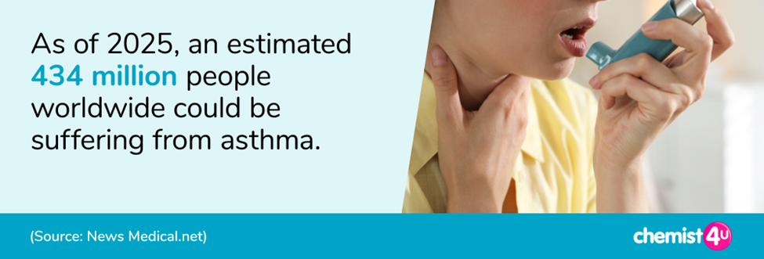
Source : (Chemist4U, 2025; Garg et al., 2022)

1.2 Burden and Prevalence of Asthma
Asthma remains an important issue in the global health of people. The World Health Organization (WHO, 2025) estimates that there are 262 million asthma cases in the world, and the disease causes about 455,000 deaths every year, most of which are deemed to be preventable with prompt diagnosis and proper management (World Health Organization, 2024).
The impact is global not just in mortality but also in healthcare spending, decreased productivity in the workplace as well as low quality of life. More than 60,000 people are hospitalized and about 1,200 die every year in the UK due to asthma (NHS England, 2023). Although there are extensive NHS services and evidence-based clinical guidelines, asthma is still causing significant strain on primary care, emergency departments and hospital resources.
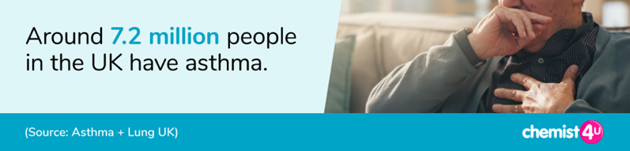
Source: (Chemist4U, 2025; Garg et al., 2022)

1.3 Risk Factors
Asthma is caused by both non-modifiable and modifiable risk factors (Prosser, 2023). Genetic predisposition, family history of asthma or allergic diseases, atopy, age and biological sex are all non-modifiable factors. Modifiable risk factors, on the other hand, also comprise tobacco smoke, air pollution, obesity, respiratory viral infections, occupational exposure to dusts and chemicals, indoor allergens (house dust mites, mould and pet dander), and poor housing conditions.
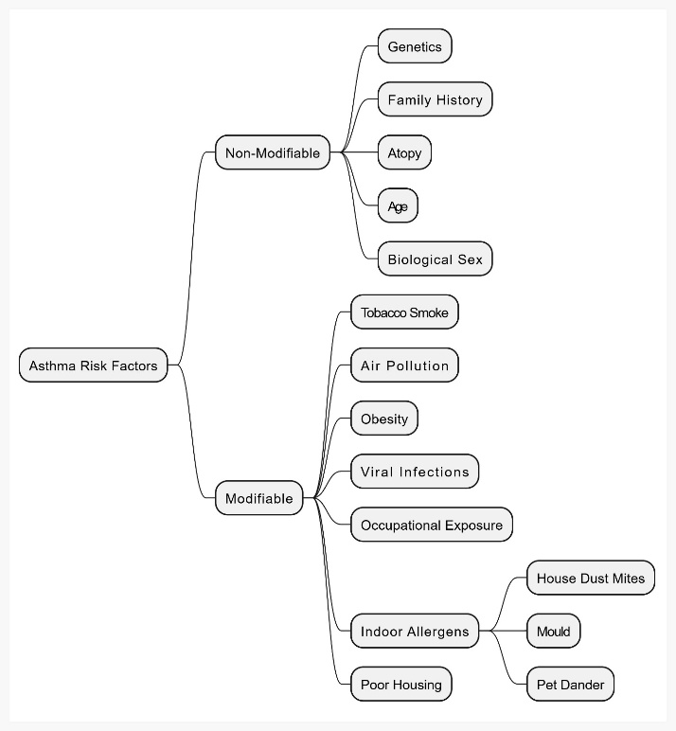
Figure 1:Key Risk Factors Associated with Asthma Development and Exacerbation
Source : self-created

The factors can cause airway inflammation and raise the risk of asthma development or exacerbation of symptoms.

1.4 Aetiology
Asthma is a multifactorial aetiological disease, due to the complex interaction between genetic predisposition and environmental exposures (Prosser, 2023). The subjects with inherited immune dysregulation and allergic sensitization are more susceptible to external influences like pollen, dust mites, tobacco smoke and air pollution which provoke chronic airway inflammation and bronchoconstriction.
Despite the increasing pharmacological treatment, chronic socioeconomic disparities, environmental exposures and suboptimal adherence to the treatment remain factors that contribute to preventable asthma exacerbation and mortality.

2. Critical Evaluation of the Impact of Asthma
Asthma is a long term non-communicable respiratory disease that is common in the world and poses greater physical, psychological, social as well as economic burden to individuals and families and health care systems. Asthma is a major source of disability worldwide, lowering the quality of life and productiveness in spite of the presence of effective treatment.

2.1 Physical Impact on Individuals
Recurring breathlessness, wheezing, chest tightness and persistent coughing is the physical burden of asthma caused by the chronic inflammation of the airways and reversible airflow obstruction (Garg et al., 2022). Nocturnal symptoms, sleep disturbance and fatigue are very common manifestations of poorly controlled asthma which diminishes physical functioning and daily productivity (Garg et al., 2022). Exercise intolerance can restrict education, employment and recreational activities especially in children and the elderly. Asthma is a major cause of disability in the world due to the number of chronic respiratory disorders and recurrent exacerbation is also linked to remodelling of the airways and the loss of lung function.

2.2 Psychological Impact
Asthma has far reaching psychological implications too. The randomness of asthma attacks can cause anxiety, depression, the fear of suffocation and lower self-esteem, especially in patients with severe or poorly controlled asthma. Nocturnal syndrome disturbs sleep, which further leads to poor cognitive performance and emotional wellbeing (Feng, Gu and Wang, 2026). Children can tolerate less education and social confidence and adults often report stress related to work absenteeism and worry about further exacerbations.

2.3 Social and Economic Impact
Asthma in socioeconomic terms has implications beyond healthcare utilization. Asthma in the world leads to significant losses to education attainment, workplace productivity and national economic output in terms of absenteeism and early retirement (Redmond et al., 2021). Families often encounter economic strains that are caused by medication expenses, transportation and care giving expenses.
Health inequalities have continued to be a major issue in the UK. Recent studies have demonstrated that the children in the most deprived communities suffer death rates related to asthma that are four times higher than that of the least deprived communities and individuals who live in the deprived and minority ethnicities are found to be disproportionately more in need of emergency care as a result of asthma (RCPCH, 2022).
These inequalities indicate that environmental exposures, substandard housing conditions, and uneven access to healthcare are still at play in determining the outcome of asthma even with universal NHS coverage.

2.4 Impact on Families and Carers
Families and informal carers are also at risk of asthma, especially in the case of children or severely diseased individuals. Caregivers usually have emotional stress associated with unexpected exacerbation, rush hospital visits and worries about the disease development in the long-term perspective. The environmental trigger avoidance, lifestyle changes, medication management and attendance of medical or healthcare appointments can interfere with employment and family schedules and add financial burdens.

2.5 Critical Evaluation
The effect of asthma is not homogeneous and highly depends on disease severity, age, adherence to treatment and socioeconomic status. Despite the improvement of disease control in most high-income countries through the advancement of pharmacological therapy and evidence-based guidelines, there are still great global disparities.

3. Evidence-Based Management of Asthma
The goals of effective asthma management include optimal symptom management, exacerbation prevention and quality of life improvement by way of early diagnosis, evidence-based pharmacological therapy and multidisciplinary care. The National Institute of Health and Care Excellence (NICE), British Thoracic Society (BTS) and Scottish Intercollegiate Guidelines Network (SIGN) Asthma Guideline (NG245, 2024) in the UK is based on the principles of patient-centred care, with personalized approaches to managing asthma (National Institute for Health and Care Excellence, 2024).

3.1 Diagnosis of Asthma
The correct diagnosis is basic in the management of asthma. The new NICE/BTS/SIGN (2024) guideline advises to use a comprehensive clinical history along with objective diagnostic testing, lessening the use of symptoms on their own, which can cause over- and under-diagnosis (G ruffydd-Jones, 2024).
The primary investigation to determine airflow obstruction and reversibility in the presence of bronchodilators is spirometry. In the presence of diagnostic uncertainty, Fractional Exhaled Nitric Oxide (FENO) should be used to identify eosinophilic inflammation of the airways, whereas in two to four weeks, peak Expiratory Flow (PEF) should be used to detect variable airflow limitation (Wu et al., 2026).
Allergy tests such as Skin-prick or serum IgE are also used in the further diagnosis of allergic triggers and in the personalized treatment plan (Birch and Pearson-Shaver, 2020). It has been indicated that about 1/3 of adults who were diagnosed with asthma before might not have active asthma when they are re-evaluated with objective diagnostic tests, which underscores the significance of evidence-based diagnosis and preventing unnecessary therapy.

3.2 Pharmacological Management
The NHS uses a progressive treatment model, which modifies the therapy based on the levels of symptom control and exacerbation risk (Abichi et al., 2026). Recent recommendations suggest that low dose inhaled corticosteroid (ICS)-formoterol should be used as Anti-inflammatory Reliever (AIR) therapy in place of short acting 2 (SABA) in single use since it is associated with the risk of exacerbation (Krings and Beasley, 2024). Persistently symptomatic patients are treated with maintenance ICS or Maintenance and Reliever Therapy (MART) with combined ICS and long-acting 2 -agonists (LABAs).
Oral corticosteroids are necessary in the acute exacerbations, but should be used only in the short term since long-term use elevates the chances of osteoporosis, diabetes, hypertension and adrenal suppression(Canonica et al., 2025). In severely eosinophilic or allergic asthma patients, biologic treatments, such as omalizumab, mepolizumab, benralizumab, dupilumab and tezepelumab, have been shown to considerably decrease exacerbations, dependence on oral corticosteroids, and hospitalization by selectively targeting immune modulators.

3.3 Lifestyle Management and Self-Management
Medication is not the only way to control asthma. Patients are advised to quit smoking and proper body weight, engage in regular exercise and reduce contact with allergens, air pollutants and work-related irritants. Infection-related exacerbations are minimized by getting annual influenza vaccinations and proper COVID-19 vaccinations, especially in high-risk groups. Personalised asthma action plans, frequent reviews of inhaler technique and adherence education are also important (Micheletto et al., 2025). It has been shown that patients who are on written asthma action plans have reduced emergency.

3.4 Multidisciplinary Team (MDT) Approach
Multidisciplinary care that incorporates general practitioners, respiratory consultants, specialist asthma nurses, pharmacists and physiotherapists is essential to the management of asthma. The diagnosis, monitoring and referrals are done by general practitioners, whereas complex or severe asthma that involves advanced therapies are done by respiratory consultants. Asthma nurses offer education to patients, inhaler technique evaluation and self-management, pharmacists maximize medication adherence and detect excessive use of reliever inhalers. Physiotherapists enhance the effectiveness of breathing and promote healthy exercise. This teamwork method improves care continuity and facilitates individualized care.
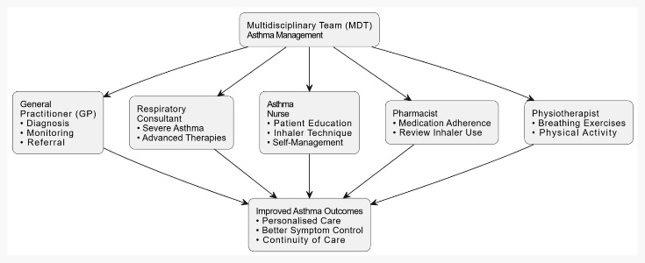
Figure 2:Multidisciplinary Team (MDT) Approach to Asthma Management within the NHS.
Source : Self-created

4. Theoretical Models Supporting Asthma Management

4.1 UK Model: NHS Long-Term Conditions Model
The NHS Long-Term Conditions (LTC) Model, which is based on the principles of Chronic Care Model, offers a systematic approach to the management of the chronic diseases like asthma (Carrier, 2022). It, focuses on person-centred care, which enables patients to take an active role in managing their disease, as well as encourages coordinated care between primary, secondary and community healthcare.

Digital innovations, such as the NHS App, electronic prescribing and remote consultations, also contribute to the increased monitoring and communication between patients and healthcare professionals.
Key NHS used statics:
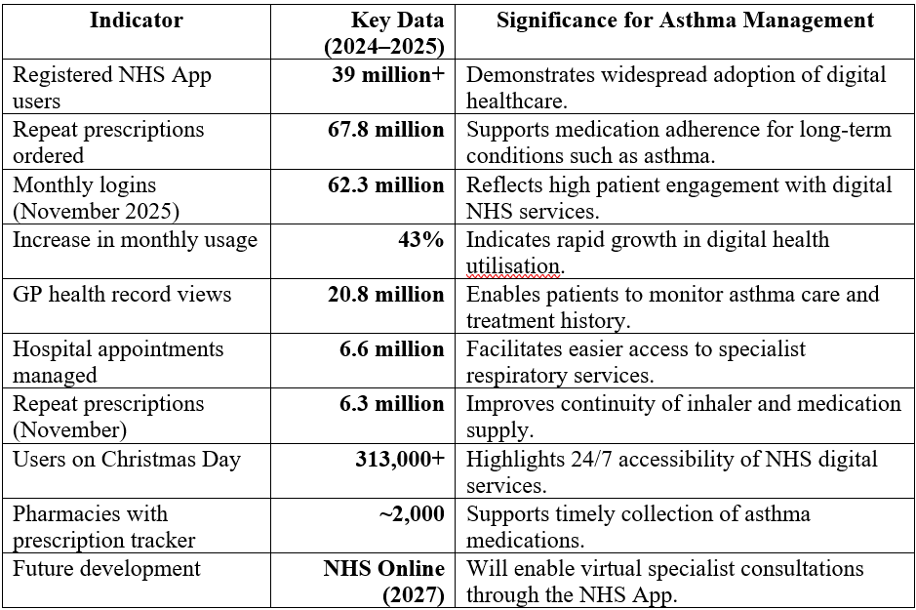
Figure 3:Key NHS used statics
Data source: (England, 2025)
Image source: self-created
More than 34 million individuals in England are registered NHS App users, showing the increased use of digital healthcare in managing long-term conditions (Laverty et al., 2026).
In spite of these strengths, there are inconsistencies in implementation across England. The disparity in accessibility to specialist respiratory care, workforce disparities, and disparities in access to diagnostic devices like Fractional Exhaled Nitric Oxide (FENO) testing still has an impact on the quality and uniformity of asthma care.

4.2 International Model: Wagner Chronic Care Model
One of the most significant international models of managing chronic diseases is the Wagner Chronic Care Model (CCM) which has been extensively adopted in North America, Europe and Australia (Eltigany et al., 2025). The model has six interrelated components including self-management support, redesigning of the delivery systems, decision support, clinical information systems, healthcare organisation and community resources.
Wagner model supports proactive relationships among informed patients and ready multidisciplinary healthcare teams unlike traditional reactive healthcare (2025). The implementation of the CCM has been shown to enhance medication adherence, asthma control and patient-reported quality of life and has decreased emergency department attendances and hospital admissions. Systematic reviews have further demonstrated that integrated CCM interventions have a significant positive effect on self-management behaviors and a decrease in healthcare utilization in people with respiratory chronic illnesses.
To be implemented successfully, it takes a significant investment in healthcare infrastructure, electronic health records, workforce training and community partnerships. As a result, adoption can be complicated in the low-resource healthcare systems where financing and the technological resources are scarce.

4.3 Comparison of the Two Models
Table 1:Comparison of the Two Models
Feature | NHS Long-Term Conditions Model | Wagner Chronic Care Model
Primary focus | Integrated NHS service delivery | Organizational redesign for chronic disease management
Strengths | Universal healthcare, multidisciplinary collaboration, personalized care and digital integration | Strong emphasis on patient empowerment, community engagement and evidence-based decision support
Limitations | Regional inequalities, workforce shortages and variation in specialist service provision | Resource-intensive implementation requiring significant financial and technological investment
Application to asthma | Supports annual reviews, personalized action plans and coordinated NHS care | Promotes proactive disease management, improved self-management and reduced hospital admissions

4.4 Critical Evaluation
The two models acknowledge that the management of asthma goes beyond the use of drugs by encouraging self-management, multidisciplinary teamwork and continuity of care.
Conversely, the Wagner Chronic Care Model offers a wider strategic approach that enhances organizational effectiveness, community involvement and digital health adoption. Integrating NHS model with the focus on clinical information systems and community partnerships of Wagner would further decrease the number of preventable cases of asthma exacerbation, improve treatment compliance and increase the long-term patient outcomes.

5. UK Health and Social Care Policies and Political Agenda Influencing Asthma Management
The management of asthma in the United Kingdom is influenced by the national health policies that facilitate early diagnosis, evidence-based treatment and integrated care. These policies will help to reduce preventable deaths relating to asthma, enhance the quality of life of patients and help to maintain sustainability of NHS services.

5.1 National Institute for Health and Care Excellence (NICE) Guideline (NG245, 2024)
The NICE/British Thoracic Society (BTS)/Scottish Intercollegiate Guidelines Network (SIGN) Guideline NG245 (2024) gives the national evidence base on the diagnosis and management of asthma (2026). The guideline has offered objective diagnostic pathways through the use of spirometry, Fractional Exhaled Nitric Oxide (FENO) testing and peak Expiratory Flow (PEF) monitoring as opposed to simply relying on symptoms. It also suggests Anti-Inflammatory Reliever (AIR) therapy and Maintenance and Reliever Therapy (MART), which will decrease overreliance on short-acting bronchodilators and enhance long-term disease management (Levy and Crooks, 2024).

5.2 NHS Long Term Plan and Integrated Care Systems (ICSs)
Respiratory disease is a national priority of the NHS Long Term Plan (2019) that seeks to encourage prevention and earlier diagnosis, community-based services, and digital healthcare (Allinson et al., 2023). Primary care providers, hospitals, community pharmacists, respiratory specialists and local authorities work together to provide person-centred care through the Integrated Care Systems (ICSs). Community respiratory services have now introduced annual asthma reviews, inhaler technique tests, smoking cessation programmes and self-management education closer to patient home and have minimized unnecessary hospital admissions and have enhanced continuity of care.

5.3 Public Health and Political Priorities
Wider determinants of asthma are also dealt with by government public health strategies; they include smoke-free laws, clean air efforts and child based immunization programs and public education. The interventions are based on the understanding that environmental pollution, tobacco exposure and poor housing are major factors that contribute to asthma exacerbations. However, there are significant health disparities related to asthma. In England, children in the most deprived localities are about four times more likely to die of asthma compared to children in the least deprived localities, which is indicative of the persistence of social and environmental risks on outcomes even with universal NHS healthcare.

5.4 Critical Evaluation
The existing UK policies have made significant progress in the management of asthma by providing standardized clinical management guidelines, multidisciplinary teamwork and increased community-based care. Nonetheless, there are still disparities in implementation by region. The availability of FeNO testing and specialist respiratory clinics and biologic therapy are unevenly distributed, and the issue of workforce shortage and rising demand keeps affecting NHS services. Moreover, the social economic deprivation, poor housing and environmental pollution are not properly addressed in the context of clinical pathways only. This means that this equity in accessing specialist services and investment in community respiratory care needs to be prioritized in future policy, alongside digital innovation and enhanced cross-sector collaboration in relation to housing, education and environmental health.

6. Recommendations for Improving Asthma Management
Although there have been significant developments in the diagnosis and management of asthma, avoidable exacerbations, hospitalization and asthma-related mortality still takes place. Future enhancement must focus on person-centred care which enables patients to be active in the long-term disease management and addressing clinical, psychological and social needs

6.1 Strengthening Person-Centered Care
Management of asthma must be based on the severity of the clinical presentation, lifestyle, cultural background and health literacy of an individual (Poureslami et al., 2022). When choosing inhaler devices, agreeing on the treatment goals and reviewing medication plans, patients should be engaged in shared decision-making by healthcare professionals. Individual asthma action plans need to be reviewed at least once a year and revised after each exacerbation.

6.2 Enhancing Self-Management
Self-management is a very cost-effective intervention in asthma management (Khaw,, Li, and Mohd Tahir, 2021). Structured education should be provided to patients on the identification of the early warning signs, proper inhaler use, trigger avoidance and medication adherence. The increased implementation of digital technologies, such as the NHS App, smart inhalers, and distance monitoring of symptoms, would assist in real-time monitoring of the disease and triggering intervention. There should be an increased involvement of community pharmacists and specialist asthma nurses in strengthening self-management education as part of routine medication review.

6.3 Reducing Health Inequalities
The plans to be developed in the future must focus on fair distribution of respiratory services particularly focusing on socioeconomically disadvantaged groups that are disproportionately affected by morbidity and mortality of asthma. The increase of access to FeNO testing, specialist respiratory clinics and biologic therapies in all Integrated Care Systems (ICSs) would facilitate the earlier diagnosis and better outcomes (Loewenthal and Menzies-Gow, 2022). Extensive population health programs in relation to air pollution, substandard housing, smoking and work-related exposures are also necessary to curb the preventable asthma attacks.

6.4 End-of-Life Care
Even though most individuals who have asthma do not need end-of-life care, they should be involved in patients with severe and treatment-resistant asthma, advanced respiratory failure or other serious co-morbidities. Person-centred care in such scenarios should encompass both advance care planning, symptom management, psychological interventions and deliberations about patient preferences and objectives of care.

6.5 Overall Recommendation
Integrating evidence-based clinical management with person-centered care and enhanced self-management support will enhance quality of life, decrease unnecessary hospital admission and help to attain more equitable respiratory health outcomes throughout the United Kingdom
.

Reference list
Abichi, M.C., Davis, A., Proudfoot, H., Norton, S., Moss-Morris, R. and Hudson, J. (2026). Current treatment outcomes and care pathways for people with comorbid physical and mental health conditions using NHS Talking Therapies services in the UK: Systematic review of quantitative studies. BJPsych Open, 12(2). doi:10.1192/bjo.2025.10957.
Allinson, J.P., Chaturvedi, N., Wong, A., Shah, I., Donaldson, G.C., Wedzicha, J.A. and Hardy, R. (2023). Early childhood lower respiratory tract infection and premature adult death from respiratory disease in Great Britain: A national birth cohort study. The Lancet, [online] 401(10383). doi:10.1016/S0140-6736(23)00131-9.
Birch, K. and Pearson-Shaver, A.L. (2020). Allergy Testing. [online] PubMed. Available at: https://www.ncbi.nlm.nih.gov/books/NBK537020/.
Canonica, G.W., Porsbjerg, C., Price, D.B., Wechsler, M.E., Heaney, L.G., Hanania, N.A., Gall, R., Pandit‐Abid, N., Jacob‐Nara, J.A. and Sacks, H.J. (2025). Burden of Oral Corticosteroid Use in Severe Asthma: Challenges and Opportunities. Allergy. doi:10.1111/all.16569.
Carrier, J. (2022). Effective management of people with a long-term condition. Routledge eBooks, pp.100–117. doi:10.4324/9781003020653-7.
Chemist4U (2025). Asthma Statistics Report. [online] Guides. Available at: https://www.chemist-4-u.com/guides/research-insights/asthma-statistics/.
Eltigany, M., Drown, L., Akala, O., Ussai, S., Bukhman, G., Cieza, A. and Adler, A.J. (2025). Models of care for noncommunicable diseases in primary care: Key elements and design in low- and middle-income countries – a scoping review. Global Health Action, 18(1). doi:10.1080/16549716.2025.2543604.
England, N. (2025). NHS England » Record numbers using NHS App to manage health. [online] England.nhs.uk. Available at: https://www.england.nhs.uk/2025/12/record-numbers-using-nhs-app-to-manage-health/.
Feng, X., Gu, Z. and Wang, Y. (2026). The relationship between allergic rhinitis and sleep disorders and mental health. Frontiers in Allergy, 7. doi:10.3389/falgy.2026.1806555.
G ruffydd-Jones, K. (2024). [online] Bjgp.org. Available at: https://bjgp.org/content/76/766/199.
Garg, R., Piplani, M., Singh, Y. and Joshi, Y. (2022). Epidemiology, Pathophysiology, and Pharmacological Status of Asthma. Current Respiratory Medicine Reviews, 18(4). doi:10.2174/1573398x18666220526164329.
Have, L.T., Meulmeester, F.L., Jong, K. de and Anneke Ten Brinke (2025). Patient-centred outcomes in severe asthma: Fatigue, sleep, physical activity and work. PubMed, 34(175). doi:10.1183/16000617.0122-2024.
Jacobs, A., Wu, R., Tomini, F., De Simoni, A. and Mihaylova, B. (2023). Strong and graded associations between level of asthma severity and all-cause hospital care use and costs in the UK. BMJ open respiratory research, [online] 10(1), p.e002003. doi:10.1136/bmjresp-2023-002003.
Khaw,, S.M., Li,, S.C. and Mohd Tahir,, N.A. (2021). A systematic review of the cost-effectiveness of medicationadherence-enhancing intervention for asthma. Journal of Asthma, pp.1–15. doi:10.1080/02770903.2021.1875483.
Koppelman, G.H., Pino-Yanes, M., Melén, E., Powell, P., Bracke, K.R., Celedón, J.C. and Brusselle, G.G. (2025). Genetic and environmental risk factors for asthma: Towards prevention. The Lancet. Respiratory medicine, [online] pp.S2213–2600(25)00256–5. doi:10.1016/S2213-2600(25)00256-5.
Krings, J.G. and Beasley, R. (2024). The Role of ICS-containing Rescue Therapy versus SABA Alone in Asthma Management Today. The Journal of Allergy and Clinical Immunology: In Practice, 12(4). doi:10.1016/j.jaip.2024.01.011.
Laverty, A.A., Reidy, C., KC, S., Papoutsi, C., Gudgin, B., Majeed, A. and Powell, J. (2026). The NHS App should focus on inequalities to improve population health. Journal of the Royal Society of Medicine, 119(2), pp.37–41. doi:10.1177/01410768261421427.
Levy, M.L. and Crooks, M.G. (2024). Anti-inflammatory reliever therapy (AIR) for asthma. ERJ Open Research, 10(5), pp.00494–2024. doi:10.1183/23120541.00494-2024.
Loewenthal, L. and Menzies-Gow, A. (2022). FeNO in Asthma. Seminars in Respiratory and Critical Care Medicine, 43(5). doi:10.1055/s-0042-1743290.
Maggi, E., Parronchi, P., Azzarone, B.G. and Moretta, L. (2022). A pathogenic integrated view explaining the different endotypes of asthma and allergic disorders. Allergy, [online] 77(11), pp.3267–3292. doi:10.1111/all.15445.
Micheletto, C., Aliberti, S., Andreoni, M., Blasi, F., Marco, F. Di, Matteo, R. Di, Gabutti, G., Harari, S., Gentile, I., Parrella, R., Siliquini, R. and Sticchi, L. (2025). Vaccination strategies in respiratory diseases: Recommendation from AIPO-ITS/ETS, SIMIT, SIP/IRS and SItI. Respiration, [online] pp.1–28. doi:10.1159/000544919.
National Institute for Health and Care Excellence (2024). Overview | Asthma: Diagnosis, monitoring and chronic asthma management (BTS, NICE, SIGN) | Guidance | NICE. [online] Nice.org.uk. Available at: https://www.nice.org.uk/guidance/NG245.
NHS England (2023). NHS England » RightCare asthma scenario. [online] Www.england.nhs.uk. Available at: https://www.england.nhs.uk/long-read/rightcare-asthma-scenario/.
Poureslami, I., FitzGerald, J.M., Tregobov, N., Goldstein, R.S., Lougheed, M.D. and Gupta, S. (2022). Health Literacy in Asthma and Chronic Obstructive Pulmonary Disease (COPD) care: A Narrative Review and Future Directions. Respiratory Research, [online] 23(1). doi:10.1186/s12931-022-02290-5.
Prosser, A. (2023). Asthma Risk Factors: Development, Prevention, and More. Healthgrades. [online] doi:10.3389/fped.2019.00006/full\.
RCPCH (2022). Child Health Inequalities Driven by Child Poverty in the UK - Position Statement. [online] RCPCH. Available at: https://www.rcpch.ac.uk/resources/child-health-inequalities-position-statement.
Redmond, C., Akinoso-Imran, A.Q., Heaney, L.G., Sheikh, A., Kee, F. and Busby, J. (2021). Socioeconomic disparities in asthma health care utilization, exacerbations, and mortality: A systematic review and meta-analysis. Journal of Allergy and Clinical Immunology, 149(5). doi:10.1016/j.jaci.2021.10.007.
Suresh, K. and Rao (2023). Management of Asthma & Its Exacerbations in Smaller Settings. International Journal of Clinical Reports and Studies, [online] 2(6). doi:10.31579/2835-8295/041.
World Health Organization (2024). Asthma. [online] World Health Organization. Available at: https://www.who.int/news-room/fact-sheets/detail/asthma.
Wu, Y., Lin, Y., Hao, H., Lin, J., Zhou, Y., Pan, Y., Zhang, M. and Bao, W. (2026). Identifying optimal flow rates for airway eosinophilia detection in asthma. European Journal of Medical Research, 31(1). doi:10.1186/s40001-026-04039-y.
(2025). [online] ResearchGate. Available at: https://www.researchgate.net/figure/The-Chronic-Care-Model-Wagner-2004-Wagner-et-al-2001_fig1_271585144.
(2026). Asthma (Chronic) | British Thoracic Society | Better lung health for all. [online] Brit-thoracic.org.uk. Available at: https://www.brit-thoracic.org.uk/clinical-resources/guidelines/asthma-chronic/.

