

CHANGE MANAGEMENT PLAN
OF
SECURITAS SECURITY SERVICES LTD

Student name: Antonio Brian Fernandez Ramos
Student ID: 1818212
Module code: BMSW6103
Module title: Leading and Implementing Workplace Change
Lecture’s name: Dr. Dudley Ofori
Executive Summary
In the context of the report, a critical evaluation of the change management process has been organised. The assessment identifies the suitable change management model for the organisation and it also delivers a specific proposal for the organisation to implement the change. The objective of the organisation to make the changes effective is also assessed in the assessment. The suitable leadership style and the step-wise process of improvement in the implementation process have been identified. The impact of the implementation process is also part of the discussion and some suitable recommendations have been provided according to the analysis developed.

Table of Contents
Introduction 4
Section 1 - Critical evaluation of the adopted change management process and Identification of the suitable strategic change option 4
1.1 Overview of the change management capabilities 4
1.2 External factors Drive changes 5
1.3 Leadership styles drive the Changes 7
1.4 Impact of organisational culture 8
1.5 Areas that could be done better 9
1.6 Areas required further improvement 9
Section 2 - Critical Evaluation of the Change Management Models 10
2.1 Critical Evaluation of Change Management Models 10
2.2 Identification of a suitable change management model for the Organisation 11
Section 3 - Proposal and Implementation of Change Strategy 12
Proposal of a change management plan based on the identified suitable change management model 12
Leadership style suitable for initiating and implementing identified strategic change 13
The process to implement the change strategy 14
Impact of the Implementation of Change Strategy on the Culture of Chosen Organisation 16
Conclusion and Recommendations 17
Summary of the findings 17
Recommendations 17
References 19

Introduction
Change is the only constant that further provides resilience to reduce the effect of unavoidable circumstances like COVID-19. It can be depicted as a systematic process that handles the transition of companies' goals and technologies. Changes are necessary for a company to survive in a cluttered market and achieve revenue (Yue et al., 2019). This study focuses on the change management model and the impact of leadership within a company. COVID-19 brings unprecedented changes within the business processes, as businesses are forced to change their usual way of doing business. Moreover, this study focuses on the issues that Securitas Security Services LTD. faces, which lead to change management. In addition to this, it can be depicted that organisational culture has a direct impact on the change management process, as an open and inclusive environment further sheds light on the development of innovative ideas that smoothens the change management process. This study further illustrates the impact of COVID-19 as well as the changes that take place in the external environment. In this study to understand the change management process of the selected company the “Kotter change management”, “Lewin’s Change Management Model” and “ADKAR change management model” is taken into consideration. The primary outcome of the report will be the critical evaluation of the change management process in the context of different theories and models.

Section 1- Critical evaluation of the adopted change management process and Identification of the suitable strategic change option

1.1 Overview of the change management capabilities
This section of the following report sheds light on the current change management capabilities that Securitas Security Services LTD. faces during COVID-19. As per reports, it can be depicted that the following company has faced considerable challenges as reflected by the reduction in earnings per share by -12%. Moreover, the company further faces business loss due to government restrictions regarding stopping physical business to reduce infection. The following company further sheds light on four different factors that help them to create resilience for tackling the adverse situation. The first primary focus area of the company was to make its focus on the engagement of clients. In order to increase engagement, the company shifts its focus to the needs and wants of the company which further allows them to increase engagement. This further creates a positive impact on the company's performance in the fiscal year 2020 the global client base of the company has increased its global client footprint to 16% in context to total sales. The next focus area for the company was to develop leadership in protective services which further takes place due to the innovation. In addition to this, it can be depicted that the model developed by the company can predict 80% of criminal incidents and further able to provide effective services to their clients. Digital technologies used by the firm, further aid the 325000 front-line personnel to work in an efficient manner. The third focus area of the selected company is efficiency. The company has increased the overall level of automation as well as digitisation which further allows them to increase their efficiency as well as value. As per reports, it can be depicted that the following company has deployed a client excellence platform that further allows reserving time for managers which can increase their productivity. In addition to this, it can be depicted that sales force software is implemented by the company to work with clients more closely. The last important factor for the company is the people. Employees are in the central system that further determines the performance of the company.

1.2 External factors Drive changes
This section of the following study sheds light on the factors that force the selected company to implement the change. As per the political situation, as illustrated by (Wrigh et al., 2022), there is a decline in the trust of individuals in the UK during COVID-19. The study further sheds light on the completeness factor of lockdown measures imposed by the government at that time to curb the spreading of the virus. In addition to this, the study also finds out that low-level trust has a negative impact on compliance with “infection-dampening rules”. The insatiable condition further creates a direct impact on the economy of the country that further results in the loss of jobs during covid. As per economic factors in the UK, the rate of inflation touches 1.5% during the April 2020 fiscal year (Bbc.com, 2020). This further creates a direct impact on the financial capability of the company despite the decrease from the previous year, the selected organisation has achieved 2.1% net “debt to EBITDA”
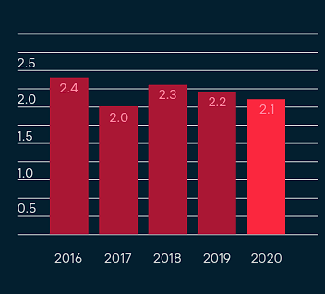
Figure 1: Net Debt To EBITDA ratio
(Source: Securitas.com, 2020)
The “operating cash flow” of the company was 147% compared to 85% in 2019, which further have a direct impact on the operation of the corporation as the company has to bear different excess costs other than solely investing in the business process as safety concerns are a prime concern during the period. Whereas as per social factors, the rising concerns about workplace safety have a direct impact on the employees. As per the survey results suggested, the percentage of employees who had been furloughed had dropped from 25% during May to 17% during June. On the other hand, the percentage of employees who worked standard hours rose from 49% in May to 56% throughout June (Cipd.co.uk, 2020). In addition to this, it can be depicted as job security was another among employees in the UK during the pandemic wave.
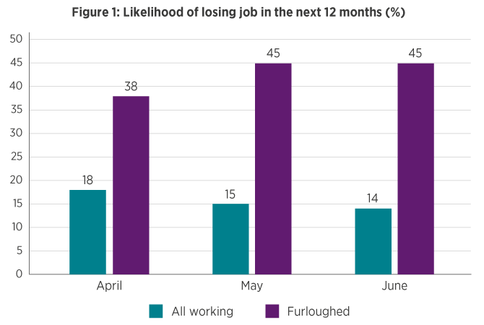
Figure 2: Job loss tension among employees
(Source: Cipd.co.uk, 2020)
As per technological factors, different firms in the UK have adopted technologies during the pandemic. In addition to this, it can be depicted that 75% of firms in the UK have adopted technologies that further allow them to increase their productivity (LSE Business Review, 2021). In addition to this, it can be depicted that remote working technologies adaptation further is evident in the UK. The rules related to coronavirus that restrict gathering in public places further have a direct impact on the business process of companies. As per studies, it can be depicted that 95% of businesses have developed short-term plans for addressing environmental concerns (Edie.net, 2020).

1.3 Leadership styles drive the Changes
This portion of the report sheds light on the leadership strategy that was further considered by the company to manage the changes. Moreover, it can be depicted that Magnus Ahlqvist was the CEO of the company who has worked for different technology companies before joining Securitas. In addition to this, the primary change that the company went through during COVID-19 is technical implementation within the technology. Moreover, it can be depicted that the company has developed an aim of becoming an “intelligent protective services partner” for their clients. In order to do this, the company further employs innovation at the company level which further depicts the visionary aspect of the CEO of the company. In addition to this, it can be depicted that the selected company further considers application on different levels that further allows them to increase their productivity and have a positive impact on their output. So, as per the leader's traits are concerned the selected organisation considers transformational leadership. As commented by (Ghasabeh, 2020), it can be depicted that the improved usage of data can be depicted as a positive factor for this kind of leader as they can take leverage from those.

1.4 Impact of organisational culture
Organisational culture can be depicted as an important aspect as it further allows members within an organisation to have a common belief, norms as well as meaning. Moreover, it can be depicted that it further allows the creation of understanding between employees and a clear communication path for the company. In addition to this, it can be depicted that organisational factors are an important aspect as it has a direct impact on the efficiency of employees and the organisational ability to deal with changes. As per the fiscal year, 2021 performances considered that the company has achieved a 22% share in installing electronic security systems and achieving an operating margin of 5.6% which further reflects the betterment in operational performance of the company (Securitas.com, 2021). The company further considers different transformative technologies through accusation to achieve projected revenue.
On the other hand, The diversity and inclusion within the company have improved as the company experiences an increment in female managers by 24% compared to 23% in the previous year.
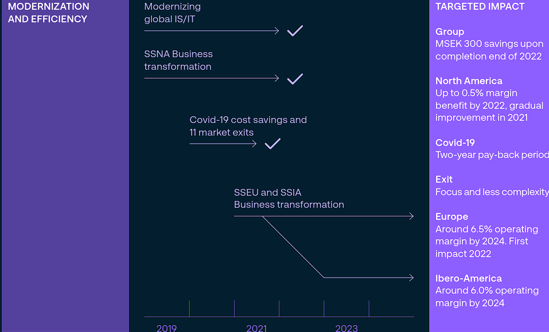
Figure 3: Transformation to digital business process
(Source: Securitas.com, 2021)
As per business, transformation or a shift in the digital process of the business is concerned the following company employs a strong culture that further increases the adoption of digital technologies that further illustrates a high-performance workforce.

1.5 Areas that could be done better
The following portion of the report sheds light on the areas that could be considered by the company to make considerable improvements. In my opinion, the company needs to develop a proper system for knowledge management and related infrastructure can have a direct impact on the organisational performance. In addition to this, it can be depicted that scarcity is an improvement in the knowledge as well as officers. Moreover, it can be depicted that factors such as scarcity of human resources are another aspect the company faces while effectively carrying out its business process. Moreover, it can be depicted that employee training to cope with the changing nature of business processes of the selected organisation needed to reform as it can improve employee activities.

1.6 Areas required further improvement
This section for the following study sheds light on the areas of the company that needed to be developed. In order to implement a high performing as well as innovative workspace, the company needed to include diversification strategies that further can allow them to employ a diverse workforce which will allow them to increase employee productivity. In addition to this, it can be depicted that inclusion is important for increasing organisational performance. For this, the company needed to include employees in the decision-making process. It not only improves the trust factor of employees but also increases their motivation which has a positive impact on the business process of the company (Baptista et al., 2020). In addition to this, as the current economic factor in the UK is constantly evolving due to rising inflation, for this, the company should implement a data-driven approach by considering the market data before investing in a new area of business so that risk associated with the investment can be analysed and maxim performance can be achieved.

Section 2 - Critical Evaluation of the Change Management Models

2.1 Critical Evaluation of Change Management Models
Change is an inevitable phenomenon and can be problematic for businesses that are at a growing stage. Culture is another important aspect when it comes to managing changes within an organisation. Favourable working culture can be a catalyst for employee motivation by providing a supportive environment. In addition to this, it can be depicted that different models that are employed in the management of change further provide a better picture of the implementation of change situations and the effective implementation of different processes. In simpler terms, it can be depicted that change management models are responsible for providing a path for the company to further act as a guide to have different transitions (Cameron and Green, 2019).
Since it helps to put more of an emphasis on the "people side" of business, organisational culture contributes when it comes to driving transformation. The repercussions of change projects can be far-reaching and can affect production, profitability, customer satisfaction, and much more. Change projects require a lot of time and resources, and they sometimes ask for the purchase of novel technology. On the other hand, it can be depicted that models of change management are implemented to maximise the ROI along with the implementation of the improved process. In this section of the report, three different change management models are described that further allow an organisation to implement different changes, that is “Kotter's change management”, “Lewin’s Change Management” and “ADKAR change management” model.
“Lewin’s Change Management” sheds light on three important aspects in the context of managing important change within the organisation. The model further sheds light on three steps that are “Unfreeze, Change, Refreeze”. The unfreeze factor sheds light on the three-factor that are unfreezing current processes that are considered by the company, Moreover, it can be depicted that the following steps further shed light on the steps that can be considered by the companies to implement the change situation (Burnes, 2020). These can be crucial for companies as understanding the process and implementing those processes to get results may have considerable gaps. For this reason, the importance of factors needed to be highlighted in the theory.
Lewins' model also increases the period of “change” which may not be applicable where quick and impactful change is needed to be implemented. The last of the model puts importance on sustaining the changes that are made. In this step, organisations mostly collect data from their employees to understand the effectiveness of the change, companies seal those right parameters in order to implement change in an effective manner. In the case of the “ADKAR change management model” the change is implemented by implementing five different steps “Awareness, desire, ability, reinforcement” which sheds light on employee participation. It highlights the steps that further allow companies to create awareness of change among employees.
It can be depicted as a “bottom-hand” mode that provides a journey from creating risk awareness to reinforcement by creating ability and knowledge. Moreover, it can be depicted that following the “people-centric” method further sheds light on the goal and knowledge. In addition to this, it can be depicted that it creates confidence among employees that a complete transformation of the process is required. For example, implementing a technical change can be implemented within an organisation by considering the factors of following the bottom-hand method. On the other hand, Kotter's model for managing change within an organisation further reflects eight different stages. The steps of the mode range from the creation of a sense of urgency to implement the change of institute.
It can be portrayed as a top-down model that is further helpful for organisations in case of building change as well as enthusiasm. On the other hand, it can be depicted that it might not be a perfect option for companies where feedbacks are crucial. It can develop the risk of resentment of an employee as well as alienation. In the case of implementing change, employee inclusion is an important aspect as it allows a firm to implement change in an effective manner. Employees are the sole factors that determine the success of a change.

2.2 Identification of a suitable change management model for the Organisation
In order to make an effective change in the company, Securitas Security Services Ltd., some necessary measures must be taken. The enhancement of the services of the company is expected to deliver greater performance in the future. In the present context of assessing and analysing the changes in the organisation, the ADKAR model is to be used. The ADKAR model is suitable for the present context as the steps of the ADKAR model provide insight into different aspects of the organisation. In terms of making suitable changes in the organisation, awareness, motivation or desire, knowledge, ability, and reinforcement are important steps to be taken (Sulistiyani, Ali and Astuti, 2020). In order to comprehend a proper implementation of the model, announcing the changes to be made is essential and this is the first important step for making progress. The model is also considered to be suitable in terms of deriving the motive of the organisation which is subject to the desire of the company. The changes made must be put to some knowledge of the reasons for change and also the way forward must be known to the managers or the changemakers. It is also essential for the organisation to assess if the company can make and accept the changes. After the assessment only, the change can be successfully implemented and reinforcement or monitoring the changes is also an essential factor.
The potential of the organisation must be effectively understood before implementing the change management process. The evidence-based performance of the organisation is also part of the assessment and to provide proper services to the consumers, some necessary measures must be accomplished properly. The change management process deals with different situations and stages and the organisation must be effectively handled during this process for implementing suitable measures for the leaders (Jaaron, Hijazi and Musleh, 2021). The leaders play an important role in terms of deriving the processes properly and implementing the change management process can be effectively processed with the help of a suitable leadership style. The ADKAR model is suitable for developing a proper change management process for the organisation and it will help your organisation to improve its quality of services. In order to deliver proper services to the consumers and help them to save themselves from criminals. Home security products must be effectively delivered by the organisation and electronic security must be effective in developing prospects for the organisation. The change must have occurred due to the relevance of the organisation and the business process must be improved this is also an objective of the organisation in the change management process.

Section 3 - Proposal and Implementation of Change Strategy

Proposal of a change management plan based on the identified suitable change management model
Securitas Security Services Ltd. must propose a suitable change for the organisation to deal with the post-pandemic situation. According to the assessment of the organisation, the company can provide different services to their customers based on their requirements. The company has several services and in terms of electronic security, some major changes are necessary to cope with the new situation. The most important aspect of the organisation is to develop its security in terms of online services (Houben et al., 2020). The company has a major role to play in the future context and for this, the organisation must be equipped with the latest technology and regular improvements of these technologies is also essential. This is a major change and it must be accomplished in different stages which are also part of the later discussions. This change must be initiated from the consumer perspective towards electronic security. Electronic security is a wider concept and it is subject to change with the development of new technologies, hence the organisation must cope with the situation and the advancement of technology must be effectively accomplished (Penchev, 2021). In order to provide proper services to the customers, the company should develop new technology and after the pandemic situation, electronic security is of utmost importance.
Several approaches can be organised in terms of providing consumers with the best quality of services. During COVID, the organisation has faced several difficulties due to a lack of staff and the infrastructure of the organisation has also worn down. In this scenario, the organisation must develop methods to deal with the situation after the pandemic. The employees of the organisation are returning after the pandemic and the infrastructure of the organisation must be improved to accommodate the employees (Balluck, Asturi and Brockman, 2020). In order to develop a better electronic security system, the organisation must hire professionals and develop a team for the betterment of the services of the company. The company developed steam based on electronic security and the teams must be led by capable leaders for this the organisation must develop proper infrastructure. In order to provide the proper services to the consumers, the organisation must improve its process and the services must be provided at the proper time. The primary change that was laid to these assessments is to develop a proper chain of services by the organisation. The delivery of the services is the prime motive of the organisation and proper service time must be maintained with the security of the electronic systems (Moraes and Cunha, 2022). The systems must efficiently deliver proper services and to prevail the data and integration of the consumer, these changes are necessary.

Leadership style suitable for initiating and implementing identified strategic change
Transformational leadership style is the most suitable style for implementing some strategic change in an organisation. In the present context, the organisation must develop or implement transformational leadership for making the change process effective. The change process is not an easy task for employers and from the employee perspective also, changes are hard to be accepted (Busari et al., 2019). The changes come with different challenges for both employers and employees. From the employee side, the challenges are in form of a lack of training and the employees are unable to understand or implement the required changes in their day-to-day work. On the other hand, employers face issues with infrastructure and proper leadership style. Transformational leadership style is the most effective leadership style for implementing any changes due to its effectiveness in engaging more people in the work. In the present context, developing transformational leadership helps engage the employees in the training process and motivating the employees is also obtained from the employer's perspective (Islam, Furuoka and Idris, 2020). The lack of resources and infrastructure is a problem that needs to be solved and the leadership style is also helpful in this context. In terms of motivating the employees, leaders must be appointed by the company and they must develop a suitable program to engage the employees with the leaders. In terms of developing an attachment to the work and making the training processes easy, an effective leadership style is necessary.

The process to implement the change strategy
The process to implement the changes is not an easy task and this cannot be accomplished in one single step. The following steps are to be discussed or subjected to divide the total process of change into different segments. In terms of developing the proper change and making an effective change management strategy, some useful measures must be taken. In order to implement the changes, proper leadership and management of the organisation and its employees is necessary.
Awareness
The primary step of a change management process is to present the changes to the employees. This must not be done after making the changes but the employees must be informed well before implementing the changes so that they can be part of the change (Yue, Men and Ferguson, 2019). In terms of making the change management process effective, awareness of the employees must be initiated and the employees must be aware of the reason for these changes. The employees must be provided with an environment of opportunity to question the changes and then the reasons for the changes can be effectively presented. Engagement with the employees is the key to being a successful change manager in the organisation. In the present context, the organisation has developed programs to deliver the changes to the employees and it is an effective measure to make the change management effective.
Desire
In terms of developing suitable changes in the organisation, the identification of employees is an essential factor. The leaders and the employers must be aware of the different employees and their motives for working. In the present context, the security features of the electronic systems must be effectively changed and the employees must be skilled enough to become followed up in this situation (Peng et al., 2020). The changes are subjected to delivery in terms of providing better services to the consumers and the employees must acquire the same objective while they work. It also affects the training of the employees if the motive of the employees is scattered. The approaches, the learning speed, and several other aspects can differ for different employees but the motive must be clear and focused on the objectives of the organisation.
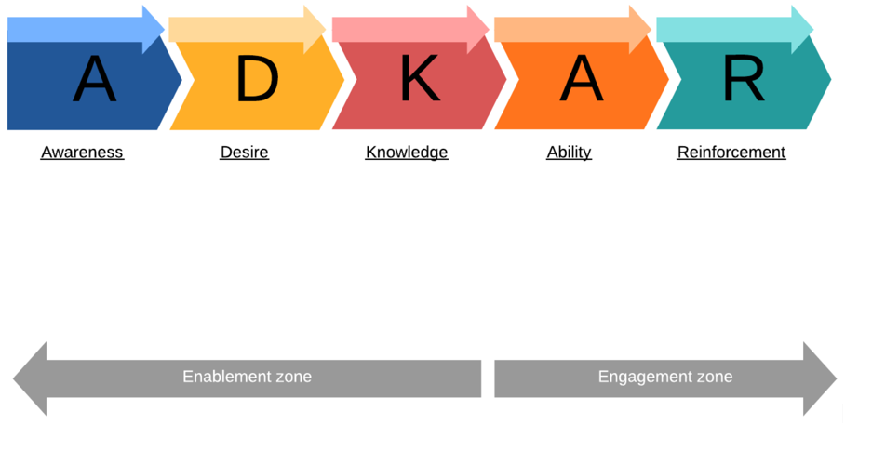
Figure 4: ADKAR Model
(Source: Jaaron, Hijazi and Musleh, 2021)
Knowledge
This face is about providing training to the employees on how the change process will be implemented. In terms of providing proper training or coaching to the employees, leaders must be capable enough to deliver the training properly and train the employees to become better in their jobs. The development of knowledge embarks potential among the employees and it is subjected to better performance in terms of delivery of the change management process (Faupel and Süß, 2018). Enhancement of employees is the key to achieving a successful change management process and the employees must also be made aware of the changes in terms of delivery and the objective-based performance of the organisation.

Ability
In the present context, security systems have been developed to deliver proper services to consumers. The organisation aims to deliver such a system to the consumer so that criminal activities are minimised and to do so continuous changes are necessary. The subjective measure in this context is the capabilities of the employees to deliver such services (Sung and Kim, 2021). The assessment of employee capability after the training is provided is an essential part of implementing the change effectively. The employees must be capable of delivering 70 to 75% of the required services so that a suitable system can be implemented.
Reinforcement
This stage explores the possibilities in terms of delivering proper services to the consumers. Capable employees can easily provide the required services but in the case of less capable employees, a suitable monitoring system must be developed. The objective of the monitoring system is to locate incompetencies in the employees and such employees must be gone through a test and training for making a better career in the future (Farahnak et al., 2019). This time the training must be effective as it is considered as reinforcement and in some cases, the employees must be replaced with suitable candidates for delivering the services to the consumers properly.

Impact of the Implementation of Change Strategy on the Culture of Chosen Organisation
Securitas Security Services Ltd. must develop and assess the cultural changes in the organisation due to the implementation of the change management process. The present context of the organisation leads to an assessment that the business culture has changed after the pandemic situation. The assessment of cultural changes in relationships for developing engagement and communication with the employees (Handtke, Schilgen and Mösko, 2019). The cultural changes impact the performance of the organisation as the employees tend to act differently when the change management process is implemented. In some cases the employees might be disturbed by the changes and the cultural aspects may become the key to the problem. The employees must be communicated with the leaders properly to assess the impact of the change on the organisation. The impact on the employee's motivation and the overall processing of the change management can impact the performance of the employee. In order to deliver the services properly, the organisation must take care of its culture and suitable measures must be taken to maintain the motivation of the employee (Syakur et al., 2020). This is the role of the leaders to manage the motivational aspect and provide a suitable range of services to the consumers without fail. The pandemic situation has forced the company to make drastic changes to deliver specific services to consumers. The idea of delivering the services and making effective change according to that comes with the primary challenge of the cultural aspect and it must be mitigated by the leaders to engage and motivate the employees.

Conclusion and Recommendations

Summary of the findings
Summarising the findings can be subjected to deliver the performance-based measures of the organisation. Securitas Security Services Ltd delivers security-related services to electronic devices and protects clients from unnecessary harm from criminal activities. The pandemic situation has been a major drawback for this organisation and the company must make necessary changes in their management to develop its organisational context. The services provided to the consumers must be effective enough to bounce back in the market and the quality of service must be improved with the help of internal changes in the organisation. The ADKAR model must be used for this change management assessment and the delivery of product base services must be effectively handled by the organisation. The assessment has been effective to determine the suitable change and the suitable model for the changes. The assessment also infields traits of the leadership qualities required for organisational development. In order to provide services to the consumers, the employees must be trained and this is also part of the change management process. The assessment also depicts how change management can be held and the following aspects provide suitable recommendations for the change management process.

Recommendations
 | Recommendation | Importance | Implementation | Negative Consequences
Short-term | The objective of the organisation should be focused on providing security to the clients. | This recommendation is important to be implemented to develop a better system for the organisation to update in the new business culture. | This recommendation can be effectively implemented within 6 months and this is necessary to comprehend within a specific time gap. | In case the recommendation is not followed, the business system of the organisation can be disrupted and the company will not be able to cope with the new era of business.
Mid-term | The employees must be trained properly to deliver proper security and services. | Training employees is necessary to provide proper services to the consumers. | Implementing the training process is also effective in terms of a 6 month gap and training must be done within the schedule effectively. | The negative consequence of not following the recommendation is to deliver a proper segment for the consumer.
Long-term | Continuous monitoring is essential for developing suitable measures for the services. | This recommendation relates to being implemented to deliver proper services to consumers within a specific time gap. | It will take a year to implement the recommendation properly. | The consequences of not following the recommendation are to develop competencies in the employees and lack of potential to deliver timely services.
Table 1: Recommendations and Analysis
(Source: Al-Samarraie et al., 2020)

References
Al-Samarraie, H. et al. (2020) ‘Telemedicine in Middle Eastern countries: Progress, barriers, and policy recommendations’, International Journal of Medical Informatics, 141, p. 104232. doi:https://doi.org/10.1016/j.ijmedinf.2020.104232.
Balluck, J., Asturi, E. and Brockman, V. (2020) ‘Use of the ADKAR® and CLARC ® Change Models to Navigate staffing model changes during the COVID-19 pandemic’, Nurse Leader, 18(6). doi:https://doi.org/10.1016/j.mnl.2020.08.006.
Bbc.com (2020). Coronavirus: UK inflation hits 1.5% as lockdown begins to bite. Available at: https://www.bbc.com/news/business-52371062 [Accessed 16 Apr. 2023].
Busari, A.H. et al. (2019) ‘Transformational leadership style, followership, and factors of employees’ reactions towards organizational change’, Journal of Asia Business Studies, 14(2), pp. 181–209. doi:https://doi.org/10.1108/jabs-03-2018-0083.
Cipd.co.uk (2020). Impact of COVID-19 on working lives | Survey reports | CIPD. [online] CIPD. Available at: https://www.cipd.co.uk/knowledge/work/trends/goodwork/covid-impact#gref [Accessed 16 Apr. 2023].
Edie.net (2020). 6 in 10 UK businesses cutting environment-related investment due to coronavirus, survey shows. [online] edie. Available at: https://www.edie.net/6-in-10-uk-businesses-cutting-environment-related-investment-due-to-coronavirus-survey-shows/ [Accessed 17 Apr. 2023].
Farahnak, L.R. et al. (2019) ‘The Influence of Transformational Leadership and Leader Attitudes on Subordinate Attitudes and Implementation Success’, Journal of Leadership & Organizational Studies, 27(1), p. 154805181882452. doi:https://doi.org/10.1177/1548051818824529.
Faupel, S. and Süß, S. (2018) ‘The effect of transformational leadership on employees during organizational change – An empirical analysis’, Journal of Change Management, 19(3), pp. 1–22. doi:https://doi.org/10.1080/14697017.2018.1447006.
‌Ghasabeh, M. (2020). Transformational Leadership, Information T ansformational Leadership, Information Technology echnology, Knowledge nowledge Management, Firm P Management, Firm Performance: How Ar formance: How Are They Linked? Journal of Values-Based Leadership, 13(2). doi:https://doi.org/10.22543/0733.132.1317.
Handtke, O., Schilgen, B. and Mösko, M. (2019) ‘Culturally competent healthcare – A scoping review of strategies implemented in healthcare organizations and a model of culturally competent healthcare provision’, PLOS ONE. Edited by C.S. Todd, 14(7). doi:https://doi.org/10.1371/journal.pone.0219971.
Houben, M.A.M. et al. (2020) ‘The ADKAR® change management model for farmer profiling with regard to antimicrobial stewardship in livestock production’, Vlaams Diergeneeskundig Tijdschrift, 89(6), pp. 309–314. doi:https://doi.org/10.21825/vdt.v89i6.17413.
Islam, M.N., Furuoka, F. and Idris, A. (2020) ‘Mapping the relationship between transformational leadership, trust in leadership and employee championing behavior during organizational change’, Asia Pacific Management Review, 26(2). doi:https://doi.org/10.1016/j.apmrv.2020.09.002.
Jaaron, A.A.M., Hijazi, I.H. and Musleh, K.I.Y. (2021) ‘A conceptual model for adoption of BIM in construction projects: ADKAR as an integrative model of change management’, Technology Analysis & Strategic Management, 34(6), pp. 1–13. doi:https://doi.org/10.1080/09537325.2021.1915975.
LSE Business Review. (2021). COVID-19 spurred a wave of new technology adoption by UK businesses. [online] Available at: https://blogs.lse.ac.uk/businessreview/2021/11/22/covid-19-spurred-a-wave-of-new-technology-adoption-by-uk-businesses/ [Accessed 17 Apr. 2023].
Moraes, C.R. de and Cunha, P.R. (2022) ‘Enterprise Servitization: Practical Guidelines for Culture Transformation Management’, Sustainability, 15(1), p. 705. doi:https://doi.org/10.3390/su15010705.
Penchev, G. (2021) ‘Planning and Implementing Change in Cyber Security Network Organisations’, Information & Security: An International Journal, 50, pp. 89–101. doi:https://doi.org/10.11610/isij.5008.
Peng, J. et al. (2020) ‘Transformational Leadership and Employees’ Reactions to Organizational Change: Evidence From a Meta-Analysis’, The Journal of Applied Behavioral Science, 57(3), p. 002188632092036. doi:https://doi.org/10.1177/0021886320920366.
Securitas.com (2020). Annual Sustainability Report 2020. Available at: https://www.securitas.com/globalassets/com/files/annual-reports/eng/securitas_annual_sustainability_report_2020.pdf [Accessed 16 Apr. 2023].
Sulistiyani, E., Ali, A.H.N. and Astuti, H.M. (2020) ‘Change Management Strategies to Implement A Fingerprint Based Attendance System in Information Systems Department Using ADKAR Model’, Applied Technology and Computing Science Journal, 3(1), pp. 22–29. doi:https://doi.org/10.33086/atcsj.v3i1.1675.
Sung, W. and Kim, C. (2021) ‘A Study on the Effect of Change Management on Organizational Innovation: Focusing on the Mediating Effect of Members’ Innovative Behavior’, Sustainability, 13(4), p. 2079. doi:https://doi.org/10.3390/su13042079.
Syakur, Abd. et al. (2020) ‘Sustainability of Communication, Organizational Culture, Cooperation, Trust and Leadership Style for Lecturer Commitments in Higher Education’, Budapest International Research and Critics Institute (BIRCI-Journal): Humanities and Social Sciences, 3(2), pp. 1325–1335. doi:https://doi.org/10.33258/birci.v3i2.980.
Wright, L., Burton, A., McKinlay, A., Steptoe, A. and Fancourt, D. (2022). Public opinion about the UK government during COVID-19 and implications for public health: A topic modeling analysis of open-ended survey response data. PLOS ONE, [online] 17(4), p.e0264134. doi:https://doi.org/10.1371/journal.pone.0264134.
Yue, C.A., Men, L.R. and Ferguson, M.A. (2019) ‘Bridging transformational leadership, transparent communication, and employee openness to change: The mediating role of trust’, Public Relations Review, 45(3), p. 101779. doi:https://doi.org/10.1016/j.pubrev.2019.04.012.
Yue, C.A., Men, L.R. and Ferguson, M.A. (2019). Bridging transformational leadership, transparent communication, and employee openness to change: The mediating role of trust. Public relations review, 45(3), p.101779. Doi; https://doi.org/10.1016/j.pubrev.2019.04.012
Securitas.com (2021). Annual Sustainability Report 2021.Available at: https://www.securitas.com/globalassets/com/files/annual-reports/eng/securitas_asr2021_eng.pdf. [Accessed 16 Apr. 2023].
‌ Baptista, J., Stein, M.K., Klein, S., Watson-Manheim, M.B. and Lee, J. (2020). Digital work and organisational transformation: Emergent Digital/Human work configurations in modern organisations. The Journal of Strategic Information Systems, 29(2), p.101618. DOI: https://doi.org/10.1016%2Fj.jsis.2020.101618.
Cameron, E. and Green, M. (2019). Making sense of change management: A complete guide to the models, tools and techniques of organizational change. London: Kogan Page Publishers.
Burnes, B. (2020). The origins of Lewin’s three-step model of change. The Journal of Applied Behavioral Science, 56(1), pp.32-59. DOI: https://doi.org/10.1177/0021886319892685

‌

