Francis Barcelo (2401983)
2401983@student.uwtsd.ac.uk
University of Wales Trinity Saint David
20/04/2026
AN Evaluation of the effect of Road surface materials on the performance of SUDS
Research Project Design (ACBA5024)

Abstract
This study evaluates the influence of different road surface materials on the performance of Sustainable Drainage Systems (SUDS), with particular focus on their hydraulic properties. The research contributes to ongoing efforts to identify suitable materials for SUDS implementation in South Wales to improve road flood prevention and surface water management. A critical analysis will be conducted using existing data alongside experimental testing carried out in accordance with current codes of practice for each material. Hydraulic performance was assessed through comparison of published data and experimentally collected results. The findings provide insight into the relative effectiveness of different surface materials and identify those most viable for improving SUDS performance in road construction.

Table of Contents
1 Introduction 3
1.1 Research Question 3
1.2 Aims & Objectives 3
2 Literature Review 5
2.1 Review of relevant literature 5
2.1.1 Road Surface Materials 6
2.1.2 Effects of Geology in South Wales 8
2.2 Identification of gaps in current research 9
2.3 How your research will address these gaps 9
3 Research Design and Methodology 11
3.1 Research Design 11
3.2 Data collection methods 11
3.3 Sampling Methods 13
3.4 Data analysis plan 14
3.4.1 Limitations 15
3.5 Ethical considerations 15
4 Timeline 17
5 Expected Outcomes 19
5.1 Potential findings 19
6 Conclusion 20
7 References 21
8 Appendix 23

Introduction
With more frequent heavy rainfall occurring in the United Kingdom, particularly in the South Wales region there has been an increase of surface water flooding and have place a significant pressure on conventional drainage infrastructure. Due to widespread use of impermeable road surfaces, it has limited natural infiltration, increased surface runoff and therefore led to an increased risk of localised flooding.
Sustainable Drainage System (SUDS) have been implemented as an alternative approach to surface water management where it promotes infiltration, temporary storage, and controlled discharge of runoff. However, a key limitation of SUDS is that their hydraulic performance is heavily influenced by the characteristics of the surface materials used in road construction. Current research provides limited evaluation of how different road surface materials perform under local conditions in South Wales. This highlights that further investigation is required to assess the suitability of alternative materials and how to optimise their applications within Sustainable Drainage Systems.

Research Question
An Evaluation of the Effect of Road Surface Materials on the Performance of Sustainable Drainage Systems (SUDS) in South Wales

Aims & Objectives
Aim:
To investigate the hydraulic and environmental performance of alternative road surface materials being used within Sustainable Drainage Systems (SUDS) and assess their suitability for application in South Wales.
Objectives:
- To investigate and compare the hydraulic performance of conventional road surfaces with alternative SUDS materials
- To review the current effects of Surface Water Management practices and SUDS implementation within South Wales
- To experimentally determine permeability, infiltration rate, and surface water runoff characteristics of selected road materials through laboratory testing.
- To identify and recommend the most effective road surface materials to use on SUDS in South Wales.

Literature Review

Review of relevant literature
Urbanisation in South Wales has seen a significant increase due to the rising population in the United Kingdom. This has had a massive impact on the hydrological processes, where it has led impermeable surfaces such as roads and pavements to have an increase in surface water runoff therefore a surge of localised flood risks. As the Uk’s climate get warmer it has also become more wetter where Figure 1 shows an upward trend from the 2000’s to today, this is expected to continue in the upcoming years (Met Office, 2025). With the combined increase in both urbanisation and rainfall frequency there has been growing pressure being placed on conventional piped drainage systems.
Current issues drainage systems in Wales are currently facing are primarily driven by aging infrastructure and the increase in climate driven severe weather condition. As a result, the Welsh Government has brought out new strategies to help tackle the problem and reduce flooding in the South Wales region (Welsh Water, n.d).
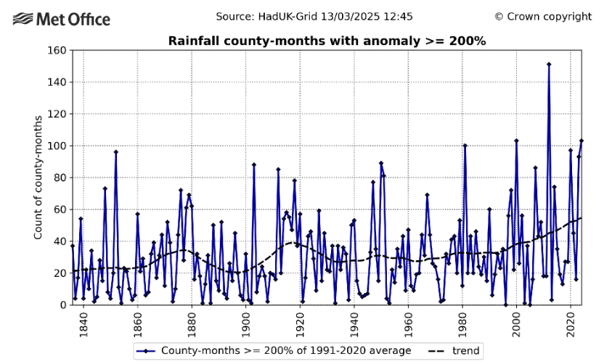
Figure 1: Graph showing trend of rainfall throughout the past years, (Met Office, 2025)
The Welsh National Standards has pointed out that “The SUDS approach mimics natural drainage, managing surface runoff at or close to the surface and as close to its source as practicable, controlling the flow and providing a range of additional benefits.” In Wales the introduction of The Flood and Water Management Act 2010 now requires all new developments to include SUDS features that are in compliance with current standards starting in 2019 (Welsh Government, 2018). Sustainable Drainage Systems today make essential contribution to helping to manage local flood risk and water quality. These are achieved where SUDS lowers flow rates, increase water storage capacity and reduces the transportation of pollution to nearby water course (BGS, 2026). With continued awareness and now a statutory compliance required, the implementation of SUDS is steadily increasing in South Wales. There are various SUDS components that are being utilised, among these components are permeable pavement structures.

Road Surface Materials
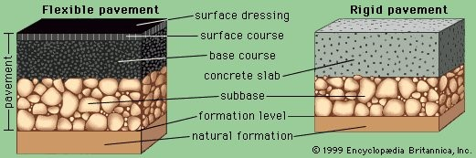
Figure 2: Diagram showing typical road make-up, (Lay. Maxwell Gordon, 2022)
Current conventional road surfaces represent a large proportion of impermeable land cover, and the surface material plays a significant role in determining the overall drainage performance. Figure 2 shows a typical road make-up in the UK, showing the various layers considered during design. An understanding about the distinct types of road surfaces and the methods used in their construction and maintenance is crucial. There are many factors that need to be considered before selecting the final surface material used. All road surfaces are designed to withstand the impact of traffic and environmental conditions. Currently the UK roads are made up of mainly asphalt and concrete which are both impermeable materials. Used for it’s fast-curing nature, long lifespan, and the ability to withstand various loads applied, asphalt has become incredibly popular for roads in the UK. However, like many surface materials asphalts has its own faults. It is prone to rutting and cracking if correct preventative and proper maintenance are not taken. With its impermeable nature it has helped increase the surface flooding in various areas around the Country. The function of impermeable road surfaces is to prevent water entering the pavement where it can weaken the pavement layers (Mazurowski. P 2024).
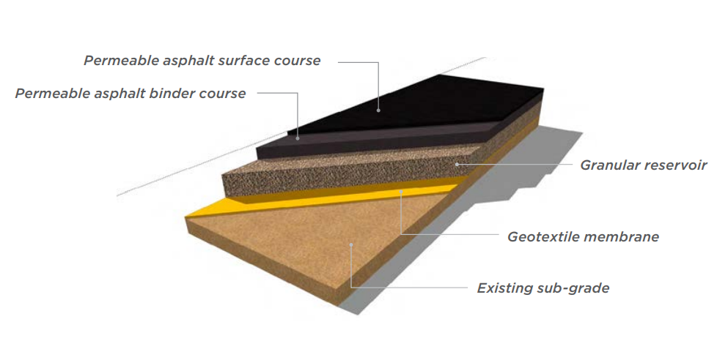
Figure 3: Diagram showing permeable asphalt road make up, (Tarmac, 2015)
For permeable road surfaces it does the exact opposite where it allows water to drain away from the surface and flows to the base layer. This layer is designed to allow water to flow laterally into drains or storage voids. Figure 3 shows a road make up with the use of permeable asphalt as the surface material. Like any conventional roads regular maintenance is needed for permeable materials to maintain permeability and fitness for purpose. In SUDS application a range of road surface materials has been developed to support SUDS functionality. These include permeable asphalt, porous concrete, and permeable block paving systems. They differ in pore structure, load-bearing capacity, and hydraulic behaviour. The major difference is that permeable materials have lower strength compared to regular concrete and asphalt roads making them unsuitable for high speed and high vehicle traffic areas (Mazurowski. P 2024).

However, with the introduction of the 20mph rule in South Wales creates a more suitable conditions for permeable materials. The introduction of the new speed limit across Wales in 2023 aims to improve road safety and promote more sustainable urban environments (Welsh Government, 2024). Reduced traffic speeds can decrease surface wear and the build-up of sediments which can help improve the longevity and maintain permeability of the road material. This can be applied in urban areas where it encourages street design to have permeable surfaces integrated. Limited research exist on how this policy change has had an effect on SUDS performance in South Wales. Therefore, a comparative evaluation of these materials is essential to understand how they behave in different types of conditions.

Effects of Geology in South Wales
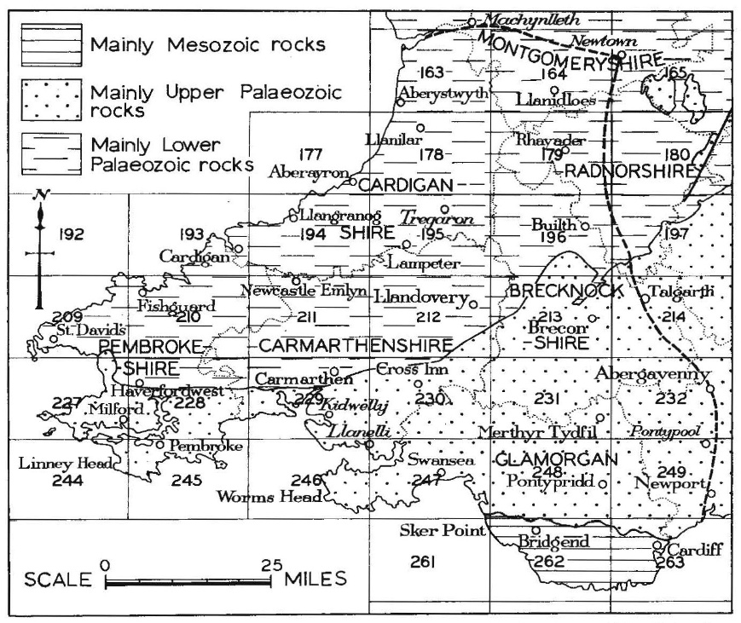
Figure 4: A map showing the three principal geological regions of South Wales (George, T. Neville (1982)
The geology of South Wales as a whole is mainly made up of Palaeozoic rocks, featuring extensive Carboniferous coalfields, Limestones, and Sandstones, and various more as seen on Figure 4. Each varies in their permeability characteristics where limestones are known to have a high permeability whereas coalfields show to have low permeability (George, T. Neville 1982). With South Wales being made up of various rock types that varies in characteristic it is essential that a comprehensive understanding on the current effects to an increase in severe weather is important. With geology having a significant effect regarding permeability and infiltration this further highlights the importance of having an understanding between the relationship of the two factors. If permeable surface road materials are used in impermeable ground, this can lead to reduce in infiltration rate which therefore increases the chance of surface water flooding.

Identification of gaps in current research
Despite the growing research in sustainable drainage systems, there has only been a small evaluation being conducted within the specific environmental context of South Wales. Regional factors such as the increase in annual rainfall, coastal weather influences, local soil and geology characteristics can has a significant effect on SUDS performance. Most of the existing research focuses on generalised UK conditions or international case study which may not fully represent local hydrological performance and behaviour. There remains a need for a comparison of how different road surface materials influence SUDS effectiveness under the conditions in South Wales.
A better understanding of the geology can help understand whether more permeable layers occur beneath shallow layers of impermeable geology in the South Wales region. Using SUDS in upcoming projects can also help overcome the challenge, where permeable surface materials can still be effective where infiltration is not possible (susdrain 2018). With more research being conducted on how an increase in severe rainfall, along with a further understanding of the geology it can help find the most viable solution to prevent the increase in localised flood problems in South Wales. More research can help determine which areas would be the most suitable for the implications of SUDS and which type of surface materials is the most effective.

How your research will address these gaps
Existing research confirms that modern conventional road surface materials play a critical role in determining the hydraulic and environmental performance of SUDS. However, there are still many uncertainties that remains regarding the long-term functionality, and under varying regional conditions. Addressing these gaps requires a better understanding of the material’s characteristics and their relationship with measurable drainage outcomes.

This research proposes to evaluate the effect of different road surface materials on SUDS within South Wales, providing evidence by doing laboratory experiments. Key parameters include determining surface run off, infiltration rate, and permeability in relation to local soil and geological conditions. The results collecting will be able to provide evidence to support more effective and regionally appropriate SUDS design and which road surface material is the viable. This contributes to helping improve South Wales water management practices.

Research Design and Methodology

Research Design
This research proposal adopts a mix of quantitative and comparative research design to fully evaluate the effect of different road surface materials on the performance of Sustainable Drainage Systems (SUDS) in South Wales. The research is structured to address the aims and objectives by combing secondary data analysis and laboratory testing together which allows both theoretical understanding and empirical evaluation of surface water management performance.
By doing a comparative approach it can help enable to assess the hydraulic performance of conventional impermeable road surfaces such as asphalt against alternative permeable SUDS materials. This gives a further understanding of measurable differences in infiltration rate, permeability, and surface runoff characteristics. The research design focuses on quantifiable performance indicators which ensures that the results collected are reliable, objective, and suitable for analysis. By adopting a quantitative approach, it helps the research to be more focused on measuring, comparing, and statically analysing numerical data relating to the material’s hydraulic characteristics. This enables objective evaluation of material performance and reduces subjectivity in interpretation.
The research follows a sequential structure, beginning with a review of current surface water management practices and SUDS implementation in South Wales. This is then followed by laboratory based experimental testing of selected road surface materials, and finally a comparative analysis of results to identify the most effective surface materials for SUDS application in South Wales. This type of structure helps ensure that each stage directly contributes to achieving the research aim and objectives.

Data collection methods
The primary data collection will be conducted through laboratory testing, designed to measure the hydraulic performance of selected road surface materials under controlled conditions. The key performance variables include infiltration rate, surface runoff volume, and permeability, which are all essential to make any SUDS features effective.
Infiltration rate will be measured using standard permeability testing equipment such as the constant head permeameter test to determine the rate at which water passes through each material. Surface runoff will be assessed by exposing the surface materials to controlled volumes of stimulated rainfall and measuring the amount of water that flows across the surface without infiltrating. Permeability testing will evaluate the movement of water through both the surface layers and subbase materials which provides a comprehensive understanding of hydraulic behaviour. Using available equipment, the ability to try and stimulate realistic rainfall simulation during testing will help ensure consistent and repeatable testing conditions across all experiments. Each experiment will be repeated multiple times, and average values will be calculated to improve accuracy and reduce the influence of any anomalies.
To create a systematic organisation of both primary and secondary data, the research paper will adopt an adapted IMRAC (Introduction, Methodology, Results and Analysis, Conclusion) framework as a guiding structure for data handling. Different stages categorise various data, making it easier to understand and navigate. The introduction stage will support the identification of relevant literature and contextual data related to SUDS and road surface materials. The Methodology stage aligns with the designs and implementation of any experimental procedures. The results and analysis stages helps organise and record raw quantitative data such as infiltration rates and permeability. This framework allows for the processing, comparison, and interpretation of results. This structured approach ensures that all data is organised, traceable, and directly aligned with the research objectives.
During any laboratory testing the replication of regional conditions should be considered. This ensures that the study reflects real world conditions that occurs in South Wales, regional environmental data can be incorporated into the analysis. Data from the Met Office can inform intensity and duration of rainfall which can be applied during simulation if viable. This can make the experimental conditions reflect realistic climatic conditions rather than arbitrary laboratory settings. The soil permeability and geological conditions will be considered when interpreting results. This ensures that the data collected are applicable to local drainage systems. This integration of regional data strengthens the practical relevance of the research and can further help determine specific recommendations on the development of SUDS features in South Wales.
A secondary data collection review will also be undertaken to evaluate the existing surface water management strategies and SUDS implementation in South Wales. This includes the analysis of current drainage design practices, the extent of how the Welsh Government has adopted SUDS in urban infrastructure, and the influence of new regulatory frameworks and planning guidance. Secondary data will also be used to compare the results collected from the test from existing published research. This is done to enhance the validity and reliability of the findings. This comparative approach helps ensures consistency in the experiments and help identify any deviations. If there were any differences that occur, these will be critically analysed in relation to variations in testing conditions, material composition, and regional conditions. This process can strengthen the credibility of the research obtained from the tests.
The main resources that will be used include industry standard guidance such as The SUDS manual, along with new published policy documents published by the Welsh Government. Technical information can be obtained from various organisations such as the Environment Agency. These sources can provide insight into best practice design, expected outcomes, and any current limitations that may occur during implementation. Any test carried out will be in accordance with British and International Standard to ensure reliability and validity of the tests.
By doing a secondary data review it can help identify key challenges and differences regarding the characteristics of the surface materials used in roads today. Challenges such as limited infiltration capacity in urban areas, maintenance requirements, and the variability in the material’s behaviour under certain loads and conditions. This stage is essential for establishing the research gap and ensuring that the experimental methodology addresses both the objectives and real-world engineering problems.

Sampling Methods
To ensure to represent current road construction practices and SUDS applications in South Wales, a purposive sampling strategy will be adopted to determine which materials under certain conditions should be used for testing. This ensures that the research focuses on materials that are most relevant to conditions found in South Wales rather than an overly broad selection.
The selected materials will include conventional impermeable asphalt as a control sample, alongside widely used permeable materials such as permeable asphalt, porous concrete, and permeable block paving. These materials have been chosen due to their widespread application in both traditional and SUDS based drainage systems, making them suitable for comparative hydraulic analysis.
In addition to surface materials, representative soil and the geology of South Wales will be included in testing. Geological and soil data provided by organisations such as the British Geological Survey will be used to ensure that conditions during testing will reflect typical ground characteristics found in South Wales. Although the sample size is limited due to time and resource constraints, repeated testing of each material will be done to improve reliability, reduce errors, and help spot any anomalies.

Data analysis plan
The data analysis plan will include the analysis of data using a quantitative comparative approach. This allows for the objective evaluation of material performance obtained from the laboratory tests and secondary data. Raw data will be organised into structured datasets (IMRAC framework), which includes infiltration time, runoff volume, and permeability. The mean values will be calculated from any repeated test to help improve reliability and to detect and reduce the impact of any anomalies. A comparative analysis will be conducted to assess the performance of each material against key indicators. These include infiltration rate efficiency, runoff reduction capacity, and the material’s overall permeability. The materials would then be ranked based on performance outcomes to identify the most effective SUDS solution. Soil testing and the collection of geological data relating to South Wales will also be incorporated into the research to further support the evaluation of material performance under varying ground conditions. This enables the evaluation of the relationship between road surface materials and local soil permeability.
Basic statistical methods like the mean and standard deviation will be calculated to assess variability and consistency in the results. Where appropriate, percentage differences between materials will also be calculated to identify performance improvements in relation to the control sample impermeable asphalt. All Findings will be presented with the use of table and graphical representations such as bar charts. This allows for a clear visual comparison between the materials. All results will then be interpreted in relation to regional environmental conditions and existing SUDS practices in South Wales.
The reliability and validity of all collected throughout the research will be ensured using standardised testing procedures and repeating experiments trials under a controlled environmental condition for each material. This helps reduces variability and ensures that results are consistent and reproducible. The validity will be strengthened by integrating laboratory results with real world contextual data such as regional rainfall and soil characteristics. By comparing with existing research, it ensures consistency with established research findings. This combination of experimental and contextual validation enhances the credibility and applicability of the research paper.

Limitations
All throughout the research, several limitations are acknowledged. Limitations such as testing not fully replicating long term field conditions in relation to material clogging, ageing, and maintenance effects on permeable surface materials. The limited number of samples and materials due to time and resource constraints can restrict the range of comparison. Any access needed to certain sites and real-world monitoring data may also be limited, which could reduce the extent of validation under actual operational conditions. Access to the appropriate equipment’s needed for the test to try and recreate real world environment conditions may be limited, and therefore affects the data collected credibility. Conditions such as realistic rainfall simulation is ideal to replicate drainage conditions, it is recognised that fully realistic rainfall patterns may not be achievable due to equipment and time constraints. Therefore, results will represent controlled conditions rather than full environmental variability.
These limitations will all need to be considered when interpreting results, and any recommendations made should be made with appropriate caution.

Ethical considerations
The research presents minimal ethical considerations, but appropriate measures will still need to be taken to ensure responsible conduct. Any use of external data where required and used for this research should be obtained with permissions asked. All data collected from experiments will be recorded accurately and reported honestly.
Environmental considerations should be addressed by minimising waste during laboratory testing and ensuring that the materials used are disposed of responsibly. Appropriate care should be taken when using any equipment’s to carry out various laboratory tests. In addition, all secondary sources such as Statistics from the Met Office, will be properly referenced to avoid plagiarism and uphold academic standards.

Timeline
The research will be conducted over an eight-month period starting from October 2026 to May 2027. This allows sufficient time for an in-depth literature, review, experimental testing, data analysis, and final reporting. A Gantt Chart would be created to accompany this timeline to clearly illustrate task sequencing, overlaps, and any key milestones throughout the project. The initial phase at the start of the project in October will focus on the literature review and contextual research which can last for 8 weeks. During this period, key academic, industry, and policy resources will be reviewed to establish a comprehensive understanding of Sustainable Drainage Systems, the various types of road surface materials currently in use, and the surface water management practices in South Wales. This phase is key in refining the research aim and objectives based on the identified gaps. This can be seen in Appendix 1 where it shows that during the Literature review, the aims & objectives and the research design & methodology would also be defined
Around December 2026, the focus will shift to finalising the research design and methodology. This includes confirming the selection of road surface materials and help define the experimental procedures needed such as figuring out the appropriate testing methods to obtain the desired data. Having a comprehensive understanding of the testing methods to identify the material permeability and infiltration will be essential during this phase. Around this time preparation for how data will be collected will be conducted. This includes sourcing materials and organising laboratory access. This can be seen in Appendix 2 where the Gantt Chart shows the intended timeline for this phase.
The data collection phase will be carried out between January and February 2027. During this time, laboratory experiments will be conducted to measure the desired parameters such as infiltration rate, permeability, and surface runoff characteristics for each of the selected material. Multiple trials will be performed to ensure reliability, and all data will be recorded systematically. Around March 2027, this would be the data analysis phase, where collected data will be processed using quantitative methods. This includes calculating mean values and comparing each material performance with each other and with existing studies. These will be presented through the use of graphs and tables. With the comparison with existing published research, it helps validate results and identify any variations. The timeline can be seen in Appendix 3 and 4.
The final phase, will span between April to May 2027 where the focus will be on writing, reviewing, and completing the Research study. This will include drafting the results, discussion, and conclusions. In this stage, earlier stages will be reviewed and refined ensuring consistency throughout the document. With the use of the Gantt Chart, time can be allocated to other phases such as proofreading, formatting, and incorporating feedback before final submission. This structured timeline helps ensures that all stages of the research are completed efficiently while allowing flexibility to address any challenges that may occur throughout the project. The timeline can be seen in Appendix 5 and 6.

Expected Outcomes
The expected outcome of this research study is to produce a quantitative comparison of the hydraulic performance of conventional and SUDS surface materials, with specific relevance to South Wales. After all data collection through secondary research and laboratory testing, it is anticipated that permeable materials such as permeable asphalt will demonstrate significantly high infiltration rates and reduced surface runoff compared to traditional asphalt helping reduce localised flooding.

Potential findings
However, these findings may vary depending on various factors such as on underlying soil conditions and geological characteristics. Different materials can perform differently in areas with low permeability soil, where a full evaluation of the ground conditions needs to be conducted. It will also depend on the fitness of purpose of the road. The introduction of 20mph speed limits in many areas of South Wales can have an influence on material suitability. As lower speed limit and traffic volume can massively reduce surface wear and clogging can help enhance long term performance of permeable materials. In contrast, in areas where there are higher traffic volume or heavier loading expected the use of conventional road surface materials may be more suitable. This suggests that further long-term research is needed to assess the performance of materials exposed in different real-world environments.

Conclusion
In conclusion, this research proposal has outlined a structured and quantitative approach to evaluate the impact of road surface materials on the performance of SUDS in South Wales. By integrating literature review, laboratory testing, and comparative analysis, the proposal aims to generate reliable, replicable and practically relevant findings. While there are limitations that can affect direct real-world applicability, the research incorporates key considerations. Overall, the research seeks to support more effective and sustainable drainage design through informed material selection tailored to both environmental and operational conditions.

References
Met Office (2025) Annual climate stocktake shows weather records and extreme now the norm in UK Climate. [online] Available at: https://www.metoffice.gov.uk/about-us/news-and-media/media-centre/weather-and-climate-news/2025/annual-climate-stocktake-shows-weather-records-and-extremes-now-the-norm-in-uk-climate#:~:text=As%20the%20UK's%20climate%20warms,is%20clear%20from%20our%20observations.%E2%80%9D (Accessed on 1 November 2026)
Welsh Government (2018) Statutory national standards for sustainable drainage systems – designing, construction, operating and maintaining surface water drainage systems. [online] Available at: https://www.gov.wales/national-standards-sustainable-drainage-systems-suds#:~:text=National%20standards%20for%20sustainable%20drainage%20systems%20(SuDS),and%20maintenance%20of%20surface%20water%20drainage%20systems. (Accessed on 1 November 2026)
Natural Resources Wales (2025) How to comply with Sustainable Drainage Systems (SuDS) standards. [online] Available at: https://naturalresources.wales/guidance-and-advice/business-sectors/planning-and-development/advice-for-developers/how-to-comply-with-sustainable-drainage-systems-standards/?lang=en (Accessed on
BGS (2026) Sustainable drainage systems. [online] Available at: https://www.bgs.ac.uk/geology-projects/suds/ (Accessed on 1 November 2026)
Lay. Maxwell Gordon and Benson. Fred (2022) Road. [online] Available at: https://www.britannica.com/technology/road/The-modern-road#ref592118 (Accessed on 15 November 2026)
Tarmac (2015) Permeable Asphalt Solution Guide. [online] Available at: https://www.tarmac.com/wp-content/plugins/tarmac.com/components/downloads/file-download.php?download_id=6832 (Accessed on 15 November 2026)
Mazurowski. P (2024) Road Surfaces: types and materials. [online] Available at: https://www.tensar.co.uk/resources/articles/road-surfaces-types-and-methods (Accessed on 15 November 2026)
Welsh Government (2024) Introducing default 20mph speed limits. [online] Available at:https://www.gov.wales/introducing-default-20mph-speed-limits?utm_source=chatgpt.com (Accessed on 6 December 2026)
George, T. Neville (1982) South Wales British Regional Geology 3rd ed. Third Impression. [online] Available at: https://webapps.bgs.ac.uk/memoirs/docs/B01384.html#:~:text=South%20Wales%20as%20a%20whole,uppermost%20Trias%20and%20lowest%20Jurassic. (Accessed on 6 December 2026)
Susdrain (2018) Overcoming common SuDS challenges – Busting some design myths. [online] Available at: https://www.susdrain.org/files/resources/fact_sheets/site_challenges_for_designing_suds_v4.pdf (Accessed on 6 December 2026)

Appendix


Appendix 1: Gantt Chart showing Research Planning Stage

Appendix 2: Gantt Chart showing December timeline

Appendix 3: Gantt Chart Showing January and February Timeline
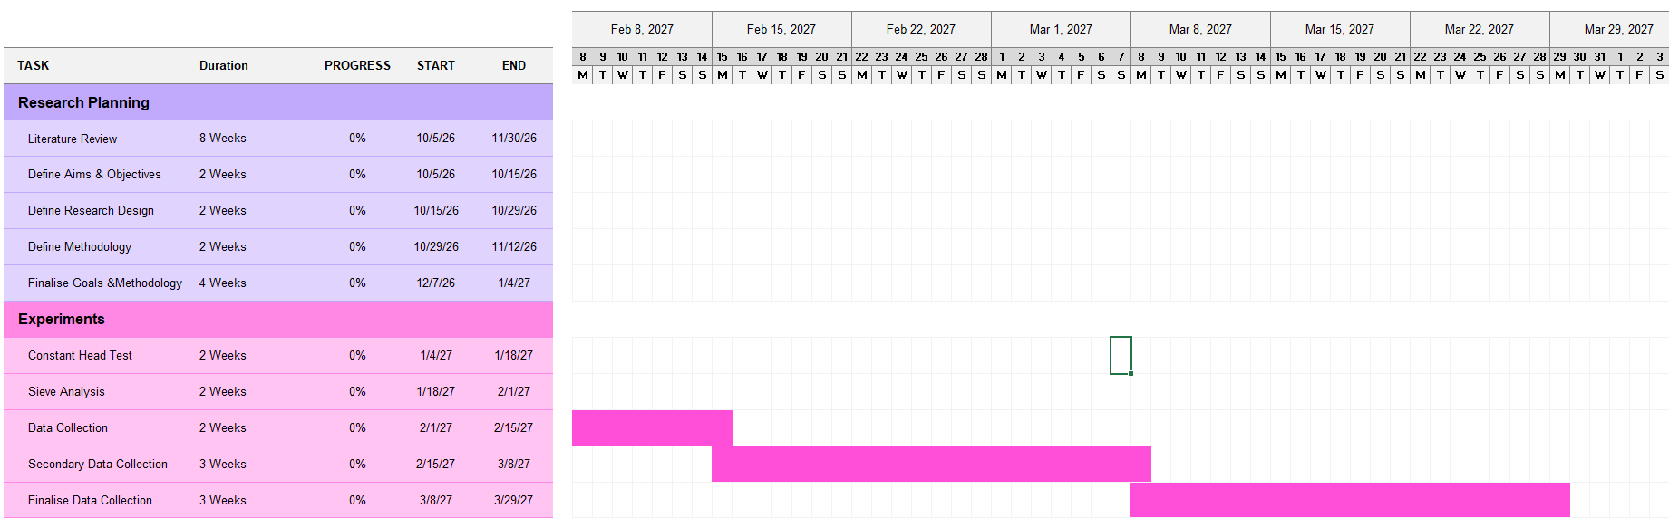
Appendix 4: Gantt Chart showing February and March Timeline
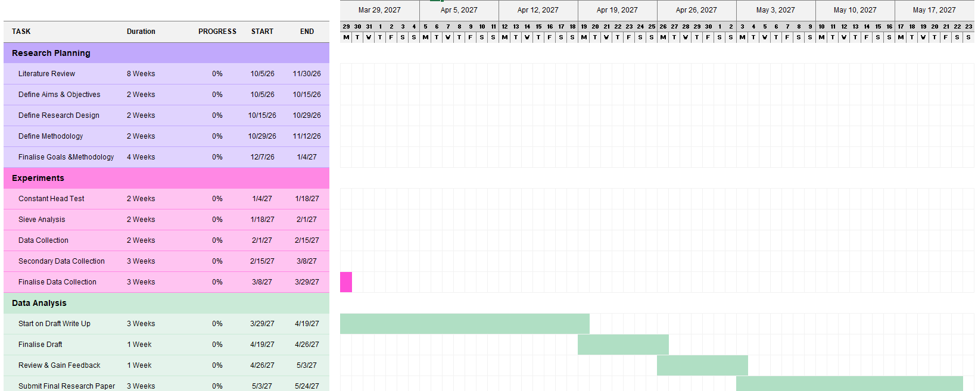
Appendix 5: Gantt Chart Showing April and May Timeline
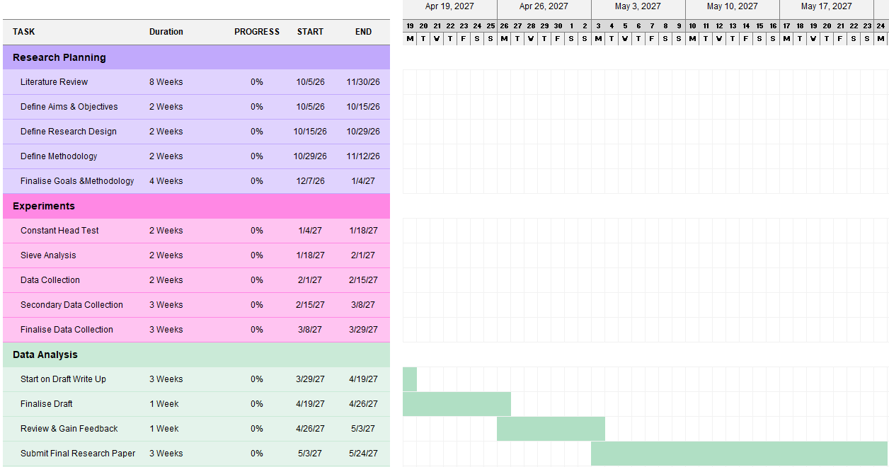
Appendix 6: Gantt Chart showing May Timeline

